Workers' Compensation Premium Audit Platform
Role-Based User Documentation
Naming Note: All product references use "the Platform" or "the Audit Platform."
Screenshot Placeholders: Where screenshots would normally appear, clearly marked placeholder blocks are included. These describe exactly what must be captured.
Version: Post-Phase 7D

Document Overview
This documentation set consists of five role guides and one reference appendix:
Document Part | Contents
Part 1 (this file) | Guide 1: Super Admin · Guide 2: Tenant Admin
Part 2 | Guide 3: Auditor · Guide 4: Reviewer
Part 3 | Guide 5: Input File Reference · Appendix: Quick Reference Cards

GUIDE 1: SUPER ADMIN USER GUIDE
Audience: The platform operator — the person or small team responsible for managing the platform at the highest level, provisioning tenant organizations, and maintaining the carrier catalog. Super Admins are not affiliated with any single tenant.

1.1 Who Is the Super Admin?
The Super Admin is the highest-privilege role in the platform. Unlike every other role, the Super Admin operates across all tenants and is not scoped to any single organization. Every other role — Tenant Admin, Auditor, Reviewer — belongs to exactly one tenant and can only see that tenant's data. The Super Admin has no tenant affiliation and therefore sees the platform from the outside: the list of all tenants, the global carrier catalog, and platform-level settings.
What the Super Admin can do that no other role can:
- Create and activate new tenant organizations via the 4-step Tenant Creation Wizard
- Deactivate or delete tenants
- Manage the platform-wide carrier catalog (add, edit, or remove carriers available for tenants to use)
- View all tenants and their identity information
- Access the Platform Admin Dashboard at the top-level platform URL
What the Super Admin cannot do:
- Enter a tenant's workspace to view audit data, policies, or reports — that data is strictly isolated inside each tenant's schema
- Manage a tenant's carrier assignments, users, or configuration after the tenant is provisioned — that is the Tenant Admin's responsibility
- Approve field mappings or trigger calculations inside any tenant
How to log in:
Super Admins log in at the platform's root domain — for example, platform.yourcompany.com. They do not use a tenant subdomain. The login URL will be provided by your system administrator.
After authentication through your identity provider (Keycloak or Microsoft Entra ID), you land directly on the Platform Admin Dashboard.
Platform Admin Dashboard — Super Admin first login Shows: The top-level admin dashboard with the tenant list table (showing all tenant names, slugs, statuses, and creation dates), a "New Tenant" button in the top right, and a "Carriers" navigation item in the sidebar. No tenant data is visible — only the list of organizations.
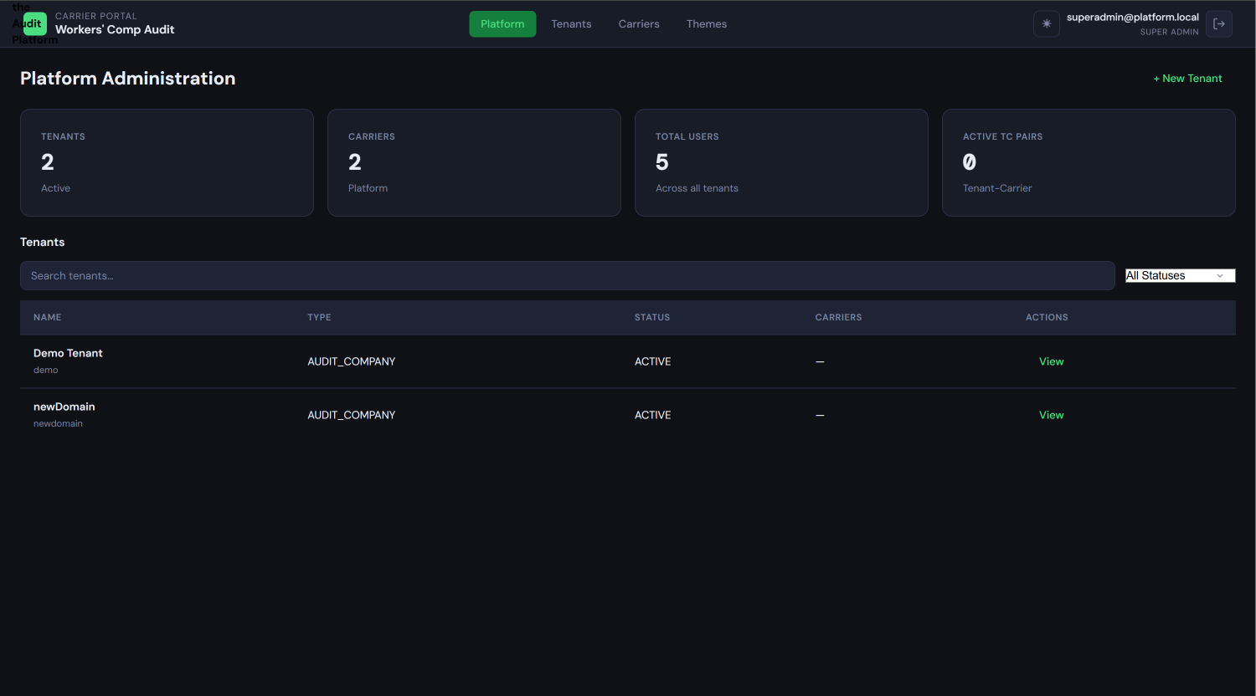

1.2 Tenant Management
Creating a New Tenant — Step by Step
To provision a new tenant organization, click the New Tenant button on the Platform Admin Dashboard. This opens the 4-step Tenant Creation Wizard.
Step 1: Tenant Identity
You will provide two pieces of information:
- Tenant Name: The full display name of the organization, for example "Acme Insurance Group" or "Midwest Audit Associates." This appears in the platform's admin interface.
- Subdomain Slug: The URL identifier for this tenant. Rules:
  - Lowercase letters, numbers, and hyphens only — no spaces, underscores, or special characters
  - Must be globally unique across the entire platform — if the slug is already taken, you will see an inline error and must choose a different one
  - Once created, the slug cannot be changed without deleting and re-creating the tenant
  - Example: if you enter acme-insurance, the tenant will be accessible at acme-insurance.platform.yourcompany.com
Tenant Creation Wizard — Step 1 Shows: Two input fields labeled "Tenant Name" and "Subdomain Slug," with a real-time slug preview showing the full URL that will be created (e.g., acme-insurance.platform.yourcompany.com), and a "Next" button.
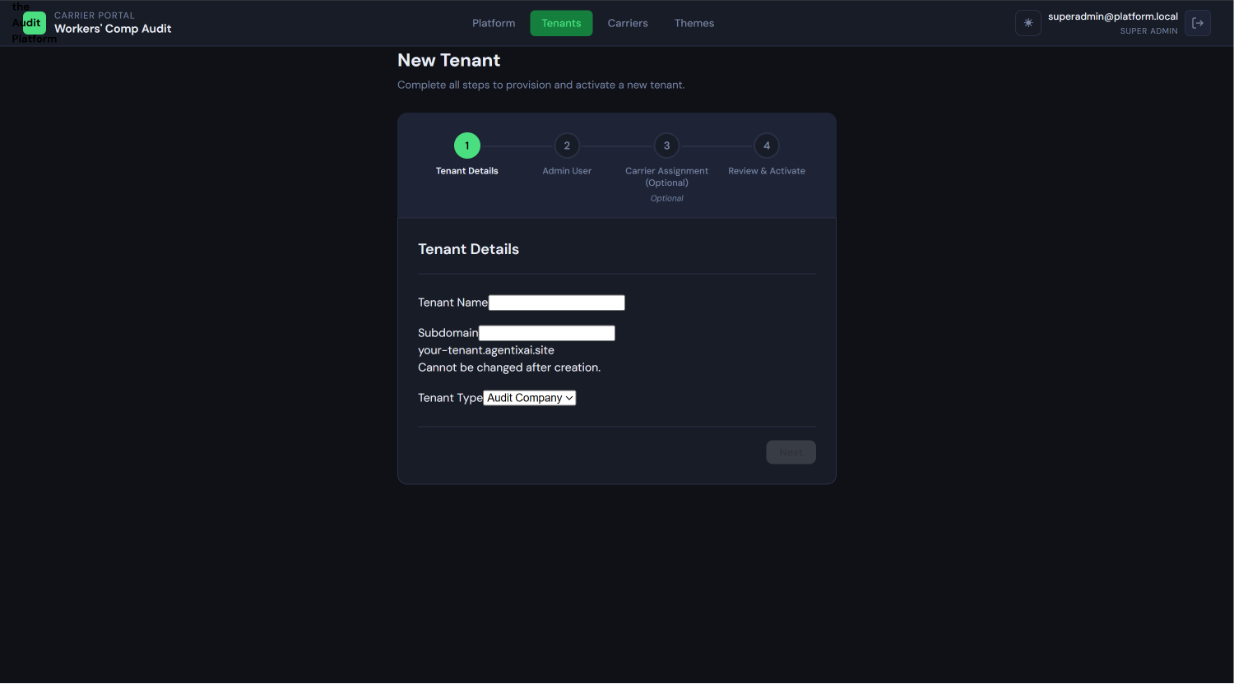
Step 2: Tenant Admin User
You must designate the first administrator for this tenant. This person will receive an invitation email allowing them to set their password and complete tenant onboarding. Provide:
- Email Address: The Tenant Admin's email. This is also their login username.
- Full Name: Their display name as it will appear in the platform.
An invitation email with a password-set link will be sent to this address once you complete Step 4 and activate the tenant. The Tenant Admin does not have access until that activation step is complete.

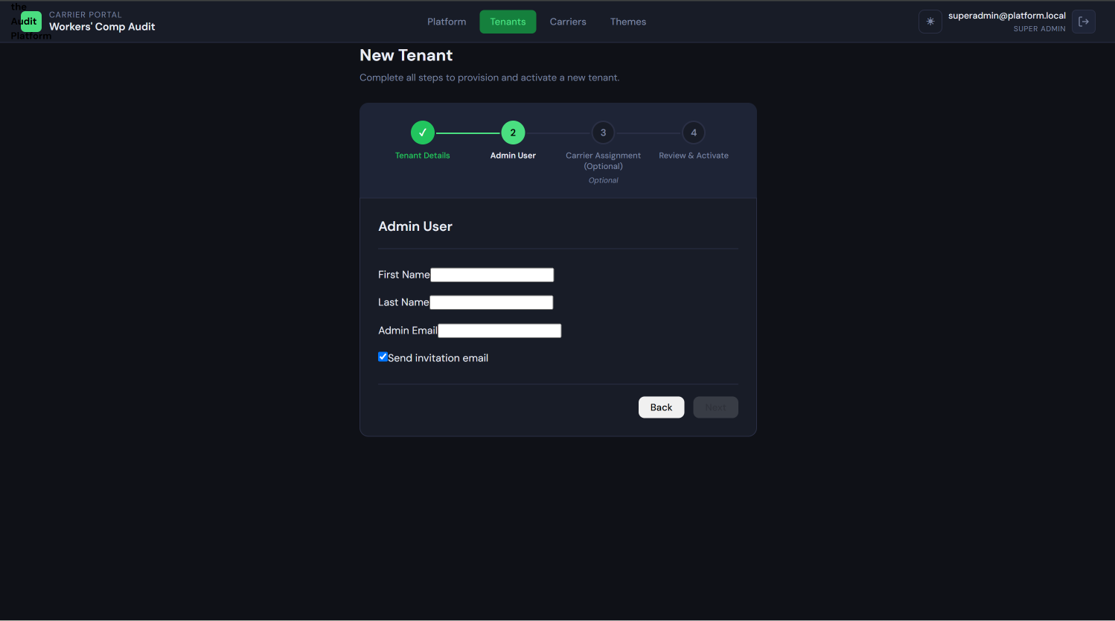
Tenant Creation Wizard — Step 2 Shows: Two input fields labeled "Email Address" and "Full Name," with a note below indicating the user will receive an invitation email upon activation.
Step 3: Carrier Assignment (Optional)
You may optionally assign one or more insurance carriers to this tenant from the platform carrier catalog. Carrier assignment at this step is optional — as of Phase 7A, the Tenant Admin can add and remove carriers independently from their administration interface after onboarding.
Two scenarios:
- If you assign carriers now: The tenant will be pre-configured with those carriers and their 22 seeded calculation rules when the tenant activates. The Tenant Admin will see them immediately on first login.
- If you skip this step: The tenant activates without any carriers. The Tenant Admin must add carriers from the Administration panel before any audit work can begin. Skipping is completely valid — the Tenant Admin is fully capable of self-managing carrier assignments.
Use the search box to find carriers by name or code. Select one or more. You may also skip by clicking Next without selecting any.
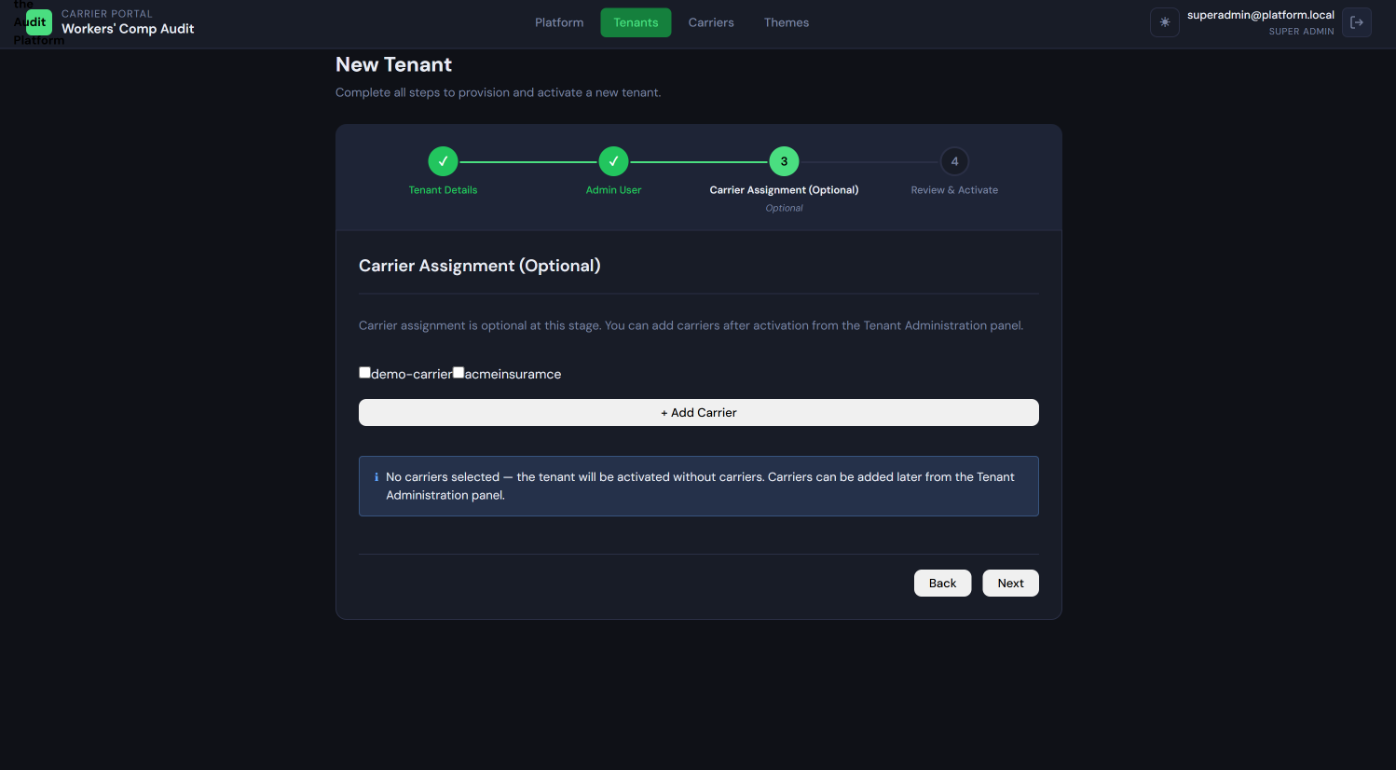
Tenant Creation Wizard — Step 3 Shows: A searchable carrier selection list with carrier names and codes, checkboxes to select multiple carriers, and a "Skip this step" link alongside the "Next" button.
Step 4: Review and Activate
A summary screen shows:
- Tenant name and subdomain URL
- Tenant Admin email and name
- Assigned carriers (or "None — to be configured by Tenant Admin")
Review for accuracy. If anything is wrong, use the Back buttons to return to earlier steps.
When you click Activate, the following happens automatically in the background:
- A new database schema is created for this tenant (tenant_{slug})
- All required database tables are created in that schema (Alembic migration runs automatically)
- If carriers were assigned, 22 calculation rules are seeded per carrier, and a carrier configuration placeholder is created
- The tenant status is set to ACTIVE in the platform database
- An invitation email is sent to the Tenant Admin with a secure password-set link
If anything fails during provisioning, the partially created schema is automatically cleaned up and you will see an error message. You may safely try again.
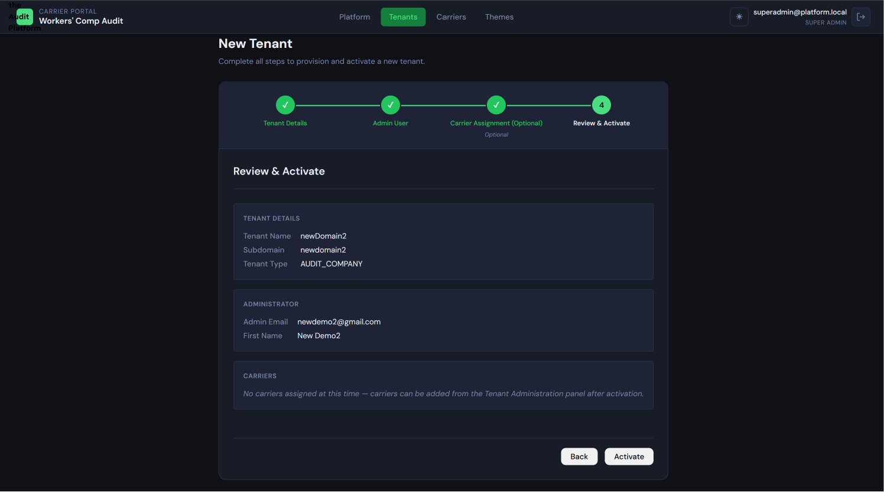
Tenant Creation Wizard — Step 4 (Review) Shows: A read-only summary of all entered information — tenant name, subdomain preview URL, Tenant Admin name and email, list of assigned carriers — with an "Activate" button and a "Back" button.
Tenant Creation Wizard — Step 4 (Activation in progress) Shows: A spinner or progress indicator with the message "Provisioning tenant schema…" indicating that the background provisioning is running.

What Happens After Activation
Once activation completes:
- The Tenant Admin receives an invitation email. It contains a time-limited link to set their password. Once they set their password, they can log in at {slug}.platform.yourcompany.com.
- The tenant's subdomain becomes live immediately.
- If carriers were assigned during provisioning, they appear in the Tenant Admin's carrier list, each fully pre-configured with 22 calculation rules in ACTIVE status.
- If no carriers were assigned, the Tenant Admin will see an empty carrier list and must add carriers before uploading any files.

Viewing and Managing Existing Tenants
From the Platform Admin Dashboard, the tenant list shows all tenants with their name, slug, status badge (ACTIVE or INACTIVE), and creation date.
Click any tenant row to open the Tenant Detail view, which shows:
- Identity section: Tenant name, slug, database schema name, and full subdomain URL
- Assigned Carriers section: The list of carriers currently assigned to this tenant. This section is read-only for the Super Admin after Phase 7A — carrier assignments are managed by the Tenant Admin. You can see which carriers are assigned but cannot add or remove them here.
- Users section: A list of all users within this tenant, their roles, and their status.
- Danger Zone: Options to deactivate or delete the tenant (see below).
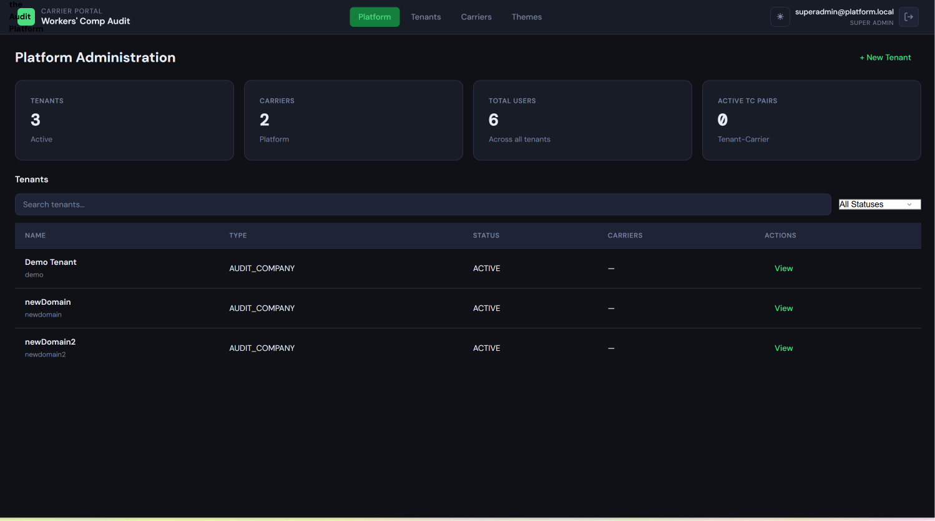
Platform Admin Dashboard — Tenant list Shows: A table with columns for Tenant Name, Slug, Status (with color-coded ACTIVE/INACTIVE badges), Assigned Carriers count, User count, and Created date. A "New Tenant" button appears in the top right.
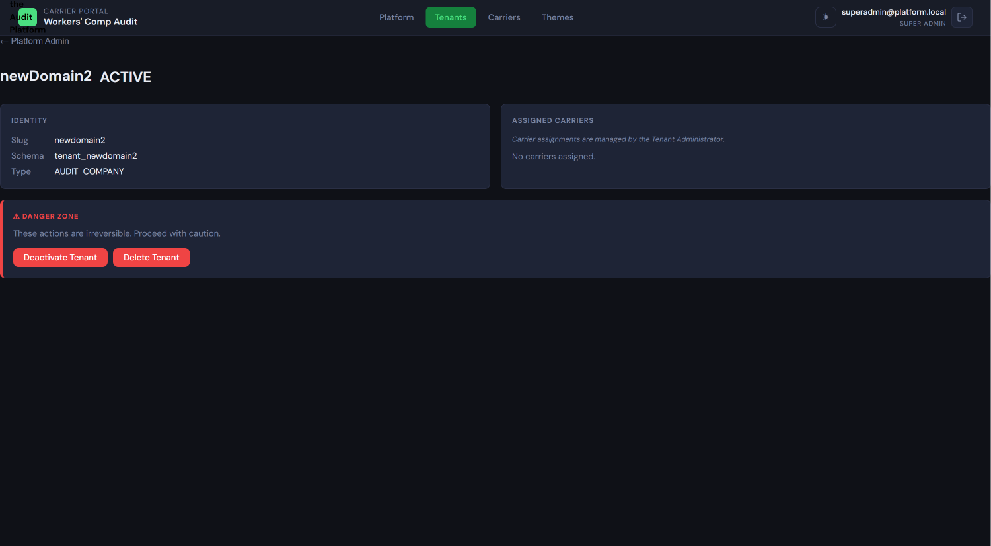
Tenant Detail view Shows: The full detail page for a single tenant, with Identity, Assigned Carriers, and Users sections visible. The "Carrier assignments are managed by the Tenant Administrator" note should be visible in the Carriers section. The Danger Zone section with Deactivate and Delete buttons appears at the bottom.

Deactivating a Tenant
Deactivating a tenant prevents all users of that tenant from logging in. It does not delete any data. The tenant's schema, configuration, and audit records are preserved. To deactivate, click Deactivate Tenant in the Danger Zone section of the Tenant Detail view and confirm the action.
You can reactivate a deactivated tenant by returning to this view and clicking Activate Tenant.

Deleting a Tenant
Deleting a tenant is permanent and irreversible. It removes:
- The entire tenant database schema and all data within it (audit records, policies, configurations, user records)
- The tenant record from the platform database
- All Keycloak/Entra ID users associated with this tenant
This action cannot be undone. Before proceeding, ensure the tenant organization no longer requires access to any of their data and that all reports have been downloaded and saved externally.
To delete, click Delete Tenant in the Danger Zone, read the warning dialog carefully, and type the tenant name to confirm.
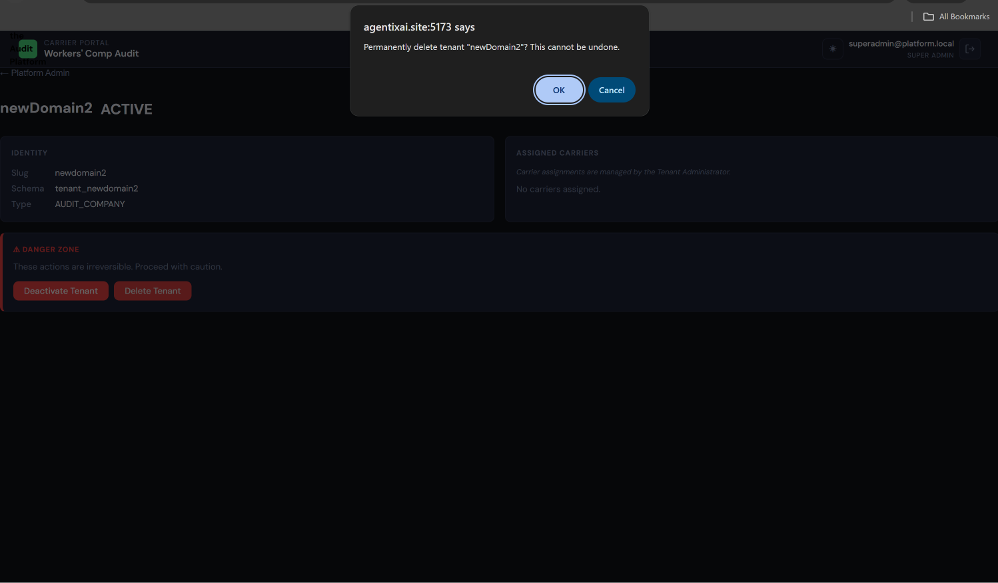
Delete Tenant confirmation dialog Shows: A modal with a red warning header, a plain-language explanation of what will be permanently deleted, a text input asking the user to type the tenant name to confirm, and a red "Delete Permanently" button alongside a "Cancel" button.

1.3 Carrier Catalog Management
The platform carrier catalog is the master list of insurance carriers available across the entire platform. When Tenant Admins add carriers to their organization, they select from this catalog. The Super Admin is responsible for maintaining this catalog.
This is distinct from a tenant's assigned carriers — the Super Admin curates what is available; the Tenant Admin chooses which available carriers to use.
To access the carrier catalog, click Carriers in the sidebar of the Platform Admin Dashboard.
Adding a New Carrier
Click Add Carrier to open the carrier creation form. Required fields:
- Carrier Name: The full carrier name as it should appear throughout the platform (e.g., "Markel Insurance")
- Carrier Code: A short identifier code used internally (e.g., MARKEL or MRK01). Must be unique across the platform. Used as a reference key.
After saving, the new carrier immediately appears in the catalog and is available for any Tenant Admin to assign to their organization.
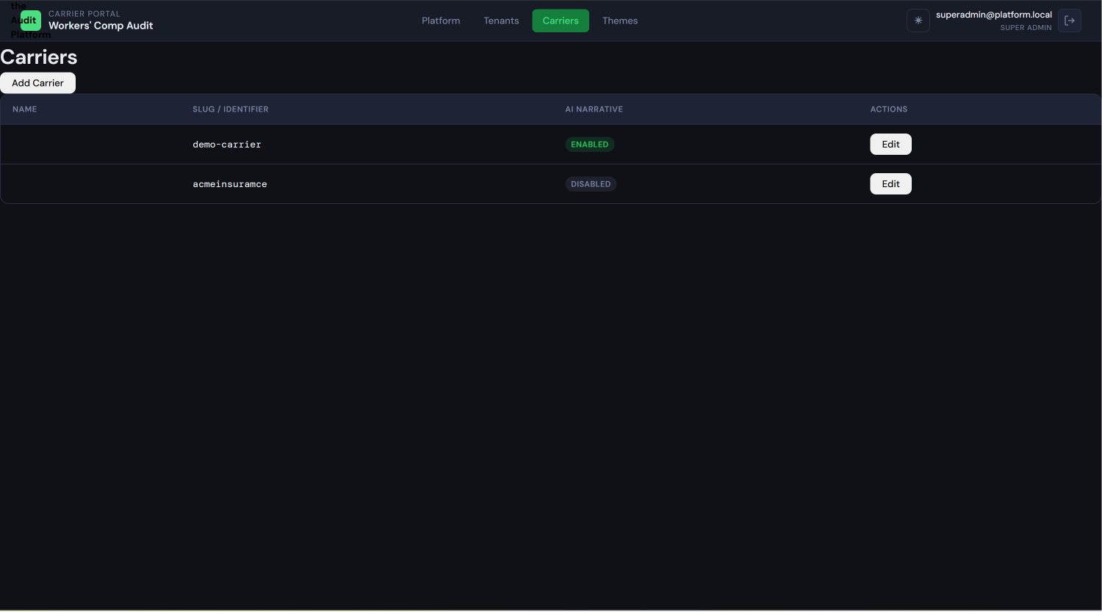
Carrier catalog list Shows: A table of all carriers in the platform catalog with columns for Carrier Name, Carrier Code, and an Actions column with Edit buttons. An "Add Carrier" button appears in the top right.
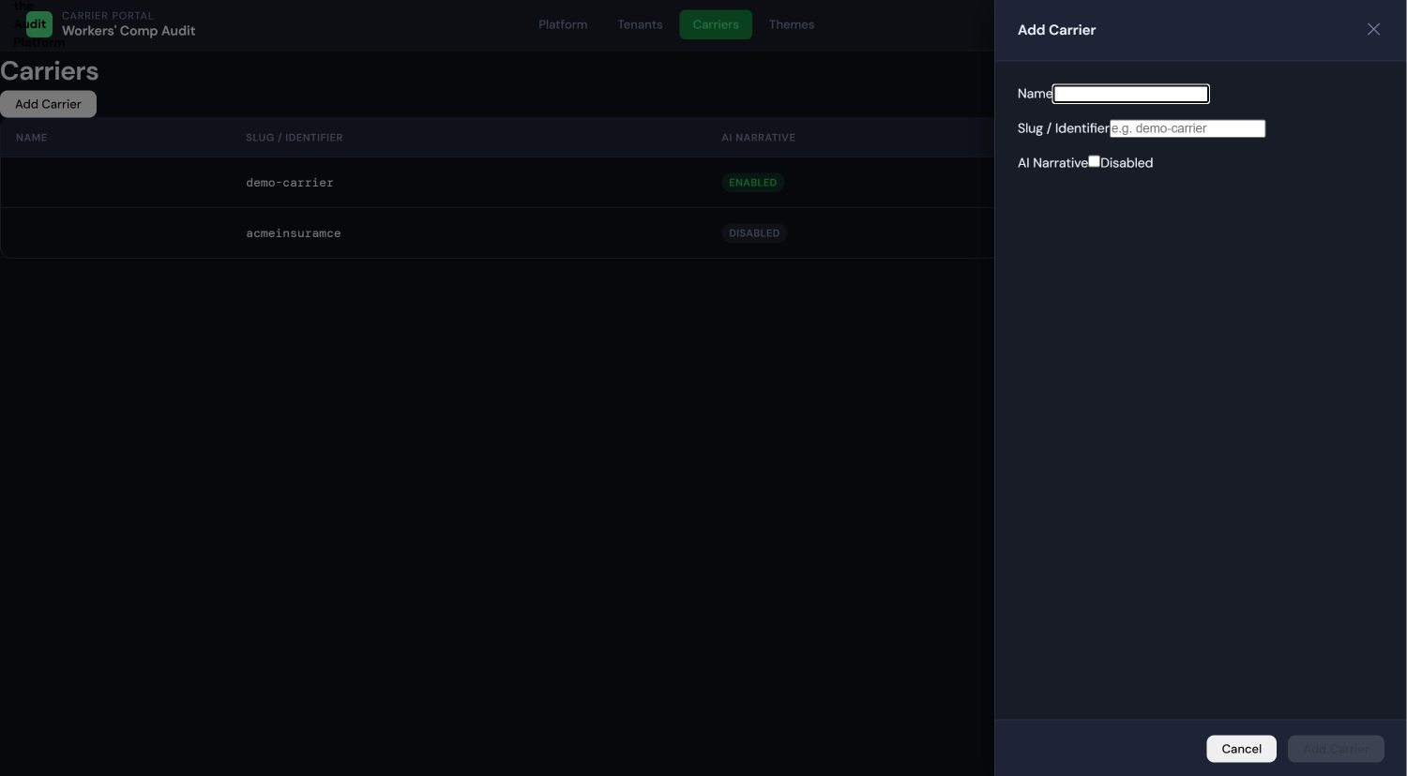
Add new carrier form Shows: A modal or inline form with "Carrier Name" and "Carrier Code" input fields, and Save/Cancel buttons.
Editing a Carrier
Click Edit on any carrier row to modify its name or code. Changes take effect immediately and are visible to all tenant admins whose organizations use this carrier.
Caution: Changing a carrier's code may affect integrations if any external system references that code. The carrier name change is cosmetic only — existing audit data is not affected.

1.4 Platform-Wide Settings
The Super Admin has access to platform-level settings. The specific controls available may expand over time, but at this release they include:
- Class Code Management: The platform maintains a reference list of workers' compensation class codes used across all tenants. These are viewable from the administration settings. Class codes are used during audit calculations to identify and categorize payroll by occupation type.
- Theme Definitions: The four built-in system themes (Default Dark, Default Light, Corporate Dark, Corporate Light) are seeded at the platform level. These are immutable — they cannot be edited or deleted. They appear as options in every tenant's theme management screens. Custom themes are managed at the tenant level and are not visible to the Super Admin.

1.5 User Management at Platform Level
The Super Admin can view users across all tenants from the Tenant Detail view of any individual tenant. There is no single cross-tenant user list.
The Super Admin does not directly create, edit, or delete tenant-scoped users. That is the Tenant Admin's responsibility. For password resets, the process depends on your identity provider configuration (Keycloak or Microsoft Entra ID) — consult your IdP administrator.

1.6 Super Admin Do's and Don'ts
Action | Super Admin Can Do This | Notes
Create a new tenant | ✓ | Via the 4-step wizard
Assign carriers to a tenant at creation time | ✓ | Optional — can skip; Tenant Admin adds later
Add or remove carriers from a tenant after creation | ✗ | Tenant Admin's responsibility
Add carriers to the platform carrier catalog | ✓ | Available anytime
Edit a carrier in the platform catalog | ✓ | Changes visible platform-wide
View a tenant's audit data, policies, or reports | ✗ | Super Admin does not enter tenant workspaces
Deactivate a tenant | ✓ | Reversible; preserves all data
Delete a tenant | ✓ | Irreversible — confirm carefully
Invite users to a tenant | ✗ | Tenant Admin's responsibility
Approve field mappings | ✗ | Tenant Admin's responsibility
Reset a Tenant Admin's password | Depends on IdP | Managed in Keycloak or Entra ID
Manage class codes | ✓ | Platform-level reference data

GUIDE 2: TENANT ADMIN USER GUIDE
Audience: The administrator of a specific tenant organization — an insurance carrier, audit company, broker, or payroll company. The Tenant Admin configures the platform for their organization, manages users and carrier relationships, and controls all aspects of how the platform behaves for their team. They have full control within their tenant and no visibility into any other tenant.

2.1 Who Is the Tenant Admin?
The Tenant Admin is the most powerful role within a tenant organization. They configure everything — carriers, calculation rules, field mappings, labels, themes — and they are the mandatory approval gate for all ingestion runs. No audit data can be processed until a Tenant Admin approves the field mapping.
Key distinction from Auditors and Reviewers: Tenant Admins configure the platform; Auditors and Reviewers use it.
What the Tenant Admin can do:
- Complete tenant onboarding (organization profile, branding, carrier setup)
- Add and remove carriers from their organization's carrier list
- Configure each carrier through the 6-tab Carrier Configuration Hub
- Pre-configure field mappings so Auditors upload files with fewer manual review steps
- Manage calculation rules (with the two-step approval workflow)
- Approve or reject field mapping proposals after file uploads
- Roll back ingestion runs (Tenant Admin exclusive)
- Invite, edit, and deactivate users within the tenant
- Run database cleanup at the end of each monthly processing cycle
What the Tenant Admin cannot do:
- Access any other tenant's data
- Modify the platform carrier catalog (only Super Admin can add carriers to the catalog)
- Change the platform-level system themes

2.2 First Login — The Onboarding Wizard
When the Super Admin activates your tenant, you will receive an invitation email from the platform. The email contains a secure link to set your password. After setting your password, your next login triggers the 5-step Onboarding Wizard automatically.
You must complete the wizard to access the main administration interface. You can return to earlier steps during the wizard. The wizard saves progress as you go.
Step 1: Organization Profile
Enter your organization's identity information:
- Company Name: Your organization's full legal or trading name
- Address: Street address, city, state, ZIP
- Contact Email: The primary contact email for your organization
- Phone Number: Primary contact phone
This information appears in report headers and other official output.
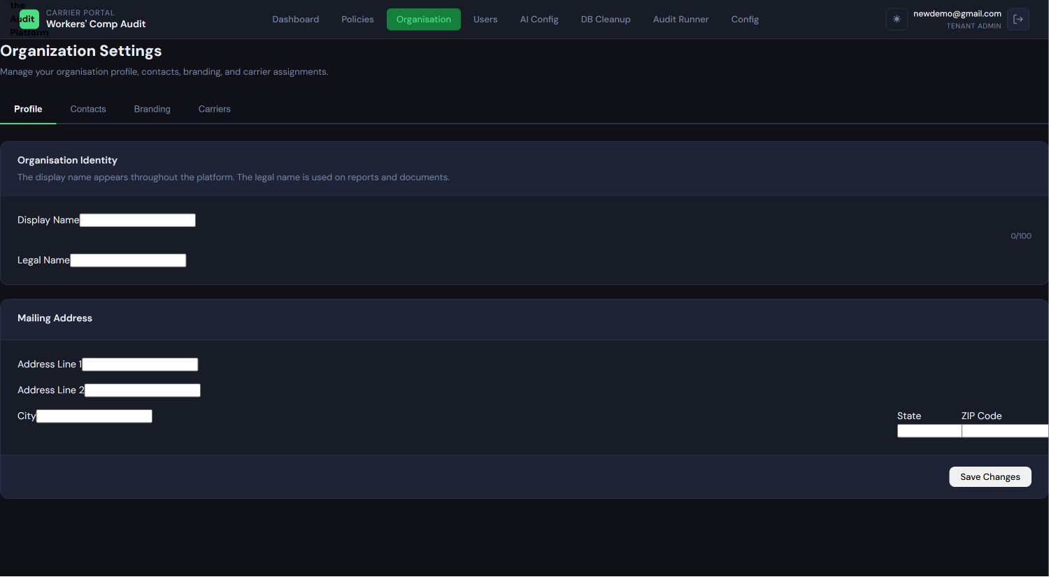
Onboarding Wizard — Step 1 (Organization Profile) Shows: A form with fields for Company Name, Address (street, city, state, ZIP), Contact Email, and Phone Number. A progress indicator shows "Step 1 of 5" at the top.
Step 2: Contact Persons
Add the key contacts for your organization — the people who should be referenced in communications and reports. You may add multiple contacts. For each contact:
- Full name
- Title / role
- Email address
- Phone number
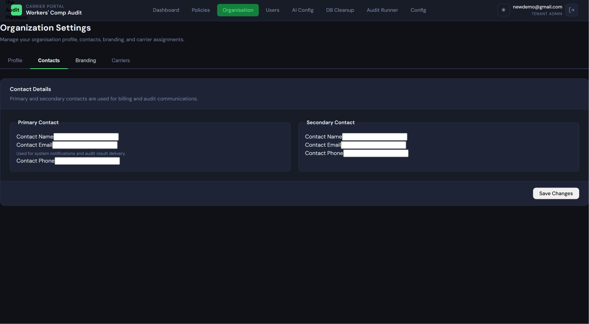
Onboarding Wizard — Step 2 (Contact Persons) Shows: An "Add Contact" form area with fields for name, title, email, and phone, alongside a list of contacts already added. A progress indicator shows "Step 2 of 5."
Step 3: Organization Branding
Upload your organization's logo. The logo appears in the platform header when your users are logged in, and it is used in generated audit reports.
- Accepted formats: PNG, JPG, SVG
- Recommended size: At least 200×60 pixels; maximum file size 2MB
- Aspect ratio: A wide/horizontal logo works best — square logos will be scaled down
After uploading, a preview shows how the logo will appear in the platform header.
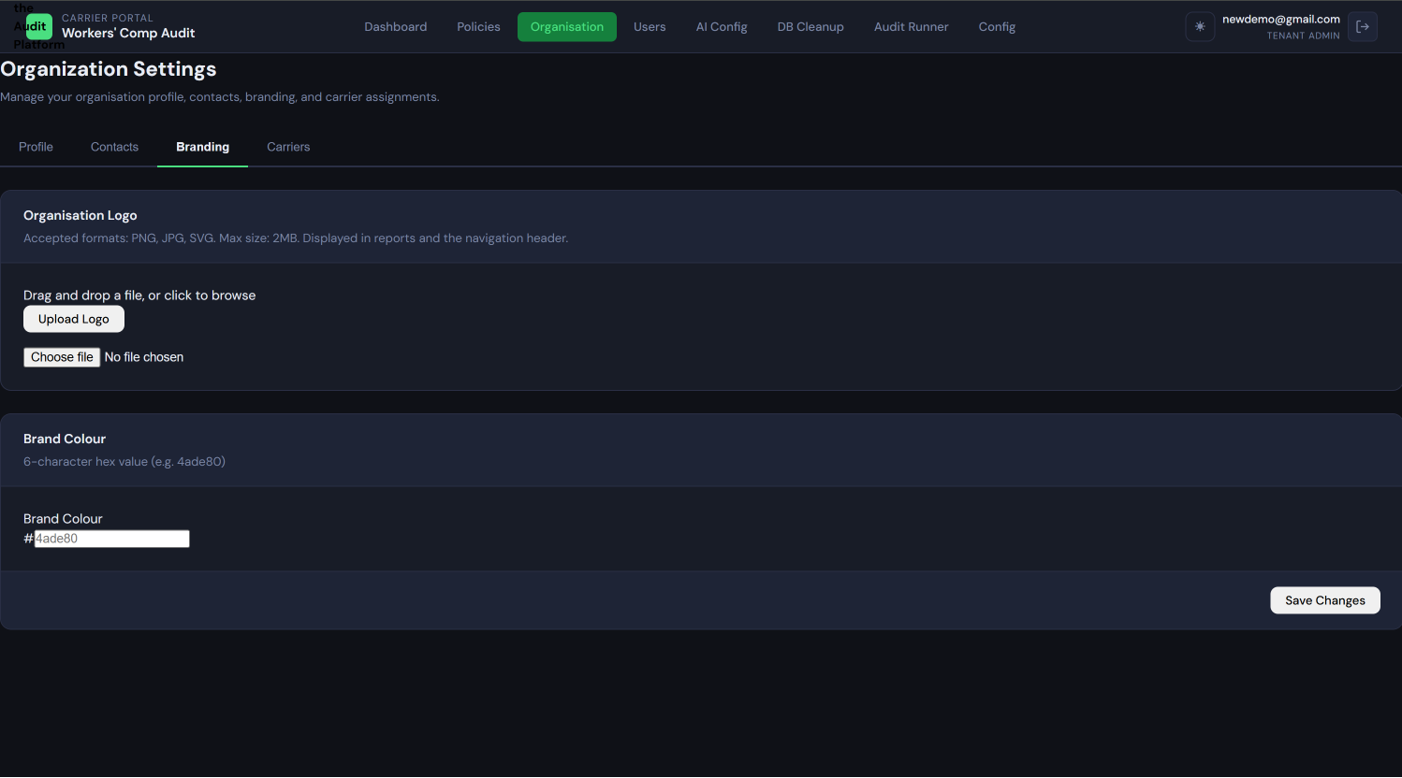
Onboarding Wizard — Step 3 (Organization Branding) Shows: A logo upload area with drag-and-drop support, a file picker button, accepted format guidance, and a live preview of how the uploaded logo will appear in the navigation header. A progress indicator shows "Step 3 of 5."
Step 4: Carrier Configuration Overview
This step shows a summary of the carriers currently assigned to your tenant. If the Super Admin assigned carriers during tenant provisioning, you will see them listed here. If no carriers were assigned, this step shows an empty list with a note that you will configure carriers after the wizard.
This screen is informational — no action is required. Detailed per-carrier configuration happens in the administration interface after the wizard is complete.
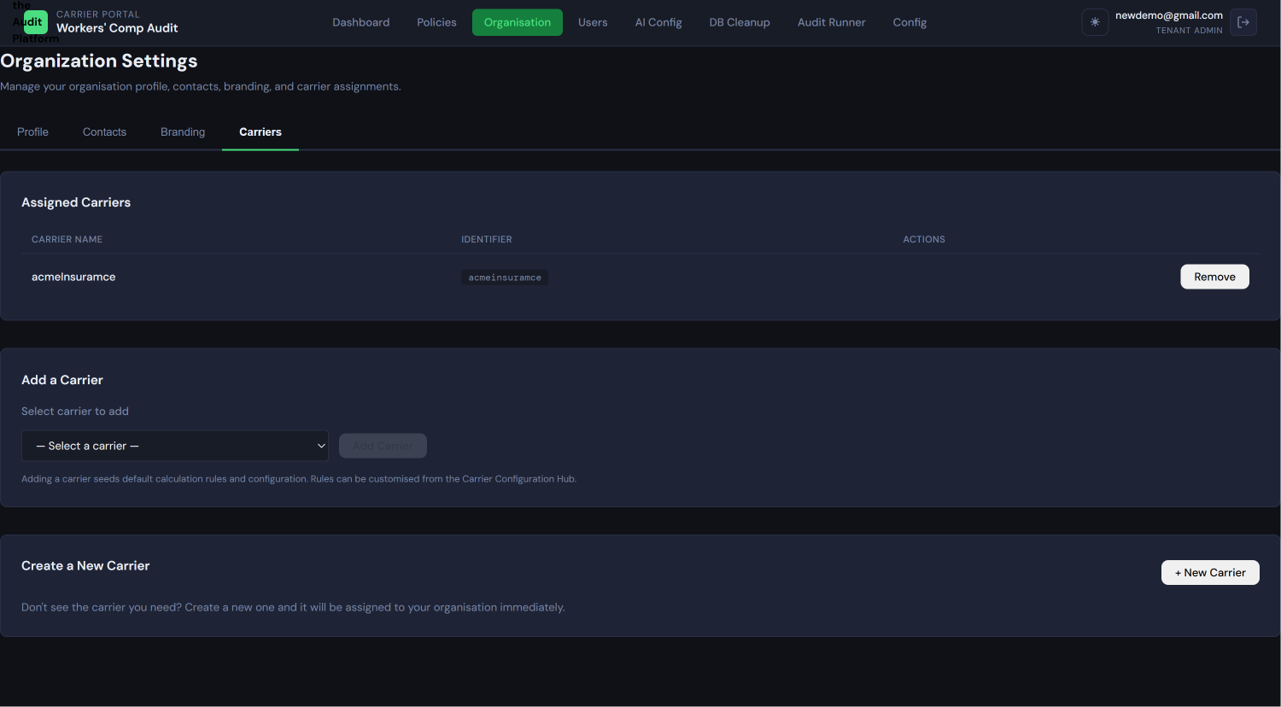
Onboarding Wizard — Step 4 (Carrier Configuration Overview) Shows: A list of assigned carriers (or an empty state if none were assigned), with a note that detailed configuration is done after the wizard. A progress indicator shows "Step 4 of 5."
Step 5: Complete
The wizard is complete. You are shown a confirmation screen with a summary of what you have configured and a button to proceed to the main administration interface.
Onboarding Wizard — Step 5 (Complete) Shows: A completion screen with a checkmark or success indicator, a summary of the organization profile and branding that was set up, and a "Go to Administration" button.

After the Wizard
After completing the wizard, you arrive at the main Administration interface. From here you can:
- Manage carriers (add, configure, remove)
- Manage users (invite, edit roles, deactivate)
- Review pending field mapping approvals
- Access ingestion run history
- Run database cleanup

2.3 Carrier Management (Post-Phase 7A)
Carrier management is a Tenant Admin responsibility. The Super Admin curates the global catalog; you choose which carriers from that catalog your organization uses.
To view your current carrier list: Navigate to Administration → Carriers. The page lists all carriers currently assigned to your tenant with their name, engine mode status, and last ingestion date.
To add a new carrier:
- From Administration → Carriers, click Add Carrier
- A list of available carriers (those in the platform catalog not yet assigned to your tenant) appears
- Select the carrier you want to add and click Add
- The platform automatically:
  - Creates the carrier assignment record
  - Seeds 22 calculation rules for this carrier (all in ACTIVE status with default expressions)
  - Creates a carrier_llm_config placeholder record for LLM narrative configuration
- The carrier now appears in your carrier list and is ready for further configuration
To remove a carrier: Click Remove next to a carrier in the list. This soft-deletes the carrier assignment (is_active = FALSE). All configuration data (rules, labels, field maps) is preserved and can be recovered if you re-add the carrier.
Important warning about removing carriers: Removing a carrier does not delete existing audit data already ingested for that carrier. However, you will no longer be able to upload new files or run calculations for a removed carrier. Before removing, ensure all audit work for that carrier is complete and all reports have been generated and downloaded.
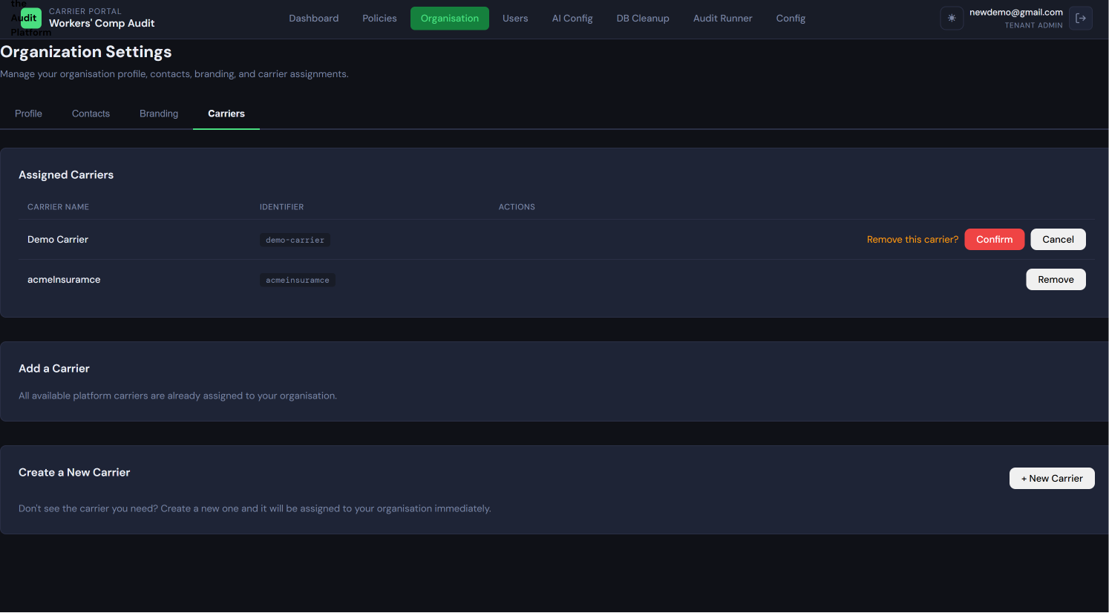
Carrier management panel (Administration → Carriers) Shows: A table listing assigned carriers with columns for Carrier Name, Engine Mode status badge (ON/OFF), and a "Configure" button per row. An "Add Carrier" button appears at the top. A "Remove" button or similar action is also visible per carrier row.

2.4 Per-Carrier Configuration Hub
The Carrier Configuration Hub is where you set up everything about how the platform handles a specific carrier's data. It is accessed per carrier and contains six tabs.
To access the Carrier Configuration Hub: Navigate to Administration → Carriers → [Carrier Name] → Configure
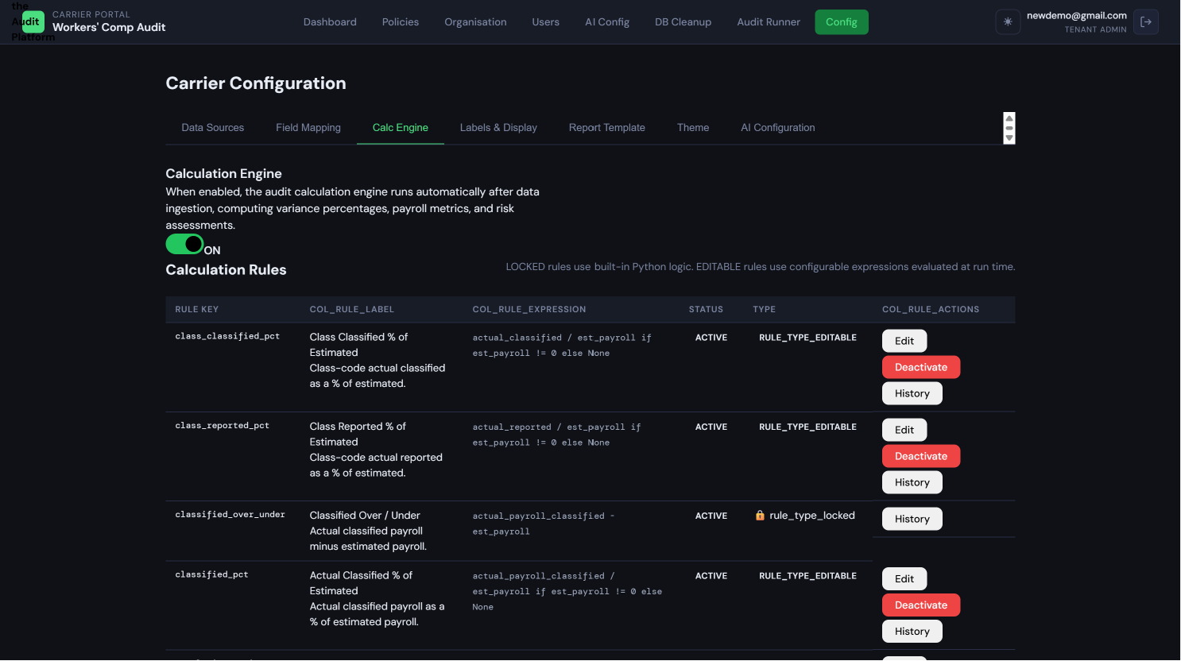
Carrier Configuration Hub — all 6 tabs visible Shows: The top-level configuration screen for a carrier, with 6 tabs labelled "Data Sources," "Field Mapping," "Calculation Rules," "Labels & Display," "Report Template," and "Theme." The first tab (Data Sources) is active.

Tab 1 — Data Sources
A data source is a named configuration that tells the platform what kind of file to expect when an Auditor uploads data for this carrier, and how to find the header row. Without a configured data source, the platform does not know how to parse the uploaded file.
You must configure at least one data source before any file can be uploaded for this carrier.
Fields for each data source:
Field | Description
Source Name | A descriptive name you choose, such as "Markel XLSX Payroll" or "Weekly CSV Export"
Source Type | XLSX, CSV, or XML — must match the file format Auditors will upload
Sheet Name | XLSX files only — the name of the worksheet tab that contains the data (e.g., Sheet0). Leave blank for CSV and XML.
Anchor String | The text that appears in the header row. The platform scans the file for this text to locate where data begins. For example, Client Name for payroll XLSX files. This allows headers that don't start at row 1.
Delimiter | CSV files only — the character separating values: comma, tab, or semicolon.
Upload & Test: After saving a data source, you can verify it against a real file. Click Upload & Test, select a sample file of the type you configured, and the platform will attempt to detect the header row using the anchor string. A successful test shows the detected column names in green. A failed test shows a red error message describing the problem (e.g., "Anchor string not found in first 100 rows").
Ingestion History: The bottom of the Data Sources tab shows the last 10 ingestion runs for this carrier. Columns: run number, upload date, file name, status, rows ingested, rows skipped, rows failed.
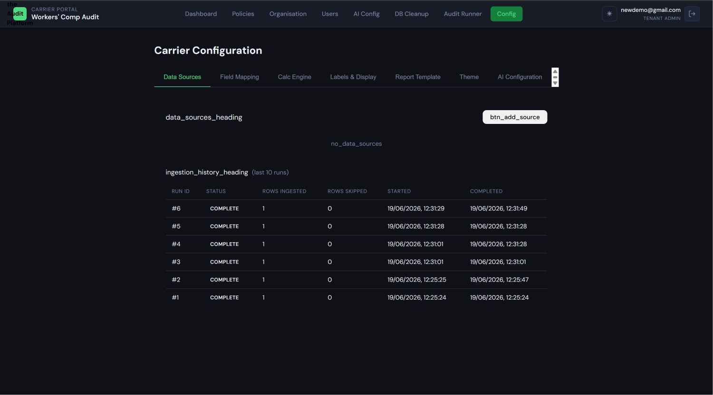
Data Sources tab with at least one source configured Shows: A list of configured data sources with their type, sheet name, and anchor string displayed. Each row has Edit and Delete buttons. An "Add Data Source" button appears above the list. The Ingestion History panel appears below.
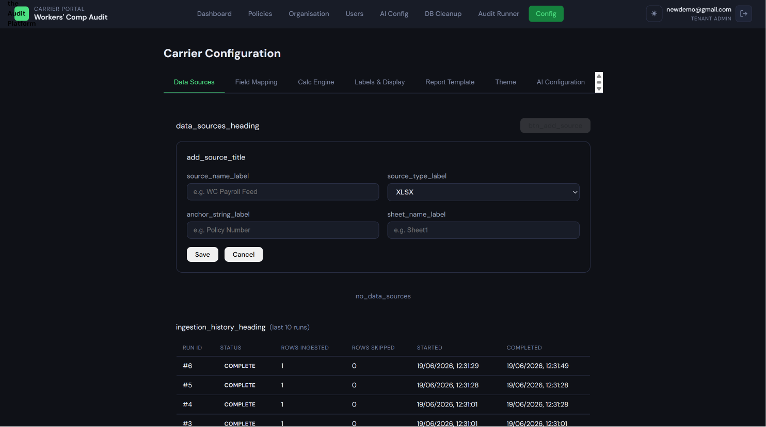

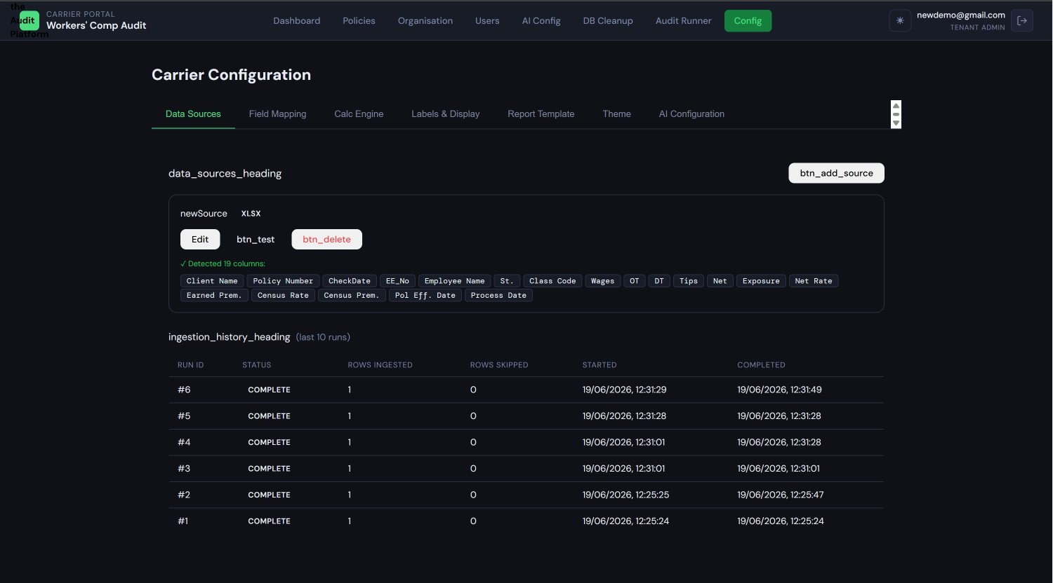

Upload & Test result (success state) Shows: The test result panel showing a green success indicator, the number of columns detected, and the full list of column header names that were found in the test file.

Tab 2 — Field Mapping (Pre-Configuration)
What pre-configured field mapping is:
When an Auditor uploads a file, the platform runs an automatic mapping algorithm that tries to match the file's column headers to the platform's canonical column names (the standardized names the system uses internally). Pre-configured mappings are saved here in advance so that any column name you have already mapped will be assigned HIGH confidence automatically at upload time — no manual review needed for those columns.
Pre-configuration here is done once by the Tenant Admin; the resulting saved mappings reduce the manual review burden during every subsequent upload.
The difference between pre-configuration and per-upload review:
- Pre-configuration (here): You set up the mapping once for a carrier and file type. These become permanent saved mappings.
- Per-upload review (at ingestion time): When an Auditor uploads a file, the auto-mapping algorithm runs. Columns that match your saved mappings get HIGH confidence; others get MEDIUM, LOW, or UNMATCHED based on fuzzy name comparison. You (the Tenant Admin) then approve or correct before ingestion proceeds.
How to set up a field map:
- Select the file type (XLSX, CSV, XML) from the dropdown
- Either upload a sample file to auto-detect column names, or type column names manually
- For each source column, use the dropdown to select the canonical platform column it corresponds to
- Optionally choose a transform function (such as date format conversion or text trimming)
- Click Save & Activate
The canonical columns available for payroll data include: policy_number, policyholder_name, as_of_date, employee_id, employee_name, state_code, class_code, wages, overtime, double_time, tips, net_wages, exposure, net_rate, earned_premium.
For audit summary report data, the canonical columns include: est_payroll, actual_payroll_reported, actual_payroll_classified, reported_over_under, reported_pct, est_premium_end, actual_premium, variance_amount, variance_pct.
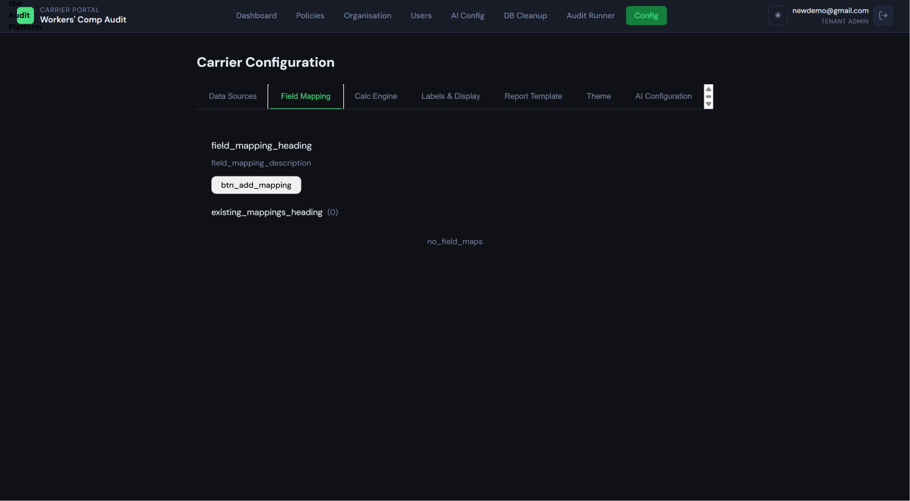
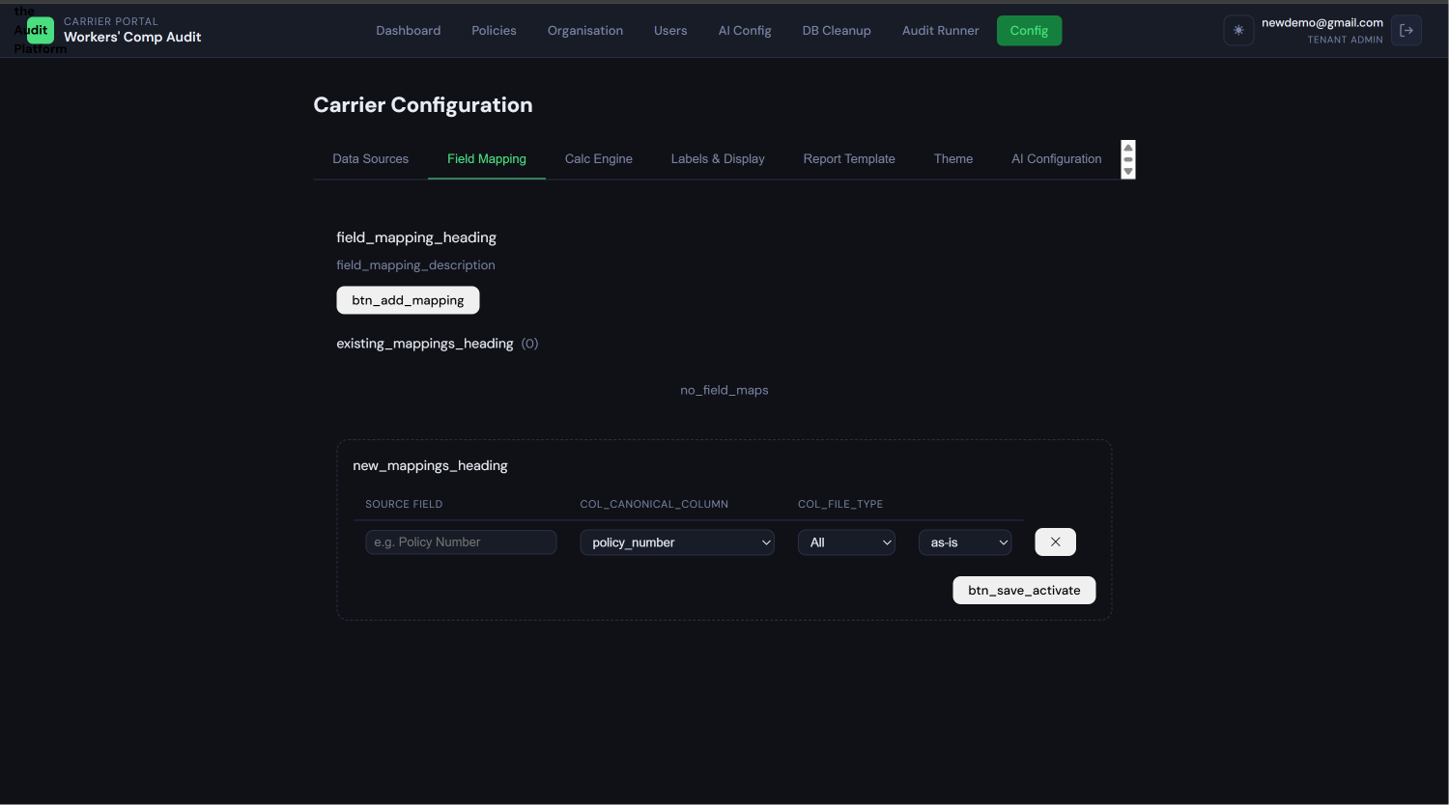
Field Mapping tab with mapping rows visible Shows: A drag-and-drop or row-based mapping interface with source column names on the left, a dropdown to select the canonical target column in the middle, and a transform function selector on the right. A "Save & Activate" button appears at the bottom.

Tab 3 — Calculation Rules & Engine Mode
The three-level engine mode hierarchy:
The platform uses a three-level hierarchy to determine whether the calculation engine runs for a given upload:
- Tenant default (lowest priority): A global setting for all carriers in your organization. If a carrier has no specific setting, this applies.
- Carrier default (overrides tenant): Each carrier can have its own engine mode that overrides the tenant default. This is configured at the top of Tab 3.
- Per-run override (highest priority): An Auditor can override the carrier default for a single upload. This takes priority over everything else.
The most specific setting always wins.
Setting the carrier-level engine mode:
At the top of Tab 3 is a toggle: Use Calculation Engine for this carrier — ON / OFF.
- ON (Calculation Engine): The platform runs all 22 calculation rules after ingestion, computing premium variance, payroll variance, risk levels, and other derived figures. Use this for standard audit processing.
- OFF (Display Only): The platform displays the ingested data as-is without running any calculations. Fields that require engine calculation show "N/A." Use this when data already contains pre-computed figures or when you only need to display carrier-provided data.
Changing this toggle takes effect immediately for all future ingestion runs for this carrier. Existing completed runs are not retroactively changed.

The calculation rules list:
Below the engine mode toggle, all 22 calculation rules are displayed. Each rule has a status badge and a plain-language description.
Rules come in two types:
- LOCKED rules (10): These use fixed, hardcoded formulas that cannot be edited. They are marked with a padlock icon. Examples include variance_amount (actual premium minus estimated premium end-date premium) and variance_pct (variance as a percentage of estimated premium). These formulas are mathematically fixed and cannot be changed.
- EDITABLE rules (12): These use configurable expressions that you can modify. Examples include risk thresholds, officer payroll limits, and payroll cycle frequency settings. An Edit button appears next to each editable rule.
Rule status badges:
Badge | Meaning
ACTIVE (green) | This version of the rule is currently live and being applied to calculations
DRAFT (grey) | A modified version has been saved but not yet submitted for review
PENDING_REVIEW (amber) | The modified version has been submitted and is awaiting approval
DEACTIVATED (red) | This rule has been turned off and is not applied to calculations

The two-step rule approval workflow:
To protect against accidental changes, every rule modification follows a mandatory two-step process before it takes effect. This creates a deliberate review checkpoint, even though both steps can be performed by the same Tenant Admin:
- Edit the rule: Click Edit on any EDITABLE rule. Modify the expression in the edit form. Click Save. The rule moves to DRAFT status. The current ACTIVE version is unchanged and still being applied to calculations.
- Submit for review: While in DRAFT, click Submit for Review. The rule moves to PENDING_REVIEW. A banner appears: "This rule is pending review and will not be applied until approved."
- Approve and activate: Review the pending rule — you can use the Expression Tester to verify it produces the correct result with sample values. Click Approve & Activate. The rule moves to ACTIVE. The previous active version is archived.
If you find a problem during review, click Revert to Draft to go back to editing without losing your changes.
Note: Changing active rules affects all future calculations for this carrier. Existing completed runs are not retroactively recalculated.
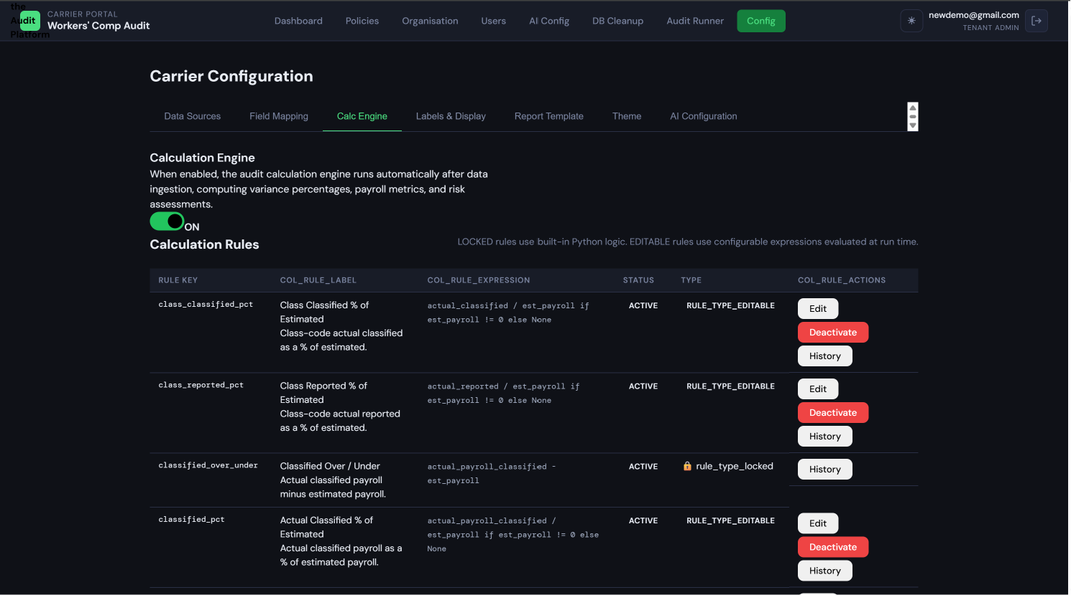 Calculation rules list with status badges Shows: The full list of 22 rules, with LOCKED rules showing a padlock icon and read-only expressions, and EDITABLE rules showing their current status badge (ACTIVE, DRAFT, PENDING_REVIEW, etc.) alongside Edit and History buttons.
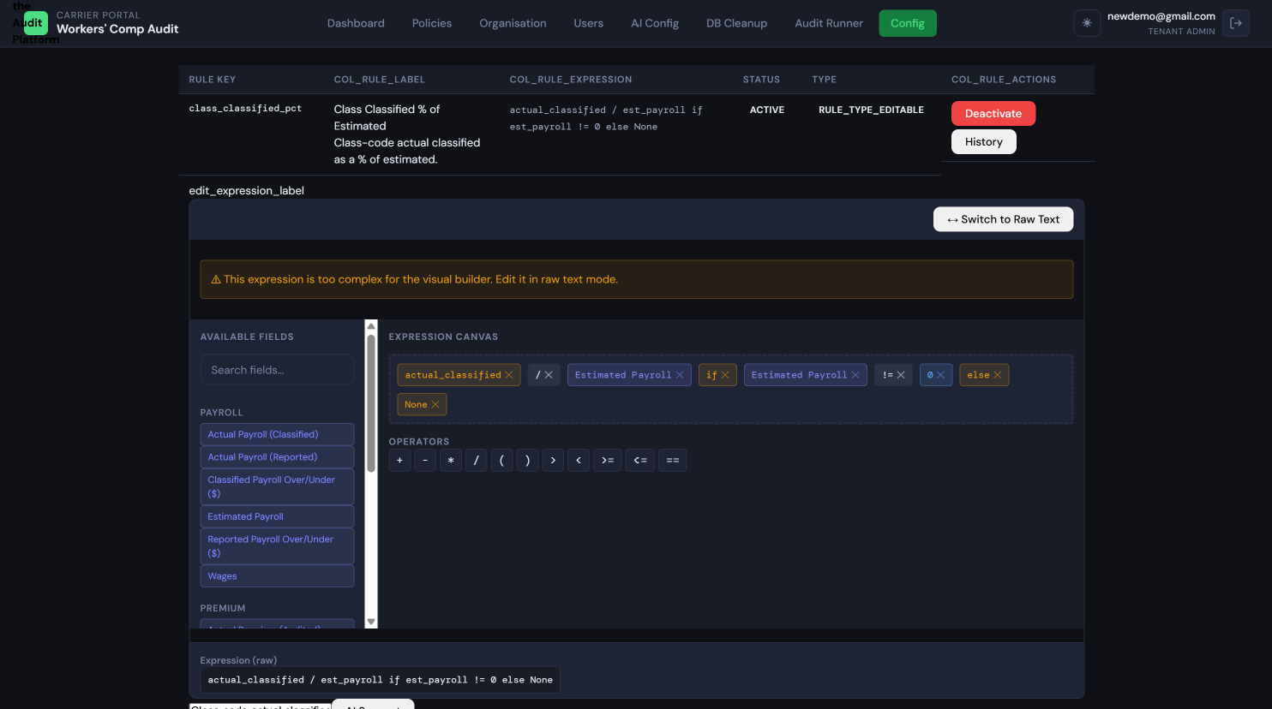
Rule edit form in DRAFT state Shows: A modal or inline editor with the rule's plain-English description, an editable expression field, an Expression Tester section with input fields for testing the expression with sample values, and Submit for Review / Cancel buttons. A DRAFT status badge is visible.

Tab 4 — Labels & Display
The platform allows every user-visible text label — column headers, section titles, status names — to be customized per carrier so the platform speaks the carrier's language. For example, a carrier might call their data "Premium Summary" rather than "Audit Summary," or use different column header terminology.
How label customization works:
Every text string in the platform has a default value (the platform default). When you add a custom value here, it overrides the default for all users in your tenant when viewing this carrier's data.
To edit a label:
- Browse the label list or use the search box to find the label key you want to change
- The current value column shows either the platform default or your existing override
- Click the edit icon on any row to enter your custom value
- Click Save to store the override
To reset a label to the platform default: click the reset icon next to any overridden label. The label reverts to the default value immediately.
Warning: Label changes take effect immediately for all users in your tenant when viewing this carrier's screens. Inform your team if you make significant label changes.
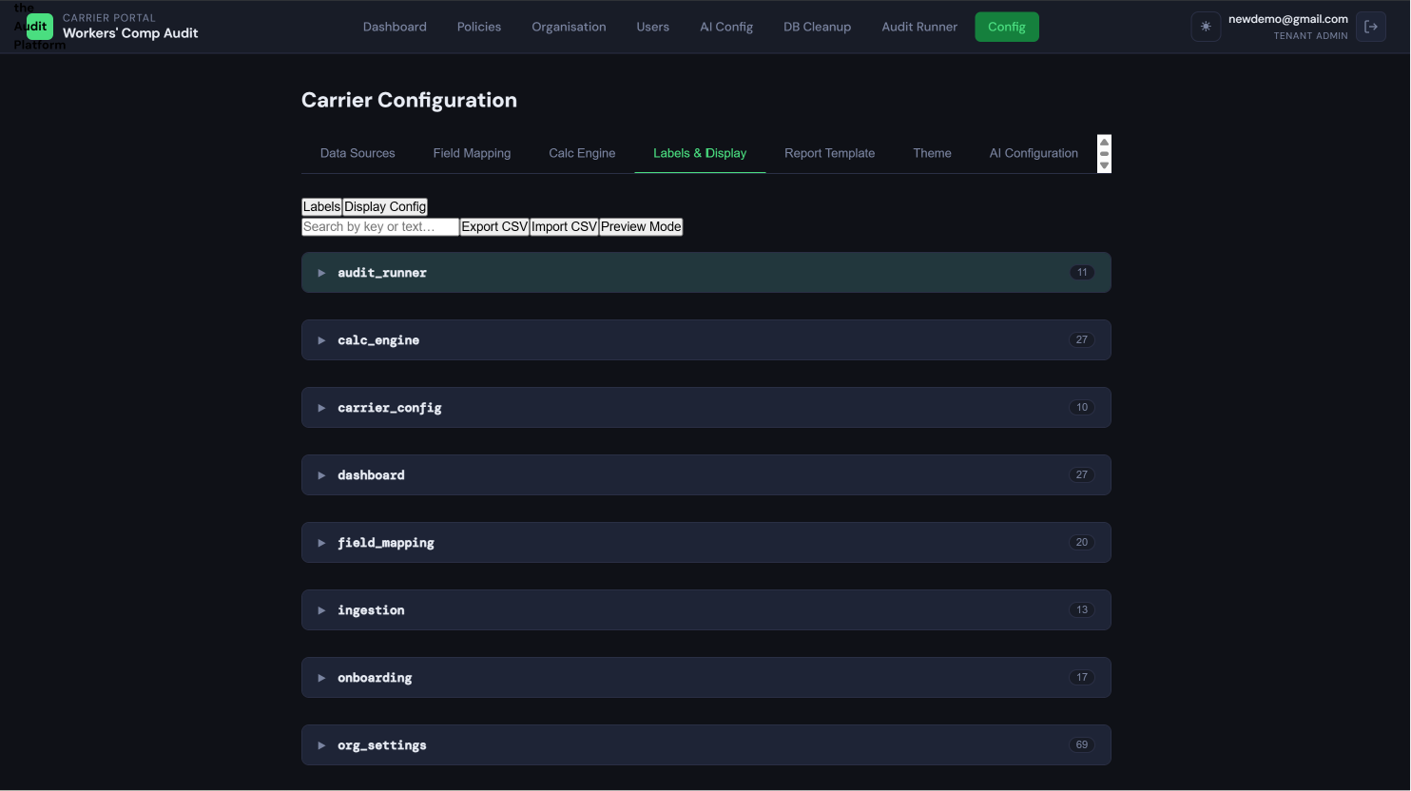
Labels & Display tab Shows: A searchable table of label keys, their default values, and current override values (if any). Override values are shown with a different visual treatment (e.g., bold or with an indicator badge). Edit and Reset icons appear on each row.

Tab 5 — Report Template
The Report Template controls the layout and content of generated audit reports for this carrier. Configuration options include:
- Carrier logo placement: Upload a carrier-specific logo to appear in report headers
- Primary and secondary colors: Set the brand colors used in report formatting
- Contact block: HTML content that appears in the report footer or header (contact information, legal disclaimers)
- PDF preview: After making changes, use the preview function to see a rendered sample of how reports will look before saving
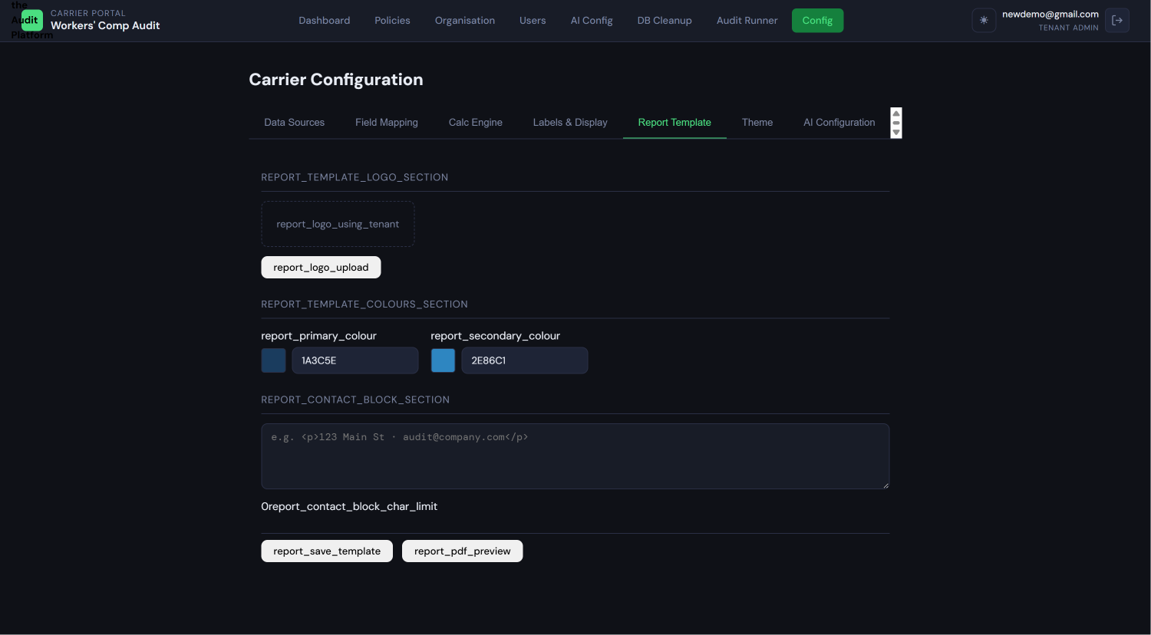
Report Template tab Shows: The report template configuration interface with logo upload, color pickers for primary and secondary colors, a contact block HTML editor, and a "Preview Report" button. A sample PDF preview thumbnail may be visible if a preview has been generated.

Tab 6 — Theme
The Theme tab controls the visual appearance of the platform for this carrier's screens. Each carrier can have a distinct color scheme from other carriers in the same tenant.
Setting the carrier's theme:
Use the theme selector dropdown to choose from:
- System themes (4 options): Default Dark, Default Light, Corporate Dark, Corporate Light. These are built-in and cannot be edited.
- Custom themes: Any themes created by you (see below)
Creating a custom theme:
- Click Create New Theme
- Select a base theme to clone (one of the 4 system themes)
- The visual editor opens with 13 color token inputs, each controlling a specific aspect of the interface:
  - --bg: Page background color
  - --surface: Card and panel backgrounds
  - --surface2: Inset areas, form inputs, code blocks
  - --border: All borders and dividers
  - --text: Primary body text
  - --muted: Secondary/label text
  - --brand: Primary brand color — nav highlights, primary buttons, positive values
  - --brand-dark: Active navigation item background
  - --accent: AI narrative, focus rings
  - --green: Positive indicators
  - --amber: Warnings, medium risk
  - --red: Errors, negative values, high risk
  - --blue: Links and info states
- A live preview panel updates in real time as you change colors
- Enter a theme name (2–60 characters, unique within your tenant)
- Click Save Theme
The new theme is available to all carriers in your tenant immediately.
Light/Dark theme pairing:
Each theme is single-mode (either dark or light). To offer a paired experience, create two themes with the same visual identity — one dark version and one light version. Users who have the light/dark toggle available will switch between them.
Importing a theme:
Click Import Theme, select a .json file. The file must contain all 13 token values in valid 6-character hex format and a valid mode (dark or light). If validation passes, the theme editor pre-fills with the imported values for your review before saving.
Exporting a theme:
Click Export on any custom theme to download its token values as a JSON file. This is useful for sharing themes between carriers or keeping backups.
Deleting a custom theme:
Click Delete on any custom theme. Before deletion, the platform checks if any carrier or user has this theme set as their default. If so, a dialog lists the affected carriers and users and asks you to choose a replacement theme before proceeding. System themes (Default Dark, Default Light, Corporate Dark, Corporate Light) cannot be deleted.
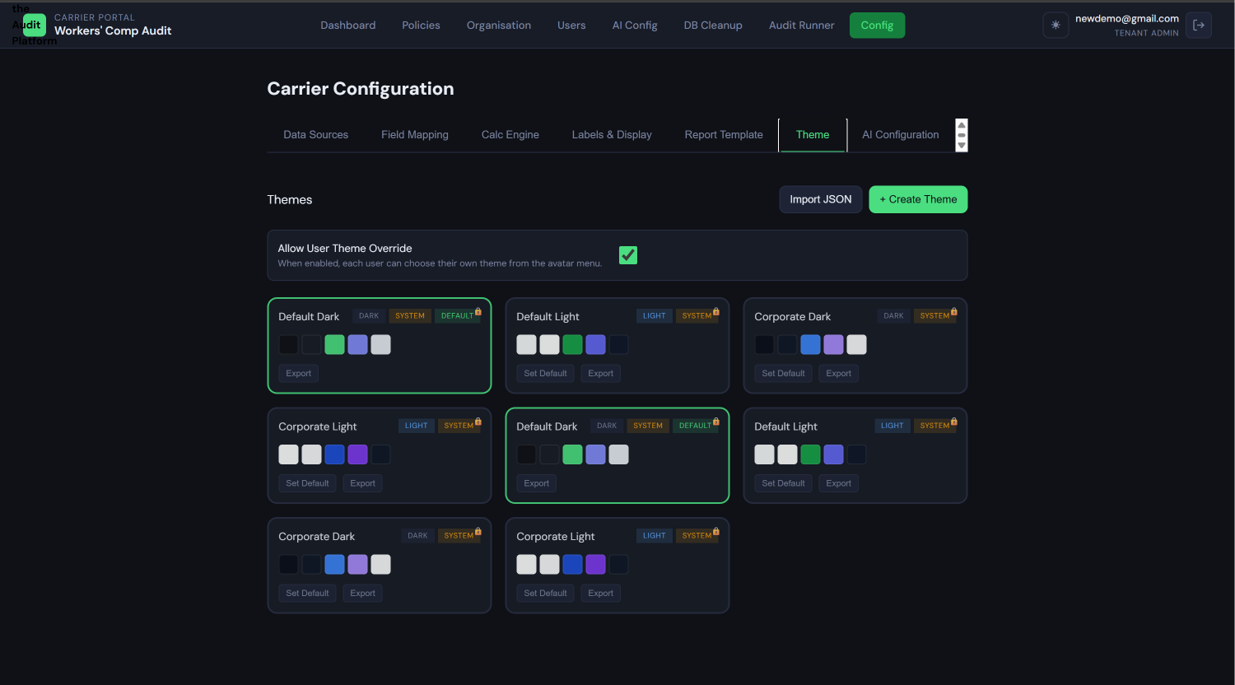 Theme tab with theme selector Shows: A theme selector dropdown showing available system and custom themes as cards with color swatches. The current active theme for this carrier is highlighted. "Create New Theme," "Import Theme," and "Export" buttons are visible.
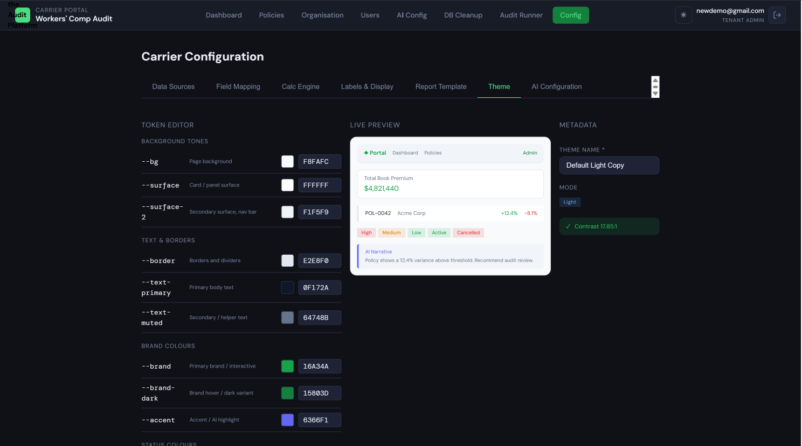
Custom theme visual editor Shows: The three-column editor layout: left column with 13 color token inputs (label, color swatch, hex value field for each token), center column with a live miniaturized platform preview updating in real time, and right column with the theme name input and metadata fields. A "Save Theme" button is visible at the bottom.

2.5 User Management
The Tenant Admin manages all users within their organization. Navigate to Administration → Users to see the user list.
Viewing users:
The user list shows all users in your tenant with their name, email, role, status (ACTIVE or INACTIVE), and last login date.
Inviting a new user:
- Click Invite User
- Enter the user's first name, last name, and email address
- Select their role:
  - AUDITOR: Can upload files, monitor ingestion, trigger calculations, resolve skipped row exceptions, and generate reports. Cannot approve field mappings or change configuration.
  - REVIEWER: Read-only access. Can view the dashboard, policies, reports, and narratives. Cannot upload, calculate, or configure anything.
- Click Send Invitation →
- The user receives an invitation email with a password-set link. They can log in only after setting their password.
Editing a user's role:
Click the user's name or the Edit action to change their role. The change takes effect immediately at their next authenticated request.
Deactivating a user:
Click Deactivate next to any active user. They lose access immediately — their current session is invalidated and they cannot log in again until reactivated. No data is deleted.
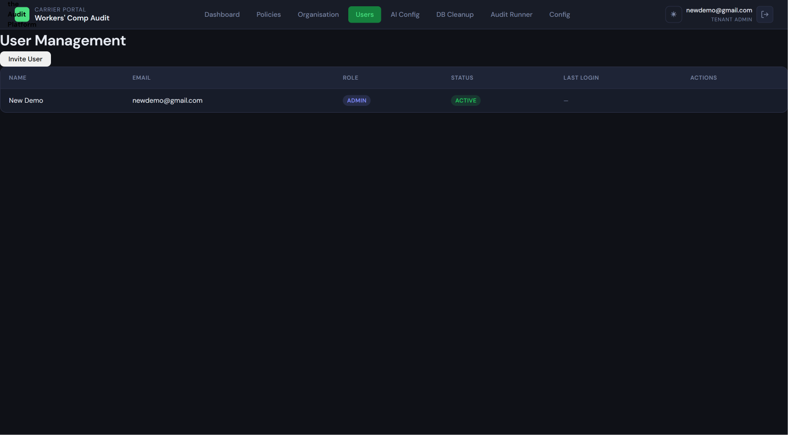
User management list (Administration → Users) Shows: A table of users with columns for Name, Email, Role (with role badge), Status (ACTIVE/INACTIVE badge), and Last Login. Edit and Deactivate action buttons appear per row. An "Invite User" button is at the top.
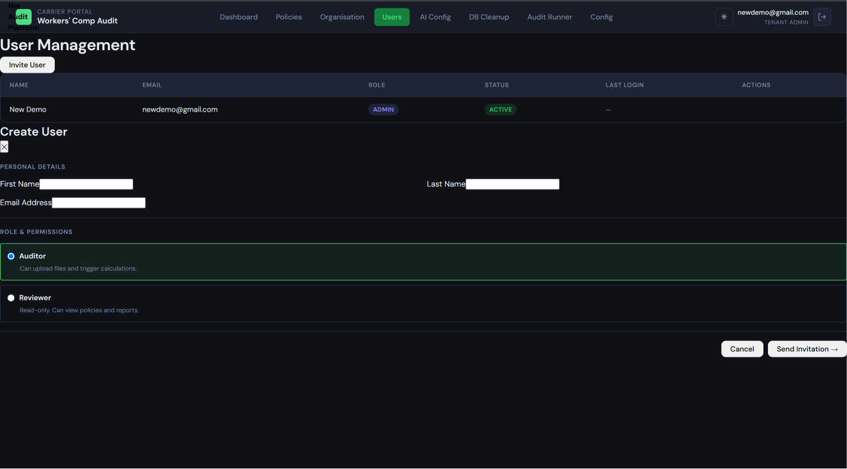
Create/invite user modal Shows: A modal with fields for First Name, Last Name, and Email Address, followed by a role selection radio group showing AUDITOR and REVIEWER options with brief descriptions under each. A "Send Invitation →" button and a "Cancel" button appear at the bottom.

2.6 Field Mapping Approval (Mandatory Gate)
The field mapping approval step is one of the most important responsibilities of the Tenant Admin. No ingestion run can proceed to data processing until you approve its field mapping. When an Auditor uploads a file, the platform automatically runs a 4-pass auto-mapping algorithm and then waits for your approval.
Why this gate exists: The mapping determines which source column in the uploaded file corresponds to which canonical platform column. An incorrect mapping (for example, accidentally mapping "Wages" to the "Policy Number" column) would corrupt all calculations. The approval step lets you verify the mapping before any data is committed.
Finding pending approvals:
You will receive a notification (if notifications are enabled) when a run is awaiting mapping approval. You can also navigate to Administration → Ingestion → Pending Mappings to see all runs in awaiting_mapping status.
The Visual Field Mapping Review screen:
Mapping proposals are organized into four confidence tiers:
Tier | Badge Color | What It Means | What to Do
HIGH | Green | Either matches a saved mapping exactly, or the column name normalizes to an exact match with a canonical column | Review briefly; these are very likely correct. Rows are pre-checked.
MEDIUM | Amber | The column name closely resembles a canonical column name (fuzzy match ≥ 75%) and the data type is compatible | Verify the mapping looks correct before approving
LOW | Orange | The column name is a weaker match or the data type is uncertain | Edit the mapping; the platform's guess may be wrong
UNMATCHED | Red | The platform found no plausible match | You must manually assign this column from the canonical column dropdown before approval is possible
Approving a mapping:
Review each tier. For MEDIUM and LOW proposals, click any row to see the source column, the proposed target column, and a sample data value. You can change the target column using the dropdown, or mark the column as Excluded if it should be ignored during ingestion.
Once all source columns have either a confirmed mapping or are marked Excluded, the Approve Mapping button becomes active. Click it to approve. Ingestion begins automatically.
Rejecting a mapping:
If the mapping is fundamentally wrong — for example, the wrong type of file was uploaded — click Reject Mapping. The ingestion run status changes to failed. The Auditor must re-upload the correct file.
Correcting an UNMATCHED field:
Click the UNMATCHED row. The target column dropdown is empty. Select the correct canonical column from the dropdown. If the column should be ignored, click Mark as Excluded. Only after all UNMATCHED fields are resolved can you approve.
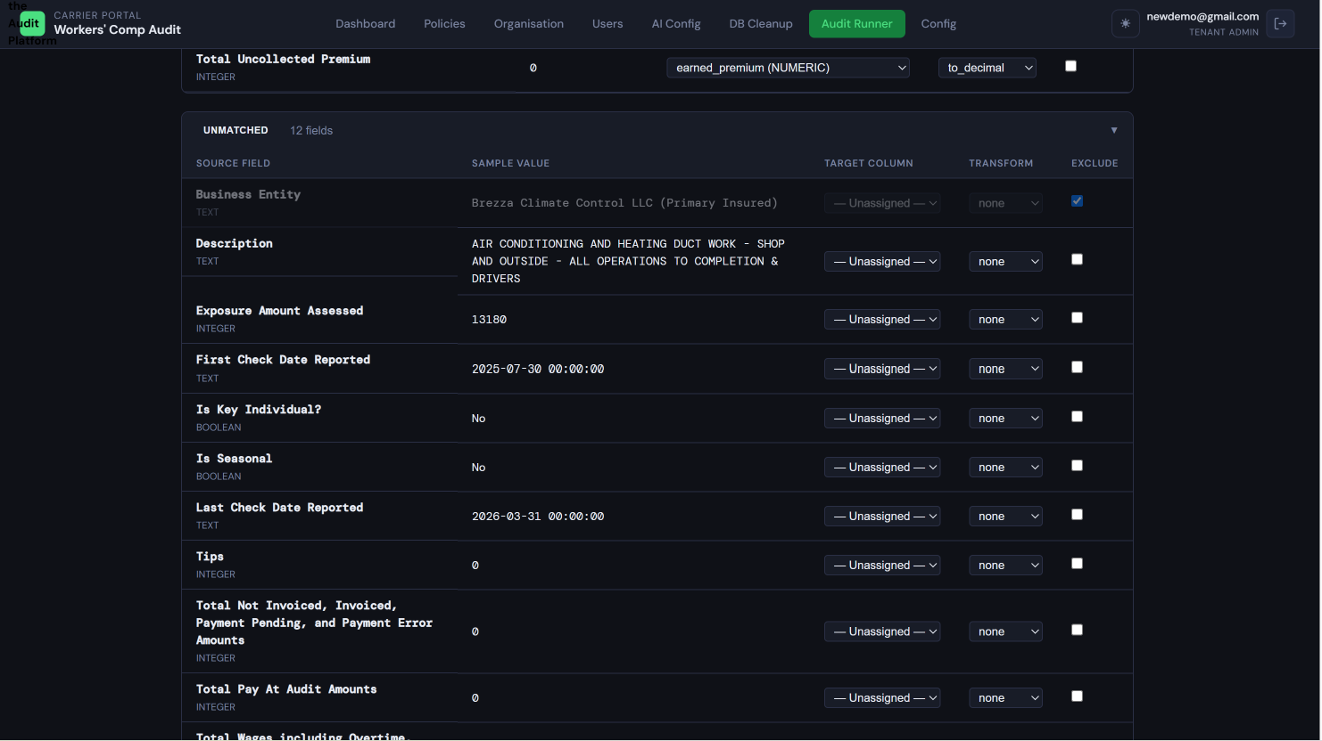 Visual Field Mapping Review screen Shows: The mapping review interface with four grouped sections (HIGH in green, MEDIUM in amber, LOW in orange, UNMATCHED in red). Each section lists the source column names and their proposed target mappings. The "Approve Mapping" button at the bottom appears greyed out until UNMATCHED fields are resolved.
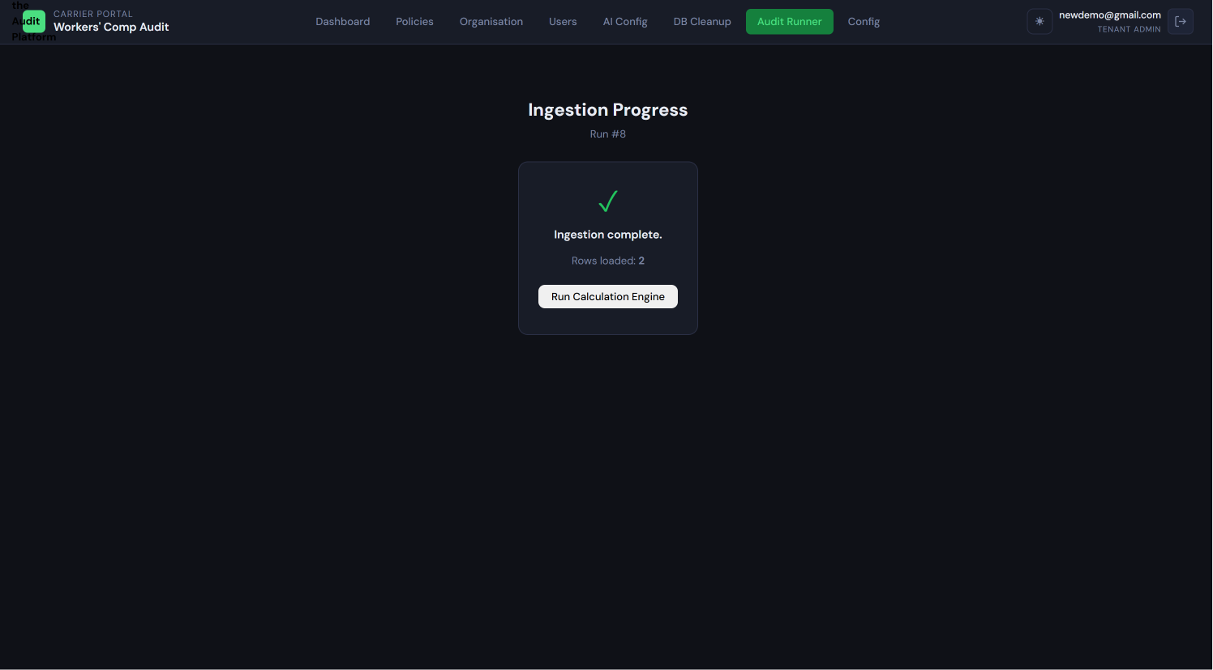 Approval confirmation dialog Shows: A confirmation modal asking "Are you sure you want to approve this field mapping? Ingestion will begin immediately." with Approve and Cancel buttons.

2.7 Ingestion Run Management (Admin View)
Navigate to Administration → Ingestion to see all ingestion runs across all carriers in your tenant.
Run status meanings:
Status | Meaning
awaiting_mapping | Files uploaded; auto-mapping complete; waiting for Tenant Admin approval
processing | Mapping approved; data is being ingested into the platform
complete | Ingestion finished successfully; all rows processed
partial | Ingestion finished but some rows were skipped due to errors (these appear in the skipped rows log)
failed | A hard error stopped the run; data may be incomplete
rolled_back | A Tenant Admin rolled back this run; fact data has been removed
Rolling back an ingestion run:
Rollback is a Tenant Admin exclusive action. Use it when an ingestion run contains incorrect data that must be removed — for example, if the wrong file was uploaded and approved, or if a data quality issue is discovered after the fact.
To roll back:
- Open the ingestion run detail (click the run number or row)
- Click Rollback
- Read the warning carefully
- Type ROLLBACK in the confirmation text field
- Click Confirm Rollback
What rollback does: Removes all fact table data (payroll variance, premium variance, zero payroll, missing payroll records) for that run. The run record itself is preserved with status rolled_back — this is an audit trail entry and cannot be deleted. The removal cannot be undone.
After rollback, the Auditor can re-upload the corrected file if needed.
Restarting a failed run:
For runs with status failed, a Restart action may be available depending on the failure type. Contact your platform administrator if a run cannot be restarted.
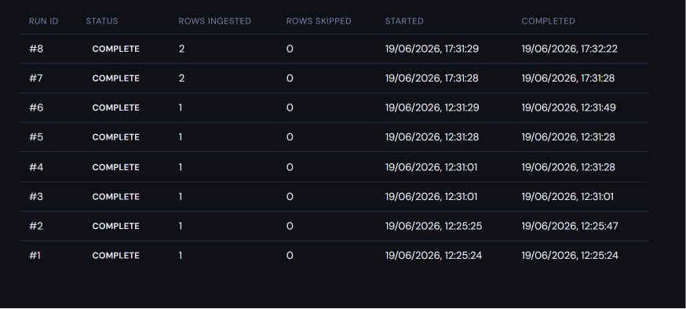 Ingestion run list with
status badges Shows: A table of ingestion runs with columns for Run ID, Carrier, Upload Date, File Name, Status (with color-coded badge), Rows Ingested, Rows Skipped, and an Actions column. Status badges show AWAITING_MAPPING, PROCESSING, COMPLETE, PARTIAL, FAILED, ROLLED_BACK.
Rollback confirmation dialog Shows: A warning modal with a red warning header explaining that rollback will permanently remove all ingested fact data for this run, a text input field requiring the user to type "ROLLBACK" to confirm, and a "Confirm Rollback" button alongside a "Cancel" button.

2.8 Database Cleanup (Monthly Processing Cycle)
The platform is designed around a monthly processing cycle. After each cycle — once all audit reports for the period have been finalized and downloaded — you can run the cleanup process to remove operational fact data and prepare the system for the next cycle.
When to run cleanup:
Only run cleanup after you have confirmed that:
- All ingestion runs for the period are in complete or partial status (none are still in progress)
- All audit reports for the period have been generated and downloaded externally
- All users who need to review data have done so
What cleanup removes:
- Payroll fact data (payroll_variance_policy, payroll_variance_class rows for the processed period)
- Premium variance records
- Zero payroll and missing payroll detection records
- Associated exception records (ingestion errors, skipped rows)
What cleanup preserves (never deleted):
- All configuration data: calculation rules, field maps, data source definitions, labels, themes, report templates
- All ingestion run records (the run history is permanent for audit trail purposes)
- All report files that have been generated
- Tenant profile, branding, and contact information
- User accounts
How to run cleanup:
Navigate to Administration → Database Cleanup. Review the summary of what will be removed. Click Run Cleanup, then confirm by typing your confirmation phrase in the dialog.
The cleanup process creates a cleanup_run record logging who ran the cleanup, when, and how many records were removed. This record is permanent and cannot be deleted.
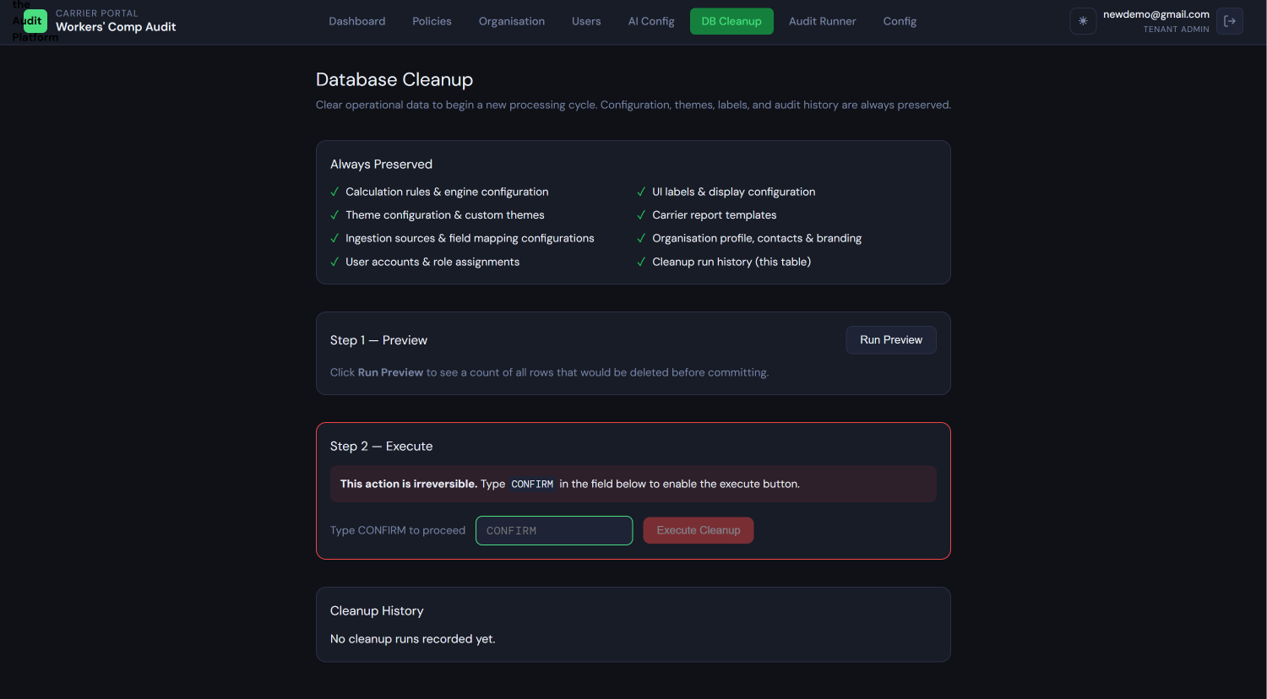 Database Cleanup confirmation screen Shows: A screen showing a summary of data that will be removed (count of records, date range), with a bold warning that this action is irreversible. A "Run Cleanup" button is present. After clicking, a confirmation dialog requires typing a confirmation phrase before proceeding.

2.9 Tenant Admin Do's and Don'ts
Action | Guideline
Approve a field mapping without reviewing MEDIUM and LOW tiers | ✗ Don't — always review amber and orange rows before approving
Run database cleanup before all reports are downloaded | ✗ Don't — report data will be deleted and cannot be recovered
Delete a user instead of deactivating them | ✗ Don't — use Deactivate; deletion removes the audit trail
Activate a calculation rule change without testing it first | ✗ Don't — use the Expression Tester in the rule editor before approving
Add carriers at any time after onboarding | ✓ Do — carrier management is fully self-service
Pre-configure field mappings before your Auditors upload files | ✓ Do — this reduces mapping review work significantly
Create paired dark/light themes for each carrier | ✓ Do — gives users a comfortable choice
Roll back an incorrect ingestion run before calculating | ✓ Do — it's much easier to roll back before calculations run than after
Change a calculation rule mid-cycle | ✗ Avoid — changes take effect on future runs only; existing data is not recalculated
Remove a carrier that still has active audit work | ✗ Don't — complete all reports first
Workers' Compensation Premium Audit Platform
Role-Based User Documentation — Part 2

GUIDE 3: AUDITOR USER GUIDE
Audience: The operational user responsible for day-to-day audit work — uploading payroll and policy files, monitoring ingestion progress, triggering calculations, reviewing exceptions, and generating reports. Auditors are domain experts in workers' compensation auditing.

3.1 Who Is the Auditor?
The Auditor is the primary operational user of the platform. Most of the platform's day-to-day activity flows through the Auditor role.
What an Auditor can do:
- Upload data files (single policy via the Audit Runner, or multiple policies via Bulk Upload)
- Monitor ingestion run progress
- View and resolve ingestion exceptions (correct or dismiss skipped rows)
- Trigger the calculation engine manually when needed
- View audit results — policy details, payroll comparisons, variance data, and the AI-generated narrative
- Generate and download audit reports
What an Auditor cannot do:
- Approve field mappings — that is the Tenant Admin's exclusive responsibility
- Roll back ingestion runs — Tenant Admin only
- Change any platform configuration — carrier settings, calculation rules, labels, themes
- Invite or manage users
How to log in:
Log in at your organization's tenant subdomain — for example, yourcompany.platform.com. Your Tenant Admin will provide the exact URL. Use the email address and password from your invitation email.
The Auditor dashboard:
After login, you land on the main dashboard showing KPI summary cards (total policies, premium variance totals, zero payroll count, missing payroll count), recent activity, and the policy list. The navigation includes Audit Runner, Bulk Upload, Policies, and Reports.
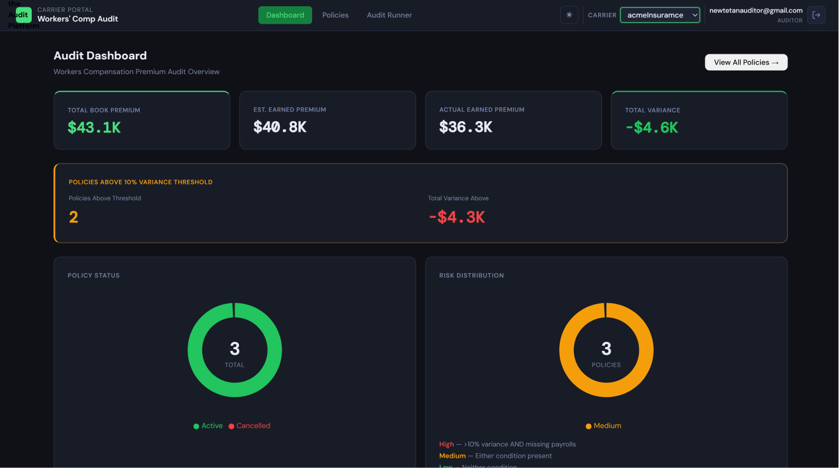 Auditor dashboard Shows: The main dashboard with KPI cards at the top (Total Policies, Total Premium Variance, Zero Payroll Policies, Missing Payroll Policies), a recent activity feed or timeline in the middle section, and the policy list at the bottom with carrier filter and search. The navigation sidebar shows Audit Runner, Bulk Upload, Policies, and Reports items.

3.2 The Audit Runner — Uploading Files for a Single Policy
The Audit Runner is used to upload and process files for one policy at a time. For uploading multiple policies in a single operation, see Section 3.3 (Bulk Upload).
Step 1 — Navigate to Audit Runner
From the navigation sidebar, click Audit Runner. The Audit Runner screen shows:
- A carrier selector (select which carrier this upload belongs to)
- The history of previous ingestion runs for the selected carrier
- An Upload New File button
Select the carrier you are working with. The run history below updates to show only runs for that carrier.
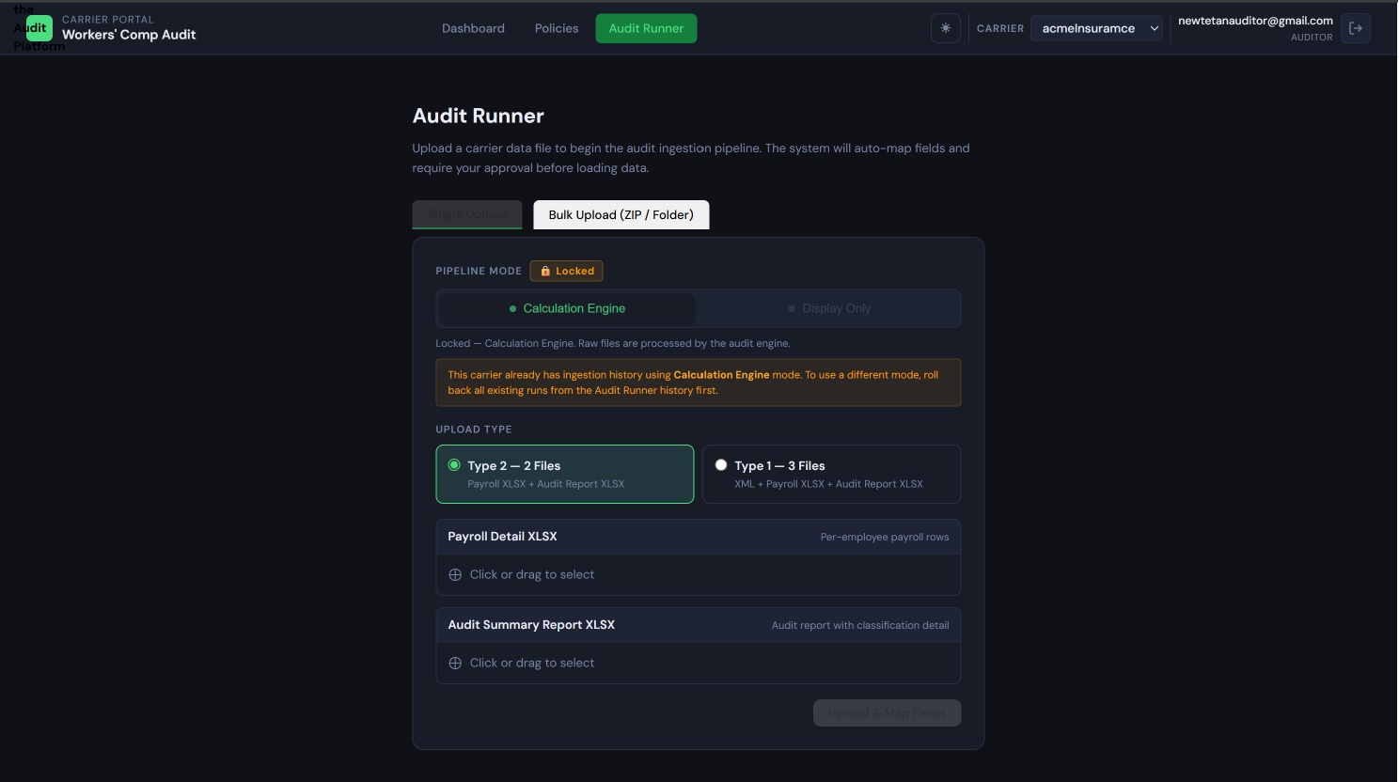 Audit Runner screen before upload Shows: The Audit Runner page with a carrier selector dropdown at the top, a table of previous ingestion runs (with status badges, upload dates, and row counts), and an "Upload New File" button. No file upload area is visible yet.

Step 2 — Choose the Ingestion Mode
Before uploading, select the ingestion mode that applies to this set of files:
Calculation Engine mode: The platform will run all 22 calculation rules after ingestion, computing premium variance, payroll variance by class code, risk levels, and other derived figures. Use this for standard audit processing — when you need the platform to calculate and assess the data.
Display Only mode: The platform will ingest and display the data as-is without running any calculations. Use this when the carrier provides pre-computed figures that you only need to present, or when you want to view raw data before deciding whether to calculate.
The mode lock — important: Once you upload the first file for a carrier in a given mode, all subsequent uploads for that carrier must use the same mode. To switch modes, all existing runs for that carrier must be rolled back first (a Tenant Admin must perform the rollbacks). If you accidentally choose the wrong mode, notify your Tenant Admin immediately before uploading additional files.

Step 3 — Choose the Upload Type (Calculation Engine mode only)
If you selected Display Only in Step 2, skip to Step 4 — you will upload a single XLSX file.
For Calculation Engine mode, select which upload type matches the files you have:
Type 1 — Three Files (XML + Payroll XLSX + Audit XLSX): Use when your carrier provides an XML policy configuration file alongside two spreadsheets. The XML contains class codes, estimated payroll exposure, policy dates, and insured details. The payroll XLSX contains per-employee or per-class payroll records. The audit XLSX contains the carrier's summary figures.
How to identify: You have a .xml file AND a _payroll.xlsx AND an _audit.xlsx or audit report .xlsx for this policy.
Type 2 — Two Files (Payroll XLSX + Audit XLSX): Use when there is no XML file. The policy identity information comes from columns within the XLSX files themselves.
How to identify: You have two .xlsx files — one payroll detail file and one audit summary/report file. No .xml file.
Type 3 — Single CSV: Use when payroll data is delivered as a single comma-delimited, tab-delimited, or semicolon-delimited file from a carrier system export.
How to identify: You have one .csv file.

Step 4 — Upload the Files
File slots appear based on your upload type selection. Drag and drop files into the appropriate slots, or click each slot to open a file picker.
File format requirements:
Slot | Accepted Formats | What to Upload
XML (Type 1 only) | .xml | The carrier's policy configuration file
Payroll Detail | .xlsx | Per-employee or per-class payroll records
Audit Summary / Report | .xlsx | Carrier's audit summary with estimated vs. actual figures
Single CSV (Type 3 only) | .csv | Combined payroll data file
Display Only | .xlsx | Any well-structured XLSX file
Files with .pdf, .doc, or other formats are rejected.
After attaching all files, click Upload. What happens next:
- The platform creates an ingestion_run record with status awaiting_mapping
- The auto-mapping algorithm runs immediately, scoring each column in the uploaded file
- You see a status message: "Awaiting mapping approval"
At this point, you must notify your Tenant Admin that a mapping is waiting for their approval. The run will not proceed until they approve it. You can continue with other work while waiting.
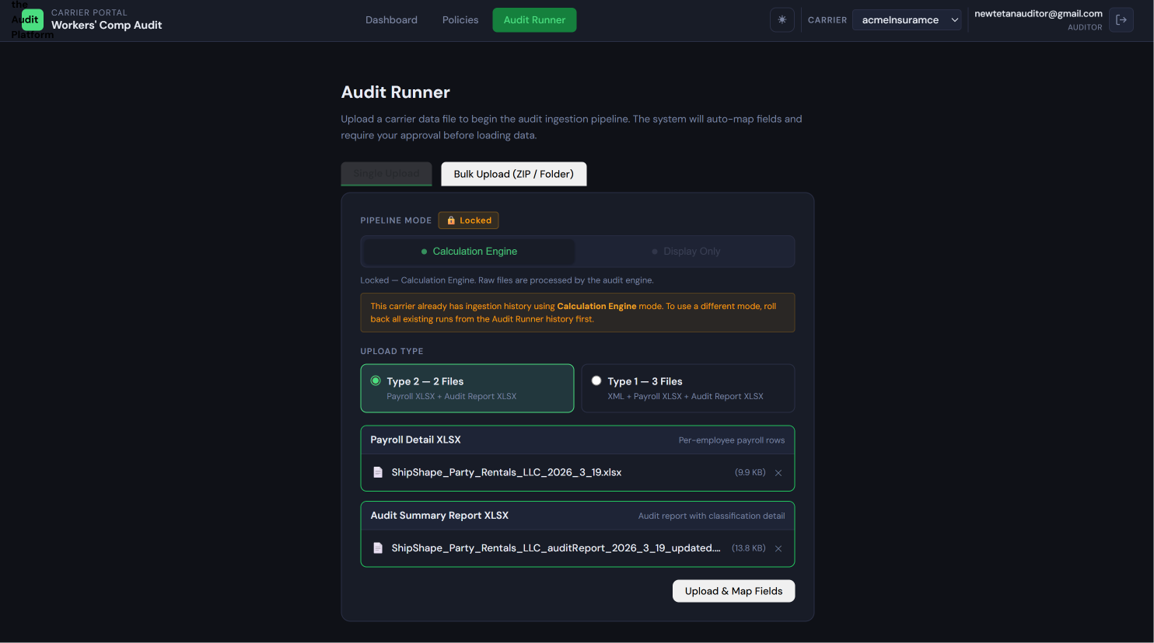 File upload slots with files attached, ready to submit Shows: The upload form with file slots populated — each slot shows the filename that has been attached, with a green checkmark or file icon. An "Upload" button is active and ready to click.
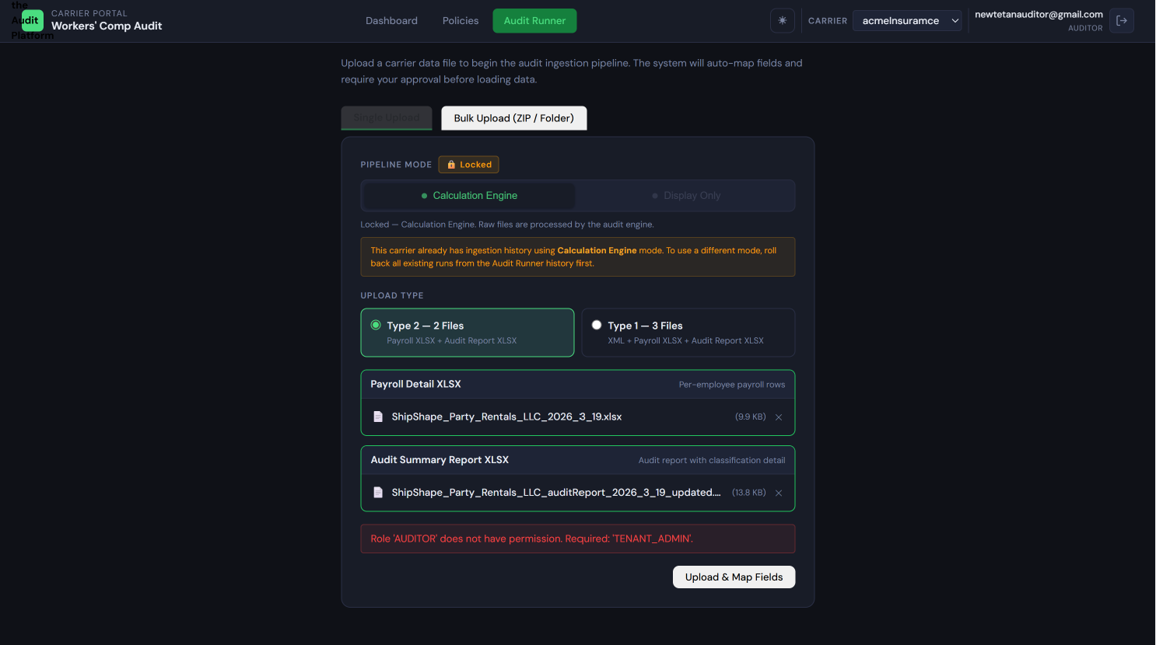 "As of now auditor cannot upload the new ingestions he/she can re-run the already executed and failed runs."

3.3 Bulk Upload — Uploading Multiple Policies at Once
Bulk Upload lets you upload files for many policies in a single session. The platform automatically groups files by policy based on filename patterns.
When to use Bulk Upload vs. Audit Runner:
- Use the Audit Runner for one policy at a time, or when you need to carefully review the file grouping before submitting
- Use Bulk Upload when you have received a batch of files for multiple policyholders and want to process them all in one operation
How to access Bulk Upload:
Click Bulk Upload in the navigation sidebar.
The three intake methods:
- Drop a ZIP archive: Drag a .zip file containing all your policy files onto the drop zone. The platform extracts the files automatically. Files starting with . or __MACOSX (common macOS ZIP artifacts) are skipped.
- Select a folder: Click the folder icon and select a folder from your computer. All .xlsx, .xml, and .csv files in the folder are included.
- Select multiple files: Click the multiple-files icon and select individual files using standard multi-select.

File Naming Conventions
Correct file naming is critical for bulk upload. Files are automatically grouped into policies by their filename prefix — incorrect names cause wrong groupings or ungrouped files.
The grouping rule:
Files are grouped by the text before the first occurrence of _payroll, _audit, _auditReport, or .xml in the filename (case-insensitive). Files sharing the same prefix are treated as one policy set.
Examples:
Filename | Policy Group | Slot
POL001_payroll.xlsx | POL001 | Payroll detail
POL001_audit.xlsx | POL001 | Audit summary
POL001.xml | POL001 | XML config
POL002_payroll.xlsx | POL002 | Payroll detail
POL002_audit.xlsx | POL002 | Audit summary
With date in filename (as used in the platform's sample files):
Filename | Policy Group
Winkelmann_Darryl_DBA_Enoteca_2026_3_19.xlsx | Winkelmann_Darryl_DBA_Enoteca
Winkelmann_Darryl_DBA_Enoteca_auditReport_2026_3_19.xlsx | Winkelmann_Darryl_DBA_Enoteca
The date suffix (_2026_3_19) and the _auditReport marker are both stripped to find the common policy key.
Type 1 group (3 files): POL001.xml + POL001_payroll.xlsx + POL001_audit.xlsx
Type 2 group (2 files): POL002_payroll.xlsx + POL002_audit.xlsx
Display Only group (1 file): POL003.xlsx (one XLSX per policy in Display Only mode)
What breaks grouping:
- Inconsistent capitalization: POL001 vs. pol001 create two separate groups
- Typos in the prefix: POL001 vs. POL0001 are treated as different policies
- Extra underscores or characters before _payroll or _audit
- Using the same prefix for different policies
Best practice: Use the carrier's policy number as the prefix and keep it exactly consistent across all files for the same policy. When working with a new batch, test with two or three policies before submitting the entire batch.

Confirming Groupings Before Submitting
After files are loaded, the platform displays the grouped policy list before you submit. Review the table carefully:
- Green (ready): Group is complete — all required files are present for its detected upload type
- Amber (incomplete): Group is missing one or more required files. You can still submit; incomplete groups are skipped and shown with a warning.
- Red (unmatched): Files that could not be assigned to any group. These will not be uploaded.
Click Submit Upload to begin processing. One ingestion run is created per complete policy group. All runs start with awaiting_mapping status.
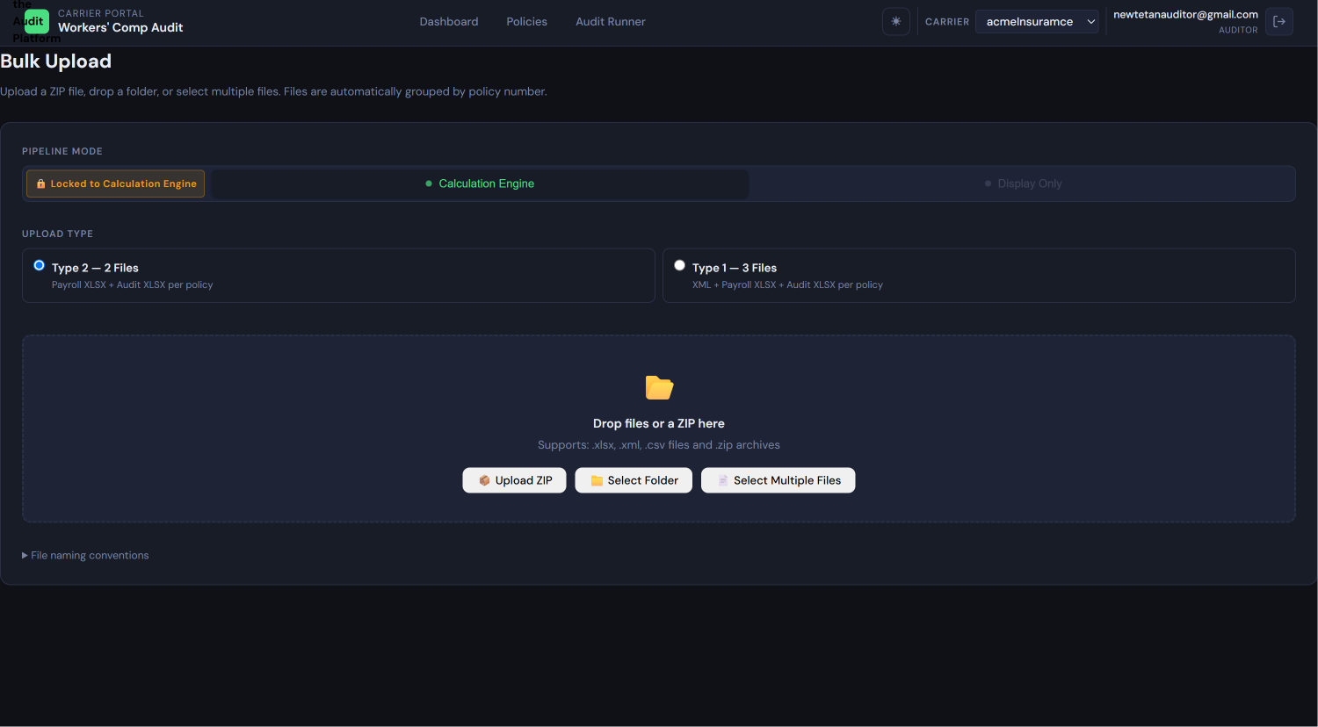 Bulk Upload drop zone Shows: The main Bulk Upload page with a large drop zone accepting ZIP archives or folder drops, three buttons below for "Upload ZIP," "Select Folder," and "Select Multiple Files," and a collapsed hint section labeled "File naming conventions."
File naming convention hint panel (expanded) Shows: The expanded naming convention hint with formatted examples: "Calc Engine (Type 2): POL001_payroll.xlsx + POL001_audit.xlsx," "Calc Engine (Type 1): POL001.xml + POL001_payroll.xlsx + POL001_audit.xlsx," "Display Only: POL001.xlsx (one file per policy)," and the grouping rule explanation.
📷 SCREENSHOT PLACEHOLDER Screen: Grouped policy list before submission Shows: The pre-submission policy list table with columns for Policy Group (the extracted prefix), Files (list of filenames with slot type icons), and Status (green "ready," amber "incomplete," or red "unmatched" badges). A count summary line shows "12 ready · 1 incomplete · 0 unmatched." A "Submit Upload" button is active.

3.4 Understanding Ingestion Statuses
After uploading files, you can track the progress of each ingestion run. Here is what each status means and what to do.
Status | What It Means | What You Should Do
awaiting_mapping | Files uploaded; auto-mapping complete; waiting for Tenant Admin to approve the field mapping | Notify your Tenant Admin that approval is needed. The run cannot proceed without their action.
processing | Mapping approved; data is actively being ingested into the platform database | Wait — no action needed. This usually completes within seconds to minutes depending on file size.
complete | All rows ingested successfully | Proceed to review results. Check for any exceptions if available.
partial | Ingestion finished but some rows were skipped due to validation errors | Review the exception log. Some data is in the system; skipped rows need your attention.
failed | A hard error stopped the run before completion | Contact your Tenant Admin. The run may need to be rolled back and restarted with a corrected file.
rolled_back | A Tenant Admin rolled back this run | All fact data from this run has been removed. Re-upload if the data is still needed.

3.5 Reviewing and Resolving Ingestion Exceptions
What Are Exceptions?
When the platform ingests data row by row from your uploaded file, it validates each row. If a row contains a problem — a date that cannot be parsed, a required field that is empty, a numeric field containing text — the platform must decide what to do.
The default behavior is skip-on-error mode: the platform records the problematic row in an exception log, skips past it, and continues ingesting the remaining rows. The run completes (with status partial) and you can then review and fix the skipped rows.
Exceptions fall into two categories:
- Errors (Error Log): Hard failures recorded with full details — the row number, which field failed, what the raw value was, the error code, and a plain-language error message.
- Skipped Rows: Individual rows that were bypassed. Each skipped row preserves the full raw record so you can correct and re-ingest it.
The Exception Dashboard
From a completed or partial run, click View Exceptions to open the exception dashboard.
Error Log columns: Row #, Field Name, Raw Value, Error Code, Error Message, Resolution status.
Skipped Rows columns: Row #, all field values from the original row (raw), Skip Reason, Resolution status (Pending / Re-ingested / Dismissed).
Common error codes and what they mean:
Error Code | Meaning
FIELD_TYPE_MISMATCH | A field contains the wrong data type (e.g., text in a numeric field)
REQUIRED_FIELD_NULL | A required field is empty in this row
POLICY_NOT_FOUND | The policy number in this row doesn't match any known policy in the run
DATE_PARSE_FAILURE | A date field could not be parsed (check date format — use MM/DD/YYYY or YYYY-MM-DD)
TRANSFORM_FAILURE | A configured transform function failed to convert the value
MAPPING_NOT_FOUND | A source column exists in the file but has no approved mapping
📷 SCREENSHOT PLACEHOLDER Screen: Exception dashboard with error log and skipped rows Shows: A tabbed interface with an "Error Log" tab and a "Skipped Rows" tab. The Error Log tab is active, showing a table with Row #, Field, Raw Value, Error Code, and Error Message columns. One or two example rows are visible with amber or red row highlights. Status badges show "Pending" for unresolved rows.

Resolving a Skipped Row
Each skipped row can be either corrected and re-ingested, or dismissed.
To correct and re-ingest a skipped row:
- Click the row in the Skipped Rows list
- The Correct & Re-ingest panel opens showing all field values from the original row
- Identify the field that caused the skip (highlighted or labeled)
- Edit the value in the correction form
- Click Submit — the platform attempts to re-ingest this single row using the corrected value
- Success: the row is added to the fact tables; the skipped row record shows "Re-ingested" status
- Failure: a new error message appears inline showing what is still wrong
📷 SCREENSHOT PLACEHOLDER Screen: Correct & Re-ingest form Shows: A panel or modal displaying all field values from the original skipped row in editable form fields. The problematic field is highlighted. A "Submit" button and a "Cancel" button appear at the bottom. The skip reason is shown at the top of the panel.
To dismiss a skipped row:
If you have reviewed a skipped row and determined the data should not be included (for example, it was a test record or a header row that slipped into the data), click Dismiss. The row receives a DISMISSED badge and will not be re-processed or included in calculations.
Dismissing is irreversible. Dismissed rows remain in the exception log as an audit trail.

3.6 Triggering Calculations Manually
In most cases, the calculation engine runs automatically after ingestion completes (if the engine mode is ON). However, you may sometimes need to trigger calculations manually — for example, after re-ingesting corrected rows, or if the automatic trigger did not fire.
How to trigger manually:
From the ingestion run detail page, click Run Calculation Engine. This button appears on runs that are in complete or partial status and have engine mode set to ON.
What the calculation engine does (plain language):
The engine applies all 22 active calculation rules to the ingested payroll and premium data for this run. It:
- Computes the premium variance (actual premium vs. estimated premium)
- Computes the payroll variance per class code (actual reported payroll vs. estimated payroll)
- Evaluates the risk threshold rules to classify the policy as High, Medium, or Low risk
- Detects zero-wage payroll submissions and flags them
- Detects missing payroll periods and flags them
- Checks officer inclusion/exclusion rules
- Calculates submission rate and frequency analysis
- After calculations complete, triggers the AI Narrative Service to generate a plain-English audit summary
While calculations are running, the run status shows processing. This typically takes a few seconds for a single policy.
When calculations are complete, the run status returns to complete and the policy detail view shows all calculated figures.
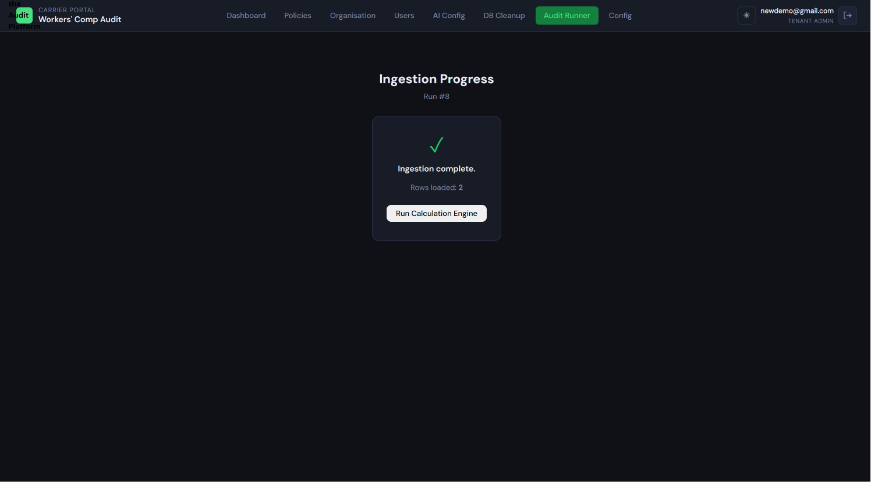 Trigger calculation button and run status Shows: The ingestion run detail page with a "Run Calculation Engine" button visible in the actions area. The current run status badge shows COMPLETE. After clicking, the status badge changes to PROCESSING with a spinner animation.

3.7 Viewing Audit Results
After calculations complete, navigate to Policies and find the policy, or click the policy link directly from the ingestion run. The Policy Detail view shows:
- Policy identity: Policy number, policyholder name, carrier, policy effective and expiration dates
- Calculation mode: Whether the Calculation Engine or Display Only mode was used for this run
- Payroll comparison table: For each class code — estimated payroll, actual payroll as reported, actual payroll as classified, and the over/under variance amount
- Premium variance summary: Estimated premium end, actual premium, variance amount (dollars), and variance percentage
- Class code breakdown: Per-class-code premium and payroll figures
- Risk level indicator: High, Medium, or Low risk (engine mode only)
- AI-generated narrative: See Section 3.8
Interpreting variance figures:
- Positive variance (e.g., +$5,000 or +12.4%): Actual payroll or premium is higher than estimated. The policyholder owes additional premium.
- Negative variance (e.g., -$2,000 or -5.1%): Actual payroll or premium is lower than estimated. A return premium may be owed to the policyholder.
- Zero variance: Actuals exactly matched the estimate (uncommon in practice).
For Display Only runs, calculated fields (variance %, risk level) show "N/A" because the engine was not run.
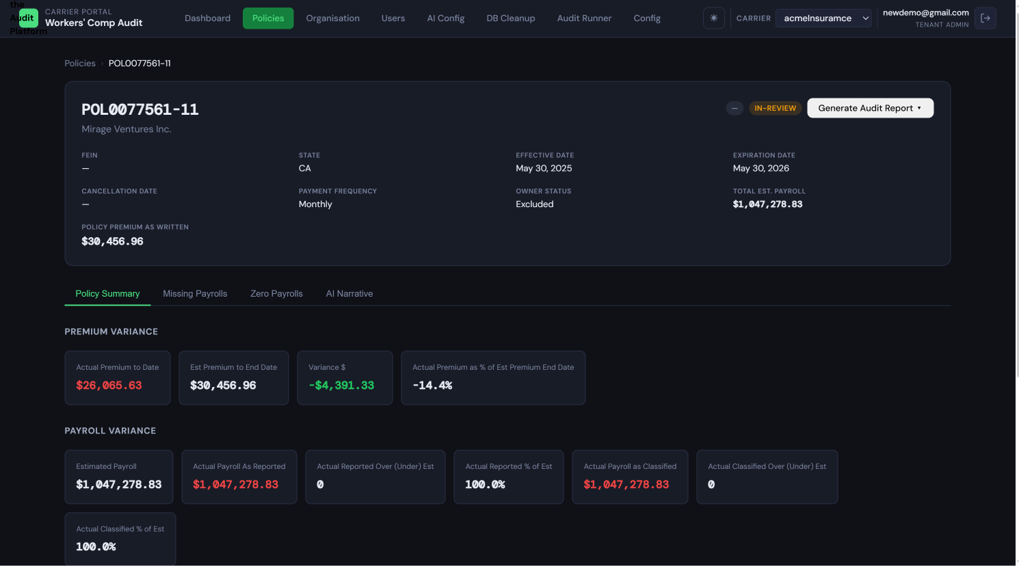 Policy detail view with variance data Shows: The full policy detail page showing the policy identity header, a payroll comparison table with estimated vs. actual columns by class code, a premium variance summary card showing variance amount and percentage with appropriate color (green for negative/return, red/amber for positive/additional premium due), and a risk level badge.

3.8 The AI-Generated Audit Narrative
The AI-Generated Audit Narrative is a plain-English summary of the audit findings, auto-generated after each successful calculation run. It appears in the Narrative Panel at the bottom of the Policy Detail view.
What it contains:
The narrative summarizes the key findings in language suitable for inclusion in communications or reports: the policy period covered, the number of payroll submissions reviewed, the premium variance amount and percentage, any missing or zero-payroll periods flagged, and an overall risk assessment.
States the Narrative Panel can show:
What you see | What it means
Full narrative text with provider badge | Normal state — the AI service generated the narrative successfully
Amber notice: "This narrative was generated using a template because the AI service was unavailable." | The AI service was temporarily unavailable; a template-based summary was used instead. The content is still accurate but less detailed than a full AI narrative.
Blue info bar: "Enable the Calculation Engine and re-run to generate an AI narrative." | The run used Display Only mode — no calculations were performed, so no narrative was generated
"No narrative available for this policy." | The narrative was not generated for this run (rare edge case)
How to use the narrative panel:
- The panel is collapsed by default to its first four lines
- Click Show Full Narrative ▼ to expand the complete narrative
- Click Collapse ▲ to return to the condensed view
- Click Copy to Clipboard to copy the full narrative text. After clicking, the button briefly shows "Copied!" as confirmation. You can paste the narrative into emails, reports, or other documents.
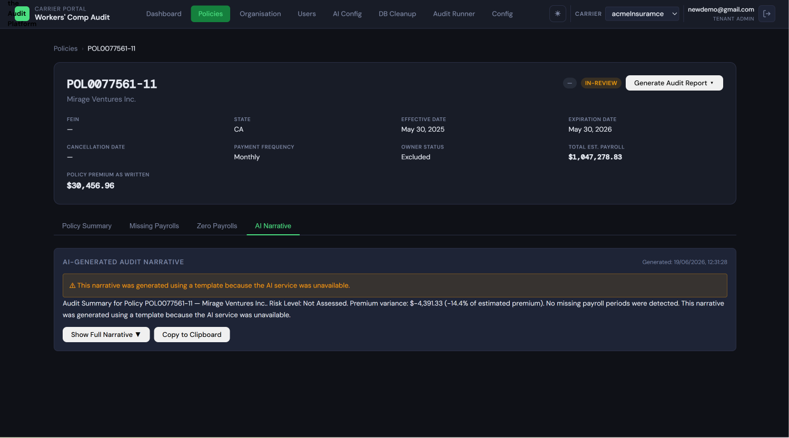: Narrative Panel (collapsed state) Shows: The Narrative Panel section at the bottom of the Policy Detail page, showing the panel title "AI-Generated Audit Narrative," a small provider badge (e.g., "via claude-sonnet-4-6"), the generated timestamp, and the first 3-4 lines of narrative text fading out with a "Show Full Narrative ▼" button below.
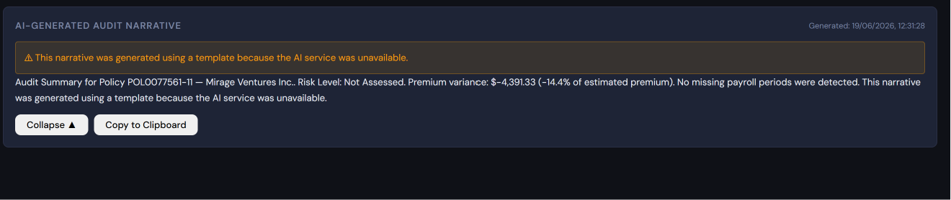 Narrative Panel (expanded state) Shows: The same Narrative Panel but fully expanded to show the complete narrative text. A "Collapse ▲" button appears at the bottom alongside a "Copy to Clipboard" button.

3.9 Generating and Downloading Reports
After a run is in complete status, you can generate a formal audit report.
How to generate a report:
From the Policy Detail view or the ingestion run detail, click Generate Report. Report generation runs in the background and may take a moment for policies with large amounts of data.
Available report types:
- Standard Audit Report: A PDF (and optionally XLSX) formatted audit report using the carrier's report template. Includes policy identity, payroll comparison, premium variance summary, and class code breakdown.
- Exception Report: Available if the run had skipped rows or errors — lists all exceptions for the run.
Downloading:
Once the report is generated, a Download Report link or button appears. Click it to download the file to your computer.
Reports are generated using the carrier's Report Template configuration (logo, colors, contact block) as set up by the Tenant Admin.
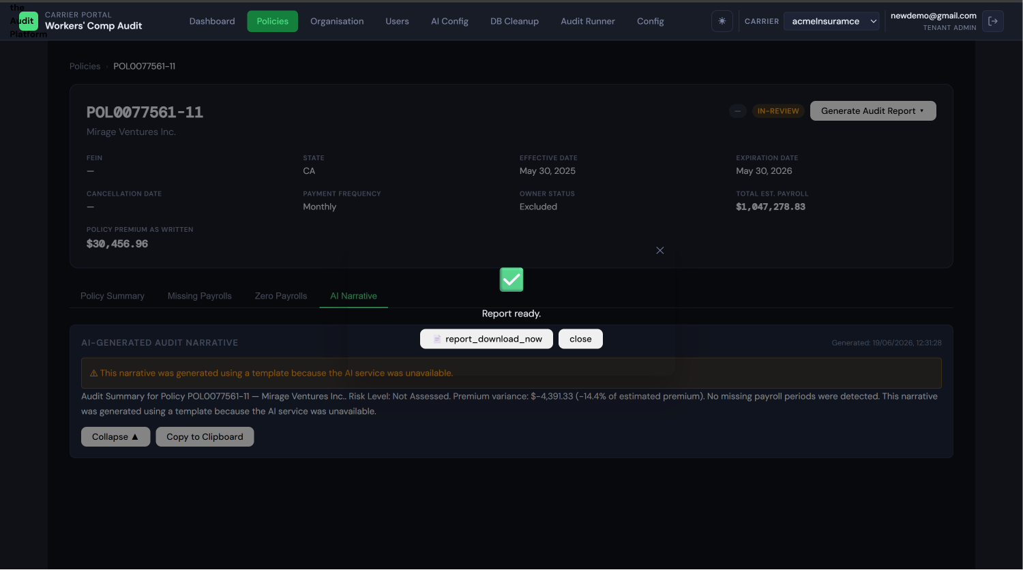 Report generation button and download link Shows: The policy detail or run detail page with a "Generate Report" button. After the report is generated, the button is replaced (or supplemented) by a "Download Report" link showing the generated filename with a file type icon.

3.10 Auditor Do's and Don'ts
Action | Guideline
Upload a file and immediately assume it is being processed | ✗ Don't — the run waits in awaiting_mapping until Tenant Admin approves. Always confirm approval before checking for results.
Notify the Tenant Admin after every upload | ✓ Do — they need to approve the mapping; without this nothing happens
Use the same ingestion mode as existing runs for a carrier | ✓ Do — mixing modes requires all runs to be rolled back first
Submit a bulk upload without checking the grouping table | ✗ Avoid — verify all policies grouped correctly before submitting
Dismiss a skipped row without reviewing it | ✗ Avoid — once dismissed, the row is excluded from all calculations and cannot be undone
Copy the AI narrative directly into a report | ✓ Do — use the Copy to Clipboard button for a clean copy
Generate a report before calculations are complete | ✗ Don't — reports generated before calculation will not contain variance data
Upload a file using the wrong upload type (e.g., Type 1 when it's a Type 2) | ✗ Don't — this creates mapping errors; use the correct type for your file set

GUIDE 4: REVIEWER USER GUIDE
Audience: A read-only user — supervisor, manager, compliance officer, or carrier representative — who monitors audit results, downloads reports, and views the audit pipeline without making any changes.

4.1 Who Is the Reviewer?
The Reviewer role is read-only. Reviewers can see everything that has been processed through the platform, but they cannot change anything.
What a Reviewer can do:
- View the dashboard with summary metrics and the policy list
- Search, filter, and browse policies
- View policy details: payroll comparisons, premium variance, class code breakdown, risk level
- Read the AI-generated audit narrative
- Download completed audit reports
- View ingestion run history and status
What a Reviewer cannot do:
Upload files, approve field mappings, trigger calculations, resolve exceptions, roll back runs, generate reports, configure any platform settings, or invite users.
How to log in:
Log in at your organization's tenant subdomain (provided by your Tenant Admin) using your invitation email and password.
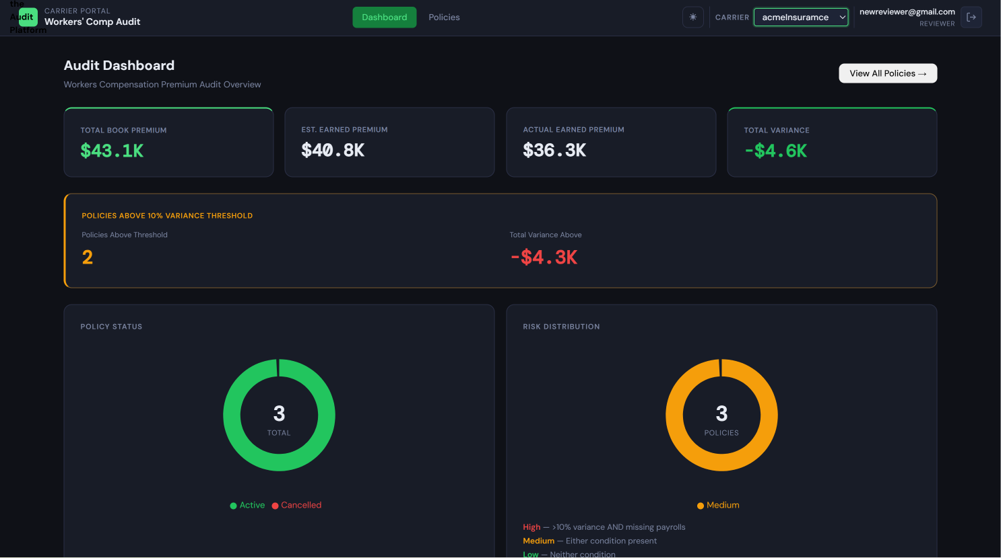
dashboard Shows: The main dashboard as seen by a Reviewer — identical visual content to the Auditor dashboard (KPI cards, policy list) but with no Upload, Calculate, or Generate Report action buttons visible. The navigation shows only Dashboard, Policies, and Reports items (no Audit Runner, Bulk Upload, or Administration).

4.2 Navigating the Dashboard
The dashboard is your starting point for monitoring audit progress.
What the dashboard shows:
- KPI summary cards at the top: Total Policies, Total Premium Variance, Zero Payroll Policies, Missing Payroll Policies — all filtered to your tenant
- Policy list: The main table of all policies, with their carrier, policy number, policyholder name, audit status, calculated risk level, and premium variance summary
Filtering and searching the policy list:
- Use the carrier filter dropdown to show only policies for a specific carrier
- Use the search box to find a policy by policy number or policyholder name
- Use the date range filter to narrow by policy period or ingestion date
- Use the status filter to show only policies with a specific audit status (complete, partial, etc.)
Sorting:
Click any column header in the policy list to sort by that column. Click again to reverse the sort order.
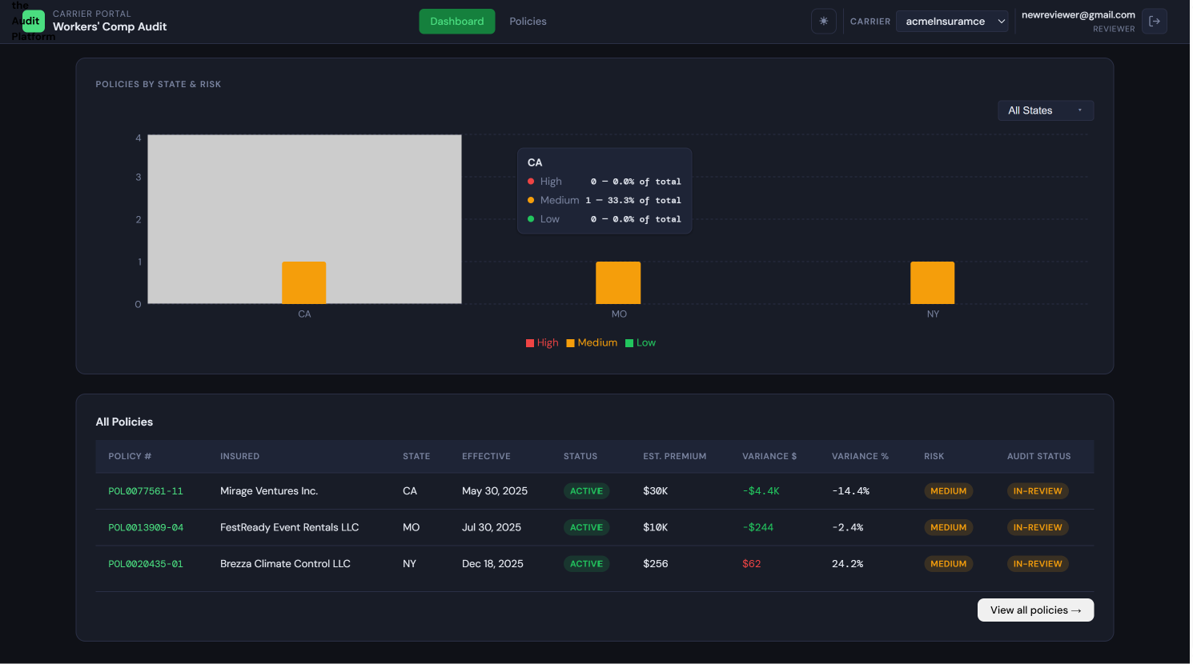 Dashboard with policy list Shows: The full dashboard with KPI cards at the top and the policy list table below. The filter bar is visible with carrier selector, search input, and date range pickers. Column headers are clickable for sorting. Several policy rows are visible with their status badges and variance amounts.

4.3 Viewing a Policy
Click any policy row in the policy list to open the Policy Detail view.
What is shown on the policy detail page:
- Policy identity: Policy number, policyholder name, policy effective and expiration dates, carrier name
- Calculation mode indicator: Shows whether the Calculation Engine or Display Only mode was used for the run that produced these results
- Ingestion run reference: Which ingestion run produced this data (run ID and date)
- Payroll comparison table: Estimated payroll vs. actual payroll (reported and classified) per class code, with variance amounts and percentages
- Premium variance summary: Estimated premium end, actual premium charged, variance amount and percentage
- Risk level indicator: High, Medium, or Low (only visible for Calculation Engine runs)
- AI narrative: The AI-Generated Audit Narrative for this policy (read-only — you can read and copy, but not regenerate)
Interpreting the numbers:
A positive variance means the policyholder's actual payroll or premium was higher than estimated — additional premium is likely owed. A negative variance means actuals were lower — a return premium may apply. For Display Only runs, variance calculations will show "N/A" because the engine was not run.
📷 SCREENSHOT PLACEHOLDER Screen: Policy detail — Reviewer view (no action buttons visible) Shows: The policy detail page as seen by a Reviewer. The policy identity header, payroll comparison table, and premium variance summary are all visible. Crucially, there are no "Generate Report," "Run Calculation Engine," or "Rollback" buttons anywhere on the page — only read-only content and a "Download Report" button (if a report has already been generated).

4.4 Downloading Reports
To download a report, open the Policy Detail view. If a report has been generated, a Download Report button or link appears.
Click Download Report to save the file to your computer.
If a report has not been generated yet:
The Download Report button will not appear. You cannot generate reports as a Reviewer. Contact your Auditor or Tenant Admin and ask them to generate the report for you. Once they do, the download link will appear the next time you view the policy.
Report download button on policy detail Shows: The bottom section of the policy detail page (or a reports section) with a "Download Report" button or a link showing the report filename with a PDF/XLSX icon. The button should be clearly styled as a download action.

4.5 Viewing Ingestion Run History
You can view the history of ingestion runs from the policy detail (the run that produced the current results) or from the carrier-level run list (if navigation allows).
What you can see:
- Run ID, carrier, upload date, file name, status, rows ingested, rows skipped, rows failed
What you cannot do:
- Approve mappings
- Roll back runs
- Restart failed runs
- Resolve exceptions
For the meaning of each status, refer to the status table in Section 3.4 of the Auditor Guide.

4.6 Theme Preference (If Enabled by Tenant Admin)
If your Tenant Admin has enabled per-user theme preference for your carrier, you can set your preferred color theme (dark or light) from your user account menu.
Click your avatar or username in the top-right corner of the screen to open the dropdown menu. If theme preference is enabled, a Theme option appears. Click it to open the theme selector and choose your preferred theme.
Your preference is saved to your user account and persists across sessions. If the Tenant Admin has not enabled per-user theme preference for a carrier, the theme selector does not appear, and all users see the carrier's default theme.
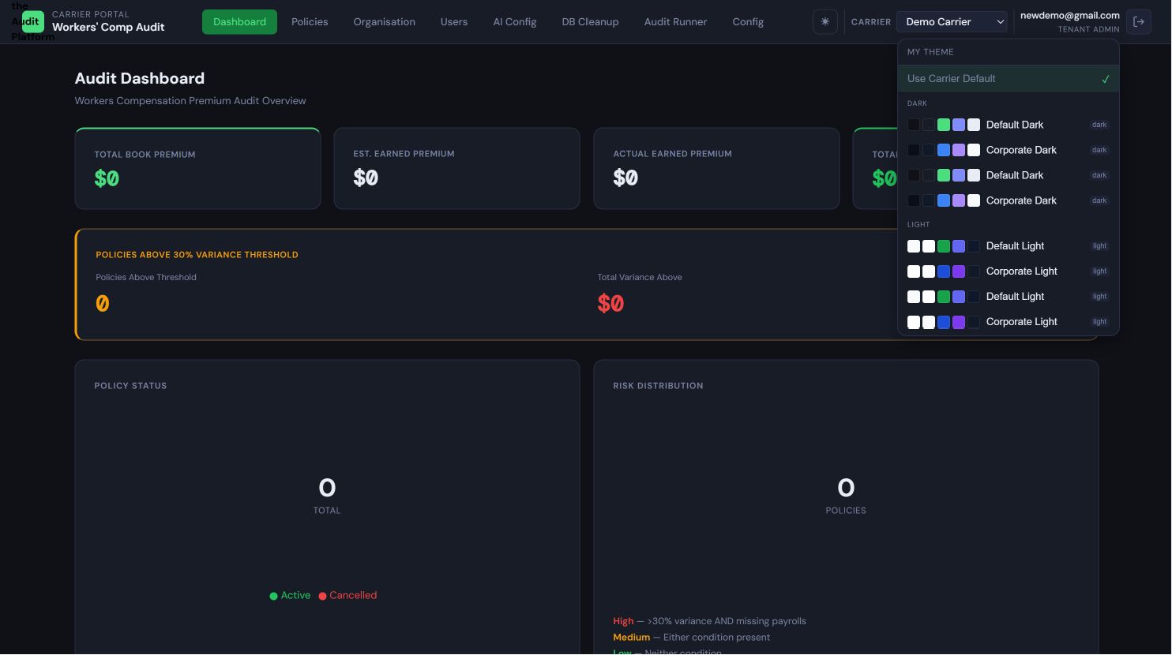 User avatar dropdown with theme selector (if enabled) Shows: The user avatar dropdown menu expanded in the top right corner, showing options including the user's name, email, and a "Theme" option. Clicking Theme reveals a theme picker sub-menu with available theme options shown as color-swatch cards.

4.7 What Reviewers Cannot Do — Quick Reference
Action | Who Can Do This Instead
Upload files | Auditor or Tenant Admin
Approve field mappings | Tenant Admin only
Trigger calculations | Auditor or Tenant Admin
Resolve exceptions (correct or dismiss skipped rows) | Auditor or Tenant Admin
Roll back an ingestion run | Tenant Admin only
Generate a report | Auditor or Tenant Admin
Change any configuration (rules, labels, themes) | Tenant Admin only
Invite new users | Tenant Admin only
Run database cleanup | Tenant Admin only
If you need any of these actions performed, contact your Tenant Admin or the Auditor assigned to the relevant carrier.
Workers' Compensation Premium Audit Platform
Role-Based User Documentation — Part 3

GUIDE 5: INPUT FILE REFERENCE GUIDE
Audience: Anyone who prepares, handles, or troubleshoots data files for upload — primarily Auditors and the Tenant Admin. IT staff at carrier organizations who generate export files will also find this guide valuable.

5.1 Overview — What Files Does the Platform Accept?
File Format | Extension | Used In | Notes
Excel Workbook | .xlsx | All upload types | Most common format; must be .xlsx not .xls
XML | .xml | Type 1 uploads only | Supplies policy configuration data (class codes, exposure amounts, dates)
CSV | .csv | Type 3 uploads only | Comma, tab, or semicolon delimited; encoding must be UTF-8
ZIP Archive | .zip | Bulk Upload only | Container for multiple policy files; extracted client-side
File detection: The platform determines file type from the filename extension (.xlsx, .xml, .csv). The MIME content-type header is used only as a fallback. Files with application/octet-stream content type are always identified by extension only. Do not rename files to a different extension — a .xls file renamed to .xlsx will fail to parse.

5.2 XLSX File Requirements
Payroll Detail XLSX
The Payroll Detail file contains per-employee or per-class-code payroll data for the audit period. One row per payroll record; one header row identifying the columns.
Required structure:
- Must have a clearly identifiable header row containing recognizable column names
- Each subsequent row represents one payroll record
- No merged cells in the header row — merged cells prevent the platform from identifying column boundaries
- If the header row is not in row 1, configure the Anchor String in the Data Source setup to tell the platform where to find it
Canonical columns for Payroll Detail:
Source Column (common names) | Canonical Target | Data Type | Required? | Description
Client Name, Insured Name | policyholder_name | TEXT | Required | Full legal or trading name of the policyholder
Policy Number | policy_number | TEXT | Required | The policy identifier — must be consistent across all files in the same upload set
CheckDate, Check Date | as_of_date | DATE | Required | The payroll period end date this record covers
EE No, EE_No, Employee Number | employee_id | TEXT | At least one of employee_id or class_code required | Employee identifier from the carrier's system
Employee Name | employee_name | TEXT | Optional | Full name of the employee
St., State | state_code | TEXT | Required | Two-letter US state abbreviation (e.g., CA, FL, PA)
Class Code | class_code | TEXT | At least one of employee_id or class_code required | Workers' compensation class code; stored as text to preserve leading zeros
Wages | wages | NUMERIC | Required | Regular wages for the period
OT, Overtime | overtime | NUMERIC | Optional | Overtime wages
DT, Double Time | double_time | NUMERIC | Optional | Double-time wages
Tips | tips | NUMERIC | Optional | Tip income
Net | net_wages | NUMERIC | Optional | Net wages after adjustments
Exposure | exposure | NUMERIC | Optional | Calculated exposure amount
Net Rate | net_rate | NUMERIC | Optional | Net premium rate per dollar of exposure
Earned Prem., Earned Premium | earned_premium | NUMERIC | Optional | Calculated earned premium for this record
Pol Eff. Date | policy_eff_date | DATE | Optional | Policy effective date
Process Date | process_date | DATE | Optional | Date the payroll record was processed
Common mistakes that cause mapping failures:
- Merged cells in the header row: Unmerge all cells in the header row before uploading
- Header row not in row 1: Use the Anchor String configuration in Data Sources to specify the text that identifies your header row (e.g., Client Name)
- Numeric policy numbers stored as text: The platform handles this, but ensure policy_number values are consistent across files (all text or all numeric, not mixed)
- Date formats the platform cannot parse: Use MM/DD/YYYY, YYYY-MM-DD, or M/D/YYYY. Avoid non-standard date formats. Excel date serial numbers (integers) are also supported.
- Extra header rows or title rows above the data: Use the Anchor String to skip these

Audit Summary Report XLSX
The Audit Summary Report file contains the carrier's audit summary showing estimated vs. actual figures. This is typically a report exported from the carrier's policy management system.
Key distinction from the Payroll Detail file: The Audit Summary Report shows aggregated figures per class code and policy — not individual payroll records. It provides the "estimated" side of the comparison and the carrier's pre-computed totals.
Canonical columns for Audit Summary Report:
Source Column (common names) | Canonical Target | Data Type | Required? | Description
Est. Payroll, Estimated Payroll, Exposure Received Per Class | est_payroll | NUMERIC | Required | The carrier's estimated payroll for this class code
Actual Payroll As Reported, Exposure Received Per Net Rate | actual_payroll_reported | NUMERIC | Required | Actual payroll as reported by the policyholder
Actual Payroll As Classified, Exposure Assessed Per Net Rate | actual_payroll_classified | NUMERIC | Optional | Actual payroll after audit classification adjustments
Actual Reported Over (Under) Estimated | reported_over_under | NUMERIC | Computed | Variance in payroll; typically a generated/calculated column
Actual Reported % of Estimated | reported_pct | NUMERIC | Computed | Reported payroll as percentage of estimated
Est Premium End Date, Total Premium Calculated | est_premium_end | NUMERIC | Required | The carrier's estimated premium at policy end
Actual Premium, Payroll Premium | actual_premium | NUMERIC | Required | Actual earned premium
Premium Variance | variance_amount | NUMERIC | Computed | Difference between actual and estimated premium
Premium Variance % | variance_pct | NUMERIC | Computed | Premium variance as percentage of estimated
Policy Number | policy_number | TEXT | Required | Must match the policy_number in the Payroll Detail file
State | state_code | TEXT | Required | State code for this class code entry
Class Code | class_code | TEXT | Required | Workers' comp class code
Important note on complex XLSX layouts: Carrier audit reports often have complex layouts with title rows, merged header cells, and multiple sections. The platform's Anchor String feature is designed to handle this — configure it to match the text that appears at the start of the actual data section (e.g., AUDIT REPORT - Classification Detail). The auto-mapping algorithm then scans from that anchor point.

Display Only XLSX
A Display Only file is a single XLSX uploaded when you need to present pre-computed data without running any calculations. There are no required canonical column names for Display Only uploads — the platform will display whatever columns are present.
Field mapping still runs in Display Only mode (so the Tenant Admin can map columns to display labels and set visibility), but no calculation rules are applied and no variance figures are computed.

5.3 XML File Requirements (Type 1 Uploads)
The XML file in a Type 1 upload supplies policy-level configuration data that supplements the payroll spreadsheets. It provides the carrier's view of the policy: class codes, estimated exposure amounts, policy dates, insured identity, and officer information.
XML format used by the platform:
The platform is designed around the PPlus (MarkelPaygo) XML format based on the sample files provided. The root element is <PPlus>.
Required structure:
<!-- Minimal valid XML structure for Type 1 upload -->
<PPlus>
<TransactionControl>
<TransactionSourceId>MarkelPaygo</TransactionSourceId>
<CompositeRatesSupplied>Yes</CompositeRatesSupplied>
<PolicyHolderKeyFieldName>PolicyHolderKey</PolicyHolderKeyFieldName>
</TransactionControl>
<Policy>
<TransactionType>REN</TransactionType>
<TransactionEffectiveDate>03/03/2025</TransactionEffectiveDate>
<PolicyData>
<PolicyHolderKey>15960232</PolicyHolderKey>
<Premium>5411.00</Premium>
<PolicyNumber>MWC0123966-08</PolicyNumber>
<EffectiveDate>03/03/2025</EffectiveDate>
<ExpirationDate>03/03/2026</ExpirationDate>
<InsuredName>AM-PM Air Conditioning Inc</InsuredName>
<!-- Address, contact, and other policy fields -->
</PolicyData>
<Officers>
<Officer>
<State>FL</State>
<ClassCode>8810</ClassCode>
<Name>Bonnie Martinez</Name>
<IncludedExcludedCd>I</IncludedExcludedCd>
<Title>ElecOfc</Title>
<OwnershipPct>0</OwnershipPct>
<Salary>46800.00</Salary>
<EffectiveDate>03/03/2025</EffectiveDate>
<ExpirationDate>03/03/2026</ExpirationDate>
</Officer>
</Officers>
<States>
<ComplexRateState>
<State>FL</State>
<Premium>5411.00</Premium>
<TimePeriod>
<EffectiveDate>03/03/2025</EffectiveDate>
<ExpirationDate>03/03/2026</ExpirationDate>
<ExposureBasedPremium>5411.00</ExposureBasedPremium>
<Rates>
<Rate>
<ClassCode>5537</ClassCode>
<CompositeRate>0.03943000</CompositeRate>
<Exposure>135166.00</Exposure>
<EstPremium>0.00</EstPremium>
<EffectiveDate>03/03/2025</EffectiveDate>
</Rate>
<!-- additional Rate elements per class code -->
</Rates>
</TimePeriod>
</ComplexRateState>
</States>
</Policy>
</PPlus>
Required elements:
Element Path | Description
PPlus/Policy/PolicyData/PolicyNumber | Policy number — must match the policy_number in the paired XLSX files
PPlus/Policy/PolicyData/InsuredName | Policyholder name
PPlus/Policy/PolicyData/EffectiveDate | Policy effective date (MM/DD/YYYY)
PPlus/Policy/PolicyData/ExpirationDate | Policy expiration date
PPlus/Policy/PolicyData/Premium | Total premium
PPlus/Policy/States/ComplexRateState/State | State code
PPlus/Policy/States/ComplexRateState/TimePeriod/Rates/Rate/ClassCode | Class code
PPlus/Policy/States/ComplexRateState/TimePeriod/Rates/Rate/Exposure | Estimated exposure/payroll for the class code
Optional elements (provide richer data):
- Officers/Officer elements: officer name, state, class code, inclusion/exclusion status, salary, ownership percentage
- PolicyData/Addr: insured address
- PolicyData/Fein: Federal employer identification number
- PolicyData/AgentContact: Agent/broker details
- TransactionControl block: transaction metadata
Common mistakes:
- XML encoding issues: Use UTF-8 encoding. Special characters in names (e.g., &, <, >) must be XML-escaped (&amp;, &lt;, &gt;)
- Policy number mismatch: The PolicyNumber in the XML must exactly match the policy number values in the paired XLSX files. A mismatch causes a POLICY_NOT_FOUND error.
- Missing required elements: The platform will report which element is missing during the upload & test phase

5.4 CSV File Requirements (Type 3 Uploads)
CSV uploads support a single file containing all payroll data for one policy.
Requirements:
- Header row: Required in row 1. The platform does not support headerless CSVs.
- Supported delimiters: Comma (,), tab (\t), semicolon (;). The platform auto-detects the delimiter by scanning the first row.
- Encoding: UTF-8 preferred. UTF-8 with BOM (Byte Order Mark) is accepted. Avoid other encodings such as Windows-1252 — these can cause character corruption.
- Quoting: Standard CSV quoting rules apply. Fields containing the delimiter character, newlines, or double-quote characters must be enclosed in double quotes. Double quotes within a field must be escaped as two consecutive double quotes ("").
- Line endings: Both \r\n (Windows) and \n (Unix) are accepted.
The same canonical column mapping applies as for XLSX — the auto-mapping algorithm looks at the column header names in row 1 and applies the same 4-pass scoring.
Common mistakes:
- Inconsistent delimiter usage: A file that uses commas most of the time but occasionally has semicolons will fail to parse correctly
- Unquoted fields containing the delimiter: A field value like Smith, John must be quoted as "Smith, John" in a comma-delimited file
- Mixed encodings in the same file: All characters must use the same encoding throughout

5.5 File Naming Conventions for Bulk Upload
Incorrect file naming is the most common cause of policy grouping errors in bulk upload. This section describes exactly how the platform determines which files belong together.
The Grouping Rule
Files are grouped into policy sets by their filename prefix — the text before the first occurrence of _payroll, _audit, _auditReport, or .xml in the filename (case-insensitive). The platform also strips date suffixes in the format _YYYY_M_D or _YYYY_MM_DD before determining the prefix. Files sharing the same resulting prefix are grouped as one policy.
Examples
Filename | Policy Group (Prefix) | Slot Type
POL001_payroll.xlsx | POL001 | Payroll detail
POL001_audit.xlsx | POL001 | Audit summary
POL001.xml | POL001 | XML config
POL002_payroll.xlsx | POL002 | Payroll detail
POL002_audit.xlsx | POL002 | Audit summary
Acme_Corp_2026_3_15.xlsx | Acme_Corp | Payroll detail
Acme_Corp_auditReport_2026_3_15.xlsx | Acme_Corp | Audit summary
Acme_Corp_2026_3_15.xml | Acme_Corp | XML config
Type 1 group (3 files, Calc Engine): POL001.xml + POL001_payroll.xlsx + POL001_audit.xlsx
Type 2 group (2 files, Calc Engine): POL002_payroll.xlsx + POL002_audit.xlsx
Display Only group (1 file per policy): POL003.xlsx

What Breaks Grouping
Problem | Effect | Solution
Inconsistent capitalization (POL001 vs pol001) | Creates two separate groups; each is incomplete | Always use consistent casing; best practice is to use the carrier's policy number format exactly
Prefix typo (POL001 vs POL0001) | Two separate groups, each with missing files | Double-check prefix consistency before submitting
Extra underscores before _payroll | May cause the prefix extraction to fail | Avoid underscores immediately before the _payroll or _audit suffix
Same prefix for different policies | Both policies lumped into one group | Each policy must have a unique prefix
Spaces in filenames | Spaces are converted to underscores during grouping; ensure this doesn't create accidental matches | Use underscores consistently instead of spaces
Recommended Naming Scheme
The most reliable approach is to use the carrier's policy number as the prefix, exactly as it appears in your system:
MWC0092315-10_payroll.xlsx
MWC0092315-10_audit.xlsx
MWC0092315-10.xml
This guarantees uniqueness (policy numbers are unique), is traceable, and matches the platform's sample files.

5.6 The Auto-Mapping Pipeline — What Happens to Your Files
When an Auditor uploads a file, the platform immediately runs an automatic mapping process to match the file's column headers to the platform's canonical column names. Understanding this process helps you prepare files that require less manual intervention.
Pass 1 — Saved Mappings (HIGH Confidence, Score 1.000)
The platform first checks whether the Tenant Admin has pre-configured a field map for this carrier and file type. Any column that exactly matches a saved mapping is flagged as HIGH confidence. These columns will not require any manual review during the approval step — unless the Tenant Admin specifically wants to override them.
Tip for IT staff: Align your exported column headers as closely as possible to the platform's canonical column names. Even better, ask your Tenant Admin to set up a saved mapping for your exact column names — subsequent uploads will then require zero manual mapping effort.
Pass 2 — Exact Name Match (HIGH Confidence, Score 0.950)
For columns not covered by a saved mapping, the platform normalizes both the source column name and each canonical column name (strips whitespace, lowercases, collapses multiple spaces) and looks for an exact match. For example, Policy Number and policy_number both normalize to policy number and match each other.
Pass 3 — Fuzzy Name Matching (MEDIUM or LOW Confidence)
For columns that don't match exactly, the platform uses fuzzy string matching to find close approximations:
- If the fuzzy match ratio is ≥ 0.75 AND the column's data type is compatible with the target → MEDIUM confidence
- If the ratio is ≥ 0.50 but the data type is uncertain or incompatible → LOW confidence
Example: "Payroll Amt" fuzzy-matches payroll_amount with a high ratio and a numeric data type → MEDIUM confidence.
Pass 4 — UNMATCHED
Columns that score below the threshold (ratio < 0.50) or whose data content cannot be correlated to any canonical column receive UNMATCHED status. The Tenant Admin must manually assign these columns before approving the mapping.
What This Means for File Preparers
The more consistently and clearly your files are named at the column header level, the higher the auto-mapping confidence — and the faster the Tenant Admin can approve:
- Best outcome: All columns match saved mappings → Tenant Admin reviews and approves in seconds
- Good outcome: All columns match exactly or fuzzy-match with HIGH/MEDIUM confidence → Tenant Admin does a quick review
- Slower outcome: Many LOW or UNMATCHED columns → Tenant Admin must manually assign each one before approving
The canonical column names listed in Section 5.2 are the target names. Aligning your exports to these names (or even exact copies of them) maximizes the first-upload match rate.

5.7 Sample File Reference
The following sample files are available in the platform project as test and reference data. This section documents each file's purpose and contents.

March 2026 Policy Batch (Type 2 — Payroll XLSX + Audit XLSX, no XML)
These files are from the March 19, 2026 processing date. Each policyholder has two files: a Payroll Detail XLSX and an Audit Summary Report XLSX. These form Type 2 upload sets (two files, no XML).
All Audit Summary Report files in this batch share a common format:
- Sheet: Audit Report
- Report structure anchored at AUDIT REPORT - Summary in row 1
- Classification detail section beginning at AUDIT REPORT - Classification Detail
- Premium breakdown section beginning at AUDIT REPORT - Breakdown of Premium
- Date run: 05/19/2026
All Payroll Detail files in this batch share a common format:
- Sheet: Sheet0
- 19-column structure with header row: Client Name, Policy Number, CheckDate, EE_No, Employee Name, St., Class Code, Wages, OT, DT, Tips, Net, Exposure, Net Rate, Earned Prem., Census Rate, Census Prem., Pol Eff. Date, Process Date

File: Winkelmann_Darryl_DBA_Enoteca_2026_3_19.xlsx Paired with: Winkelmann_Darryl_DBA_Enoteca_auditReport_2026_3_19.xlsx Company: Winkelmann, Darryl DBA: Enoteca File Type: Payroll Detail XLSX (Type 2 upload) Policy Number: MWC0092315-10 Policy Period: 05/28/2025 – 05/28/2026 State: CA Class Codes: 9083 (Restaurants — fast food or fast casual) Data Rows: 12 payroll records (monthly payroll from June 2025 through May 2026) Intended Use: Reference example of a California restaurant policy with consistent monthly payroll

File: Winkelmann_Darryl_DBA_Enoteca_auditReport_2026_3_19.xlsx Paired with: Winkelmann_Darryl_DBA_Enoteca_2026_3_19.xlsx Company: Winkelmann, Darryl DBA: Enoteca File Type: Audit Summary Report XLSX (Type 2 upload) Policy Number: MWC0092315-10 Policy Period: 05/28/2025 – 05/28/2026 Key Data: Total exposure received and assessed: 149,979.74; Net rate: 0.037157; Total premium: 5,572.79 Intended Use: Paired audit report for the Enoteca payroll file above

File: Williams_Air_and_Services_LLC_DBA_Matthew_Michael_Williams_auditReport_2026_3_19.xlsx Paired payroll file: Not included in the sample set (audit report only) Company: Williams Air and Services LLC DBA: Matthew Michael Williams File Type: Audit Summary Report XLSX Policy Number: MWC0145893-07 Policy Period: 05/25/2025 – 05/25/2026 Intended Use: Example of an audit report without a paired payroll file — useful for testing audit-only upload scenarios

File: Yoders_Heating__Cooling_LLC_2026_3_19.xlsx Paired with: Yoders_Heating__Cooling_LLC_auditReport_2026_3_19.xlsx Company: Yoders Heating & Cooling, LLC File Type: Payroll Detail XLSX (Type 2 upload) Policy Number: MWC0146269-07 Policy Period: 05/31/2025 – 05/31/2026 Data Rows: 0 payroll rows (header only — payroll not yet received for this client) Intended Use: Example of a policy where payroll data has not been received — useful for testing the zero payroll detection and exception handling for empty payroll files

File: Yoders_Heating__Cooling_LLC_auditReport_2026_3_19.xlsx Paired with: Yoders_Heating__Cooling_LLC_2026_3_19.xlsx Company: Yoders Heating & Cooling, LLC File Type: Audit Summary Report XLSX (Type 2 upload) Policy Number: MWC0146269-07 Key Data: "Payroll has not yet been received for this client." — all premium figures are zero Intended Use: Example of a zero-premium audit report for a policy with no payroll received

File: Mudd_Turf_Specialties_a_corp_DBA_Mudd_Landscapes_2026_3_19.xlsx Paired with: Mudd_Turf_Specialties_a_corp_DBA_Mudd_Landscapes_auditReport_2026_3_19.xlsx Company: Mudd Turf Specialties (a corp) DBA: Mudd Landscapes File Type: Payroll Detail XLSX (Type 2 upload) Policy Number: MWC0223691-02 Policy Period: 05/18/2025 – 05/18/2026 States: AZ, CA (multi-state policy) Class Codes: 0042 (Landscaping — not otherwise classified) Data Rows: Approximately 170 payroll records Intended Use: Multi-state landscaping policy with numerous employees — good test case for multi-state class code handling and high row count ingestion

File: Mudd_Turf_Specialties_a_corp_DBA_Mudd_Landscapes_auditReport_2026_3_19.xlsx Paired with: Mudd_Turf_Specialties_a_corp_DBA_Mudd_Landscapes_2026_3_19.xlsx Company: Mudd Turf Specialties (a corp) DBA: Mudd Landscapes File Type: Audit Summary Report XLSX (Type 2 upload) Policy Number: MWC0223691-02 Intended Use: Paired audit report for the Mudd Landscapes payroll file

File: Mose_Rodney_an_individual_DBA_Rod_Mose__Company_auditReport_2026_3_19.xlsx Paired payroll file: Not included in the sample set (audit report only) Company: Mose, Rodney (an individual) DBA: Rod Mose & Company File Type: Audit Summary Report XLSX Policy Number: MWC0211674-03 Policy Period: 05/17/2025 – 05/17/2026 Intended Use: Example of a sole proprietor DBA audit report; useful for testing policies with individual-as-policyholder naming patterns

File: Oakdale_Development_LLC_2026_3_19.xlsx Paired with: Oakdale_Development_LLC_auditReport_2026_3_19.xlsx Company: Oakdale Development, LLC File Type: Payroll Detail XLSX (Type 2 upload) Policy Number: WC0161112-11 Policy Period: 05/20/2025 – 05/20/2026 State: PA Class Codes: 0880 (Farm — general, not otherwise classified) Data Rows: Approximately 209 payroll records Intended Use: Pennsylvania-based development company with a large number of payroll records — useful for testing ingestion performance and pagination

File: Oakdale_Development_LLC_auditReport_2026_3_19.xlsx Paired with: Oakdale_Development_LLC_2026_3_19.xlsx Company: Oakdale Development, LLC File Type: Audit Summary Report XLSX (Type 2 upload) Policy Number: WC0161112-11 Intended Use: Paired audit report for the Oakdale Development payroll file

File: Oasis_Inc__2026_3_19.xlsx Paired with: Oasis_Inc__auditReport_2026_3_19.xlsx Company: Oasis, Inc. File Type: Payroll Detail XLSX (Type 2 upload) Policy Number: MWC0077561-11 Policy Period: 05/30/2025 – 05/30/2026 Data Rows: Approximately 12 payroll records Intended Use: Smaller policy with a compact payroll record set — good for quick integration testing

File: Oasis_Inc__auditReport_2026_3_19.xlsx Paired with: Oasis_Inc__2026_3_19.xlsx Company: Oasis, Inc. File Type: Audit Summary Report XLSX (Type 2 upload) Policy Number: MWC0077561-11 Intended Use: Paired audit report for the Oasis Inc. payroll file

February 2026 Policy Batch (Type 1 — XML + Payroll XLSX + Audit XLSX)
These files are from the February 24, 2026 processing date. Each policyholder has three files: an XML policy configuration file, a Payroll Detail XLSX, and an Audit Summary Report XLSX. These form Type 1 upload sets.
Note: The Payroll Detail and Audit Report XLSX files in this batch show max_column = 1 in their file metadata when read by openpyxl in read-only mode. This suggests these files may be password-protected, contain complex formatting, or use an internal structure that requires a different parsing approach. The XML files are fully readable and documented below. For actual upload testing, use these files with caution and verify they open correctly in Excel before uploading.

Files: AMPM_Air_Conditioning_Inc_2026_2_24.xlsx + AMPM_Air_Conditioning_Inc_auditReport_2026_2_24.xlsx + AM-PM_Air_Conditioning_Inc_2026_02_24.xml Company: AM-PM Air Conditioning Inc Upload Type: Type 1 (XML + Payroll XLSX + Audit XLSX) Policy Number: MWC0123966-08 Policy Period: 03/03/2025 – 03/03/2026 State: FL XML Transaction Type: REN (Renewal) XML Class Codes: 5537 (Electrical Wiring — within buildings, estimated exposure: 135,166.00), 8810 (Clerical Office) Officers in XML: 2 officers — Bonnie Martinez (Class 8810, Included, salary $46,800); Pedro Martinez (Class 5537, Excluded, 50% ownership, salary $50,000) Total Premium (XML): $5,411.00 Insured address: Lake Worth, FL 33461 XML Data Source: MarkelPaygo (TransactionSourceId) Intended Use: Primary example of a Type 1 Florida HVAC company policy. The XML demonstrates the full PPlus structure including officer definitions, multi-class code setup, and composite rate data.

Files: Bakeland_LLC_2026_2_24.xlsx + Bakeland_LLC_auditReport_2026_2_24.xlsx + Bakeland_LLC_2026_02_24.xml Company: Bakeland LLC Upload Type: Type 1 (XML + Payroll XLSX + Audit XLSX) XML Transaction Type: REIN (Reinstatement — policy was previously cancelled and reinstated) XML Transaction Effective Date: 03/18/2025 XML Data Source: MarkelPaygo Intended Use: Example of a reinstatement transaction type in the XML — useful for testing how the platform handles non-renewal transaction types. The REIN transaction type distinguishes this from the standard renewal flow.

Files: AUSPICE_HOME_CARE_SOLUTIONS_LLC_2026_2_24.xlsx + AUSPICE_HOME_CARE_SOLUTIONS_LLC_auditReport_2026_2_24.xlsx + AUSPICE_HOME_CARE_SOLUTIONS_LLC_2026_02_24.xml Company: AUSPICE HOME CARE SOLUTIONS LLC Upload Type: Type 1 (XML + Payroll XLSX + Audit XLSX) XML Transaction Type: REN (Renewal) XML Transaction Effective Date: 02/22/2025 XML Data Source: MarkelPaygo Intended Use: Example of a home care services company — typically a high-employee-count, multi-class-code policy type. Useful for testing home health care industry class code handling.

Supplementary Reference Files
These files are not policy-level data files but rather summary outputs or exception reports. They provide context for what the platform produces or for identifying issues.
File: Premum_Var.xlsx — Sheet: Premium Var Contents: Premium variance summary report output from the platform Intended Use: Example of what a generated premium variance report looks like
File: Pr_var.xlsx — Sheet: PR Var Contents: Payroll variance report Intended Use: Example of payroll variance report output
File: Payroll_Var.xlsx — Sheet: Payroll Var Contents: Payroll variance detail Intended Use: Reference output for payroll variance analysis
File: Missing_Pr.xlsx — Sheet: Missing PR Contents: List of policies with missing payroll periods detected Intended Use: Example of the missing payroll exception report
File: Zero_Pr.xlsx — Sheet: Zero PR Contents: List of employees or policies with zero-wage payroll records Intended Use: Example of the zero payroll exception report

APPENDIX: QUICK REFERENCE CARDS

Card A — Super Admin Quick Reference
Login URL: platform.yourcompany.com (root platform domain — not a tenant subdomain)
Key actions and where to find them:
Task | Location
Create a new tenant | Platform Admin Dashboard → New Tenant (4-step wizard)
View all tenants | Platform Admin Dashboard → tenant list
View/edit a specific tenant | Tenant list → click tenant row
Deactivate a tenant | Tenant Detail → Danger Zone → Deactivate Tenant
Delete a tenant | Tenant Detail → Danger Zone → Delete Tenant
Add carrier to platform catalog | Carriers → Add Carrier
Edit existing carrier | Carriers → Edit button on carrier row
Tenant Creation Wizard — Step Summary:
- Tenant name + subdomain slug (lowercase, hyphens, globally unique)
- Tenant Admin email + full name (receives invitation on activation)
- Carrier assignment (optional — Tenant Admin can add later)
- Review → Activate (provisions schema, seeds rules, sends invitation)
After activation: Tenant Admin gets invitation email; subdomain goes live immediately.
Escalation: For identity provider issues (password resets, SSO problems), contact your Keycloak or Microsoft Entra ID administrator.

Card B — Tenant Admin Quick Reference
Login URL: yourslug.platform.yourcompany.com
First-time setup checklist (in order):
- ☐ Receive invitation email → set password → log in
- ☐ Complete 5-step Onboarding Wizard (Profile, Contacts, Branding, Carrier Overview, Complete)
- ☐ Add carriers if none were assigned at provisioning: Administration → Carriers → Add Carrier
- ☐ Configure each carrier's Data Sources (Tab 1 of Carrier Config Hub)
- ☐ Pre-configure field mappings for each carrier (Tab 2)
- ☐ Review and configure calculation rules if needed (Tab 3)
- ☐ Set carrier themes and labels if required (Tabs 4 and 6)
- ☐ Invite Auditor and Reviewer users: Administration → Users → Invite User
Daily/monthly task checklist:
Task | When | Where
Approve pending field mappings | After every Auditor upload | Administration → Ingestion → Pending Mappings
Review ingestion run statuses | Daily during audit cycle | Administration → Ingestion
Roll back incorrect runs | As needed | Ingestion Run Detail → Rollback
Generate reports (if Auditor has not done so) | End of audit cycle | Policy Detail → Generate Report
Run database cleanup | After all reports downloaded | Administration → Database Cleanup
Where to find pending field mapping approvals: Administration → Ingestion → filter by status awaiting_mapping
When to run database cleanup: Only after all ingestion runs are complete, all reports generated and downloaded, and all team members have finished reviewing data for the period. Cleanup is irreversible.

Card C — Auditor Quick Reference
Login URL: yourslug.platform.yourcompany.com
Single-policy upload — 4-step checklist:
- ☐ Navigate to Audit Runner → select carrier
- ☐ Choose ingestion mode (Calculation Engine or Display Only)
- ☐ Choose upload type (Type 1: XML+XLSX+XLSX / Type 2: XLSX+XLSX / Type 3: CSV / Display Only: XLSX)
- ☐ Attach files to correct slots → click Upload
- ☐ Notify Tenant Admin that mapping approval is needed
- ☐ After approval and processing: check run status, review exceptions if partial
- ☐ Trigger calculations if needed (engine mode ON) → verify results
- ☐ Generate and download report
Bulk upload — file naming rules:
- Files with the same prefix before _payroll, _audit, _auditReport, or .xml are one policy group
- Use the policy number as the prefix for reliable grouping
- Check the grouping table before submitting — incomplete groups are skipped
- XML + _payroll.xlsx + _audit.xlsx = Type 1 | _payroll.xlsx + _audit.xlsx = Type 2
Status meanings at a glance:
Status | Your Action
awaiting_mapping | Notify Tenant Admin to approve
processing | Wait
complete | Review results; generate report
partial | Review exceptions; correct or dismiss skipped rows
failed | Contact Tenant Admin
rolled_back | Re-upload if needed
Who to contact for each problem:
Problem | Contact
Run stuck in awaiting_mapping | Tenant Admin (they need to approve the mapping)
Run shows failed | Tenant Admin (may need rollback and restart)
Need to switch ingestion mode | Tenant Admin (all existing runs must be rolled back first)
Wrong carrier shown in configuration | Tenant Admin (carrier setup issue)
Login issues | IT / Tenant Admin

Card D — Reviewer Quick Reference
Login URL: yourslug.platform.yourcompany.com
How to find a policy:
Dashboard → use the search box (policy number or policyholder name) or filter by carrier → click the policy row
How to download a report:
Policy Detail → look for the Download Report button or link in the Reports section
What to do if a report isn't ready yet:
A report must be generated first by an Auditor or Tenant Admin. Contact them and ask them to generate the report. Once generated, refresh the Policy Detail page — the download link will appear.
What to do if the data looks wrong:
You cannot make changes. Document your concern and contact your Tenant Admin or Auditor with the specific policy number, the field in question, and what you expected to see. They can investigate the ingestion run and correct the data if needed.
Reviewers cannot:
Upload · Approve mappings · Trigger calculations · Generate reports · Resolve exceptions · Change any settings · Roll back runs · Invite users

