**Demo 6**

**Creating Jobs**

**Objective:** To create and set up Jobs

**Tools required:** kubeadm, kubectl

**Prerequisites: kubeadm** and **kubectl** should be installed

**Note 1:** This demo is based on Kubernetes version 1.23

Steps to be followed:

1. Configuring and setting up the Pod files

**Step 1: Configuring and setting up the Pod files**

1. Create the **jobs.yaml** file:

**vi jobs.yaml**



1. Write the following code in **jobs.yaml** to create the Pod:

**apiVersion: batch/v1**

**kind: Job**

**metadata:**

**name: pi**

**spec:**

**template:**

**spec:**

**containers:**

**- name: pi**

**image: perl**

**command: ["perl", "-Mbignum=bpi", "-wle", "print bpi(2000)"]**

**restartPolicy: Never**

**backoffLimit: 4**

Then, press **Esc** and write **:wq**, and then press enter.

1. Create the Job by using the following command:

**kubectl create -f jobs.yaml** 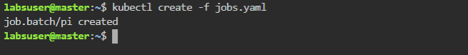

1. Verify the Pod that you’ve created and save the name using the below command:

1. Check the logs of the Pod and replace **Filename** with your Pod’s name:

**

The logs of the Pod are successfully listed as seen in the above screenshot.