**Assignment – 3**

Name: Sudheer Gajulapalli

Student Id: 700741485

GIT HUB URL:

Video: https://drive.google.com/file/d/10wmL2H9rI2QepZOZ2My7X_RQaZcSRJy6/view

1. Numpy:

a. Using NumPy create random vector of size 15 having only Integers in the range 1-20.

1. Reshape the array to 3 by 5

2. Print array shape.

3. Replace the max in each row by 0

Create a 2-dimensional array of size 4 x 3 (composed of 4-byte integer elements), also print the shape, type, and data type of the array.

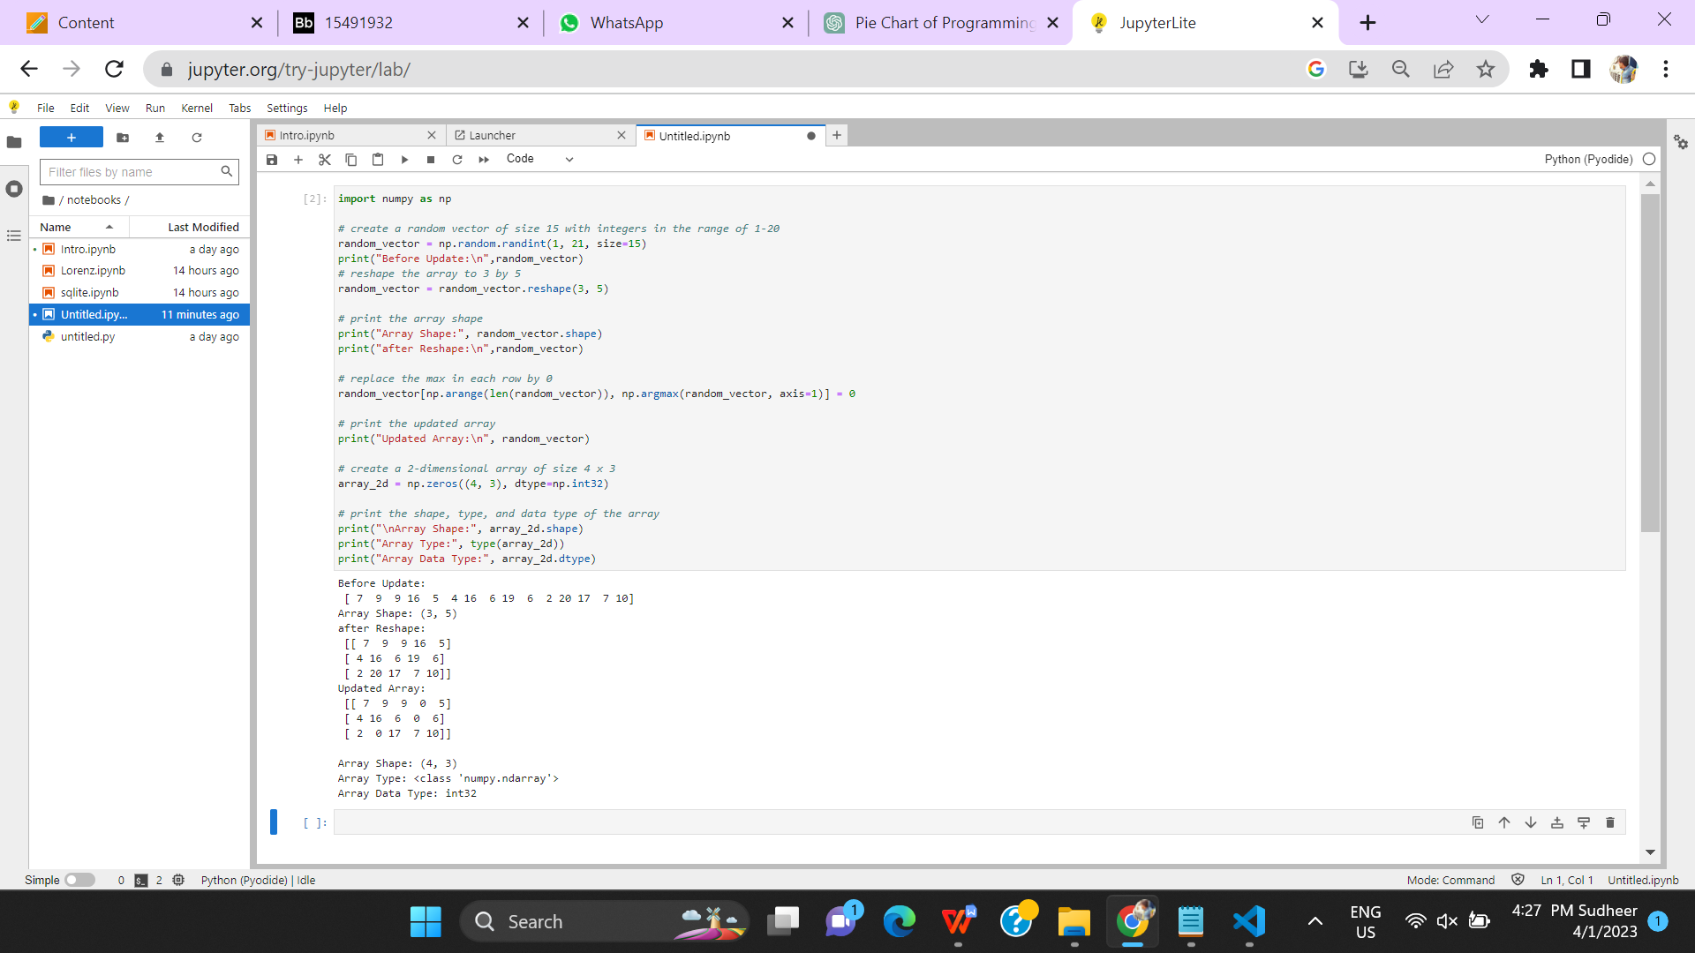

Explanation:

* The program starts by creating a random array of 15 integers in the range of 1-20 using the NumPy library's randint() function.
* The program then reshapes the 1-dimensional array into a 3x5 matrix using the reshape() method.
* The program finds the maximum value in each row of the matrix using the argmax() method and the axis=1 parameter. It then uses NumPy's advanced indexing to replace the maximum value in each row with 0.
* Finally, the program creates a 2-dimensional array of zeros with a shape of 4x3 and a data type of int32 using NumPy's zeros() method. It then prints the shape, type, and data type of the array.

b. Write a program to compute the eigenvalues and right eigenvectors of a given square array given below: [[ 3 -2] [ 1 0]]

Explanation:

* The program starts by defining a square 2x2 array using NumPy's array() method.
* The program then uses the eig() function from the NumPy linear algebra library to compute the eigenvalues and right eigenvectors of the array.
* The computed eigenvalues and eigenvectors are stored in the variables eigenvalues and eigenvectors, respectively.
* Finally, the program prints the computed eigenvalues and right eigenvectors using the print() function.

c. Compute the sum of the diagonal element of a given array. [[0 1 2] [3 4 5]]

Explanation:

* The program starts by defining a 2x3 array using NumPy's array() method.
* The program then uses the trace() method from the NumPy linear algebra library to compute the sum of the diagonal elements of the array.
* The computed sum of diagonal elements is stored in the variable sum_of_diagonal.
* Finally, the program prints the computed sum of diagonal elements using the print() function. The sum of diagonal elements is printed as a single integer.

d. Write a NumPy program to create a new shape to an array without changing its data.

Reshape 3x2:

[[1 2]

[3 4]

[5 6]]

Reshape 2x3:

[[1 2 3]

[4 5 6]]

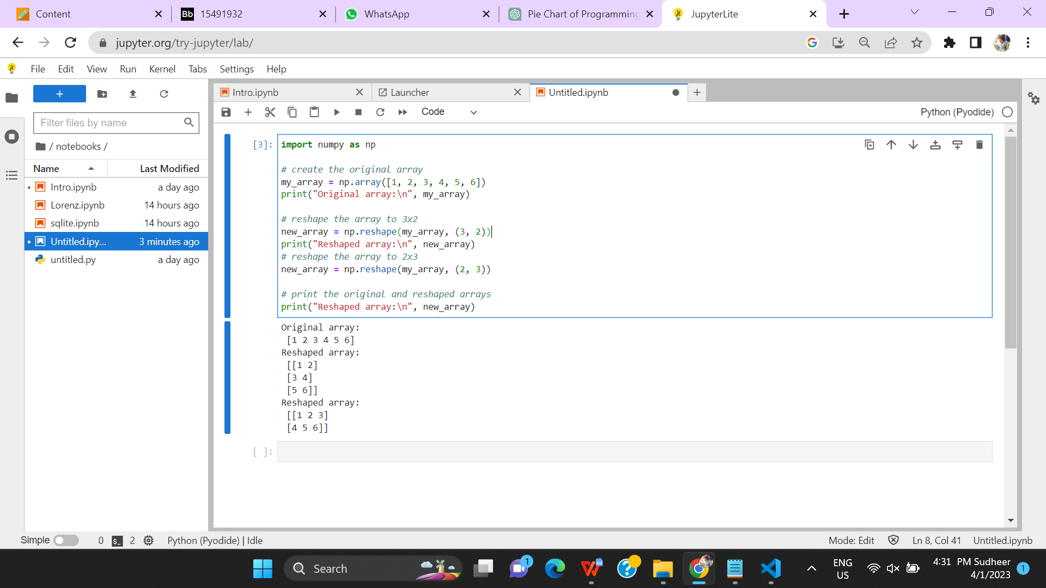

Explanation:

* The program starts by creating an original 3x2 array using NumPy's array() method.
* The program then uses NumPy's reshape() method to reshape the original array into a 2x3 array.
* The reshaped array is stored in the variable reshaped_array.
* Finally, the program uses the print() function to print both the original and reshaped arrays on separate lines. The arrays are printed using the newline character (\n) and the string representation of the arrays.

**2. Matplotlib**

1. Write a Python programming to create a below chart of the popularity of programming Languages.

2. Sample data:

Programming languages: Java, Python, PHP, JavaScript, C#, C++

Popularity: 22.2, 17.6, 8.8, 8, 7.7, 6.7

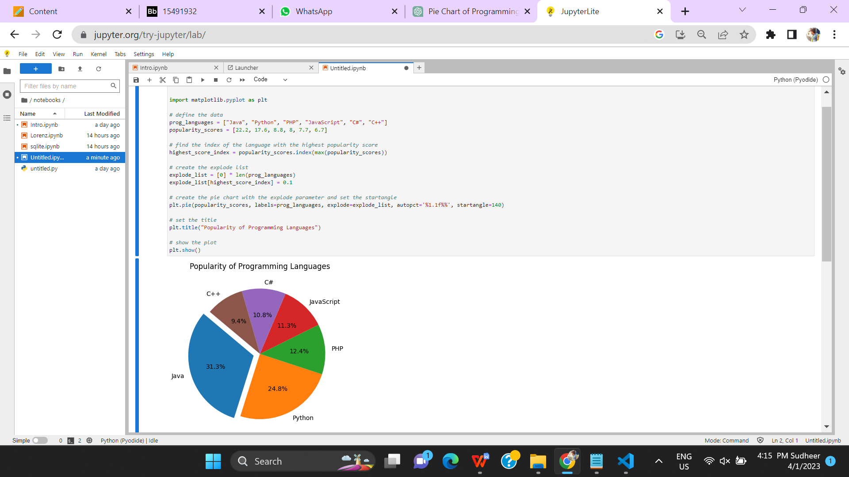

Explanation:

* The program defines two lists: languages and popularity.
* The program finds the index of the language with the highest popularity using the max() function and the index() method.
* The program creates a new list called explode to highlight the most popular language.
* The program creates a pie chart of the popularity data using the explode list and other parameters. The chart is titled "Popularity of Programming Languages" and is displayed using the show() function.