**JAVA**

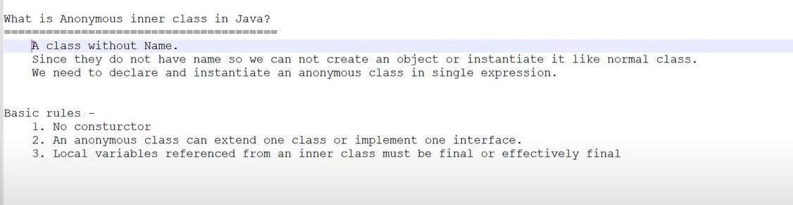

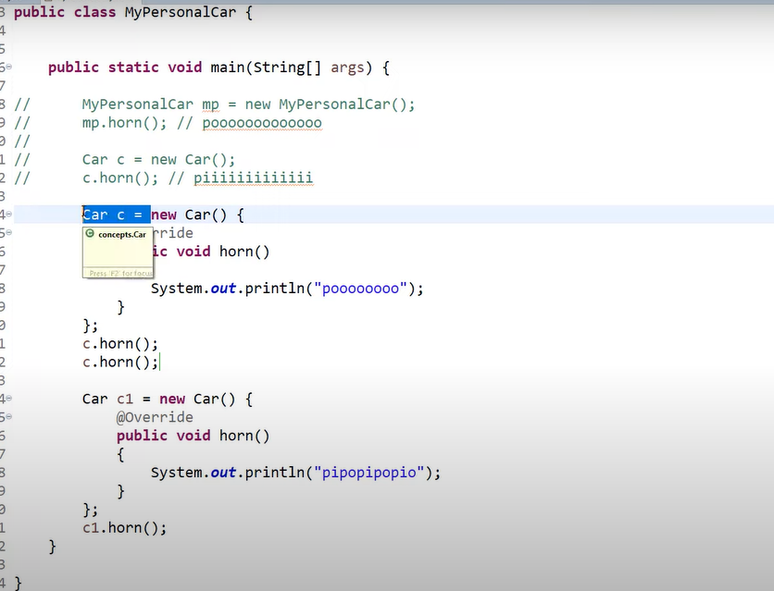

An interface which has single abstract method. Then that interface is called functional interface.

Note: **Functional interfaces** can have only one abstract class. It can have multiple default and static methods.

**Streams**

A Stream in Java can be defined as a **sequence of elements from a source**. The source of elements here refers to a [Collection](https://howtodoinjava.com/java/collections/into-to-java-collection/) or [Array](https://howtodoinjava.com/series/java-arrays/) that provides data to the Stream.

* Java streams are designed in such a way that most of the stream operations (called **intermediate operations**) return a Stream. This helps to create a chain of stream operations. This is called **stream pipe-lining**.
* Java streams also support the **aggregate or terminal operations** on the elements. The aggregate operations are operations that allow us to express common manipulations on stream elements quickly and clearly, for example, finding the max or min element, finding the first element matching giving criteria, and so on.
* Not that a ***stream maintains the same ordering* of the elements *as the ordering in the stream source***.

The Stream API is used to process collections of objects

A stream is a sequence of objects that supports various methods which can be pipelined to produce the desired result.

The features of Java stream are –

* A stream is not a data structure instead it takes input from the Collections, Arrays or I/O channels.
* Streams don’t change the original data structure, they only provide the result as per the pipelined methods.
* Each intermediate operation is lazily executed and returns a stream as a result, hence various intermediate operations can be pipelined. Terminal operations mark the end of the stream and return the result.

Collections -> represent group of element/objects as single entity and to store group of objects.

Streams -> Streams are used to process the data from collection.

**Stream Creation**

Streams can be created from different element sources

e.g.

1. collection or array with the help of stream()

2. of() methods

String[] arr = {"a","b","c","d"};

Stream<String> stream=Arrays.*stream*(arr);

stream.map(x-> x.startsWith("d")).forEach(x -> System.***out***.println("Starts with..............."+x));

**Stream.of()**

In the given example, we are creating a stream of a fixed number of integers.

Stream<Integer> stream = Stream.of(1,2,3,4,5,6,7,8,9);

stream.forEach(p -> System.out.println(p));

**Multi-threading With Streams**

Arrays.asList(arr).parallelStream().forEach(

x -> System.***out***.println("Parallel with..............."+x));

**Stream Operations**

1. They are divided into intermediate operations (return Stream<T>) and terminal operations (return a result of definite type). Intermediate operations allow chaining.
2. It's also worth noting that operations on streams don't change the source.

**long** count = list.stream().distinct().count();

So, the distinct() method represents an intermediate operation, which creates a new stream of unique elements of the previous stream. And the count() method is a terminal operation, which returns stream's size.

### ****Iterating****

### Stream API helps to substitute for, for-each, and while loops. It allows concentrating on operation's logic, but not on the iteration over the sequence of elements.

List<String> list =Arrays.*asList*("a","b","c","d");

**boolean** b= list.stream().anyMatch(x -> list.contains("a"));

System.***out***.println("Boolean b is...."+ b);

1. anyMatch
2. allMatch
3. noneMatch

### ****Filtering****

### The filter() method allows us to pick a stream of elements that satisfy a predicate.

ArrayList<String> list = **new** ArrayList<>();

list.add("One");

list.add("OneAndOnly");

list.add("Derek");

list.add("Change");

list.add("factory");

list.add("justBefore");

list.add("Italy");

list.add("Italy");

list.add("Thursday");

list.add("");

list.add("");

list.stream().filter(x -> x.contains("d")).collect(Collectors.*toList*())

.forEach(x -> System.***out***.println(x));

**Mapping**

List<String> uris = **new** **ArrayList**<>(); uris.add("C:\\My.txt"); Stream<Path> stream = uris.stream().map(uri -> Paths.get(uri));

List<Detail> details = **new** **ArrayList**<>(); details.add(**new** **Detail**()); Stream<String> stream = details.stream().flatMap(detail -> detail.getParts().stream());

**Matching**

**boolean** isValid = list.stream().anyMatch(element -> element.contains("h")); // true

**boolean** isValidOne = list.stream().allMatch(element -> element.contains("h")); // false

**boolean** isValidTwo = list.stream().noneMatch(element -> element.contains("h")); // false

**Reduction**

Stream API allows reducing a sequence of elements to some value according to a specified function with the help of the reduce() method of the type Stream. This method takes two parameters: first – start value, second – an accumulator function.

List<Integer> integers = Arrays.asList(1, 1, 1);

**Integer** reduced = integers.stream().reduce(23, (a, b) -> a + b);

Collections are used to store group of objects and streams are used to process the data.

Stream :

1. Filter
2. Map

Filter is used to filter the condition and store the result in the other collection.

**Stream**.

1. Collect
2. Count
3. Sorted
4. Distinct
5. Foreach
6. Min
7. Max

**Non-Terminal methods**

1. Filter()
2. Map()
3. FlatMap()
4. Distinct()
5. Limit()

Note: Non-Terminal methods returns stream of objects.

**Terminal Operations**

1. Collect()
2. Count()
3. Min()
4. Max()
5. Foreach()
6. toArray()

**FlatMap**

FlatMap return group of objects.

FlatMap return multiple values.

## Working with Streams

### 7.1 Creating Streams

* concat()
* empty()
* generate()
* iterate()
* of()

### 7.2 Intermediate Operations

* [filter()](https://howtodoinjava.com/java8/java-stream-filter-example/)
* [map()](https://howtodoinjava.com/java8/stream-map-example/)
* [flatMap()](https://howtodoinjava.com/java8/stream-flatmap-example/)
* [distinct()](https://howtodoinjava.com/java8/java-stream-distinct-examples/)
* [sorted()](https://howtodoinjava.com/java8/stream-sorted-method/)
* [peek()](https://howtodoinjava.com/java8/java-stream-peek-example/)
* [limit()](https://howtodoinjava.com/java8/java-stream-limit-method-example/)
* [skip()](https://howtodoinjava.com/java8/stream-skip-example/)

### 7.3. Terminal Operations

* [forEach()](https://howtodoinjava.com/java8/java-stream-foreach/)
* [forEachOrdered()](https://howtodoinjava.com/java8/java-stream-foreachordered/)
* [toArray()](https://howtodoinjava.com/java8/convert-stream-to-array/)
* reduce()
* collect()
* [min()](https://howtodoinjava.com/java8/java-stream-min/)
* [max()](https://howtodoinjava.com/java8/java-stream-max/)
* [count()](https://howtodoinjava.com/java8/stream-count-elements-example/)
* [anyMatch()](https://howtodoinjava.com/java8/stream-anymatch-example/)
* [allMatch()](https://howtodoinjava.com/java8/stream-allmatch-example/)
* [noneMatch()](https://howtodoinjava.com/java8/stream-nonematch-example/)
* [findFirst()](https://howtodoinjava.com/java8/stream-findfirst-findany/)
* [findAny()](https://howtodoinjava.com/java8/stream-findfirst-findany/)

Stream<Integer> randomNumbers = Stream.generate(() -> (**new** Random()).nextInt(100));

randomNumbers.limit(20).forEach(System.out::println);