Visualization Tool for Electric Vehicle Charge and Range Analysis

1. Introduction:
The Visualization Tool for Electric Vehicle Charge and Range Analysis is a data analytics web application developed to analyze and visualize electric vehicle performance and charging infrastructure data.
The project integrates:
- Data Visualization using Tableau
- Web Integration using Flask
- Dashboard & Storyboard publishing
- Responsive Web Deployment
The goal of this project is to analyze EV data and present insights in an interactive and user-friendly manner.

2. Project Objectives:
The objectives of this project are:
- To connect Tableau with multiple datasets
- To perform data cleaning and preparation
- To create interactive dashboards
- To develop storyboards for business storytelling
- To embed Tableau visualizations into a web application
- To deploy the web application online
3. DataSets:
The project contains four datasets:
• EV India
• Electric Vehicle Charging Station List
• ElectricCarData_Clean
• Cheapestelectriccars-EVDatabase

4. Data Preparation:
Data preparation was performed using Tableau Public.
Steps involved:
Import CSV files into Tableau.
Handle missing values.
Remove unnecessary columns.
Convert data types (String → Number where required).
Remove suffix values for numerical analysis.
Standardize column names.
Ensure proper formatting for visualization.
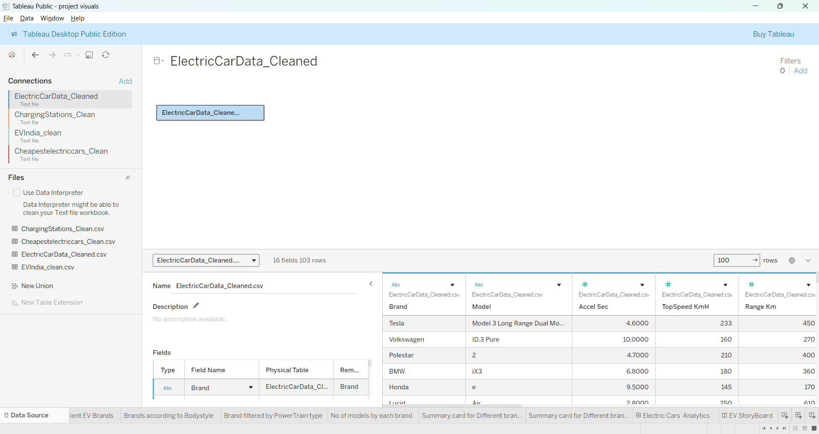
5. Data Visualization
Various visualizations were created including:
- Bar Charts
- Line Charts
- Scatter Plots
- Maps (Charging Stations by Region)
- Comparative Analysis Charts
6. Dashboard Development:
An interactive dashboard was created to:
- Compare EV models
- Analyze performance metrics
- Visualize charging infrastructure
- Identify trends in range and pricing
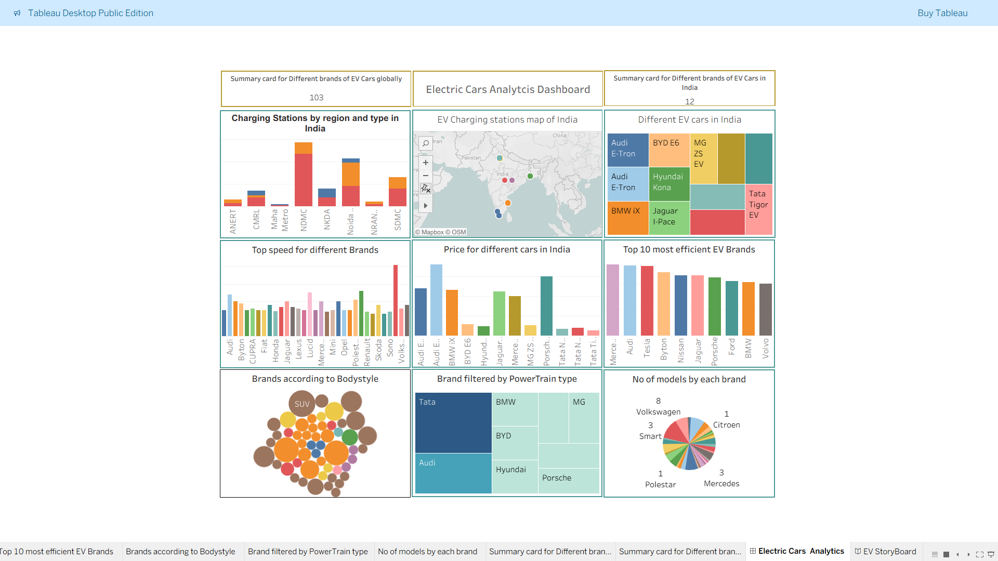

7. Storyboard Development
A storyboard was developed to present:
- Problem statement
- Data insights
- Comparative analysis
- Infrastructure overview
- Business implications
The storyboard provides structured storytelling using visual insights.
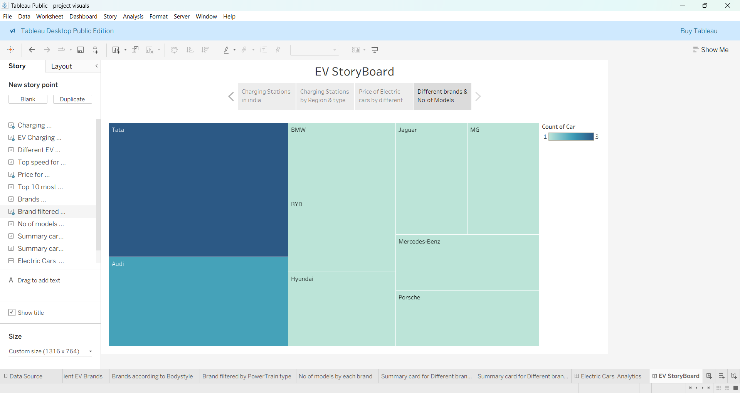

8. Web Application Development
A Flask-based web application was developed to embed Tableau visualizations.
Technologies Used:
- Python (Flask)
- HTML
- CSS
- Git & GitHub

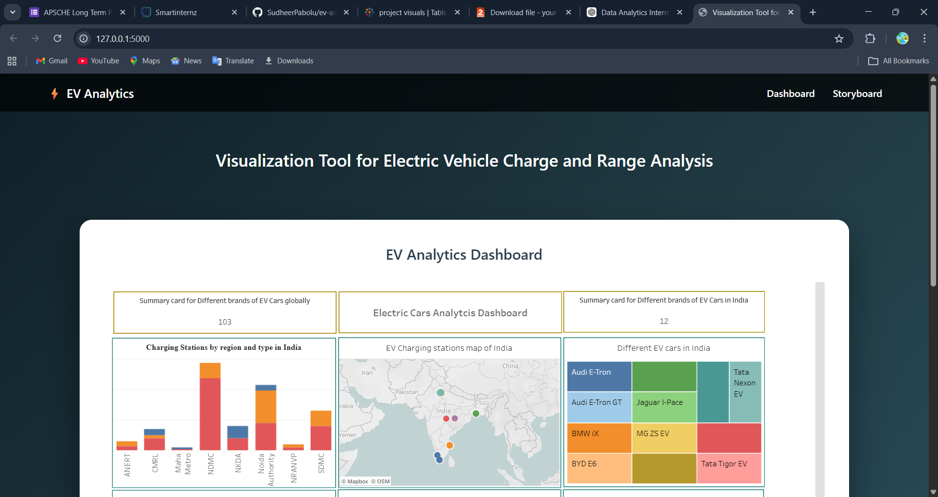

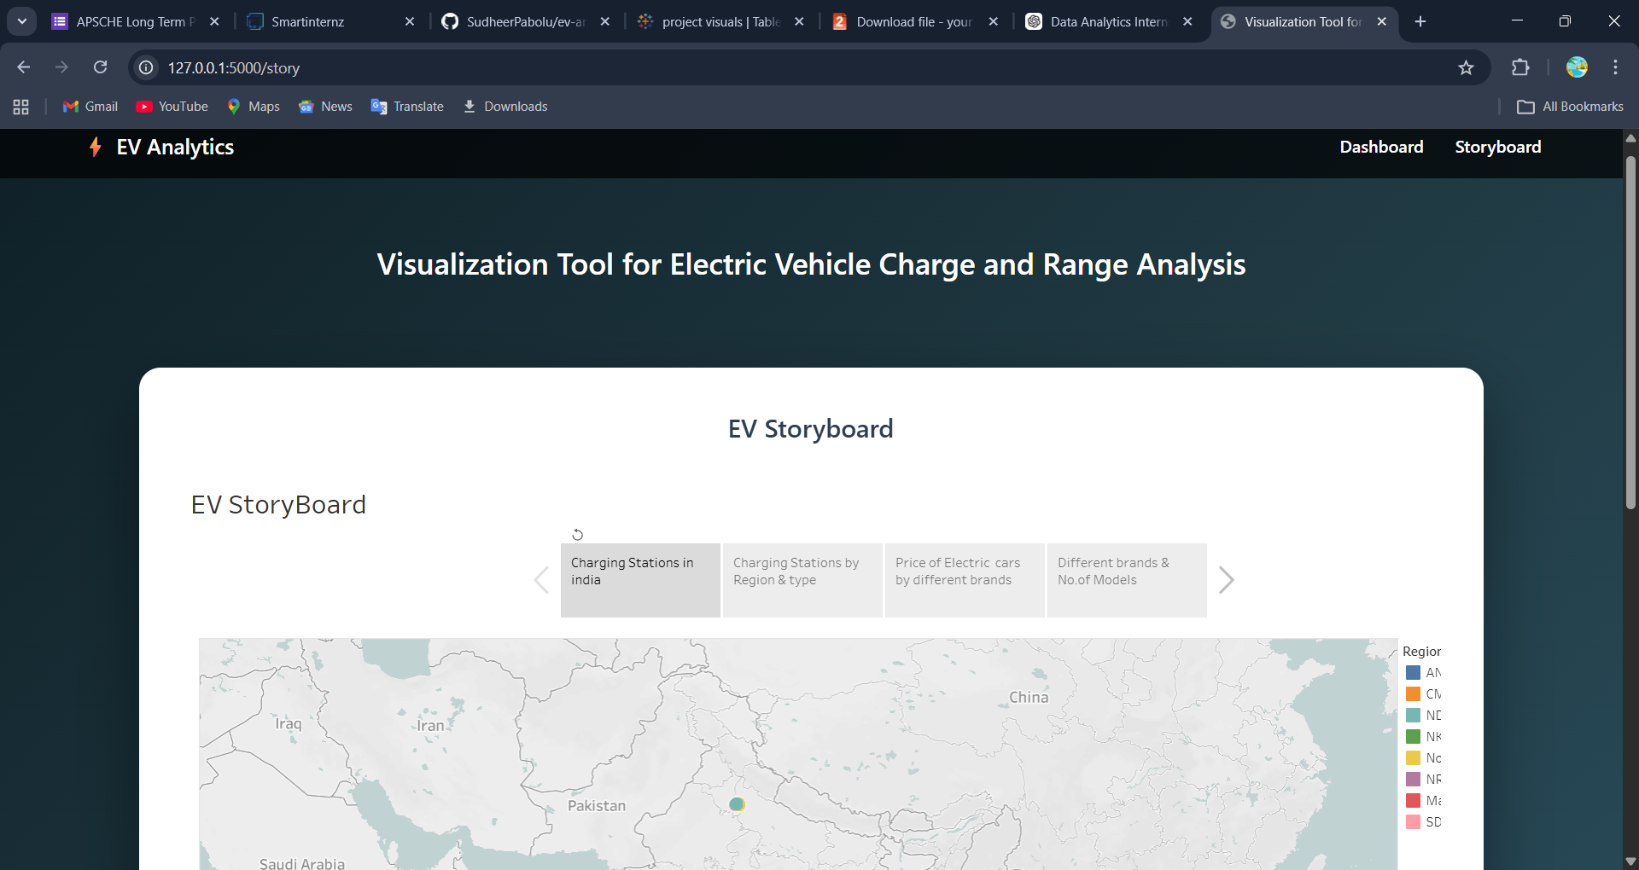

9.Conclusion
The Visualization Tool for Electric Vehicle Charge and Range Analysis demonstrates effective use of:
- Data Analytics
- Tableau Visualization
- Web Integration
- Full Deployment Pipeline
This project provides valuable insights into EV market trends and charging infrastructure development.

