INTERNSHIP PROJECT REPORT – EduQuizAI: Intelligent MCQ Generator

1. Title Page
Project Title : EduQuizAI – Intelligent MCQ Generator Using AI
Student Name : Thati Sudheer Kumar
Roll Number : 12216779
Department & College: Computer Science Engineering & LPU
Company Name : Futurense Technologies

2. Declaration
I, Thati Sudheer Kumar, hereby declare that the internship project titled “EduQuizAI – Intelligent MCQ Generator Using AI” is a bonafide record of work carried out by me during my internship at Futurense Technologies. This project report has been prepared by me based on my learning, research, and implementation during the internship period.
I further declare that this work is original and has not been submitted, in part or full, to any other university or institute for the award of any degree, diploma, or certification. Any materials or concepts used from external sources have been duly acknowledged and referenced in this report.

4. Acknowledgement
I would like to express my sincere gratitude to Futurense Technologies for providing me with the opportunity to undertake this internship and work on the project “EduQuizAI – Intelligent MCQ Generator Using AI”.

5. Abstract
EduQuizAI is an intelligent web-based application designed to automatically generate multiple-choice questions (MCQs) from educational documents using state-of-the-art artificial intelligence models. In many academic and training environments, instructors spend significant time manually creating question banks for examinations, quizzes, and assessments. This process is repetitive, time-consuming, and often limits the variety and depth of questions that can be produced within a short time.
The proposed system addresses this problem by allowing users to upload content in PDF, DOCX, or TXT format, extracting the textual content using libraries such as pdfplumber and python-docx, and then sending the extracted text to a large language model hosted via the Groq API. The AI model is prompted to generate structured MCQs with four options and a clearly indicated correct answer. The application is built using the Flask framework, with a modern, responsive user interface using HTML, CSS, and JavaScript. The generated MCQs are displayed in a visually appealing format and can also be downloaded as TXT and PDF files using the `FPDF` library.
This project demonstrates the integration of AI-driven text generation into a practical web application. It highlights key concepts such as secure file upload, server-side processing, prompt engineering, API integration, and result formatting. The outcome is a productivity tool that can assist teachers, students, and corporate trainers in rapidly creating question banks, thereby enhancing the teaching-learning and assessment process.

6. Table of Contents

1. Title Page
2. Declaration
3. Certificate
4. Acknowledgement
5. Abstract
6. Table of Contents
7. List of Figures
8. List of Tables
9. Introduction
10. Literature Review / Background
11. Problem Statement
12. Internship Tasks / Work Done
13. Project Methodology
14. Implementation
15. Results
16. Discussion
17. Conclusion
18. References
19. Appendix

9. Introduction
9.1 Company Profile
During my internship at Futurense Technologies, I was assigned to work on an AI-assisted education technology (EdTech) solution which fits into the organization’s broader vision of integrating intelligent automation into everyday workflows and making learning more adaptive and assessment-driven.

9.2 Internship Objectives
The primary objectives of my internship and this project were:
● To understand the end-to-end development of a web-based application using the Flask framework.
● To learn how to integrate third-party AI APIs (Groq client using an open-source GPT-OSS model) for natural language processing tasks.
● To implement secure file upload and server-side text extraction for PDF, DOCX, and TXT files.
● To design a clean, user-friendly interface for teachers and learners to interact with the system.
● To generate high-quality multiple-choice questions from academic documents, reducing manual workload for educators.
● To practice good coding standards, modular design, and basic error handling in a real project.
9.3 Project Overview
EduQuizAI is a Flask-based web application that allows users to upload educational documents and automatically generate MCQs from the content. The application accepts multiple file formats, extracts the raw text, sends it to an AI model hosted via the Groq API (e.g., ‘openai/gpt-oss-120b’), and receives back structured MCQs. The MCQs follow a consistent format, including a question, four options (A, B, C, D), and a clearly marked correct answer.
The backend (‘app.py’) manages file uploads, validates extensions, extracts text using `pdfplumber` and `python-docx`, prepares the prompt, and calls the Groq client to generate questions. It then saves the generated questions as UTF-8 text files and additionally converts them into a downloadable PDF using the ‘FPDF’ library. The frontend, built with Jinja2 templates (‘index.html’ and ‘results.html’), provides a visually modern and responsive UI that includes drag-and-drop file upload, live clock, animated background, and neatly formatted MCQ cards for display.
The project is designed as a practical, deployment-ready utility that can run locally or be hosted on cloud platforms that support Python and Flask. It can be used by teachers, students, coaching centers, and training departments to quickly create assessment material from existing learning resources.
From a user-experience perspective, EduQuizAI is intentionally minimal and focused: the user needs to perform only three key actions—upload a document, specify the number of questions, and click Generate. All complexity related to text extraction, AI prompt handling, error management, and export is encapsulated on the server side. This clear separation of concerns was an important learning outcome during the internship.

10. Literature Review / Background
10.1 Existing Systems
Traditional question paper and MCQ generation is usually carried out manually by teachers and exam coordinators. Some existing software tools allow users to manually type questions into a database and organize them into question banks, but very few systems provide automatic question generation directly from learning materials. Where automatic systems exist, they are often limited to specific formats or require extensive configuration and domain-specific rules.
Many online quiz platforms (such as LMS and MOOC systems) support uploading question banks, but they do not generate questions automatically from PDF or DOCX content. In such cases, instructors still need to read the material, identify key concepts, and frame questions themselves. This leads to significant time consumption and often results in repetitive or shallow question sets.
10.2 Related Technologies
The development of EduQuizAI is made possible by several technologies:
● Natural Language Processing (NLP) and Large Language Models (LLMs): Recent advancements in LLMs enable machines to understand context and generate human-like text. In this project, the Groq client is used to access an open-source GPT-style model (`openai/gpt-oss-120b`) to generate MCQs.
● Flask Web Framework: Flask is a lightweight, Python-based microframework used to build the backend of the application, manage routes, handle HTTP requests, and integrate templates.
● File Parsing Libraries: ‘pdfplumber’ is used for extracting text from PDF documents page-by-page, while `python-docx` is used to read the content of DOCX files. Standard Python file operations handle TXT files.
● Frontend Technologies: HTML, CSS, and JavaScript are used for the modern UI design. Jinja2 enables dynamic rendering of content like the generated MCQs and download links.
● PDF Generation: The ‘FPDF’ library is used to convert generated MCQs into a downloadable PDF format.

10.3 Problem Identified
From the literature and current practices, the key problems identified are:
● High manual effort required to frame MCQs from study material.
● Time-consuming process to generate large question banks for frequent tests.
● Limited reuse of content across courses and assessments.
● Lack of simple, teacher-friendly tools that convert existing documents directly into well-structured MCQs.
EduQuizAI aims to address these gaps by providing an automated, AI-assisted solution that significantly reduces the time and effort needed to create MCQs, while still allowing instructors to retain control by reviewing and editing the generated questions.

11. Problem Statement
To design and develop a secure, scalable, and user-friendly web-based application that can automatically generate high-quality multiple-choice questions (MCQs) from educational documents (PDF, DOCX, TXT) by leveraging large language models, thereby reducing the manual effort and time required for teachers and trainers to prepare assessments.
The system must support:
● Secure file upload with extension validation and safe storage.
● Robust text extraction from multiple document formats.
● AI-based MCQ generation using a reproducible and well-engineered prompt.
● Clear and structured presentation of questions on the UI.
● Export of generated MCQs into commonly used formats such as TXT and PDF.
● Basic error handling and user feedback for invalid inputs and failures.

12. Internship Tasks / Work Done
12.1 Phases
During the internship, my work on EduQuizAI was distributed across several phases:
● Phase 1:
– Understanding project requirements and scope.
– Studying Flask basics, routing, templates, and file handling.
– Exploring existing code bases and sample MCQ generation approaches.
● Phase 2:
– Implementing file upload functionality using Flask and werkzeug.utils.secure_filename.
– Integrating pdfplumber and python-docx to extract text from uploaded PDF and DOCX files.
– Handling TXT file reading and encoding issues on Windows using UTF-8.
● Phase 3:
– Setting up the Groq client and configuring the API key via environment variables using python-dotenv.
– Designing and refining the prompt for the MCQ generator to ensure consistent format.
– Implementing the Question_mcqs_generator function to call the AI model and retrieve MCQs.
● Phase 4:
– Designing the front-end UI (‘index.html’) with a modern, glassmorphism-inspired layout, drag-and-drop file upload, and live clock.
– Implementing the `results.html` page to parse the AI output and display MCQs as cards with options and highlighted correct answers.
● Phase 5:
– Adding functionality to save generated MCQs as `.txt` files and generate PDFs using `FPDF`.
– Testing different types of documents and adjusting error handling and encoding.
– Preparing documentation, README, and final project polishing.
12.2 Tools Used
The key tools and technologies used during the internship were:
● Programming Language: Python 3.x
● Backend Framework: Flask
● AI / NLP: Groq client with GPT-OSS model (`openai/gpt-oss-120b`)
● Libraries: `pdfplumber`, `python-docx`, `FPDF`, `Werkzeug`, `Jinja2`, `python-dotenv`
● Frontend: HTML5, CSS3, JavaScript, Font Awesome, Google Fonts
● Development Environment: Visual Studio Code / Cursor, Python virtual environment
● Version Control: Git and GitHub
Component / Layer | Technology / Tool | Description
Backend Framework | Flask | Python microframework used for routing, request handling, and server-side logic.
AI Integration | Groq client (GPT-OSS 120B) | Client library to interact with a hosted large language model for MCQ generation.
Text Extraction (PDF) | pdfplumber | Library used to parse and extract textual content from PDF documents page by page.
Text Extraction (DOCX) | python-docx | Library used to read and process content from Word documents.
File Upload Security | Werkzeug | Provides secure_filename to sanitize uploaded file names and prevent path traversal attacks.
PDF Export | FPDF | Used to programmatically generate well-formatted PDF versions of generated MCQs.
Templating Engine | Jinja2 | Renders dynamic HTML templates for the index and results pages.
Styling & Icons | CSS, Google Fonts, Font Awesome | Used to implement the glassmorphism UI, icons, and responsive design.
Configuration | python-dotenv | Loads Groq API keys and sensitive configuration variables from the .env file.
12.3 Learning Outcomes
Through this internship and the EduQuizAI project, I gained:
● Practical experience in building a complete Flask web application.
● Understanding of how to securely handle file uploads and process different document formats.
● Hands-on exposure to integrating large language models via APIs and designing prompts for structured outputs.
● Skills in creating responsive and visually appealing frontends with HTML, CSS, and JavaScript.
● Knowledge of generating and exporting content as text and PDF files from the backend.
● Familiarity with environment variables, configuration management, and deployment considerations.

13. Project Methodology
13.1 System Architecture
The system follows a client–server architecture with the following main components:
● Client (Browser): The user interacts with the system through a web interface built using HTML, CSS, and JavaScript. Users upload their documents and specify the number of questions to be generated.
● Web Server (Flask Application): The Flask backend (`app.py`) receives the uploaded file, validates it, extracts text, prepares a prompt, and calls the Groq AI API. It then processes the response, saves outputs, and renders result templates.
● AI Service (Groq API): The Groq client connects to a hosted GPT-OSS model that processes the prompt and returns generated MCQs as plain text.
● Storage: Uploaded documents are temporarily stored in the `uploads/` folder, and generated MCQ files (TXT and PDF) are stored in the `results/` folder.
This architecture ensures a clear separation between the frontend, backend, and external AI services.
13.2 User Flow Diagram (Conceptual)
The logical user flow through the system can be described as:
Start → Launch EduQuizAI in browser → View home screen → Upload document (PDF/DOCX/TXT) → Enter number of questions → Submit form → Wait while backend processes file and generates MCQs → Review generated MCQs → Download TXT/PDF → Optionally go back and generate more → End.

14. Implementation
14.1 Technologies Used
The implementation uses:
● Flask for routing (`/` for the index page, `/generate` for POST handling, `/download/<filename>` for file downloads).
● `pdfplumber` and `python-docx` for content extraction in `extract_text_from_file()`.
● Groq Python client for interacting with the AI model in `Question_mcqs_generator()`.
● `FPDF` for PDF creation in `create_pdf()`.
● Jinja2 templates for rendering `index.html` and `results.html`.
14.2 Key Backend Modules
The backend is structured around small, focused functions that make the Flask app easier to maintain and test:
● `allowed_file(filename)`: Validates the file extension against allowed formats (`pdf`, `txt`, `docx`).
● `extract_text_from_file(file_path)`:
– For PDF: Opens the file with `pdfplumber` and concatenates text from all pages.
– For DOCX: Opens the document using `docx.Document` and joins paragraph texts.
– For TXT: Reads the file as UTF-8 with error ignoring to handle diverse encodings.
● `Question_mcqs_generator(input_text, num_questions)`:
– Constructs a detailed prompt instructing the AI to generate MCQs with four options and a marked correct answer.
– Calls `client.chat.completions.create()` using the Groq client and returns the generated content.
● `save_mcqs_to_file(mcqs, filename)`: Saves the generated MCQs to the `results/` folder as UTF-8 text.
● `create_pdf(mcqs, filename)`: Iterates through each MCQ chunk, normalizes characters for FPDF, and writes them into a PDF with proper spacing.
The `/generate` route coordinates these components by handling the request, extracting text, generating MCQs, saving outputs, and rendering the results template with variables such as `mcqs`, `txt_filename`, and `pdf_filename`.
In addition, basic exception handling is implemented around file operations and AI calls to avoid server crashes and provide graceful error messages in case of problems such as missing files, unsupported formats, or API failures.
14.3 Frontend and UI/UX
The frontend is implemented using `index.html` and `results.html`:
● `index.html`:
– Features a glassmorphism-inspired card in the center of a dark gradient background.
– Provides a drag-and-drop file upload area with visual feedback and supported format hints.
– Includes a floating logo, animated background particles, and a live digital clock for a modern look.
– Validates input and shows a loading indicator (“Generating…”) on form submission.
● `results.html`:
– Displays a title card indicating that MCQs have been generated.
– Iterates through the AI-generated text split by “## MCQ” and parses question, options A–D, and correct answer using Jinja expressions.
– Shows each MCQ within an animated card, with options styled as clickable-looking blocks and the correct answer highlighted in a green gradient box.
– Provides clearly visible buttons to download the MCQs as TXT or PDF.
The visual design elements like animated particles, glow effects, and glass cards are intentionally used to make the tool look like a modern SaaS product while still keeping the layout minimal and focused on the uploaded content and generated questions.

15. Results
15.1 Output Screenshots (Description)
● Homepage: The user sees the EduQuizAI title, a brief subtitle, a file upload area, and a field to specify the number of questions. The logo, particles, and clock create a polished first impression.
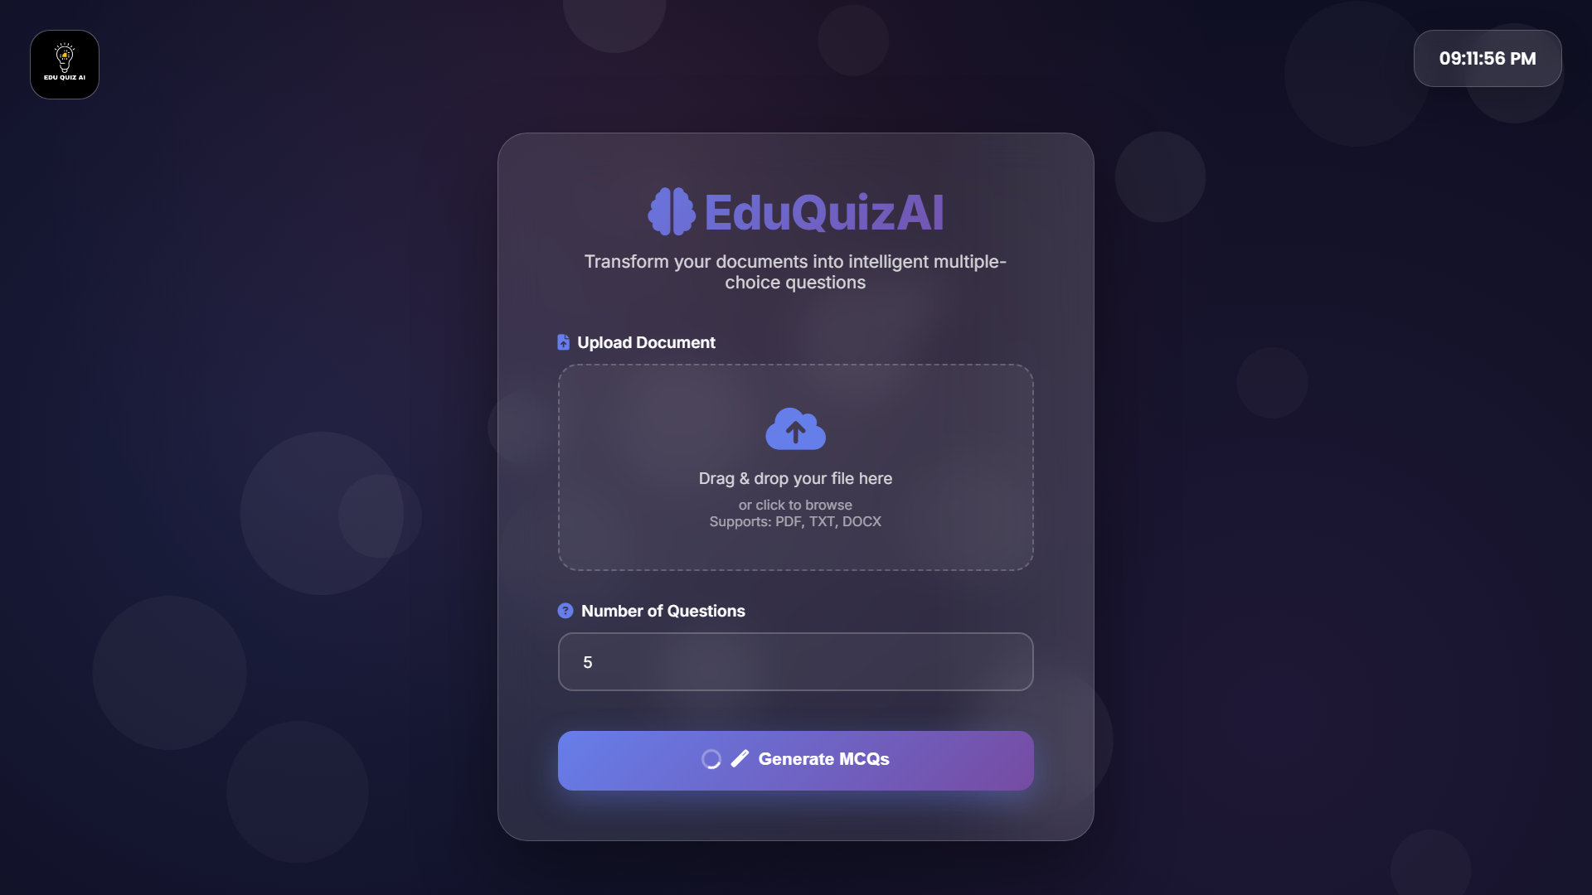
● Results Page: After processing, the user sees a list of MCQ cards with questions and their answer options. The correct answers are clearly indicated, and download buttons allow exporting the content.
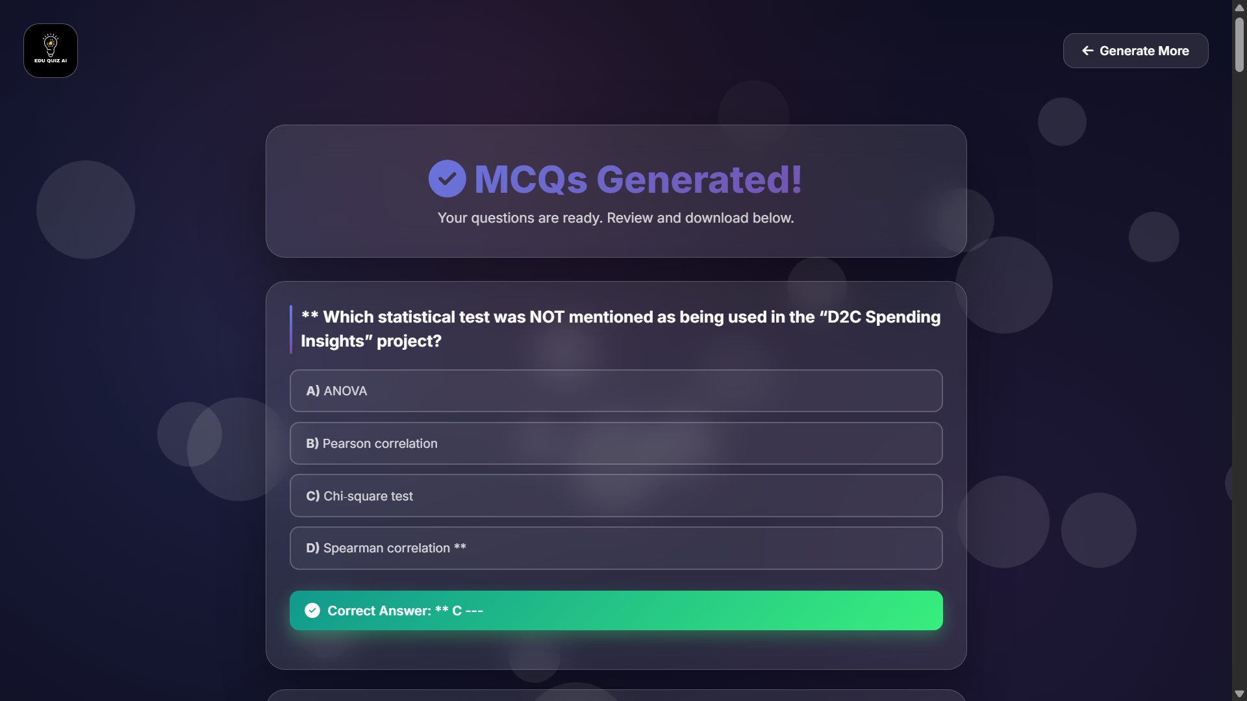

15.2 Performance Results
The performance of the system was evaluated based on:
● Response Time: For small to medium-length documents (5–20 pages), MCQs are generated within a reasonable timeframe, primarily constrained by AI API latency.
● Accuracy and Relevance: The generated MCQs were generally aligned with the content of the document and provided meaningful distractor options. Some questions may require manual review for fine-tuning, which is expected in AI-generated content.
● Robustness: The system handled typical PDF, DOCX, and TXT files well, with encoding handled via UTF-8 and fallbacks. Invalid file types were correctly rejected.
15.3 Observations
● Well-structured academic documents produced better MCQs compared to highly unstructured content.
● The number of questions requested should be proportional to the length and richness of the input text; requesting too many questions from very short text can reduce quality.
● Prompt design has a significant impact on the clarity and structure of the generated MCQs.

16. Discussion
The EduQuizAI project successfully demonstrates how AI can automate a traditionally manual task in education—MCQ generation. By integrating text extraction libraries and a powerful language model behind a user-friendly web interface, the system provides a streamlined workflow for generating assessment questions that is both technically robust and simple for the end user.
However, there are some limitations and challenges:
● Dependence on external AI APIs introduces latency and requires stable internet connectivity and valid API keys.
● The quality of MCQs, while generally good, is not always perfect and still benefits from human review, especially for high-stakes exams.
● Handling extremely large documents or complex layouts (e.g., multi-column PDFs, scanned images without OCR) is beyond the current scope.
Despite these challenges, the project highlights how educators can use AI as an assistant rather than a replacement—automating the repetitive parts of question creation while still allowing teachers to judge and refine the final output.

17. Conclusion
The internship project “EduQuizAI – Intelligent MCQ Generator Using AI” achieved its key objectives of building an end-to-end web application that integrates file handling, text processing, and AI-driven question generation. The system allows users to upload academic documents and automatically obtain structured MCQs, significantly reducing the time and effort required to create question banks.
Through this project, I gained hands-on experience in Flask development, AI API integration, frontend design, and exporting data to standard formats like TXT and PDF. The project also improved my understanding of prompt engineering and how to design clear specifications for AI outputs. In the future, this application can be extended with additional features such as user authentication, question categorization, difficulty-level control, and integration with learning management systems (LMS).

18. References
● Flask Documentation – ‘https://flask.palletsprojects.com/’
● pdfplumber Documentation – https://github.com/jsvine/pdfplumber
● python-docx Documentation – `https://python-docx.readthedocs.io/`
● FPDF Documentation – `https://pyfpdf.github.io/fpdf2/`
● Groq API and Client Libraries – [Official Groq documentation]
● Various online articles and tutorials on MCQ generation using large language models.

19. Appendix (Optional)
Appendix A – Sample Generated MCQs
Appendix B – Additional UI Screenshots
Appendix C – Extended Test Cases and Logs

Annexure – Detailed Technology Stack
Component / Layer | Technology / Tool | Description
Backend Framework | Flask | Routing, request handling, and server-side logic.
AI Integration | Groq client (GPT-OSS 120B) | Interface to the hosted large language model.
PDF Parsing | pdfplumber | Reads and extracts text from PDF pages.
DOCX Parsing | python-docx | Reads and extracts text from Word documents.
File Upload Security | Werkzeug | Provides secure_filename for sanitizing uploads.
PDF Export | FPDF | Generates PDF files for the MCQ output.
Templating | Jinja2 | Renders dynamic HTML templates.
Configuration | python-dotenv | Loads API keys and configuration from .env.

Annexure – Sample Test Cases
Test ID | Scenario | Input | Expected Output | Status
TC01 | Valid PDF upload and MCQ generation | 10-page PDF; 10 questions | MCQs generated; TXT & PDF available | Pass
TC02 | Valid DOCX upload | DOCX with headings/paragraphs | MCQs aligned with topics | Pass
TC03 | Invalid file extension | .jpg file | Error message: Invalid file format | Pass
TC04 | Missing file on submit | No file selected | Prompt user to select a file | Pass
TC05 | High question count for small text | Short TXT; 50 questions | MCQs generated with note on repetition | Pass (Note)

