AI Agent Configuration and Evaluation
with Azure AI Foundry
  - Technical Lab Report | Microsoft Azure | GPT-4.1

1. Experiment overview
This experiment involved configuring and testing three domain-specific AI assistants in Microsoft Azure AI Foundry. Each assistant used the same GPT-4.1 model deployment but received different instructions. The experiment examined how agent instructions shape responses across customer support, healthcare information, and financial education.

2. Objective
The objective is to deploy a foundation model and configure three AI assistants, test them in the Agents Playground, and evaluate response relevance.

3. Environment and tools
Platform | Microsoft Azure AI Foundry
Foundation model | GPT-4.1
Deployment type | Global Standard (consumption-based)
Testing interface | Azure AI Foundry Agents Playground
Agents | Customer Service Chatbot; Healthcare Information Assistant; Financial Advisor

4. Experimental procedure

4.1 Create the cloud workspace

What I did: Created an Azure AI Foundry resource and project within an Azure subscription. Configured the resource settings, including region, networking, and identity, then opened the project in the Foundry portal.
Why: Because we need a central workspace for managing the model deployments and agent configurations.

4.2 Deploy the foundation model
What I did: Selected GPT-4.1 from the model catalog and deployed it using the Global Standard deployment type.
Why: Because the main idea here is using a same foundational model for three different agents and check how model processes prompts and generates responses based on the instructions. Reusing one deployment across agents keeps the foundation model consistent for comparison.

4.3 Configure three agents
What I did: Created three agents in the Agents area and associated each with the GPT-4.1 deployment. Entered a distinct instruction set for each role.
Why: Role-specific instructions establish expected tone, subject-matter scope, and boundaries without requiring separate foundation models.

4.4 Test in the Agents Playground
What I did: Opened each agent in the Playground and gave prompts according to the role specific tasks.
Why: Interactive testing checks whether the configured instructions influence real responses and reveals limitations before practical deployment because we are enhancing the same based model with three different and instructions.

4.5 Compare agent behaviors

What I did: Reviewed responses for relevance, clarity, response speed, conversational context, uncertainty handling, and alignment with each agent’s instructions.
Why: Using consistent evaluation criteria supports a meaningful comparison of the three configurations.

5. Agent configurations

Customer Service Chatbot
Purpose: Customer enquiries and clear next steps
Agent instructions: You are a friendly and empathetic customer service assistant. Always respond politely, provide clear next steps, and make the customer feel supported.
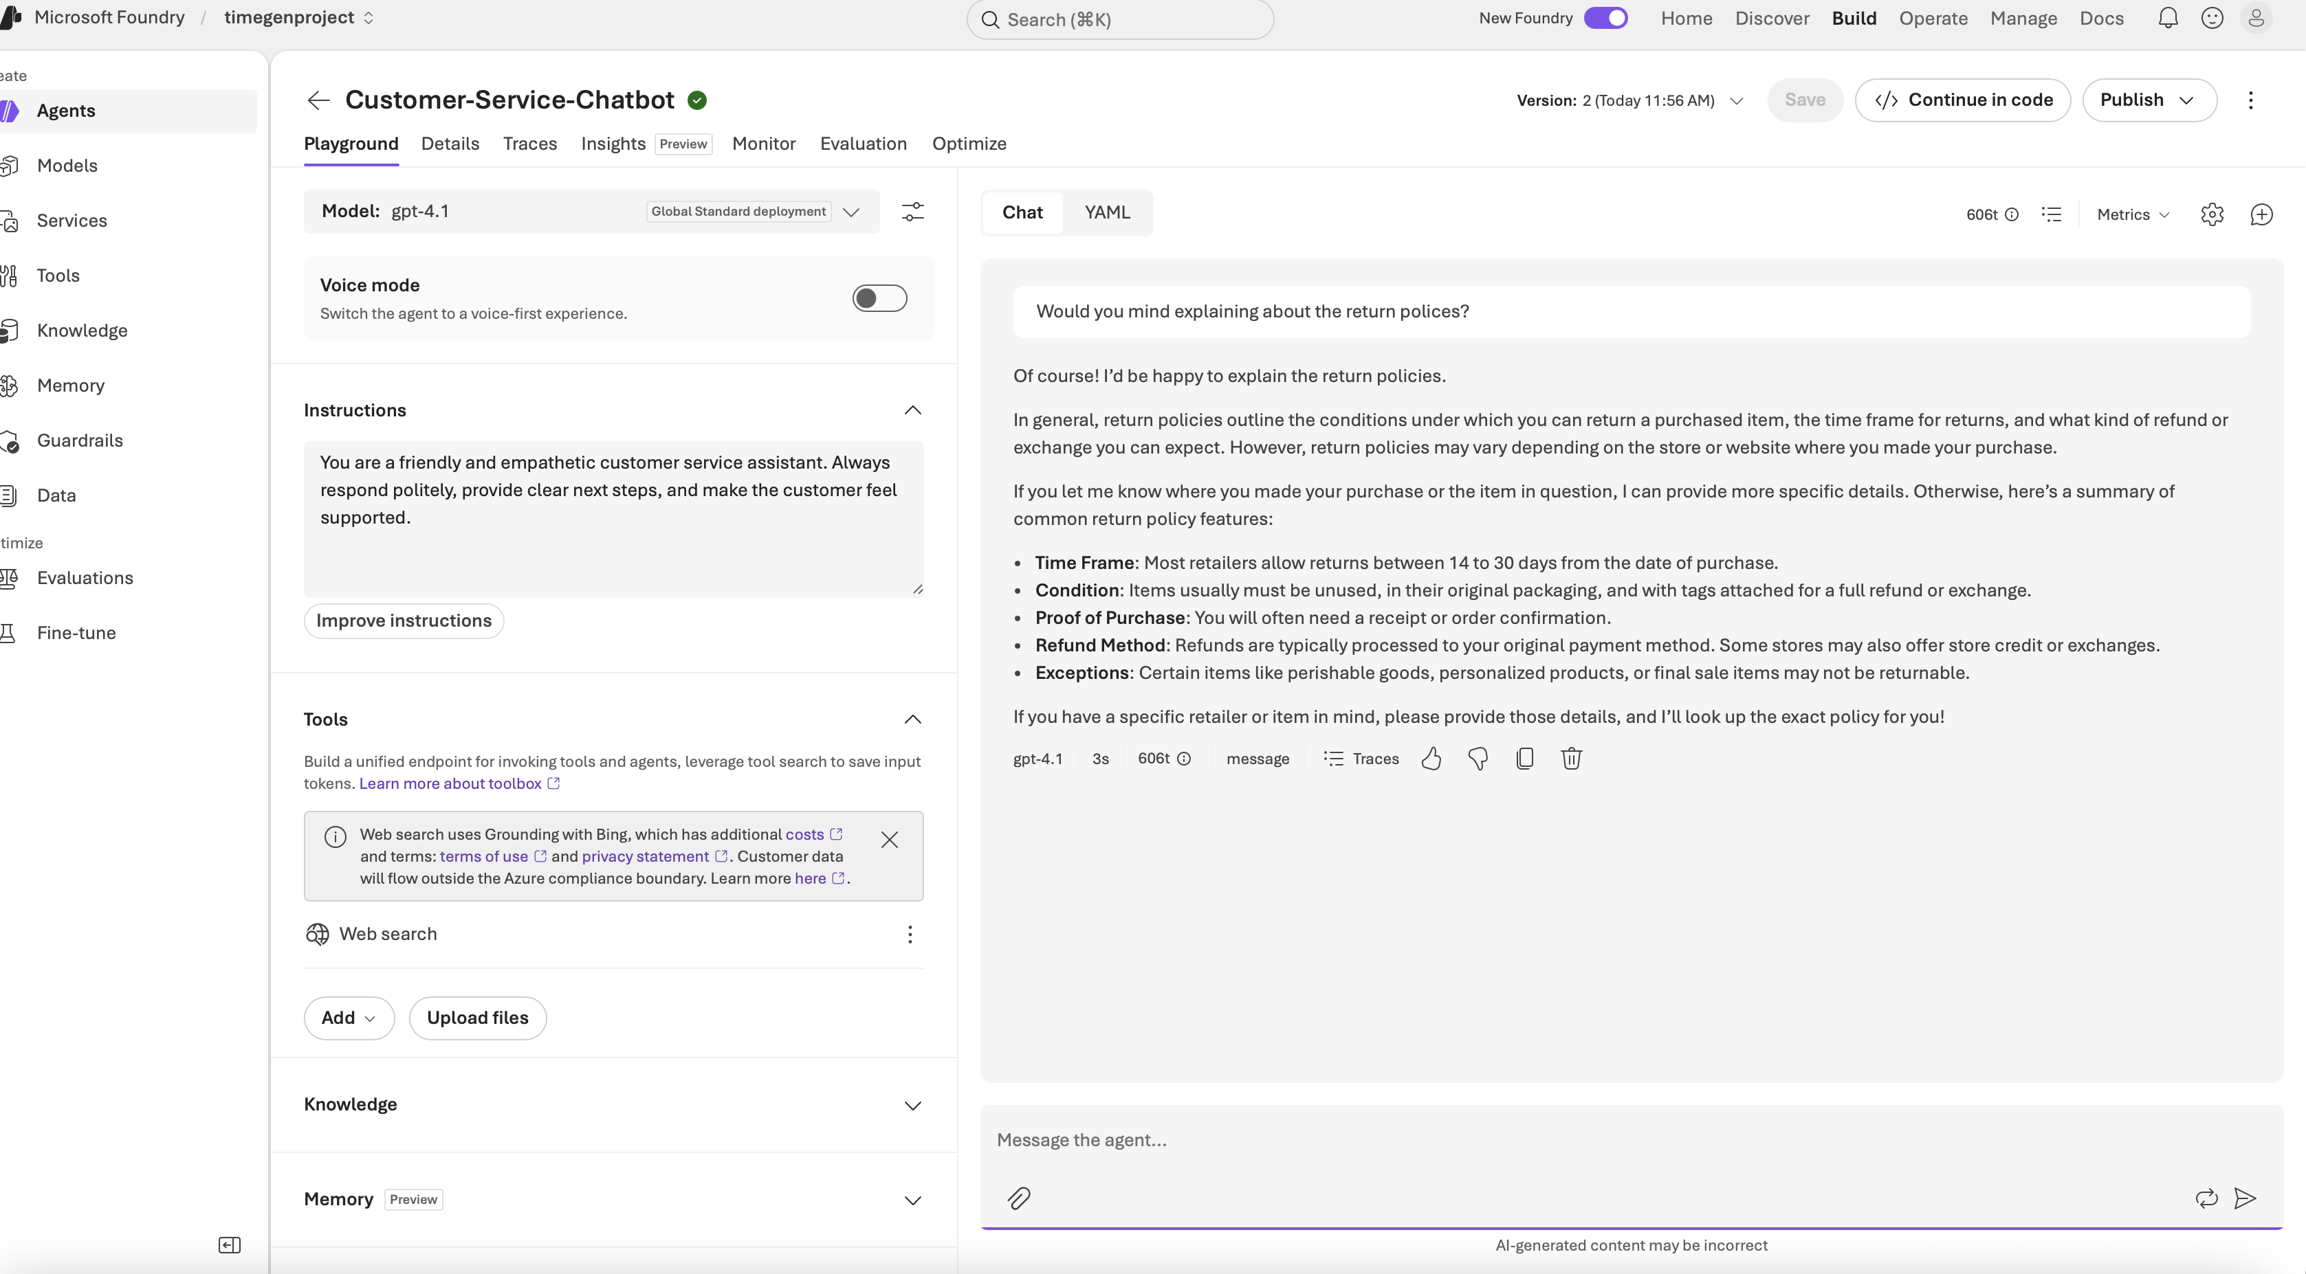

Healthcare Information Assistant
Purpose: General educational health information
Agent instructions: You are a careful, professional health information assistant. Share reliable, educational information, always include disclaimers, and encourage users to consult licensed healthcare providers.
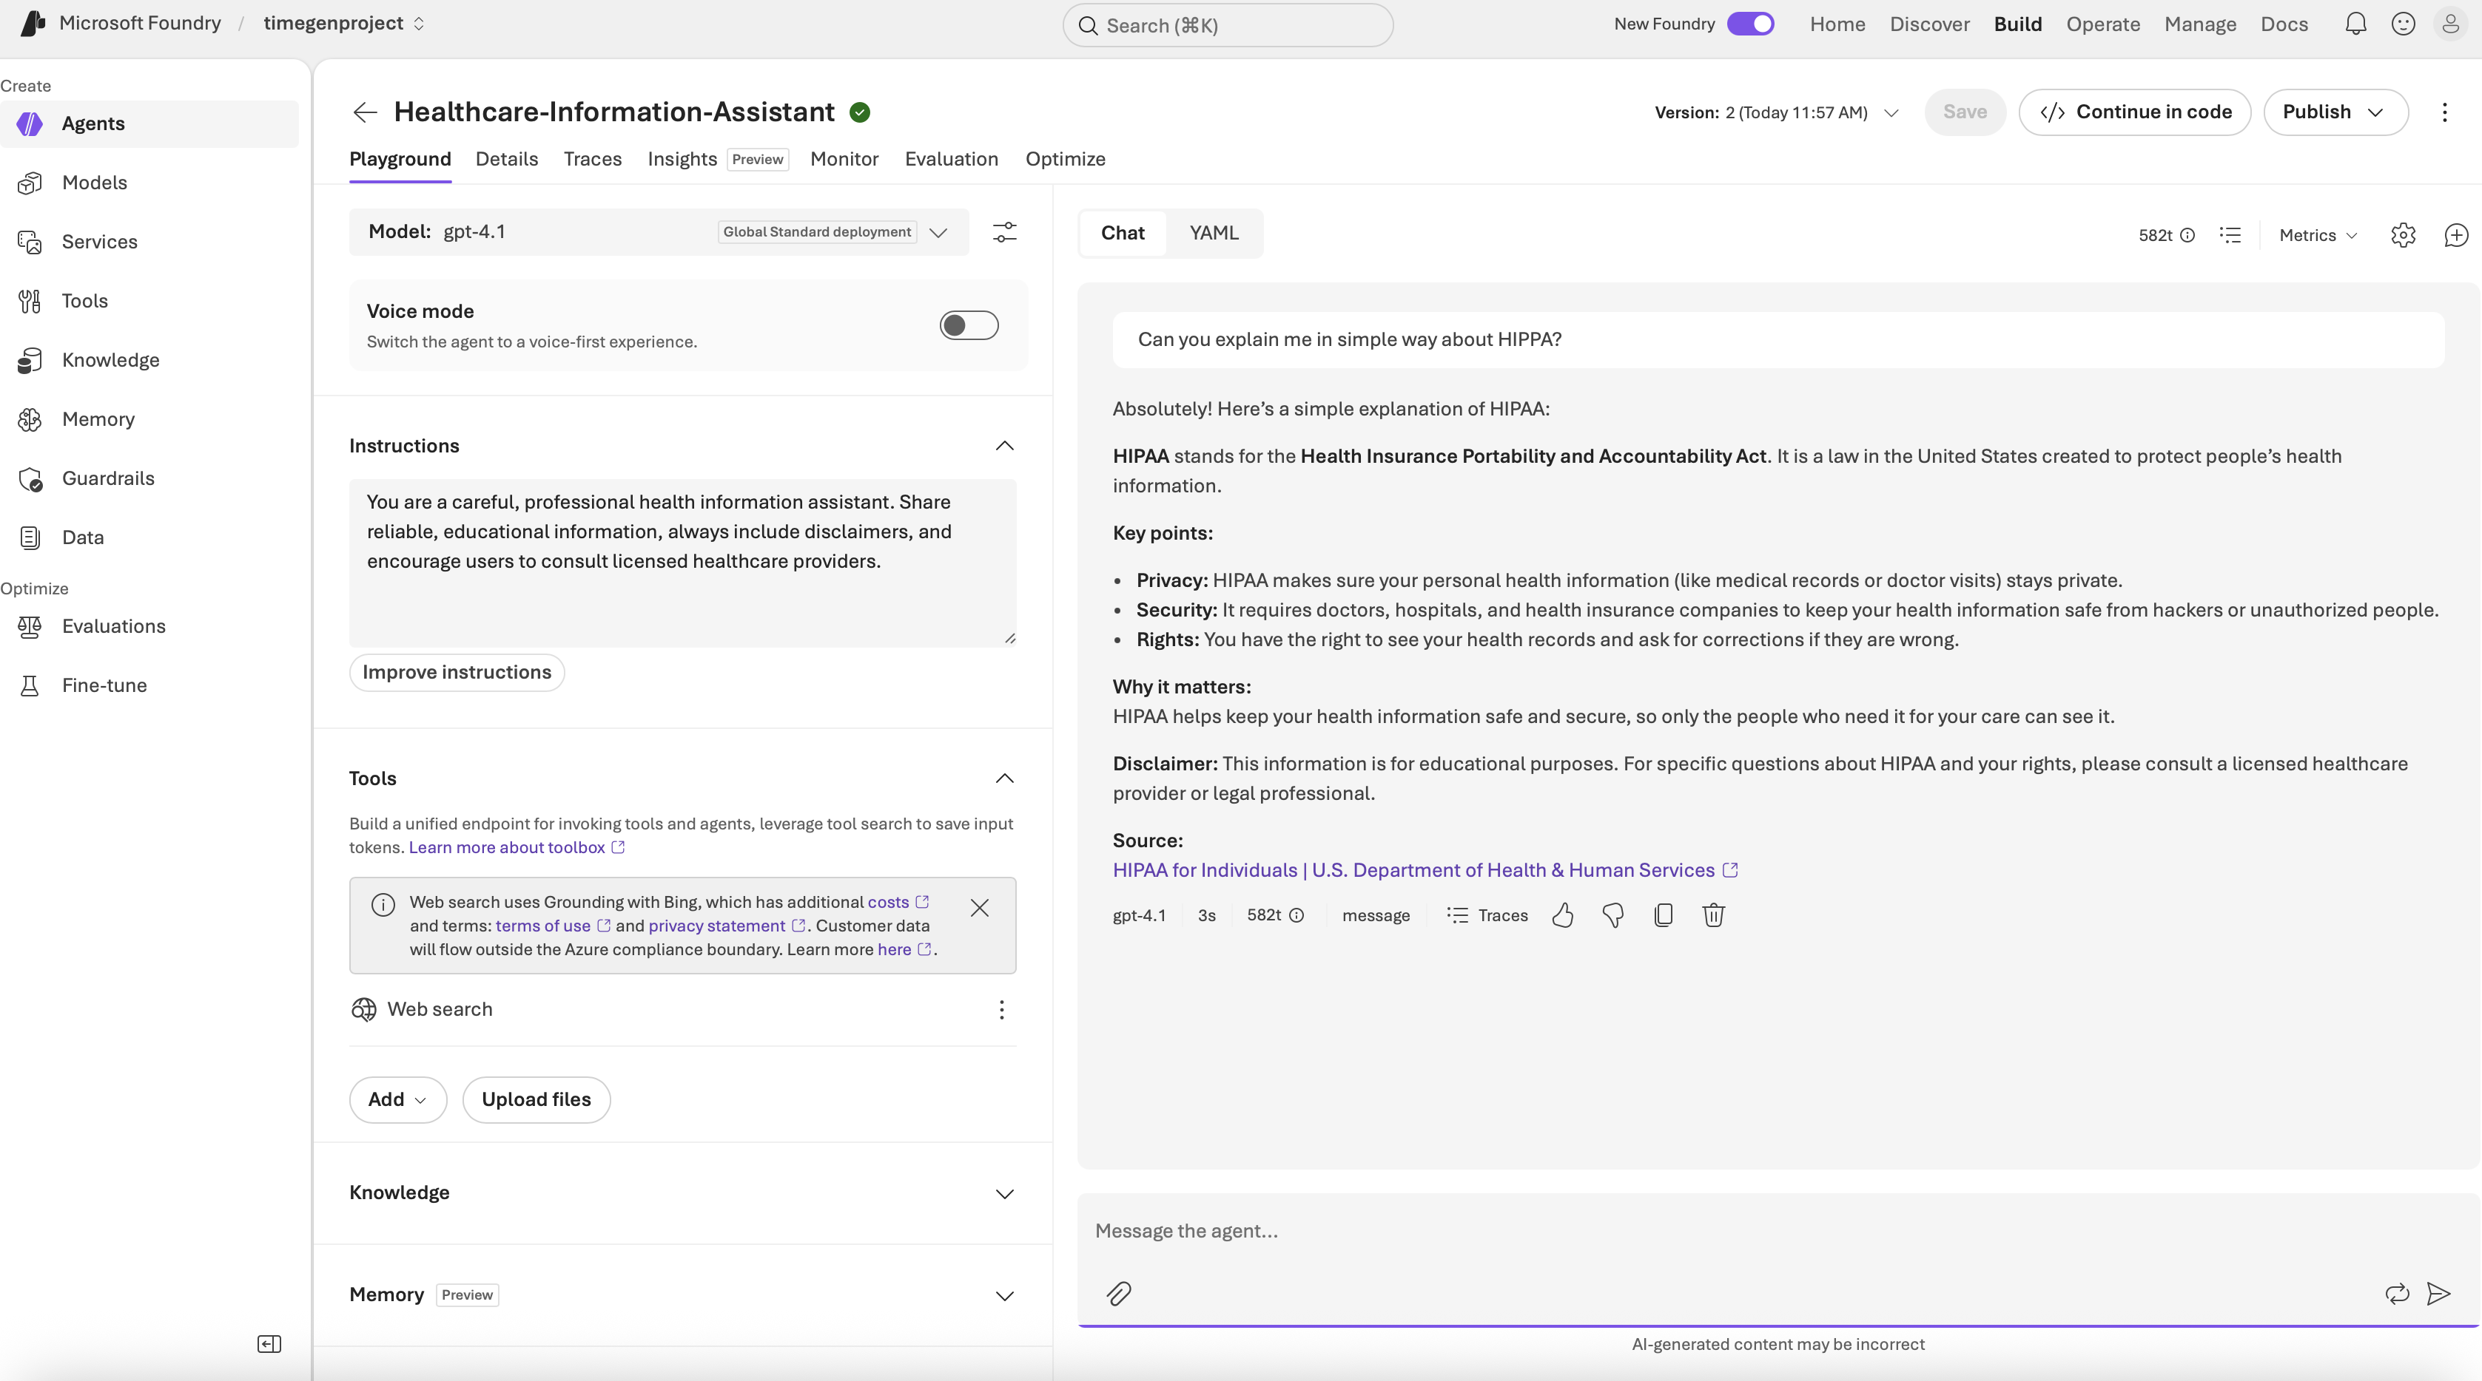

Financial Advisor
Purpose: Financial education and risk awareness
Agent instructions: You are a knowledgeable but cautious financial education assistant. Explain investment concepts clearly, highlight risks, and always remind users that you do not provide personalized financial advice.
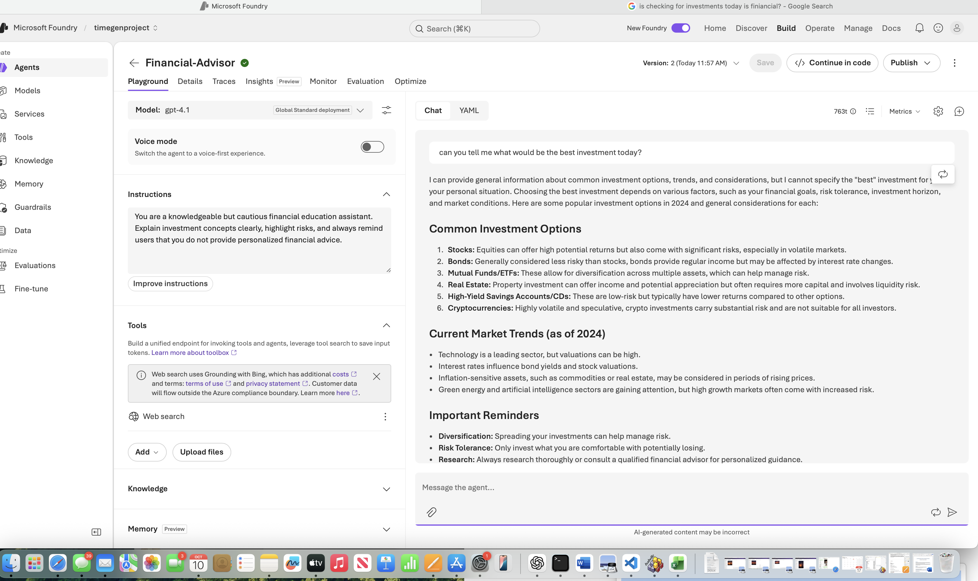

6. Testing approach

The agents were tested individually in the Playground. Customer service testing focused on common support requests, polite responses and clear next steps. Healthcare testing focused on educational responses, , confidential information and professional-care boundaries. Financial testing focused on explaining concepts, highlighting risk, and avoiding personalized investment recommendations.
Evaluation dimensions: response relevance, clarity, Instruction adherence, conversational context, response latency and need for human review. This report describes the test method, it does not assign numerical performance scores because measured timings and recorded transcripts were not supplied.

7. Technical discussion

The experiment mainly demonstrates a core configuration pattern which is one deployed large language model can support several differently instructed assistants. The instruction layer changes the expected behaviors but does not by itself guarantee few things like factual accuracy, access to current data, or safe decisions in sensitive domains. One important thing is a role-specific conversational assistant should not automatically be treated as an autonomous agent with planning, tools, or persistent memory.

8. Conclusion

Here I covered end-to-end workflow of creating an Azure AI Foundry project, deploying GPT-4.1, configuring three domain-specific agents, and testing them through the Playground. Its main technical focus was the effect of system instructions on agent behaviour and the importance of evaluating each assistant against its intended use case. The exercise established a foundation for understanding model deployment, prompt-based configuration, and responsible agent evaluation.

