Named Entity Recognition Using Azure AI Foundry
  - Experiment report | Language Playground

1. Aim
The objective of this experiment is to explore the Extract Named Entities feature in Azure AI Foundry Language Playground and observe how it identifies named entities in sample travel and banking text.

2. Platform and Configuration
- Platform: Microsoft Azure AI Foundry
- Tool: Language Playground → Extract Information → Extract Named Entities
- Text language: English
- API version shown: 2025-05-15-preview
- Model version shown: latest (GA)
- Normalize values: enabled

3. Procedure
- Opened the Language Playground and selected Extract Named Entities.
- Used the Travel sample and reviewed the highlighted entities and the Details panel through extract named entities part of the Language playground.
- Switched to the Banking sample and reviewed its highlighted entities and confidence scores.
- Captured screenshots of both examples as experiment evidence.

4. Observations

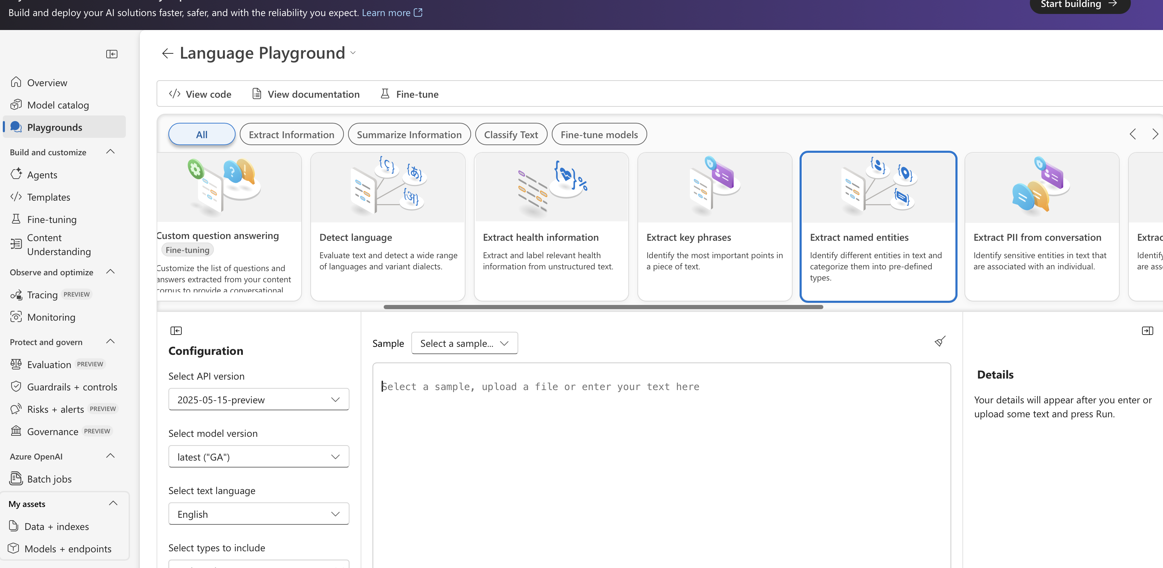

Sample A — Travel
The travel passage describes a visit to Los Angeles, a stay at Contoso Hotel, a museum visit, and a restaurant meal. The screenshot highlights entities such as “wife” (PersonType), “Los Angeles” (City), “August 17th, 2019” (Date), and “Hollywood Boulevard” (Location). The Details panel shows 98% confidence for “wife” and 100% for “Los Angeles.”
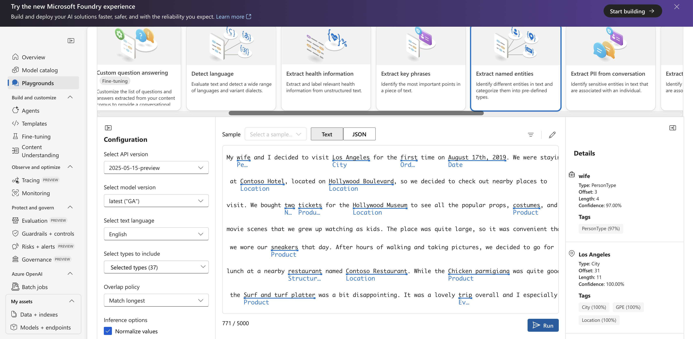

Figure 1. Travel sample with highlighted named entities.

Sample B — Banking
The banking passage describes a lost credit card and includes a customer name, date, purchase, and personal details. The screenshot highlights “Mateo Gomez” (Person), “August 17th” (Date), “Chicken parmigiana” (Product), “Contoso Restaurant” (Location), and other entities. The Details panel shows 100% confidence for “Mateo Gomez” and 80% for “August 17th.”
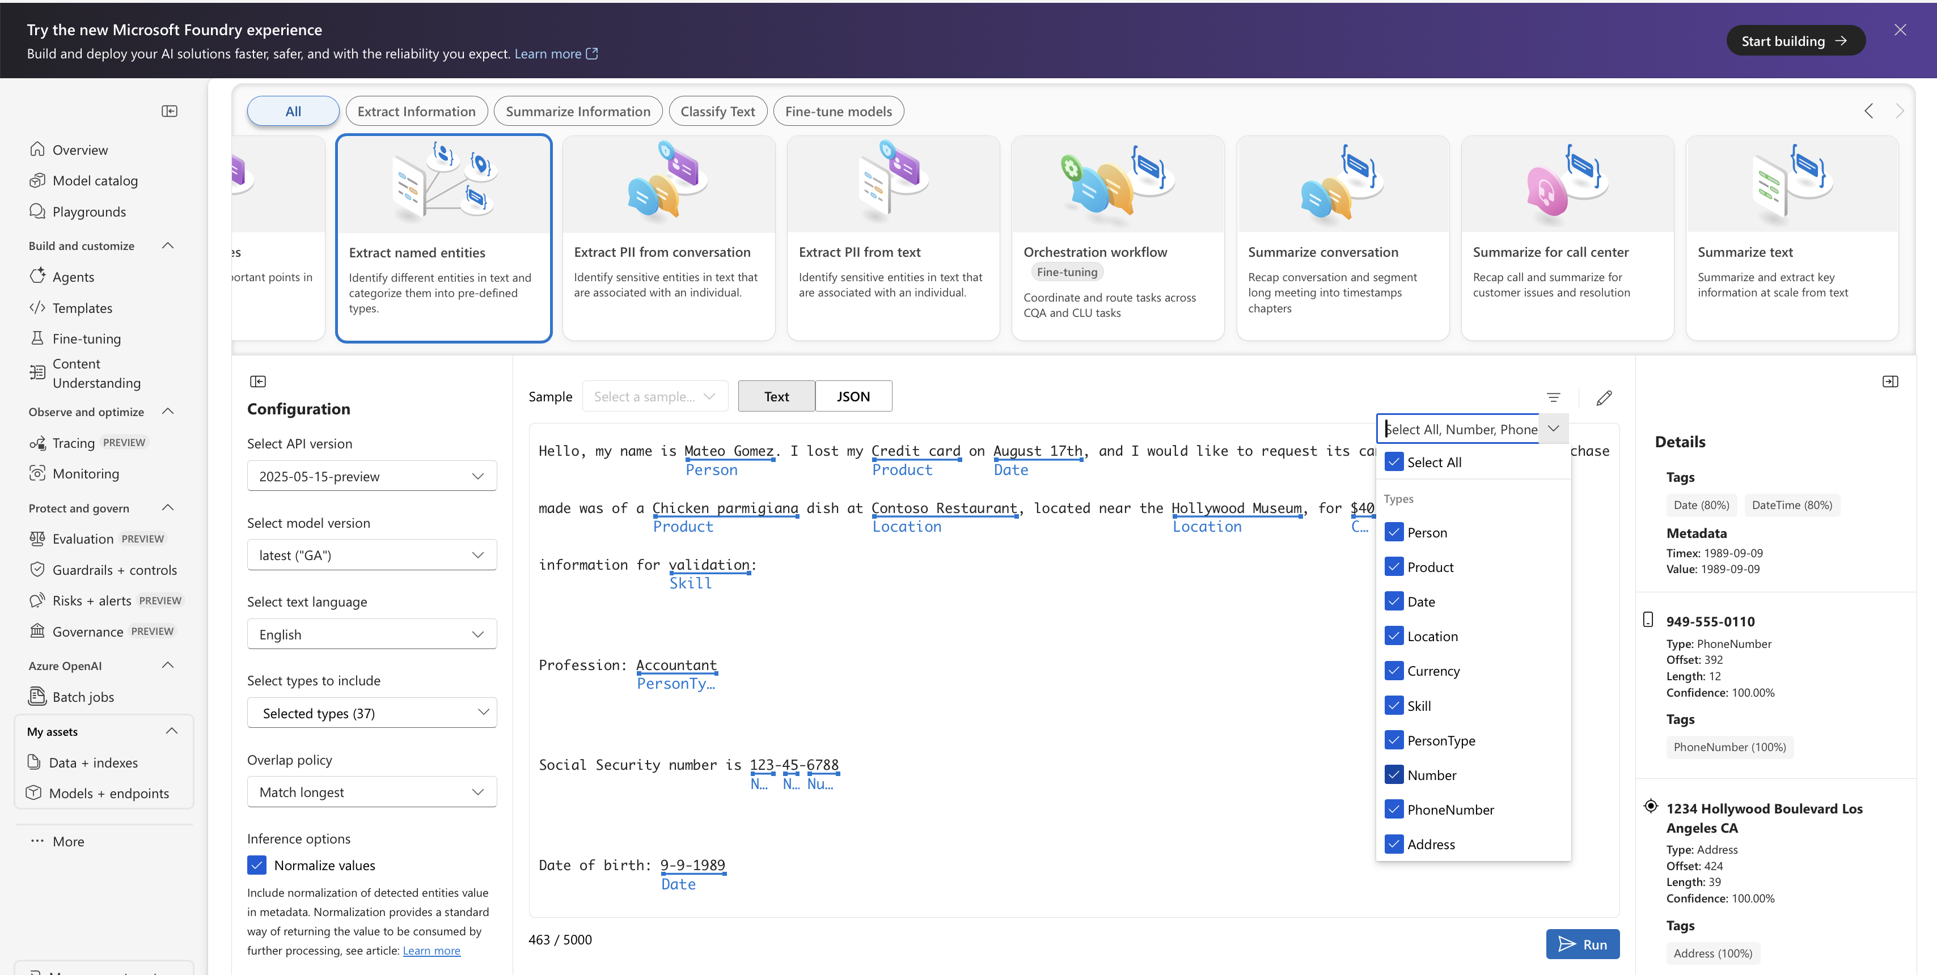
Figure 2. Banking sample with highlighted named entities.

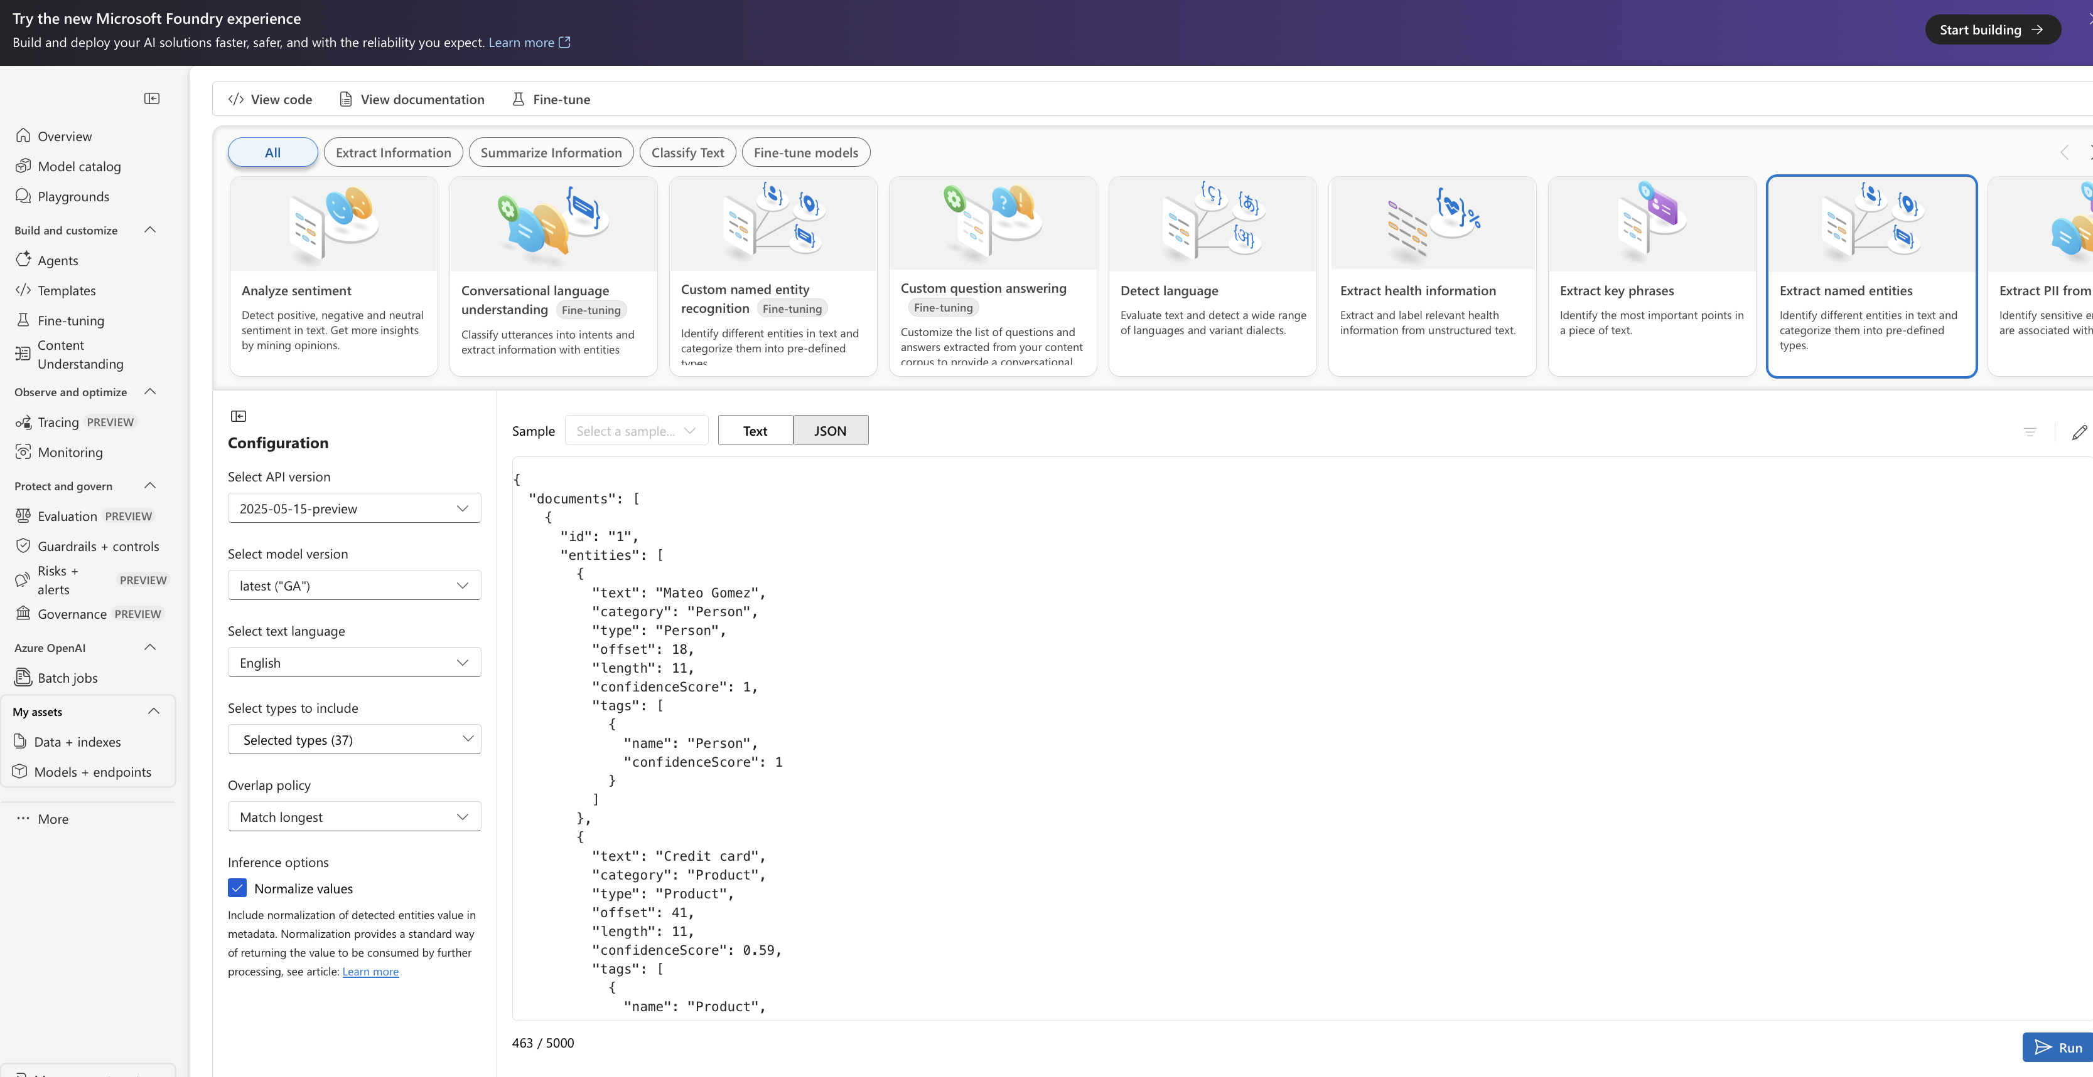
Figure 3. Banking sample Metadata.

5. Result
The Language Playground visually identified multiple named entities in both sample passages and displayed their entity types and confidence scores. These observations are based on the two screenshots only, no custom hotel intent model, hotel-specific entity model, or 20-query evaluation was performed as part of this documented experiment. Also, the confidence scores were checked and observed.

6. Conclusion
The experiment demonstrated how Azure AI Language named entity recognition can identify people, dates, locations, products, and other information in unstructured text. Named entity recognition is different from intent classification, a separate classification setup would be needed to recognize hotel guest intents.
Note: The banking screenshot contains fictional sample personal information.

