Oakwood Hotel AI Agent – Knowledge System
Experiment documentation | Azure AI Foundry

1. Objective

Building a hotel information agent that retrieves reliable answers from uploaded hotel knowledge base documents and includes a source citation in each response.

2. Tools and knowledge sources

Platform: Microsoft Azure AI Foundry (Agents and Playground).
Documents: Hotel policies, Restaurant menus, Spa service list, Local area guide, and FAQ compilation.

3. Implementation steps
- Open Azure AI Foundry → Agents and select the hotel information agent.
- Go to tools option, choose Files, create a vector store, and upload the five hotel documents. Save the configuration.
- Set retrieval instructions to prioritize the relevant documents and require citations.
- Open the Playground, select the agent, and test guest questions against the uploaded knowledge base.

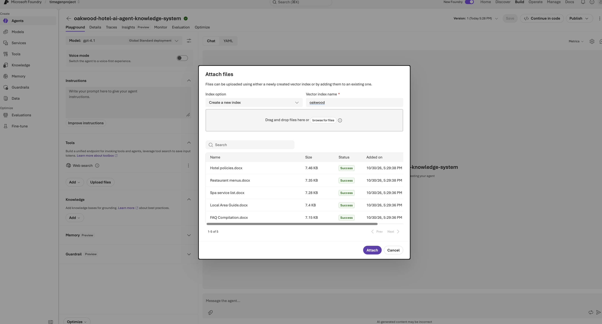

4. Agent instructions

- Search all documents before responding.
- Always cite sources using [Source: filename].
- Prioritize the hotel policies document for rules.
- Check restaurant menus first for food-related questions.
- Limit answers to information available in the uploaded documents.
- If information is missing, say it is not available rather than guessing.

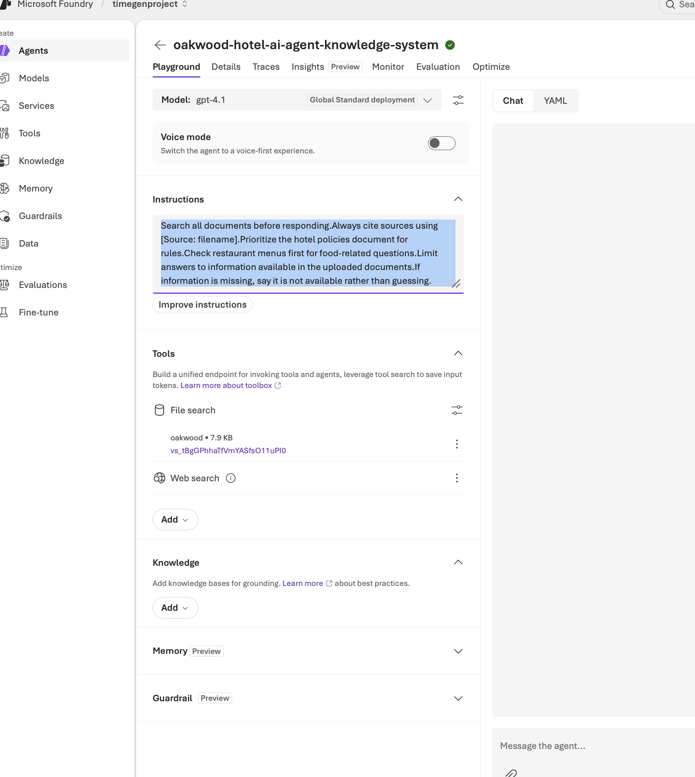

5. Test cases and expected behavior
Guest question | Expected behavior
What are the restaurant hours, and does the spa require reservations? | Retrieve from restaurant and spa files; cite both.
Tell me about your services. | Provide a grounded overview; do not invent details.
Can I check in early? | Prioritize hotel policies and cite that file.
When does the restaurant open, and what are the spa rules for children? | Combine two sources and cite each.
Do you offer a service not mentioned in the documents? | State that the available documents do not confirm it.

6. Verification and outcome
1. What are the restaurant hours, and does the spa require reservations?
2. Tell me about your services.
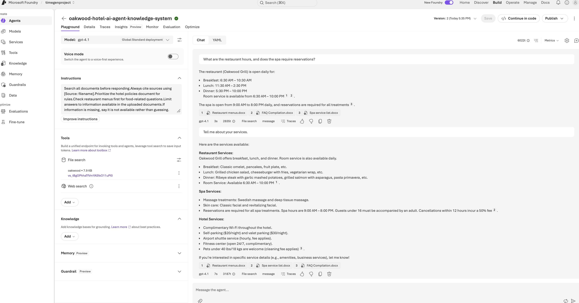

3. Can I check in early?
4. When does the restaurant open, and what are the spa rules for children?
5. Do you offer a service not mentioned in the documents?
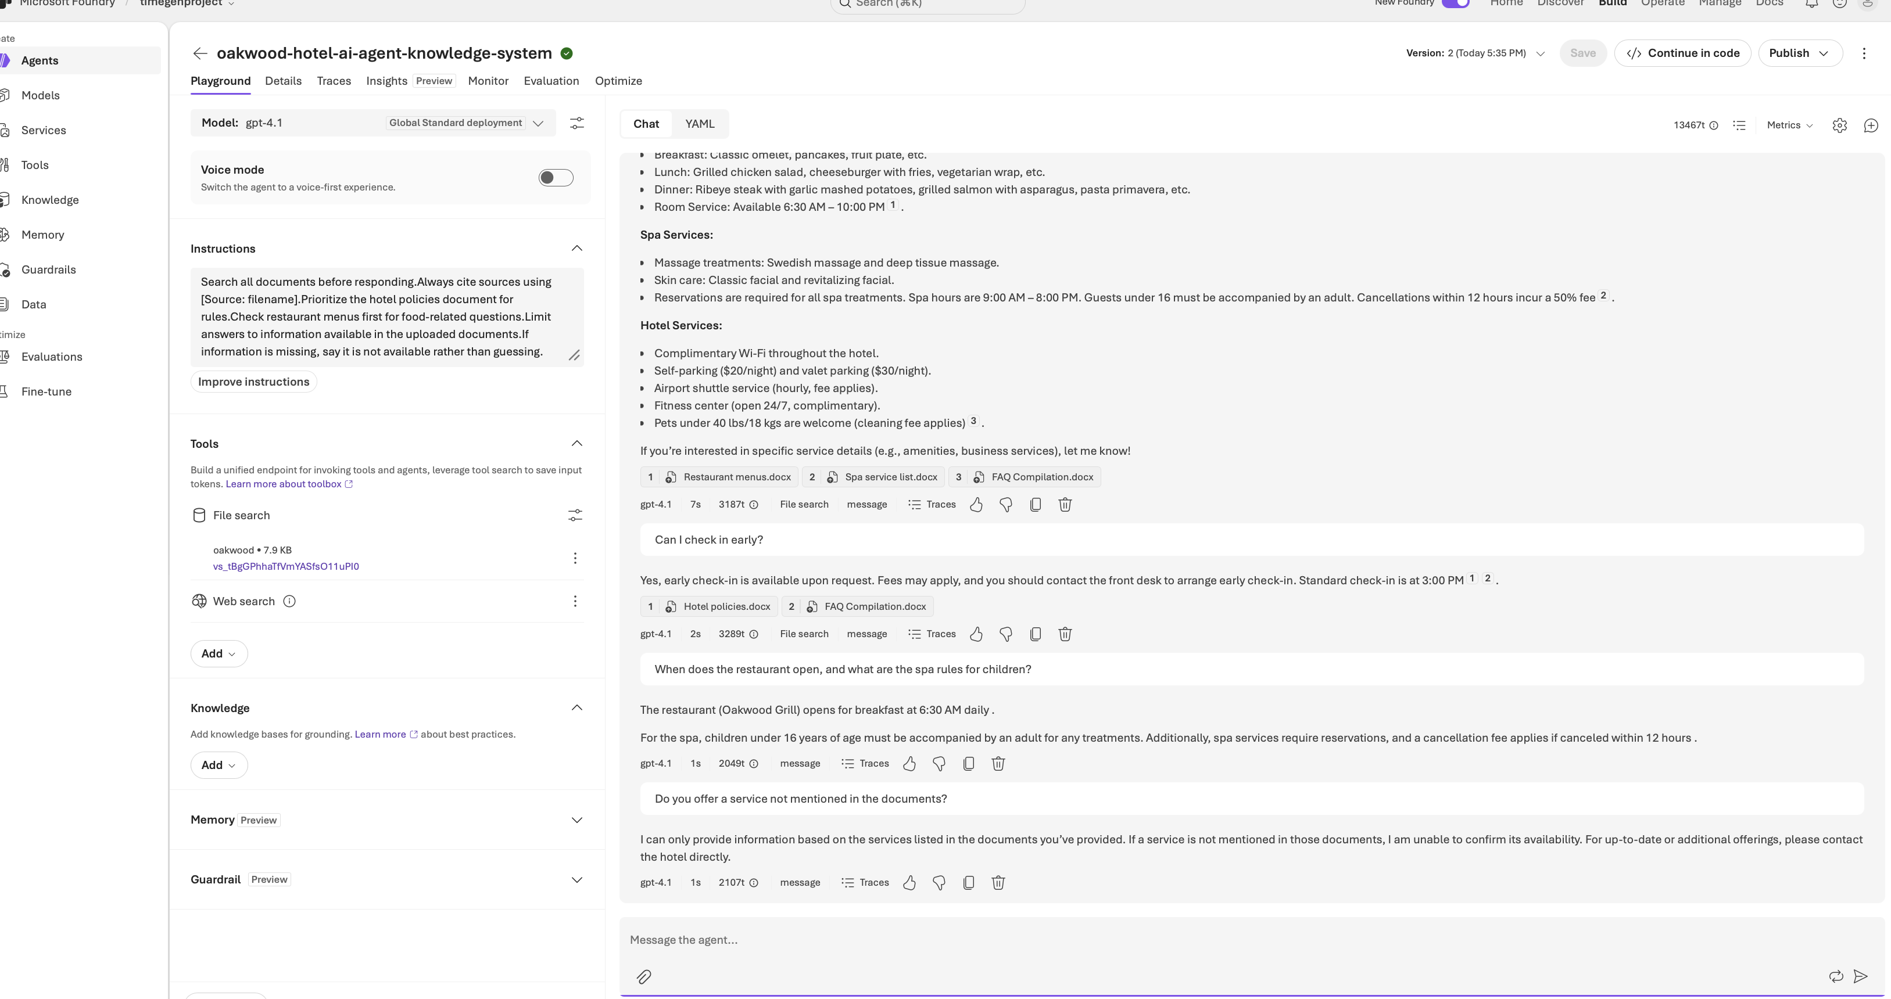

7. Conclusion

The Oakwood Hotel AI Agent knowledge system is successfully implemented using Microsoft Azure AI Foundry. The agent was configured by uploading the hotel-related documents, including hotel policies, restaurant menus, spa services, local attractions, and FAQs.
The agent was tested with different guest queries, including simple, complex, and multi-topic questions along with fallback scenario. It successfully retrieved relevant information from the uploaded documents and provided accurate responses along with source citations.

