Why Version control system?

* Collaboration b/w all developers
* Storing versions with comments
* Backup
* Analysis with comments provided while check in

GIT:

* Designed in 2005 by Linus Torvalds
* This is Distributed source control system
* This is open source
* Large and active community
* Light weight
* Allows branching
* Secure – this converts committed data into hexadecimal code

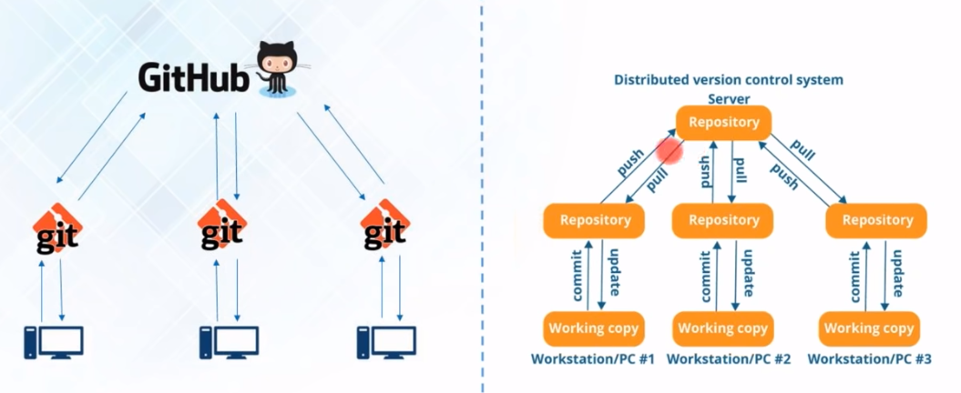

Commands: (Here branch name is master)

Version – git version

Git init – To create git repository in local system (creates .git folder)

Clear – to clear the screen

Git remote add origin “<repository URL>” – to link the git repo with local repo

Git pull origin <branch name>– to pull the files from master branch

Git status – to know the status of the files, anything modified or not

Git add – to add the files to index (local repository)

Git commit –m “<message>” – refers to record the snapshot of the repository, these snapshots will never change unless we change them manually

Git add –A – To add multiple files at a time to index

Git commit –a –m “<message>“ – to commit multiple files

Git log – To view all the commits

Git branch <branch name> - To create a new branch, this will create new branch but the location will be master only.

Git checkout <branch name> - To switch the branch

Ls – To list the files in the current directory

Git pull=git fetch+git merge

**Merging**:

When we create new branches, it is necessary to merge the branches with master. When we are merging with master, we need to present in master branch in gitbash.

Git merge <branchname> : merging with master

**Rebasing:**

This is also same as merging, these two performs same operation. To maintain cleaner project history and linear workflow we use rebasing.

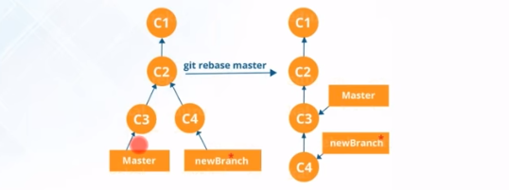

Git rebase <branch name>: This should be done in master

**Push:**

To push the files into central repository we need to do in SSH mode, for this we need to have SSH key.

To generate SSH key, type ssh-keygen in gitbash.

To view the key, cat <file name>

This will create SSH key, we need to paste this key in github settings SSH key

We need to authorize the SSH key using this command ssh –T [git@github.com](mailto:git@github.com)

To push from new branch, git checkout <branch name>

Git push origin <branch name> : To push the files to github

To get the particular version of the file: we need to get the hash code that commit, take first 8 digits and follow the below command:

Git checkout <8digit hash code> <file name>

Overall picture:

