N1.ReactJs-HOL
App.js:
function App() {
return (
<div>
<h1>Welcome to the first session of React</h1>
</div>
);
}

export default App;

Output:
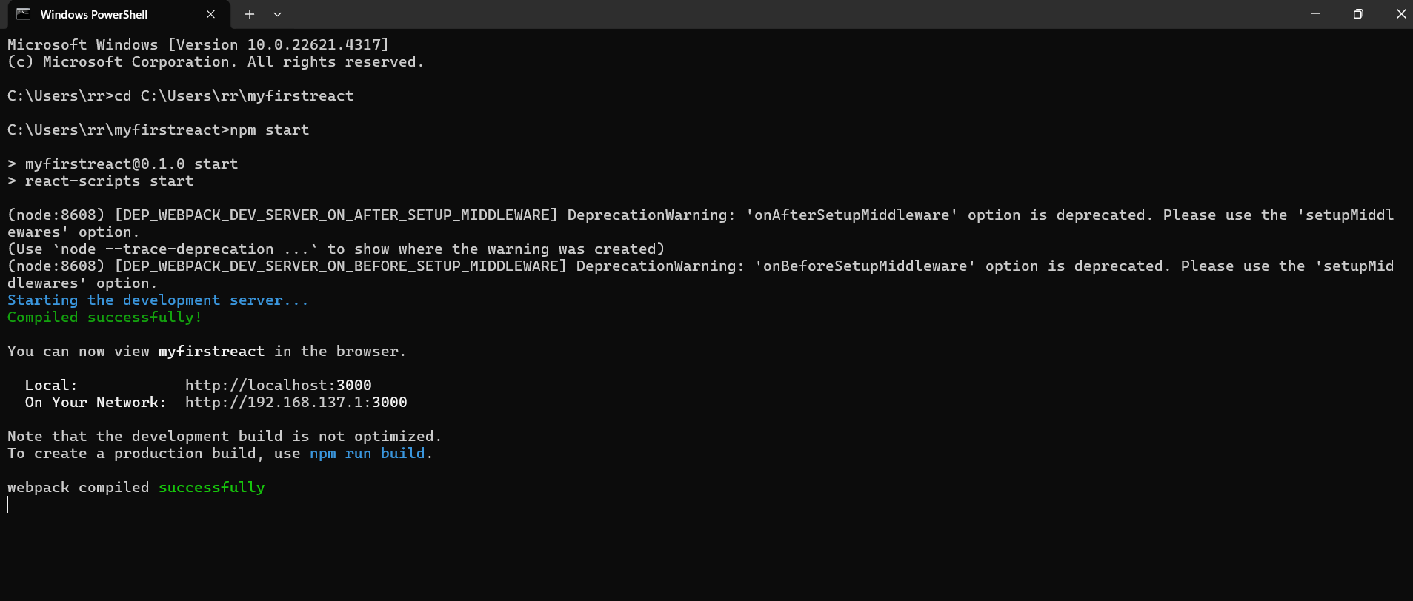

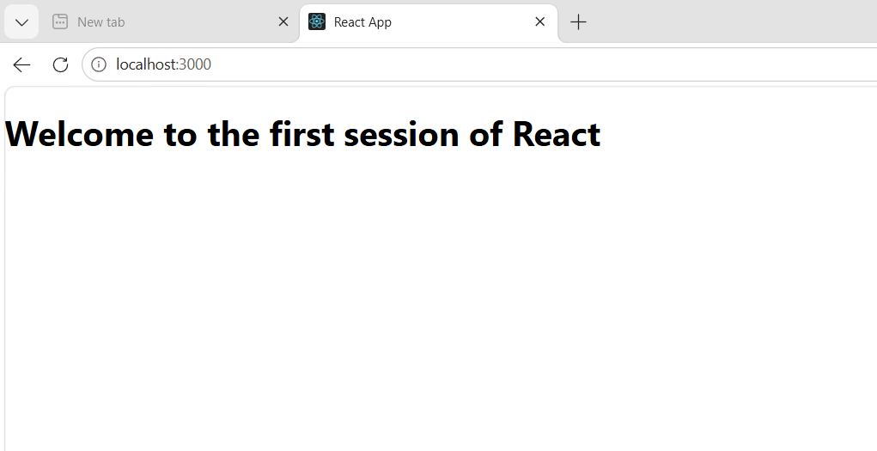

2.ReactJs-HOL
About.js:
import React, { Component } from "react";

class About extends Component {
render() {
return (
<div>
<h2>Welcome to the About page of Student Management Portal</h2>
</div>
);
}
}

export default About;

Contact.js:
import React, { Component } from "react";

class Contact extends Component {
render() {
return (
<div>
<h2>Welcome to the Contact page of Student Management Portal</h2>
</div>
);
}
}

export default Contact;

Home.js:
import React, { Component } from "react";

class Home extends Component {
render() {
return (
<div>
<h2>Welcome to the Home page of Student Management Portal</h2>
</div>
);
}
}

export default Home;

App.js:
import React from "react";
import Home from "./Components/Home";
import About from "./Components/About";
import Contact from "./Components/Contact";

function App() {
return (
<div>
<Home />
<About />
<Contact />
</div>
);
}

export default App;

Output:
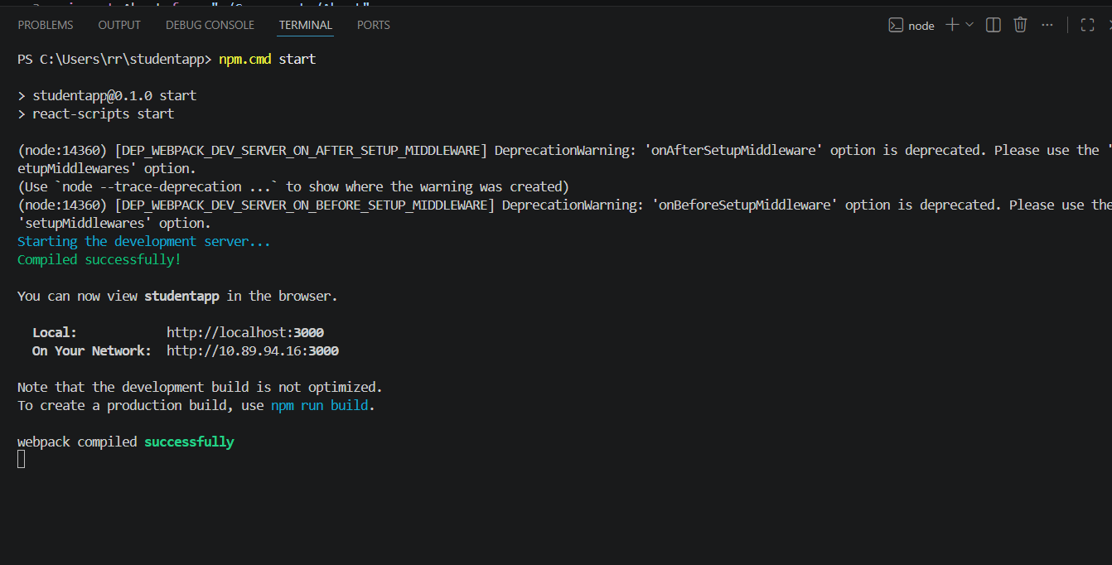
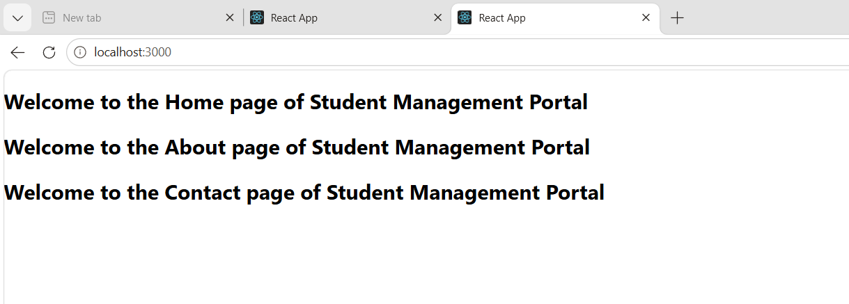

3.ReactJs-HOL
CalculateScore.js:
import React from "react";
import "../Stylesheets/mystyle.css";

function CalculateScore(props) {
const average = props.Total / props.goal;

return (
<div className="box">
<h2>Student Score Calculator</h2>

<p><b>Name:</b> {props.Name}</p>
<p><b>School:</b> {props.School}</p>
<p><b>Total Marks:</b> {props.Total}</p>
<p><b>Subjects:</b> {props.goal}</p>
<p><b>Average Score:</b> {average}</p>
</div>
);
}

export default CalculateScore;

mystyle.css:
body{
background-color:#f5f5f5;
font-family:Arial;
}

.box{
width:400px;
margin:40px auto;
padding:20px;
border:2px solid blue;
border-radius:10px;
background-color:white;
}

h2{
color:blue;
text-align:center;
}

p{
font-size:18px;
}

App.js:
import React from "react";
import CalculateScore from "./Components/CalculateScore";

function App() {
return (
<div>
<CalculateScore
Name="Naveen Kumar"
School="ABC Higher Secondary School"
Total={450}
goal={5}
/>
</div>
);
}

export default App;

index.js:
import React from 'react';
import ReactDOM from 'react-dom/client';
import './index.css';
import App from './App';
import reportWebVitals from './reportWebVitals';

const root = ReactDOM.createRoot(document.getElementById('root'));
root.render(
<React.StrictMode>
<App />
</React.StrictMode>
);

// If you want to start measuring performance in your app, pass a function
// to log results (for example: reportWebVitals(console.log))
// or send to an analytics endpoint. Learn more: https://bit.ly/CRA-vitals
reportWebVitals();

Output:
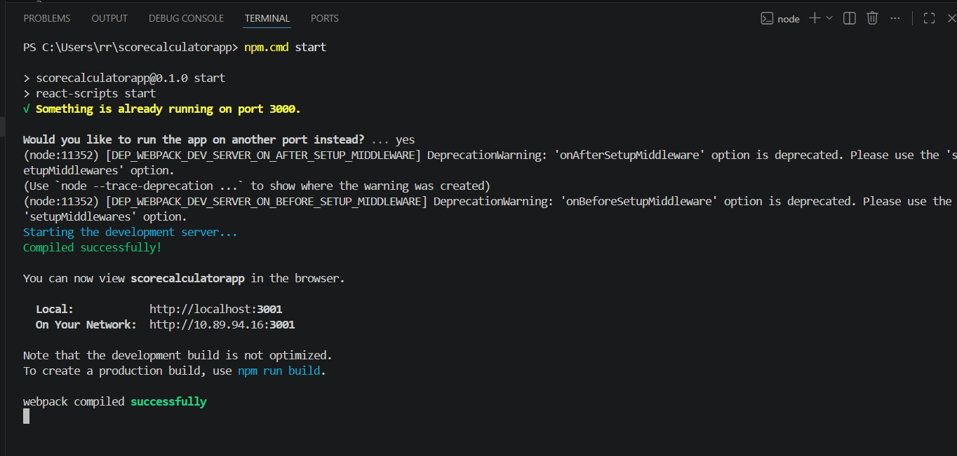
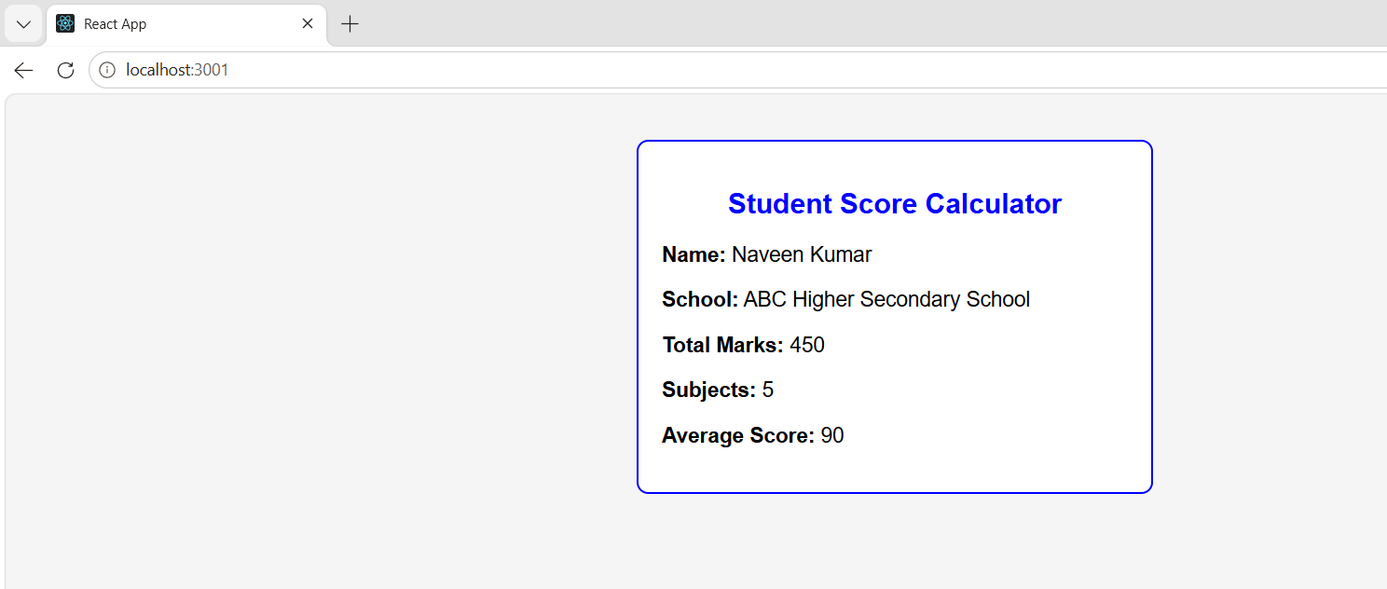

4.ReactJs-HOL
App.js:
import React from "react";
import Posts from "./Posts";

function App() {

return (

<div>

<Posts />

</div>

);

}

export default App;

Post.js:
class Post {
constructor(userId, id, title, body) {
this.userId = userId;
this.id = id;
this.title = title;
this.body = body;
}
}

export default Post;

Posts.js:
import React, { Component } from "react";
import Post from "./Post";

class Posts extends Component {

constructor(props) {
super(props);

this.state = {
posts: []
};
}

loadPosts() {

fetch("https://jsonplaceholder.typicode.com/posts")
.then(response => response.json())
.then(data => {

const posts = data.map(
item => new Post(
item.userId,
item.id,
item.title,
item.body
)
);

this.setState({
posts: posts
});

});
}

componentDidMount() {
this.loadPosts();
}

componentDidCatch(error) {
alert(error);
}

render() {

return (

<div>

<h1>Blog Posts</h1>

{
this.state.posts.map(post => (

<div key={post.id}>

<h3>{post.title}</h3>

<p>{post.body}</p>

<hr />

</div>

))
}

</div>

);
}

}

export default Posts;

Output:
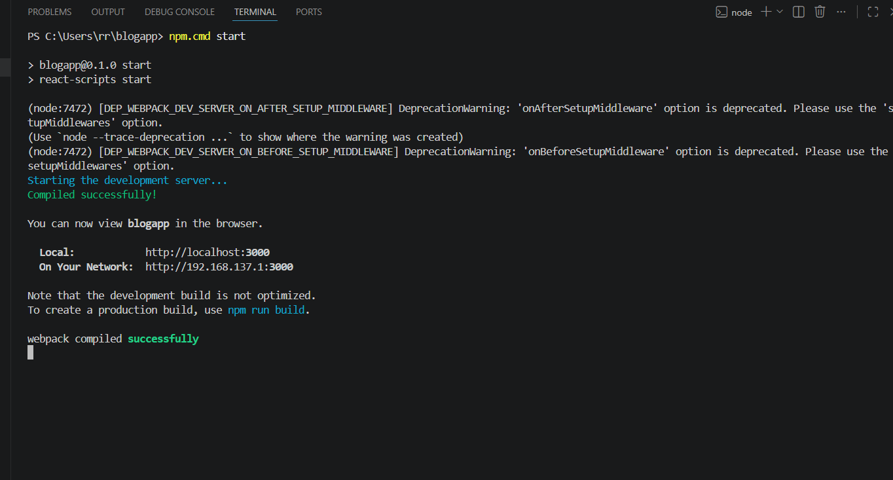
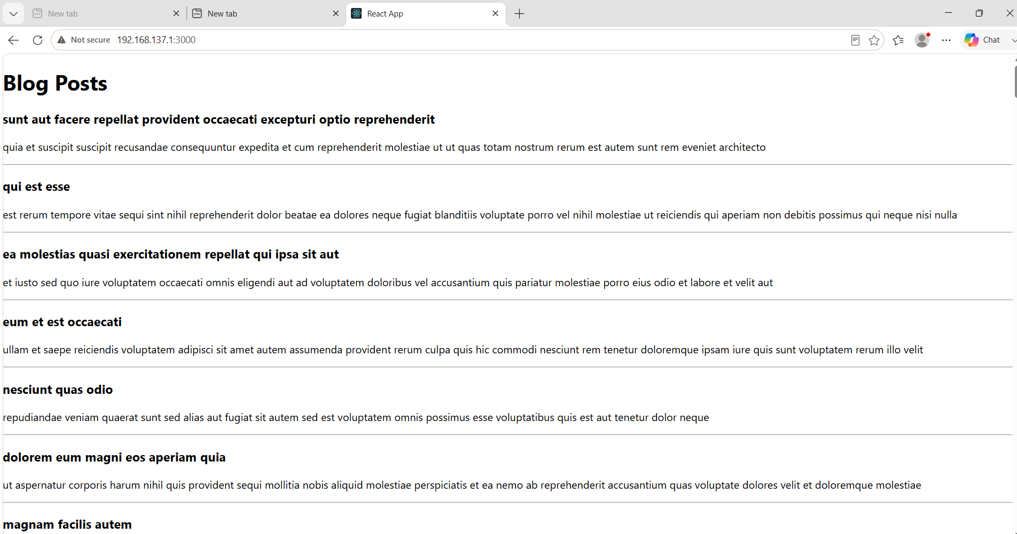

5.ReactJs-HOL
CohortDetails.module.css:
.box{
width:300px;
display:inline-block;
margin:10px;
padding:10px 20px;
border:1px solid black;
border-radius:10px;
}

dt{
font-weight:500;
}

CohortDetails.js:
import React from "react";
import styles from "../Styles/CohortDetails.module.css";

function CohortDetails(props) {

const headingStyle = {
color: props.status === "Ongoing" ? "green" : "blue"
};

return (

<div className={styles.box}>

<h3 style={headingStyle}>
{props.name}
</h3>

<dl>

<dt>Current Status</dt>
<dd>{props.status}</dd>

<dt>Coach</dt>
<dd>{props.coach}</dd>

<dt>Trainer</dt>
<dd>{props.trainer}</dd>

</dl>

</div>

);

}

export default CohortDetails;

App.js:
import React from "react";
import CohortDetails from "./Components/CohortDetails";

function App() {

return (

<div>

<h1>My Academy Dashboard</h1>

<CohortDetails
name="React Batch"
status="Ongoing"
coach="John"
trainer="David"
/>

<CohortDetails
name="Java Full Stack"
status="Completed"
coach="Smith"
trainer="Robert"
/>

<CohortDetails
name="Python"
status="Ongoing"
coach="James"
trainer="William"
/>

</div>

);

}

export default App;

Output:
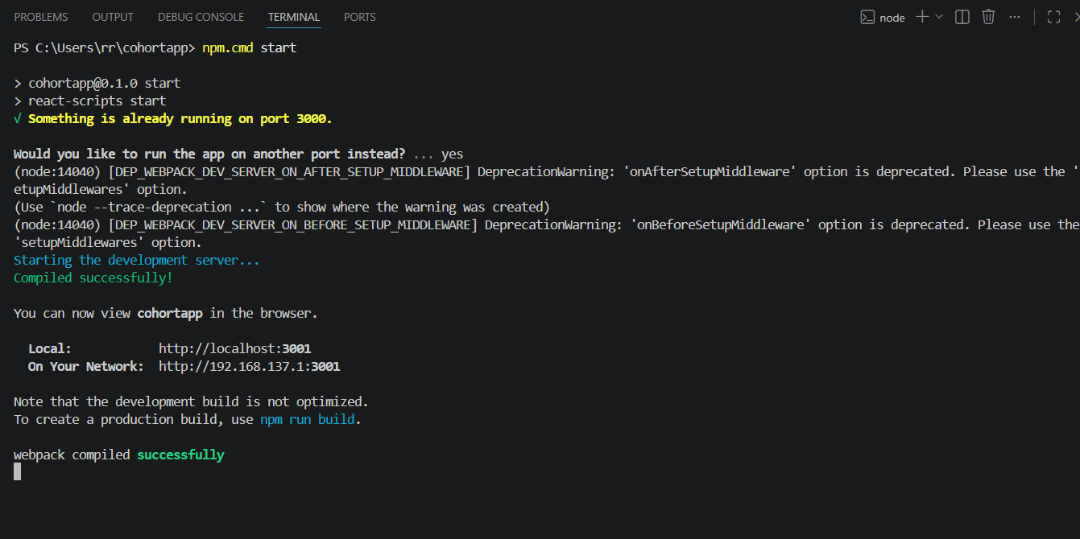

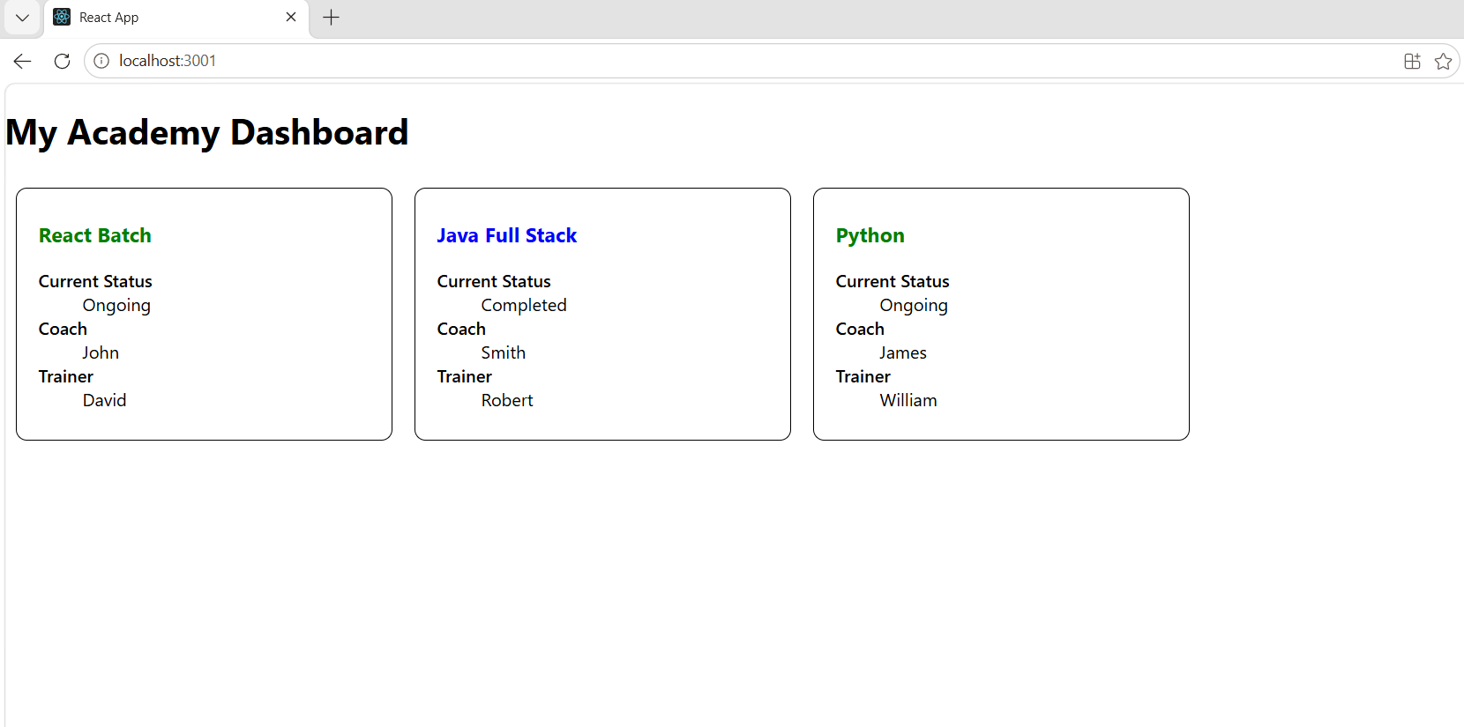
9.ReactJs-HOL
ListofPlayers.js:
import React from "react";

function ListofPlayers() {

const players = [
{ name: "Virat", score: 95 },
{ name: "Rohit", score: 82 },
{ name: "Gill", score: 60 },
{ name: "Rahul", score: 75 },
{ name: "Pant", score: 68 },
{ name: "Hardik", score: 88 },
{ name: "Jadeja", score: 72 },
{ name: "Ashwin", score: 65 },
{ name: "Shami", score: 55 },
{ name: "Bumrah", score: 91 },
{ name: "Siraj", score: 45 }
];

const lowScorePlayers = players.filter(player => player.score < 70);

return (
<div>
<h2>List of Players</h2>

<h3>All Players</h3>

<table border="1" cellPadding="10">
<thead>
<tr>
<th>Name</th>
<th>Score</th>
</tr>
</thead>

<tbody>
{
players.map((player, index) => (
<tr key={index}>
<td>{player.name}</td>
<td>{player.score}</td>
</tr>
))
}
</tbody>
</table>

<h3>Players with Score Below 70</h3>

<ul>
{
lowScorePlayers.map((player, index) => (
<li key={index}>
{player.name} - {player.score}
</li>
))
}
</ul>

</div>
);
}

export default ListofPlayers;

IndianPlayers.js:

function IndianPlayers() {

const team = [
"Virat",
"Rohit",
"Gill",
"Rahul",
"Pant",
"Hardik"
];

const [odd1, even1, odd2, even2, odd3, even3] = team;

const T20players = [
"Virat",
"Rohit",
"Hardik"
];

const RanjiPlayers = [
"Pujara",
"Rahane",
"Iyer"
];

const mergedPlayers = [...T20players, ...RanjiPlayers];

return (
<div>

<h2>Odd Team Players</h2>

<ul>
<li>{odd1}</li>
<li>{odd2}</li>
<li>{odd3}</li>
</ul>

<h2>Even Team Players</h2>

<ul>
<li>{even1}</li>
<li>{even2}</li>
<li>{even3}</li>
</ul>

<h2>Merged Players</h2>

<ul>
{
mergedPlayers.map((player, index) => (
<li key={index}>{player}</li>
))
}
</ul>

</div>
);
}

export default IndianPlayers;

App.js:
import React from "react";
import ListofPlayers from "./ListofPlayers";
import IndianPlayers from "./IndianPlayers";

function App() {

const flag = true;

if (flag) {
return (
<div>
<ListofPlayers />
</div>
);
}
else {
return (
<div>
<IndianPlayers />
</div>
);
}

}

export default App;

index.js:
import React from "react";
import ReactDOM from "react-dom/client";
import App from "./App";

const root = ReactDOM.createRoot(document.getElementById("root"));

root.render(
<App />
);

Output:
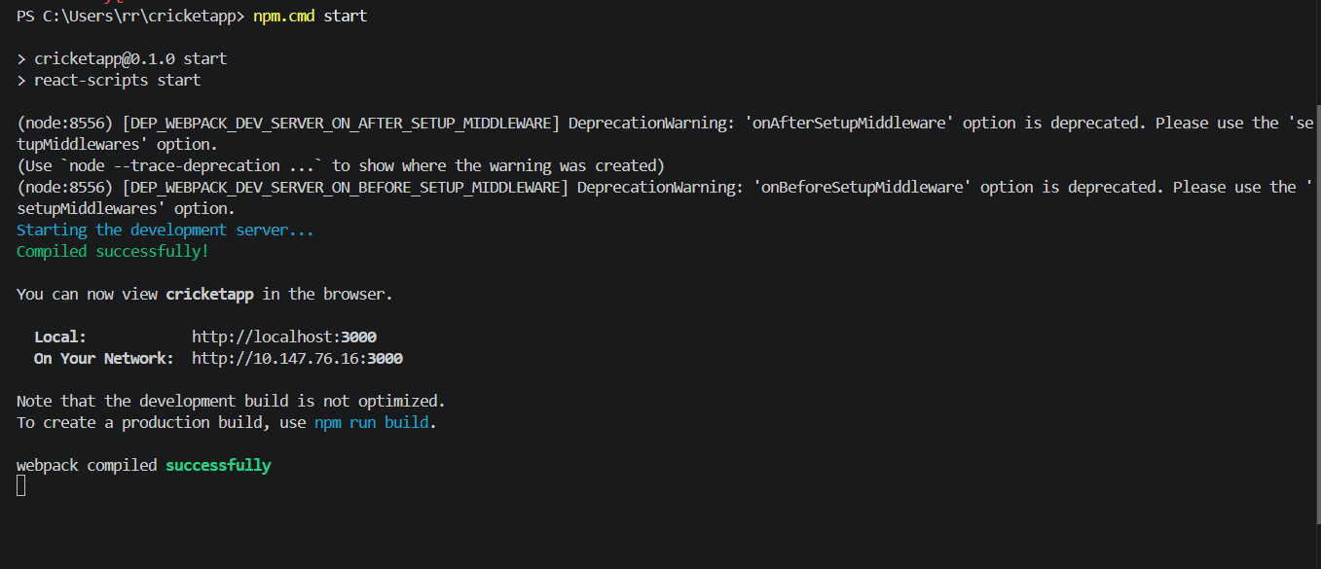

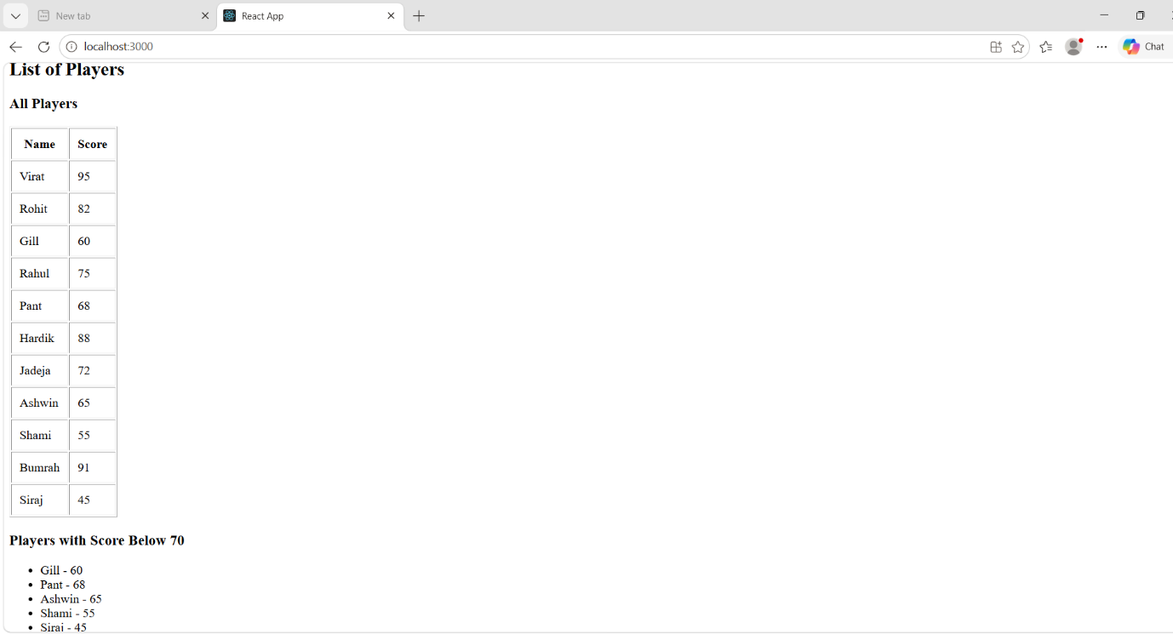

10.ReactJs-HOL
App.js:
import React from "react";
import "./App.css";

function App() {

// Single Office Object
const office = {
name: "Sky Tower",
rent: 55000,
address: "Chennai"
};

// List of Office Objects
const offices = [
{
name: "Sky Tower",
rent: 55000,
address: "Chennai"
},
{
name: "Tech Park",
rent: 75000,
address: "Bangalore"
},
{
name: "Business Hub",
rent: 45000,
address: "Hyderabad"
},
{
name: "Global Plaza",
rent: 90000,
address: "Mumbai"
}
];

return (
<div className="container">

<h1>Office Space Rental App</h1>

<img
src="https://images.unsplash.com/photo-1497366754035-f200968a6e72?w=600"
alt="Office Space"
/>

<h2>Single Office Details</h2>

<p><strong>Name:</strong> {office.name}</p>

<p>
<strong>Rent:</strong>
<span
style={{
color: office.rent < 60000 ? "red" : "green",
fontWeight: "bold"
}}
>
{" "}₹{office.rent}
</span>
</p>

<p><strong>Address:</strong> {office.address}</p>

<hr />

<h2>All Office Spaces</h2>

{
offices.map((item, index) => (
<div className="card" key={index}>

<h3>{item.name}</h3>

<p>
<strong>Rent:</strong>

<span
style={{
color: item.rent < 60000 ? "red" : "green",
fontWeight: "bold"
}}
>
{" "}₹{item.rent}
</span>
</p>

<p>
<strong>Address:</strong> {item.address}
</p>

</div>
))
}

</div>
);
}

export default App;

App.css:
.container {
padding: 20px;
font-family: Arial, sans-serif;
}

h1 {
color: navy;
}

img {
width: 500px;
height: 300px;
border-radius: 8px;
margin-bottom: 20px;
}

.card {
border: 1px solid gray;
padding: 15px;
margin-top: 15px;
width: 500px;
border-radius: 5px;
background-color: #f8f8f8;
}

index.js:
import React from "react";
import ReactDOM from "react-dom/client";
import "./index.css";
import App from "./App";

const root = ReactDOM.createRoot(document.getElementById("root"));

root.render(
<React.StrictMode>
<App />
</React.StrictMode>
);

index.css:
body {
margin: 0;
background-color: white;
}

index.html:
<!DOCTYPE html>
<html lang="en">

<head>
<meta charset="utf-8" />
<meta name="viewport" content="width=device-width, initial-scale=1" />
<title>Office Space Rental App</title>
</head>

<body>
<div id="root"></div>
</body>

</html>

package.json:
{
"name": "officespacerentalapp",
"version": "0.1.0",
"private": true,
"dependencies": {
"react": "^19.1.0",
"react-dom": "^19.1.0",
"react-scripts": "5.0.1"
},
"scripts": {
"start": "react-scripts start",
"build": "react-scripts build",
"test": "react-scripts test",
"eject": "react-scripts eject"
},
"browserslist": {
"production": [
">0.2%",
"not dead",
"not op_mini all"
],
"development": [
"last 1 chrome version",
"last 1 firefox version",
"last 1 safari version"
]
}
}

Output:
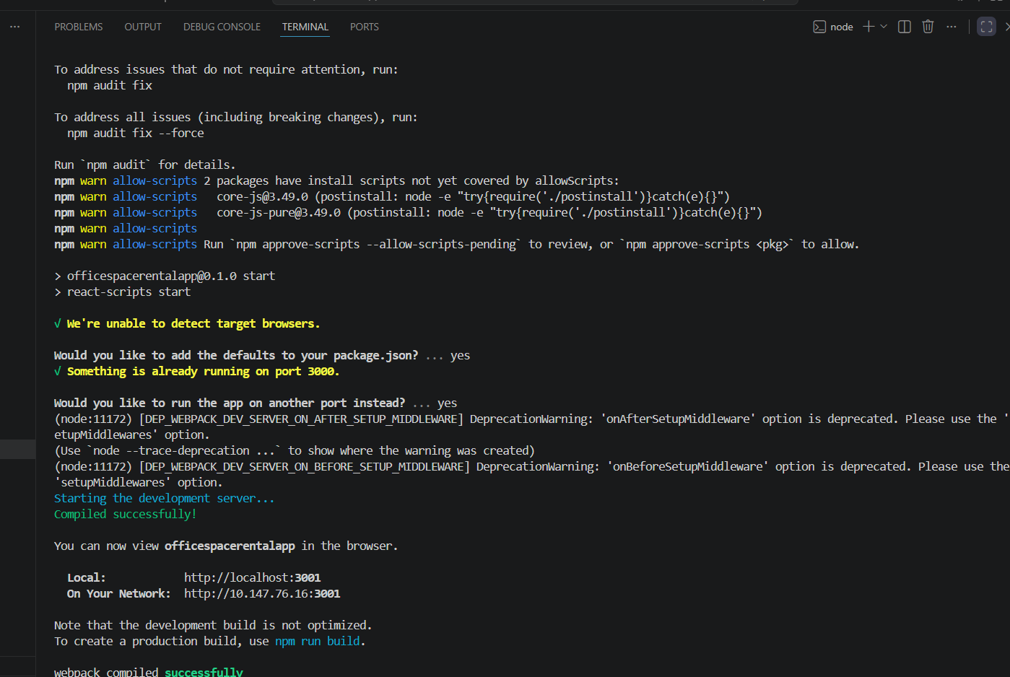

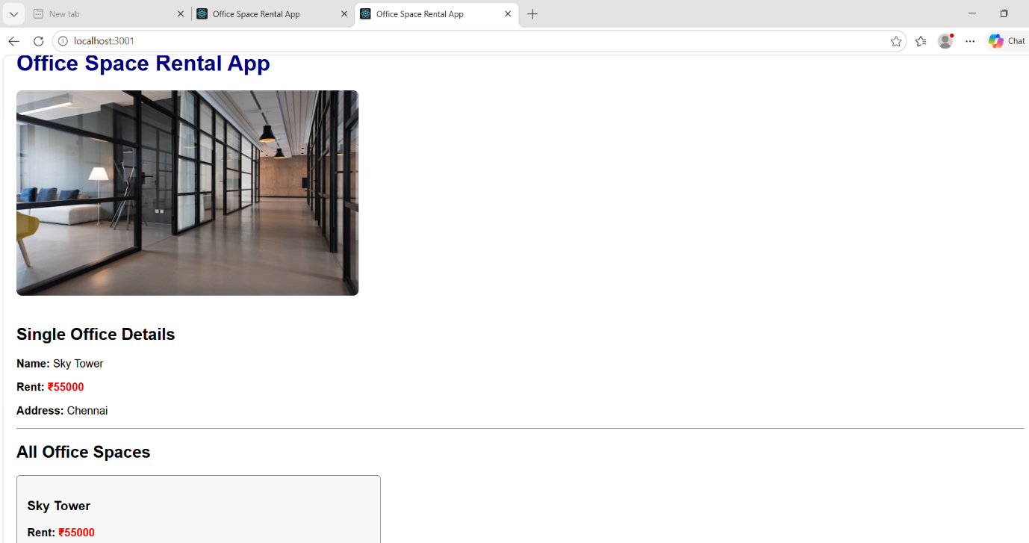

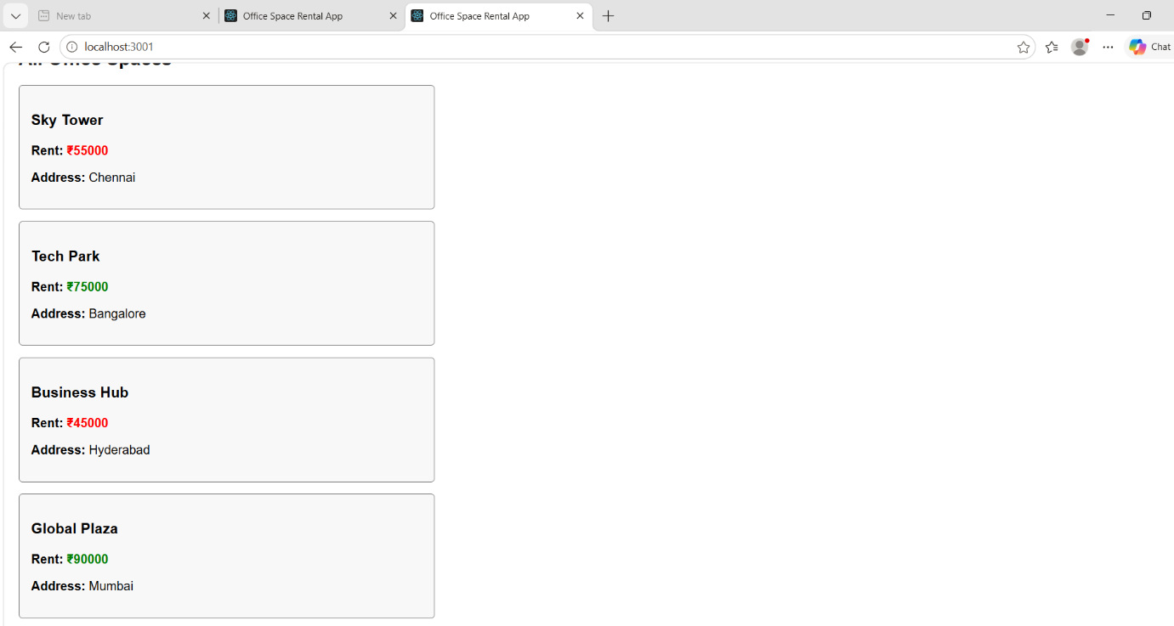

11.ReactJs-HOL
App.js:
import React from "react";
import "./App.css";
import EventExamples from "./EventExamples";
import CurrencyConvertor from "./CurrencyConvertor";

function App() {
return (
<div className="container">
<EventExamples />
<hr />
<CurrencyConvertor />
</div>
);
}

export default App;

EventExamples.js:
import React, { Component } from "react";

class EventExamples extends Component {

constructor() {
super();

this.state = {
count: 0
};
}

increment = () => {
this.setState({
count: this.state.count + 1
});
};

decrement = () => {
this.setState({
count: this.state.count - 1
});
};

sayHello = () => {
alert("Hello! Have a Nice Day.");
};

increase = () => {
this.increment();
this.sayHello();
};

sayWelcome = (msg) => {
alert(msg);
};

onPress = () => {
alert("I was clicked");
};

render() {

return (

<div>

<h1>Event Examples</h1>

<h2>Counter : {this.state.count}</h2>

<button onClick={this.increase}>
Increment
</button>

&nbsp;

<button onClick={this.decrement}>
Decrement
</button>

<br /><br />

<button onClick={() => this.sayWelcome("Welcome")}>
Say Welcome
</button>

<br /><br />

<button onClick={this.onPress}>
OnPress
</button>

</div>

);
}

}

export default EventExamples;

CurrencyConvertor.js:
import React, { Component } from "react";

class CurrencyConvertor extends Component {

constructor() {
super();

this.state = {
rupees: "",
euro: ""
};
}

handleChange = (event) => {
this.setState({
rupees: event.target.value
});
};

handleSubmit = () => {

const euro = this.state.rupees / 90;

this.setState({
euro: euro.toFixed(2)
});

};

render() {

return (

<div>

<h1>Currency Convertor</h1>

<input
type="number"
placeholder="Enter Rupees"
value={this.state.rupees}
onChange={this.handleChange}
/>

<br /><br />

<button onClick={this.handleSubmit}>
Convert
</button>

<h2>Euro : € {this.state.euro}</h2>

</div>

);

}

}

export default CurrencyConvertor;

App.css:
.container {
padding: 20px;
}

h1 {
color: navy;
text-align: center;
}

h2 {
color: darkblue;
}

button {
background-color: #007bff;
color: white;
border: none;
padding: 10px 15px;
margin: 5px;
border-radius: 5px;
cursor: pointer;
}

button:hover {
background-color: #0056b3;
}

input {
padding: 8px;
width: 200px;
margin-top: 10px;
}

hr {
margin: 30px 0;
}

index.css:
body {
margin: 0;
padding: 20px;
font-family: Arial, Helvetica, sans-serif;
background-color: #f5f5f5;
}

* {
box-sizing: border-box;
}

index.js:
import React from "react";
import ReactDOM from "react-dom/client";
import "./index.css";
import App from "./App";

const root = ReactDOM.createRoot(document.getElementById("root"));

root.render(
<React.StrictMode>
<App />
</React.StrictMode>
);

Output:
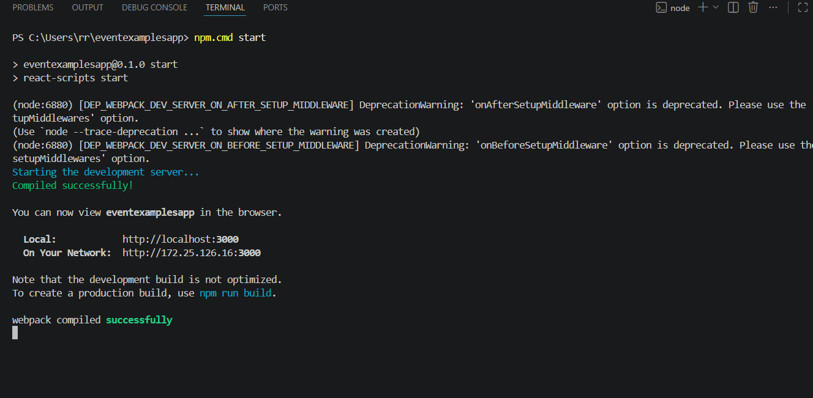
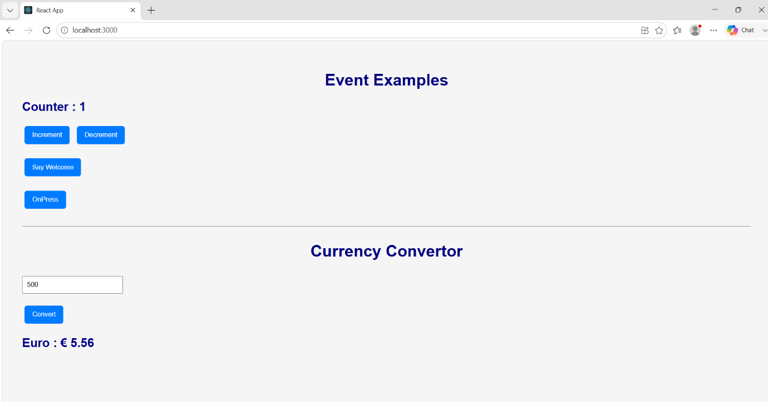

12.ReactJs-HOL
App.js:
import React, { useState } from "react";
import "./App.css";
import Guest from "./Guest";
import User from "./User";

function App() {

const [isLoggedIn, setIsLoggedIn] = useState(false);

return (
<div className="container">

<h1>Ticket Booking App</h1>

{
isLoggedIn ? (
<>
<button onClick={() => setIsLoggedIn(false)}>
Logout
</button>

<User />
</>
) : (
<>
<button onClick={() => setIsLoggedIn(true)}>
Login
</button>

<Guest />
</>
)
}

</div>
);
}

export default App;

Guest.js:
import React from "react";

function Guest() {
return (
<div>

<h2>Welcome Guest</h2>

<p>You can browse the available flights.</p>

<table border="1" cellPadding="10">
<thead>
<tr>
<th>Flight</th>
<th>From</th>
<th>To</th>
<th>Fare</th>
</tr>
</thead>

<tbody>
<tr>
<td>AI101</td>
<td>Chennai</td>
<td>Delhi</td>
<td>₹5000</td>
</tr>

<tr>
<td>AI202</td>
<td>Bangalore</td>
<td>Mumbai</td>
<td>₹4500</td>
</tr>
</tbody>
</table>

<p><b>Please login to book tickets.</b></p>

</div>
);
}

export default Guest;

User.js:
import React from "react";

function User() {
return (
<div>

<h2>Welcome User</h2>

<p>You are logged in.</p>

<table border="1" cellPadding="10">
<thead>
<tr>
<th>Flight</th>
<th>From</th>
<th>To</th>
<th>Fare</th>
</tr>
</thead>

<tbody>
<tr>
<td>AI101</td>
<td>Chennai</td>
<td>Delhi</td>
<td>₹5000</td>
</tr>

<tr>
<td>AI202</td>
<td>Bangalore</td>
<td>Mumbai</td>
<td>₹4500</td>
</tr>
</tbody>
</table>

<button>Book Ticket</button>

</div>
);
}

export default User;

index.js:
import React from "react";
import ReactDOM from "react-dom/client";
import "./index.css";
import App from "./App";

const root = ReactDOM.createRoot(document.getElementById("root"));

root.render(
<React.StrictMode>
<App />
</React.StrictMode>
);

App.css:
.container {
padding: 20px;
text-align: center;
}

button {
padding: 10px 20px;
margin: 15px;
background-color: royalblue;
color: white;
border: none;
cursor: pointer;
border-radius: 5px;
}

button:hover {
background-color: darkblue;
}

table {
margin: 20px auto;
border-collapse: collapse;
}

th {
background-color: #007bff;
color: white;
}

th,
td {
padding: 10px;
}

index.css:
body {
margin: 0;
font-family: Arial, sans-serif;
background-color: #f5f5f5;
}

* {
box-sizing: border-box;
}

Output:
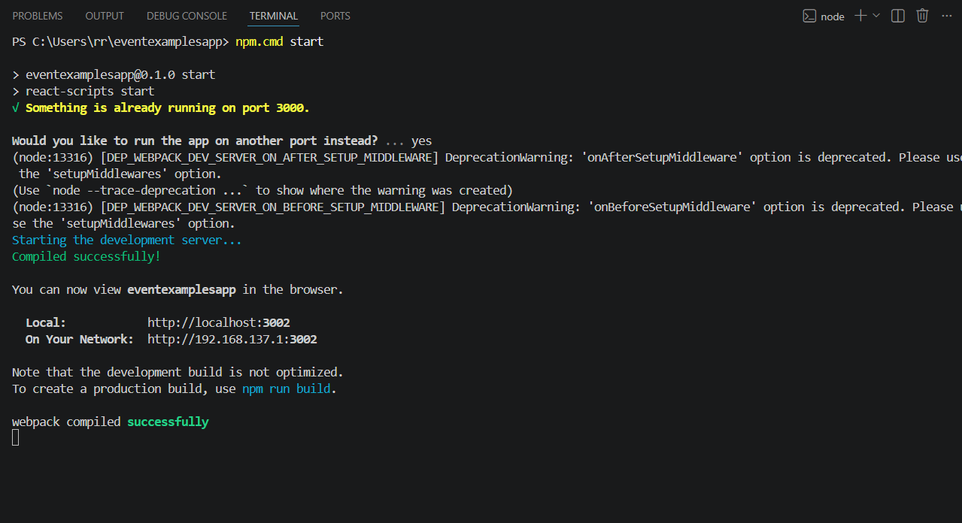

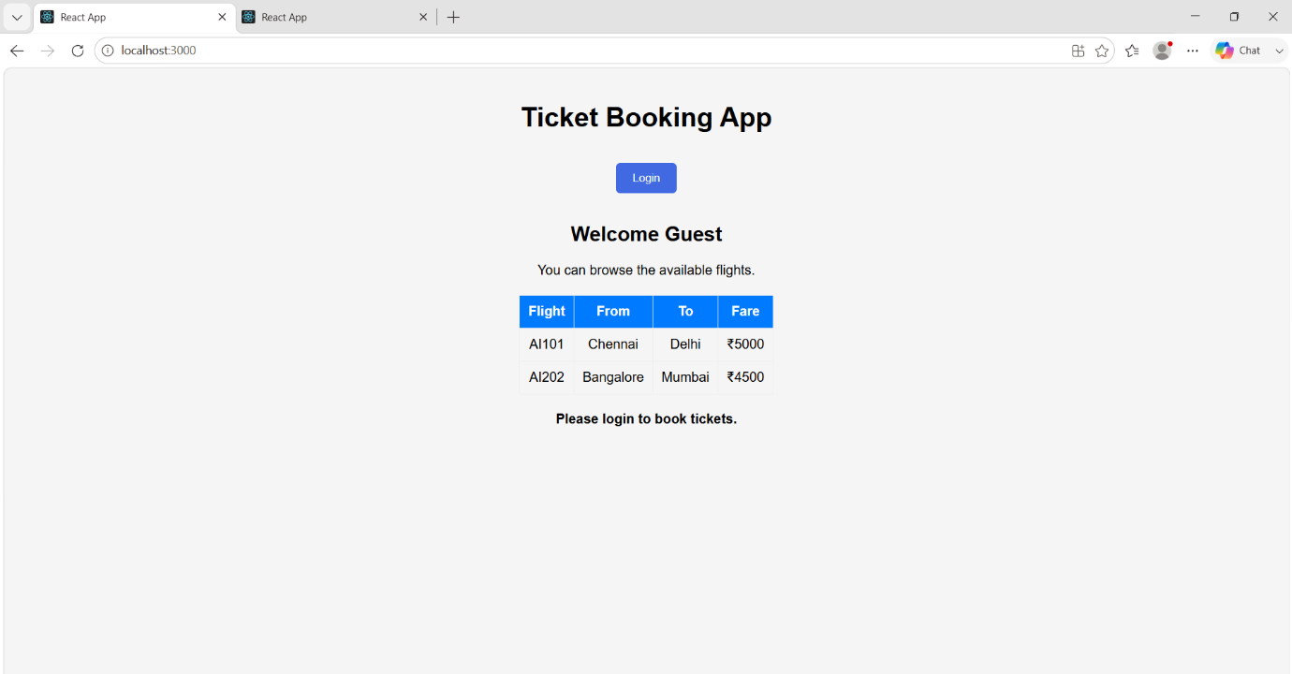

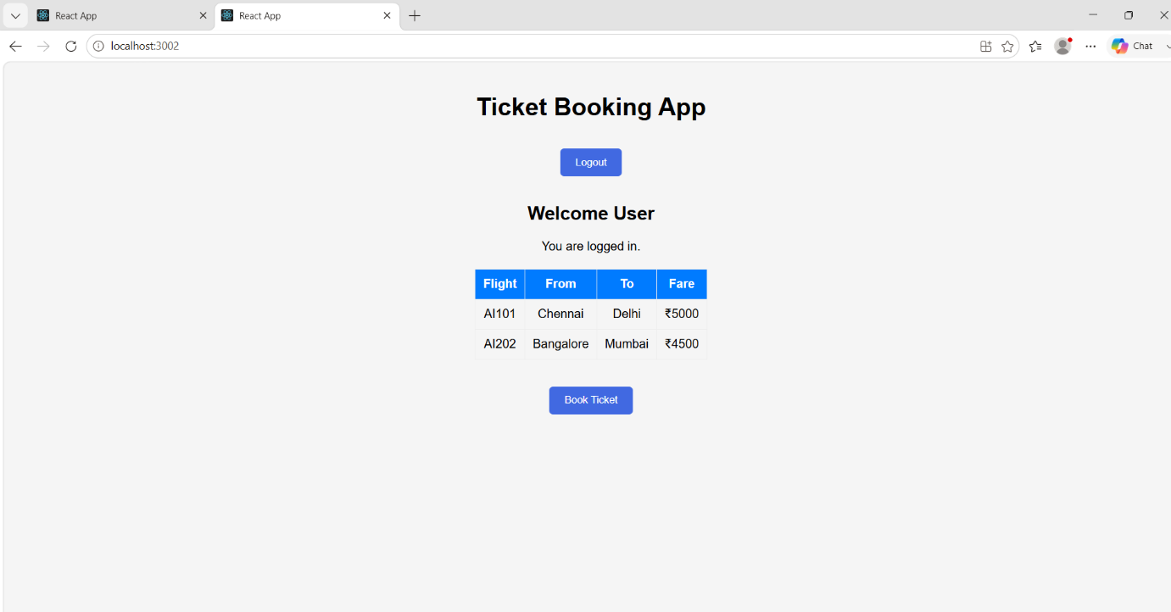

13.ReactJs-HOL
App.js:
import React from "react";
import "./App.css";
import BookDetails from "./BookDetails";
import BlogDetails from "./BlogDetails";
import CourseDetails from "./CourseDetails";

function App() {

const showBook = true;
const showBlog = true;
const showCourse = true;

// Element Variable
let blogComponent;

if (showBlog) {
blogComponent = <BlogDetails />;
}

return (
<div className="container">

<h1>Blogger App</h1>

{/* Method 1 : if-else */}
{showBook && <BookDetails />}

<hr />

{/* Method 2 : Element Variable */}
{blogComponent}

<hr />

{/* Method 3 : Ternary Operator */}
{showCourse ? <CourseDetails /> : <h3>No Course Available</h3>}

</div>
);
}

export default App;

App.css:
.container {
text-align: center;
padding: 20px;
}

table {
margin: 20px auto;
border-collapse: collapse;
}

th {
background-color: royalblue;
color: white;
}

th,
td {
padding: 10px;
}

ul {
list-style: none;
padding: 0;
}

li {
margin: 8px;
}

BookDetails.js:
import React from "react";

function BookDetails() {

const books = [
{
id: 1,
title: "React Basics",
author: "John",
price: 500
},
{
id: 2,
title: "Java Programming",
author: "James",
price: 650
},
{
id: 3,
title: "Python Guide",
author: "David",
price: 450
}
];

return (

<div>

<h2>Book Details</h2>

<table border="1" cellPadding="10">

<thead>

<tr>
<th>Title</th>
<th>Author</th>
<th>Price</th>
</tr>

</thead>

<tbody>

{
books.map(book => (

<tr key={book.id}>
<td>{book.title}</td>
<td>{book.author}</td>
<td>₹{book.price}</td>
</tr>

))
}

</tbody>

</table>

</div>

);

}

export default BookDetails;

BlogDetails.js:
import React from "react";

function BlogDetails() {

const blogs = [
{
id: 1,
title: "React Hooks",
writer: "Naveen"
},
{
id: 2,
title: "Java Full Stack",
writer: "Kumar"
},
{
id: 3,
title: "Spring Boot",
writer: "Admin"
}
];

return (

<div>

<h2>Blog Details</h2>

<ul>

{
blogs.map(blog => (

<li key={blog.id}>
{blog.title} - {blog.writer}
</li>

))
}

</ul>

</div>

);

}

export default BlogDetails;

CourseDetails.js:
import React from "react";

function CourseDetails() {

const courses = [
{
id: 1,
name: "React",
duration: "30 Days"
},
{
id: 2,
name: "Spring Boot",
duration: "45 Days"
},
{
id: 3,
name: "Python",
duration: "40 Days"
}
];

return (

<div>

<h2>Course Details</h2>

<table border="1" cellPadding="10">

<thead>

<tr>
<th>Course</th>
<th>Duration</th>
</tr>

</thead>

<tbody>

{
courses.map(course => (

<tr key={course.id}>
<td>{course.name}</td>
<td>{course.duration}</td>
</tr>

))
}

</tbody>

</table>

</div>

);

}

export default CourseDetails;

index.js:
import React from "react";
import ReactDOM from "react-dom/client";
import "./index.css";
import App from "./App";

const root = ReactDOM.createRoot(document.getElementById("root"));

root.render(
<React.StrictMode>
<App />
</React.StrictMode>
);

index.css:
body {
margin: 0;
font-family: Arial, Helvetica, sans-serif;
background-color: #f5f5f5;
}

* {
box-sizing: border-box;
}

Output:
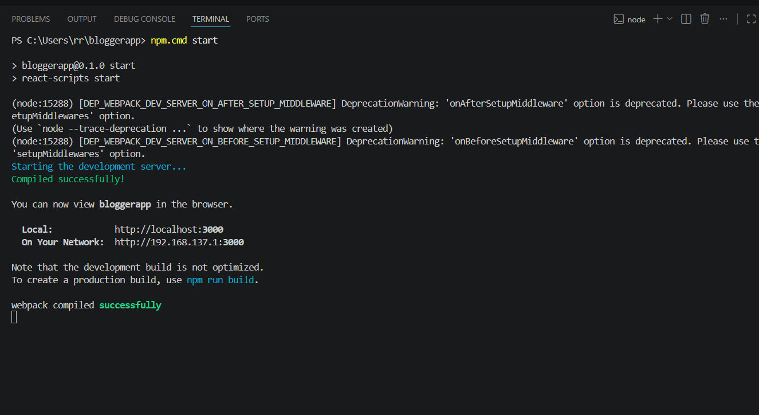

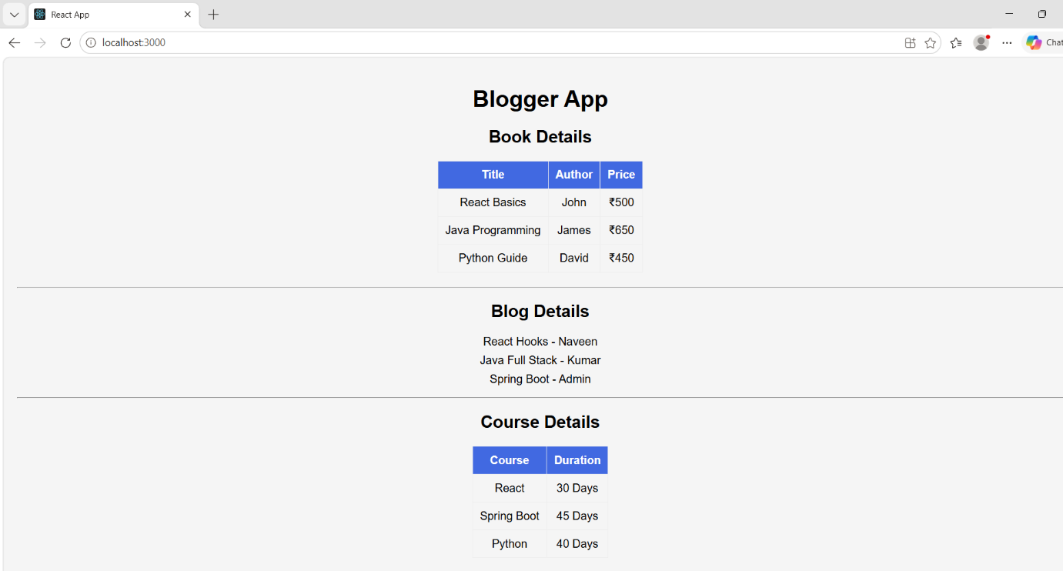

6.ReactJs-HOL:
App.js:
import React from "react";
import "./App.css";
import OnlineShopping from "./OnlineShopping";

function App() {
return (
<div className="container">
<h1>Shopping App</h1>
<OnlineShopping />
</div>
);
}

export default App;

App.css:
.container {
text-align: center;
padding: 20px;
}

table {
margin: auto;
border-collapse: collapse;
}

th {
background-color: royalblue;
color: white;
}

th,
td {
padding: 10px;
}

Home.js:
import React from "react";

function Home() {
return (
<div>
<h2>Welcome to Trainers App</h2>
<p>Select Trainers to view trainer details.</p>
</div>
);
}

export default Home;

Trainer.js:

class Trainer {
constructor(id, name, email, phone, technology, skills) {
this.trainerId = id;
this.name = name;
this.email = email;
this.phone = phone;
this.technology = technology;
this.skills = skills;
}
}

export default Trainer;

TrainersMock.js:
import Trainer from "./Trainer";

const trainers = [
new Trainer(
1,
"Rahul",
"rahul@gmail.com",
"9876543210",
"React",
"React, JavaScript, HTML, CSS"
),

new Trainer(
2,
"Priya",
"priya@gmail.com",
"9876501234",
"Java",
"Java, Spring Boot, Hibernate"
),

new Trainer(
3,
"Arun",
"arun@gmail.com",
"9123456789",
"Python",
"Python, Django, Flask"
)
];

export default trainers;

TrainersList.js:
import React from "react";
import trainers from "./TrainersMock";
import { Link } from "react-router-dom";

function TrainersList() {
return (
<div>

<h2>Trainers List</h2>

<ul>

{
trainers.map((trainer) => (

<li key={trainer.trainerId}>

<Link to={`/trainer/${trainer.trainerId}`}>
{trainer.name}
</Link>

</li>

))
}

</ul>

</div>
);
}

export default TrainersList;

TrainerDetails.js:
import React from "react";
import { useParams } from "react-router-dom";
import trainers from "./TrainersMock";

function TrainerDetails() {

const { id } = useParams();

const trainer = trainers.find(
(t) => t.trainerId === parseInt(id)
);

if (!trainer)
return <h2>Trainer Not Found</h2>;

return (
<div>

<h2>Trainer Details</h2>

<p><b>ID:</b> {trainer.trainerId}</p>

<p><b>Name:</b> {trainer.name}</p>

<p><b>Email:</b> {trainer.email}</p>

<p><b>Phone:</b> {trainer.phone}</p>

<p><b>Technology:</b> {trainer.technology}</p>

<p><b>Skills:</b> {trainer.skills}</p>

</div>
);
}

export default TrainerDetails;

App.js:
import React from "react";
import "./App.css";

import {
BrowserRouter,
Routes,
Route,
Link,
Navigate
} from "react-router-dom";

import Home from "./Home";
import TrainersList from "./TrainersList";
import TrainerDetails from "./TrainerDetails";

function App() {

return (

<BrowserRouter>

<div className="container">

<h1>Cognizant Trainers App</h1>

<nav>

<Link to="/">Home</Link>

{" | "}

<Link to="/trainers">
Trainers
</Link>

</nav>

<hr />

<Routes>

<Route
path="/"
element={<Navigate to="/home" />}
/>

<Route
path="/home"
element={<Home />}
/>

<Route
path="/trainers"
element={<TrainersList />}
/>

<Route
path="/trainer/:id"
element={<TrainerDetails />}
/>

</Routes>

</div>

</BrowserRouter>

);

}

export default App;

index.js:
import React from "react";
import ReactDOM from "react-dom/client";
import "./index.css";
import App from "./App";

const root = ReactDOM.createRoot(document.getElementById("root"));

root.render(
<React.StrictMode>
<App />
</React.StrictMode>
);

App.css:
.container{
padding:20px;
font-family:Arial;
}

nav{
margin:15px 0;
}

nav a{
text-decoration:none;
color:blue;
font-weight:bold;
margin-right:15px;
}

nav a:hover{
color:red;
}

Output:
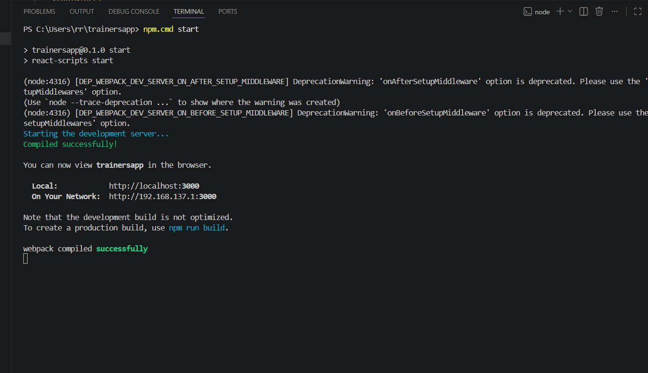
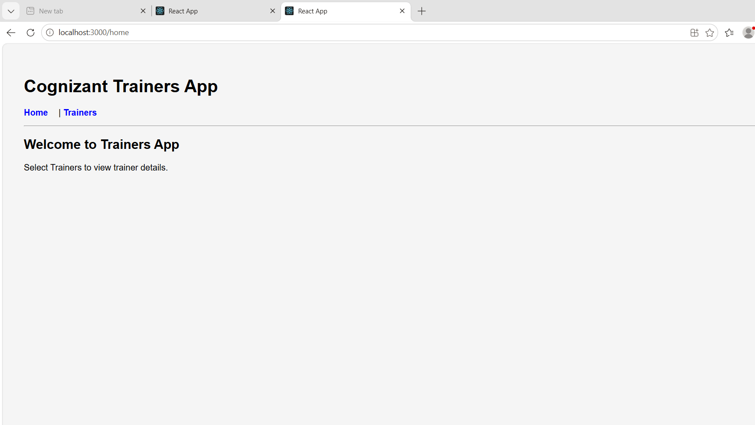
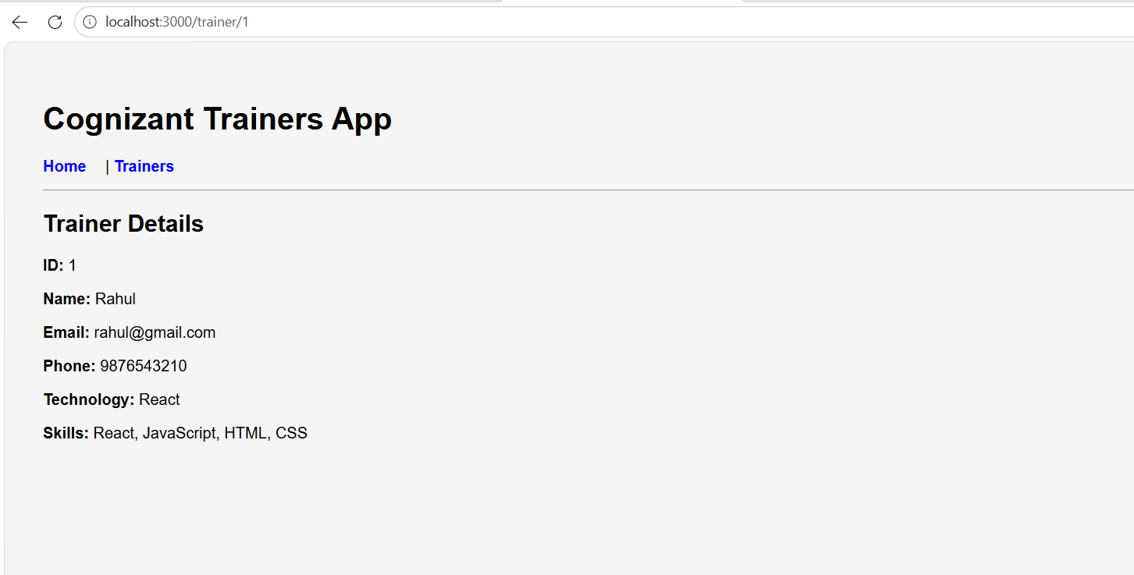

7.ReactJs-HOL
App.js:
import React from "react";
import "./App.css";
import OnlineShopping from "./OnlineShopping";

function App() {
return (
<div className="container">
<h1>Shopping App</h1>
<OnlineShopping />
</div>
);
}

export default App;

App.css:
.container {
text-align: center;
padding: 20px;
}

table {
margin: auto;
border-collapse: collapse;
}

th {
background-color: royalblue;
color: white;
}

th,
td {
padding: 10px;
}

Cart.js:
import React, { Component } from "react";

class Cart extends Component {
render() {
return (
<tr>
<td>{this.props.itemName}</td>
<td>₹{this.props.price}</td>
</tr>
);
}
}

export default Cart;
OnlineShopping.js:
import React, { Component } from "react";
import Cart from "./Cart";

class OnlineShopping extends Component {

constructor() {
super();

this.items = [
{ itemName: "Laptop", price: 60000 },
{ itemName: "Mobile", price: 25000 },
{ itemName: "Headphones", price: 2000 },
{ itemName: "Keyboard", price: 1500 },
{ itemName: "Mouse", price: 800 }
];
}

render() {
return (
<div>

<h2>Online Shopping Cart</h2>

<table border="1" cellPadding="10">

<thead>
<tr>
<th>Item Name</th>
<th>Price</th>
</tr>
</thead>

<tbody>

{
this.items.map((item, index) => (
<Cart
key={index}
itemName={item.itemName}
price={item.price}
/>
))
}

</tbody>

</table>

</div>
);
}
}

export default OnlineShopping;

index.js:
import React from "react";
import ReactDOM from "react-dom/client";
import "./index.css";
import App from "./App";

const root = ReactDOM.createRoot(document.getElementById("root"));

root.render(
<React.StrictMode>
<App />
</React.StrictMode>
);

index.css:
body {
margin: 0;
font-family: Arial, Helvetica, sans-serif;
background-color: #f5f5f5;
}

* {
box-sizing: border-box;
}

Output:
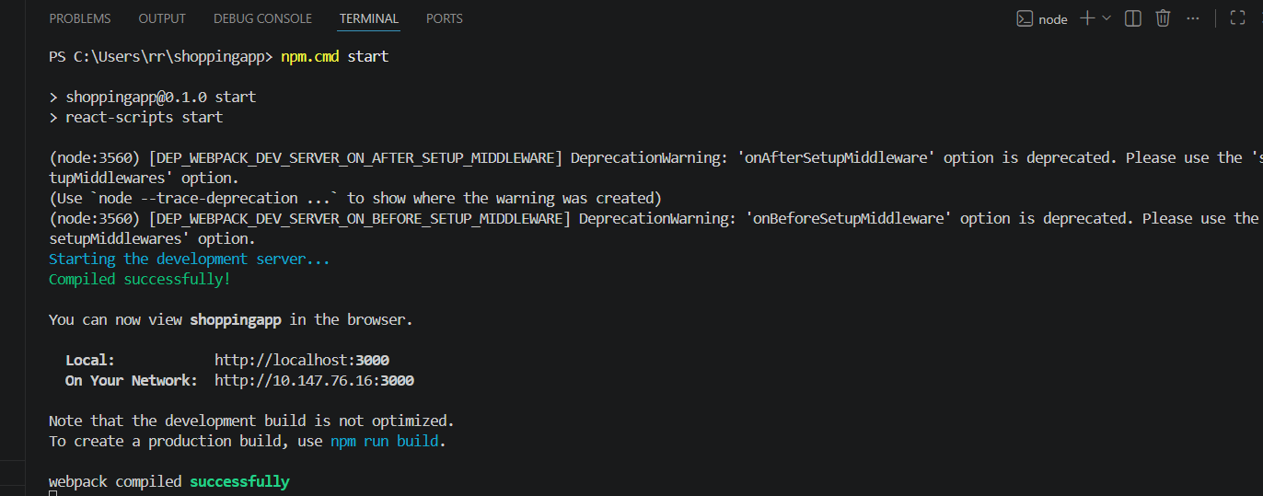

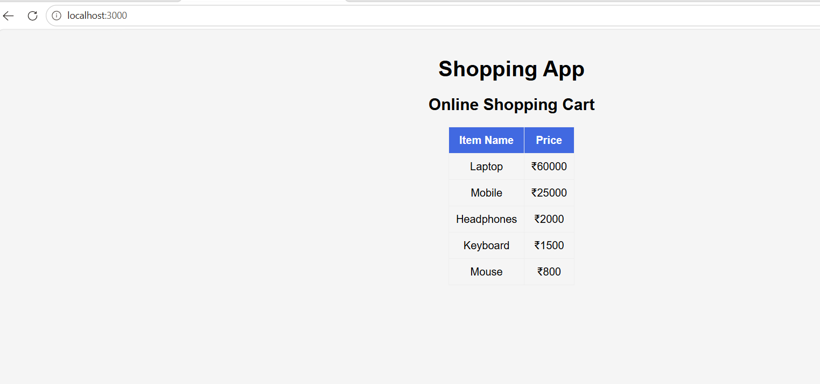

8.ReactJs-HOL:
App.js:
import React from "react";
import "./App.css";
import CountPeople from "./CountPeople";

function App() {
return (
<div className="container">
<h1>Counter App</h1>
<CountPeople />
</div>
);
}

export default App;

App.css:
.container {
text-align: center;
margin-top: 40px;
}

button {
padding: 10px 20px;
margin: 10px;
background-color: royalblue;
color: white;
border: none;
border-radius: 5px;
cursor: pointer;
}

button:hover {
background-color: darkblue;
}

CountPeople.js:
import React, { Component } from "react";

class CountPeople extends Component {

constructor() {
super();

this.state = {
entryCount: 0,
exitCount: 0
};
}

UpdateEntry = () => {
this.setState({
entryCount: this.state.entryCount + 1
});
};

UpdateExit = () => {
this.setState({
exitCount: this.state.exitCount + 1
});
};

render() {
return (
<div>

<h2>Mall Entry Counter</h2>

<h3>People Entered : {this.state.entryCount}</h3>

<button onClick={this.UpdateEntry}>
Login
</button>

<br /><br />

<h3>People Exited : {this.state.exitCount}</h3>

<button onClick={this.UpdateExit}>
Exit
</button>

</div>
);
}
}

export default CountPeople;

index.js:
import React from "react";
import ReactDOM from "react-dom/client";
import "./index.css";
import App from "./App";

const root = ReactDOM.createRoot(document.getElementById("root"));

root.render(
<React.StrictMode>
<App />
</React.StrictMode>
);
index.css:
body {
margin: 0;
font-family: Arial, Helvetica, sans-serif;
background-color: #f5f5f5;
}

* {
box-sizing: border-box;
}

Output:
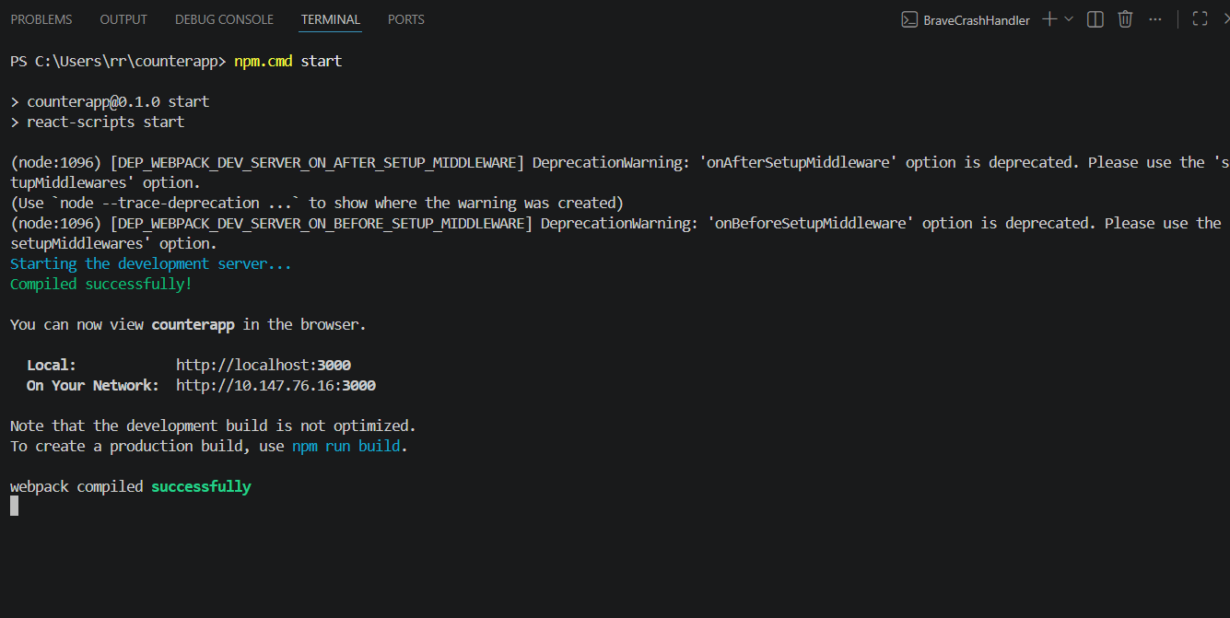
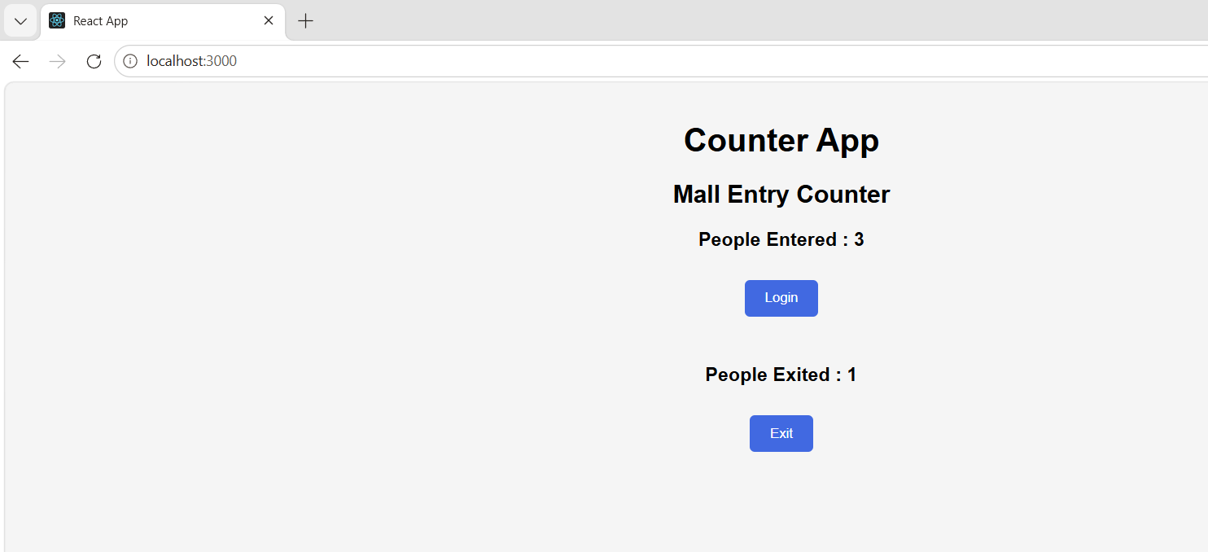

14.ReactJs-HOL:
App.js:
import React, { useState } from "react";
import "./App.css";
import EmployeeList from "./EmployeeList";
import ThemeContext from "./ThemeContext";

function App() {

const [theme] = useState("dark"); // change to "light" or "dark"

return (
<ThemeContext.Provider value={theme}>
<div className="container">
<h1>Employee Management</h1>
<EmployeeList />
</div>
</ThemeContext.Provider>
);
}

export default App;

EmployeeList.js:
import React from "react";
import EmployeeCard from "./EmployeeCard";

function EmployeeList() {

const employees = [

{
id:101,
name:"Rahul",
department:"React"
},

{
id:102,
name:"Priya",
department:"Java"
},

{
id:103,
name:"Arun",
department:"Python"
}

];

return (

<div>

{
employees.map(emp=>(
<EmployeeCard
key={emp.id}
employee={emp}
/>
))
}

</div>

);

}

export default EmployeeList;

EmployeeCard.js:
import React, { useContext } from "react";
import ThemeContext from "./ThemeContext";

function EmployeeCard({ employee }) {

const theme = useContext(ThemeContext);

return (
<div className="card">

<h3>{employee.name}</h3>

<p><b>ID:</b> {employee.id}</p>

<p><b>Department:</b> {employee.department}</p>

<button className={theme}>
View Details
</button>

</div>
);
}

export default EmployeeCard;

ThemeContext.js:
import { createContext } from "react";

const ThemeContext = createContext("light");

export default ThemeContext;

App.css:
.container{
text-align:center;
padding:20px;
}

.card{
width:320px;
margin:20px auto;
padding:20px;
border:1px solid #888;
border-radius:8px;
background:white;
}

.light{
background:white;
color:black;
border:2px solid black;
padding:10px 18px;
cursor:pointer;
}

.dark{
background:black;
color:white;
border:none;
padding:10px 18px;
cursor:pointer;
}

index.js:
import React from "react";
import ReactDOM from "react-dom/client";
import "./index.css";
import App from "./App";

const root = ReactDOM.createRoot(
document.getElementById("root")
);

root.render(
<React.StrictMode>
<App />
</React.StrictMode>
);

index.css:
body{
margin:0;
font-family:Arial;
background:#f5f5f5;
}

*{
box-sizing:border-box;
}

Output:

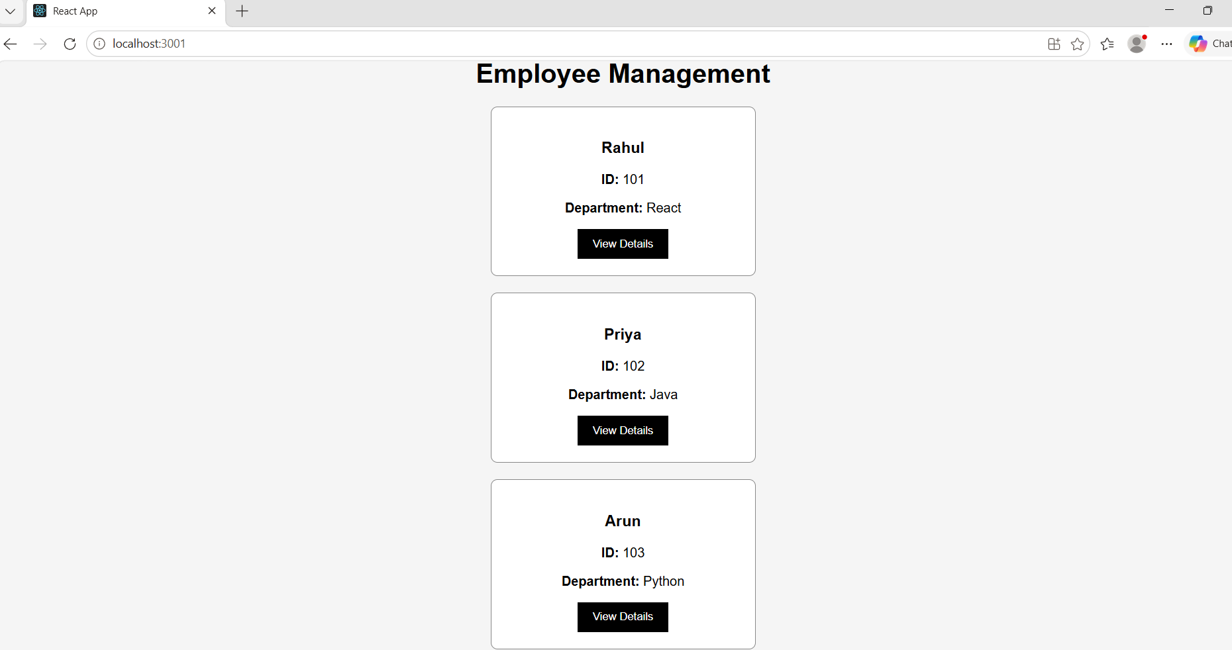

15.ReactJs-HOL:
App.js:
import React from "react";
import "./App.css";
import ComplaintRegister from "./ComplaintRegister";

function App() {
return (
<div className="container">
<ComplaintRegister />
</div>
);
}

export default App;

ComplaintRegister.js:
import React, { Component } from "react";

class ComplaintRegister extends Component {

constructor() {
super();

this.state = {
employeeName: "",
complaint: ""
};
}

handleNameChange = (event) => {
this.setState({
employeeName: event.target.value
});
};

handleComplaintChange = (event) => {
this.setState({
complaint: event.target.value
});
};

handleSubmit = (event) => {
event.preventDefault();

const refNo = Math.floor(Math.random() * 100000);

alert(
"Complaint Registered Successfully!\n\n" +
"Employee Name: " + this.state.employeeName +
"\nReference Number: " + refNo
);

this.setState({
employeeName: "",
complaint: ""
});
};

render() {

return (

<div className="form-container">

<h1>Ticket Raising App</h1>

<form onSubmit={this.handleSubmit}>

<label>Employee Name</label>

<br />

<input
type="text"
value={this.state.employeeName}
onChange={this.handleNameChange}
placeholder="Enter Employee Name"
required
/>

<br /><br />

<label>Complaint</label>

<br />

<textarea
rows="5"
cols="40"
value={this.state.complaint}
onChange={this.handleComplaintChange}
placeholder="Enter Complaint"
required
/>

<br /><br />

<button type="submit">
Submit Complaint
</button>

</form>

</div>

);
}

}

export default ComplaintRegister;

App.css:
.container{
display:flex;
justify-content:center;
align-items:center;
margin-top:40px;
}

.form-container{
width:450px;
padding:20px;
border:1px solid gray;
border-radius:8px;
background:#f9f9f9;
}

h1{
text-align:center;
}

label{
font-weight:bold;
}

input,
textarea{
width:100%;
padding:8px;
margin-top:5px;
font-size:16px;
}

button{
width:100%;
padding:10px;
background:royalblue;
color:white;
border:none;
cursor:pointer;
font-size:16px;
}

button:hover{
background:darkblue;
}

index.js:
import React from "react";
import ReactDOM from "react-dom/client";
import "./index.css";
import App from "./App";

const root = ReactDOM.createRoot(
document.getElementById("root")
);

root.render(
<React.StrictMode>
<App />
</React.StrictMode>
);

index.css:
body{
margin:0;
font-family:Arial, Helvetica, sans-serif;
background:#f2f2f2;
}

*{
box-sizing:border-box;
}

Output:
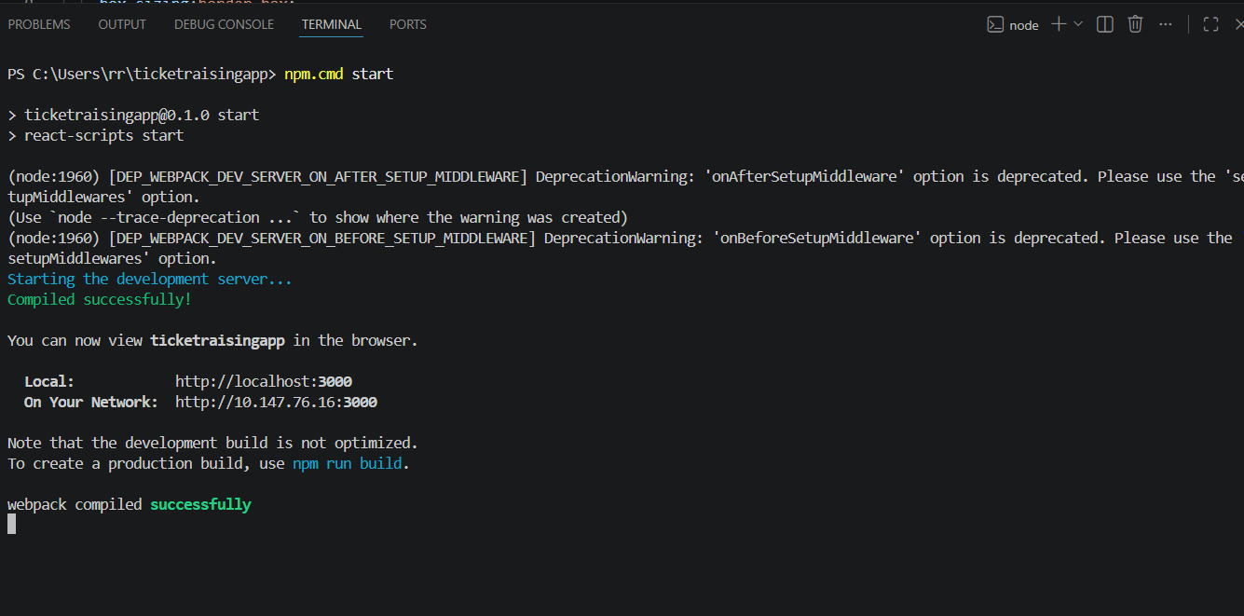

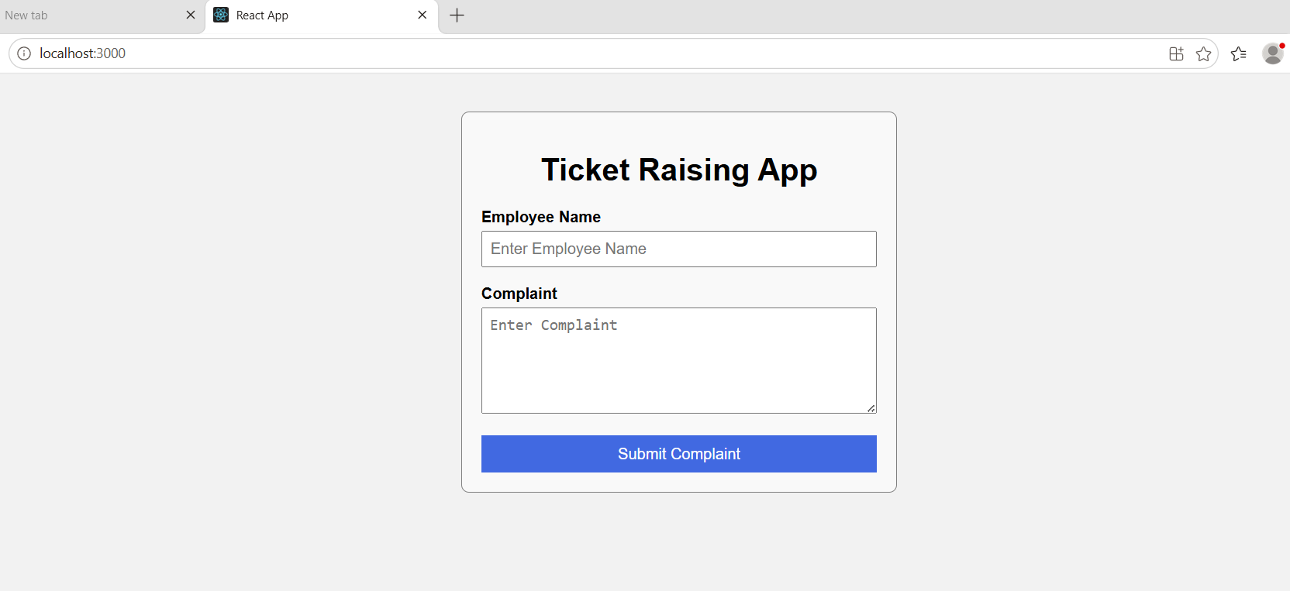
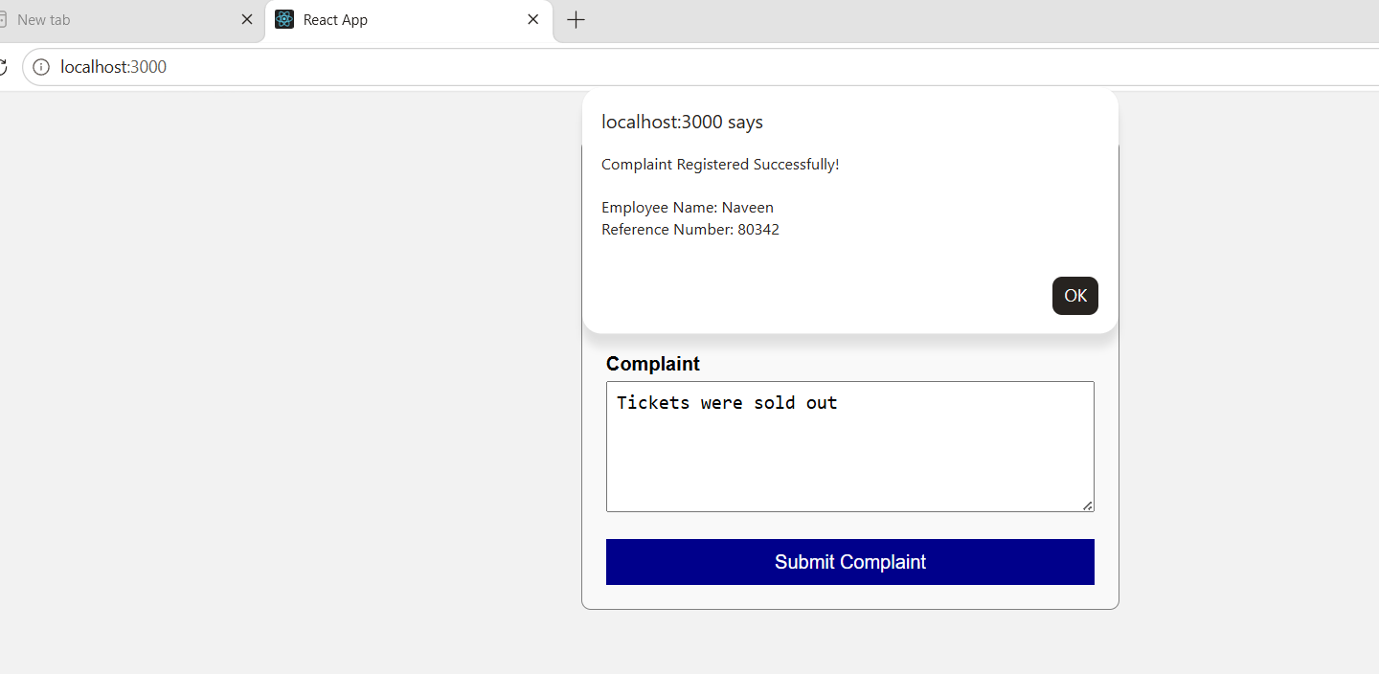

16.ReactJs-HOL:
App.js:
import React from "react";
import "./App.css";
import Register from "./Register";

function App() {
return (
<div className="container">
<Register />
</div>
);
}

export default App;

Register.js:
import React, { Component } from "react";

class Register extends Component {
constructor() {
super();

this.state = {
name: "",
email: "",
password: "",
errors: {}
};
}

handleChange = (event) => {
this.setState({
[event.target.name]: event.target.value
});
};

validate = () => {
let errors = {};

// Name Validation
if (this.state.name.length < 5) {
errors.name = "Name should have at least 5 characters";
}

// Email Validation
if (
!this.state.email.includes("@") ||
!this.state.email.includes(".")
) {
errors.email = "Enter a valid Email";
}

// Password Validation
if (this.state.password.length < 8) {
errors.password = "Password should have at least 8 characters";
}

this.setState({ errors });

return Object.keys(errors).length === 0;
};

handleSubmit = (event) => {
event.preventDefault();

if (this.validate()) {
alert("Registration Successful");
}
};

render() {
return (
<div className="form-box">

<h2>Mail Registration</h2>

<form onSubmit={this.handleSubmit}>

<label>Name</label>

<input
type="text"
name="name"
value={this.state.name}
onChange={this.handleChange}
/>

<span className="error">
{this.state.errors.name}
</span>

<label>Email</label>

<input
type="text"
name="email"
value={this.state.email}
onChange={this.handleChange}
/>

<span className="error">
{this.state.errors.email}
</span>

<label>Password</label>

<input
type="password"
name="password"
value={this.state.password}
onChange={this.handleChange}
/>

<span className="error">
{this.state.errors.password}
</span>

<button type="submit">
Register
</button>

</form>

</div>
);
}
}

export default Register;

App.css:
.container{
display:flex;
justify-content:center;
margin-top:40px;
}

.form-box{
width:350px;
padding:20px;
border:1px solid gray;
border-radius:8px;
background:#f8f8f8;
}

h2{
text-align:center;
}

label{
display:block;
margin-top:15px;
font-weight:bold;
}

input{
width:100%;
padding:8px;
margin-top:5px;
}

button{
width:100%;
margin-top:20px;
padding:10px;
background:royalblue;
color:white;
border:none;
cursor:pointer;
}

button:hover{
background:darkblue;
}

.error{
color:red;
font-size:14px;
}

index.js:
import React from "react";
import ReactDOM from "react-dom/client";
import "./index.css";
import App from "./App";

const root = ReactDOM.createRoot(
document.getElementById("root")
);

root.render(
<React.StrictMode>
<App />
</React.StrictMode>
);

index.css:
body{
margin:0;
font-family:Arial, Helvetica, sans-serif;
background:#eeeeee;
}

*{
box-sizing:border-box;
}

Output:

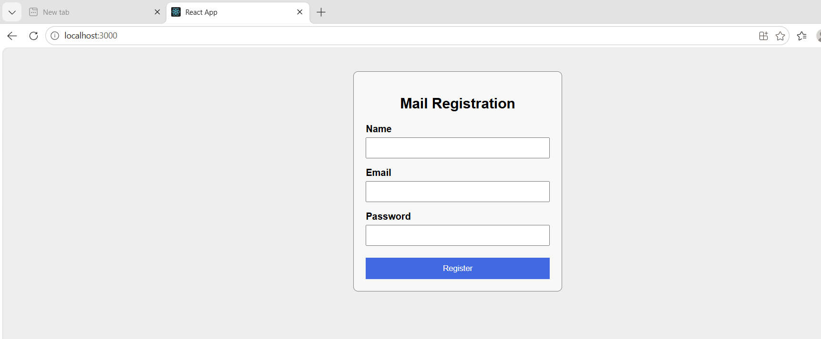
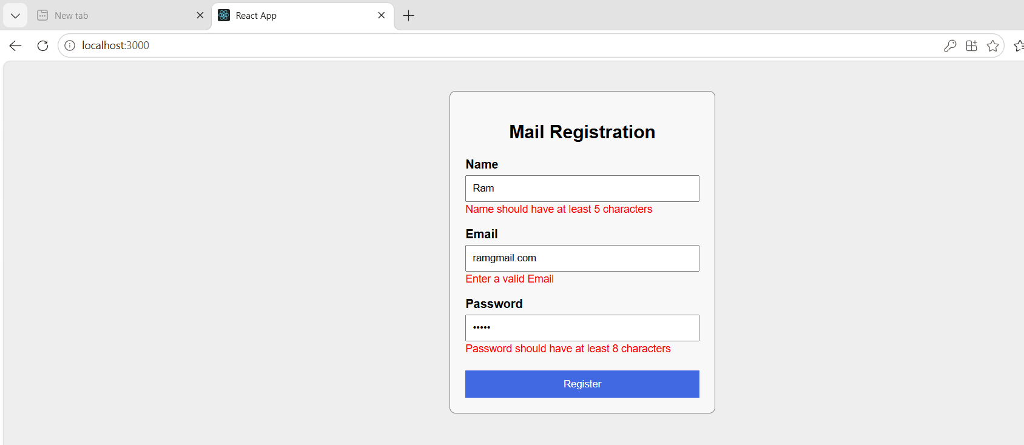

17.ReactJs-HOL:
App.js:
import React from "react";
import "./App.css";
import Getuser from "./Getuser";

function App() {
return (
<div className="container">
<Getuser />
</div>
);
}

export default App;

Getuser.js:
import React, { Component } from "react";

class Getuser extends Component {

constructor() {
super();

this.state = {
title: "",
firstName: "",
image: ""
};
}

async componentDidMount() {

const response = await fetch("https://api.randomuser.me/");

const data = await response.json();

const user = data.results[0];

this.setState({
title: user.name.title,
firstName: user.name.first,
image: user.picture.large
});

}

render() {

return (

<div className="card">

<h1>Fetch User App</h1>

<img
src={this.state.image}
alt="User"
/>

<h2>
{this.state.title} {this.state.firstName}
</h2>

</div>

);

}

}

export default Getuser;

App.css:
.container{
display:flex;
justify-content:center;
align-items:center;
margin-top:40px;
}

.card{
width:300px;
padding:20px;
text-align:center;
border:1px solid gray;
border-radius:10px;
background:#f8f8f8;
}

img{
width:150px;
height:150px;
border-radius:50%;
}

index.js:
import React from "react";
import ReactDOM from "react-dom/client";
import "./index.css";
import App from "./App";

const root = ReactDOM.createRoot(
document.getElementById("root")
);

root.render(
<React.StrictMode>
<App />
</React.StrictMode>
);

index.css:
body{
margin:0;
font-family:Arial, Helvetica, sans-serif;
background:#eeeeee;
}

*{
box-sizing:border-box;
}

Output:
