**Day28 - Practice Exercise: Spring Boot Application CI Pipeline**

Step 1: Create a Simple Spring Boot Application

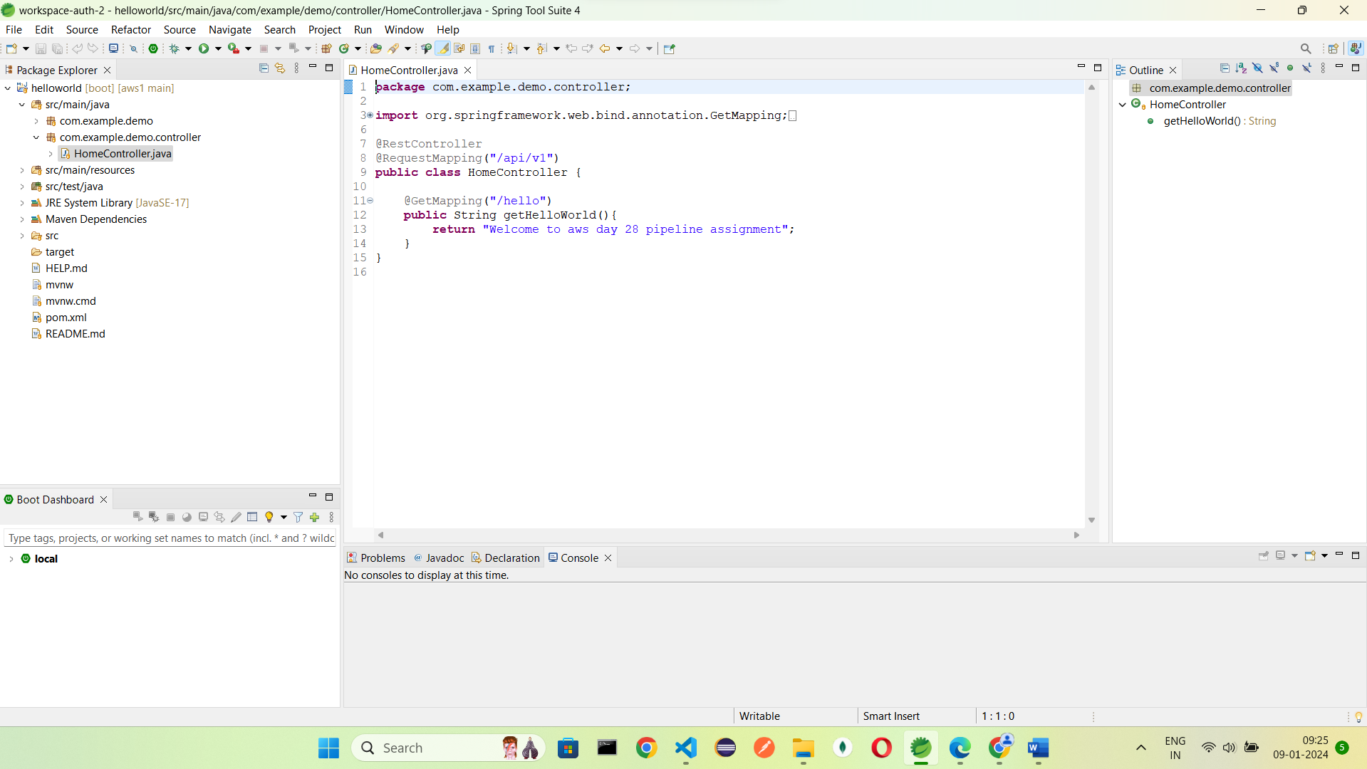

Step 2: Create a Github Repository

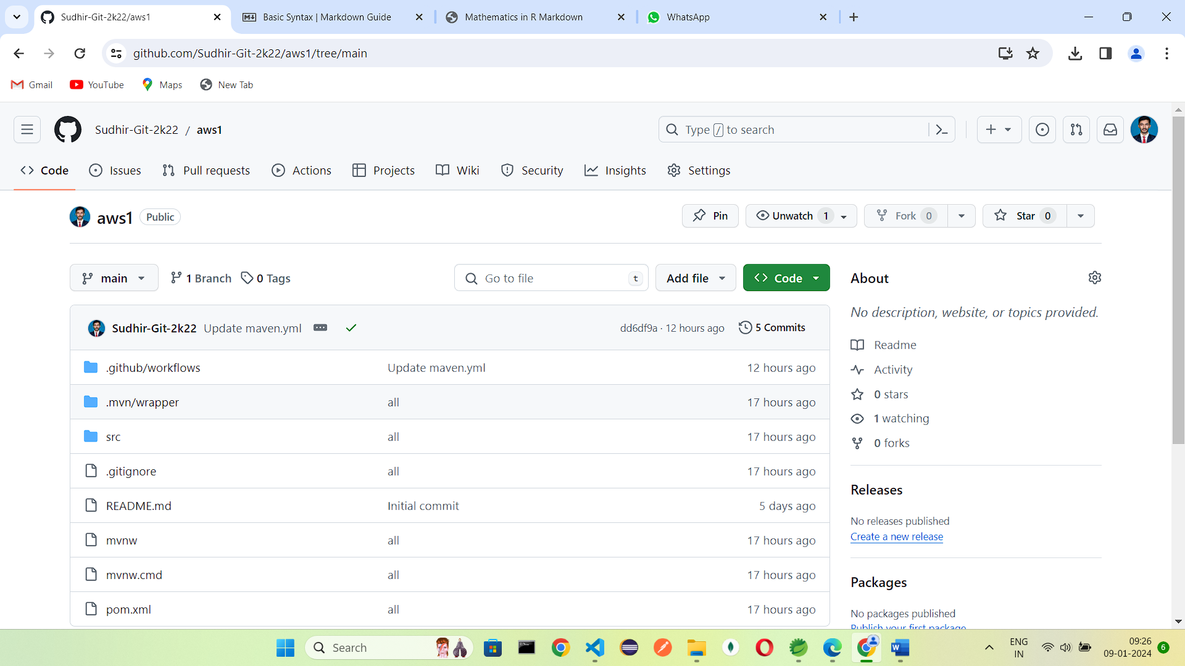

Step 3: Commit the initial code and push it to a remote repository GitHub.

Step 4: Create a GitHub Actions Workflow:

In the root of your project, create a .github/workflows folder.

Inside this folder, create a YAML file ( **maven.yml**) for the GitHub Actions workflow.

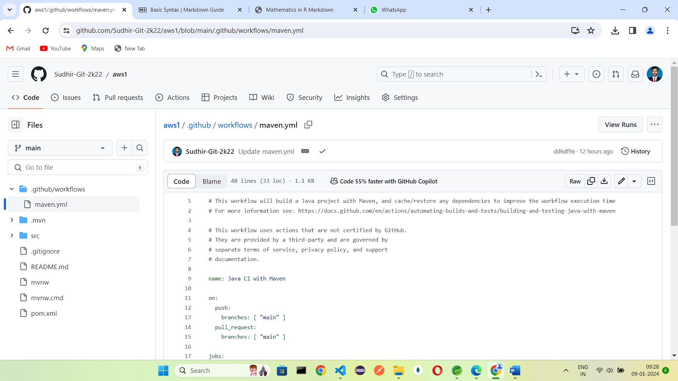

Step 5: Open GitHub Actions Workflow: It will start building

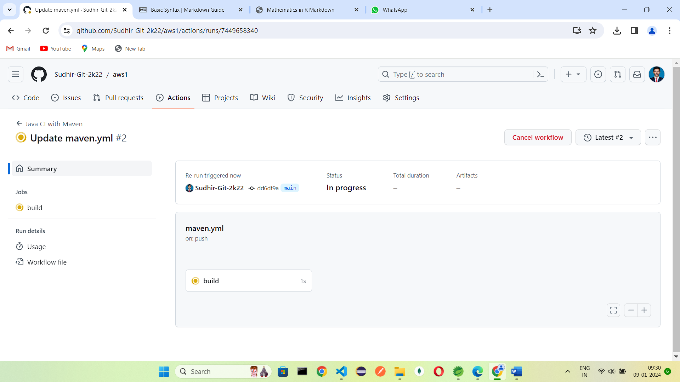

Build successful  
