AUMS UI Evaluation:

# Sudhir.R.T

# Cb.en.u4cys21074

## Schneiderman Principles of UI

* Strive for consistency.
* Enable frequent users to use shortcuts.
* Offer informative feedback.
* Design dialogue to yield closure.
* Offer simple error handling.
* Permit easy reversal of actions.
* Support internal locus of control.
* Reduce short term memory load.

AUMS ( Amrita University Management System ) is a web-based application that is used by students, faculty, and staff at Amrita University to access a variety of online resources and services related to their academic and administrative needs.

The AUMS is actually based on the open source Sakai Project. The patches applied to AUMS gives the AUMS the look and feel are not open sourced , but the core that is based on it.

# UIE:

ID: AUMS_UIE_001

To access something related to a course in AUMS is very hard as one you need to remember the respective course’s code and two even if you know the code you can just see the start of the course code and you need to hover over the tab to see the full course code (not possible on phone) .

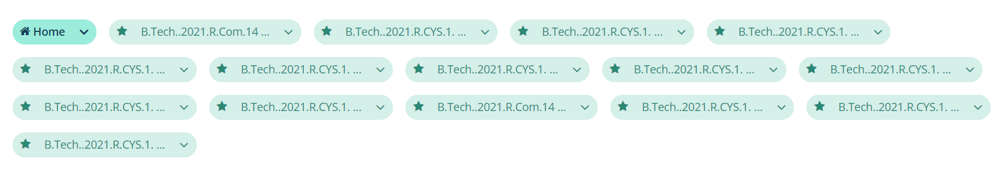

Principles Violated:

* Reduce short term memory load.
* Offer informative feedback.

Suggestion:

Just keep the subject names as the name of the tabs.

ID: AUMS_UIE_002

Sometimes when you try to login you are greeted with a logout successful page it’s such a annoying hassle as you need to login again and during exams and quizzes on aums this is a waste of time.

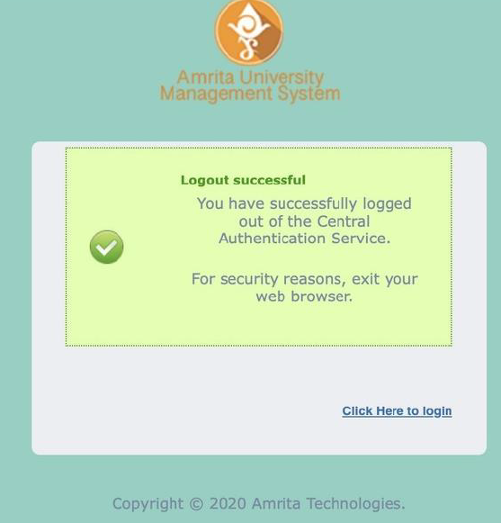

Principle Violated :

* Support internal locus of control.

Suggestion:

Maintain sessions properly.

ID: AUMS_UIE_003

Some resource materials in resources section is not accessible after more than a certain number of number of files have been added.

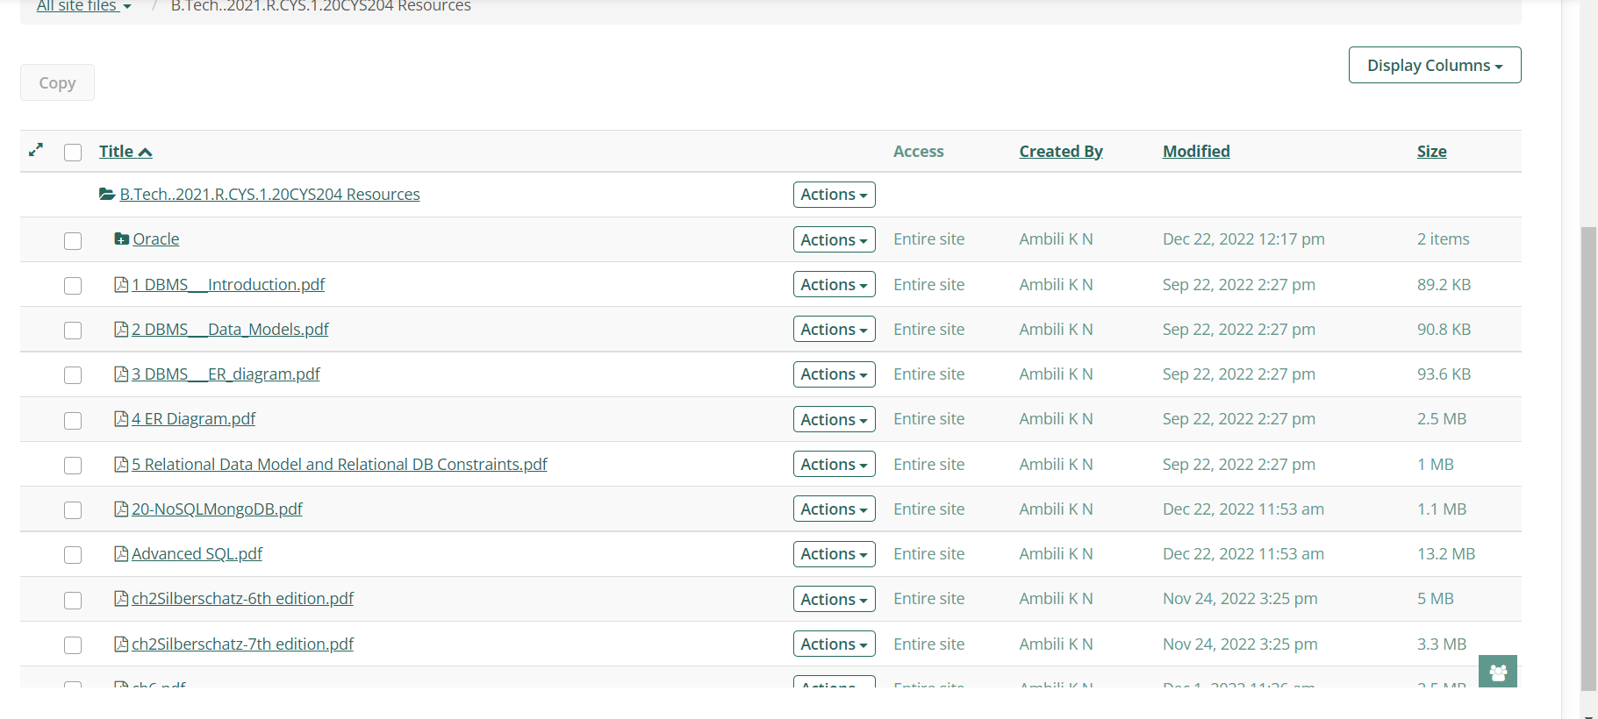

Principle Violated:

* Support internal locus of control.

Suggestion:

Add a scroll function to the resource list.

ID: AUMS_UIE_004

It becomes hard to scroll past and display the next row in the marks table if the number of rows exceeds a certain limit.

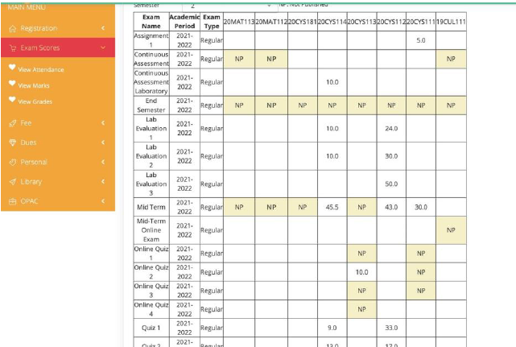

Principle Violated :

Strive for consistency.

Suggestion :

The table's alignment needs to be changed dynamically using CSS.

ID: AUMS_UIE_005:

It is difficult for the user to read the text since it is cut off multiple times.

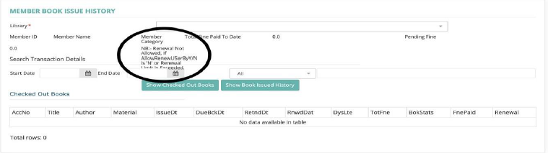

Principle Violated :

Strive for consistency.

Suggestion :

CSS must be used to dynamically modify the text's alignment.