Deep Learning Framework for Automated Plant Disease Detection Using Leaf Images
ABSTRACT
Plant diseases significantly affect crop quality, productivity, and farmers' income. Traditional disease identification mainly depends on manual inspection by farmers or agricultural experts, which can be time-consuming, subjective, and difficult to scale. This project proposes a Deep Learning Framework for Automated Plant Disease Detection Using Leaf Images. The system analyzes images of plant leaves and automatically identifies whether a leaf is healthy or affected by a particular disease. The proposed framework uses image preprocessing and deep learning techniques, particularly Convolutional Neural Networks (CNNs), to learn visual patterns such as spots, discoloration, lesions, and texture changes associated with different plant diseases. A suitable publicly available leaf-image dataset can be used to train and evaluate the model. The methodology includes image acquisition, preprocessing, feature extraction, feature selection, model training, and classification. The framework aims to provide a fast, consistent, and accessible approach for preliminary plant disease detection. Such a system can support farmers and agricultural professionals in identifying diseases at an early stage and potentially reducing crop losses.

1. INTRODUCTION
1.1 Background
Agriculture plays an important role in food production and economic development. However, plant diseases are one of the major factors responsible for reduced agricultural productivity. Diseases can affect leaves, stems, fruits, and roots, with visible symptoms often appearing on plant leaves in the form of spots, color changes, lesions, or abnormal textures.
Traditionally, identifying plant diseases requires farmers or agricultural experts to visually inspect plants. This approach requires experience and may become difficult when large agricultural fields need to be monitored. Differences in lighting, disease stages, plant varieties, and environmental conditions can also make manual identification challenging.
Recent developments in Artificial Intelligence (AI), Machine Learning (ML), Computer Vision, and Deep Learning have created opportunities for automated plant disease detection. Deep learning models can learn complex visual patterns directly from images, making them suitable for classifying healthy and diseased leaves.
Therefore, this project focuses on developing a deep learning-based framework that can automatically detect plant diseases from leaf images.

1.2 Problem Statement
Plant diseases can spread rapidly and cause significant crop losses if they are not identified at an early stage. Manual disease identification is often dependent on expert knowledge and may be slow, subjective, and difficult to apply to large numbers of plants.
The problem addressed in this project is:
How can a deep learning framework automatically identify plant diseases from leaf images with reliable classification performance?
The proposed system aims to process a leaf image and classify it into the appropriate disease category or identify it as healthy.

1.3 Research Gap
Several existing studies have demonstrated that machine learning and deep learning can successfully classify plant diseases from leaf images. However, many existing approaches have limitations.
Some traditional machine learning systems depend heavily on manually designed features such as color, texture, and shape. These features may not perform consistently under different lighting conditions or for visually similar diseases.
Deep learning approaches can automatically learn useful features from images, but they may require large datasets, significant computational resources, and careful preprocessing. Furthermore, models trained on controlled laboratory images may not always perform equally well on real-world field images.
Therefore, there is a need for a framework that combines appropriate image preprocessing, automatic feature extraction, feature selection, and deep learning classification to create an effective and practical plant disease detection system.

1.4 Research Objectives
The main objectives of this project are:
- To develop a deep learning framework for automated plant disease detection using leaf images.
- To preprocess leaf images to improve their suitability for model training.
- To extract meaningful visual features from plant leaf images using deep learning.
- To implement feature selection or dimensionality reduction where appropriate.
- To train a deep learning classification model for identifying different plant diseases.
- To evaluate the performance of the proposed framework using standard classification metrics.
- To investigate the potential of automated disease detection as a support tool for early identification of plant diseases.

1.5 Research Questions
The project addresses the following research questions:
RQ1: How effectively can deep learning models detect plant diseases from leaf images?
RQ2: How does image preprocessing affect plant disease classification performance?
RQ3: Which visual features are most useful for distinguishing healthy and diseased leaves?
RQ4: Can feature selection improve the efficiency and performance of the classification model?
RQ5: How accurately can the proposed framework classify different plant disease categories?

1.6 Contributions
The major contributions of this project are:
- A systematic framework for automated plant disease detection from leaf images.
- An image preprocessing pipeline for preparing leaf images for deep learning.
- Automatic extraction of important visual characteristics from leaf images.
- Implementation of feature selection to identify relevant features.
- Development of a deep learning-based disease classification model.
- Evaluation of the model using accuracy, precision, recall, F1-score, and confusion matrix.
- A potential foundation for developing an accessible plant disease detection application.

1.7 Organization of the Paper
The paper is organized into the following sections. Section 1 introduces the background, problem statement, research gap, objectives, research questions, and contributions. Section 2 discusses existing machine learning, deep learning, and explainability approaches for plant disease detection. Section 3 presents the proposed methodology, including the system architecture, dataset, preprocessing, feature engineering, and feature selection techniques. The subsequent sections can present the implementation, experimental results, discussion, conclusion, and future work.

2. RELATED WORK
2.1 Existing Approaches
Early plant disease detection systems primarily relied on manual inspection and image-processing techniques. Researchers extracted visual characteristics from leaf images, including color, shape, texture, and lesion patterns, and used these characteristics to identify diseases.
Traditional computer vision approaches generally follow a pipeline consisting of image acquisition, image segmentation, feature extraction, and classification. Although these methods can work effectively under controlled conditions, their performance may decrease when images contain complex backgrounds, different lighting conditions, or variations in disease appearance.

2.2 Machine Learning Approaches
Traditional machine learning algorithms have been applied to plant disease classification using manually extracted image features.
Common algorithms include:
- Support Vector Machine (SVM)
- Random Forest
- K-Nearest Neighbors (KNN)
- Decision Tree
- Naive Bayes
For example, color features can be extracted from RGB, HSV, or other color spaces, while texture features can be obtained using techniques such as Local Binary Patterns (LBP) or Gray-Level Co-occurrence Matrix (GLCM).
The extracted features are then provided to a machine learning classifier.
The general process is:
Leaf Image → Preprocessing → Feature Extraction → Feature Selection → ML Classifier → Disease Class
The major limitation is that the quality of the final model depends heavily on the manually selected features.

2.3 Deep Learning Approaches
Deep learning has become increasingly useful for image-based plant disease detection because it can automatically learn hierarchical features directly from images.
Convolutional Neural Networks (CNNs) are particularly suitable for image classification. A CNN can learn low-level features such as edges and colors in early layers and progressively learn higher-level features such as shapes, lesions, and disease patterns in deeper layers.
A typical CNN architecture consists of:
- Input layer
- Convolutional layers
- Activation functions
- Pooling layers
- Fully connected layers
- Output classification layer
Transfer learning can also be used with pretrained architectures such as:
- VGG
- ResNet
- MobileNet
- EfficientNet
- DenseNet
Instead of training a model completely from scratch, a pretrained model can be fine-tuned using plant leaf images. This can reduce training time and improve performance when the available dataset is limited.

2.4 Explainability / Existing Techniques
Deep learning models can provide high classification accuracy but are often considered black-box models because it can be difficult to understand why a particular prediction was made.
Explainable AI techniques can help identify the regions of an image that influenced the model's decision.
Common techniques include:
- Grad-CAM (Gradient-weighted Class Activation Mapping)
- LIME
- SHAP
- Saliency Maps
For image-based disease detection, Grad-CAM can be particularly useful because it can generate a heatmap showing the regions of a leaf that contributed strongly to the predicted disease class.
For example, if the model predicts a leaf as diseased, an explainability technique can highlight the infected region, allowing researchers or agricultural experts to understand whether the model focused on meaningful disease symptoms.

2.5 Critical Comparison
Approach | Feature Extraction | Accuracy Potential | Advantages | Limitations
Manual Inspection | Human expertise | Variable | Simple and familiar | Time-consuming and subjective
Traditional Image Processing | Handcrafted | Moderate | Computationally simple | Sensitive to image conditions
SVM | Handcrafted | Good | Effective for smaller datasets | Requires feature engineering
Random Forest | Handcrafted | Good | Robust and interpretable | Depends on feature quality
CNN | Automatic | High | Learns image features automatically | Requires computational resources
Transfer Learning | Automatic | High | Works well with limited data | Requires pretrained model
CNN + Explainability | Automatic | High | Provides prediction + visual explanation | Additional computational cost
Deep learning approaches generally provide greater flexibility because feature extraction is learned automatically. However, they require suitable datasets and careful model training.

2.6 Research Gap
Although deep learning has demonstrated strong potential for plant disease detection, challenges remain in developing systems that are both accurate and practical for real-world use.
Important challenges include:
- Variation in image quality.
- Different lighting conditions.
- Complex backgrounds.
- Similar visual symptoms between diseases.
- Limited availability of high-quality field images.
- Computational requirements of deep learning models.
- Lack of interpretability in some deep learning predictions.
The proposed project addresses these challenges by developing a structured framework involving image preprocessing, feature engineering, feature selection, deep learning classification, and potential explainability.

3. PROPOSED METHODOLOGY
3.1 Overall Framework / System Architecture
The proposed system follows a sequential image-classification pipeline.
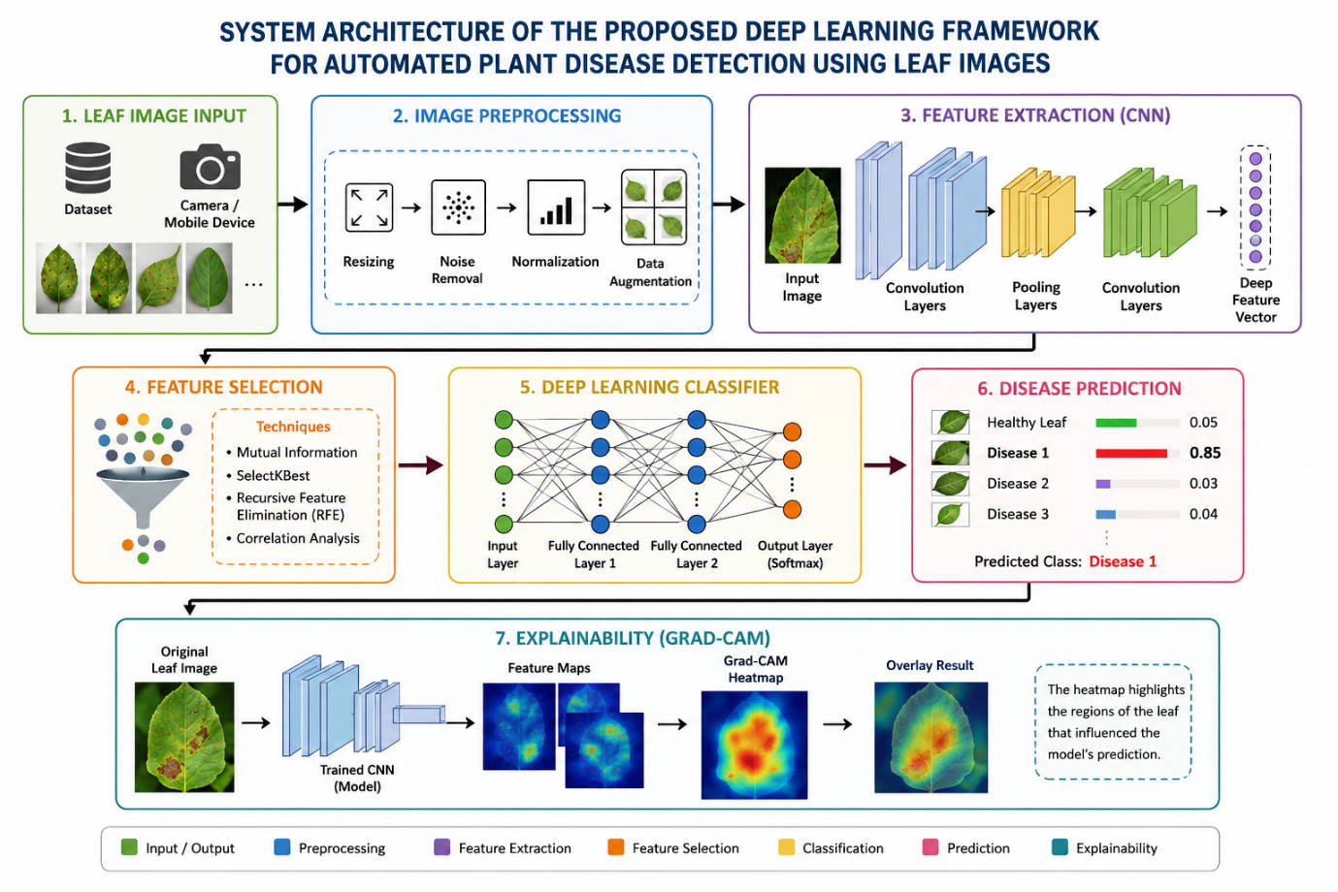

Main stages
Input: Leaf image collected from the dataset.
Preprocessing: Images are resized, normalized, and optionally augmented.
Feature Engineering: Relevant visual information is represented using image features or deep features.
Feature Selection: Redundant or less informative features can be removed.
Classification: The processed data is given to a CNN/deep learning model.
Output: The system predicts the corresponding plant disease class.

3.2 Dataset
For implementation, a publicly available plant leaf-image dataset such as the PlantVillage dataset can be used.
The dataset contains images representing healthy and diseased plant leaves across multiple plant and disease categories.
The dataset can be divided into:
- Training set: Used to train the model.
- Validation set: Used to tune model parameters.
- Testing set: Used to evaluate the final model.
A typical split can be:
Dataset | Percentage
Training | 70%
Validation | 15%
Testing | 15%
The exact distribution can be adjusted according to the dataset and experimental requirements.

3.3 Data Preprocessing
Image preprocessing is performed before training the deep learning model.
Step 1: Image Resizing
Images may have different dimensions. Therefore, all images are resized to a fixed size such as:
224 × 224 pixels
This is also suitable for many transfer-learning architectures.
Step 2: Normalization
Pixel values are normalized to an appropriate numerical range. For example:
Original pixel range: 0 – 255

Normalized range: 0 – 1
This helps the model train more efficiently.
Step 3: Data Augmentation
Data augmentation can be used to increase the diversity of training images.
Possible transformations include:
- Rotation
- Horizontal flipping
- Vertical flipping
- Zooming
- Translation
- Brightness adjustment
For example:
Original Image
↓
┌─────────────┐
│ Augmentation│
└──────┬──────┘
↓
┌──────┼──────┬─────────┐
↓ ↓ ↓ ↓
Rotate Flip Zoom Brightness
Data augmentation can help reduce overfitting and improve the model's ability to handle variations in leaf images.

3.4 Feature Engineering
Feature engineering involves representing important characteristics of leaf images.
For this project, features can be categorized into:
Color Features
Disease symptoms often produce changes in leaf color.
Possible features include:
- RGB values
- HSV values
- Color histograms
- Mean and standard deviation of color channels
Texture Features
Diseased regions may have different textures compared with healthy regions.
Possible texture features include:
- Contrast
- Homogeneity
- Energy
- Correlation
- Local Binary Pattern features
Shape Features
The shape and structure of leaves can also provide useful information.
Possible features include:
- Leaf area
- Perimeter
- Aspect ratio
- Shape descriptors
Deep Features
Instead of manually designing all features, a CNN can automatically learn useful representations from leaf images.
The deep learning pipeline can therefore be represented as:
Image → Convolution → Feature Maps → Deep Features → Classification
This automatic feature extraction is one of the main advantages of CNN-based approaches.

3.5 Feature Selection
Feature selection is used to identify the most relevant features and remove redundant or less useful information.
For traditional image features, techniques such as:
- Correlation-based feature selection
- Recursive Feature Elimination (RFE)
- Mutual Information
- SelectKBest
- Random Forest feature importance
can be considered.
For example, using SelectKBest:
from sklearn.feature_selection import SelectKBest, mutual_info_classif

selector = SelectKBest(
score_func=mutual_info_classif,
k=20
)

X_selected = selector.fit_transform(X, y)

print("Original features:", X.shape[1])
print("Selected features:", X_selected.shape[1])
Here, the algorithm selects the 20 most informative features based on mutual information.
For a CNN-based system, feature selection can be performed on the extracted deep feature vectors before passing them to a separate classifier. Alternatively, the CNN can learn feature representations end-to-end, making explicit handcrafted feature selection less essential.

Proposed implementation flow

Leaf Images
↓
Preprocessing
↓
Feature Extraction
↓
Feature Selection
↓
Selected Features
↓
Deep Learning / Classifier
↓
Disease Prediction
Recommended mini-hackathon implementation: use a CNN or transfer-learning model such as MobileNetV2/ResNet50, because it gives you a strong practical deep-learning component while keeping the project manageable. You can then demonstrate feature importance/selection on extracted features and optionally add Grad-CAM for explainability.

