**DVS Technologies Aws & Devops**

Compiled and Scrutinized by

Mr. Shaan Shaik

(Senior DevOps Lead)

Words To The Students

Though we have taken utmost efforts to present you this book error free, but still it may contain some errors or mistakes. Students are encouraged to bring, if there are any mistakes or errors in this document to our notice. So that it may be rectified in the next edition of this document.

“Suppressing your doubts is Hindering your growth”.

We urge you to work hard and make use of the facilities we are providing to you, because there is no substitute for hard work. We wish you all the best for your future.

“The grass isn’t greener on the other side; the grass is greener where you water it.”

You and your suggestions are valuable to us; Help us to serve you better. In case of any suggestions, grievance, or complaints, please feel free to write us your suggestions, grievance and feedback on the following

Dvs.training@gmail.com

DVS Technologies, Opp Home Town, Beside Biryani Zone, Marathahalli, Bangalore Phone: 9632558585 Mobile: 8892499499 Mail : dvs.training@gmail.com Web: www.dvstechnologies.in

**DVS Technologies Aws & Devops**

**1. Introduction**

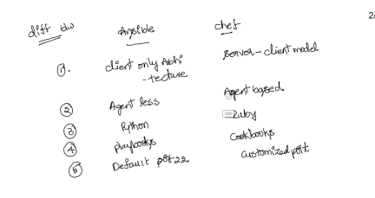

**Complete theory about the background process of ansible execution What exactly happens in background?**

**1. Generate a python script**

**2. Copy the script to respective servers**

**3. Execute the script on respective servers**

**4. Wait for the script to complete execution on all hosts**

**It's Important To note that:**

**1. Ansible runs each task in parallel across all hosts**

**2. Ansible waits until all hosts have completed a task befor moving to the next node 3. Ansible runs the tasks in the order that you specify them.**

**4. To manage a server with ansible, the server needs to have ssh & python 2.5 or later installed or python 2.4 with the python simple json library installed 5. Ansible is an agent less configuration tool which works on ssh port (22)**

DVS Technologies, Opp Home Town, Beside Biryani Zone, Marathahalli, Bangalore Phone: 9632558585 Mobile: 8892499499 Mail : dvs.training@gmail.com Web: www.dvstechnologies.in

**DVS Technologies Aws & Devops**

**6. Pushbased: Unlike chef and puppet ansible is push based . It simply executes the playbook from parent/ansible server to its clients. Whereas puppet and ansible are agent based.**

**7. Ansible scales down: Which means you can define a single host to "n" number of hosts for configuring.**

**\* Idempotent**

**Idempotent in simple: If its installed then it won't do anything, if its not installed it will install it. If any changes are made then it will revert back. Hence these type of behaviour is called Idempotent.**

**YAML Basics:**

**Examples For YML :**

**#Hello all this is the comment section**

**val1: 430**

**bool1: "Ture"**

**l1:**

**- 1**

**- 2**

**- 3**

**l2: [1,2,3,4]**

**dict1:**

**- name: "n1"**

**dict2:**

**- name: "dvs"**

**- 1**

**- 2**

**- 3**

**- place: "blr"**

**- l1:**

**- 1**

**- 2**

**- 3**

DVS Technologies, Opp Home Town, Beside Biryani Zone, Marathahalli, Bangalore Phone: 9632558585 Mobile: 8892499499 Mail : dvs.training@gmail.com Web: www.dvstechnologies.in

**DVS Technologies Aws & Devops** 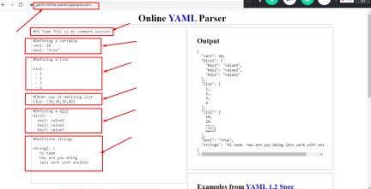

**Lab Setup:**

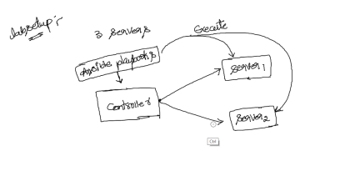

DVS Technologies, Opp Home Town, Beside Biryani Zone, Marathahalli, Bangalore Phone: 9632558585 Mobile: 8892499499 Mail : dvs.training@gmail.com Web: www.dvstechnologies.in

**DVS Technologies Aws & Devops** 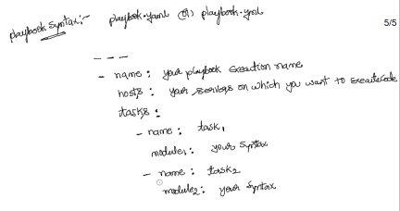

**2. Installation & Configuration of Ansible**

**Let's spin up three servers 1 controller & 2 servers (slaves)**

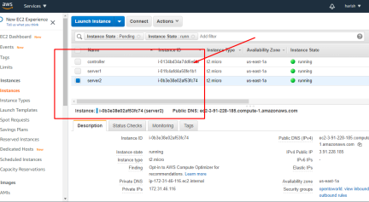

DVS Technologies, Opp Home Town, Beside Biryani Zone, Marathahalli, Bangalore Phone: 9632558585 Mobile: 8892499499 Mail : dvs.training@gmail.com Web: www.dvstechnologies.in

**DVS Technologies Aws & Devops Installing ansible package:**

**Make sure you are adding the local dns**

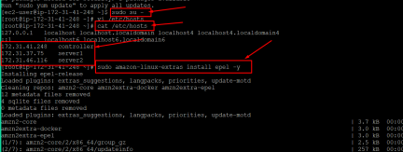

**Installing**

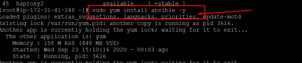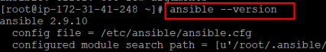

**Ansible Custom configuration:**



DVS Technologies, Opp Home Town, Beside Biryani Zone, Marathahalli, Bangalore Phone: 9632558585 Mobile: 8892499499 Mail : dvs.training@gmail.com Web: www.dvstechnologies.in

**DVS Technologies Aws & Devops 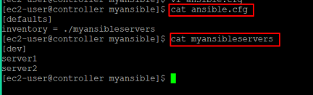Text Data:**

**[ec2-user@controller ~]$ mkdir myansible**

**[ec2-user@controller ~]$ cd myansible/**

**[ec2-user@controller myansible]$ touch ansible.cfg**

**[ec2-user@controller myansible]$ vi ansible.cfg**

**[ec2-user@controller myansible]$ cat ansible.cfg**

**[defaults]**

**inventory = ./myansibleservers**

**[ec2-user@controller myansible]$ touch myansibleservers**

**[ec2-user@controller myansible]$ vi myansibleservers**

**[ec2-user@controller myansible]$ cat myansibleservers**

**[dev]**

**server1**

**server2**

**[ec2-user@controller myansible]$**

**Common Issue with access:**

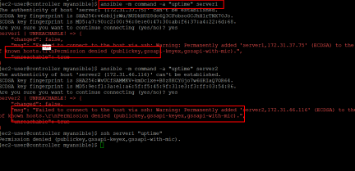

DVS Technologies, Opp Home Town, Beside Biryani Zone, Marathahalli, Bangalore Phone: 9632558585 Mobile: 8892499499 Mail : dvs.training@gmail.com Web: www.dvstechnologies.in

**DVS Technologies Aws & Devops**

**Solution:**

**Add your pem key to the ansible.cfg**

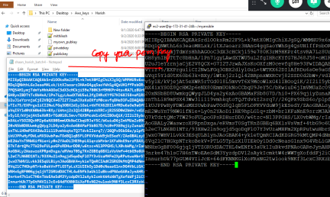

DVS Technologies, Opp Home Town, Beside Biryani Zone, Marathahalli, Bangalore Phone: 9632558585 Mobile: 8892499499 Mail : dvs.training@gmail.com Web: www.dvstechnologies.in

**DVS Technologies Aws & Devops** 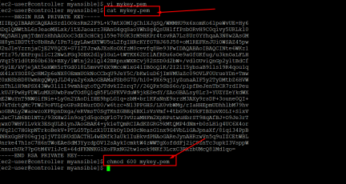

**Finally make sure that you are adding the content to the ansible.cfg file as below.**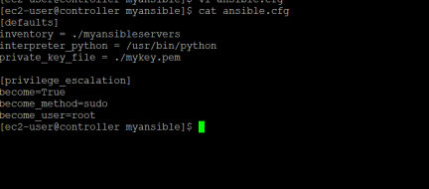

DVS Technologies, Opp Home Town, Beside Biryani Zone, Marathahalli, Bangalore Phone: 9632558585 Mobile: 8892499499 Mail : dvs.training@gmail.com Web: www.dvstechnologies.in

**DVS Technologies Aws & Devops 3. Working with Ansible**

**Executing code in single, group, all servers as part of our ansible hosts file like below.** 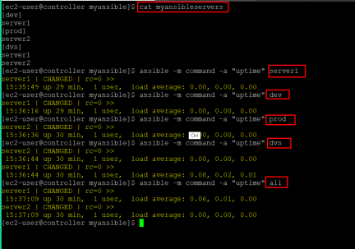

DVS Technologies, Opp Home Town, Beside Biryani Zone, Marathahalli, Bangalore Phone: 9632558585 Mobile: 8892499499 Mail : dvs.training@gmail.com Web: www.dvstechnologies.in

**DVS Technologies Aws & Devops**

**Re-modifying vim editor as per out requirement:**



**Configuring VIM as per our requirement ::**

**highlight-ansible-yaml-and-jinja-syntax-in-vim-editor ::**

**mkdir -p ~/.vim/autoload ~/.vim/bundle**

**curl -LSso ~/.vim/autoload/pathogen.vim https://protect**

**eu.mimecast.com/s/WnjQC2xmRcpygplnc2nVUs?domain=tpo.pe**

**Now add the following lines to vim ~/.vimrc to activate this and start autoloading bundles.**

**[root@slave1 ansible]# vim ~/.vimrc**

**execute pathogen#infect()**

**syntax on**

**filetype plugin indent on**

**autocmd FileType yaml setlocal ts=2 sts=2 sw=2 expandtab**

DVS Technologies, Opp Home Town, Beside Biryani Zone, Marathahalli, Bangalore Phone: 9632558585 Mobile: 8892499499 Mail : dvs.training@gmail.com Web: www.dvstechnologies.in

**DVS Technologies Aws & Devops**

**4. Working with Modules**

**Command Module:**

**If you want to get the output of your playbook execution you can use "-v" option**

**Note: -v stands for verbose**

**File Module:**

**Before playbook execution:**

DVS Technologies, Opp Home Town, Beside Biryani Zone, Marathahalli, Bangalore Phone: 9632558585 Mobile: 8892499499 Mail : dvs.training@gmail.com Web: www.dvstechnologies.in

**DVS Technologies Aws & Devops **

**Post playbook execution:**



**Copy Module:**

**Before Execution:**

DVS Technologies, Opp Home Town, Beside Biryani Zone, Marathahalli, Bangalore Phone: 9632558585 Mobile: 8892499499 Mail : dvs.training@gmail.com Web: www.dvstechnologies.in

**DVS Technologies Aws & Devops Code:**



DVS Technologies, Opp Home Town, Beside Biryani Zone, Marathahalli, Bangalore Phone: 9632558585 Mobile: 8892499499 Mail : dvs.training@gmail.com Web: www.dvstechnologies.in

**DVS Technologies Aws & Devops**

**Script Module:**

**Executing python script via ansible**

**Debug Module:**

DVS Technologies, Opp Home Town, Beside Biryani Zone, Marathahalli, Bangalore Phone: 9632558585 Mobile: 8892499499 Mail : dvs.training@gmail.com Web: www.dvstechnologies.in

**DVS Technologies Aws & Devops **

**Let's stream line the output:**

DVS Technologies, Opp Home Town, Beside Biryani Zone, Marathahalli, Bangalore Phone: 9632558585 Mobile: 8892499499 Mail : dvs.training@gmail.com Web: www.dvstechnologies.in

**DVS Technologies Aws & Devops **

DVS Technologies, Opp Home Town, Beside Biryani Zone, Marathahalli, Bangalore Phone: 9632558585 Mobile: 8892499499 Mail : dvs.training@gmail.com Web: www.dvstechnologies.in

**DVS Technologies Aws & Devops**

**Final Code:**

**[ec2-user@master ansible]$ cat modules.yml ---**

**- name: working with playbooks**

**hosts: all**

**tasks:**

**- name: working with command module shell: "uptime;df -hT"**

**- name: working with file module**

**file:**

**path: /etc/foo.conf**

**owner: root**

**mode: '0644'**

**state: touch**

**- name: working with copy module**

**copy:**

**src: /etc/hosts**

**dest: /etc/hosts**

**owner: root**

**group: root**

**mode: '0644'**

**- name: working with template**

**template:**

**src: /etc/passwd**

**dest: /tmp/dvsbatch/**

**force: no**

**- name: working with script**

**script: ./for1.py**

**register: script_output**

**- debug: msg="{{script_output.stdout_lines[0]}}"**

DVS Technologies, Opp Home Town, Beside Biryani Zone, Marathahalli, Bangalore Phone: 9632558585 Mobile: 8892499499 Mail : dvs.training@gmail.com Web: www.dvstechnologies.in

**DVS Technologies Aws & Devops**

**5. Variables**

**We have many ways of variable declarations few of them are as below vars section:**



**[ec2-user@controller myansible]$ cat main.yaml**

**---**

**- name: working with variables**

**hosts: server1**

**vars:**

**var1: 20**

**var2: 30**

**tasks:**

**- name: printing the variable values**

**command: echo "{{ var1 }} {{ var2 }}"**

**vars_files:**

DVS Technologies, Opp Home Town, Beside Biryani Zone, Marathahalli, Bangalore Phone: 9632558585 Mobile: 8892499499 Mail : dvs.training@gmail.com Web: www.dvstechnologies.in

**DVS Technologies Aws & Devops **

**[ec2-user@controller myansible]$ cat main.yaml**

**---**

**- name: working with variables**

**hosts: server1**

**vars_files:**

**- myvars.yaml**

**tasks:**

**- name: printing the variable values**

**command: echo "{{ myvar1 }} {{ myvar2 }}"**

**host_vars Section:**



DVS Technologies, Opp Home Town, Beside Biryani Zone, Marathahalli, Bangalore Phone: 9632558585 Mobile: 8892499499 Mail : dvs.training@gmail.com Web: www.dvstechnologies.in

**DVS Technologies Aws & Devops **

**Now test the same execution on server2**

**group_vars:**

DVS Technologies, Opp Home Town, Beside Biryani Zone, Marathahalli, Bangalore Phone: 9632558585 Mobile: 8892499499 Mail : dvs.training@gmail.com Web: www.dvstechnologies.in

**DVS Technologies Aws & Devops **

DVS Technologies, Opp Home Town, Beside Biryani Zone, Marathahalli, Bangalore Phone: 9632558585 Mobile: 8892499499 Mail : dvs.training@gmail.com Web: www.dvstechnologies.in

**DVS Technologies Aws & Devops**

**set_fact section:**

**Run time variables:**

**Normal execution:**

**Passing parameters from command line:**

DVS Technologies, Opp Home Town, Beside Biryani Zone, Marathahalli, Bangalore Phone: 9632558585 Mobile: 8892499499 Mail : dvs.training@gmail.com Web: www.dvstechnologies.in

**DVS Technologies Aws & Devops **\

**6. Conditions**

**Setup module:**

**Let's start working on conditions**

**== operator:**



DVS Technologies, Opp Home Town, Beside Biryani Zone, Marathahalli, Bangalore Phone: 9632558585 Mobile: 8892499499 Mail : dvs.training@gmail.com Web: www.dvstechnologies.in

**DVS Technologies Aws & Devops**

**Let's check the false condition**



**Or operator:**

**Case1:**

DVS Technologies, Opp Home Town, Beside Biryani Zone, Marathahalli, Bangalore Phone: 9632558585 Mobile: 8892499499 Mail : dvs.training@gmail.com Web: www.dvstechnologies.in

**DVS Technologies Aws & Devops Case2:**



**and operator:**



DVS Technologies, Opp Home Town, Beside Biryani Zone, Marathahalli, Bangalore Phone: 9632558585 Mobile: 8892499499 Mail : dvs.training@gmail.com Web: www.dvstechnologies.in

**DVS Technologies Aws & Devops **

**< & > operators:**

**defined & undefined:**

DVS Technologies, Opp Home Town, Beside Biryani Zone, Marathahalli, Bangalore Phone: 9632558585 Mobile: 8892499499 Mail : dvs.training@gmail.com Web: www.dvstechnologies.in

**DVS Technologies Aws & Devops **

DVS Technologies, Opp Home Town, Beside Biryani Zone, Marathahalli, Bangalore Phone: 9632558585 Mobile: 8892499499 Mail : dvs.training@gmail.com Web: www.dvstechnologies.in

**DVS Technologies Aws & Devops**

**7. Loops**

**With_items:**



**With_fileglob:**

**With_lines:**

DVS Technologies, Opp Home Town, Beside Biryani Zone, Marathahalli, Bangalore Phone: 9632558585 Mobile: 8892499499 Mail : dvs.training@gmail.com Web: www.dvstechnologies.in

**DVS Technologies Aws & Devops **

**with_dict:**

**Input data i.e dict:**



DVS Technologies, Opp Home Town, Beside Biryani Zone, Marathahalli, Bangalore Phone: 9632558585 Mobile: 8892499499 Mail : dvs.training@gmail.com Web: www.dvstechnologies.in

**DVS Technologies Aws & Devops **

**with_sequence:**

**.**

DVS Technologies, Opp Home Town, Beside Biryani Zone, Marathahalli, Bangalore Phone: 9632558585 Mobile: 8892499499 Mail : dvs.training@gmail.com Web: www.dvstechnologies.in

**DVS Technologies Aws & Devops 8. Special Cases with ansible**

**ignore_errors:**



DVS Technologies, Opp Home Town, Beside Biryani Zone, Marathahalli, Bangalore Phone: 9632558585 Mobile: 8892499499 Mail : dvs.training@gmail.com Web: www.dvstechnologies.in

**DVS Technologies Aws & Devops **

**Delegate_to:**



DVS Technologies, Opp Home Town, Beside Biryani Zone, Marathahalli, Bangalore Phone: 9632558585 Mobile: 8892499499 Mail : dvs.training@gmail.com Web: www.dvstechnologies.in

**DVS Technologies Aws & Devops **

**Serial:**

**Parallel execution example:**

**Converting parallel to sequential execution:**

DVS Technologies, Opp Home Town, Beside Biryani Zone, Marathahalli, Bangalore Phone: 9632558585 Mobile: 8892499499 Mail : dvs.training@gmail.com Web: www.dvstechnologies.in

**DVS Technologies Aws & Devops **

**Executing code on a single server/group/all from commandline:**

**Now I want to execute the code in a sinle/group/all servers without modify the files/code**

DVS Technologies, Opp Home Town, Beside Biryani Zone, Marathahalli, Bangalore Phone: 9632558585 Mobile: 8892499499 Mail : dvs.training@gmail.com Web: www.dvstechnologies.in

**DVS Technologies Aws & Devops **

**Executing code from custom servers list :**



DVS Technologies, Opp Home Town, Beside Biryani Zone, Marathahalli, Bangalore Phone: 9632558585 Mobile: 8892499499 Mail : dvs.training@gmail.com Web: www.dvstechnologies.in

**DVS Technologies Aws & Devops Ansible Vault:**

**Creating a secret file with all the variables**



DVS Technologies, Opp Home Town, Beside Biryani Zone, Marathahalli, Bangalore Phone: 9632558585 Mobile: 8892499499 Mail : dvs.training@gmail.com Web: www.dvstechnologies.in

**DVS Technologies Aws & Devops **

**Passing password from a file:**



DVS Technologies, Opp Home Town, Beside Biryani Zone, Marathahalli, Bangalore Phone: 9632558585 Mobile: 8892499499 Mail : dvs.training@gmail.com Web: www.dvstechnologies.in

**DVS Technologies Aws & Devops**

**9. Checking Your Playbook before Execution**

**1. Syntax Check: (--syntax-check)**



**2. List Hosts: (--list-hosts)**

**3. Listing All the Tasks: (--list-tasks)**

DVS Technologies, Opp Home Town, Beside Biryani Zone, Marathahalli, Bangalore Phone: 9632558585 Mobile: 8892499499 Mail : dvs.training@gmail.com Web: www.dvstechnologies.in

**DVS Technologies Aws & Devops **

**4. Check Mode: (-C)**

**5. Step: (--step)**

DVS Technologies, Opp Home Town, Beside Biryani Zone, Marathahalli, Bangalore Phone: 9632558585 Mobile: 8892499499 Mail : dvs.training@gmail.com Web: www.dvstechnologies.in

**DVS Technologies Aws & Devops 6. Start-at-Task: (--start-at-task)**



DVS Technologies, Opp Home Town, Beside Biryani Zone, Marathahalli, Bangalore Phone: 9632558585 Mobile: 8892499499 Mail : dvs.training@gmail.com Web: www.dvstechnologies.in

**DVS Technologies Aws & Devops **

**7. Tagging: (tags/-t)**



DVS Technologies, Opp Home Town, Beside Biryani Zone, Marathahalli, Bangalore Phone: 9632558585 Mobile: 8892499499 Mail : dvs.training@gmail.com Web: www.dvstechnologies.in

**DVS Technologies Aws & Devops 8. import_playbook**



DVS Technologies, Opp Home Town, Beside Biryani Zone, Marathahalli, Bangalore Phone: 9632558585 Mobile: 8892499499 Mail : dvs.training@gmail.com Web: www.dvstechnologies.in

**DVS Technologies Aws & Devops **

**10. Working with ansible playbooks**

**Example1: Installing and configuring httpd using ansible playbook**

**[ec2-user@controller myansible]$ cat httpd.yaml**

**---**

**- name: working with apache installation & configuration hosts: all**

**tasks:**

**- name: Gathering public ipaddress of the server**

**command: curl http://169.254.169.254/latest/meta-data/public-ipv4 register: myip**

**- set_fact: mypubip="{{myip.stdout}}"**

**- name: Installing apache package**

**yum:**

**name: httpd**

**state: present**

**- name: enabling apache package**

**systemd:**

**name: httpd**

**enabled: yes**

**- name: copying index.html file**

**template: src=index.html dest=/var/www/html/**

DVS Technologies, Opp Home Town, Beside Biryani Zone, Marathahalli, Bangalore Phone: 9632558585 Mobile: 8892499499 Mail : dvs.training@gmail.com Web: www.dvstechnologies.in

**DVS Technologies Aws & Devops**

**notify: httpd restart**

**- name: modifying httpd.conf file**

**replace:**

**path: /etc/httpd/conf/httpd.conf**

**regexp: '^#ServerName www.example.com'**

**replace: 'ServerName {{mypubip}}'**

**notify: httpd restart**

**handlers:**

**- name: httpd restart**

**systemd:**

**name: httpd**

**state: restarted**

**Execution:**

**[ec2-user@controller myansible]$ ansible-playbook httpd.yaml**

**PLAY [working with apache installation & configuration]**

**\*\*\*\*\*\*\*\*\*\*\*\*\*\*\*\*\*\*\*\*\*\*\*\*\*\*\*\*\*\*\*\*\*\*\*\*\*\*\*\*\*\*\*\*\*\*\*\*\*\*\*\*\*\*\*\*\*\*\*\*\*\*\*\*\*\***

**TASK [Gathering Facts]**

**\*\*\*\*\*\*\*\*\*\*\*\*\*\*\*\*\*\*\*\*\*\*\*\*\*\*\*\*\*\*\*\*\*\*\*\*\*\*\*\*\*\*\*\*\*\*\*\*\*\*\*\*\*\*\*\*\*\*\*\*\*\*\*\*\*\*\*\*\*\*\*\*\*\*\*\*\*\* \*\*\*\*\*\*\*\*\*\*\*\*\*\*\*\*\*\*\*\*\***

**ok: [server2]**

**ok: [server1]**

**TASK [Gathering public ipaddress of the server]**

**\*\*\*\*\*\*\*\*\*\*\*\*\*\*\*\*\*\*\*\*\*\*\*\*\*\*\*\*\*\*\*\*\*\*\*\*\*\*\*\*\*\*\*\*\*\*\*\*\*\*\*\*\*\*\*\*\*\*\*\*\*\*\*\*\*\*\*\*\*\*\*\*\*\* [WARNING]: Consider using the get_url or uri module rather than running 'curl'. If you need to use command because**

**get_url or uri is insufficient you can add 'warn: false' to this command task or set 'command_warnings=False' in**

**ansible.cfg to get rid of this message.**

**changed: [server2]**

**changed: [server1]**

**TASK [set_fact]**

**\*\*\*\*\*\*\*\*\*\*\*\*\*\*\*\*\*\*\*\*\*\*\*\*\*\*\*\*\*\*\*\*\*\*\*\*\*\*\*\*\*\*\*\*\*\*\*\*\*\*\*\*\*\*\*\*\*\*\*\*\*\*\*\*\*\*\*\*\*\*\*\*\*\*\*\*\*\* \*\*\*\*\*\*\*\*\*\*\*\*\*\*\*\*\*\*\*\*\*\*\*\*\*\*\*\***

**ok: [server1]**

**ok: [server2]**

DVS Technologies, Opp Home Town, Beside Biryani Zone, Marathahalli, Bangalore Phone: 9632558585 Mobile: 8892499499 Mail : dvs.training@gmail.com Web: www.dvstechnologies.in

**DVS Technologies Aws & Devops**

**TASK [Installing apache package]**

**\*\*\*\*\*\*\*\*\*\*\*\*\*\*\*\*\*\*\*\*\*\*\*\*\*\*\*\*\*\*\*\*\*\*\*\*\*\*\*\*\*\*\*\*\*\*\*\*\*\*\*\*\*\*\*\*\*\*\*\*\*\*\*\*\*\*\*\*\*\*\*\*\*\*\*\*\*\* \*\*\*\*\*\*\*\*\*\*\***

**ok: [server2]**

**ok: [server1]**

**TASK [enabling apache package]**

**\*\*\*\*\*\*\*\*\*\*\*\*\*\*\*\*\*\*\*\*\*\*\*\*\*\*\*\*\*\*\*\*\*\*\*\*\*\*\*\*\*\*\*\*\*\*\*\*\*\*\*\*\*\*\*\*\*\*\*\*\*\*\*\*\*\*\*\*\*\*\*\*\*\*\*\*\*\* \*\*\*\*\*\*\*\*\*\*\*\*\***

**ok: [server2]**

**ok: [server1]**

**TASK [copying index.html file]**

**\*\*\*\*\*\*\*\*\*\*\*\*\*\*\*\*\*\*\*\*\*\*\*\*\*\*\*\*\*\*\*\*\*\*\*\*\*\*\*\*\*\*\*\*\*\*\*\*\*\*\*\*\*\*\*\*\*\*\*\*\*\*\*\*\*\*\*\*\*\*\*\*\*\*\*\*\*\* \*\*\*\*\*\*\*\*\*\*\*\*\***

**ok: [server1]**

**changed: [server2]**

**TASK [modifying httpd.conf file]**

**\*\*\*\*\*\*\*\*\*\*\*\*\*\*\*\*\*\*\*\*\*\*\*\*\*\*\*\*\*\*\*\*\*\*\*\*\*\*\*\*\*\*\*\*\*\*\*\*\*\*\*\*\*\*\*\*\*\*\*\*\*\*\*\*\*\*\*\*\*\*\*\*\*\*\*\*\*\* \*\*\*\*\*\*\*\*\*\*\***

**ok: [server2]**

**ok: [server1]**

**RUNNING HANDLER [httpd restart]**

**\*\*\*\*\*\*\*\*\*\*\*\*\*\*\*\*\*\*\*\*\*\*\*\*\*\*\*\*\*\*\*\*\*\*\*\*\*\*\*\*\*\*\*\*\*\*\*\*\*\*\*\*\*\*\*\*\*\*\*\*\*\*\*\*\*\*\*\*\*\*\*\*\*\*\*\*\*\* \*\*\*\*\*\*\*\*\*\*\*\***

**changed: [server2]**

**PLAY RECAP**

**\*\*\*\*\*\*\*\*\*\*\*\*\*\*\*\*\*\*\*\*\*\*\*\*\*\*\*\*\*\*\*\*\*\*\*\*\*\*\*\*\*\*\*\*\*\*\*\*\*\*\*\*\*\*\*\*\*\*\*\*\*\*\*\*\*\*\*\*\*\*\*\*\*\*\*\*\*\* \*\*\*\*\*\*\*\*\*\*\*\*\*\*\*\*\*\*\*\*\*\*\*\*\*\*\*\*\*\*\*\*\***

**server1 : ok=7 changed=1 unreachable=0 failed=0 skipped=0 rescued=0 ignored=0**

**server2 : ok=8 changed=3 unreachable=0 failed=0 skipped=0 rescued=0 ignored=0**

DVS Technologies, Opp Home Town, Beside Biryani Zone, Marathahalli, Bangalore Phone: 9632558585 Mobile: 8892499499 Mail : dvs.training@gmail.com Web: www.dvstechnologies.in

**DVS Technologies Aws & Devops**

**11. Working with roles**

**Aligning ansible playbooks to roles**



**Roles:**

**Follow the below steps:**

**mkdir ./roles/apache -p**

**mkdir ./roles/apache/templates -p**

**mkdir ./roles/apache/tasks -p**

**mkdir ./roles/apache/handlers -p**

**Know segregate your ansible playbook the respective folders like below**

DVS Technologies, Opp Home Town, Beside Biryani Zone, Marathahalli, Bangalore Phone: 9632558585 Mobile: 8892499499 Mail : dvs.training@gmail.com Web: www.dvstechnologies.in

**DVS Technologies Aws & Devops **

DVS Technologies, Opp Home Town, Beside Biryani Zone, Marathahalli, Bangalore Phone: 9632558585 Mobile: 8892499499 Mail : dvs.training@gmail.com Web: www.dvstechnologies.in

**DVS Technologies Aws & Devops **

DVS Technologies, Opp Home Town, Beside Biryani Zone, Marathahalli, Bangalore Phone: 9632558585 Mobile: 8892499499 Mail : dvs.training@gmail.com Web: www.dvstechnologies.in

**DVS Technologies Aws & Devops**

**12. Configuring Word press application**

**Let's configure our word press application manually.**

**1. Manual Installation of Database ::**

**yum install mariadb-server**

**systemctl enable mariadb.service**

**systemctl restart mariadb.service**

**mysql:**

**CREATE USER 'admin'@'%' IDENTIFIED BY 'admin123'; GRANT ALL PRIVILEGES ON * . * TO 'admin'@'%'; FLUSH PRIVILEGES;**

**create database devopsdb;**

**Verification::**

**select host, user, password from mysql.user;**

**DROP USER 'admin'@'localhost';**

**Automating the configuration using ansible roles ::**

**2. Manual Installation of application**

**sudo amazon-linux-extras install -y lamp-mariadb10.2-php7.2 php7.2 sudo yum install -y httpd**

**sudo systemctl start httpd**

**sudo systemctl enable httpd**

**wget https://wordpress.org/latest.tar.gz**

**tar -xzf latest.tar.gz**

**sudo cp -r wordpress/* /var/www/html/**

**cd /var/www/html/**

**sudo cp wp-config-sample.php wp-config.php**

**Post db installation do the below.**

**sudo vi wp-config.php --> add the database details to this file sudo chown -R apache /var/www**

**sudo chgrp -R apache /var/www**

**sudo chmod 775 /var/www**

**sudo find /var/www -type d -exec sudo chmod 2775 {} \; sudo find /var/www -type f -exec sudo chmod 0664 {} \;**

DVS Technologies, Opp Home Town, Beside Biryani Zone, Marathahalli, Bangalore Phone: 9632558585 Mobile: 8892499499 Mail : dvs.training@gmail.com Web: www.dvstechnologies.in

**DVS Technologies Aws & Devops**

**sudo systemctl restart httpd**

**Automating the configuration using ansible roles ::**

**Final Code ::**

**https://github.com/shan5a6/wordpress-mariadb.git**

**13. Integrating Ansible with AWS**

**Basic Requirement:**

**# aws configure**

**[root@master playbooks]# aws configure**

**AWS Access Key ID [****************EBFA]:**

**AWS Secret Access Key [****************DOqF]:**

**Default region name [us-west-2]: eu-west-2**

**Default output format [json]: json**

**Installtin boto3**

**pip install boto3 boto**

**Note: If anisble is not there make sure you are installing it with "pip install ansible"**

**If you are getting below error then make sure you are adding "become: False" in the playbook.**

**TASK [creating a normal basic instance]**

**\*\*\*\*\*\*\*\*\*\*\*\*\*\*\*\*\*\*\*\*\*\*\*\*\*\*\*\*\*\*\*\*\*\*\*\*\*\*\*\*\*\*\*\*\*\*\*\*\*\*\*\*\*\*\*\*\*\*\*\*\*\*\* fatal: [localhost]: FAILED! => {"changed": false, "msg": "No handler was ready to authenticate. 1 handlers were checked. ['HmacAuthV4Handler'] Check your credentials"}**

**Examples:**

**1. Creating Ec2 instance using "ec2" module**

**[root@master playbooks]# cat ec2-create.yml**

**---**

**- name: working with ec2 instance creation**

**vars:**

**- serv_count: 0**

**hosts: localhost**

DVS Technologies, Opp Home Town, Beside Biryani Zone, Marathahalli, Bangalore Phone: 9632558585 Mobile: 8892499499 Mail : dvs.training@gmail.com Web: www.dvstechnologies.in

**DVS Technologies Aws & Devops**

**become: False**

**tasks:**

**- name: creating a normal basic instance**

**ec2:**

**key_name: newkeys_swamy_useast1**

**instance_type: t2.micro**

**image: ami-97785bed**

**wait: yes**

**group: opentoworld**

**count: "{{serv_count}}"**

**vpc_subnet_id: subnet-d88cbcf4**

**assign_public_ip: yes**

**region: us-east-1**

**register: output**

**- debug: msg="{{output}}"**

**2. Creating a VPC with a public subnet and security groups.**

**---**

**- name: creating a vpc**

**hosts: localhost**

**become: False**

**tasks:**

**- name: working with VPC creation**

**ec2_vpc_net:**

**name: "mytestvpc"**

**cidr_block: "192.168.0.0/16"**

**region: "us-east-1"**

**state: "present"**

**register: myvpc**

**# Assigning the vpc id to a variable**

**- set_fact: vpc_id="{{myvpc.vpc.id}}"**

**- command: echo "{{vpc_id}}"**

**# Creating a public Subnet**

**- name: creating a public Subnet**

**ec2_vpc_subnet:**

**state: "present"**

**vpc_id: "{{vpc_id}}"**

**cidr: "192.168.10.0/24"**

**resource_tags:**

DVS Technologies, Opp Home Town, Beside Biryani Zone, Marathahalli, Bangalore Phone: 9632558585 Mobile: 8892499499 Mail : dvs.training@gmail.com Web: www.dvstechnologies.in

**DVS Technologies Aws & Devops**

**Name: "Public Subnet"**

**register: my_public_subnet**

**# Assigning public subnet id to a variable**

**- set_fact: pub_sub_id="{{my_public_subnet.subnet.id}}" # Creating IGW for the vpc**

**- name: creating the IGW**

**ec2_vpc_igw:**

**vpc_id: "{{vpc_id}}"**

**region: "us-east-1"**

**state: "present"**

**register: my_vpc_igw**

**# Assigning igw id to a variable**

**- set_fact: igw_id="{{my_vpc_igw.gateway_id}}" # Creating the route table**

**- name: creating our own route table**

**ec2_vpc_route_table:**

**vpc_id: "{{vpc_id}}"**

**region: "us-east-1"**

**tags:**

**Name: "public"**

**subnets:**

**- "{{pub_sub_id}}"**

**routes:**

**- dest: "0.0.0.0/0"**

**gateway_id: "{{igw_id}}"**

**# Creating our own security group**

**- name: creating our own security group**

**ec2_group:**

**name: "Ansible securitygroup"**

**description: "Ansible SG"**

**vpc_id: "{{vpc_id}}"**

**region: "us-east-1"**

**rules:**

DVS Technologies, Opp Home Town, Beside Biryani Zone, Marathahalli, Bangalore Phone: 9632558585 Mobile: 8892499499 Mail : dvs.training@gmail.com Web: www.dvstechnologies.in

**DVS Technologies Aws & Devops**

**- proto: "tcp" from_port: 0 to_port: 65000 cidr_ip: "0.0.0.0/0"**

DVS Technologies, Opp Home Town, Beside Biryani Zone, Marathahalli, Bangalore Phone: 9632558585 Mobile: 8892499499 Mail : dvs.training@gmail.com Web: www.dvstechnologies.in