Dvs Technologies Aws & Devops

Compiled and Scrutinized by

Mr. Shaan Shaik

(Senior DevOps Lead)

Words To The Students

Though we have taken utmost efforts to present you this book error free, but still it may contain some errors or mistakes. Students are encouraged to bring, if there are any mistakes or errors in this document to our notice. So that it may be rectified in the next edition of this document.

“Suppressing your doubts is Hindering your growth”.

We urge you to work hard and make use of the facilities we are providing to you, because there is no substitute for hard work. We wish you all the best for your future.

“The grass isn’t greener on the other side; the grass is greener where you water it.”

You and your suggestions are valuable to us; Help us to serve you better. In case of any suggestions, grievance, or complaints, please feel free to write us your suggestions, grievance and feedback on the following

Dvs.training@gmail.com

DVS Technologies, Opp Home Town, Beside Biryani Zone, Marathahalli, Bangalore Phone: 9632558585 Mobile: 8892499499 Mail : dvs.training@gmail.com Web: www.dvstechnologies.in

**Jenkins Class Notes**

**Introduction to Jenkins:**

**What is Jenkins:**

**Jenkins is a leading open source automation server, Jenkins provides hundreds of plugins to support building, deploying,**

**and automating any project.**

**Jenkins is an application that monitors executions of repeated jobs, such as building a software project or jobs run**

**by cron.**

**Traditionally, development make s/w available in a repository and then operations builds and deploys the software to**

**one or more environments.**

**A QA(Quality Assurance) team may then execute load and performance test against that build and release it for**

**production use**

**Jenkins can automate large portions of that repeatable process.**

**What's so great about it:**

**Its a open source!**

**it works for most people**

**Its easy to setup and configure**

**Its hightly flexible with a ton of plugin support.**

**Works in just about any environment.**

**It doesn't use a lot of resources**

**What's Covered in this course:**

**CI & CD**

**Installing Jenkins and Prerequisites**

**Configuring and securing jenkins**

**BasicProjects - Configuring and concepts**

**Folders and views**

**Working with plugins**

**and etc ...**

DVS Technologies, Opp Home Town, Beside Biryani Zone, Marathahalli, Bangalore Phone: 9632558585 Mobile: 8892499499 Mail : dvs.training@gmail.com Web: www.dvstechnologies.in

**Continuous Integration and Continuous Delivery:**

**CI:**

**It's a s/w development practice where contributors are integrating their work frequency. This results in**

**multiple daily integrations**

**to a mainline. Automated testing(post-commit promotion) is commonly used.**

**Basic Workflow:**

**1. Checkout from source code management (like git)**

**2. Branch and make local changes**

**3. Add or change tests as necessary**

**4. Trigger automated build locally**

**5. If successful, consider committing**

**6. Update with latest from mainline**

**7. Push changes, build and test on integration**

**Continuous Delivery:**

**A s/w development discipline where software is built so that it can be released to production at anytime**

**Keys and Assumptions:**

**S/w is always deployable throughout s/w development life cycle (SDLC) Not breaking the build is prioritized over adding features.**

**Feedback is fast and production readiness is known.**

**Push-button deployments are possible of any version of the s/w**

**Close/Collaborative working relationship**

**Best practices:**

**1. Maintain a single source repository**

**2. Have a common mainline branch (usually master)**

**3. Automate the build**

**4. Minimize potential for user error,automate everything possible**

**5. Make the build self-testing - self-testing code**

**6. Everyone commits frequently (at least daily preferably)**

**7. Communication is a key!**

**8. Frequent mergers will help**

DVS Technologies, Opp Home Town, Beside Biryani Zone, Marathahalli, Bangalore Phone: 9632558585 Mobile: 8892499499 Mail : dvs.training@gmail.com Web: www.dvstechnologies.in

**9. The working branch should be updated as frequently as possible to help avoid very large diffs while merging.**

**10. Build every commit**

**11. Prioritize fixing broken builds**

**12. Keep your builds fast !!!**

**13. Testing environment should be as close to prod as possible**

**14. Make it easy for anyone to get the latest**

**15. Keep it open, everyone should see what's happening**

**16. Automate the deployment**

**Must Do:**

**\* Backup Jenkins(at least Jenkins home for job security)**

**\* use file fingerprinting to manage dependencies**

**\* Build from source control whenever possible (will generate clean builds) * Integrate Jenkins with an issue management or help desk system**

**\* Take advantages of automated testing(with java builds,) generate and look at the reports * Layout your jenkins install on the disk with the most storage (both jenkins jobs and build process will take up space)**

**\* Before deleting a job, have an archive copy. better: never delete, move to an archive group or folder and disable the jobs**

**\* Resist the temptation to have one build job for multiple environments (dev,test,prod) - Consider creating one job to specialize in each**

**environment to retain flexibility to make changes**

**\* Email the results to all developers and operations staff for every job, particularly if jenkins is not integrated into and issue management system**

**\* User Jenkins for common maintenance or clean up tasks that are run regularly. * Tag merge or baseline your code in source control after a successful build * Keep your jenkins up to date- atleast be on the latest LTS version**

**\* keep your plugins up to date- review the bug reports and see what they address *DON'T BUILD ON MASTER except on very small deployments. If you have more than a dozen jobs and they are used by more than two or three**

**people, set up slaves to do the work.**

**All the above are the best practices which helps you to be in safe side. Build Pipeline:**

**It is a process by which the software build is broken down in sections:**

**1. Unit test**

**2. Acceptance test**

**3. Packaging**

**4. Reporting**

**5. Deployment**

DVS Technologies, Opp Home Town, Beside Biryani Zone, Marathahalli, Bangalore Phone: 9632558585 Mobile: 8892499499 Mail : dvs.training@gmail.com Web: www.dvstechnologies.in

**6. Notification**

**these can then be executed in series, or in parallel, and depending on the Success or failure of any phase,**

**it can automatically be moved to the next phase.**

**Where is "Devops" in that, through automation, the tools and skills needed are very "cross domain"**

**Best Practices:**

**jenkins and devops movement have caused companies to think of common tasks differently:**

**\* Build Management**

**\* Release Management**

**\* Deployment Automation**

**\* Test Orchestration**

**Difference b/w CI & CD (continuous delivery):**

**Continuous delivery is the ability to release at any time.**

**Continuous integration is just the practice of integrating code continuously. Continuous Delivery Versus Continuous Deployment:**

**Continuous Delivery means the code can be delivered at anytime**

**Continuous deployment is that code is released continuously as part of an automated pipeline**

**Questions & Answers:**

**1) What's the difference between Continuous Delivery and Continuous Deployment? Continuous Delivery means the code CAN be released at any time, while Continuous Deployment means it is released continuously.**

**2) Which answer best describes Continuous Integration?**

**A software development practice where contributors are integrating their work very frequently.**

**3) Which answer best describes Continuous Deployment?**

**A software development discipline where software is released continuously as part of an automated pipeline.**

DVS Technologies, Opp Home Town, Beside Biryani Zone, Marathahalli, Bangalore Phone: 9632558585 Mobile: 8892499499 Mail : dvs.training@gmail.com Web: www.dvstechnologies.in

**4) Which is NOT a Continuous Integration best practice?**

**Do everything manually with great care.**

**5) Which answer best describes Continuous Delivery?**

**A software development discipline where software is built so that it can be released to production at any time.**

**Jenkins Installation**

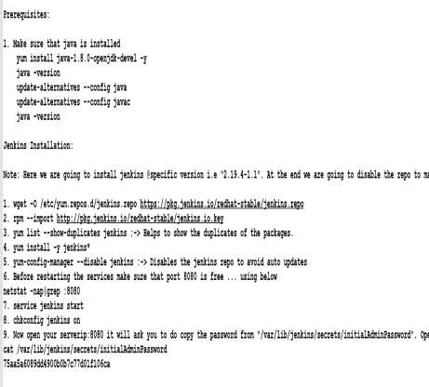

DVS Technologies, Opp Home Town, Beside Biryani Zone, Marathahalli, Bangalore Phone: 9632558585 Mobile: 8892499499 Mail : dvs.training@gmail.com Web: www.dvstechnologies.in

**Verification:**

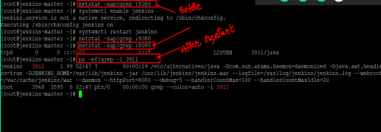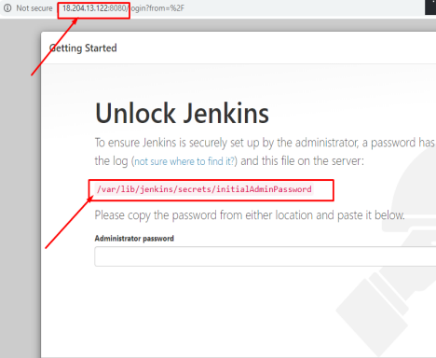

DVS Technologies, Opp Home Town, Beside Biryani Zone, Marathahalli, Bangalore Phone: 9632558585 Mobile: 8892499499 Mail : dvs.training@gmail.com Web: www.dvstechnologies.in

**In Server:**

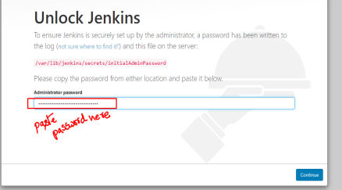

DVS Technologies, Opp Home Town, Beside Biryani Zone, Marathahalli, Bangalore Phone: 9632558585 Mobile: 8892499499 Mail : dvs.training@gmail.com Web: www.dvstechnologies.in

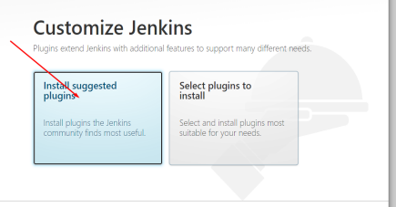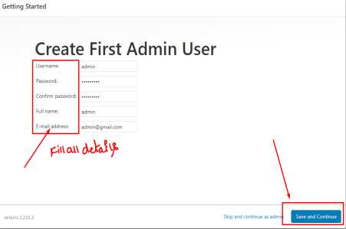

DVS Technologies, Opp Home Town, Beside Biryani Zone, Marathahalli, Bangalore Phone: 9632558585 Mobile: 8892499499 Mail : dvs.training@gmail.com Web: www.dvstechnologies.in

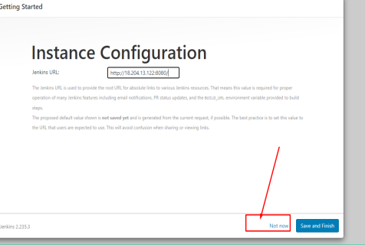

DVS Technologies, Opp Home Town, Beside Biryani Zone, Marathahalli, Bangalore Phone: 9632558585 Mobile: 8892499499 Mail : dvs.training@gmail.com Web: www.dvstechnologies.in

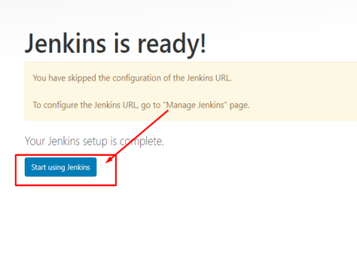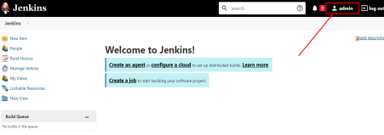

DVS Technologies, Opp Home Town, Beside Biryani Zone, Marathahalli, Bangalore Phone: 9632558585 Mobile: 8892499499 Mail : dvs.training@gmail.com Web: www.dvstechnologies.in

**User Management**

**Creating User:**

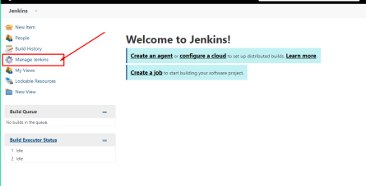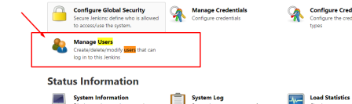

DVS Technologies, Opp Home Town, Beside Biryani Zone, Marathahalli, Bangalore Phone: 9632558585 Mobile: 8892499499 Mail : dvs.training@gmail.com Web: www.dvstechnologies.in

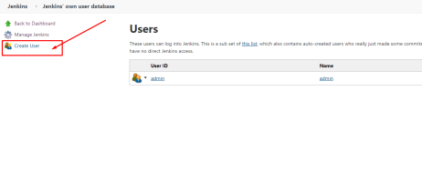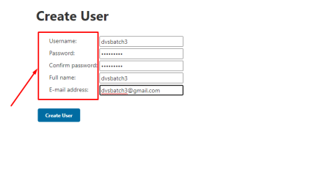

DVS Technologies, Opp Home Town, Beside Biryani Zone, Marathahalli, Bangalore Phone: 9632558585 Mobile: 8892499499 Mail : dvs.training@gmail.com Web: www.dvstechnologies.in

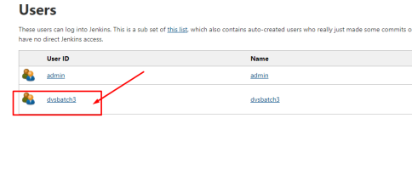**Verifying the Access:**



DVS Technologies, Opp Home Town, Beside Biryani Zone, Marathahalli, Bangalore Phone: 9632558585 Mobile: 8892499499 Mail : dvs.training@gmail.com Web: www.dvstechnologies.in

**Restricting User Access:**



DVS Technologies, Opp Home Town, Beside Biryani Zone, Marathahalli, Bangalore Phone: 9632558585 Mobile: 8892499499 Mail : dvs.training@gmail.com Web: www.dvstechnologies.in



DVS Technologies, Opp Home Town, Beside Biryani Zone, Marathahalli, Bangalore Phone: 9632558585 Mobile: 8892499499 Mail : dvs.training@gmail.com Web: www.dvstechnologies.in



DVS Technologies, Opp Home Town, Beside Biryani Zone, Marathahalli, Bangalore Phone: 9632558585 Mobile: 8892499499 Mail : dvs.training@gmail.com Web: www.dvstechnologies.in



DVS Technologies, Opp Home Town, Beside Biryani Zone, Marathahalli, Bangalore Phone: 9632558585 Mobile: 8892499499 Mail : dvs.training@gmail.com Web: www.dvstechnologies.in



DVS Technologies, Opp Home Town, Beside Biryani Zone, Marathahalli, Bangalore Phone: 9632558585 Mobile: 8892499499 Mail : dvs.training@gmail.com Web: www.dvstechnologies.in

**Creating freestyle jobs**



DVS Technologies, Opp Home Town, Beside Biryani Zone, Marathahalli, Bangalore Phone: 9632558585 Mobile: 8892499499 Mail : dvs.training@gmail.com Web: www.dvstechnologies.in



DVS Technologies, Opp Home Town, Beside Biryani Zone, Marathahalli, Bangalore Phone: 9632558585 Mobile: 8892499499 Mail : dvs.training@gmail.com Web: www.dvstechnologies.in



DVS Technologies, Opp Home Town, Beside Biryani Zone, Marathahalli, Bangalore Phone: 9632558585 Mobile: 8892499499 Mail : dvs.training@gmail.com Web: www.dvstechnologies.in

**Verfiying Build job in the jenkins server:**

DVS Technologies, Opp Home Town, Beside Biryani Zone, Marathahalli, Bangalore Phone: 9632558585 Mobile: 8892499499 Mail : dvs.training@gmail.com Web: www.dvstechnologies.in



**Adding a slave node**

**Do the below on slave1**



DVS Technologies, Opp Home Town, Beside Biryani Zone, Marathahalli, Bangalore Phone: 9632558585 Mobile: 8892499499 Mail : dvs.training@gmail.com Web: www.dvstechnologies.in

**Do below in master**



DVS Technologies, Opp Home Town, Beside Biryani Zone, Marathahalli, Bangalore Phone: 9632558585 Mobile: 8892499499 Mail : dvs.training@gmail.com Web: www.dvstechnologies.in

**Configure Slave Node in jenkins :**



DVS Technologies, Opp Home Town, Beside Biryani Zone, Marathahalli, Bangalore Phone: 9632558585 Mobile: 8892499499 Mail : dvs.training@gmail.com Web: www.dvstechnologies.in



DVS Technologies, Opp Home Town, Beside Biryani Zone, Marathahalli, Bangalore Phone: 9632558585 Mobile: 8892499499 Mail : dvs.training@gmail.com Web: www.dvstechnologies.in



DVS Technologies, Opp Home Town, Beside Biryani Zone, Marathahalli, Bangalore Phone: 9632558585 Mobile: 8892499499 Mail : dvs.training@gmail.com Web: www.dvstechnologies.in



DVS Technologies, Opp Home Town, Beside Biryani Zone, Marathahalli, Bangalore Phone: 9632558585 Mobile: 8892499499 Mail : dvs.training@gmail.com Web: www.dvstechnologies.in



DVS Technologies, Opp Home Town, Beside Biryani Zone, Marathahalli, Bangalore Phone: 9632558585 Mobile: 8892499499 Mail : dvs.training@gmail.com Web: www.dvstechnologies.in



**Executing build job in slave1**



DVS Technologies, Opp Home Town, Beside Biryani Zone, Marathahalli, Bangalore Phone: 9632558585 Mobile: 8892499499 Mail : dvs.training@gmail.com Web: www.dvstechnologies.in



DVS Technologies, Opp Home Town, Beside Biryani Zone, Marathahalli, Bangalore Phone: 9632558585 Mobile: 8892499499 Mail : dvs.training@gmail.com Web: www.dvstechnologies.in



DVS Technologies, Opp Home Town, Beside Biryani Zone, Marathahalli, Bangalore Phone: 9632558585 Mobile: 8892499499 Mail : dvs.training@gmail.com Web: www.dvstechnologies.in



DVS Technologies, Opp Home Town, Beside Biryani Zone, Marathahalli, Bangalore Phone: 9632558585 Mobile: 8892499499 Mail : dvs.training@gmail.com Web: www.dvstechnologies.in



**Plugin Manager**

**Installing thin backup plugin :**



DVS Technologies, Opp Home Town, Beside Biryani Zone, Marathahalli, Bangalore Phone: 9632558585 Mobile: 8892499499 Mail : dvs.training@gmail.com Web: www.dvstechnologies.in



DVS Technologies, Opp Home Town, Beside Biryani Zone, Marathahalli, Bangalore Phone: 9632558585 Mobile: 8892499499 Mail : dvs.training@gmail.com Web: www.dvstechnologies.in



DVS Technologies, Opp Home Town, Beside Biryani Zone, Marathahalli, Bangalore Phone: 9632558585 Mobile: 8892499499 Mail : dvs.training@gmail.com Web: www.dvstechnologies.in

**Downgrade the plugin version:**



DVS Technologies, Opp Home Town, Beside Biryani Zone, Marathahalli, Bangalore Phone: 9632558585 Mobile: 8892499499 Mail : dvs.training@gmail.com Web: www.dvstechnologies.in



DVS Technologies, Opp Home Town, Beside Biryani Zone, Marathahalli, Bangalore Phone: 9632558585 Mobile: 8892499499 Mail : dvs.training@gmail.com Web: www.dvstechnologies.in



DVS Technologies, Opp Home Town, Beside Biryani Zone, Marathahalli, Bangalore Phone: 9632558585 Mobile: 8892499499 Mail : dvs.training@gmail.com Web: www.dvstechnologies.in

**Verification:**



DVS Technologies, Opp Home Town, Beside Biryani Zone, Marathahalli, Bangalore Phone: 9632558585 Mobile: 8892499499 Mail : dvs.training@gmail.com Web: www.dvstechnologies.in

**Uninstall:**



**Working with Parameters**



DVS Technologies, Opp Home Town, Beside Biryani Zone, Marathahalli, Bangalore Phone: 9632558585 Mobile: 8892499499 Mail : dvs.training@gmail.com Web: www.dvstechnologies.in



**GLOBAL VARIBALE REFERENCE:**

**PRINTING DEFAULT VARIABLES/PARAMETERS:**

DVS Technologies, Opp Home Town, Beside Biryani Zone, Marathahalli, Bangalore Phone: 9632558585 Mobile: 8892499499 Mail : dvs.training@gmail.com Web: www.dvstechnologies.in



DVS Technologies, Opp Home Town, Beside Biryani Zone, Marathahalli, Bangalore Phone: 9632558585 Mobile: 8892499499 Mail : dvs.training@gmail.com Web: www.dvstechnologies.in

**USER DEFINED PARAMETERS:**

DVS Technologies, Opp Home Town, Beside Biryani Zone, Marathahalli, Bangalore Phone: 9632558585 Mobile: 8892499499 Mail : dvs.training@gmail.com Web: www.dvstechnologies.in



DVS Technologies, Opp Home Town, Beside Biryani Zone, Marathahalli, Bangalore Phone: 9632558585 Mobile: 8892499499 Mail : dvs.training@gmail.com Web: www.dvstechnologies.in



DVS Technologies, Opp Home Town, Beside Biryani Zone, Marathahalli, Bangalore Phone: 9632558585 Mobile: 8892499499 Mail : dvs.training@gmail.com Web: www.dvstechnologies.in



DVS Technologies, Opp Home Town, Beside Biryani Zone, Marathahalli, Bangalore Phone: 9632558585 Mobile: 8892499499 Mail : dvs.training@gmail.com Web: www.dvstechnologies.in



**Working with Git integration**

GIT CLONE:



DVS Technologies, Opp Home Town, Beside Biryani Zone, Marathahalli, Bangalore Phone: 9632558585 Mobile: 8892499499 Mail : dvs.training@gmail.com Web: www.dvstechnologies.in



DVS Technologies, Opp Home Town, Beside Biryani Zone, Marathahalli, Bangalore Phone: 9632558585 Mobile: 8892499499 Mail : dvs.training@gmail.com Web: www.dvstechnologies.in



DVS Technologies, Opp Home Town, Beside Biryani Zone, Marathahalli, Bangalore Phone: 9632558585 Mobile: 8892499499 Mail : dvs.training@gmail.com Web: www.dvstechnologies.in

GITHUB with JENKINS Integration:



DVS Technologies, Opp Home Town, Beside Biryani Zone, Marathahalli, Bangalore Phone: 9632558585 Mobile: 8892499499 Mail : dvs.training@gmail.com Web: www.dvstechnologies.in



DVS Technologies, Opp Home Town, Beside Biryani Zone, Marathahalli, Bangalore Phone: 9632558585 Mobile: 8892499499 Mail : dvs.training@gmail.com Web: www.dvstechnologies.in

In Git repo do the below:

DVS Technologies, Opp Home Town, Beside Biryani Zone, Marathahalli, Bangalore Phone: 9632558585 Mobile: 8892499499 Mail : dvs.training@gmail.com Web: www.dvstechnologies.in



DVS Technologies, Opp Home Town, Beside Biryani Zone, Marathahalli, Bangalore Phone: 9632558585 Mobile: 8892499499 Mail : dvs.training@gmail.com Web: www.dvstechnologies.in



DVS Technologies, Opp Home Town, Beside Biryani Zone, Marathahalli, Bangalore Phone: 9632558585 Mobile: 8892499499 Mail : dvs.training@gmail.com Web: www.dvstechnologies.in

**Final Testing:**

**Perform the below to test the connectivity**



DVS Technologies, Opp Home Town, Beside Biryani Zone, Marathahalli, Bangalore Phone: 9632558585 Mobile: 8892499499 Mail : dvs.training@gmail.com Web: www.dvstechnologies.in