DVS Technologies Aws & Devops

Compiled and Scrutinized by

Mr. Shaan Shaik

(Senior DevOps Lead)

Words To The Students

Though we have taken utmost efforts to present you this book error free, but still it may contain some errors or mistakes. Students are encouraged to bring, if there are any mistakes or errors in this document to our notice. So that it may be rectified in the next edition of this document.

“Suppressing your doubts is Hindering your growth”.

We urge you to work hard and make use of the facilities we are providing to you, because there is no substitute for hard work. We wish you all the best for your future.

“The grass isn’t greener on the other side; the grass is greener where you water it.”

You and your suggestions are valuable to us; Help us to serve you better. In case of any suggestions, grievance, or complaints, please feel free to write us your suggestions, grievance and feedback on the following

Dvs.training@gmail.com

DVS Technologies, Opp Home Town, Beside Biryani Zone, Marathahalli, Bangalore Phone: 9632558585 Mobile: 8892499499 Mail : dvs.training@gmail.com Web: www.dvstechnologies.in

DVS Technologies Aws & Devops

1.Enable password less authentication

Create a user called rajesh



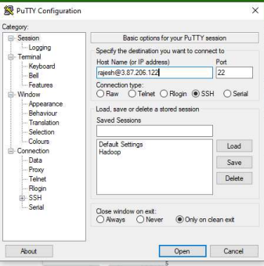

DVS Technologies, Opp Home Town, Beside Biryani Zone, Marathahalli, Bangalore Phone: 9632558585 Mobile: 8892499499 Mail : dvs.training@gmail.com Web: www.dvstechnologies.in

DVS Technologies Aws & Devops 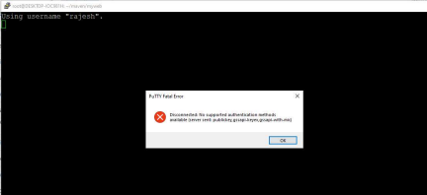

User rajesh can't login as he is not having access to the system

Now let's try to generate the key for rajesh user

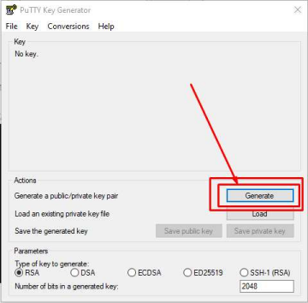

DVS Technologies, Opp Home Town, Beside Biryani Zone, Marathahalli, Bangalore Phone: 9632558585 Mobile: 8892499499 Mail : dvs.training@gmail.com Web: www.dvstechnologies.in

DVS Technologies Aws & Devops

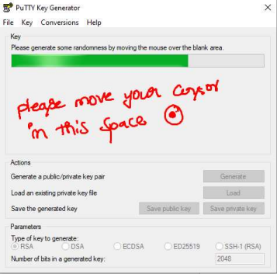

DVS Technologies, Opp Home Town, Beside Biryani Zone, Marathahalli, Bangalore Phone: 9632558585 Mobile: 8892499499 Mail : dvs.training@gmail.com Web: www.dvstechnologies.in

DVS Technologies Aws & Devops 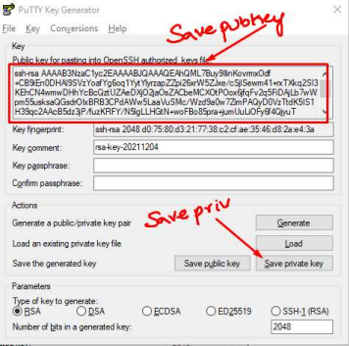

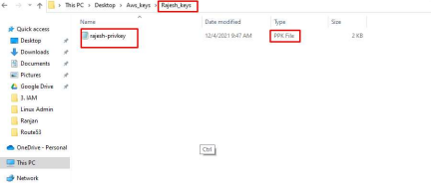

DVS Technologies, Opp Home Town, Beside Biryani Zone, Marathahalli, Bangalore Phone: 9632558585 Mobile: 8892499499 Mail : dvs.training@gmail.com Web: www.dvstechnologies.in

DVS Technologies Aws & Devops

Saving Public key:

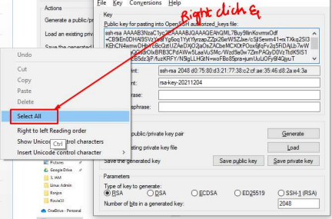

DVS Technologies, Opp Home Town, Beside Biryani Zone, Marathahalli, Bangalore Phone: 9632558585 Mobile: 8892499499 Mail : dvs.training@gmail.com Web: www.dvstechnologies.in

DVS Technologies Aws & Devops 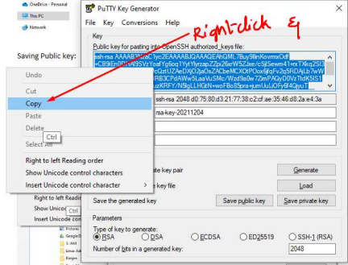

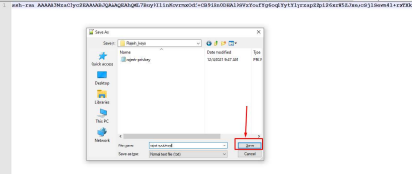

DVS Technologies, Opp Home Town, Beside Biryani Zone, Marathahalli, Bangalore Phone: 9632558585 Mobile: 8892499499 Mail : dvs.training@gmail.com Web: www.dvstechnologies.in

DVS Technologies Aws & Devops 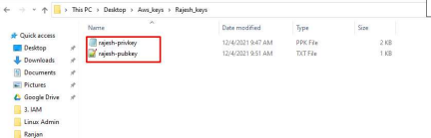

Once you are done with generating keys please execute the below in the server

mkdir /home/rajesh/.ssh

vi /home/rajesh/.ssh/authorized_keys

chmod 700 /home/rajesh/.ssh

chmod 600 /home/rajesh/.ssh/authorized_keys

chown rajesh:rajesh /home/rajesh/.ssh -R

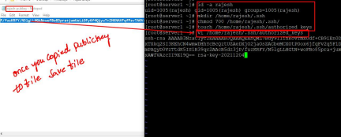

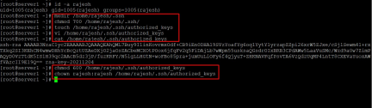

DVS Technologies, Opp Home Town, Beside Biryani Zone, Marathahalli, Bangalore Phone: 9632558585 Mobile: 8892499499 Mail : dvs.training@gmail.com Web: www.dvstechnologies.in

DVS Technologies Aws & Devops

Run the pageant



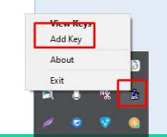



DVS Technologies, Opp Home Town, Beside Biryani Zone, Marathahalli, Bangalore Phone: 9632558585 Mobile: 8892499499 Mail : dvs.training@gmail.com Web: www.dvstechnologies.in

DVS Technologies Aws & Devops

Verifying keys in pageant:





Once done with the above changes try to login to the system as "rajesh" user with his private key. Open putty & try to login now

DVS Technologies, Opp Home Town, Beside Biryani Zone, Marathahalli, Bangalore Phone: 9632558585 Mobile: 8892499499 Mail : dvs.training@gmail.com Web: www.dvstechnologies.in

DVS Technologies Aws & Devops 



DVS Technologies, Opp Home Town, Beside Biryani Zone, Marathahalli, Bangalore Phone: 9632558585 Mobile: 8892499499 Mail : dvs.training@gmail.com Web: www.dvstechnologies.in

DVS Technologies Aws & Devops 

2.Grant root access for rajesh user

Before:



Execute the below commands

DVS Technologies, Opp Home Town, Beside Biryani Zone, Marathahalli, Bangalore Phone: 9632558585 Mobile: 8892499499 Mail : dvs.training@gmail.com Web: www.dvstechnologies.in

DVS Technologies Aws & Devops 

Note: Relogin to the system

Post Changes try to login to the system:



DVS Technologies, Opp Home Town, Beside Biryani Zone, Marathahalli, Bangalore Phone: 9632558585 Mobile: 8892499499 Mail : dvs.training@gmail.com Web: www.dvstechnologies.in

DVS Technologies Aws & Devops

3. Username & password authentication





DVS Technologies, Opp Home Town, Beside Biryani Zone, Marathahalli, Bangalore Phone: 9632558585 Mobile: 8892499499 Mail : dvs.training@gmail.com Web: www.dvstechnologies.in

DVS Technologies Aws & Devops 

How to enable the password based authentication for a user in aws:





Now try to login to the system using suresh user via putty

DVS Technologies, Opp Home Town, Beside Biryani Zone, Marathahalli, Bangalore Phone: 9632558585 Mobile: 8892499499 Mail : dvs.training@gmail.com Web: www.dvstechnologies.in

DVS Technologies Aws & Devops 



DVS Technologies, Opp Home Town, Beside Biryani Zone, Marathahalli, Bangalore Phone: 9632558585 Mobile: 8892499499 Mail : dvs.training@gmail.com Web: www.dvstechnologies.in

DVS Technologies Aws & Devops

4.Password Less Authentication

Create three servers let's say basemachine,server1 & server2. Our requirement is to collect information from server1 & server2 from base machine.

In order to full fill this requirement we need to enable password less authentication.





In Basemachine do the below changes:



Host name resolution:



Make sure that you are adding the entires in /etc/hosts

DVS Technologies, Opp Home Town, Beside Biryani Zone, Marathahalli, Bangalore Phone: 9632558585 Mobile: 8892499499 Mail : dvs.training@gmail.com Web: www.dvstechnologies.in

DVS Technologies Aws & Devops

Before:



After Adding entries:



Now when we try to login to the system:



Now it prompts for yes/no. when you give yes then



Its throwing the error because we didn't pass the privatekey or pem key to login to the server1.

Let's configure a user called "automation" in all the servers. Once done make sure that you are generating the keypair & copying the public key to all the servers for this user under a file called "/home/automation/.ssh/authorized_keys"

DVS Technologies, Opp Home Town, Beside Biryani Zone, Marathahalli, Bangalore Phone: 9632558585 Mobile: 8892499499 Mail : dvs.training@gmail.com Web: www.dvstechnologies.in

DVS Technologies Aws & Devops

Create a user called automation:



Generate keypair for this user:



DVS Technologies, Opp Home Town, Beside Biryani Zone, Marathahalli, Bangalore Phone: 9632558585 Mobile: 8892499499 Mail : dvs.training@gmail.com Web: www.dvstechnologies.in

DVS Technologies Aws & Devops 

Save your public& privatekeys:



DVS Technologies, Opp Home Town, Beside Biryani Zone, Marathahalli, Bangalore Phone: 9632558585 Mobile: 8892499499 Mail : dvs.training@gmail.com Web: www.dvstechnologies.in

DVS Technologies Aws & Devops





DVS Technologies, Opp Home Town, Beside Biryani Zone, Marathahalli, Bangalore Phone: 9632558585 Mobile: 8892499499 Mail : dvs.training@gmail.com Web: www.dvstechnologies.in

DVS Technologies Aws & Devops 



DVS Technologies, Opp Home Town, Beside Biryani Zone, Marathahalli, Bangalore Phone: 9632558585 Mobile: 8892499499 Mail : dvs.training@gmail.com Web: www.dvstechnologies.in

DVS Technologies Aws & Devops

Now our keys are ready. Let's copy the public key to all the servers using below command in the servers.

mkdir /home/automation/.ssh

chmod 700 /home/automation/.ssh

vi /home/automation/.ssh/authorized_keys

make sure you are copying the public key to this file

chmod 600 /home/automation/.ssh/authorized_keys

chown -R automation:automation /home/automation/.ssh









NOTE: Please execute the above steps in all the machines

We are done with user creation in all the servers.

DVS Technologies, Opp Home Town, Beside Biryani Zone, Marathahalli, Bangalore Phone: 9632558585 Mobile: 8892499499 Mail : dvs.training@gmail.com Web: www.dvstechnologies.in

DVS Technologies Aws & Devops

NOTE: we can't use our privatekey to login from linux server to linux server. We have to convert our privatekey to pem key. Please follow the below steps to convert our private key to pem key

Problem:



Solution:

Generating pem key from privatekey

DVS Technologies, Opp Home Town, Beside Biryani Zone, Marathahalli, Bangalore Phone: 9632558585 Mobile: 8892499499 Mail : dvs.training@gmail.com Web: www.dvstechnologies.in

DVS Technologies Aws & Devops 

DVS Technologies, Opp Home Town, Beside Biryani Zone, Marathahalli, Bangalore Phone: 9632558585 Mobile: 8892499499 Mail : dvs.training@gmail.com Web: www.dvstechnologies.in

DVS Technologies Aws & Devops 

DVS Technologies, Opp Home Town, Beside Biryani Zone, Marathahalli, Bangalore Phone: 9632558585 Mobile: 8892499499 Mail : dvs.training@gmail.com Web: www.dvstechnologies.in

DVS Technologies Aws & Devops 

DVS Technologies, Opp Home Town, Beside Biryani Zone, Marathahalli, Bangalore Phone: 9632558585 Mobile: 8892499499 Mail : dvs.training@gmail.com Web: www.dvstechnologies.in

DVS Technologies Aws & Devops 

DVS Technologies, Opp Home Town, Beside Biryani Zone, Marathahalli, Bangalore Phone: 9632558585 Mobile: 8892499499 Mail : dvs.training@gmail.com Web: www.dvstechnologies.in

DVS Technologies Aws & Devops 

Now let's copy this pem key to the basemachine & try to access the servers.



DVS Technologies, Opp Home Town, Beside Biryani Zone, Marathahalli, Bangalore Phone: 9632558585 Mobile: 8892499499 Mail : dvs.training@gmail.com Web: www.dvstechnologies.in

DVS Technologies Aws & Devops 



Enable direct login to servers via automation user:

DVS Technologies, Opp Home Town, Beside Biryani Zone, Marathahalli, Bangalore Phone: 9632558585 Mobile: 8892499499 Mail : dvs.training@gmail.com Web: www.dvstechnologies.in

DVS Technologies Aws & Devops 



DVS Technologies, Opp Home Town, Beside Biryani Zone, Marathahalli, Bangalore Phone: 9632558585 Mobile: 8892499499 Mail : dvs.training@gmail.com Web: www.dvstechnologies.in

DVS Technologies Aws & Devops 

Finally we can login to server1 & server2 via our automation user from basemachine

DVS Technologies, Opp Home Town, Beside Biryani Zone, Marathahalli, Bangalore Phone: 9632558585 Mobile: 8892499499 Mail : dvs.training@gmail.com Web: www.dvstechnologies.in