**ASP PROJECT :**

Default.aspx: starting page of website

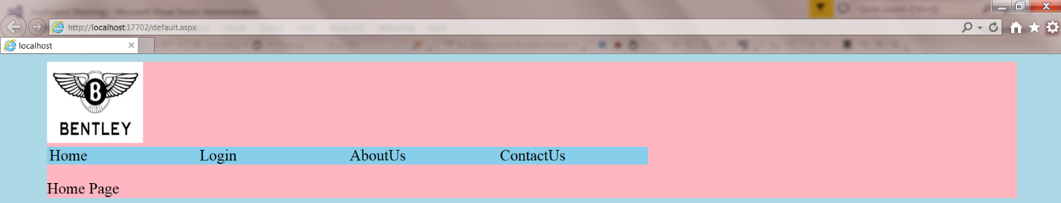

Login Page:

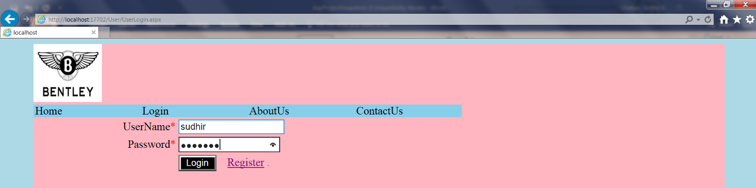

Registration.aspx:

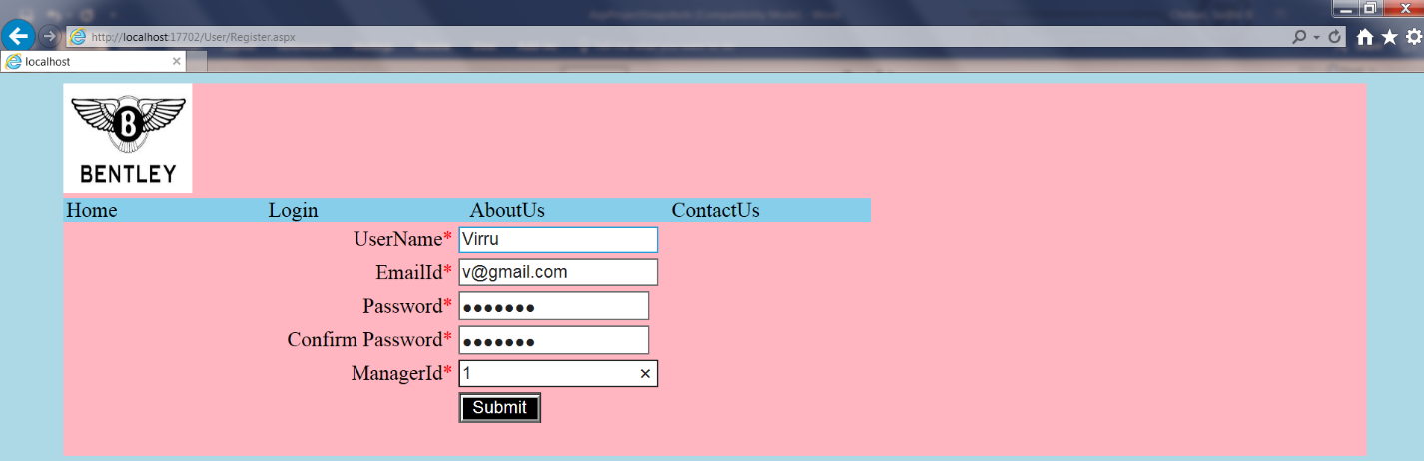

UserHome.aspx : User login the login form then redirect to UserHome.aspx

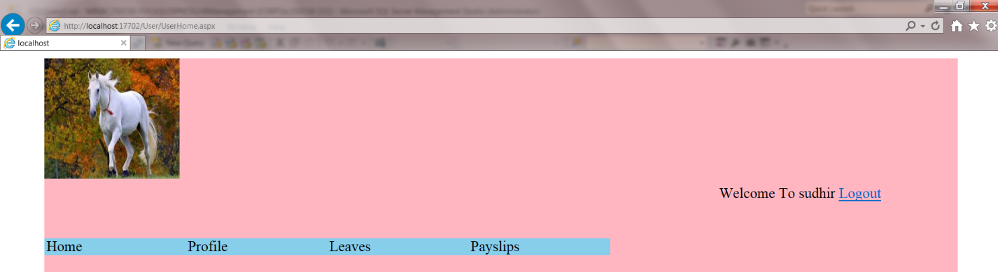

Userprofile.aspx :

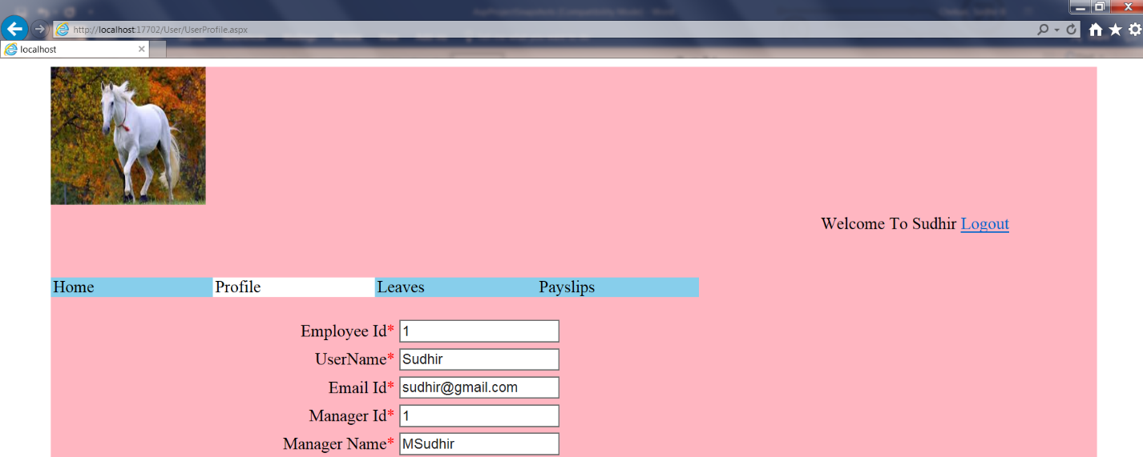

Userleaves.aspx :

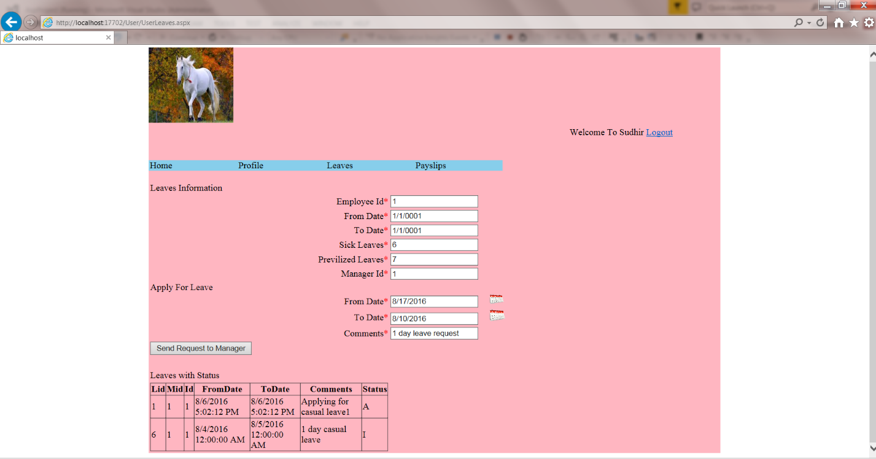

UserPayslips.aspx

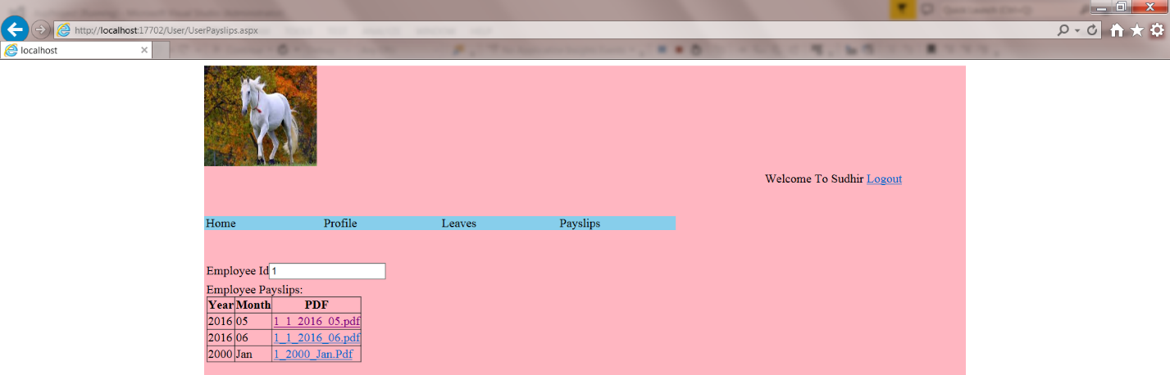

Adminlogin.aspx :

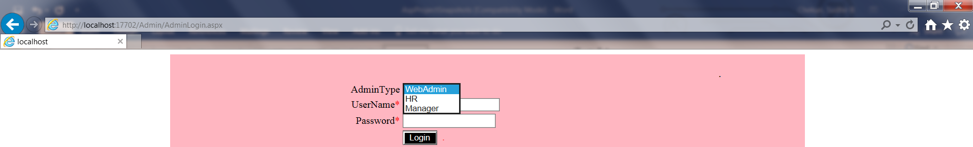

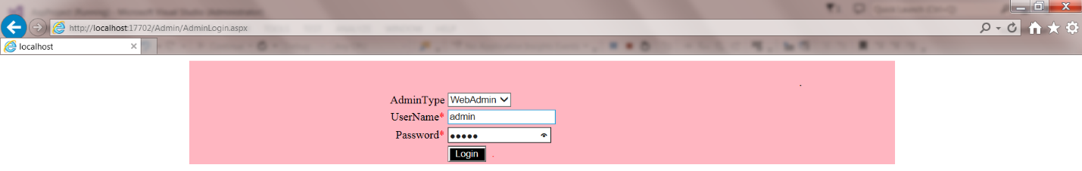

In this form represents 3 modules.

1.webadmin , 2.HR ,3.Manager

* webadmin login the required credentials to redirect WebadminHome.aspx

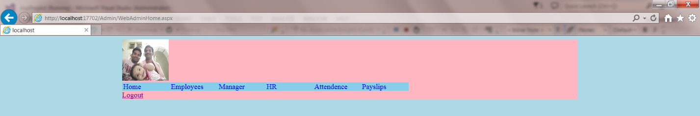

WebAdminEmployee.aspx:

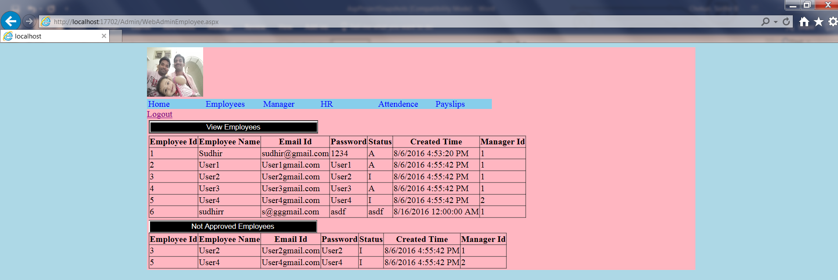

WebAdminManager.aspx:

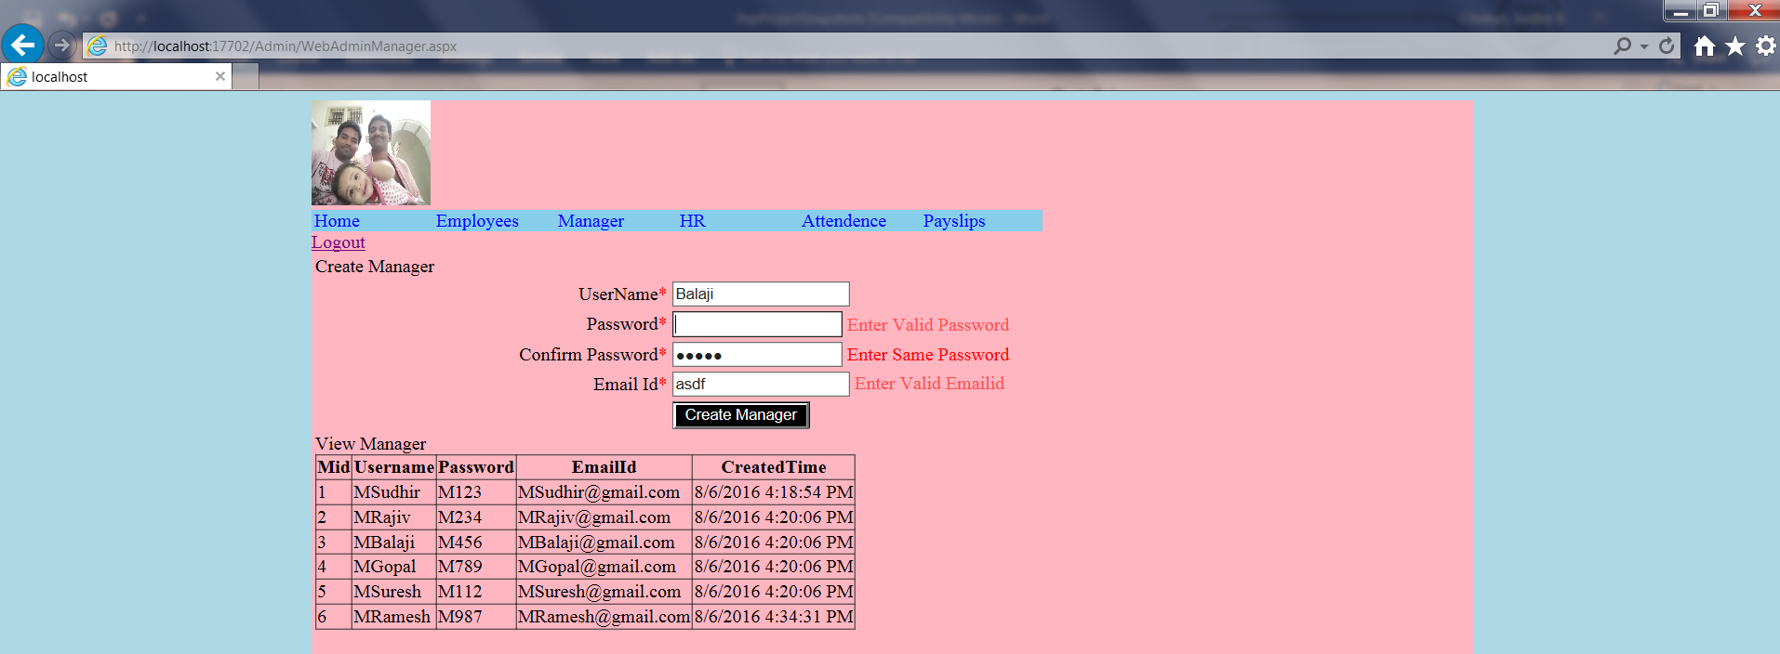

WebAdminHR.aspx:

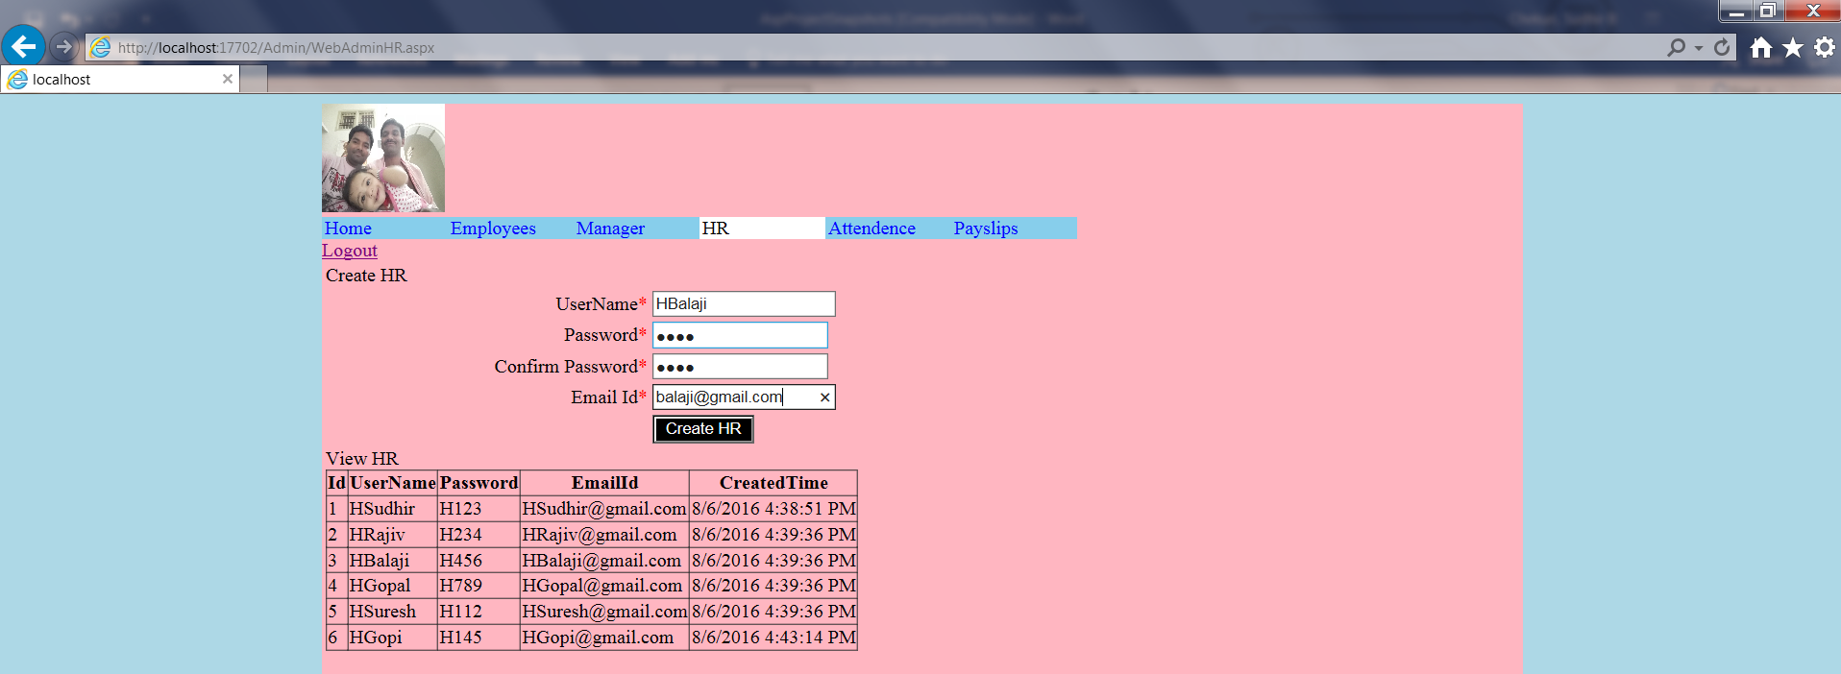

WebAdminAttendence.aspx :

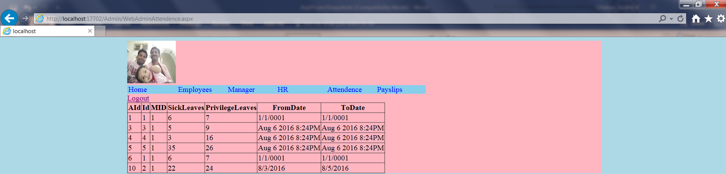

WebAdminPayslips.aspx :

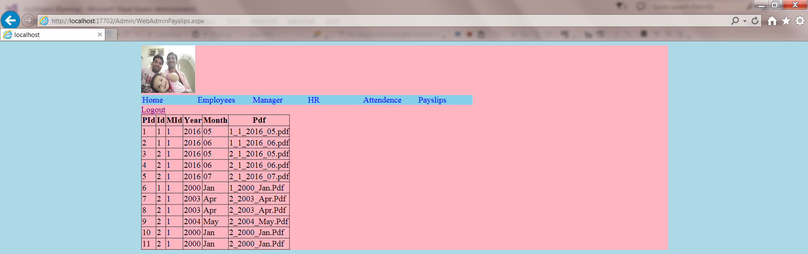

Adminlogin.aspx : HR Login the required credential to redirect HRHome.aspx

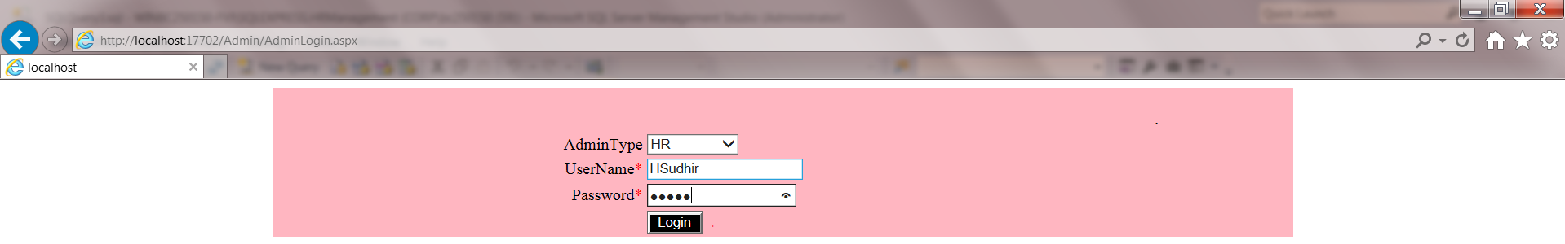

HRHome.aspx:

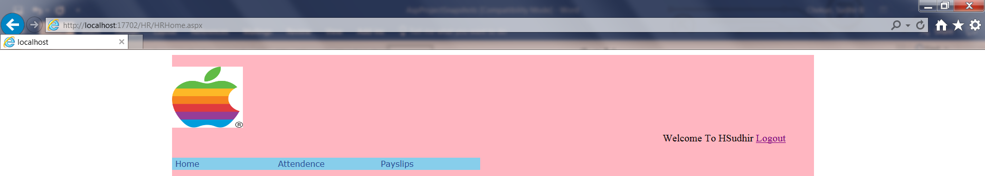

HRAttendence.aspx :

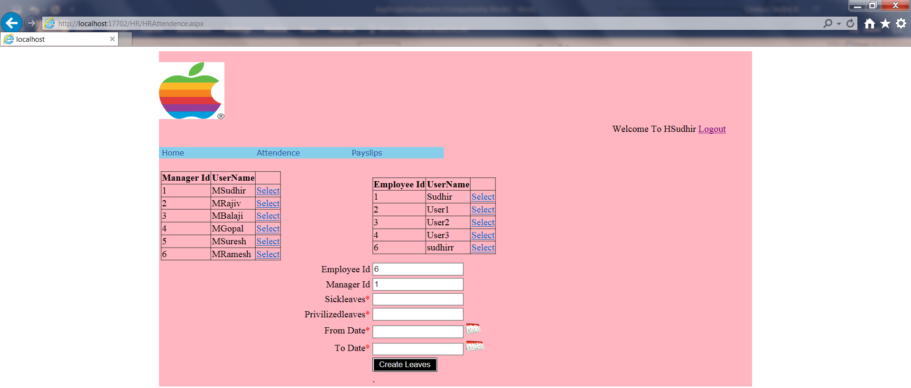

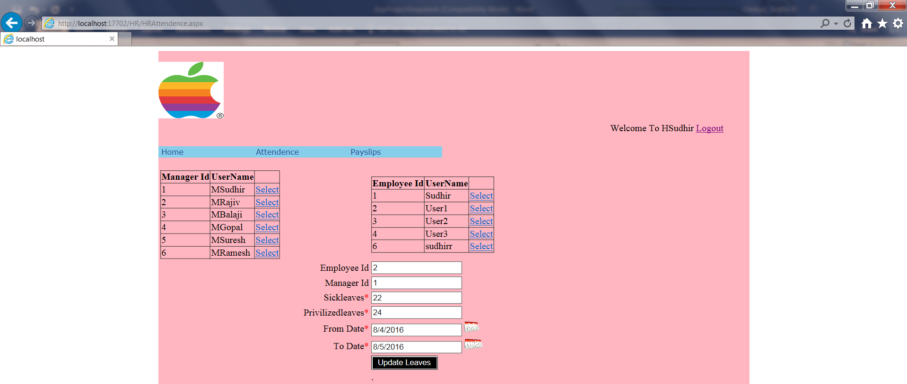

HRPayslips.aspx :

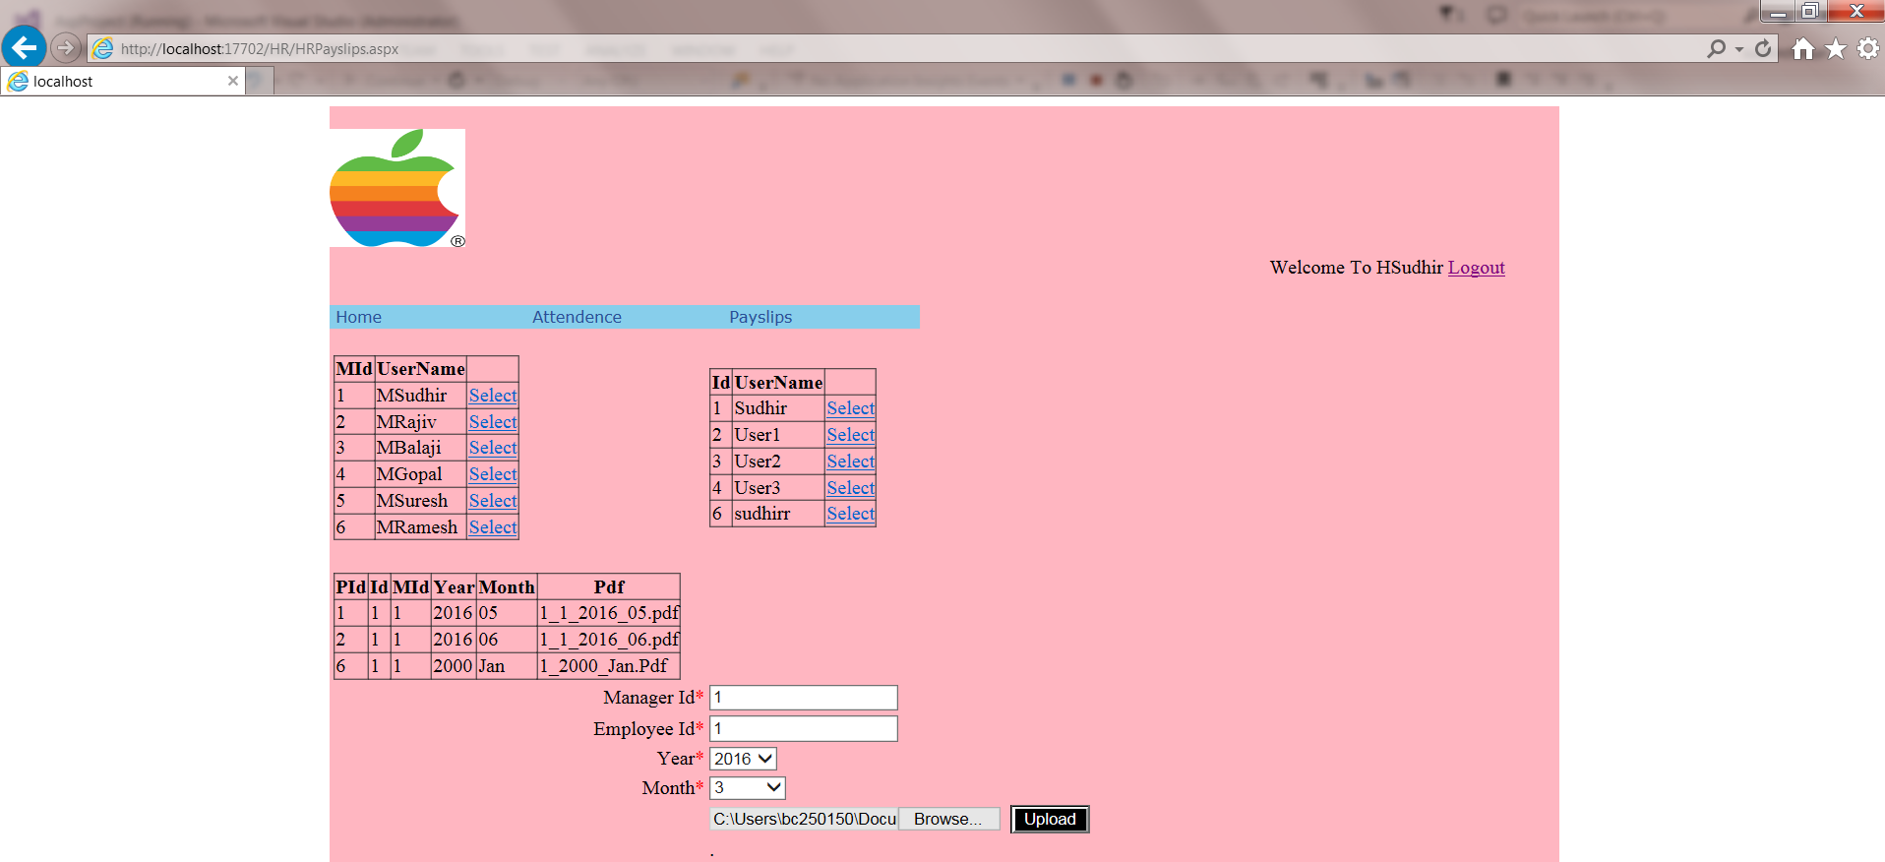

Adminlogin.aspx: Manager login the required credential to redirect the ManagerHome.aspx

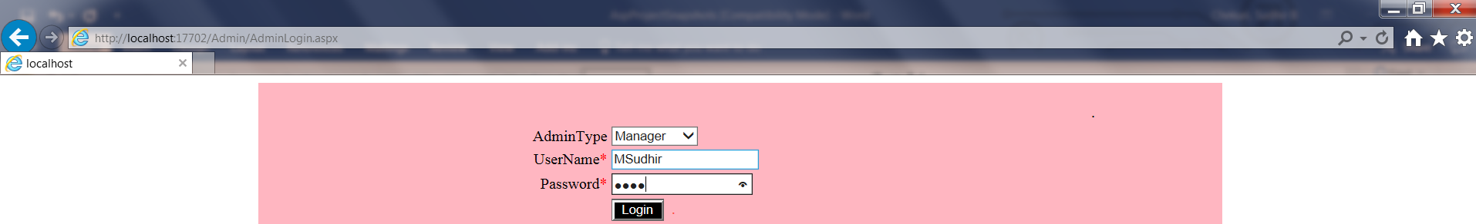

ManagerHome.aspx :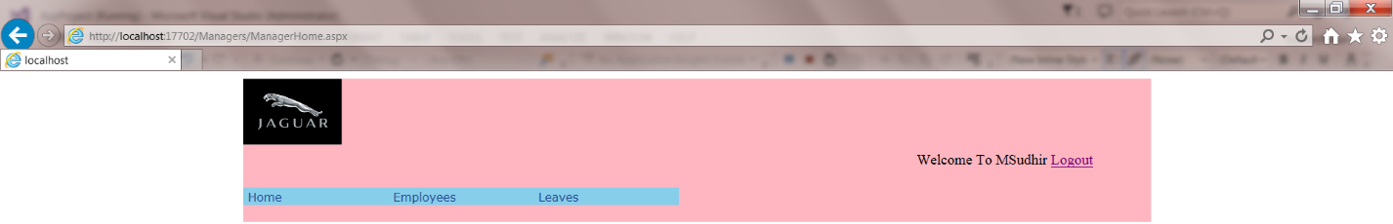

ManagerEmployee.aspx :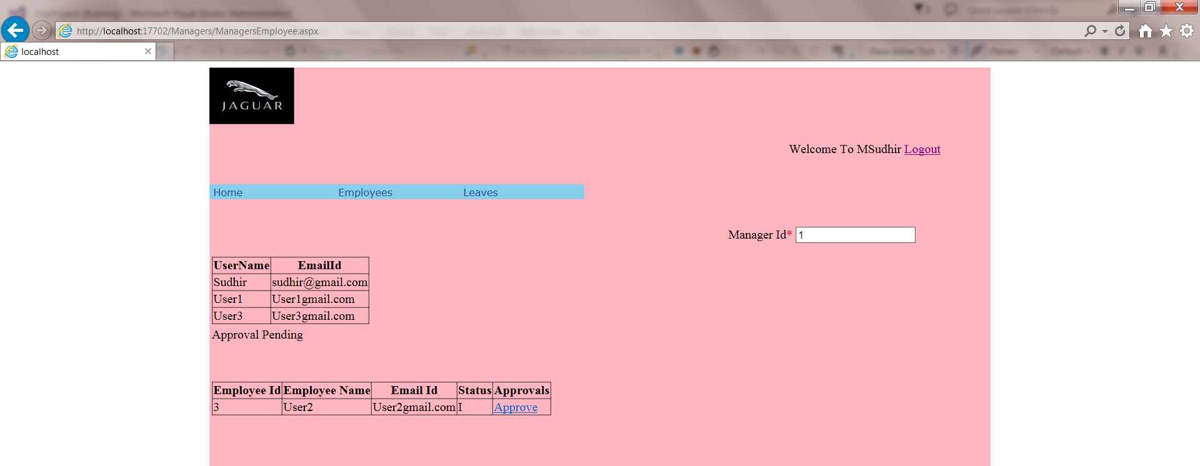

ManagerLeaves.aspx :

