TALLY CONNECT
Tally Prime Integration & Business Intelligence Platform

Project Name: Tally Connect – Tally Prime Integration Platform
Document Type: Complete Technical Project Documentation
Version: 1.0.0
Prepared By: Sudhir Morchale
Date: February 2026
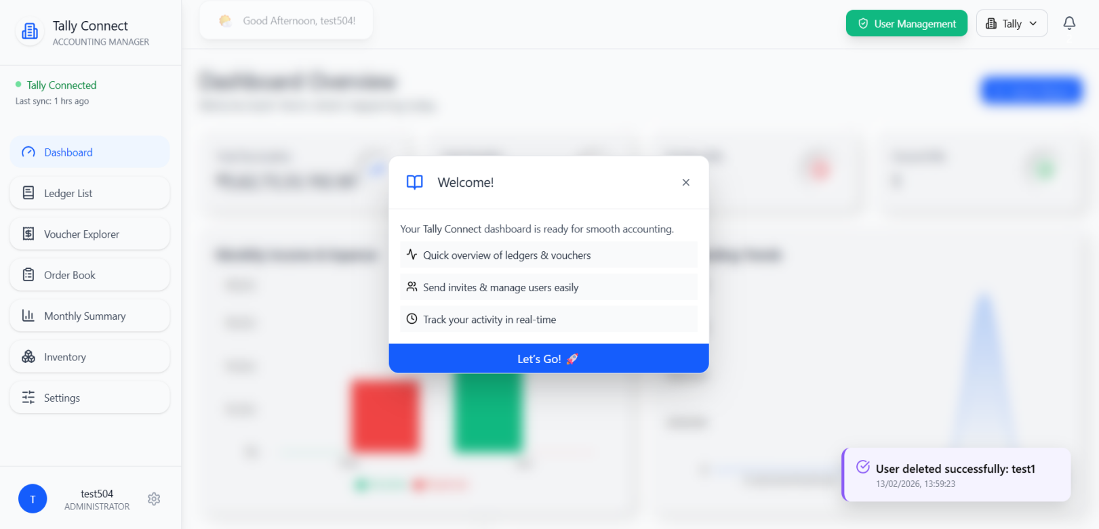

1. TABLE OF CONTENTS

1. Project Overview ………………………………………………………………………………………….3
1.1 Purpose of the Project
1.2 Problem Statement
1.3 Project Objectives

2. System Architecture ………………………………………………………………………………………4
2.1 Architecture Overview with Diagrams

3. System Workflow & Data Flow ………………………………………………………………………….7
3.1 End-to-End Process Flows
3.2 Data Synchronization Flow
3.3 Voucher & Bill Write-Back Flow
3.4 Authentication Flow
3.5 Notification Flow

4. Use Case Diagram and Activity Diagram ……………………………………………………………..10
4.1 Actor & Use Case Overview
4.2 Actor Descriptions
4.3 Use Case Summary

5. Database Design ………………………………………………………………………………………..14
5.1 Entity Relationship Overview
5.2 Database Domain Overview
5.3 Key Table Descriptions
5.4 Primary and Foreign Key Summary

6. Technology ………………………………………………………………………………………………17
6.1 Frontend
6.2 Backend
6.3 Database & Agent

7. File Structure and Execution ………………………………………………………………………….19

8. Database Schema ……………………………………………………………………………………..24

9. Core Features ………………………………………………………………………………………….39
9.1 Tally Prime Integration via agent.exe
9.2 Admin Dashboard
9.3 Greeting & Welcome Notifications
9.4 Ledger Management
9.5 Voucher Explorer
9.6 Bill Creation
9.7 Order Book
9.8 Monthly Summary
9.9 Inventory Management
9.10 Notification Management
9.11 User & Permission Management
9.12 Multi-Company Management
9.13 Global Search & Pagination
9.14 Data Delete History of Tally Prime
9.15 Data Delete History Rollback to Tally Prime
9:16 User Invitation via Emails.
9:17 Permission Access Notification Emails

10. Authentication & Authorization Flow ……………………………………………………………….44
10.1 Admin Registration
10.2 User Invitation
10.3 Role-Based Access Control

11. API Documentation ………………………………………………………………………………….45
11.1 Overview
11.2 Authentication Endpoint
11.3 User Management Endpoints
11.4 Data Endpoints
11.5 Notification Endpoints
11.6 Sync / Agent Endpoints
11.7 Standard Response Format

12. Security Measures ………………………………………………………………………………….48
12.1 Authentication Security
12.2 Data Access Security
12.3 Agent & Communication Security

13. Deployment Details …………………………………………………………………………………49
13.1 Server Requirements
13.2 Client Machine Requirements
13.3 Key Environment Variables

14. Limitations …………………………………………………………………………………………..50

15. Future Enhancements .…………………………………………………………………………….50

16. Conclusion ………………………………………………………………………………………….51

17. Error Messages and Reasons ……………………………………………………………………52
17.1 Agent Errors
18 . Per User Cost Infrastructure Cost Breakdown …………………………………………………56

1. Project Overview

1.1 Purpose of the Project
Tally Connect is an advanced web-based business intelligence and data management platform built to seamlessly integrate with Tally Prime — India's most widely used accounting software. The platform bridges the gap between Tally Prime's powerful accounting engine and the need for modern, accessible, multi-user, role-based business data visibility. Tally Connect enables businesses to view, analyze, and interact with their Tally data through a clean, secure, and feature-rich web interface without requiring users to directly access the Tally Prime desktop application.

1.2 Problem Statement
Businesses using Tally Prime face several operational challenges that Tally Connect resolves:
- Tally Prime is a desktop-based application with limited multi-user access, requiring all users to be on the same local network.
- No built-in role-based access control for restricting data visibility at the row or column level per user.
- Real-time monitoring of financial data, inventory, ledgers, and vouchers is not available outside the Tally environment.
- Sharing reports and notifications with non-Tally users is manual and time-consuming.
- Managing multiple companies simultaneously with different user permissions is complex and error-prone.
- There is no mechanism to invite external stakeholders with controlled, granular data access.

1.3 Project Objectives
- Provide real-time data synchronization from Tally Prime to a web platform every 5 minutes using an intelligent desktop agent (agent.exe).
- Enable secure, role-based access for multiple users with fine-grained control over which data rows and columns are visible.
- Deliver a comprehensive financial dashboard with key metrics, charts, and analytics without requiring direct Tally access.
- Allow direct creation of vouchers and bills from the web platform that instantly reflect in Tally Prime.
- Support multi-company management with company-wise user assignments and independent permissions.
- Provide automated notification systems for financial events, user activities, and scheduled downloadable PDF reports.
- Enable admin-level user management including email invitation, OTP-based access activation, and bulk permission assignment.

2. System Architecture

2.1 High-Level Architecture Overview
Tally Connect follows a four-layer client-server architecture with a dedicated desktop agent component. Data flows from Tally Prime on the client's Windows machine, through the agent.exe desktop bridge, to the cloud backend and PostgreSQL database, and finally is served to the web frontend accessed by admins and users.

Figure 2.1: Tally Connect – System Architecture Diagram
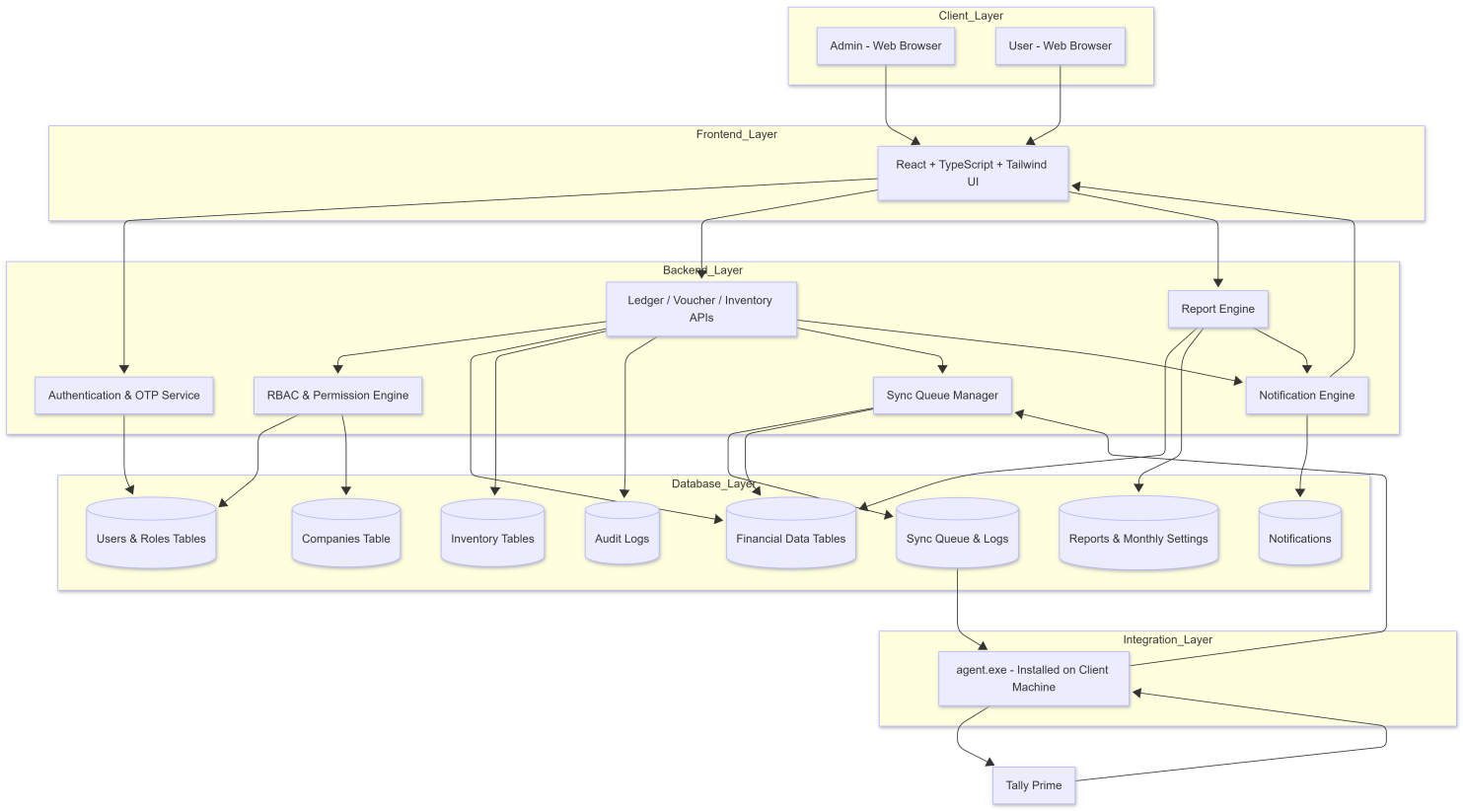
Figure 2.2: Tally Connect – System Architecture Diagram another example
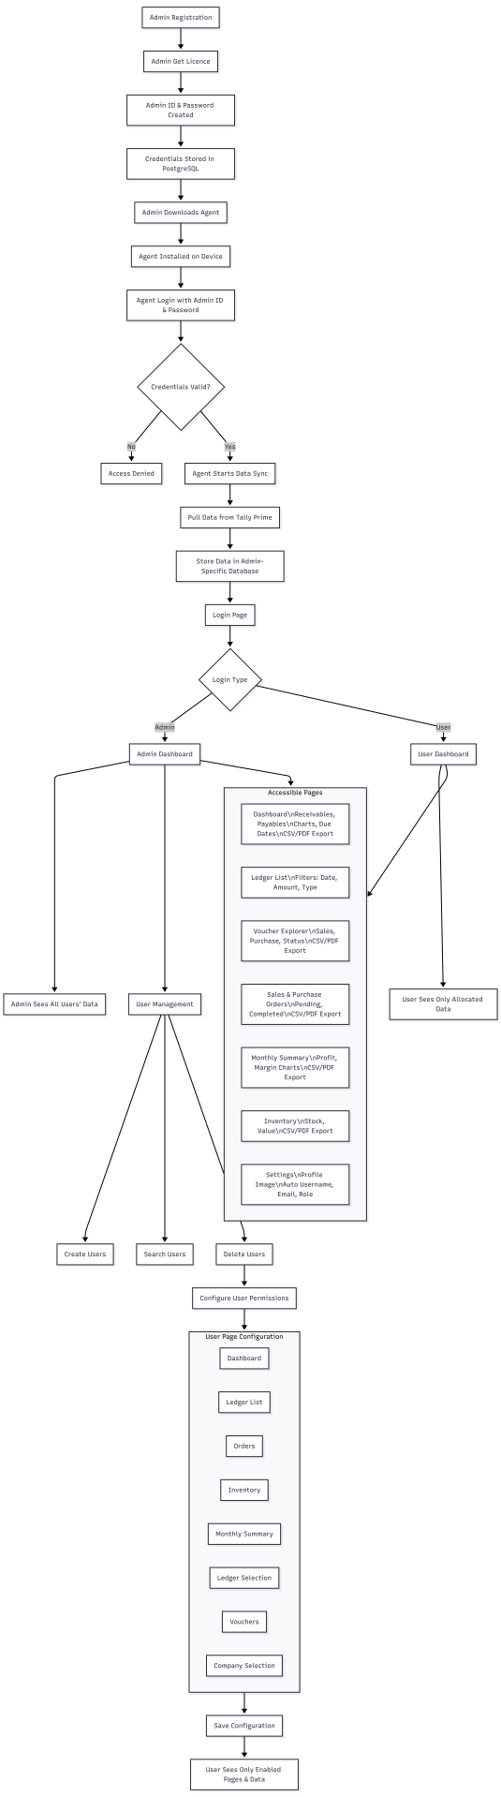

Layer 1: Tally Prime (Data Source)
Tally Prime runs on the client's Windows machine as the primary accounting data source. It exposes ledgers, vouchers, invoices, orders, and inventory data through its XML-based TDL HTTP API interface.

Layer 2: agent.exe (Desktop Bridge)
A lightweight Windows application installed on the Tally machine. It pulls data from Tally every 5 minutes, extracts custom fields and contact details, and pushes processed data to the cloud backend. It also receives write commands (voucher/bill creation) from the backend and executes
them in Tally Prime.

Layer 3: Cloud Backend (API Server)
A cloud-hosted Node.js + Express server that manages all business logic, sync queues, user management, permission evaluation, notification dispatch, and scheduled report generation. Exposes RESTful APIs consumed by the frontend.

Layer 4: Web Frontend (Browser)
A React.js web application providing the user interface for admins and users to view dashboards, ledgers, vouchers, orders, and inventory; manage users and permissions; create vouchers and bills; and download reports — all based on assigned role-based permissions.

3. System Workflow & Data Flow

3.1 End-to-End Process Flows
The diagram below illustrates the four primary workflows operating within Tally Connect: the data sync flow (Tally to frontend), the write-back flow (frontend to Tally), the authentication flow, and the notification dispatch flow.

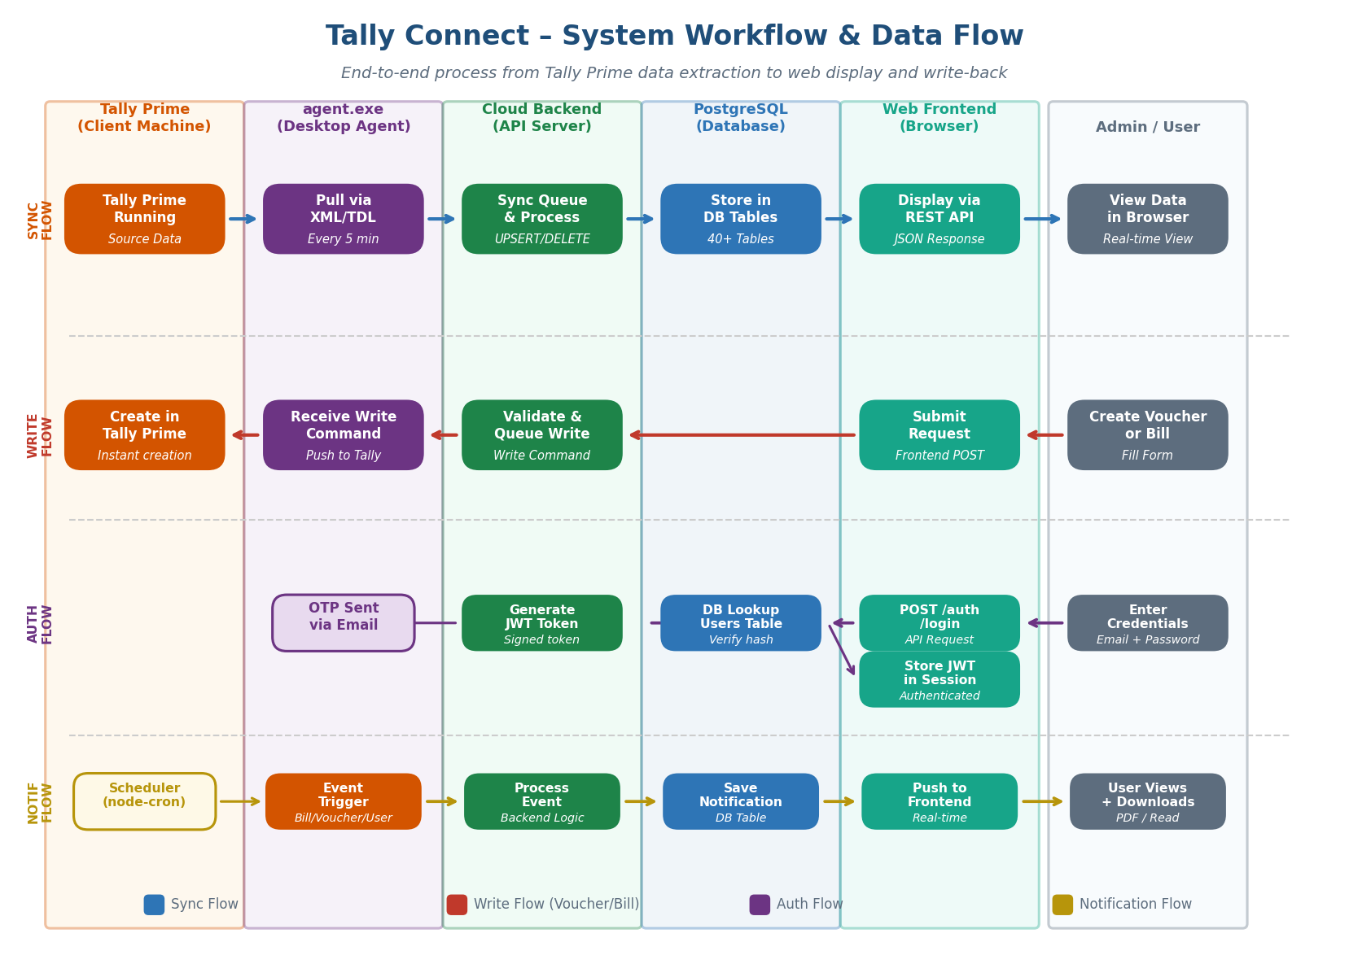
Figure 2: Tally Connect – System Workflow

3.2 Data Synchronization Flow
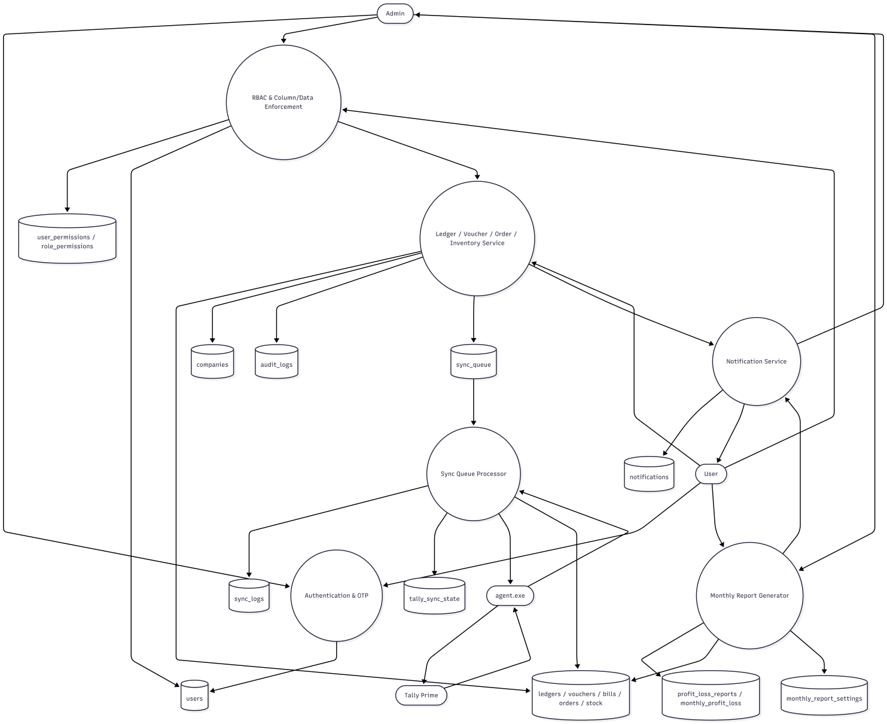
Figure 2: Tally Connect – Data Workflow
1 .Tally Prime runs on the client machine with data stored locally.
2 .agent.exe connects to Tally via the local TDL HTTP API every 5 minutes.
3 .Agent checks the alter ID to identify new or changed records incrementally.
4 .Extracted data (Ledgers, Vouchers, Bills, Orders, Inventory) is pushed to the backend via HTTPS.
5 .Backend processes the sync queue and performs UPSERT/DELETE operations in PostgreSQL.
6 Frontend fetches updated data via REST API and displays it to the user in real time.

3.3 Voucher & Bill Write-Back Flow
1 . User fills in voucher or bill details on the web frontend and submits.
2 .Frontend sends a POST request to the backend API.
- Backend validates the request, evaluates permissions, and queues a write command for the agent.
4 .agent.exe picks up the write command and sends it to Tally Prime via TDL XML.
5 .Tally Prime creates the voucher/bill and assigns a GUID.
6 .The new record is picked up in the next sync cycle and displayed on the frontend.

3.4 Authentication Flow
1.User enters email and password on the login screen.
2 .Backend validates credentials against the hashed password in the users table.
3 .On success, a signed JWT token is generated and returned to the frontend.
4 .JWT is stored in the browser session and attached to all subsequent API requests.
5 .For first-time users or permission updates, an OTP is sent to email for additional verification.

3.5 Notification Flow
1.An event is triggered (Bill created, Low stock, User added, Scheduled report time reached).
2 .The backend processes the event based on user notification preferences.
3 .A notification record is created in the notifications table with type, message, and metadata.
4 .The notification is pushed to the frontend and appears in the user's notification panel.
5 .For Monthly Reports, a PDF is generated and attached as a one-click downloadable link.

4. Use Case Diagram and Activity Diagram

4.1 Actor & Use Case Overview
The use case diagram below identifies all actors interacting with the Tally Connect system and maps them to the functional use cases they can perform. Actors include the Admin, Business User, agent.exe (system), and Tally Prime (external system).

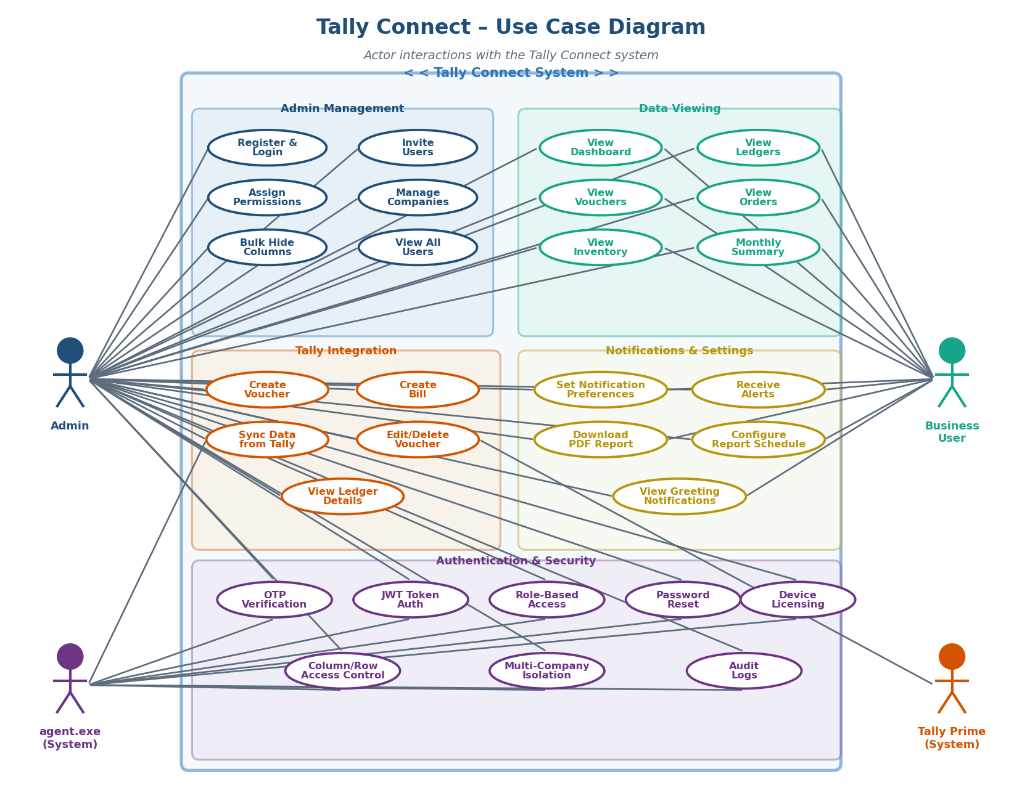FFigure 3: Tally Connect – Use Case Diagram
Figure 3.1: Tally Connect – Use Case Diagram in different format
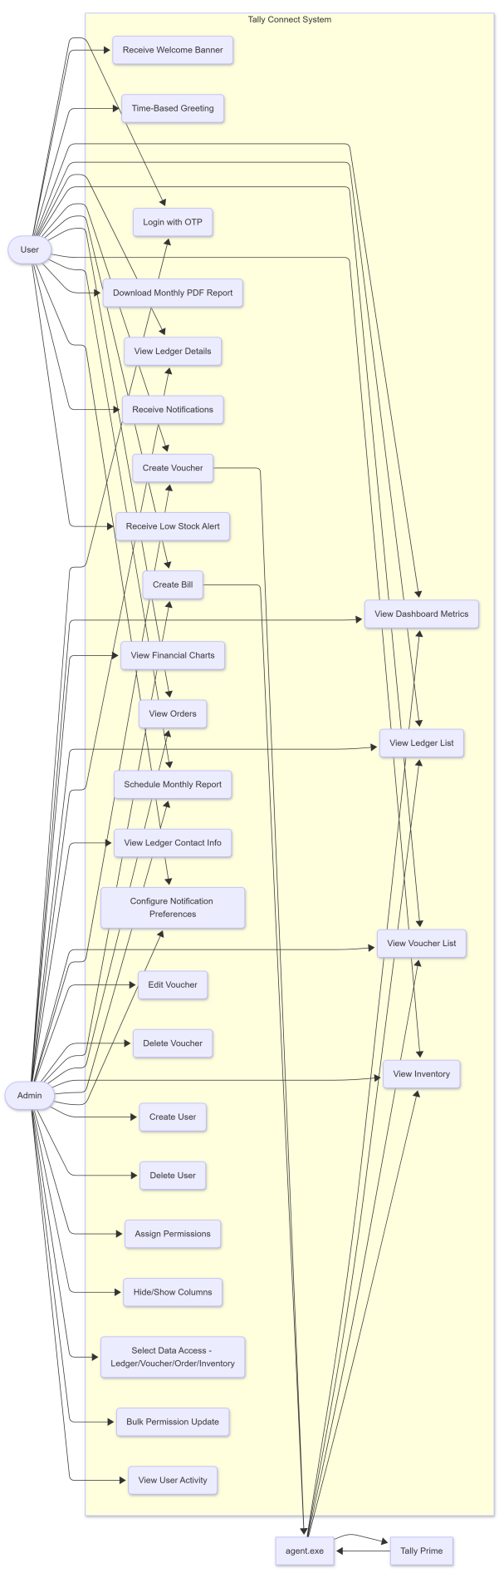

4.2 Actor Descriptions
Actor | Type | Description
Admin | Primary Human | The primary system owner. Has full access to all features, user management, company setup, and data across all companies.
Business User | Secondary Human | An invited user with access restricted to data and pages explicitly permitted by the admin.
agent.exe | System Actor | The desktop agent installed on the client machine. Responsible for all Tally Prime data extraction and write-back operations.
Tally Prime | External System | The source accounting system. Receives write commands and provides data for sync operations.

4.3 Use Case Summary
Use Case Group | Use Cases | Primary Actor
Admin Management | Register & Login, Invite Users, Assign Permissions, Manage Companies, Bulk Hide Columns, View All Users | Admin
Data Viewing | View Dashboard, View Ledgers, View Vouchers, View Orders, View Inventory, Monthly Summary | Admin, User
Tally Integration | Create Voucher, Create Bill, Edit/Delete Voucher, Sync Data, View Ledger Details | Admin, agent.exe
Notifications & Settings | Set Preferences, Receive Alerts, Download PDF Report, Configure Report Schedule, View Greetings | Admin, User
Authentication & Security | OTP Verification, JWT Auth, Role-Based Access, Password Reset, Device Licensing, Audit Logs | Admin, agent.exe
Activity Diagram
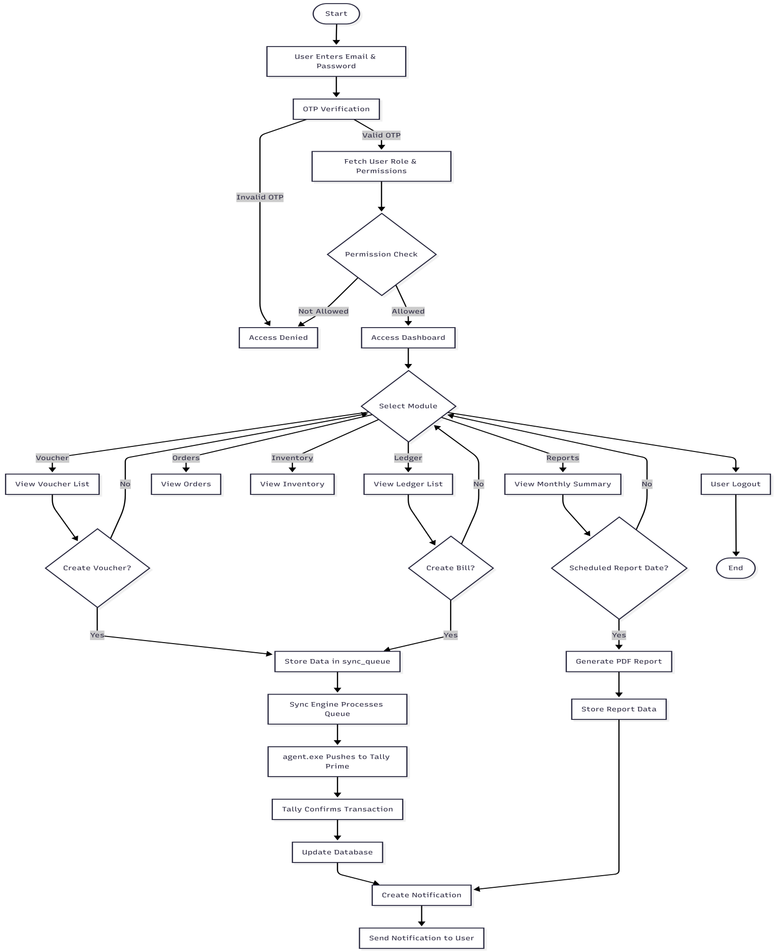

5. Database Design

5.1 Entity Relationship Overview
The Tally Connect database is built on PostgreSQL and consists of 40+ relational tables organized into logical domains. The schema follows a multi-tenant design where data is partitioned by admin_id and company_guid. The ER diagram below shows the key entities and their relationships.

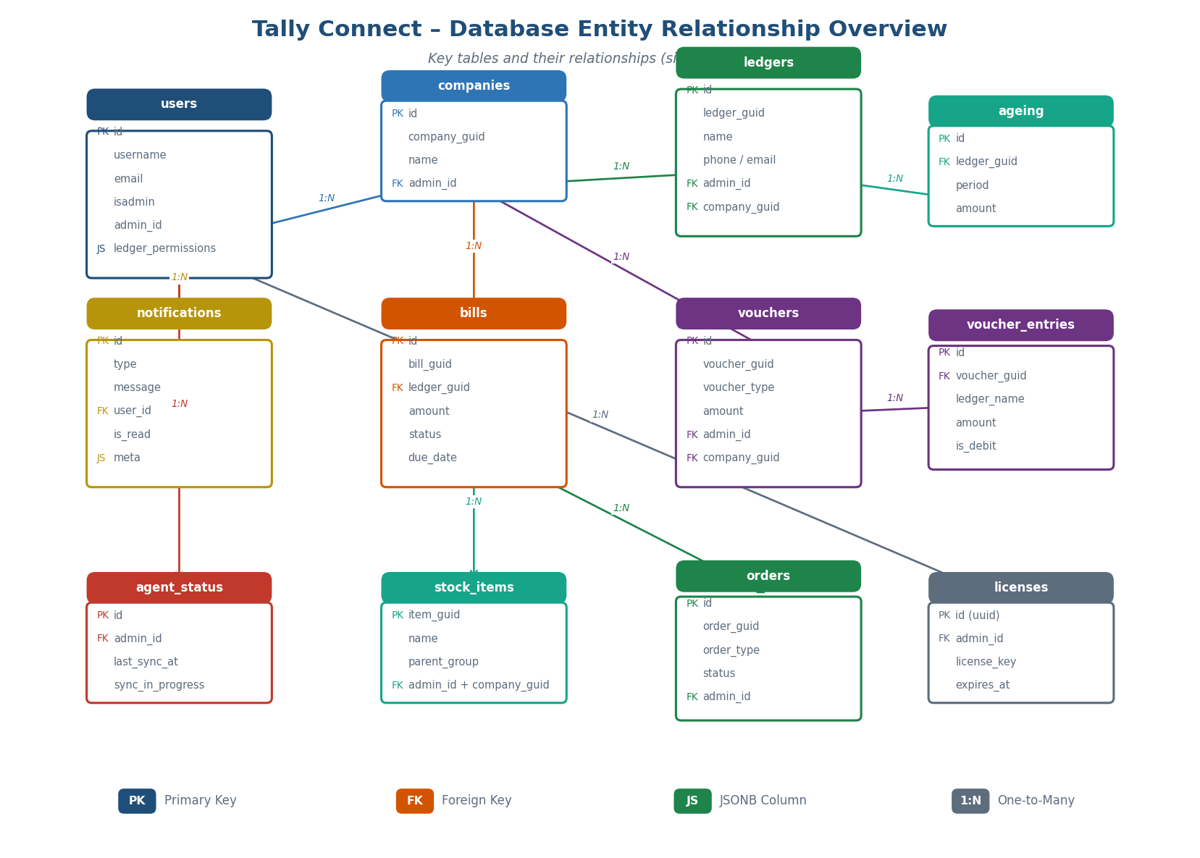
Figure 4: Tally Connect – Database ER Overview Diagram

5.2 Database Domain Overview
Domain | Key Tables | Purpose
User Management | users, User, registration_otps, password_reset_requests, permissions, user_permissions | Manage all users, authentication, OTP flows, and permission definitions.
Company Management | companies, active_company, selected_companies | Multi-company isolation with per-admin company registration and selection.
Financial Data | ledgers, vouchers, voucher_entries, bills, invoices, invoice_items, ageing | Core Tally financial data synced from Tally Prime.
Orders | orders, sales_orders, sales_order_items | Sales and purchase order tracking with item-level detail.
Inventory | stock_items, stock_balances, stock_summary, inventory_movements | Real-time stock quantities, values, and movement history.
Sync & Agent | agent_devices, agent_status, sync_queue, sync_logs, tally_sync_state, audit_logs | Full sync lifecycle management from agent registration to log archival.
Analytics & Reports | profit_loss, monthly_profit_loss, profit_loss_reports, profit_loss_items, monthly_report_settings | Financial performance data and configurable scheduled report generation.
Access Control | role_permissions, user_ledger_permissions, user_inventory_permissions, JSONB columns in users | Granular row and column level access control per user.
Notifications | notifications, JSONB notification_preferences in users | System-wide notification storage and per-user preference management.
Licensing | licenses, license_devices, licensed_devices | License key management and agent device activation control.

5.3 Key Table Descriptions

users Table
Central table for all system users (admins and invited users). Stores credentials, role (isadmin flag), admin_id linkage, and all permission JSONB columns including ledger_permissions, vouchers_permissions, orders_permissions, inventory_permissions, dashboard_permissions, and notification_preferences.

companies Table
Stores Tally company records per admin including company_guid (from Tally), name, Tally credentials, and authentication status. Composite unique key on (admin_id, company_guid) enforces multi-tenant isolation.

ledgers Table
Stores all ledger master records synced from Tally Prime. Extended with phone, email, GSTIN, and PAN fields automatically extracted by the agent from Tally address fields. Linked to companies via composite FK.

vouchers & voucher_entries Tables
vouchers stores the header record for each transaction. voucher_entries stores individual debit/credit line items per voucher, enabling full double-entry accounting visibility.

sync_queue Table
Acts as the processing queue for all data operations. Each record represents an entity (UPSERT or DELETE) with the full JSON payload, status (pending/processed/failed), and a payload hash for deduplication.

5.4 Primary and Foreign Key Summary
Table | Primary Key | Foreign Keys
users | id (serial) | admin_id references users(id)
companies | id (serial) | admin_id references users(id)
ledgers | id (serial) | (admin_id, company_guid) references companies
vouchers | id (serial) | (admin_id, company_guid) references companies
voucher_entries | id (serial) | (admin_id, company_guid, voucher_guid) references vouchers
bills | id (serial) | (admin_id, company_guid) references companies
orders | id (serial) | admin_id references users(id)
notifications | id (serial) | user_id references users(id)
agent_devices | id (serial) | admin_id references users(id)
licenses | id (uuid) | admin_id references users(id)
user_permissions | (user_id, permission_id) | user_id → users, permission_id → permissions
monthly_report_settings | id (serial) | user_id references users(id), (admin_id, company_guid) → companies

6. Technology Stack

6.1 Frontend
Component | Technology | Purpose
UI Framework | React.js / Next.js | Component-based interactive web application
Styling | Tailwind CSS | Responsive, utility-first UI design
State Management | Redux / Context API | Global state and session management
Charts | Chart.js / Recharts | Income vs Expense, Trend, and Summary charts
HTTP Client | Axios | REST API communication with backend

6.2 Backend
Component | Technology | Purpose
Runtime | Node.js | Server-side JavaScript execution environment
API Framework | Express.js | RESTful API routing, middleware, and request handling
Authentication | JWT + bcrypt + OTP | Secure stateless token-based authentication
Email Service | Nodemailer / SendGrid | User invitation emails, OTP delivery, notifications
Job Scheduler | node-cron | Scheduled sync triggers and automatic report generation
PDF Generation | Puppeteer / PDFKit | Monthly financial report PDF creation

6.3 Database & Agent
Component | Technology | Purpose
Primary Database | PostgreSQL 14+ | Relational storage for all 40+ entity tables
Query Layer | pg / Knex.js | SQL query management with parameterized statements
Desktop Agent | agent.exe (Windows) | Installed on client machine, bridges Tally and cloud backend
Tally API | TDL XML HTTP | Communication protocol for Tally Prime data pull and write-back
Sync Interval | Every 5 Minutes | Automatic incremental data refresh using alter ID tracking

7. File Structure and Execution

Dashboard
Tally-agent
Tally-agent/
├─ compiled/
│ ├─ index.js
│ └─ package.json
├─ dist/
│ └─ tally-agent.exe
├─ .gitignore
├─ agent-config.json
├─ agent-sync-state.json
├─ agent.cjs
├─ compiled.cjs
├─ package-lock.json
└─ package.json
tally-Backend
tally-backend/
├─ cron/
│ └─ monthlyReportCron.js
├─ middleware/
│ ├─ requireAdmin.js
│ ├─ requireAuth.js
│ ├─ requireInventoryPermission.js
│ └─ uploadAvatar.js
├─ routes/
│ ├─ UniversalUpdate/
│ │ └─ voucherCommand.js
│ ├─ adminNotifications.js
│ ├─ ageing.js
│ ├─ agent.routes.js
│ ├─ agentStatus.js
│ ├─ auth.js
│ ├─ bills.js
│ ├─ companies.js
│ ├─ dashboard.js
│ ├─ forgotPassword.js
│ ├─ inventory.js
│ ├─ invoice.bulk.js
│ ├─ invoice.routes.js
│ ├─ invoiceItem.bulk.js
│ ├─ invoiceItem.routes.js
│ ├─ ledgers.js
│ ├─ notifications.js
│ ├─ orders.js
│ ├─ queueWorker.js
│ ├─ reports.js
│ ├─ salesOrder.js
│ ├─ salesOrderItem.js
│ ├─ stockItem.js
│ ├─ stockSummary.js
│ ├─ sync.routes.js
│ ├─ syncQueueRoutes.js
│ ├─ users.js
│ ├─ voucherEntry.bulk.js
│ └─ voucherEntry.js
├─ uploads/
│ └─ avatars/
│ ├─ user-11.jpg
│ ├─ user-13.jpg
│
├─ utils/
│ ├─ diffPayload.js
│ ├─ generateMonthlyReport.js
│ ├─ jwt.js
│ ├─ notification.js
│ └─ notifyIfEnabled.js
├─ .env
├─ .gitignore
├─ db.js
├─ index.js
├─ package-lock.json
├─ package.json
└─ server.js

Frontend
frontend/
├─ build/
│ ├─ assets/
│ │ ├─ html2canvas.esm-B0tyYwQk.js
│ │ ├─ index-DdE2ehaN.css
│ │ ├─ index-DmlVBfeV.js
│ │ ├─ index.es-KHOi0u08.js
│ │ └─ purify.es-B9ZVCkUG.js
│ └─ index.html
├─ src/
│ ├─ assets/
│ │ ├─ .png
│ │ ├─ login.png
│ │ └─ nodata.json
│ ├─ components/
│ │ ├─ admin/
│ │ │ ├─ permissions/
│ │ │ │ ├─ BulkDashboardPermissions.tsx
│ │ │ │ ├─ BulkInventoryPermissions.tsx
│ │ │ │ ├─ BulkInventorySelectionPermissions.tsx
│ │ │ │ ├─ BulkLedgerPermissions.tsx
│ │ │ │ ├─ BulkLedgerSelectionPermissions.tsx
│ │ │ │ ├─ BulkOrderBookPermissions.tsx
│ │ │ │ ├─ BulkOrderSelectionPermissions.tsx
│ │ │ │ ├─ BulkVoucherSelectionPermissions.tsx
│ │ │ │ ├─ CompanySelectionPermissions.tsx
│ │ │ │ ├─ DashboardPermissions.tsx
│ │ │ │ ├─ InventoryPermissions.tsx
│ │ │ │ ├─ InventorySelectionPermissions.tsx
│ │ │ │ ├─ LedgerPermissions.tsx
│ │ │ │ ├─ LedgerSelectionPermissions.tsx
│ │ │ │ ├─ OrderBookPermissions.tsx
│ │ │ │ ├─ OrderSelectionPermissions.tsx
│ │ │ │ ├─ UserPermissionsPage.tsx
│ │ │ │ ├─ VoucherPermissions.tsx
│ │ │ │ └─ VoucherSelectionPermissions.tsx
│ │ │ ├─ AdminDashboard.tsx
│ │ │ ├─ CreateUserModal.tsx
│ │ │ └─ MonthlySummaryControls.tsx
│ │ ├─ figma/
│ │ │ └─ ImageWithFallback.tsx
│ │ ├─ ui/
│ │ │ ├─ accordion.tsx
│ │ │ ├─ alert-dialog.tsx
│ │ │ ├─ alert.tsx
│ │ │ ├─ aspect-ratio.tsx
│ │ │ ├─ avatar.tsx
│ │ │ ├─ badge.tsx
│ │ │ ├─ breadcrumb.tsx
│ │ │ ├─ button.tsx
│ │ │ ├─ calendar.tsx
│ │ │ ├─ card.tsx
│ │ │ ├─ carousel.tsx
│ │ │ ├─ chart.tsx
│ │ │ ├─ checkbox.tsx
│ │ │ ├─ collapsible.tsx
│ │ │ ├─ command.tsx
│ │ │ ├─ context-menu.tsx
│ │ │ ├─ dialog.tsx
│ │ │ ├─ drawer.tsx
│ │ │ ├─ dropdown-menu.tsx
│ │ │ ├─ form.tsx
│ │ │ ├─ hover-card.tsx
│ │ │ ├─ input-otp.tsx
│ │ │ ├─ input.tsx
│ │ │ ├─ label.tsx
│ │ │ ├─ menubar.tsx
│ │ │ ├─ navigation-menu.tsx
│ │ │ ├─ pagination.tsx
│ │ │ ├─ popover.tsx
│ │ │ ├─ progress.tsx
│ │ │ ├─ radio-group.tsx
│ │ │ ├─ resizable.tsx
│ │ │ ├─ scroll-area.tsx
│ │ │ ├─ select.tsx
│ │ │ ├─ separator.tsx
│ │ │ ├─ sheet.tsx
│ │ │ ├─ sidebar.tsx
│ │ │ ├─ skeleton.tsx
│ │ │ ├─ slider.tsx
│ │ │ ├─ sonner.tsx
│ │ │ ├─ switch.tsx
│ │ │ ├─ table.tsx
│ │ │ ├─ tabs.tsx
│ │ │ ├─ textarea.tsx
│ │ │ ├─ toggle-group.tsx
│ │ │ ├─ toggle.tsx
│ │ │ ├─ tooltip.tsx
│ │ │ ├─ use-mobile.ts
│ │ │ └─ utils.ts
│ │ ├─ BillingPage.tsx
│ │ ├─ DashboardHome.tsx
│ │ ├─ DashboardLayout.tsx
│ │ ├─ DataState.tsx
│ │ ├─ InventoryPage.tsx
│ │ ├─ LedgerDetailView.tsx
│ │ ├─ LedgerList.tsx
│ │ ├─ LoginPage.tsx
│ │ ├─ MonthlySummary.tsx
│ │ ├─ OrderBook.tsx
│ │ ├─ SettingsPage.tsx
│ │ ├─ Sidebar.tsx
│ │ ├─ TopBar.tsx
│ │ ├─ VoucherDataUpdate.tsx
│ │ ├─ VoucherExplorer.tsx
│ │ └─ WelcomeBanner.tsx
│ ├─ guidelines/
│ │ └─ Guidelines.md
│ ├─ pages/
│ │ ├─ AccountsPage.js
│ │ ├─ Leadger.js
│ │ └─ TransactionsPage.js
│ ├─ styles/
│ │ └─ globals.css
│ ├─ api.js
│ ├─ App.tsx
│ ├─ Attributions.md
│ ├─ index.css
│ ├─ main.tsx
│ └─ vite-env.d.ts
├─ .env
├─ .gitignore
├─ index.html
├─ package-lock.json
├─ package.json
├─ README.md
└─ vite.config.ts

Execution

1 ) backend Command :-
command first :- cd tally-backend
command second :- npm start
2 ) frontend Command :-
command first :- cd frontend
command second :- npm run dev
3 ) Agent Command :-
command first :- cd tally-agent
command second :- node agent.cjs
Next Step :- Add Email id which has active license then password

8. Database Schema

-- This script was generated by the ERD tool in pgAdmin 4.
-- Please log an issue at https://github.com/pgadmin-org/pgadmin4/issues/new/choose if you find any bugs, including reproduction steps.
BEGIN;

CREATE TABLE IF NOT EXISTS public."User"
(
id serial NOT NULL,
email text COLLATE pg_catalog."default" NOT NULL,
name text COLLATE pg_catalog."default",
password text COLLATE pg_catalog."default",
otp text COLLATE pg_catalog."default",
otp_expires timestamp without time zone,
created_at timestamp without time zone DEFAULT now(),
CONSTRAINT "User_pkey" PRIMARY KEY (id),
CONSTRAINT "User_email_key" UNIQUE (email)
);

CREATE TABLE IF NOT EXISTS public.active_company
(
admin_id integer NOT NULL,
company_guid text COLLATE pg_catalog."default" NOT NULL,
updated_at timestamp without time zone DEFAULT now(),
CONSTRAINT active_company_pkey PRIMARY KEY (admin_id)
);

CREATE TABLE IF NOT EXISTS public.ageing
(
id serial NOT NULL,
ledger_guid text COLLATE pg_catalog."default",
company_guid text COLLATE pg_catalog."default",
period text COLLATE pg_catalog."default",
amount numeric,
created_at timestamp without time zone DEFAULT now(),
admin_id integer,
CONSTRAINT ageing_pkey PRIMARY KEY (id)
);

CREATE TABLE IF NOT EXISTS public.agent_devices
(
id serial NOT NULL,
device_id text COLLATE pg_catalog."default" NOT NULL,
admin_id integer NOT NULL,
company_guid text COLLATE pg_catalog."default" NOT NULL,
is_active boolean DEFAULT true,
last_seen timestamp without time zone,
created_at timestamp without time zone DEFAULT now(),
CONSTRAINT agent_devices_pkey PRIMARY KEY (id),
CONSTRAINT agent_devices_device_id_key UNIQUE (device_id)
);

CREATE TABLE IF NOT EXISTS public.agent_status
(
id integer NOT NULL GENERATED ALWAYS AS IDENTITY ( INCREMENT 1 START 1 MINVALUE 1 MAXVALUE 2147483647 CACHE 1 ),
last_sync_at timestamp without time zone,
admin_id integer,
company_guid text COLLATE pg_catalog."default",
sync_in_progress boolean DEFAULT false,
CONSTRAINT agent_status_pkey PRIMARY KEY (id),
CONSTRAINT uq_agent_status_admin_company UNIQUE (admin_id, company_guid)
);

CREATE TABLE IF NOT EXISTS public.audit_logs
(
id serial NOT NULL,
company_guid text COLLATE pg_catalog."default",
action text COLLATE pg_catalog."default",
payload jsonb,
created_at timestamp without time zone DEFAULT now(),
CONSTRAINT audit_logs_pkey PRIMARY KEY (id)
);

CREATE TABLE IF NOT EXISTS public.bills
(
id serial NOT NULL,
bill_guid text COLLATE pg_catalog."default" NOT NULL,
ledger_guid text COLLATE pg_catalog."default",
company_guid text COLLATE pg_catalog."default",
bill_name text COLLATE pg_catalog."default",
bill_type text COLLATE pg_catalog."default",
amount numeric,
due_date date,
created_at timestamp without time zone DEFAULT now(),
admin_id integer,
ledger_name text COLLATE pg_catalog."default",
bill_date date,
bill_amount numeric DEFAULT 0,
pending_amount numeric DEFAULT 0,
status text COLLATE pg_catalog."default" DEFAULT 'Pending'::text,
CONSTRAINT bills_pkey PRIMARY KEY (id),
CONSTRAINT bills_unique_bill UNIQUE (admin_id, company_guid, ledger_name, bill_name),
CONSTRAINT uq_bills_admin_company_bill_composite UNIQUE (admin_id, company_guid, bill_guid, bill_name)
);

CREATE TABLE IF NOT EXISTS public.companies
(
id serial NOT NULL,
company_guid text COLLATE pg_catalog."default",
name text COLLATE pg_catalog."default" NOT NULL,
created_at timestamp without time zone DEFAULT now(),
tally_username text COLLATE pg_catalog."default",
tally_password text COLLATE pg_catalog."default",
is_authenticated boolean DEFAULT false,
is_protected boolean DEFAULT false,
updated_at timestamp without time zone DEFAULT now(),
admin_id integer NOT NULL,
CONSTRAINT companies_pkey PRIMARY KEY (id),
CONSTRAINT uq_companies_admin_company UNIQUE (admin_id, company_guid)
);

CREATE TABLE IF NOT EXISTS public.deleted_records
(
id serial NOT NULL,
admin_id integer,
company_guid text COLLATE pg_catalog."default",
entity_type text COLLATE pg_catalog."default",
entity_guid text COLLATE pg_catalog."default",
entity_data jsonb,
deleted_at timestamp without time zone DEFAULT now(),
deleted_from text COLLATE pg_catalog."default",
CONSTRAINT deleted_records_pkey PRIMARY KEY (id)
);

CREATE TABLE IF NOT EXISTS public.inventory_movements
(
id serial NOT NULL,
admin_id integer NOT NULL,
company_guid text COLLATE pg_catalog."default" NOT NULL,
item_name text COLLATE pg_catalog."default" NOT NULL,
qty numeric NOT NULL,
movement_type text COLLATE pg_catalog."default",
voucher_type text COLLATE pg_catalog."default",
voucher_date date,
created_at timestamp without time zone DEFAULT now(),
CONSTRAINT inventory_movements_pkey PRIMARY KEY (id)
);

CREATE TABLE IF NOT EXISTS public.invoice_items
(
id serial NOT NULL,
invoice_guid text COLLATE pg_catalog."default",
item_name text COLLATE pg_catalog."default",
quantity numeric,
rate numeric,
amount numeric,
admin_id integer,
CONSTRAINT invoice_items_pkey PRIMARY KEY (id),
CONSTRAINT uq_invoice_items_admin_invoice_item UNIQUE (admin_id, invoice_guid, item_name)
);

CREATE TABLE IF NOT EXISTS public.invoices
(
id serial NOT NULL,
invoice_guid text COLLATE pg_catalog."default",
company_guid text COLLATE pg_catalog."default" NOT NULL,
invoice_no text COLLATE pg_catalog."default",
invoice_date date,
invoice_type text COLLATE pg_catalog."default",
party_name text COLLATE pg_catalog."default",
total_amount numeric,
created_at timestamp without time zone DEFAULT now(),
company_name text COLLATE pg_catalog."default",
admin_id integer NOT NULL,
CONSTRAINT invoices_pkey PRIMARY KEY (id),
CONSTRAINT invoices_invoice_guid_company_guid_unique UNIQUE (invoice_guid, company_guid),
CONSTRAINT uq_invoices_admin_company_guid UNIQUE (admin_id, company_guid, invoice_guid)
);

CREATE TABLE IF NOT EXISTS public.ledgers
(
id serial NOT NULL,
ledger_guid text COLLATE pg_catalog."default",
company_guid text COLLATE pg_catalog."default",
name text COLLATE pg_catalog."default" NOT NULL,
parent_group text COLLATE pg_catalog."default",
closing_balance numeric,
created_at timestamp without time zone DEFAULT now(),
opening_balance numeric DEFAULT 0,
type text COLLATE pg_catalog."default",
company_name text COLLATE pg_catalog."default",
owner_user_id integer,
admin_id integer NOT NULL,
phone character varying(20) COLLATE pg_catalog."default",
email character varying(100) COLLATE pg_catalog."default",
gstin character varying(20) COLLATE pg_catalog."default",
pan character varying(20) COLLATE pg_catalog."default",
category text COLLATE pg_catalog."default",
CONSTRAINT ledgers_pkey PRIMARY KEY (id),
CONSTRAINT ledgers_company_ledger_unique UNIQUE (company_guid, ledger_guid),
CONSTRAINT unique_ledger_per_admin_company UNIQUE (admin_id, company_guid, ledger_guid)
);

CREATE TABLE IF NOT EXISTS public.license_devices
(
id uuid NOT NULL DEFAULT gen_random_uuid(),
license_id uuid NOT NULL,
device_fingerprint text COLLATE pg_catalog."default" NOT NULL,
activated_at timestamp without time zone DEFAULT now(),
last_seen timestamp without time zone,
CONSTRAINT license_devices_pkey PRIMARY KEY (id),
CONSTRAINT license_devices_license_id_device_fingerprint_key UNIQUE (license_id, device_fingerprint)
);

CREATE TABLE IF NOT EXISTS public.licensed_devices
(
id serial NOT NULL,
license_id uuid,
device_fingerprint text COLLATE pg_catalog."default",
first_seen timestamp without time zone DEFAULT now(),
last_seen timestamp without time zone,
is_active boolean DEFAULT true,
CONSTRAINT licensed_devices_pkey PRIMARY KEY (id),
CONSTRAINT licensed_devices_device_fingerprint_key UNIQUE (device_fingerprint)
);

CREATE TABLE IF NOT EXISTS public.licenses
(
id uuid NOT NULL DEFAULT gen_random_uuid(),
license_key text COLLATE pg_catalog."default" NOT NULL,
admin_id integer NOT NULL,
company_guid text COLLATE pg_catalog."default",
max_devices integer DEFAULT 1,
is_active boolean DEFAULT true,
created_at timestamp without time zone DEFAULT now(),
expires_at timestamp without time zone,
CONSTRAINT licenses_pkey PRIMARY KEY (id),
CONSTRAINT licenses_license_key_key UNIQUE (license_key)
);

CREATE TABLE IF NOT EXISTS public.monthly_report_settings
(
id serial NOT NULL,
admin_id integer,
company_guid text COLLATE pg_catalog."default",
report_day integer NOT NULL DEFAULT 1,
report_time character varying(5) COLLATE pg_catalog."default" NOT NULL DEFAULT '09:00'::character varying,
is_active boolean DEFAULT true,
created_at timestamp without time zone DEFAULT now(),
user_id integer NOT NULL,
enabled boolean DEFAULT true,
day_of_month integer,
updated_at timestamp without time zone DEFAULT now(),
CONSTRAINT monthly_report_settings_pkey PRIMARY KEY (id),
CONSTRAINT uq_monthly_report UNIQUE (admin_id, company_guid),
CONSTRAINT uq_monthly_report_user UNIQUE (user_id)
);

CREATE TABLE IF NOT EXISTS public.notifications
(
id serial NOT NULL,
type character varying(50) COLLATE pg_catalog."default",
message text COLLATE pg_catalog."default",
user_id integer,
created_at timestamp without time zone DEFAULT CURRENT_TIMESTAMP,
is_read boolean DEFAULT false,
meta jsonb DEFAULT '{}'::jsonb,
CONSTRAINT notifications_pkey PRIMARY KEY (id)
);

CREATE TABLE IF NOT EXISTS public.orders
(
id serial NOT NULL,
order_guid text COLLATE pg_catalog."default",
company_guid text COLLATE pg_catalog."default",
order_no text COLLATE pg_catalog."default",
order_date date,
party_name text COLLATE pg_catalog."default",
order_type text COLLATE pg_catalog."default",
amount numeric,
due_date date,
status text COLLATE pg_catalog."default",
admin_id integer,
is_active boolean DEFAULT true,
CONSTRAINT orders_pkey PRIMARY KEY (id),
CONSTRAINT orders_order_guid_key UNIQUE (order_guid)
);

CREATE TABLE IF NOT EXISTS public.password_reset_requests
(
id serial NOT NULL,
user_id integer,
token text COLLATE pg_catalog."default" NOT NULL,
expires_at timestamp without time zone NOT NULL,
approved boolean DEFAULT false,
approved_at timestamp without time zone,
CONSTRAINT password_reset_requests_pkey PRIMARY KEY (id),
CONSTRAINT password_reset_requests_token_key UNIQUE (token)
);

CREATE TABLE IF NOT EXISTS public.permissions
(
id serial NOT NULL,
code character varying(50) COLLATE pg_catalog."default" NOT NULL,
description text COLLATE pg_catalog."default",
CONSTRAINT permissions_pkey PRIMARY KEY (id),
CONSTRAINT permissions_code_key UNIQUE (code)
);

CREATE TABLE IF NOT EXISTS public.registration_otps
(
id serial NOT NULL,
name character varying(100) COLLATE pg_catalog."default" NOT NULL,
email character varying(100) COLLATE pg_catalog."default" NOT NULL,
password character varying(200) COLLATE pg_catalog."default" NOT NULL,
otp character varying(6) COLLATE pg_catalog."default" NOT NULL,
expires_at timestamp without time zone NOT NULL,
CONSTRAINT registration_otps_pkey PRIMARY KEY (id)
);

CREATE TABLE IF NOT EXISTS public.role_permissions
(
id serial NOT NULL,
role text COLLATE pg_catalog."default" NOT NULL,
resource text COLLATE pg_catalog."default" NOT NULL,
can_view boolean DEFAULT false,
allowed_fields text[] COLLATE pg_catalog."default",
CONSTRAINT role_permissions_pkey PRIMARY KEY (id)
);

CREATE TABLE IF NOT EXISTS public.sales_order_items
(
id serial NOT NULL,
order_guid uuid,
stock_item text COLLATE pg_catalog."default",
quantity numeric,
rate numeric,
amount numeric,
admin_id integer,
CONSTRAINT sales_order_items_pkey PRIMARY KEY (id)
);

CREATE TABLE IF NOT EXISTS public.sales_orders
(
order_guid character varying(50) COLLATE pg_catalog."default" NOT NULL,
company_guid character varying(50) COLLATE pg_catalog."default",
order_no text COLLATE pg_catalog."default",
order_date date,
party_name text COLLATE pg_catalog."default",
order_type text COLLATE pg_catalog."default",
total_amount numeric,
status text COLLATE pg_catalog."default" DEFAULT 'Open'::text,
created_at timestamp without time zone DEFAULT now(),
due_date date,
voucher_type text COLLATE pg_catalog."default",
admin_id integer NOT NULL,
CONSTRAINT sales_orders_pkey PRIMARY KEY (admin_id, order_guid),
CONSTRAINT uq_sales_orders_guid UNIQUE (order_guid)
);

CREATE TABLE IF NOT EXISTS public.selected_companies
(
id serial NOT NULL,
admin_id integer NOT NULL,
company_guid text COLLATE pg_catalog."default" NOT NULL,
selected_at timestamp without time zone DEFAULT now(),
CONSTRAINT selected_companies_pkey PRIMARY KEY (id),
CONSTRAINT selected_companies_admin_id_company_guid_key UNIQUE (admin_id, company_guid)
);

CREATE TABLE IF NOT EXISTS public.stock_balances
(
company_guid text COLLATE pg_catalog."default" NOT NULL,
stock_item text COLLATE pg_catalog."default" NOT NULL,
godown text COLLATE pg_catalog."default" NOT NULL,
quantity numeric,
value numeric,
admin_id integer,
CONSTRAINT stock_balances_pkey PRIMARY KEY (company_guid, stock_item, godown)
);

CREATE TABLE IF NOT EXISTS public.stock_items
(
item_guid text COLLATE pg_catalog."default" NOT NULL,
company_guid text COLLATE pg_catalog."default" NOT NULL,
name text COLLATE pg_catalog."default",
parent_group text COLLATE pg_catalog."default",
unit text COLLATE pg_catalog."default",
opening_qty numeric,
opening_value numeric,
admin_id integer NOT NULL,
CONSTRAINT pk_stock_items_admin_company PRIMARY KEY (admin_id, company_guid, item_guid)
);

CREATE TABLE IF NOT EXISTS public.stock_summary
(
id serial NOT NULL,
company_guid text COLLATE pg_catalog."default" NOT NULL,
item_name text COLLATE pg_catalog."default" NOT NULL,
closing_qty numeric DEFAULT 0,
closing_value numeric DEFAULT 0,
updated_at timestamp without time zone DEFAULT CURRENT_TIMESTAMP,
admin_id integer NOT NULL,
CONSTRAINT stock_summary_pkey PRIMARY KEY (id),
CONSTRAINT uniq_stock_summary UNIQUE (admin_id, company_guid, item_name)
);

CREATE TABLE IF NOT EXISTS public.sync_controller
(
admin_id integer NOT NULL,
is_active boolean DEFAULT false,
last_login timestamp without time zone,
last_logout timestamp without time zone,
CONSTRAINT sync_controller_pkey PRIMARY KEY (admin_id)
);

CREATE TABLE IF NOT EXISTS public.sync_logs
(
id serial NOT NULL,
company_guid text COLLATE pg_catalog."default",
entity_type text COLLATE pg_catalog."default",
entity_guid text COLLATE pg_catalog."default",
message text COLLATE pg_catalog."default",
level text COLLATE pg_catalog."default" DEFAULT 'info'::text,
created_at timestamp without time zone DEFAULT now(),
queue_id integer,
action text COLLATE pg_catalog."default",
status text COLLATE pg_catalog."default",
payload_hash text COLLATE pg_catalog."default",
diff jsonb,
admin_id integer,
CONSTRAINT sync_logs_pkey PRIMARY KEY (id)
);

CREATE TABLE IF NOT EXISTS public.sync_queue
(
id serial NOT NULL,
company_guid text COLLATE pg_catalog."default",
entity_type text COLLATE pg_catalog."default",
entity_guid text COLLATE pg_catalog."default" NOT NULL,
action text COLLATE pg_catalog."default",
payload jsonb,
status text COLLATE pg_catalog."default" DEFAULT 'pending'::text,
error text COLLATE pg_catalog."default",
created_at timestamp without time zone DEFAULT now(),
processed_at timestamp without time zone,
operation character varying(20) COLLATE pg_catalog."default" NOT NULL DEFAULT 'UPSERT'::character varying,
source character varying(20) COLLATE pg_catalog."default" DEFAULT 'TALLY'::character varying,
payload_hash text COLLATE pg_catalog."default",
admin_id integer,
CONSTRAINT sync_queue_pkey PRIMARY KEY (id),
CONSTRAINT uq_sync_queue_entity UNIQUE (admin_id, company_guid, entity_type, entity_guid)
);

CREATE TABLE IF NOT EXISTS public.sync_state
(
company_guid text COLLATE pg_catalog."default" NOT NULL,
last_alterid bigint DEFAULT 0,
CONSTRAINT sync_state_pkey PRIMARY KEY (company_guid)
);

CREATE TABLE IF NOT EXISTS public.tally_sync_state
(
company_guid text COLLATE pg_catalog."default" NOT NULL,
entity_type text COLLATE pg_catalog."default" NOT NULL,
last_alterid bigint,
last_sync_at timestamp without time zone,
admin_id integer NOT NULL,
CONSTRAINT pk_tally_sync_state_admin PRIMARY KEY (admin_id, company_guid, entity_type)
);

CREATE TABLE IF NOT EXISTS public.user_inventory_permissions
(
user_id integer NOT NULL,
item_name text COLLATE pg_catalog."default" NOT NULL,
columns jsonb DEFAULT '{}'::jsonb,
admin_id integer NOT NULL,
CONSTRAINT uq_user_inventory_admin UNIQUE (admin_id, user_id, item_name)
);

CREATE TABLE IF NOT EXISTS public.user_ledger_permissions
(
ledger_name text COLLATE pg_catalog."default" NOT NULL,
user_id integer NOT NULL,
ledger_guid text COLLATE pg_catalog."default"
);

CREATE TABLE IF NOT EXISTS public.user_orders
(
id serial NOT NULL,
user_id uuid NOT NULL,
order_guid uuid NOT NULL,
created_at timestamp without time zone DEFAULT now(),
CONSTRAINT user_orders_pkey PRIMARY KEY (id)
);

CREATE TABLE IF NOT EXISTS public.user_permissions
(
user_id integer NOT NULL,
permission_id integer NOT NULL,
CONSTRAINT user_permissions_pkey PRIMARY KEY (user_id, permission_id)
);

CREATE TABLE IF NOT EXISTS public.users
(
id serial NOT NULL,
username character varying(100) COLLATE pg_catalog."default" NOT NULL,
email character varying(255) COLLATE pg_catalog."default" NOT NULL,
password character varying(255) COLLATE pg_catalog."default" NOT NULL,
isadmin boolean DEFAULT false,
role character varying(20) COLLATE pg_catalog."default",
ledger_permissions jsonb,
vouchers_permissions jsonb DEFAULT '{"columns": {}}'::jsonb,
orders_permissions jsonb DEFAULT '{"columns": {}, "can_view": true}'::jsonb,
inventory_permissions jsonb DEFAULT '{"columns": {}}'::jsonb,
dashboard_permissions jsonb DEFAULT '{}'::jsonb,
company character varying(150) COLLATE pg_catalog."default",
notification_preferences jsonb DEFAULT '{}'::jsonb,
avatar_url text COLLATE pg_catalog."default",
admin_id integer,
voucher_selection_permissions jsonb DEFAULT '{}'::jsonb,
order_selection_permissions jsonb DEFAULT '{}'::jsonb,
inventory_selection_permissions jsonb DEFAULT '{}'::jsonb,
reset_otp character varying(6) COLLATE pg_catalog."default",
otp_expiry timestamp without time zone,
CONSTRAINT users_pkey PRIMARY KEY (id),
CONSTRAINT users_email_key UNIQUE (email),
CONSTRAINT users_username_key UNIQUE (username)
);

CREATE TABLE IF NOT EXISTS public.voucher_entries
(
id serial NOT NULL,
voucher_guid text COLLATE pg_catalog."default",
ledger_name text COLLATE pg_catalog."default",
amount numeric,
is_debit boolean,
company_guid text COLLATE pg_catalog."default" NOT NULL,
created_at timestamp without time zone DEFAULT now(),
voucher_date date,
voucher_type text COLLATE pg_catalog."default",
reference_no text COLLATE pg_catalog."default",
is_active boolean DEFAULT true,
admin_id integer NOT NULL,
CONSTRAINT voucher_entries_pkey PRIMARY KEY (id),
CONSTRAINT uq_voucher_entries_admin_company UNIQUE (admin_id, company_guid, voucher_guid, ledger_name)
);

CREATE TABLE IF NOT EXISTS public.vouchers
(
id serial NOT NULL,
voucher_guid text COLLATE pg_catalog."default",
company_guid text COLLATE pg_catalog."default",
voucher_type text COLLATE pg_catalog."default",
voucher_number text COLLATE pg_catalog."default",
date date,
ledger_name text COLLATE pg_catalog."default",
amount numeric,
created_at timestamp without time zone DEFAULT now(),
company_name text COLLATE pg_catalog."default",
admin_id integer,
net_amount numeric,
is_deleted boolean DEFAULT false,
is_active boolean DEFAULT true,
voucher_date date,
reference_no text COLLATE pg_catalog."default",
CONSTRAINT vouchers_pkey PRIMARY KEY (id),
CONSTRAINT uq_vouchers_admin_company UNIQUE (admin_id, company_guid, voucher_guid)
);

ALTER TABLE IF EXISTS public.active_company
ADD CONSTRAINT active_company_admin_fk FOREIGN KEY (admin_id)
REFERENCES public.users (id) MATCH SIMPLE
ON UPDATE NO ACTION
ON DELETE CASCADE;
CREATE INDEX IF NOT EXISTS active_company_pkey
ON public.active_company(admin_id);

ALTER TABLE IF EXISTS public.agent_devices
ADD CONSTRAINT agent_devices_admin_id_fkey FOREIGN KEY (admin_id)
REFERENCES public.users (id) MATCH SIMPLE
ON UPDATE NO ACTION
ON DELETE NO ACTION;

ALTER TABLE IF EXISTS public.bills
ADD CONSTRAINT bills_company_admin_fkey FOREIGN KEY (admin_id, company_guid)
REFERENCES public.companies (admin_id, company_guid) MATCH SIMPLE
ON UPDATE NO ACTION
ON DELETE CASCADE;
CREATE INDEX IF NOT EXISTS idx_bills_company_admin
ON public.bills(admin_id, company_guid);

ALTER TABLE IF EXISTS public.companies
ADD CONSTRAINT companies_admin_fk FOREIGN KEY (admin_id)
REFERENCES public.users (id) MATCH SIMPLE
ON UPDATE NO ACTION
ON DELETE CASCADE;

ALTER TABLE IF EXISTS public.invoices
ADD CONSTRAINT invoices_company_admin_fkey FOREIGN KEY (admin_id, company_guid)
REFERENCES public.companies (admin_id, company_guid) MATCH SIMPLE
ON UPDATE NO ACTION
ON DELETE CASCADE;

ALTER TABLE IF EXISTS public.ledgers
ADD CONSTRAINT ledgers_company_admin_fkey FOREIGN KEY (admin_id, company_guid)
REFERENCES public.companies (admin_id, company_guid) MATCH SIMPLE
ON UPDATE NO ACTION
ON DELETE CASCADE;

ALTER TABLE IF EXISTS public.ledgers
ADD CONSTRAINT ledgers_owner_user_id_fkey FOREIGN KEY (owner_user_id)
REFERENCES public.users (id) MATCH SIMPLE
ON UPDATE NO ACTION
ON DELETE NO ACTION;

ALTER TABLE IF EXISTS public.license_devices
ADD CONSTRAINT license_devices_license_fk FOREIGN KEY (license_id)
REFERENCES public.licenses (id) MATCH SIMPLE
ON UPDATE NO ACTION
ON DELETE CASCADE;

ALTER TABLE IF EXISTS public.licensed_devices
ADD CONSTRAINT licensed_devices_license_id_fkey FOREIGN KEY (license_id)
REFERENCES public.licenses (id) MATCH SIMPLE
ON UPDATE NO ACTION
ON DELETE NO ACTION;

ALTER TABLE IF EXISTS public.licenses
ADD CONSTRAINT licenses_admin_id_fkey FOREIGN KEY (admin_id)
REFERENCES public.users (id) MATCH SIMPLE
ON UPDATE NO ACTION
ON DELETE NO ACTION;

ALTER TABLE IF EXISTS public.monthly_report_settings
ADD CONSTRAINT monthly_report_user_fk FOREIGN KEY (user_id)
REFERENCES public.users (id) MATCH SIMPLE
ON UPDATE NO ACTION
ON DELETE CASCADE;
CREATE INDEX IF NOT EXISTS uq_monthly_report_user
ON public.monthly_report_settings(user_id);

ALTER TABLE IF EXISTS public.password_reset_requests
ADD CONSTRAINT password_reset_requests_user_id_fkey FOREIGN KEY (user_id)
REFERENCES public.users (id) MATCH SIMPLE
ON UPDATE NO ACTION
ON DELETE NO ACTION;

ALTER TABLE IF EXISTS public.selected_companies
ADD CONSTRAINT selected_companies_admin_id_fkey FOREIGN KEY (admin_id)
REFERENCES public.users (id) MATCH SIMPLE
ON UPDATE NO ACTION
ON DELETE CASCADE;

ALTER TABLE IF EXISTS public.stock_items
ADD CONSTRAINT stock_items_company_admin_fkey FOREIGN KEY (admin_id, company_guid)
REFERENCES public.companies (admin_id, company_guid) MATCH SIMPLE
ON UPDATE NO ACTION
ON DELETE CASCADE;

ALTER TABLE IF EXISTS public.sync_controller
ADD CONSTRAINT sync_controller_admin_fk FOREIGN KEY (admin_id)
REFERENCES public.users (id) MATCH SIMPLE
ON UPDATE NO ACTION
ON DELETE CASCADE;
CREATE INDEX IF NOT EXISTS sync_controller_pkey
ON public.sync_controller(admin_id);

ALTER TABLE IF EXISTS public.sync_logs
ADD CONSTRAINT sync_logs_queue_id_fkey FOREIGN KEY (queue_id)
REFERENCES public.sync_queue (id) MATCH SIMPLE
ON UPDATE NO ACTION
ON DELETE CASCADE;
CREATE INDEX IF NOT EXISTS idx_sync_logs_queue_id
ON public.sync_logs(queue_id);

ALTER TABLE IF EXISTS public.tally_sync_state
ADD CONSTRAINT tally_sync_state_company_admin_fkey FOREIGN KEY (admin_id, company_guid)
REFERENCES public.companies (admin_id, company_guid) MATCH SIMPLE
ON UPDATE NO ACTION
ON DELETE CASCADE;

ALTER TABLE IF EXISTS public.user_inventory_permissions
ADD CONSTRAINT user_inventory_permissions_admin_fk FOREIGN KEY (admin_id)
REFERENCES public.users (id) MATCH SIMPLE
ON UPDATE NO ACTION
ON DELETE CASCADE;

ALTER TABLE IF EXISTS public.user_inventory_permissions
ADD CONSTRAINT user_inventory_permissions_user_id_fkey FOREIGN KEY (user_id)
REFERENCES public.users (id) MATCH SIMPLE
ON UPDATE NO ACTION
ON DELETE CASCADE;

ALTER TABLE IF EXISTS public.user_ledger_permissions
ADD CONSTRAINT user_ledger_permissions_user_id_fkey FOREIGN KEY (user_id)
REFERENCES public.users (id) MATCH SIMPLE
ON UPDATE NO ACTION
ON DELETE CASCADE;
CREATE INDEX IF NOT EXISTS idx_user_ledger_permissions_user
ON public.user_ledger_permissions(user_id);

ALTER TABLE IF EXISTS public.user_permissions
ADD CONSTRAINT user_permissions_permission_id_fkey FOREIGN KEY (permission_id)
REFERENCES public.permissions (id) MATCH SIMPLE
ON UPDATE NO ACTION
ON DELETE CASCADE;

ALTER TABLE IF EXISTS public.vouchers
ADD CONSTRAINT vouchers_company_admin_fkey FOREIGN KEY (admin_id, company_guid)
REFERENCES public.companies (admin_id, company_guid) MATCH SIMPLE
ON UPDATE NO ACTION
ON DELETE CASCADE;
CREATE INDEX IF NOT EXISTS idx_vouchers_company_admin
ON public.vouchers(admin_id, company_guid);

END;

9. Core Features

9.1 Tally Prime Integration via agent.exe
- Polls Tally Prime every 5 minutes using incremental alter ID tracking — fetches only new or changed data.
- Supports extraction from any standard or custom field defined in the client's Tally configuration.
- Intelligently parses Tally address fields to extract phone numbers and email IDs automatically.
- Bi-directional communication — pulls data AND pushes voucher/bill creation commands back to Tally.
- Last sync timestamp displayed on the admin dashboard for real-time data freshness awareness.
- Agent device registered with unique fingerprint; validated on every sync operation.

9.2 Admin Dashboard

Key Financial Metrics
- Total Receivable — Outstanding amounts owed to the business.
- Total Payable — Outstanding amounts owed by the business.
- Pending Bills and Cleared Bills — Count and value breakdown.

Visual Analytics
- Monthly Income vs Expense Chart — Comparative bar/line chart for trend analysis.
- Outstanding Trends Chart — Historical view of receivable and payable movement.

Welcome Banner
- Displayed prominently on first login with personalized greeting and user name.
- Confirms Tally integration is active; highlights key platform capabilities.
- Includes quick shortcuts for orientation of first-time and daily users.

9.3 Greeting & Welcome Notifications
- Good Morning notification sent in morning hours, personalized with user name.
- Good Night notification sent in evening hours, personalized with user name.
- Welcome notification on first login includes user name and admin who created the account.
- Available for both Admins and all invited Users.

9.4 Ledger Management

Ledger List View
- Displays: Party Name, Ledger Type, Opening Balance, Outstanding Amount, Due Days, Action.
- Admin additionally sees: Phone Number and Email ID extracted from Tally address fields.
- Users see only ledgers and columns permitted by the admin.

Ledger Detail View (View Details Button)
- VOUCHERS Tab — All vouchers connected to this ledger with type, date, reference, debit, credit.
- INVOICES Tab — All invoices linked to this ledger party.
- BILLS Tab — Outstanding and cleared bills for this ledger.
- AGEING Tab — Outstanding amounts broken into configurable time buckets.

9.5 Voucher Explorer
- Fields: Date, Voucher Type, Reference Number, Party Name, Amount, Status, Action.
- Filters by type: Sales, Purchase, Payment, Receipt, Journal.
- Create new vouchers directly from the web UI — instantly synced to Tally Prime.
- Edit and Delete voucher actions push changes back to Tally Prime immediately.

9.6 Bill Creation
- Create bills directly from the Tally Connect interface.
- Bill is instantly created in Tally Prime via agent.exe.
- Bill appears in the UI in the next sync cycle with updated status.
- Bill Created notification dispatched to users with that preference enabled.

9.7 Order Book
- Filters: All Orders, Sales Orders, Purchase Orders.
- Fields: Order Number, Order Type, Date, Status, Customer / Supplier, Due Date.
- Supports status tracking and due date monitoring for order management.

9.8 Monthly Summary
- Total Turnover, Total Expenses, Net Profit, and Profit Margin for selected month.
- Monthly Comparison — side-by-side view of current vs previous months.
- Monthly Trend Analysis — graphical profit/loss trajectory over time.

9.9 Inventory Management
- Overview Metrics: Total Items, Total Stock Value, Low Stock Alerts, Stock Movement.
- List Fields: Item Code, Item Name, Opening Stock, Inward, Outward, Closing Stock, Rate, Value.
- Low stock alerts highlight items below threshold for proactive restocking.

9.10 Notification Management
Notification Type | Trigger | Recipient
New User Created | Admin creates a new user | Admin + New User
User Deleted | Admin deletes a user account | Admin
Payment Due Reminders | Bill approaches or passes due date | Admin + Users
Low Stock Alerts | Inventory falls below threshold | Admin + Users
New Voucher Created | Voucher created via platform or sync | Admin + Users
Bill Created | New bill created in system | Admin + Users
Monthly Reports | Configured report time reached (auto) | Individual User
Welcome Notification | First login or account activation | New User
Good Morning Greeting | Morning time window | All Users
Good Night Greeting | Evening time window | All Users

Monthly Report notifications include a direct one-click downloadable PDF link. Users can retrieve the full financial report without leaving the notification panel.

9.11 User & Permission Management

Individual User Permissions
- Admin views all users with name and email. Create, delete, or update any user.
- OTP re-verification required when permissions are updated — ensures security.
- 10 dedicated sub-pages in User Management for complete visibility control.

Bulk Permission Management
- Admin selects multiple users simultaneously using bulk selection controls.
- Single action hides or shows specific columns across all selected users at once.
- Dramatically reduces overhead when managing large numbers of users.

Column Visibility Control Pages
Page | Data Controlled | Type
Dashboard | Dashboard widgets and financial metrics | Column / Widget Hide
Ledger List | Ledger table column visibility | Column Hide
Voucher List | Voucher table column visibility | Column Hide
Orders | Order table column visibility | Column Hide
Inventory | Inventory table column visibility | Column Hide
Monthly Summary | Summary metrics and chart visibility | Column Hide

Data Row Selection Pages
Page | Data Controlled | Type
Ledger Selection | Which specific ledger records user can view | Row-Level Access
Voucher Selection | Which specific voucher records user can view | Row-Level Access
Order Selection | Which specific order records user can view | Row-Level Access
Inventory Selection | Which specific inventory items user can view | Row-Level Access

9.12 Multi-Company Management
- Each admin manages multiple Tally Prime companies within a single Tally Connect account.
- Companies are fully isolated — data from one company never mixes with another.
- Users are assigned to specific companies and see only that company's data.
- Role-based structure applies independently per company for complete segregation.

9.13 Global Search & Pagination
- Search bar on all listing pages enables real-time text filtering across visible records.
- Pagination on all pages: 10, 15, 20, 50, or 100 records per page.
- Improves performance and readability when handling large Tally datasets.

9.14 Data Delete History of Tally Prime
The system automatically tracks and records all ledger and voucher records deleted within Tally Prime.
Whenever a record is deleted in Tally Prime, the synchronization agent detects the deletion during the next sync cycle and stores a secure snapshot of the deleted data in the Tally Connect database.
Captured information includes:
• Entity Type (Ledger or Voucher)
• Entity Name
• Associated Company GUID
• Full Data Snapshot of the deleted record
• Exact Deletion Timestamp
This allows administrators to maintain a complete audit trail of removed financial records and review historical deletions directly from the platform.

9.15 Data Delete History Rollback to Tally Prime
Tally Connect provides a Rollback functionality that allows administrators to restore previously deleted records back into Tally Prime.
From the Delete History page, administrators can:
• View all deleted ledger and voucher records
• Select one or multiple records
• Restore them using the Rollback Selected action

9.16 User Invitation via Gmail
Administrators can invite new users to access the Tally Connect platform through an automated email invitation system powered by Gmail. After creating a new user account, the administrator can click the Send Invite option from the User Management panel.
The invited user receives an email containing:
• Registered Email ID
• Temporary Password or Login Credentials
• Direct Login Button linking to the platform dashboard
• Information about the administrator who created the account
Using the provided credentials, the invited user can immediately access their assigned dashboard and begin using the system.
This invitation mechanism works for both:
• Single User Creation — invite sent individually after creating a user
• Bulk User Creation — invitation emails sent automatically to all selected users
This ensures quick onboarding without requiring manual credential sharing.

9.17 Permission Access Notification via Gmail
Tally Connect automatically notifies users whenever an administrator grants new data permissions. When the administrator updates access rights—such as allowing visibility to specific data, columns, or records—the affected users receive an immediate notification email through Gmail.
These access notifications inform users about newly granted permissions, such as:
• Access to specific ledgers
• Access to voucher data
• Visibility of additional table columns
• Access to new modules or pages
The email clearly indicates that the user has received new data access permissions, helping them stay informed about changes in their account privileges.
This notification system works for both:
• Individual Permission Updates — when a single user's permissions are modified
• Bulk Permission Updates — when permissions are updated for multiple users simultaneously
This ensures complete transparency and keeps users informed about their available data access in real time.

10. Authentication & Authorization Flow

10.1 Admin Registration
1 .Admin enters name, email, and password on the registration page.
2 .System generates a 6-digit OTP stored in registration_otps with expiry timestamp.
3 .OTP is sent to the admin's email via SMTP.
4 .Admin verifies OTP on the confirmation screen.
5 .Account is created in the users table with isadmin = true.

10.2 User Invitation
1 .Admin creates a new user by entering name and email in User Management.
2 .System auto-generates User ID and temporary password.
3 .Invitation email dispatched with User ID and password.
4 .New User Created notification sent to both admin and the new user.
5 .User logs in with provided credentials and verifies identity via OTP.
6 .Any subsequent permission updates also require OTP re-verification.

10.3 Role-Based Access Control
- Admin Level: Full access to all features, users, companies, and data.
- User Level: Access restricted to pages, columns, and data rows explicitly granted by admin.
- Page-Level Access: Controls which pages (Dashboard, Ledger, Voucher, Orders, Inventory, Monthly Summary) are accessible.
- Column-Level Access: Admin can hide specific columns per user or for multiple users simultaneously.
- Row-Level Access: Admin controls which specific records (ledgers, vouchers, orders, items) each user can see.

11. API Documentation

11.1 Overview
Tally Connect exposes a RESTful API secured with JWT Bearer Token authentication. Base URL: https://api.tallyconnect.com/api/v1. All protected endpoints require: Authorization: Bearer <jwt_token>.

11.2 Authentication Endpoints
Method | Endpoint | Description | Auth
POST | /auth/register | Admin registration — sends OTP | No
POST | /auth/verify-otp | Verify OTP and create account | No
POST | /auth/login | Login — returns JWT token | No
POST | /auth/logout | Logout — updates sync controller | Yes
POST | /auth/forgot-password | Request password reset token | No
POST | /auth/reset-password | Reset with approved token | No

11.3 User Management Endpoints
Method | Endpoint | Description | Auth
GET | /users | Get all users under admin | Admin
POST | /users/invite | Invite user — generates credentials | Admin
DELETE | /users/:id | Delete user and permissions | Admin
PUT | /users/:id/permissions | Update user permissions + OTP | Admin
POST | /users/bulk-permissions | Bulk column hide/show for multiple users | Admin

11.4 Data Endpoints
Method | Endpoint | Description | Auth
GET | /ledgers | Get all ledgers (permission-filtered) | Yes
GET | /ledgers/:guid | Ledger details with vouchers, bills, invoices, ageing | Yes
GET | /vouchers | Get all vouchers (type-filtered) | Yes
POST | /vouchers | Create voucher — synced to Tally | Yes
PUT | /vouchers/:guid | Edit voucher in Tally | Yes
DELETE | /vouchers/:guid | Soft-delete voucher | Admin
GET | /bills | Get all bills | Yes
POST | /bills | Create bill — synced to Tally | Yes
GET | /orders | Get all orders | Yes
GET | /inventory | Get inventory items (permission-filtered) | Yes
GET | /monthly-summary | Get monthly P&L summary | Yes

11.5 Notification Endpoints
Method | Endpoint | Description | Auth
GET | /notifications | Get all notifications for current user | Yes
PUT | /notifications/:id/read | Mark notification as read | Yes
GET | /notifications/preferences | Get notification preferences | Yes
PUT | /notifications/preferences | Update notification preferences | Yes
GET | /notifications/:id/report | Download monthly PDF report | Yes

11.6 Sync / Agent Endpoints
Method | Endpoint | Description | Auth
POST | /sync/agent/register | Register agent device | Agent Key
POST | /sync/push | Agent pushes extracted Tally data | Agent Key
GET | /sync/status | Get sync status and last sync time | Yes
GET | /sync/queue/pending | Agent fetches pending write commands | Agent Key
PUT | /sync/queue/:id/complete | Agent marks write as complete | Agent Key

11.7 Standard Response Format

Success
{ "success": true, "data": { ... }, "message": "Operation completed successfully" }

Error
{ "success": false, "error": "Error description", "code": "ERROR_CODE", "statusCode": 400 }

12. Security Measures

12.1 Authentication Security
- All passwords hashed with bcrypt (salt factor 10 minimum) — never stored in plain text.
- JWT tokens are stateless with configurable expiry — prevent session fixation attacks.
- OTP-based verification confirms email ownership on account creation and permission changes.
- OTPs expire after a configured time window to prevent replay attacks.
- Password reset requires a time-limited unique token with admin approval.

12.2 Data Access Security
- All API endpoints (except auth) require valid JWT Bearer Token.
- Admin and user role is evaluated server-side on every protected request.
- Permission checks enforced in the backend — frontend cannot bypass restrictions.
- Multi-tenant isolation: admin_id is always validated in every query.

12.3 Agent & Communication Security
- agent.exe communicates with backend exclusively over HTTPS with TLS encryption.
- Each agent device registered with unique fingerprint, validated on every sync request.
- License keys limit the maximum number of devices per admin account.
- All client-server communication uses CORS policies restricting allowed origins.
- All database queries use parameterized statements — SQL injection prevention.

13. Deployment Details

13.1 Server Requirements
Component | Requirement
OS | Ubuntu 20.04+ LTS
Node.js | v18.x or higher
PostgreSQL | v14 or higher
RAM | Minimum 4 GB (8 GB recommended)
Storage | Minimum 50 GB SSD
SSL | Valid SSL/TLS certificate for HTTPS

13.2 Client Machine Requirements (agent.exe)
Requirement | Specification
Operating System | Windows 10 / Windows 11 / Windows Server 2016+
Tally Prime | Tally Prime 2.0+ with HTTP API enabled
RAM | Minimum 4 GB
Internet | Stable connection for backend API communication
Permissions | Administrator rights for installation and operation

13.3 Key Environment Variables
Variable | Purpose
DATABASE_URL | PostgreSQL connection string
JWT_SECRET | Secret key for JWT token signing
JWT_EXPIRES_IN | Token expiry duration (e.g., '7d')
SMTP_HOST / SMTP_PORT | Email server for notifications and OTP
SMTP_USER / SMTP_PASS | SMTP authentication credentials
AGENT_API_KEY | Secret key for agent.exe authentication
FRONTEND_URL | Frontend URL for CORS and email links
SYNC_INTERVAL_MINUTES | Sync interval (default: 5)
OTP_EXPIRES_MINUTES | OTP validity window in minutes
14. Limitations

- agent.exe is currently Windows-only, consistent with Tally Prime's Windows-only platform requirement.
- Data synchronization occurs every 5 minutes — second-by-second real-time updates are not available between sync cycles.
- If Tally Prime is closed or the client machine is offline, sync pauses until connectivity is restored.
- Maximum agent devices per admin is controlled by license configuration.
- Custom Tally field extraction depends on consistent client-side Tally field mapping.
- Bulk report generation for very large datasets may introduce server processing delays.
- Platform currently supports Tally Prime only — Tally ERP 9 not supported without agent modification.
15. Future Enhancements

- Mobile Application — iOS and Android apps for on-the-go financial dashboard access.
- AI-Driven Analytics — Cash flow forecasting, voucher anomaly detection, and predictive inventory alerts.
- GST Compliance Reports — Automated GSTR-1, GSTR-3B report generation from synced Tally data.

16. Conclusion

Tally Connect represents a significant step forward in making Tally Prime's powerful accounting capabilities accessible, collaborative, and intelligent for modern businesses. By combining a lightweight Windows agent with a cloud-based web platform, the system enables businesses to expose their Tally data to multiple stakeholders with full control over what each person can see and do.

The platform's multi-layered permission system — spanning page access, column visibility, and row-level data selection — provides unmatched granularity in data access control. The ability to create vouchers and bills directly from the web interface and have them instantly appear in Tally Prime eliminates data entry duplication and streamlines day-to-day operations.

Automated notifications, scheduled one-click downloadable PDF reports, personalized greeting messages, and a dynamic welcome banner contribute to a platform that is not just technically robust but also user-friendly and engaging. The multi-company architecture and bulk permission management tools make Tally Connect equally effective for individual businesses and accounting professionals managing multiple client companies.

With a solid PostgreSQL schema, well-defined RESTful APIs, four comprehensive diagrams documenting the architecture, workflows, use cases, and data model, Tally Connect is positioned as a scalable, secure, and enterprise-ready solution for Tally Prime integration and business intelligence.

17. Error Message and there reasons

17.1 Agent
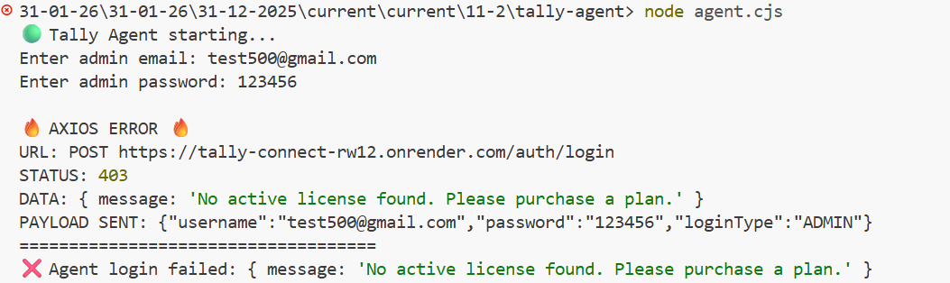
reason :- No active license
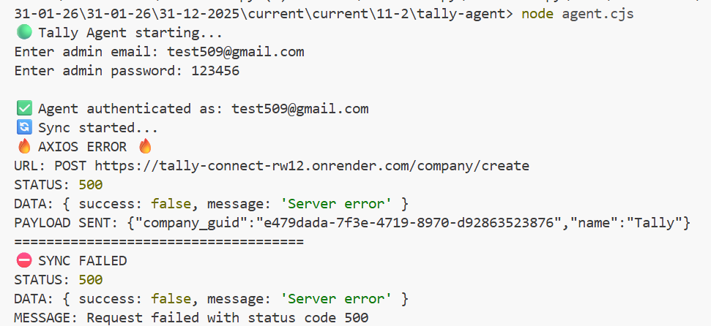
reason :- Company is already registered for Another Admin
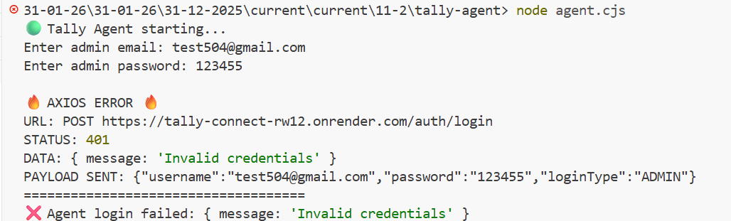
Reason :- Invalid Credentials Email Id / Password
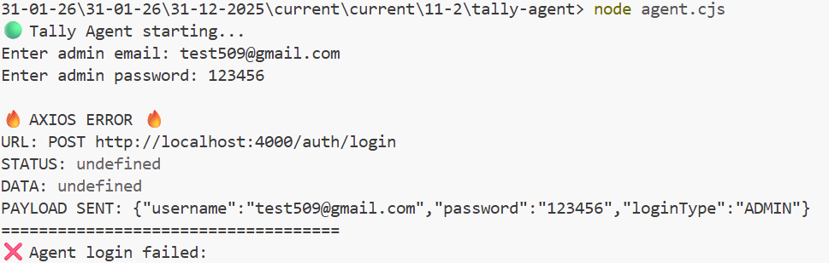
Reason :- Backend is not working
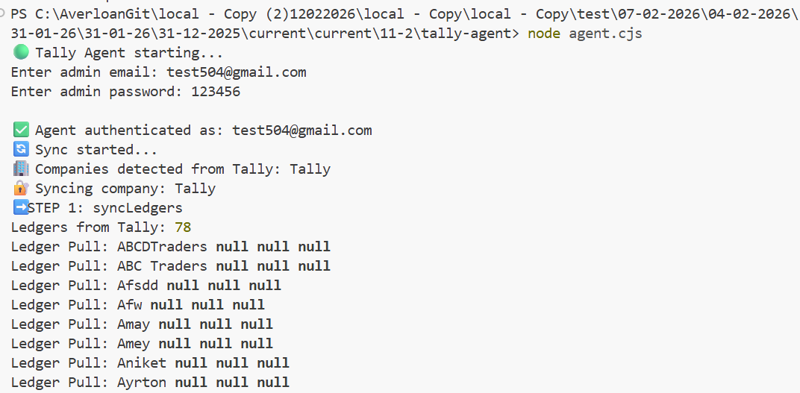
Reason :- Success Agent is started correctly
— End of Document —

18 . Per User Cost
Infrastructure Cost Breakdown

Infrastructure Component | Monthly Cost
Database (PostgreSQL + Storage) | ₹842
Backend Server (Node Starter) | ₹561
Static Frontend Hosting | ₹0
Total Infrastructure Cost | ₹1403 / month

Total Users | Total Server Cost (₹/month) | Server Cost per User (₹/month) | Server Cost per User (₹/day)
1 | ₹1403 | ₹1403 | ₹46.77
10 | ₹1403 | ₹140.30 | ₹4.68
20 | ₹1403 | ₹70.15 | ₹2.34
50 | ₹1403 | ₹28.06 | ₹0.94
100 | ₹1403 | ₹14.03 | ₹0.47
125 | ₹1403 | ₹11.22 | ₹0.37
150 | ₹1403 | ₹9.35 | ₹0.31

