- Problem Statement
GoalBridge is a financial-literacy organisation that conducts workshops for first-time earners. Its participants may understand the approximate present-day cost of financial goals such as higher education, but often find it difficult to translate that cost into a practical monthly investment requirement. GoalBridge therefore requires a simple, mobile-friendly Goal-Based Investment Planner that allows users to enter the present cost of a goal, time available, expected inflation, expected investment return and savings already accumulated. The application will estimate the future inflation-adjusted cost of the goal, future value of existing savings, remaining funding gap and monthly contribution required to address that gap. The application is intended as an educational scenario-planning tool rather than investment advice; it will not recommend financial products, promise returns, require registration or collect unnecessary personal information.
- Primary User Persona
The primary user of the GoalBridge application is a first-time earner aged approximately 20–30 years who has limited investment knowledge and primarily uses a mobile device.
The user may understand the present cost of a future goal but may not know how inflation, investment returns and existing savings affect the monthly amount required to achieve that goal.
The application should therefore use simple language, clearly labelled inputs, readable INR values and straightforward explanations without unexplained financial jargon.
User need statement:
The user needs a simple way to convert a future financial goal into an understandable monthly contribution requirement and to explore how changing assumptions such as inflation, expected return and time horizon affects the outcome.
- User Journey
Step 1 — Open the application
The user opens GoalBridge in a browser without registration or login.
Step 2 — Define the goal
The user enters the goal name and its estimated cost in today's money.
Step 3 — Enter planning assumptions
The user enters
- the number of years remaining,
- expected inflation rate,
- expected investment return and
- any savings already allocated to the goal.
Step 4 — Calculate the plan
The user selects Calculate.
Step 5 — Review results
The application displays:
- Inflation-adjusted future goal amount
- Future value of existing savings
- Funding gap
- Estimated monthly contribution required
- Total projected contribution
- Projected investment growth
Step 6 — Understand the result
The user sees a plain-language summary, a visual representation and the assumptions/disclaimer.
Step 7 — Explore alternatives
The user changes:
- inflation,
- return,
- time horizon or
- savings
- Recalculates to understand how different assumptions affect the monthly contribution.
Step 8 — Reset
The user can reset the application and start a new goal calculation.

- Inputs, Outputs and Finance Calculation Model
  - Application Inputs
The application will collect the following six inputs, exactly covering the mandatory fields in the brief.
Input | Description | Example
Goal Name | Name/purpose of financial goal | Higher Education Fund
Goal Amount Today | Estimated cost of the goal in today's money | ₹12,00,000
Time to Goal | Number of years remaining | 8 years
Expected Inflation | Expected annual increase in goal cost | 6%
Expected Investment Return | Assumed annual return on investments | 10%
Current Savings | Amount already accumulated specifically for this goal | ₹1,50,000
We can use these demonstration values as the default/pre-filled values so that the evaluator can immediately reproduce the supplied case.

  - Application Outputs
The application will calculate and display:
Output | What it tells the user
Future Goal Value | What today's goal may cost at the goal date after inflation
Future Value of Current Savings | What the user's existing savings may grow to
Funding Gap | Amount still required at the goal date
Monthly Contribution Required | Estimated monthly SIP/contribution required
Total Projected Contributions | Total amount the user contributes through monthly investments
Projected Growth | Estimated investment growth generated by the contributions
Plain-language Summary | Easy explanation of the result
These are the required outputs specified by the project.

  - Finance Calculation Model
Now we define the mathematics before writing any code.
Let:
- G = Goal amount today
- I = Annual inflation rate
- R = Expected annual investment return
- Y = Years remaining
- S = Current savings
- N = Number of monthly contributions
Step 1 — Future cost of the goal
We inflate today's cost over the remaining years:
$$Future Goal=G{\left(1+I\right)}^{Y}$$
For our demonstration case:
$$\text{₹}12,00,000×{\left(1.06\right)}^{8}$$
This tells us approximately what a goal costing ₹12 lakh today could cost eight years later assuming 6% annual inflation.

Step 2 — Future value of current savings
Existing savings are already invested toward the goal, so we allow those savings to compound:
$$FV_{Savings}=S{\left(1+R\right)}^{Y}$$
For our demonstration case:
$$\text{₹}1,50,000×{\left(1.10\right)}^{8}$$
This gives the estimated value of today's ₹1.5 lakh at the goal date.

Step 3 — Funding gap
Now:
$$Funding Gap=Future Goal-FV_{Savings}$$
However, the project specifically says the funding gap must have a minimum value of zero.
Therefore our actual logic is:
$$Funding Gap=max⁡\left(0 , Future Goal-FV_{Savings}\right)$$
Why?
Suppose: Future goal = ₹20 lakh but existing savings are projected to become: ₹22 lakh
We don't show: Funding gap = −₹2 lakh, Instead: Funding gap = ₹0 and the application can tell the user that, under the assumptions entered, the existing savings are projected to cover the goal.

  - Monthly Contribution Calculation
This is where we will make one design decision.
The brief says:
“Use monthly compounding for the contribution calculation. Convert annual rates to monthly rates consistently. Document whether you divide the annual rate by 12 or use an effective monthly-rate conversion.”
We therefore have two permissible methods.
Method A
$$Monthly Rate=\frac{Annual Rate}{12}$$
or Method B:
$$Monthly Rate={\left(1+Annual Rate\right)}^{1/12}-1$$
We will use: Method B - Use the effective monthly rate.
If the user enters an expected annual return of 10%:
$$r_{m}={\left(1.10\right)}^{1/12}-1$$
This gives a monthly rate which, when compounded for 12 months, produces exactly a 10% effective annual return.
Step 5 — Number of contributions
$$N=Years×12$$
Therefore: 8 years × 12 = 96 monthly contributions.

Step 6 — Required Monthly Contribution
We'll treat the contributions as an ordinary annuity, i.e. contributions occurring at the end of each month.
Future value of an ordinary annuity is:
$$FV=PMT×\frac{{\left(1+r\right)}^{N}-1}{r}$$
We already know the future amount we need — the funding gap.
Therefore rearranging:
$$PMT=Funding Gap×\frac{r}{{\left(1+r\right)}^{N}-1}$$
This gives us the estimated monthly contribution/SIP required.

  - Zero-return handling
This is explicitly mandatory , If expected return = 0%, the normal SIP formula would involve division by zero.
Therefore:
If R > 0:
use the annuity formula.
If R = 0:
$$Monthly Contribution=\frac{Funding Gap}{Number of Months}$$
Example:
Funding gap = ₹9,60,000
Period = 96 months
Monthly requirement:
$$\text{₹}9,60,000/96=\text{₹}10,000$$
No error and no division by zero.

  - Total Projected Contribution
Once PMT is calculated:
$$Total Monthly Contributions=PMT×N$$
For example, if required SIP were ₹15,000 for 96 months:
$$\text{₹}15,000×96=\text{₹}14,40,000$$

  - Projected Growth
For the monthly contribution component, we can calculate:
$$Projected Growth from Contributions=Funding Gap-Total Monthly Contributions$$
This tells the user how much of the future funding gap is projected to come from investment growth rather than their monthly contributions.
We'll label it clearly so that it isn't confused with growth generated by the user's existing savings.

  - Calculation Flow
This is worth putting into the Word document because later it can become a diagram in our report:
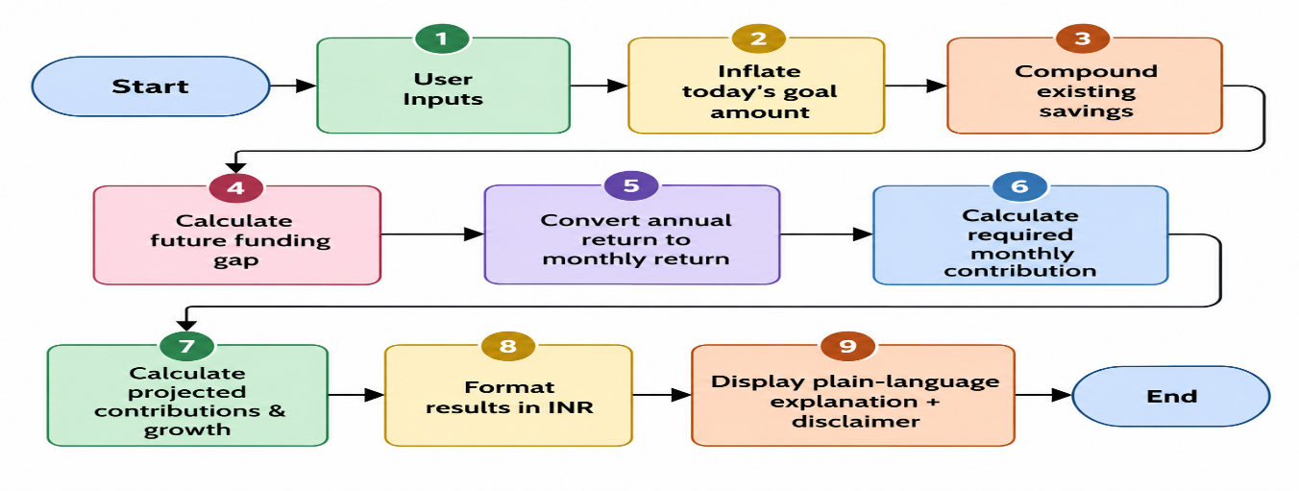

- Assumptions & Limitations

  - Assumptions

- Inflation remains constant throughout the goal period at the annual rate entered by the user.
- Investment return remains constant throughout the goal period at the expected annual return entered by the user.
- Existing savings are assumed to remain invested until the goal date and earn the same expected return.
- Monthly contributions are assumed to be made at the end of each month.
- The annual expected investment return is converted into an effective monthly rate using:
- $Monthly Rate = (1 + Annual Return)^(1/12) - 1$
- Monthly contributions are assumed to remain constant throughout the goal period.
- The model does not account for taxes, investment expenses, transaction costs or changes in taxation.
- The model assumes the user makes every planned monthly contribution without interruption.
- If projected existing savings are sufficient to fund the future goal, the funding gap and required monthly contribution are set to ₹0.
- A 0% expected investment return is handled separately by dividing the funding gap equally across the remaining months.

  - Limitations

  - GoalBridge provides an estimate based on assumptions entered by the user. Actual inflation, investment returns and future goal costs may differ from these assumptions.
  - The application does not model market volatility, changing returns, changing inflation, taxes, investment expenses or interruptions in contributions.
  - It does not recommend any financial product or investment strategy and should not be treated as financial advice.

  - Visible app disclaimer

The above is for our documentation. The dashboard itself should have something shorter:
Educational Use Only: GoalBridge provides illustrative estimates based on the assumptions you enter. Actual inflation, investment returns and goal costs may vary. This tool does not provide investment advice, recommend financial products or guarantee returns.
That is particularly important because the brief explicitly says no product recommendations, no promised returns, and no regulated financial advice.

- Acceptance Criteria

ID | Acceptance Criterion | How We Will Verify
AC01 | The application shall allow the user to enter all six required inputs: goal name, present goal amount, years remaining, inflation rate, expected investment return and current savings. | Manual UI test
AC02 | The application shall correctly calculate the inflation-adjusted future value of the goal. | Compare with independent Excel model
AC03 | The application shall correctly calculate the future value of existing savings using the expected return entered by the user. | Compare with Excel
AC04 | The application shall calculate the funding gap as the future goal value minus future value of existing savings, with the funding gap never falling below ₹0. | Excel + fully-funded test case
AC05 | The application shall correctly calculate the required monthly contribution using monthly compounding and shall correctly handle a 0% expected-return scenario without producing a calculation error. | Excel base case + zero-return test
AC06 | The application shall reject or clearly warn the user about blank, negative, zero-invalid or unrealistic input values rather than producing misleading results. | Validation tests
AC07 | Results shall be displayed clearly in Indian Rupee format and include future goal value, future savings, funding gap, monthly contribution, total projected contributions and projected growth. | UI inspection
AC08 | The user shall be able to change assumptions and recalculate results, and the Reset function shall restore the calculator to its default state. | Functional test
AC09 | The application shall work without registration/login and remain usable on both mobile and desktop screen sizes, including keyboard navigation and visible focus states. | Mobile/desktop + keyboard tests
AC10 | The application shall display a plain-language result summary together with assumptions and an educational-use disclaimer stating that calculations are illustrative, returns are not guaranteed and the application does not provide investment advice or product recommendations. | UI inspection

Each acceptance criterion will be mapped to one or more test cases during the testing phase. Calculation-related criteria will be independently verified against the Excel Finance Verification Model before the application is accepted for deployment.

- Proposed Application Wireframe / Application Layout

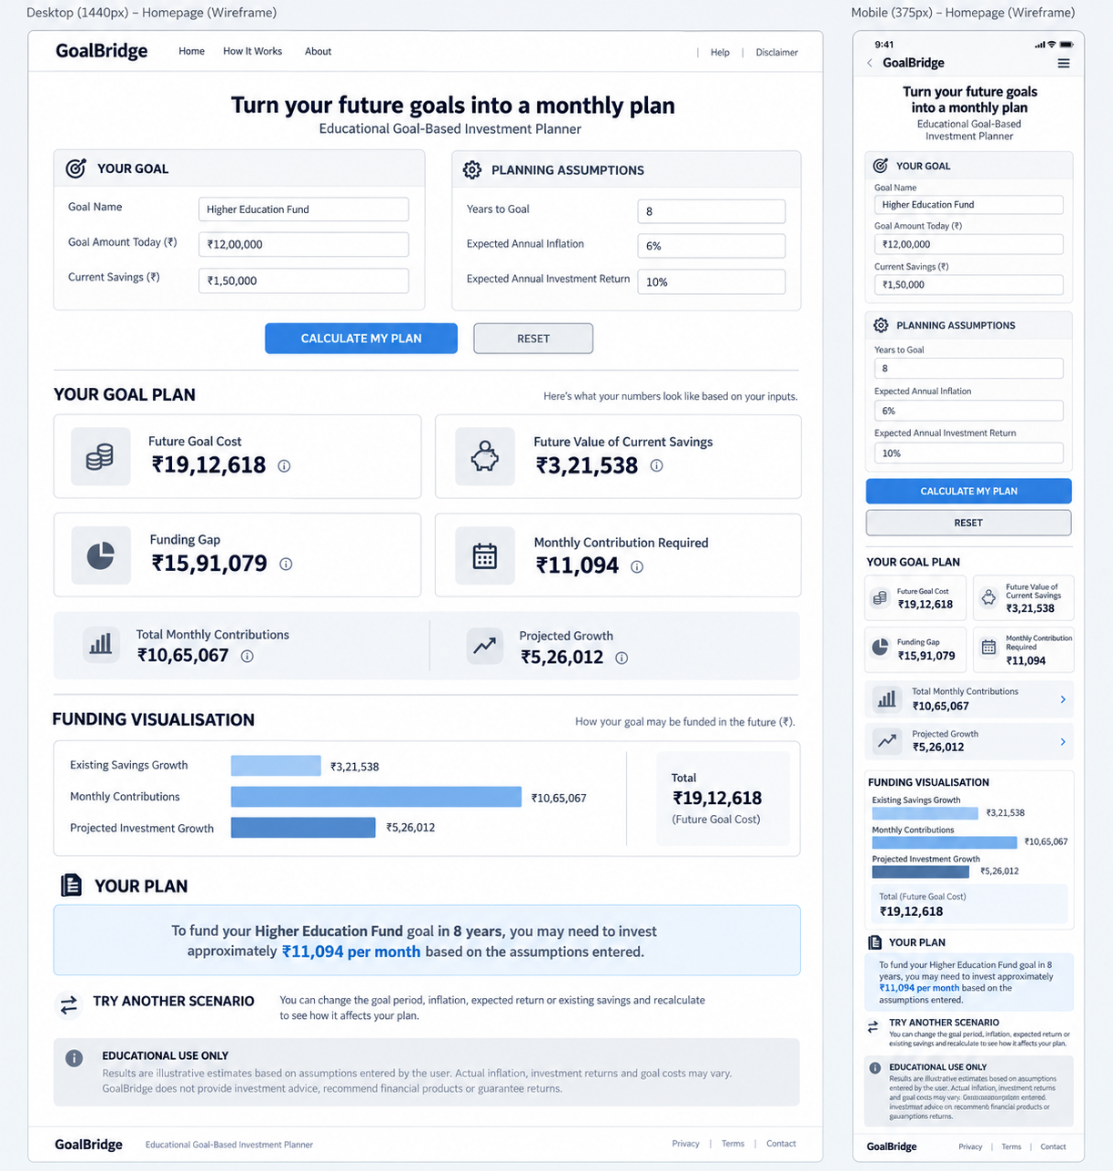
Figure 1: Proposed GoalBridge desktop and mobile application wireframe. The wireframe defines the planned information hierarchy, user-input flow, result presentation and responsive behaviour prior to application development. Final visual styling may be refined during implementation while retaining the defined functional requirements.
- Next

