

SC4172
INTERNET OF THINGS – TINY MACHINE LEARNING

PROJECT REPORT

DHANAPALAN SWAMINATHAN SUDHISHNA JANAVI
U2320155K

- INTRODUCTION
The increased growth of smart cities built using intelligent transport systems observed over the past years portray the rising demand for detection of critical acoustic events in urban domains in real-time. A critical example would be the identification of emergency vehicle siren sounds, such as fire trucks and ambulance sirens, whose identification can help in the improvement of road safety in such smart cities. Machine learning systems can rely on cloud-based processing, which involves the usage of remote server presence for sending the data over for performing analysis. However, this introduces issues such as privacy concerns, increased latency and significant power consumption due to the data being transmitted continuously from the local device to the server. Tiny Machine Learning helps us tackle this issue by deploying the trained machine learning models directly on resource-constrained devices for the inference of the sensor data to be performed locally, whilst the model training is done (on a powerful computer, this project used Anaconda Jupyter notebook on a Mac Book Pro to achieve this) prior to the deployment. This allows the sensor data to be analyzed through inference locally on the device, thereby helping reduce power consumption, enhance data privacy and lower the latency.

This project involves the building of a real-time sound classification system to help detect emergency vehicle sounds/sirens using Tiny Machine Learning techniques and methods. For use in this project, an Arduino Nano 33 BLE Sense board is used for the deployment of the trained model for performing inference locally using its on-board microphone. The on-board microphone is used to record audio signals from the environment it’s present in, which is later processed into MFCCs (Mel-Frequency Cepstral Coefficients). A CNN (Convolutional Neural Network) model that was trained to categorize the different sounds recognized are fed with these MFCCs features.

The model classifies the recorded audio snippet into each of the three categories: ambulance siren (ambulance_priority), firetruck siren (fire_rescue_priority), and background urban road noise (urban_ambient).

A real-world application/usage of this project would be involving intelligent traffic management systems and smart vehicles. For example, deploying the model at several intersections of the road can help identify/detect which type of emergency vehicle is approaching the intersection. This can help the system to automatically adjust the traffic signals at the intersection to give more priority by providing the passage to the vehicles recognized to have emergency sirens (such as ambulance or firetruck). This timely adjustment to reduce significant delays for fire trucks and ambulances can potentially aid in saving lives in crisis or critical emergency situations. Furthermore, the model could also be deployed on other vehicles which will enable notifying the drivers of any emergency vehicles nearby or getting closer so they can give way to those, making them especially useful in noisy urban environments where the sound of sirens might not be easily heard by the drivers. The low latency and energy-efficient model can hence be deployed on a large-scale for building smart traffic management systems.

- SYSTEM OVERVIEW
The following steps are performed in this project for training the model, equipping a complete Tiny Machine Learning pipeline: Data preprocessing, Extraction of features, Model training, Quantizing the model, Deployment of model on resource-constrained hardware (Arduino Nano 33 BLE Sense board) as shown in figure 1.

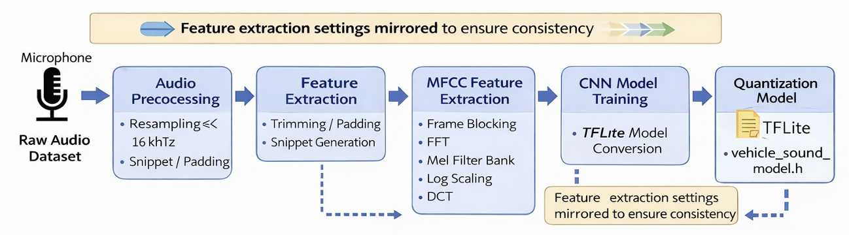
Figure 1: Training pipeline
A key concept involved while performing the deployment to hardware is finding the right balance between accuracy and strict memory constraints of the microcontroller device. This proves the aspect of considering feasibility when deploying deep learning models on edge devices for real-time audio recognition/classification. This will be seen in the later parts of the report.

- DATASET & PREPROCESSING
The dataset used to train the lightweight CNN model is taken from the Kaggle dataset named ‘Emergency Vehicle Siren Sounds’ which is available for public use (Kaggle, n.d.). The dataset consists of audio recordings with labels identifying which of the 3 categories they belong to (including various emergency vehicle sirens and environmental sounds). This dataset was chosen considering its close match with the real-world setting, proving as a useful source which will help us train the model with relevant and representative audio clips that ensures generalized and unbiased model performance thereby helping tackle the chosen problem domain.

The following three classes were used and processed from the dataset: 1. ambulance_priority, 2. fire_rescue_priority, 3. urban_ambient.
The class categories choice was made following the need to simulate realistic urban environment where emergency sounds must be differentiated from general urban noise.
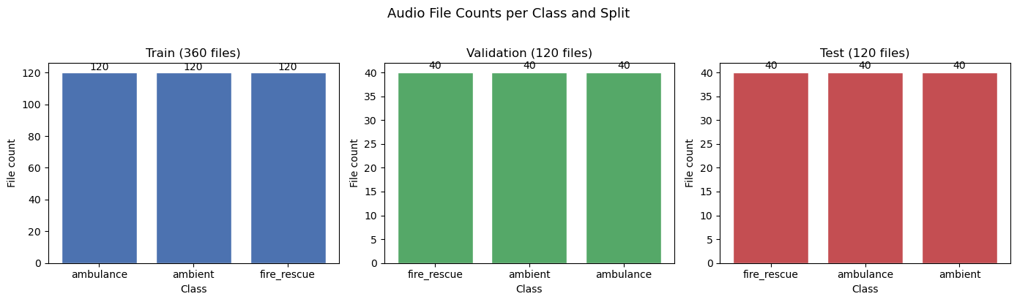
Figure 2: Dataset split and distribution
  - Data balancing
Since the dataset downloaded contained equal amount of data for each of the 3 classes (that is 200 each), there was no need to use data balancing technique separately as the dataset was already balanced. Note: Unbalanced datasets could lead to biased models that favor majority classes, hence leading to poorer performance of the model. The dataset was split into train, validation and test datasets for each of the class, thereby bringing the per class data proportion as follows 120:40:40 corresponding to (Train: Validation: Test) dataset distribution/ratio as shown in figure 2.

  - Preprocessing pipeline
Preprocessing of all the data is done so that they follow the same format and can be converted into input for the CNN model with meaningful features.

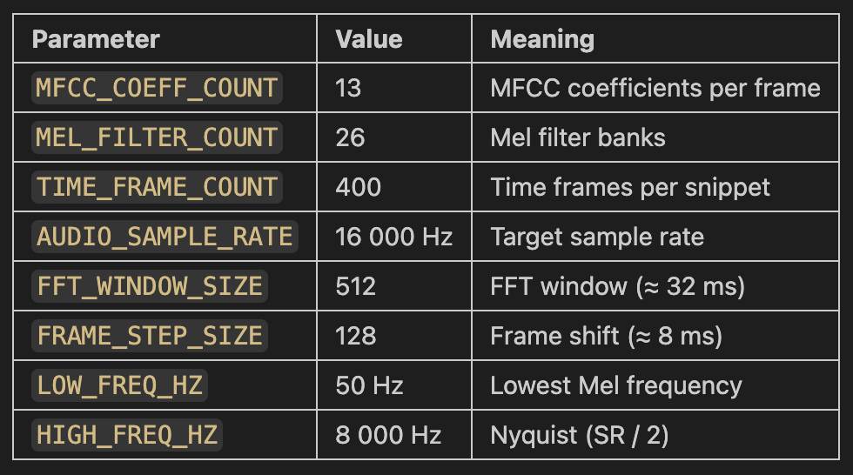
Resampling: A frequency of 16000 Hz is used as sampling rate for audio classification and is sufficient to capture frequencies up to 8000 Hz (in correspondence to the Nyquist theorem). This is also appropriate for emergency siren sounds as the important spectral information lie well below the limit whilst also keeping the computation manageable.

Frame size and window size: Considering a sampling rate of 16000 Hz and frame sample of size 512, the frame duration is $frame duration=\frac{512}{16000}=0.032s=32ms$ and since the chosen window size is 128 samples, the hop duration is $window duration=\frac{128}{16000}=0.008s=8ms$. The frame duration of 32ms was settled upon as it’s long enough to capture the structure of siren sounds while also being short enough to preserve the changes noticed over time. Additionally, an initial window size of 16ms was used, however, after some experimentation it was noticed that decreasing its size to 8ms allowed in a higher overlap between adjacent frames, thereby allowing a smoother tracking of the pitch variations and repeating siren patterns. The overlap is $\frac{512-128}{512}×100=75\%$. This increased overlap from using a 50% overlap initially (when using 256 samples for window size) helped improve the temporal details, which was especially useful for preserving the gradual frequency sweeps and repeating cycles for emergency sirens which are normally continuous and have slow and smooth changes in them.
Figure 3: Parameters set for MFCC feature extraction

Mel spectrogram conversion and MFCC feature extraction: The system uses 26 Mel filter banks to avoid making the feature map very large for computation. Additionally, the frequency ranges from 50 Hz – 8000 Hz helps avoid low-frequency noise recorded while the upper bound helps match the Nyquist frequency limit. Furthermore, for each of the frames, 13 MFCC coefficients are used, which gives a compact representation of the spectral information. Lastly, but also importantly, the number of frames used is set to 400. This value was achieved progressively through experimentation. Initially, the value tested with was 200, then 300 frames and finally 400 frames. Increasing the frame count allowed the model to be able to access the audio signal for longer portions, which helped improvise the inference accuracy. The total audio duration covered by 400 frames is as follows: $total duration=\frac{512+(400-1)×128}{16000}=3.224s$. For comparison, when using 200 frames, $total duration=\frac{512+(200-1)×128}{16000}=1.624s$, and when using 300 frames $total duration=\frac{512+(300-1)×128}{16000}=2.424s$. This was particularly useful for siren sounds like those coming from fire trucks and ambulances whose pattern can be predicted over longer durations. Emergency vehicle sirens normally consist of repeated rise-and-fall tonal patterns over a longer time span, hence using shorter inputs might lead to not enough information being captured and hence giving a poorer inference accuracy in the temporal context. Using 200 for frames resulted in a lower test dataset accuracy and inference accuracy. Finally, on the basis if these experimentations, the final values of frame count 400 and window size of 128 samples were chosen as it gave better accuracy while also being feasible for deployment on the microcontroller on Arduino Nano 33 BLE Sense board.

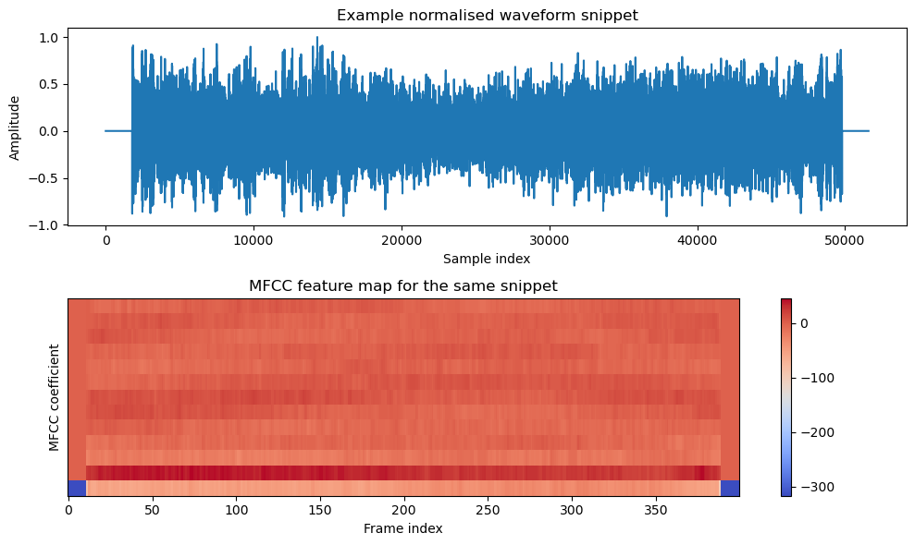
MFCC Feature Generation Functions: 4 main preprocessing functions are used to generate the MFCC dataset. peak_normalize_waveform helps normalize the audio signal amplitude to a fixed range to ensure that variations in loudness don’t affect the feature extraction and all are consistent. split_clip_into_snippets helps in splitting the audio recordings into smaller clips which helps every input size of the model be uniform. compute_mfcc_features
Converts each of these audio clips into the MFCC features using the parameters that were defined earlier, thus providing a compact time-frequency representation from initial raw audio files received. Lastly, build_mfcc_dataset helps build the final input tensor along with their according labels for training after applying all the preprocessing steps using other functions mentioned above.
Figure 4: Normal waveform versus MFCC feature map for same audio snippet for comparison

The following figure 5 shows the representative MFCC feature maps for each of the 3 classes where the vertical axis is represented by MFCC coefficients and horizontal axis by the time frames. In the image, it can be interpreted that the regions with higher energy are brighter in the specific frequency bands. And as it can be seen from the images, the distinctive patterns exhibited by each of the classes can be used by the trained CNN model to perform classification by learning their features/patterns.
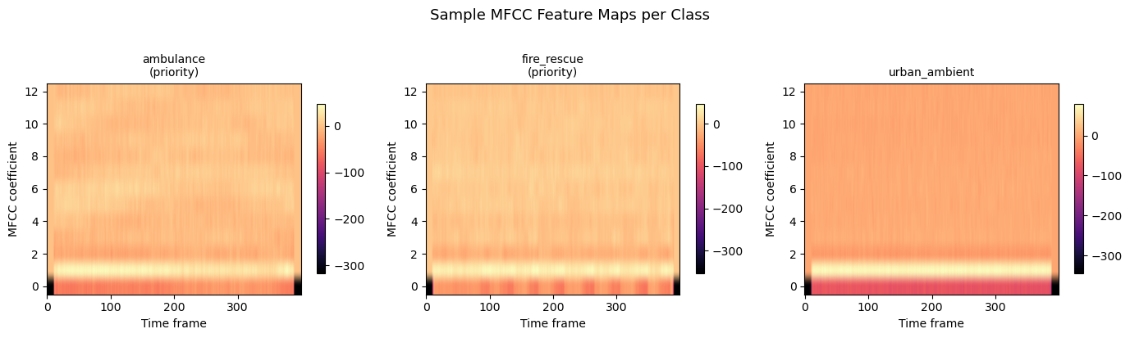
Figure 5: MFCC feature maps for each class shown for sample

- MODEL DESIGN & TRAINING
The model architecture was implemented keeping in mind the following specificities: maintain a balance between the classification accuracy of the model, and the computational efficiency, which is important while deploying the model on memory-constrained microcontroller hardware. The model involves using a CNN (Convolutional Neural Network) which helps in learning spatial patterns from the MFCC feature maps which are produced. These can then be interpreted as 2-dimensional images which represent the audio clips that were preprocessed from earlier.

  - Model Input representation
For each of the input sample, it consists of an MFCC feature map which has the following shape: (13, 400, 1) where 13 represents the frequency related features specified through the MFCC_COEFF_COUNT parameter in the code initially. And 400 portrays the temporal progression as it depicts the energy for the number of frames selected. Thus, CNN helps extract both temporal and spectral patterns from the audio signal.

  - Model architecture used
The final architecture that was decided upon after several experimentation has the following layers as shown in figure 6:
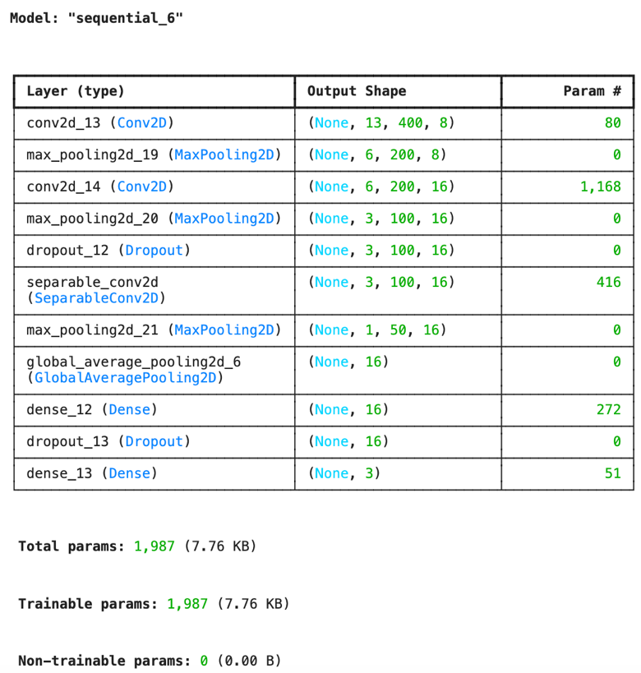
Figure 6: Final model architecture used
  - Design rationale
The model architecture was designed taking the following details into account. Using Convolutional layers: Firstly, the use of convolutional layers helped extract the temporal and spectral details from the dataset which are low-level features. To increase the model’s complexity, the number of filters were increased from 8 to 16 to increase the number of feature maps produced in the early stages.

Using Separable Convolution: Instead of the standard convolution layer, separable convolution that consists of Depthwise Convolution (involving channel-wise filtering) and Pointwise convolution (involving channel combination) was used to reduce the number of parameters and the overall computational cost while also quite strongly maintaining the feature extraction capacity.

Using Pooling and Global Average Pooling: The MaxPooling layers help in reducing the size of the feature maps produced by every convolution layer, thereby reducing the computational complexity. Additionally, Global Average Pooling is used instead of FC (Fully Connected) layers in order to reduce the total number of parameters and prevent overfitting.

Batch normalization: although this technique was tested, it was observed that introducing this to the model degraded its performance, possibly due to the mismatch between training statistics and the differing real-time input conditions. Hence, this feature was removed from the model.

Using Regularization (Dropout): A Dropout value of 0.2 is used to prevent overfitting of the model by disabling neurons randomly while training.

Training optimization techniques (callbacks) - EarlyStopping & ReduceLROnPlateau: EarlyStopping helps to stop the training of the model when the validation accuracy stops to improve. If there are no improvements for over 15 epochs, then training is stopped and the previous best model’s weights are restored to avoid overfitting. ReduceLROnPlateau helps reduce the learning rate when the training plateaus. It monitors the validation loss and reduces the learning rate by 50% if no improvement is seen for over 5 epochs. This helps improves the final accuracy.

  - Training setup
The configurations used included using an Adam optimizer due to its fast convergence and stable performance across different architectures. Also, a Categorical Cross entropy was used as a loss function to monitor and Accuracy for metric.

  - Model selection from multiple experimentations
Table 1: Model-wise training and validation accuracy and loss graphs
S. No | Model description | Training & validation accuracy and loss graphs over epochs
1 | Simple CNN (CNN + Depthwise only) | 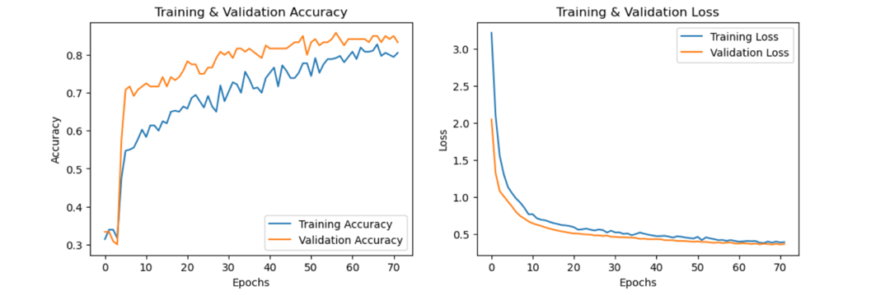
2 | Deeper CNN (more Conv layers) | 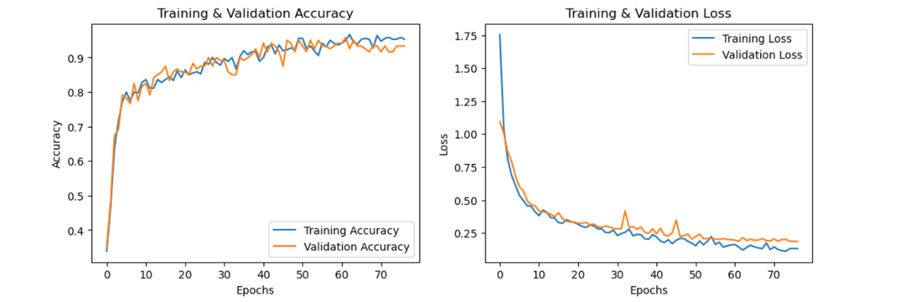
3 | Higher filter model (Conv16 -> Conv16) | 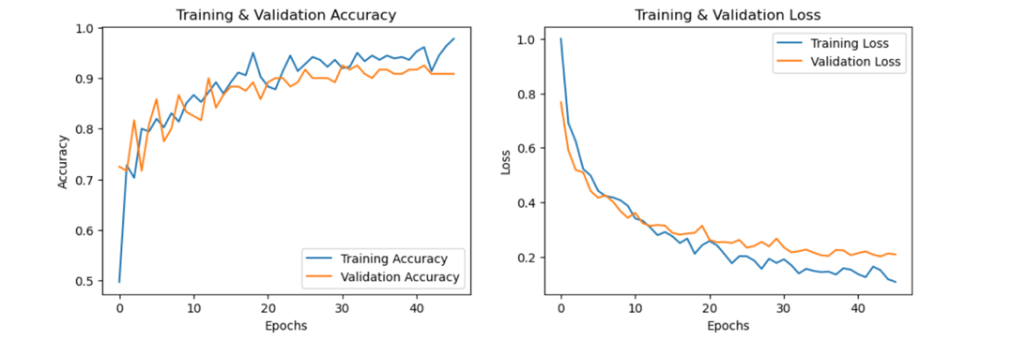
4 | Separable Conv | 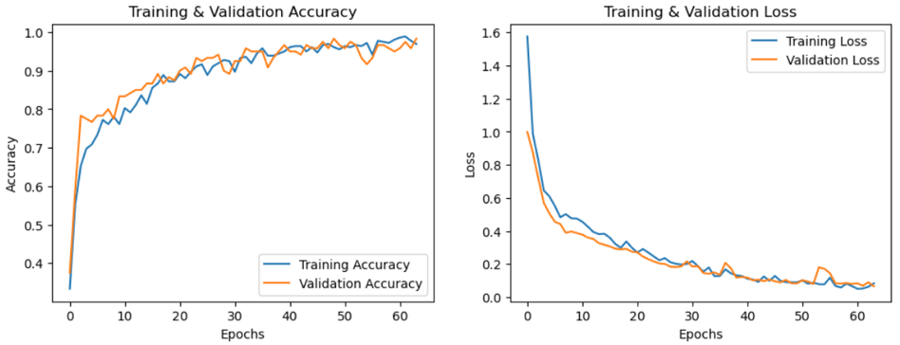

Table 2: Model-wise test loss and test accuracy values
S. No | Model description | Test loss & accuracy
1 | Simple CNN (CNN + Depthwise only) | Test loss: 0.40771248936653137  Test accuracy: 0.7583333253860474
2 | Deeper CNN (more Conv layers) | Test loss: 0.17024685442447662  Test accuracy: 0.949999988079071
3 | Higher filter model (Conv16 -> Conv16) | Test loss: 0.20026597380638123  Test accuracy: 0.949999988079071
4 | Separable Conv | Test loss: 0.12695066630840302  Test accuracy: 0.9583333134651184

Model architecture of the model used in the project: Model number 4, considering its highest test accuracy and lowest test loss compared to the three other models as shown in the table 2. View table 4 in the Appendix to see the architecture of other models used during experimentation for comparison.

- MODEL OPTIMIZATION
In the context of Tiny Machine Learning, a major factor that must be kept in mind while training and building a model are the resource-constraints and shortage of memory capacity of the microcontroller on which the model is to be deployed for inference. To account for this, a middle point that makes the model accurate but at the same time use an acceptable amount of microcontroller memory space (reduce model size) must be achieved. For this, optimization techniques can be applied to the model to reduce its size whilst maintaining its classification accuracy and improving the inference efficiency.

  - Quantization for deployment on the Arduino Nano 33 BLE Sense board
The model that was trained and tested for accuracy and loss on the test dataset is later converted into a TensorFlow Lite format (Flatbuffer format). This is further optimized using some techniques such as post-training quantization. In order to evaluate the effectiveness of optimization, 3 versions of the TFLite model were generated: 1. Unquantized Floating Point 32-bit TFLite model, 2. Model with dynamic quantization, 3. Full Integer INT8 quantized model.

Dynamic range quantization and the full-integer quantization methods were selected for comparison as they are two commonly used techniques for optimization in Tiny Machine Learning (TensorFlow, n.d.). Dynamic quantization on one hand allows model compression with minimal impact on accuracy, while the full-integer method allows the deployment on microcontrollers more efficiently as it also converts the activations and weights to integer representations.

The accuracy and size of each of the three models were generated for comparison and is shown below for reference in figure 7.
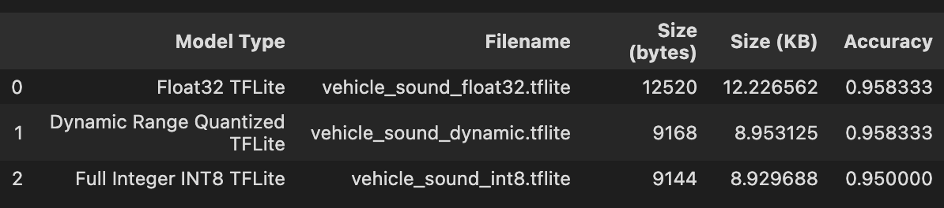
Figure 7: Comparison of 3 model in terms of their size and accuracy
As expected, the Float32 model showcased the highest accuracy, however it also had the largest model size of 12520 bytes. With the same accuracy level, but a smaller model size, dynamically quantized model takes the next place. Lastly, the full-integer quantization decreased the model size further down from 9168 to 9144 bytes in comparison to dynamic quantization, while maintaining a similar accuracy. This slight drop in accuracy while keeping the model size small led to the conclusion of using the INT8 model for deploying on the hardware for inference performance testing. As it can be seen on the confusion matrices drawn for all 3 models as shown in figure 8, there were very few minor misclassifications with more misclassifications being in the INT8 model especially between the ambulance sirens and firetruck sirens mainly due to their similar acoustic patterns. However, the overall high accuracy and robust performance make this full-integer quantized INT8 model a suitable one for deployment as it offered the best trade-off between model size and inference accuracy.

The full-integer quantized model was used for deployment to support the resource-constrained hardware which has limited processing power and low memory. To ensure that the quantized model is still accurate enough to maintain the classification accuracy broadly, confusion matrices are draw for the 3 models and compared as shown below.
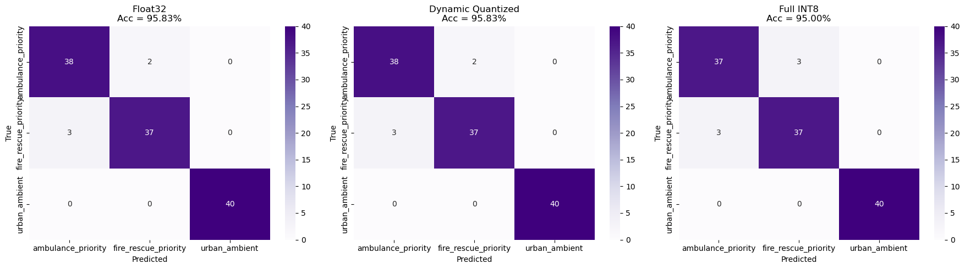
Figure 8: Confusion matrices of the 3 models produced for visual comparison
For the Float32 model: ${Accuracy}_{float32}=\frac{38+37+40}{120}=95.83\%$, the dynamically quantized model: ${Accuracy}_{dynamic}=\frac{38+37+40}{120}=95.83\%$, and for the INT8 full-integer quantized model: ${Accuracy}_{int8}=\frac{37+37+40}{120}=95.00\%$, which shows a total accuracy drop of: $drop=95.83\%-95.00\%=0.83\%$.

Table 3: TP, FP, and FN obtained from the confusion matrix of the INT8 Quantized model
Class | True Positives TP | False Positives FP | False Negatives FN
Ambulance_priority | 37 | 3 | 3
Fire_rescue_priority | 37 | 3 | 3
Urban_ambient | 40 | 0 | 0

In this project, the presence of FN can be critical as failing to detect emergency vehicles approaching and hence not providing priority passages could result in safety risks and delayed responses endangering lives. From table 3, Precision and Recall for ambulance_priority and fire_rescue_priority are 0.925 (37/(37+3)). Hence, the value of F1 metric for both the classes are also 0.925, demonstrating a slight confusion when classifying between siren type. However, the high F1 score also shows that the model holds a good balance between precision and recall confirming reliable classification performance even after optimization via quantization. Additionally, the perfect score of F1 for urban_ambient shows the strong ability of the model to distinguish background road noises from emergency siren sounds.

Hence, it can be concluded that the full-integer INT8 quantized model retains its ability to distinguish between each of the 3 predefined classes with a high classification accuracy: ambulance sirens, fire truck sirens, and background urban noise.

- DEPLOYMENT AND REAL-TIME ON-DEVICE INFERENCE
The final optimized INT8 model was then deployed on Arduino Nano 33 BLE Sense board with an on-board microphone to enable the real-time classification of emergency vehicle siren sounds.
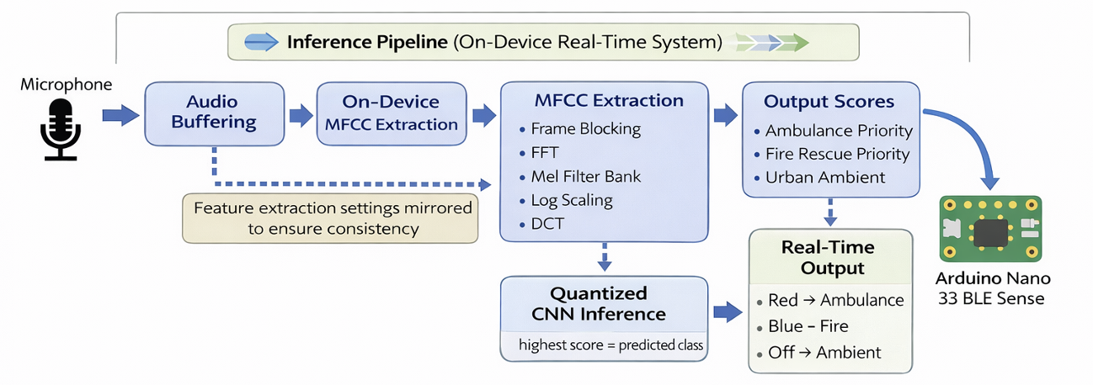
Figure 9: Inference pipeline
For inference performance, the following pipeline with 4 main stages are used as shown in figure 9:
- Data acquisition: Using the PDM microphone on the Arduino Nano 33 BLE Sense board, audio can be captured at a sampling rate of 16000 Hz which can be buffered into frames for processing the signals further.
- Using MFCC for feature extraction: the raw form of audio signals that are captured are transformed into MFCCS, which help in compactly representing the audio waveform, thereby helping reduce the data dimensionality drastically whilst also conserving the critical spectral characteristics of the audio signal captured.
- TensorFlow Lite Micro inference using trained CNN model: The MFCC features that were extracted are then passed into the pre-trained CNN model for output probability scores which corresponds to each of the three predefined classes (ambulance_priority, fire_rescue_priority, urban_ambient).
- Final predicted class as output: Amongst the three predefined classes, the class with the highest recorded probability is chosen for the final prediction.

  - Requirements and setup
Firstly, to ensure that the trained model is consistent with the code used for deployment on Arduino, all the preprocessing parameters as shown in figure 3 must be kept identical as in the Python code used to train the model. The code on .ino file for uploading the model into Arduino must match these parameters. Alongside this, the deployment requires 2 pre-generated header files: 1. vehicle_sound_model.h: this model contains the quantized INT8 TensorFlow Lite model as a C array. 2. mel_filter_bank.h: containing the precomputed Mel filter coefficients. Note: the Mel Filter Bank also must match the preprocessing parameter configurations exactly as that used in the Python file for model training to ensure that the feature extraction for inference is performed accurately.

  - Audio acquisition and buffering
At a sampling rate of 16000 Hz, incoming audio signals are continuously captured by the PDM microphone on the board, which are stored in a buffer of the size set to hold one full inference window. Basically, $Buffer size=512+\left(128×\left(400-1\right)\right)=51584$. And, this corresponds to 3.224 seconds of audio as $\frac{51584}{16000}=3.224s$, ensuring that a sufficient amount of audio clip is captured before inference begins. Once the buffer is filled, the captured audio signal is taken for feature extraction and is processed.

  - MFCC feature extraction done on-device
The following procedure is performed for each of the frame in the audio snippet taken for inference followed by peak normalization: Apply Hanning window, compute FFT (Fast Fourier Transform), calculate the Power Spectrum, apply Mel filter bank, perform the log scaling and apply DCT (Discrete Cosine Transform) to get the MFCC coefficients. This process finally produces a feature map of the following shape: (13, 400).

  - Inference performance
The model that is deployed is operated using the INT8 quantized inputs and outputs. Once the input is available followed by MFCC feature extraction and their quantization using input tensor scale, TensorFlow Lite Micro is equipped to execute the inference on the device. The output of the model gives 3 scores which are dequantized and compared with the help of argmax function to finally detect the predicted class amongst the 3 classes: ambulance_priority, fire_rescue_priority, and urban_ambient. Additionally, to enhance the real-time interpretability of the system, the onboard RGB LED of Arduino Nano 33 BLE Sense board was used. It was programmed such that the LED would blink red when the predicted class is ambulance_priority, blue when it is fire_rescue_priority and no LED indication for urban_ambient. Since the LEDs onboard operate on an Active-Low logic, the control signals were inverted and used for correct behavior. This feature was added to help the users quickly identify the emergency vehicle siren approaching even without having to look at the serial monitor display, thereby making it more usable in real-world cases.

- RESULTS, DISCUSSION AND CONCLUSION
The model trained achieved a high classification accuracy when tested both using the test data (using the quantized model) and on real-time deployment on the Arduino Nano 33 BLE Sense board. The INT8 model achieved a total accuracy of 95.00% which makes this model particularly strong in terms of being used as a reliable source for distinguishing between different emergency vehicle siren sounds. As it can be seen from the confusion matrices displayed above, most of the predictions made by the model lie diagonally in the matrix, hence proving that it’s able to distinguish between the 3 classes ambulance_priority, fire_rescue_priority, and urban_ambient with high accuracy.

It can also be noticed that the misclassifications in the quantized model are more when predicting the fire_rescue_priority incorrectly as ambulance_priority. This is expected as the two classes share similar acoustic characteristics, which includes their overlapping frequency ranges and similar periodic siren patterns.

Importantly, it can also be noted that the model is able to highly accurately differentiate the emergency vehicle siren sounds from the urban ambient noise, making it robust for use in real-world use cases for practical scenarios. After multiple inference testing performed after deploying the model on the Arduino Nano 33 BLE Sense board, it can also be concluded that the model was able to accurately differentiate the emergency vehicle siren sounds (which was tested by playing the siren sound from a mobile phone placed 5cm for testing purposes). Thereby, the quantized model can be confirmed to be suitable for real-time embedded inference. This successful deployment also demonstrates the feasibility of implementing smart and intelligent audio classification systems on edge devices with low-power and resource constraints.

- LIMITATIONS AND FUTURE WORK
Although the model designed, trained and tested in this project showcased a high classification accuracy, it must be taken into account that several limitations do exist. Firstly, the dataset is only limited to 3 classes which don’t completely represent the real-world acoustic variability. Secondly, the dataset is small (not large enough to capture road noise differences across different regions and countries as the noise level may differ drastically across various places). The same applies for ambulance siren sounds and firetruck siren sounds as well. A broader dataset consisting of a wide range of road noises collected from different regions (highway, urban area, etc.) could be collected alongside the siren sounds of vehicles used in different countries in order to make the model prediction more robust and reliable for more generalized usage. Lastly, there are still some misclassifications at times when distinguishing between the ambulance sound from fire truck siren sound due to their similar acoustic patterns, this again can be overcome with the help of collecting more data across different places/countries to help the model recognize and learn the patterns better.

Future work may include:
- Build a model incorporating dataset that is more diverse and includes more noisy real-world recordings.
- Optimize the power consumption on the resource-constrained hardware for continuous deployment, and include event-triggered actions. A suggestion would be to turn the device on for running inference for use only when travelling (maybe in highways or high traffic roads to save power otherwise).
- Include additional classes to the model for recognition of other different sirens (such as police sirens and other urban noises that could be detected).

- APPENDIX
Table 4: Model architecture of all the models used for comparison to derive at the final model architecture
Model 1: Simple CNN (CNN + Depthwise only) | Model 2: Deeper CNN (more Conv layers)
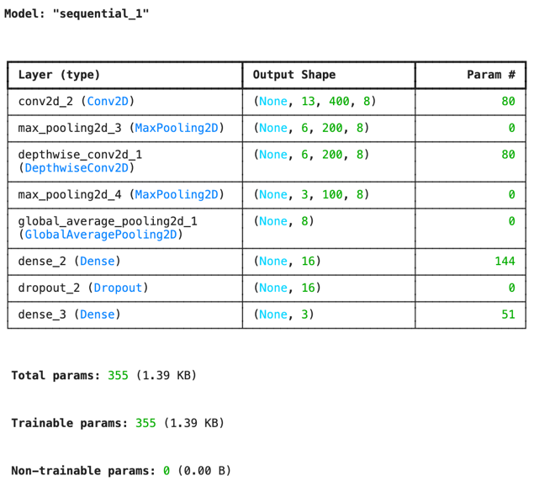 | 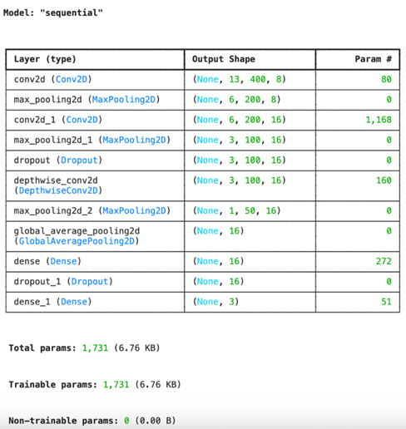
Model 3: Higher filter model (Conv16 -> Conv16) | Model 4: Separable Conv
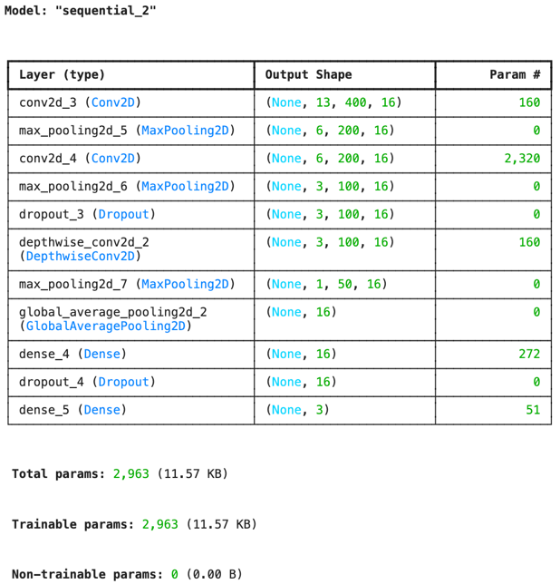 | 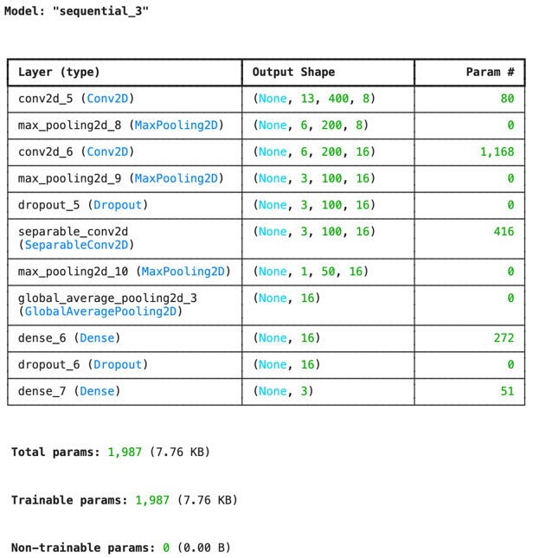

REFERENCES
Kaggle. (n.d.). Emergency vehicle siren sounds. Retrieved April 6, 2026, from Kaggle: https://www.kaggle.com/datasets/vishnu0399/emergency-vehicle-siren-sounds
TensorFlow. (n.d.). Post-training quantization. Retrieved April 6, 2026, from TensorFlow: https://www.tensorflow.org/lite/performance/post_training_quantization

