Model 1 of 5 - Rule Baseline
Unit 2, model comparison. No machine learning: hand-written patterns only.

1. What this model is
A list of hand-written IF-THEN patterns, checked in order, first match wins. If no pattern matches, the model abstains rather than guessing. It performs no learning of any kind, so it is the control group: it establishes what plain keyword matching achieves, and therefore what a learned model must beat to justify its complexity.
The patterns use generic banking vocabulary only - MORTGAGE, RENT, PAYROLL, OVERDRAFT FEE - and contain no merchant names. A rule asserting that NETFLIX means Subscription would score well on merchants already seen while revealing nothing about new ones, and would turn the baseline into a lookup table built from the answers.

1.1 Worked example
Input: DEBIT FLAGSTAR BANK MORTGAGE <NUM> PPD ID <NUM>
Income? needs CREDIT, this is DEBIT -> skip
Transfer? ZELLE|WIRE|VENMO ... -> no match
Mortgage? MORTGAGE|MTG PMT ... -> MATCH on 'MORTGAGE'
Answer: Mortgage (correct)
Input: DEBIT TST GOLDEN DRAGON OAKLAND
... all twelve rules ... -> no match
Answer: abstains (true answer: Restaurants)
The second case is the normal case. A human reads 'Golden Dragon' and infers a restaurant; the rules cannot, because the description contains a shop name and no banking vocabulary.

2. Results
Protocol | n | Accuracy | Macro-F1 | Coverage | Precision when it answered
Stratified (validation) | 4,780 | 0.1701 | 0.2924 | 17.3% | 98.2%
Merchant held out (validation) | 4,812 | 0.1671 | 0.2849 | 16.8% | 99.4%
of which strictly novel | 2,457 | 0.1579 | 0.3068 | 15.8% | 100.0%

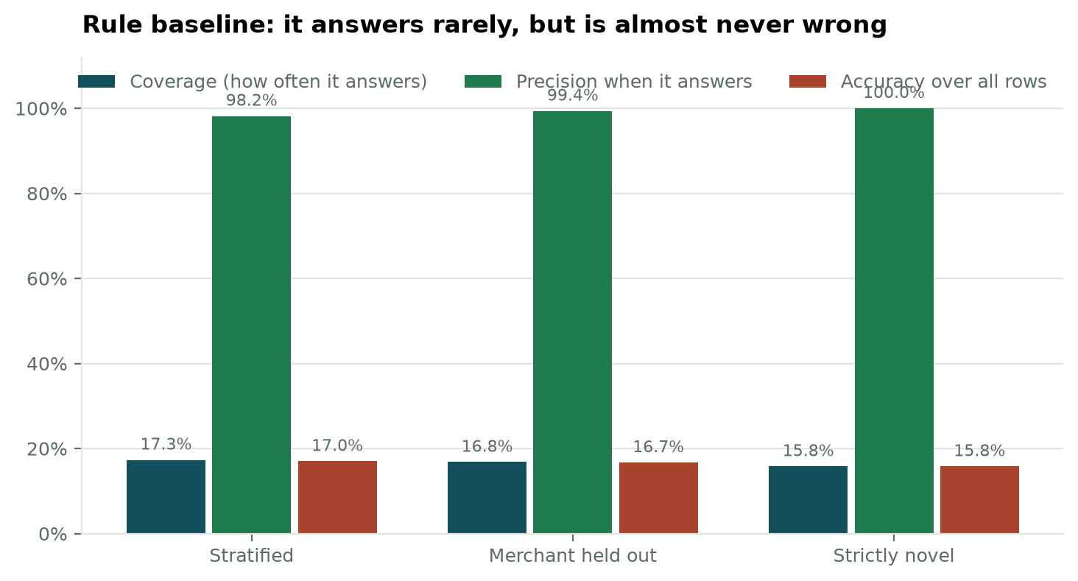
Figure 1. Coverage, precision and accuracy for the rule baseline across the three evaluation protocols.

2.1 Reading the accuracy column
Accuracy of 0.1701 looks like failure and is not. The rules abstain on more than eighty percent of transactions, and every abstention is counted as a miss. Accuracy here is simply coverage multiplied by precision: 17.3% of rows answered, 98.2% of those correct, giving 0.1701. The meaningful quantity for a layer that is allowed to abstain is precision on the rows it commits to.

2.2 The finding that matters
Precision does not fall as the task becomes harder. It is 98.2% on merchants the system has seen, 99.4% when merchants are held out entirely, and 100.0% on the strictly novel subset where no merchant word occurs anywhere in training. Because the patterns describe banking vocabulary rather than particular shops, they are indifferent to whether the merchant is familiar.
This is the argument for retaining a deterministic rule layer in the deployed cascade. The learned models are expected to be weakest precisely where this layer is strongest, so the two are complementary rather than competing.
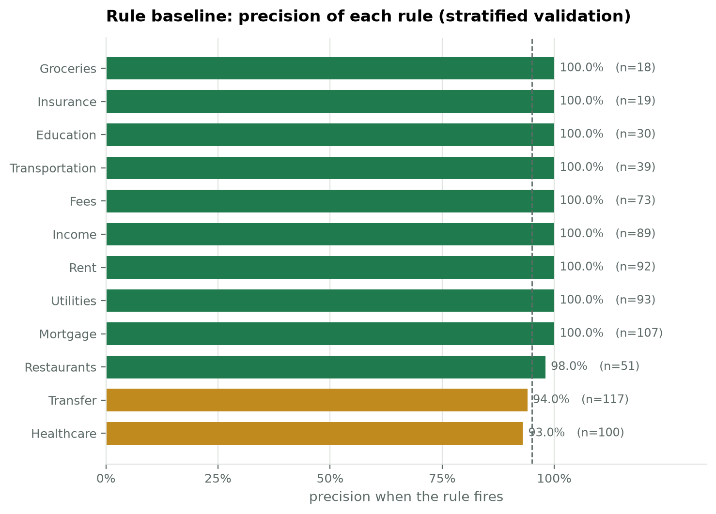
Figure 2. Precision of each individual rule on the stratified validation set, with the number of times each fired. The dashed line marks 95%.

3. Faults found and corrected
Four faults were diagnosed on the training split rather than validation, so the set used to compare models remains untouched.
Fault | Evidence on train | Correction
Transfer claimed incoming Zelle | CREDIT ZELLE PAYMENT FROM MARGARET ROBINSON is Income, 343 times | money arriving from a named person is treated as income
Insurance matched software tiers | TELEGRAM PREMIUM, ZOHO PREMIUM, X CORP PREMIUM, 76 times | the bare word PREMIUM was removed
Transportation claimed airport parking | AIRPORT PARKING INC is Travel, 30 times | PARKING guarded against a preceding AIRPORT
Subscription was unresolvable | the word appears in TICKETMASTER SUBSCRIPTION (Entertainment), SUBSCRIPTION PAYMENT DELL (Shopping) and SUBSCRIPTION PAYMENT BRILLIANT ORG (Education) | the rule was removed entirely

The fourth is a finding rather than a repair. Deciding Subscription requires knowing the merchant, which a rule layer cannot do and a learned model can. Removing the rule lowered coverage from 19.6% to 17.3% while raising precision from 85.1% to 98.2%: the layer answers less often and is substantially more trustworthy when it does.

4. Limitations
- Coverage is low by construction. More than eighty percent of transactions carry no banking vocabulary and are left entirely to the models that follow.
- The rules were written by hand against this taxonomy. They do not transfer to a different label set without being rewritten, which is a maintenance cost a learned model does not have.
- Categories dominated by merchant identity rather than vocabulary - Shopping, Entertainment, Personal Care, Travel - receive no rule at all and are invisible to this layer.

5. For the report
The rule baseline answers 17.3% of transactions at 98.2% precision, and its precision is unaffected by whether the merchant has been seen before, reaching 100.0% on strictly novel merchants. The remaining four fifths of transactions carry no deterministic signal and define the problem the machine-learned models exist to solve.

