Model 1b of 6 - Merchant Memory
Unit 2, model comparison. Lookup, not learning: the deliberate opposite of the rule baseline.

1. What this model is
A lookup table. During training it records which category each merchant received; at prediction time it returns that category again. If the merchant was never seen it abstains. No learning, no generalisation, no features.
It is the deliberate opposite of Model 1. The rule baseline contains no merchant names and depends entirely on generic banking vocabulary. This one contains nothing but merchant names. Between them they bracket the problem, and the gap is the space the learned models have to occupy.

1.1 A deliberate restriction
The prepared CSVs already carry a `merchant_key`, but that key was derived from statistics over the whole corpus, which a deployed system would not possess when a single new transaction arrives. Using it would hand this baseline information it could not have in practice, so the fingerprint is instead computed from one description in isolation: drop bank noise, processor prefixes, numbers and reference codes, then keep the leading two tokens.
Matching is exact. A fuzzy variant tolerating small spelling differences would raise coverage and is how the deployed cascade would be built, but exact matching keeps the baseline interpretable: it answers if and only if it has seen the merchant.

2. Results
Protocol | n | Accuracy | Macro-F1 | Coverage | Precision when it answered
Stratified (validation) | 4,780 | 0.8140 | 0.8500 | 82.2% | 99.1%
Merchant held out (validation) | 4,812 | 0.0374 | 0.0752 | 3.8% | 98.4%
of which strictly novel | 2,457 | 0.0016 | 0.0156 | 0.3% | 57.1%

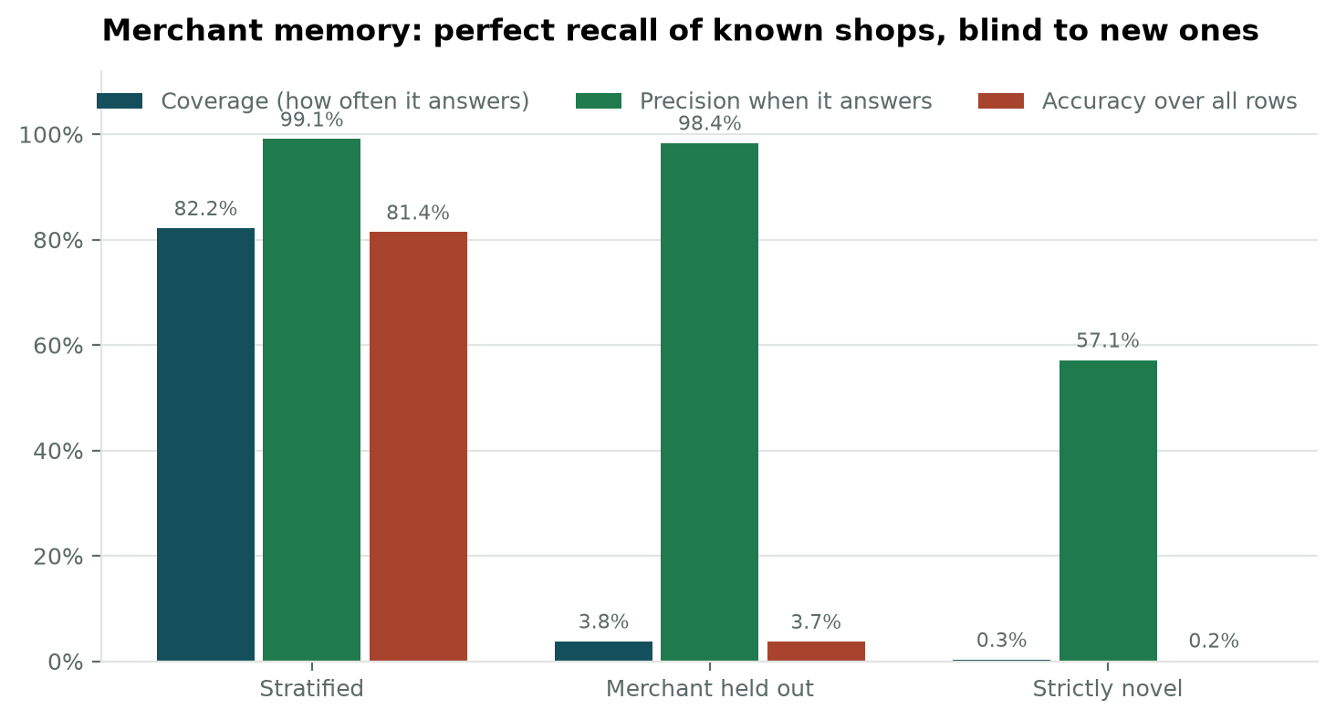
Figure 1. Coverage, precision and accuracy across the three protocols.
The behaviour is exactly as designed and the numbers say so plainly. On the stratified protocol the memory answers 82.2% of transactions at 99.1% precision. With merchants held out, coverage falls to 3.8%, and on strictly novel merchants to 0.3%.
This is not a failure of the method; it is the definition of it. A lookup table cannot answer a question it has never been asked. The value of running it is that it quantifies how much of the stratified protocol's apparent difficulty is simply merchant recall.

3. The two deterministic layers are complementary
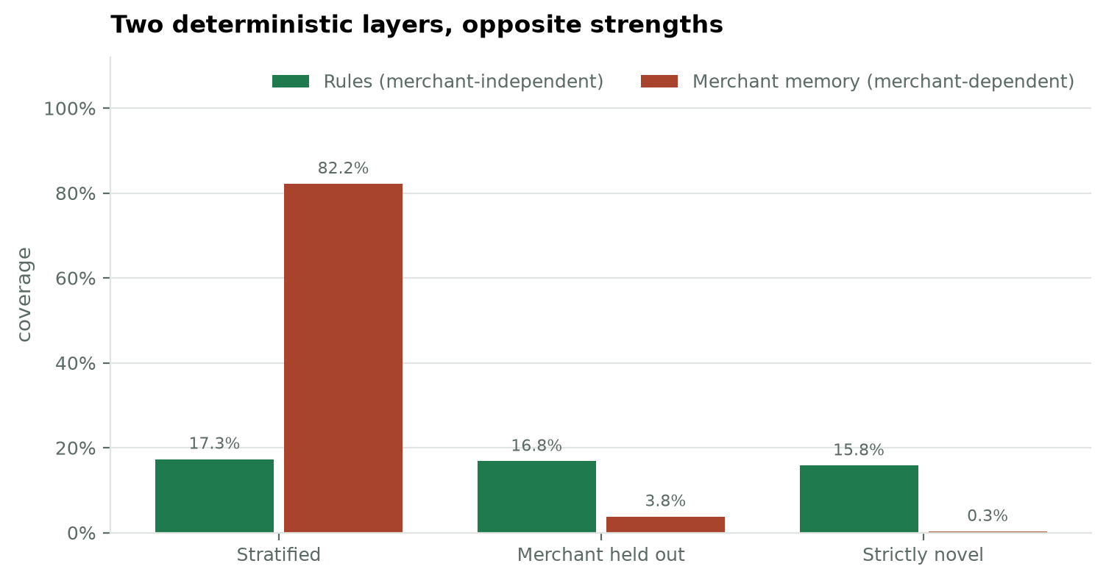
Figure 2. Coverage of the rule baseline against the merchant memory across the three protocols. The rules hold roughly steady; the memory collapses.
Layer | Stratified coverage | Merchant held out | Strictly novel
Rules (merchant-independent) | 17.3% | 16.8% | 15.8%
Merchant memory (merchant-dependent) | 82.2% | 3.8% | 0.3%

The rules barely move between protocols because they describe banking vocabulary rather than particular shops. The memory collapses between protocols because it describes nothing else. Neither is better; they fail in different places, which is the argument for arranging them in a cascade rather than choosing between them.
On the stratified validation set | Rows | Share
A rule answers, memory does not | 33 | 0.7%
Memory answers, no rule does | 3,133 | 65.5%
Both answer | 795 | 16.6%
Neither answers: must go to a model | 819 | 17.1%

Taken together the two deterministic layers answer 82.9% of transactions at 99.3% precision, leaving 17.1% that carry neither recognisable vocabulary nor a known merchant. That remainder is the genuine machine-learning problem, and it is what the comparison between Models 2 to 5 is really about.

4. Limitations
- It cannot generalise at all. Coverage on unfamiliar merchants is near zero by construction, and no tuning changes that.
- Memory grows with every merchant ever seen, and stale entries persist after a merchant changes its trading name or line of business.
- Exact matching misses trivial spelling variants that a fuzzy matcher would catch, so the coverage reported here is a lower bound for what a deployed memory layer would achieve.

5. For the report
A merchant-memory lookup answers 82.2% of transactions at 99.1% precision when merchants recur between training and evaluation, and 0.3% when they do not. Contrasting it with the rule baseline, whose coverage is almost unchanged across the same protocols, demonstrates empirically why the system combines deterministic layers with a learned model rather than relying on any one of them.

