Model 2 of 5 - TF-IDF with Multinomial Naive Bayes
Unit 2, model comparison. The first model here that learns from data.

1. What this model is
Multinomial Naive Bayes counts how strongly each text feature is associated with each category and applies Bayes' rule, assuming the features are independent once the category is known. That assumption is plainly false for text, since MORTGAGE and PMT co-occur constantly, which is why the method is called naive. It survives as a standard baseline because the violated assumption distorts the probabilities far more than it distorts the ranking of the classes.
It is included as the cheap learned baseline. If a model that trains in 0.58 seconds performs close to logistic regression or a support vector machine, the additional complexity of those models must be justified by something other than raw accuracy.

1.2 Input representation
The text is converted to TF-IDF features: word unigrams and bigrams capture whole terms and short phrases such as OVERDRAFT FEE, while character n-grams of length three and four capture fragments inside words, which lets an unfamiliar merchant still be recognised from its shape. Both vectorisers are fitted on the training split alone, producing 23,864 features. Fitting them on all of the data would leak vocabulary and document frequencies from validation into training and inflate every number that follows.
Models 2, 3 and 4 share this representation exactly, so differences between them reflect the classifier rather than the features.

2. Results
Protocol | n | Accuracy | Macro-F1
Stratified (validation) | 4,780 | 0.9782 | 0.9809
Merchant held out (validation) | 4,812 | 0.5939 | 0.5903
of which strictly novel | 2,457 | 0.4461 | 0.4657

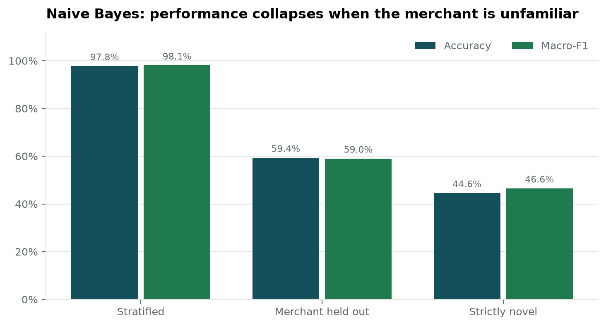
Figure 1. Accuracy and macro-F1 across the three evaluation protocols.
On the stratified protocol the model reaches a macro-F1 of 0.9809. Holding merchants out entirely reduces that to 0.5903, and on the strictly novel subset it falls to 0.4657 - a drop of 0.515 between the easiest and hardest conditions, with the model and the metric unchanged. The only thing that varies is whether the merchant has been seen before, which identifies merchant familiarity as the dominant factor in this model's apparent accuracy.

2.1 Which categories hold up, and which do not
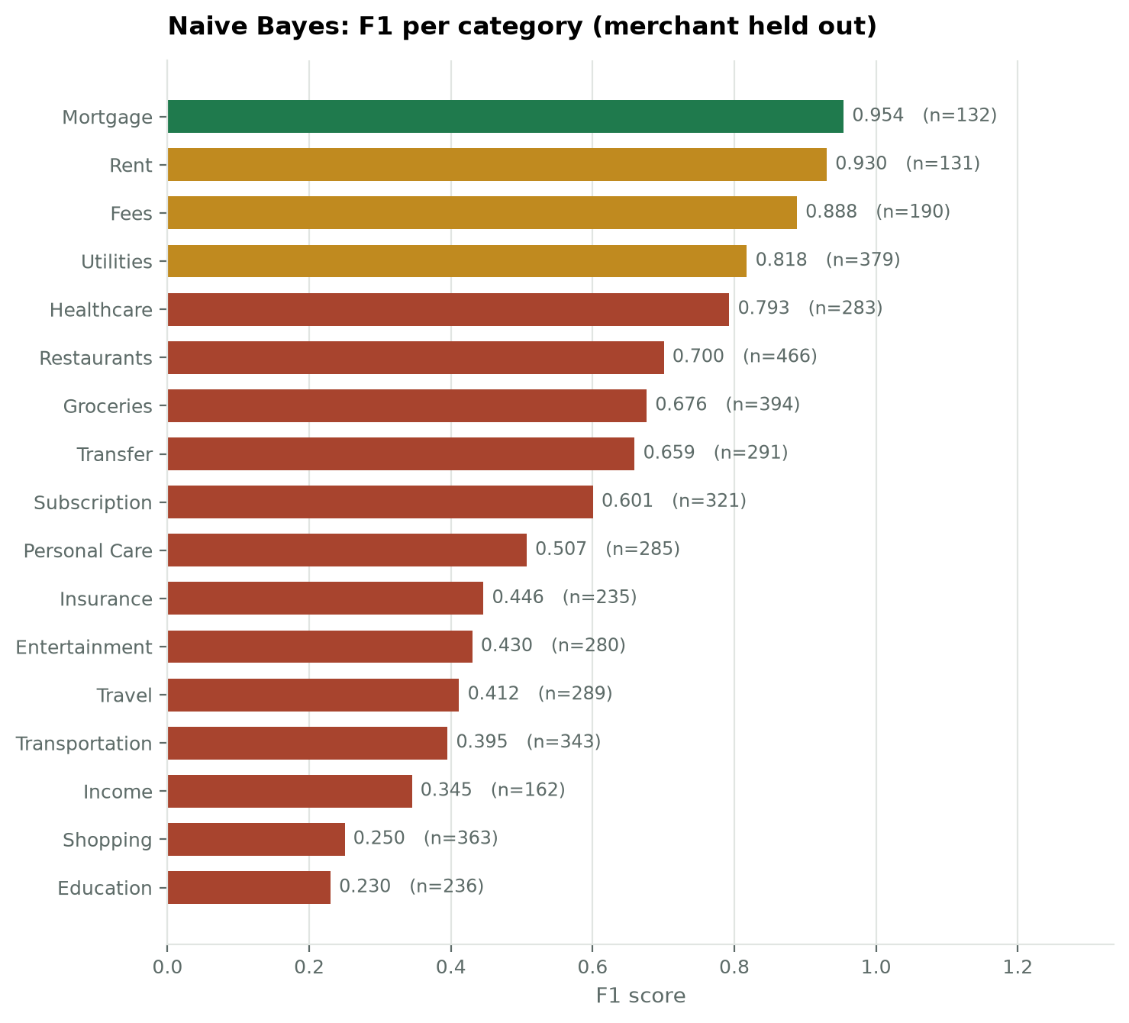
Figure 2. F1 for each of the 17 categories under the merchant-held-out protocol, weakest at the bottom.
The strongest categories are Mortgage, Rent, Fees, Utilities. These are defined by vocabulary that recurs across merchants, so the model can still recognise them when the merchant changes.
The weakest are Education, Shopping, Income, Transportation. These are defined by who the merchant is rather than by any word in the description, so once the merchant is unfamiliar there is little signal left.

2.2 What is confused with what
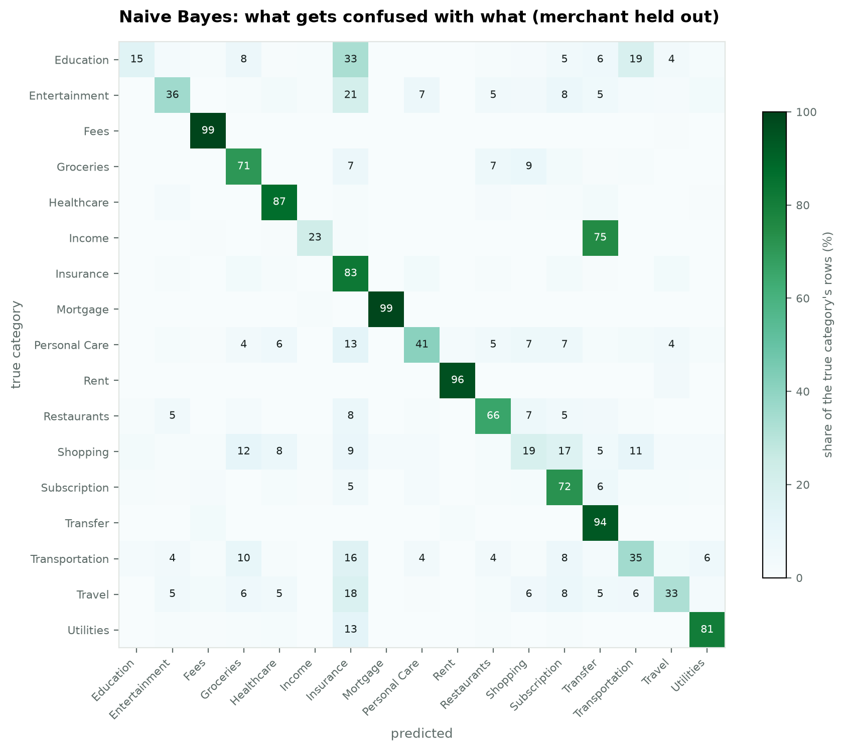
Figure 3. Confusion matrix under the merchant-held-out protocol. Each row is normalised to the true category's row total, so values are the percentage of that category routed to each prediction.
True category | Predicted as | Share | Rows
Income | Transfer | 74.9% | 131
Education | Insurance | 33.3% | 82
Entertainment | Insurance | 21.0% | 59
Education | Transportation | 19.1% | 47
Travel | Insurance | 17.6% | 50
Shopping | Subscription | 16.7% | 62
Transportation | Insurance | 15.6% | 51
Utilities | Insurance | 13.2% | 50

These confusions are informative rather than random. Categories collide where the underlying transactions genuinely resemble one another in text, which is a limit of the representation rather than a defect in the classifier.

3. Comparison with Model 1
The rule baseline answered 17.3% of transactions at 98.2% precision. Naive Bayes answers every transaction and reaches 97.8% accuracy on the stratified protocol. The learned model is therefore not merely better, it addresses a different problem: the rules are a precise instrument over a narrow slice, while the model is a general one over everything. That difference is what motivates combining them in a cascade rather than choosing between them.

4. Limitations
- The independence assumption is violated by construction, so the predicted probabilities should not be trusted as confidence estimates without calibration. This matters for the review gate and is measured properly for later models.
- Performance depends heavily on merchant familiarity, as Figure 1 shows. The stratified figure alone would materially overstate how the system behaves for a new user.
- Categories defined by merchant identity rather than vocabulary remain weak however the model is tuned, because the necessary information is absent from the text.

5. For the report
TF-IDF with multinomial Naive Bayes reaches a macro-F1 of 0.9809 where merchants recur between training and evaluation, 0.5903 when merchants are held out, and 0.4657 on strictly novel merchants. Training takes 0.58 seconds, which establishes a demanding cost baseline for the more expensive models that follow.

