Model 3 of 5 - TF-IDF with Logistic Regression
Unit 2, model comparison. The first model whose confidence is measured, and the first that explains itself exactly.

1. What this model is
Multinomial logistic regression learns one weight per feature per category and converts the resulting scores into probabilities. It uses exactly the same TF-IDF features as Model 2, so any difference between the two reflects the classifier alone.
Two properties make it important to this project beyond its accuracy.
- It is linear, so it explains itself exactly. A feature's contribution to a category score is its weight multiplied by its value. Nothing needs to be approximated after the fact; the explanation is the arithmetic the model already did.
- Its probabilities are fitted, not inferred. Logistic regression maximises likelihood, which optimises the probabilities themselves. The architecture sends low-confidence predictions to a human, so a model whose confidence is untrustworthy would push errors through that gate unflagged.
class_weight is set to balanced, because deduplication left the categories uneven - Restaurants has 3,110 rows against Rent's 874 - and macro-F1 penalises a model that favours the larger ones. Naive Bayes addresses the same imbalance through its class priors rather than a weight, which is a difference worth noting when comparing the two.

2. Results
Protocol | n | Accuracy | Macro-F1
Stratified (validation) | 4,780 | 0.9973 | 0.9976
Merchant held out (validation) | 4,812 | 0.6022 | 0.5980
of which strictly novel | 2,457 | 0.4550 | 0.4636

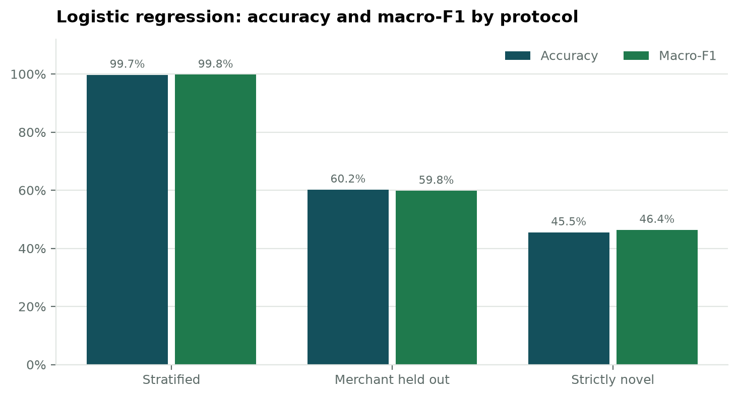
Figure 1. Accuracy and macro-F1 across the three evaluation protocols.
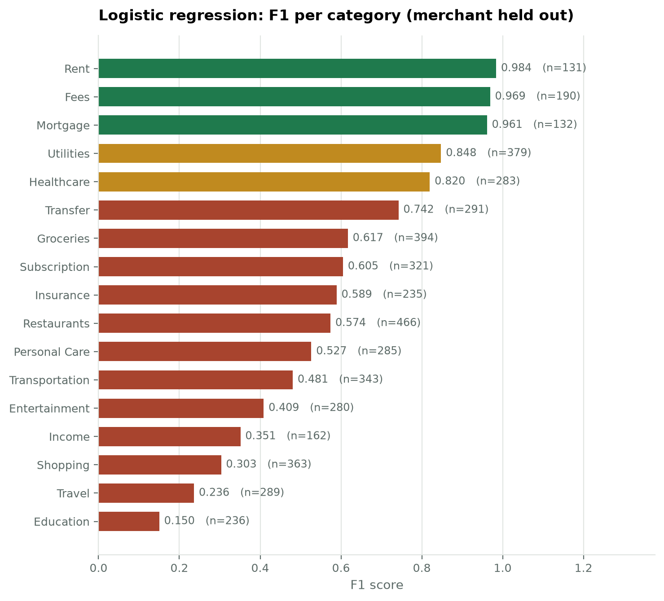
Figure 2. F1 for each of the 17 categories under the merchant-held-out protocol, weakest at the bottom.
The strongest categories are Rent, Fees, Mortgage, Utilities; the weakest are Education, Travel, Shopping, Income. The pattern matches Model 2: categories carrying their own vocabulary survive the merchant holdout, while those defined by merchant identity do not.
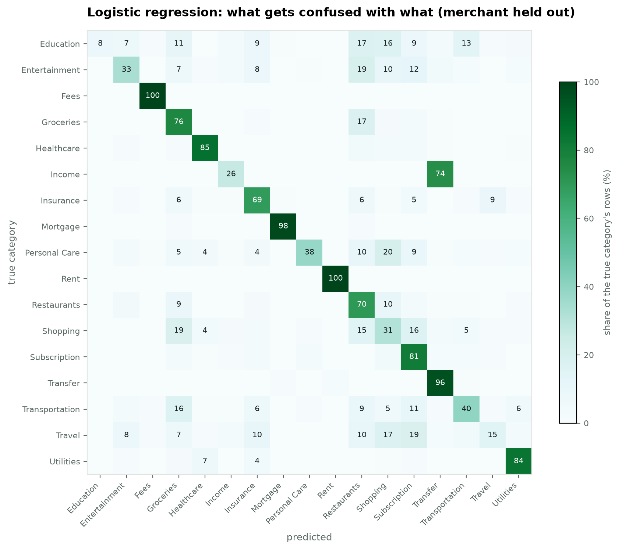
Figure 3. Confusion matrix under the merchant-held-out protocol, each row normalised to its own total.
True category | Predicted as | Share | Rows
Income | Transfer | 73.7% | 129
Personal Care | Shopping | 20.1% | 63
Entertainment | Restaurants | 19.2% | 54
Travel | Subscription | 18.7% | 53
Shopping | Groceries | 18.5% | 69
Groceries | Restaurants | 17.2% | 69

3. Calibration
Accuracy says how often a model is right. Calibration says whether its confidence can be believed, which is what determines whether the review gate works. A model claiming 90% confidence should be right about 90% of the time.
Protocol | ECE | MCE | Brier | Mean confidence | Accuracy | Gap
stratified | 0.0582 | 0.6498 | 0.0147 | 0.9393 | 0.9973 | -0.0580
merchant | 0.0406 | 0.1316 | 0.4965 | 0.5744 | 0.6022 | -0.0279
strictly novel | 0.0509 | 0.2613 | 0.6480 | 0.4961 | 0.4550 | +0.0411

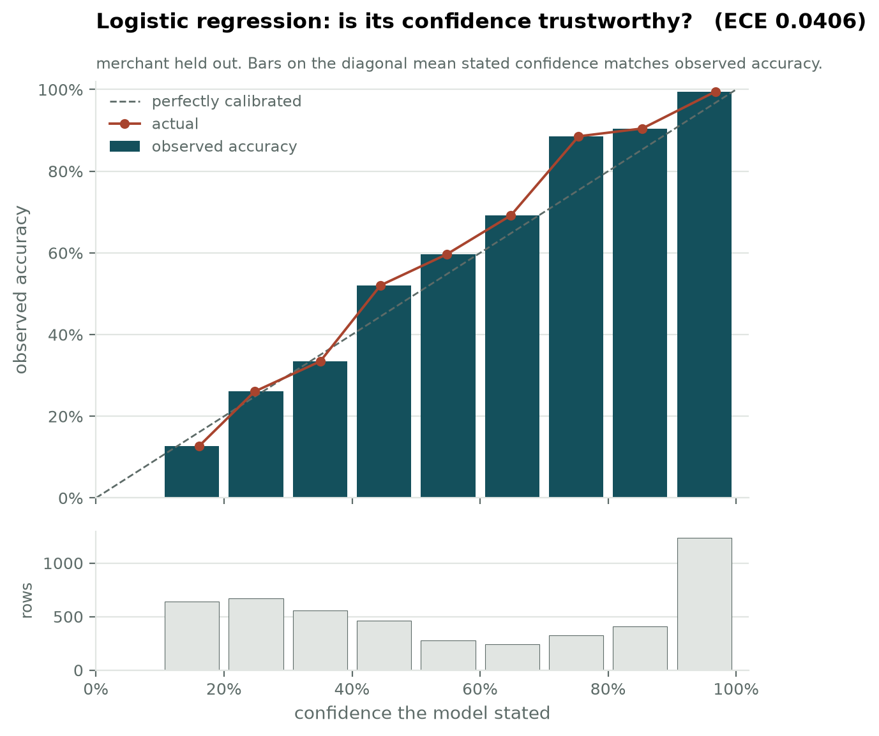
Figure 4. Reliability diagram, merchant held out. Bars sitting on the dashed diagonal indicate stated confidence matching observed accuracy. The lower panel shows how many predictions fall in each confidence band.
On the merchant-held-out protocol the expected calibration error is 0.0406, with mean confidence 0.5744 against accuracy 0.6022, a gap of -0.0279. On strictly novel merchants the gap is +0.0411 with mean confidence 0.4961 against accuracy 0.4550.

4. The model explains itself
Because the model is linear, the evidence behind any prediction can be read directly from the weights. No surrogate model or sampling procedure is involved, so the explanation is exact rather than approximate.
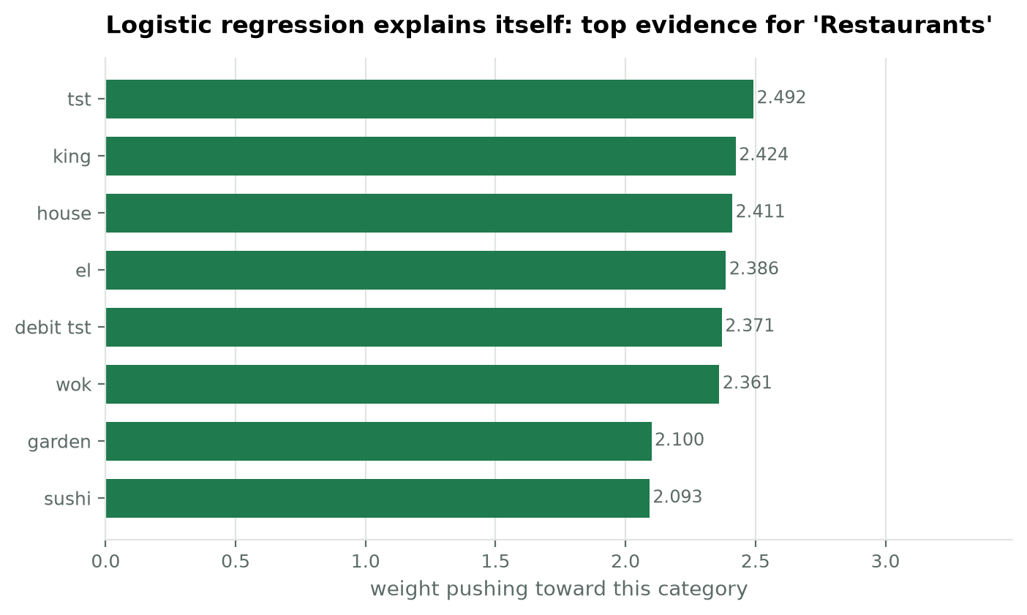
Figure 5. The word features that push hardest toward the Restaurants category, taken straight from the fitted weights.
Category | Strongest evidence learned
Mortgage | mortgage (+3.08), cu (+2.71), mtg (+2.65), escrow (+2.53), num web (+2.30)
Restaurants | tst (+2.49), king (+2.42), house (+2.41), el (+2.39), debit tst (+2.37)
Income | payment from (+3.78), credit zelle (+3.78), zelle (+2.97), zelle payment (+2.97), payroll (+2.85)
Shopping | amazon com (+2.98), tiktok shop (+2.89), mercari (+2.72), target (+2.51), offerup (+2.50)

These weights are worth reading as a sanity check on the model. Evidence that is generic banking vocabulary will transfer to merchants never seen; evidence that is a brand name will not, and predicts exactly where the merchant-held-out score will fall.

5. Comparison so far
Model | Stratified macro-F1 | Merchant held out | Strictly novel
1. Rule baseline (17% coverage) | 0.2924 | 0.2849 | 0.3068
2. Naive Bayes | 0.9809 | 0.5903 | 0.4657
3. Logistic regression | 0.9976 | 0.5980 | 0.4636

6. Limitations
- Training is slower than Naive Bayes by roughly an order of magnitude (3.97 seconds here), which is only worth paying for if the accuracy or the calibration justify it.
- The explanation is exact for this model, but reports word features only. Character n-grams contribute to the decision and are omitted from the display because they read as fragments rather than evidence.
- Performance still depends heavily on merchant familiarity. Being linear and interpretable does not supply information the description does not contain.

7. For the report
TF-IDF with logistic regression reaches a macro-F1 of 0.9976 on familiar merchants, 0.5980 when merchants are held out and 0.4636 on strictly novel merchants, with an expected calibration error of 0.0406 on the merchant-held-out protocol. Being linear, it supplies exact token-level explanations at no additional inference cost, which is the property the application's explainability requirement depends on.

