Model 4 of 5 - TF-IDF with a Calibrated Linear SVM
Unit 2, model comparison. The strongest classical linear model, and the one that has to be wrapped before its confidence can be used.

1. What this model is
A linear support vector machine finds the separating boundary with the widest margin between classes. On sparse, high-dimensional text it is usually the strongest of the classical linear models, which makes it the natural test of how much accuracy this feature representation can yield at all. It uses the same TF-IDF features as Models 2 and 3.

1.1 Why it needs wrapping
The SVM produces distances, not probabilities. It reports how far a point lies from each boundary, and those numbers carry no probabilistic meaning: a distance of 2.0 does not indicate twice the likelihood. Because this project routes low-confidence predictions to human review, a raw distance is unusable as a confidence score.
CalibratedClassifierCV therefore wraps the SVM and learns the mapping from distance to probability by fitting a sigmoid on held-out folds of the training data, a procedure known as Platt scaling. This is a second model fitted on top of the first. Whether it yields trustworthy confidence is an empirical question, and answering it is the main reason this model is interesting here.
The cost is time. With three folds the SVM is fitted three times plus the calibrator, taking 2.62 seconds against 3.97 for logistic regression and 0.58 for Naive Bayes.

2. Results
Protocol | n | Accuracy | Macro-F1
Stratified (validation) | 4,780 | 0.9981 | 0.9984
Merchant held out (validation) | 4,812 | 0.6170 | 0.6393
of which strictly novel | 2,457 | 0.4481 | 0.5146

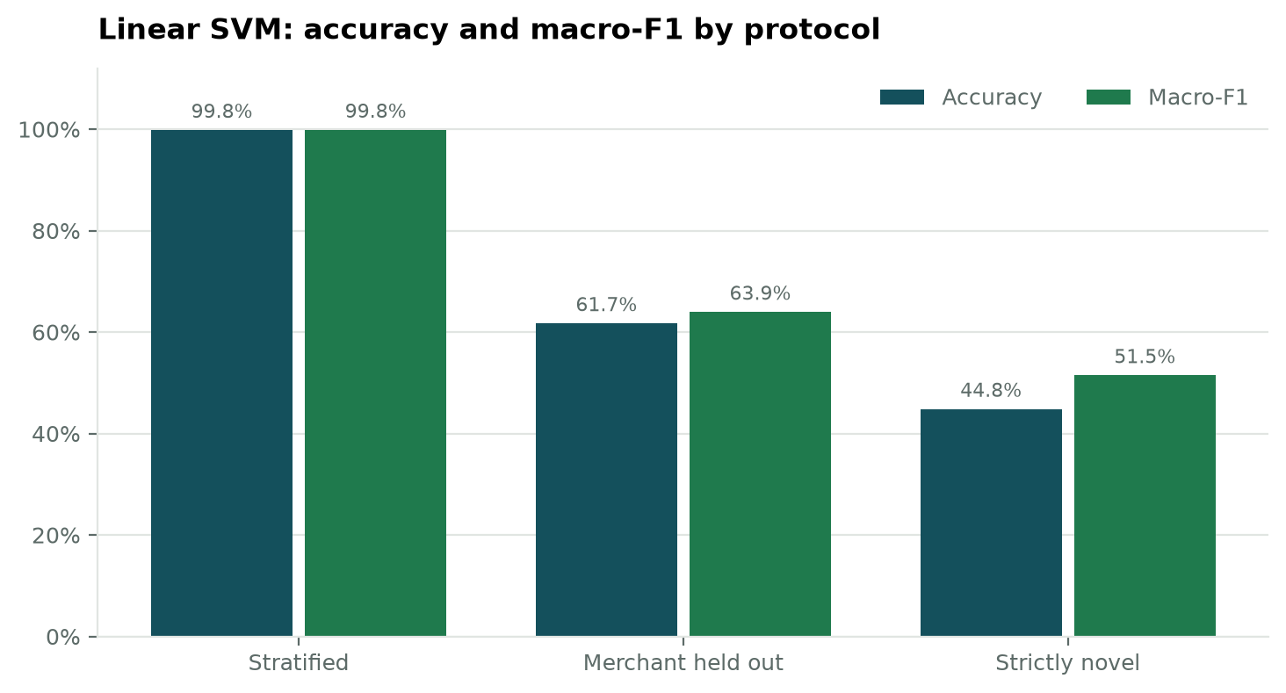
Figure 1. Accuracy and macro-F1 across the three evaluation protocols.
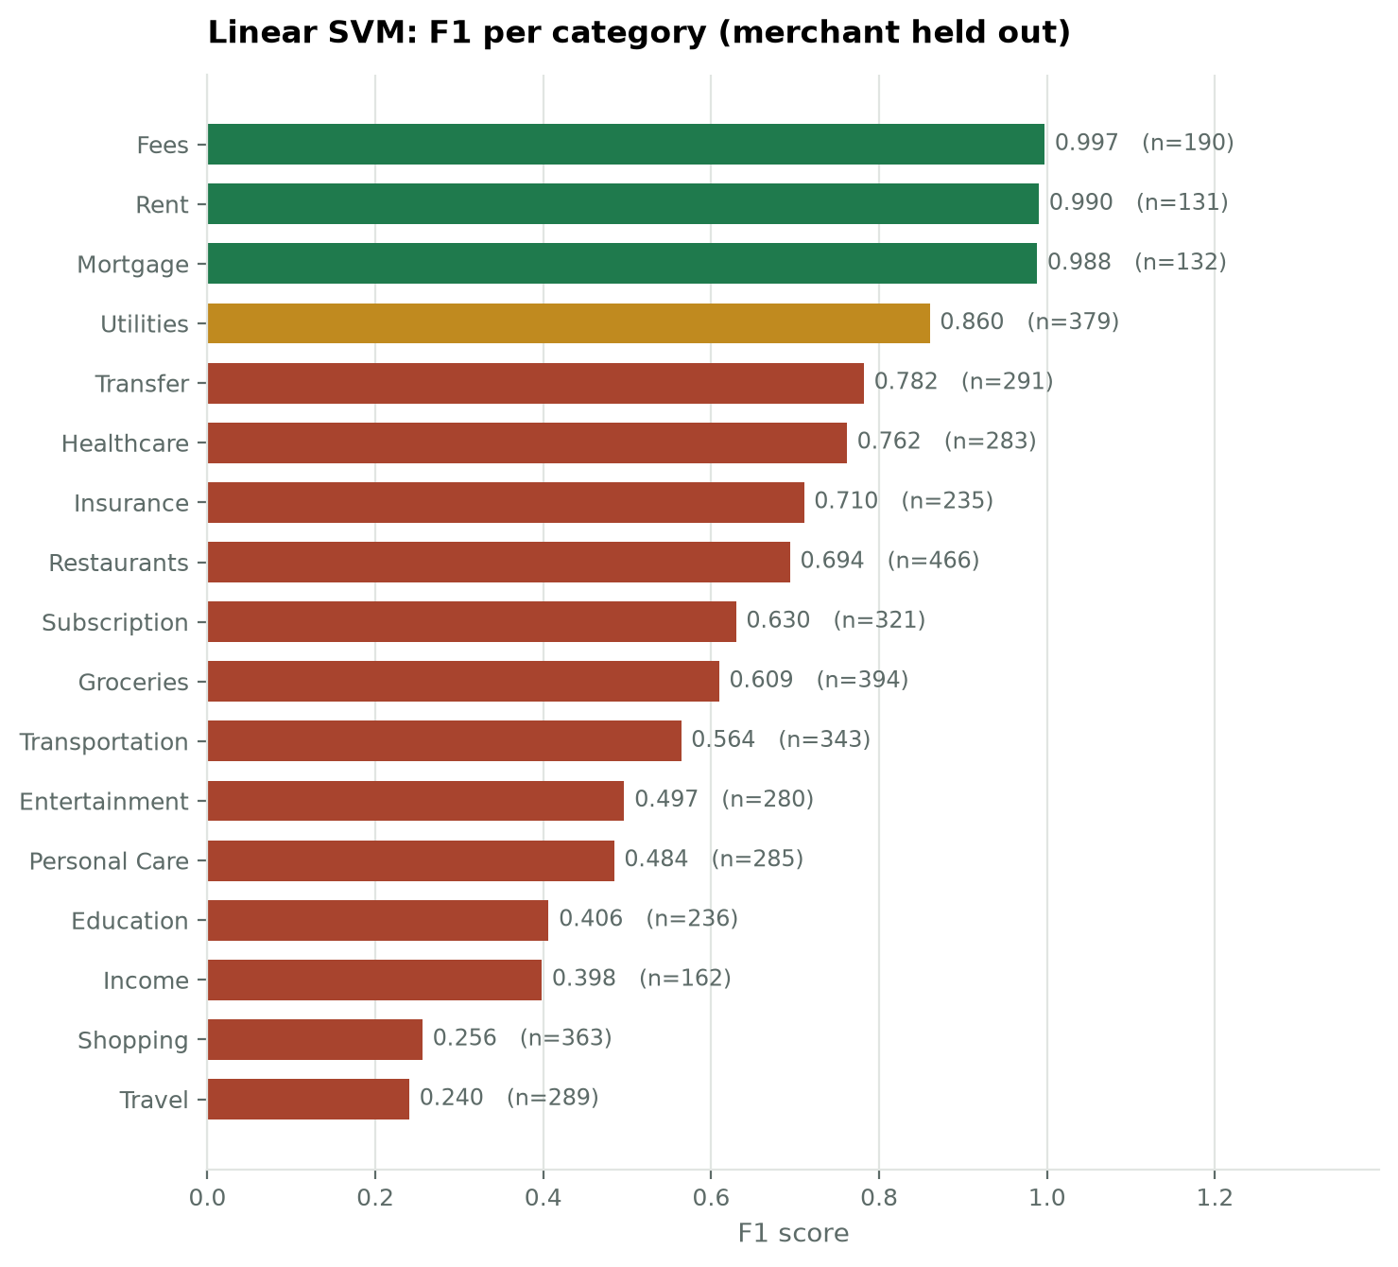
Figure 2. F1 for each of the 17 categories under the merchant-held-out protocol, weakest at the bottom.
The strongest categories are Fees, Rent, Mortgage, Utilities; the weakest are Travel, Shopping, Income, Education. The ordering is consistent with Models 2 and 3, which indicates the limit lies in what the description contains rather than in any particular classifier.
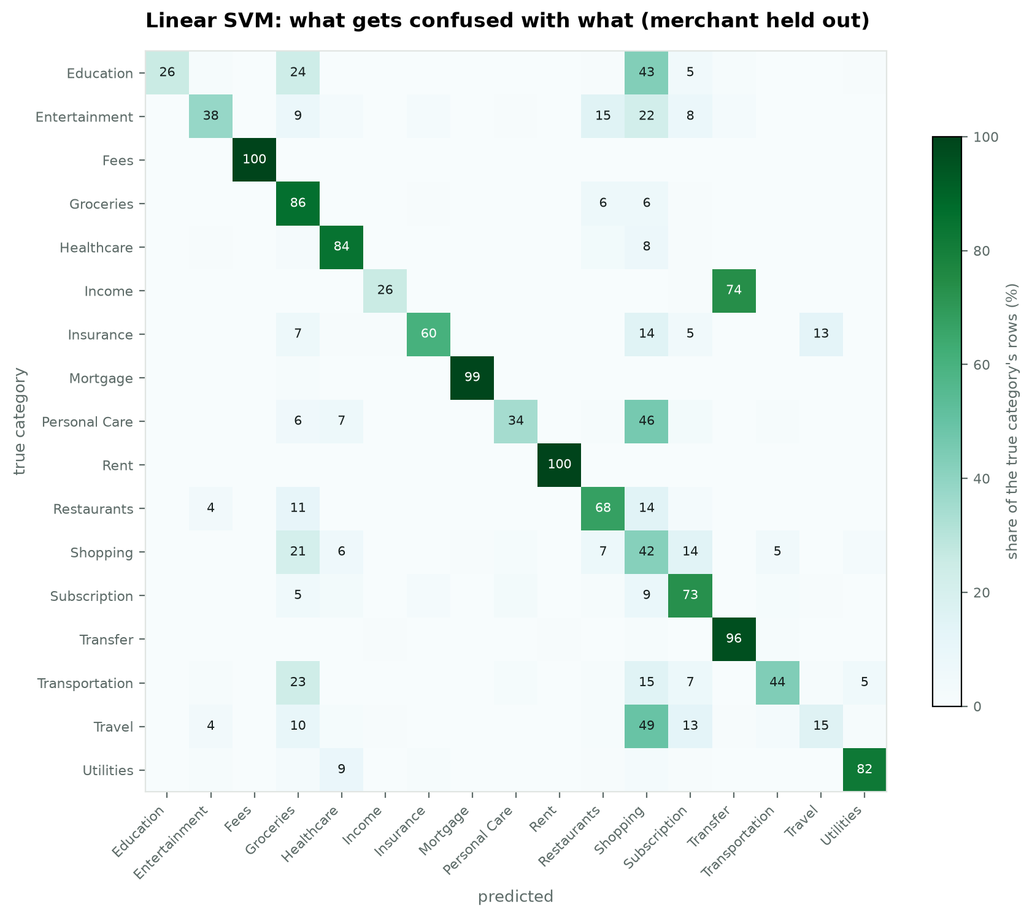
Figure 3. Confusion matrix under the merchant-held-out protocol, each row normalised to its own total.
True category | Predicted as | Share | Rows
Income | Transfer | 73.7% | 129
Travel | Shopping | 49.3% | 140
Personal Care | Shopping | 45.9% | 144
Education | Shopping | 43.1% | 106
Education | Groceries | 23.6% | 58
Transportation | Groceries | 23.2% | 76

3. Calibration: did the wrapper work?
Protocol | ECE | MCE | Brier | Mean confidence | Accuracy | Gap
stratified | 0.0068 | 0.5242 | 0.0028 | 0.9923 | 0.9981 | -0.0058
merchant | 0.1452 | 0.3700 | 0.5327 | 0.7622 | 0.6170 | +0.1452
strictly novel | 0.2372 | 0.4639 | 0.7487 | 0.6854 | 0.4481 | +0.2372

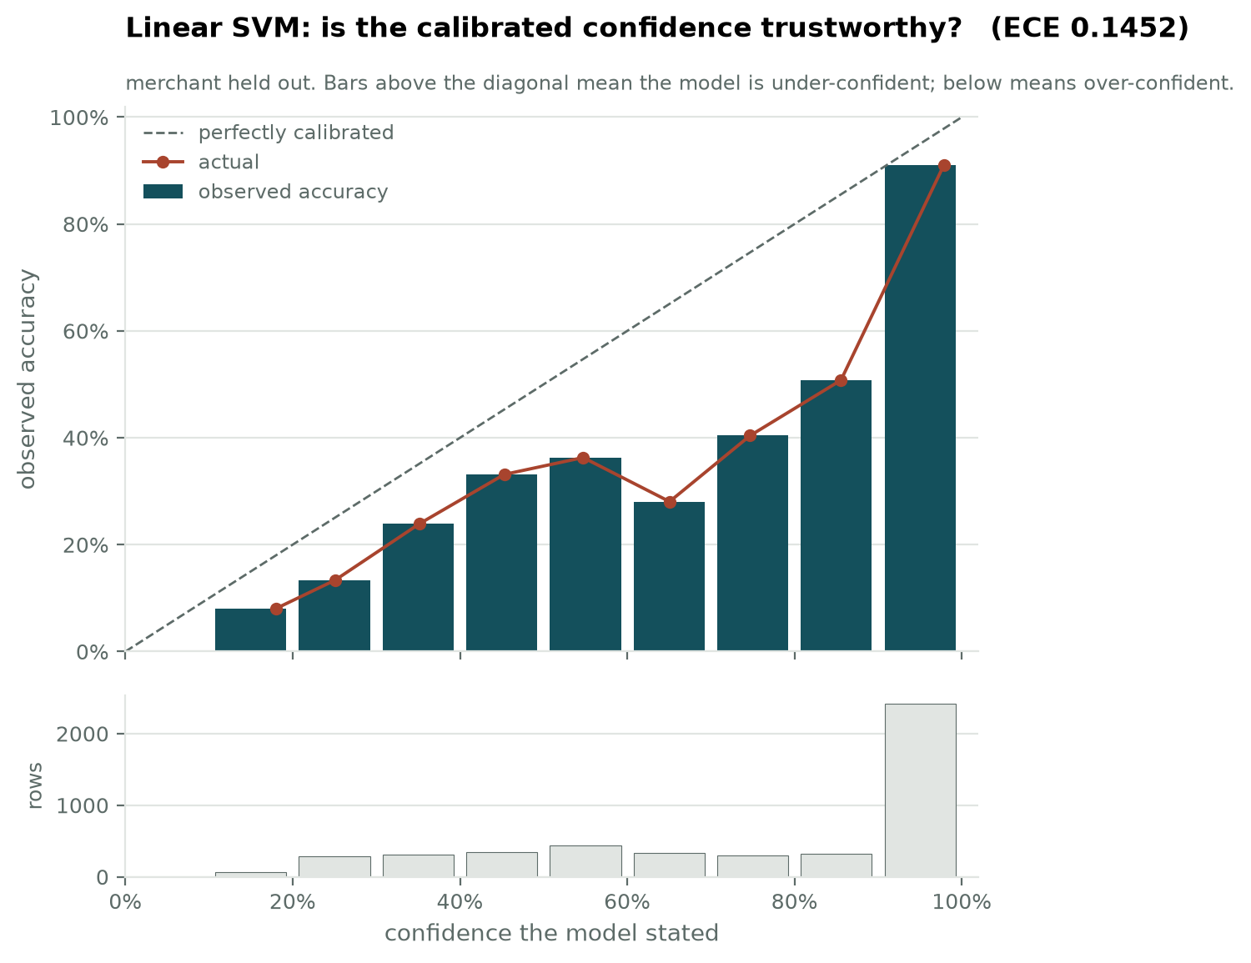
Figure 4. Reliability diagram, merchant held out.
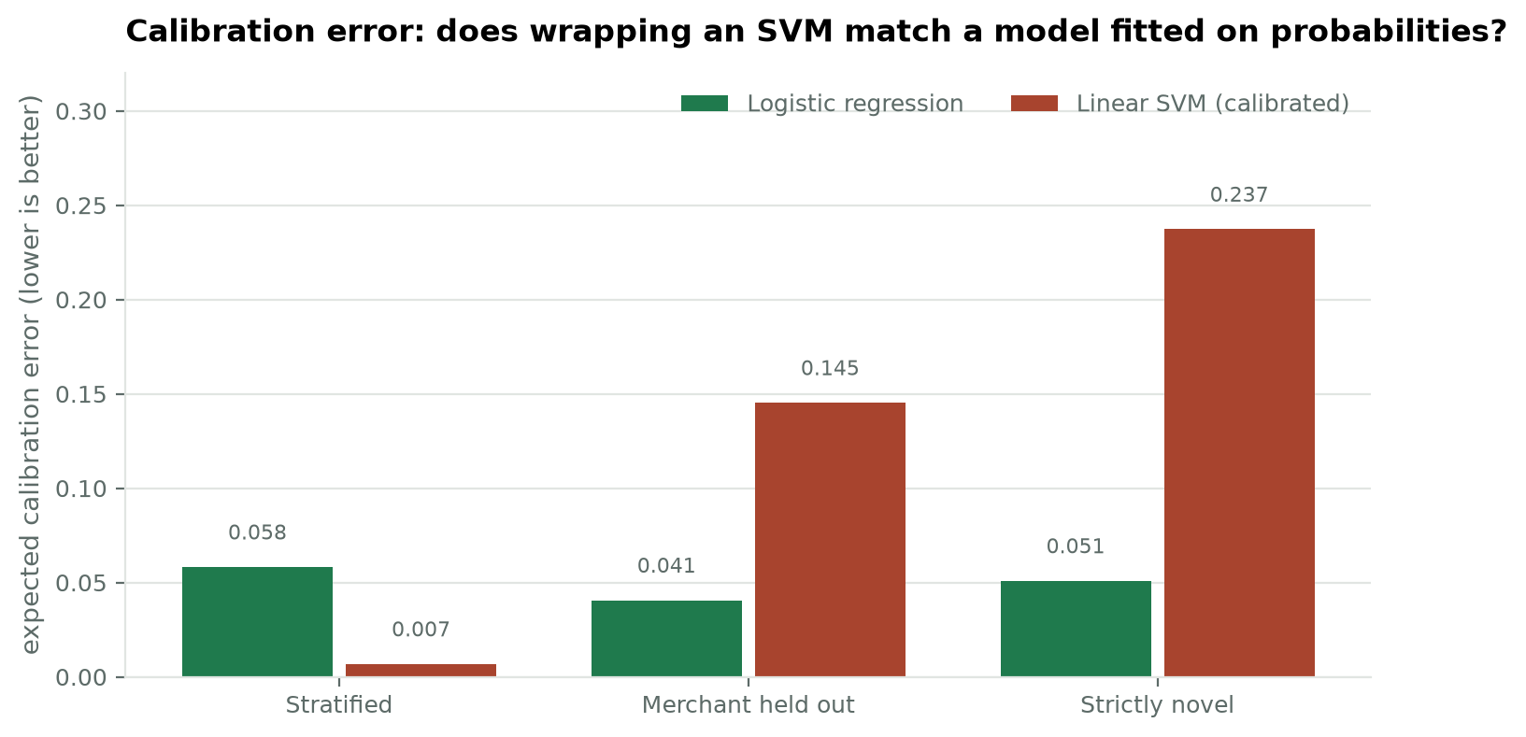
Figure 5. Expected calibration error compared with logistic regression across all three protocols. Lower is better.
On the merchant-held-out protocol the wrapped SVM records an expected calibration error of 0.1452 against 0.0406 for logistic regression, with mean confidence 0.7622 against accuracy 0.6170, a gap of +0.1452.
Calibrating a model after the fact is therefore measurably worse than fitting one on probabilities from the start, which is what logistic regression does. This matters because the deployed system uses the confidence score to decide what a human should check, so the comparison between these two models is not settled by macro-F1 alone.

4. Comparison so far
Model | Stratified | Merchant held out | Strictly novel | Merchant ECE | Train (s)
1. Rule baseline (17% coverage) | 0.2924 | 0.2849 | 0.3068 | n/a | 0.00
2. Naive Bayes | 0.9809 | 0.5903 | 0.4657 | n/a | 0.58
3. Logistic regression | 0.9976 | 0.5980 | 0.4636 | 0.0406 | 3.97
4. Linear SVM (calibrated) | 0.9984 | 0.6393 | 0.5146 | 0.1452 | 2.62

The SVM edges ahead of logistic regression on macro-F1 with merchants held out, while costing substantially more to train. Model selection for this project therefore cannot rest on macro-F1 alone: the deployed model also has to supply confidence the review gate can act on, and an explanation the interface can display.

5. Limitations
- The probabilities are produced by a sigmoid fitted after the fact rather than by the model itself, so they inherit whatever the calibration procedure gets wrong.
- Explanation is harder than for logistic regression. The underlying SVM is linear and has weights, but the deployed object is an ensemble of three fitted folds wrapped in a calibrator, so there is no single weight vector to read.
- Training takes 2.62 seconds, roughly 5 times Naive Bayes, which has to be justified by the results rather than assumed.

6. For the report
A calibrated linear SVM over the same TF-IDF features reaches a macro-F1 of 0.9984 on familiar merchants, 0.6393 with merchants held out and 0.5146 on strictly novel merchants, with an expected calibration error of 0.1452. It confirms that the ceiling of this representation has been reached: three different linear classifiers over identical features agree to within a few points on every protocol, and all of them fall by roughly half when the merchant becomes unfamiliar.

