Model 5 of 5 - MiniLM Sentence Embeddings with a Logistic Regression Head
Unit 2, model comparison. The only model that represents meaning rather than counting surface patterns.

1. What this model is
all-MiniLM-L6-v2 is a small transformer, pre-trained by others on roughly a billion sentence pairs, which maps any text to 384 numbers arranged so that texts with similar meaning land near one another. Unlike TF-IDF it does not count words; it places the whole description in a learned semantic space.

1.1 What is actually trained here
The encoder is downloaded and frozen. No neural network is trained by this project. Only a logistic regression head is fitted on top of the 384 numbers the encoder produces, taking 1.24 seconds. That head is identical to Model 3, so the comparison between Models 3 and 5 isolates the representation: counted surface patterns against learned semantics.

1.2 The hypothesis under test
Bank descriptions are codes rather than prose: TST*GOLDEN DRAGON, PPD ID, PYPL*365 MARKET. A semantic encoder should in principle recognise that an unfamiliar BISTRO relates to a familiar RESTAURANT, which is exactly the weakness every previous model displayed once merchants were held out. Whether that advantage survives on text this far from natural language is the question this model answers.

2. Results
Protocol | n | Accuracy | Macro-F1 | ECE
Stratified (validation) | 4,780 | 0.9029 | 0.9167 | 0.1096
Merchant held out (validation) | 4,812 | 0.6311 | 0.6479 | 0.0360
of which strictly novel | 2,457 | 0.5710 | 0.5936 | 0.0436

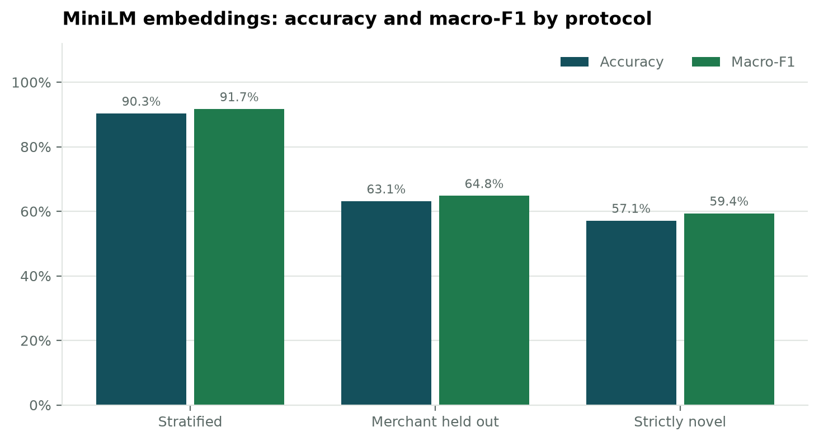
Figure 1. Accuracy and macro-F1 across the three protocols.
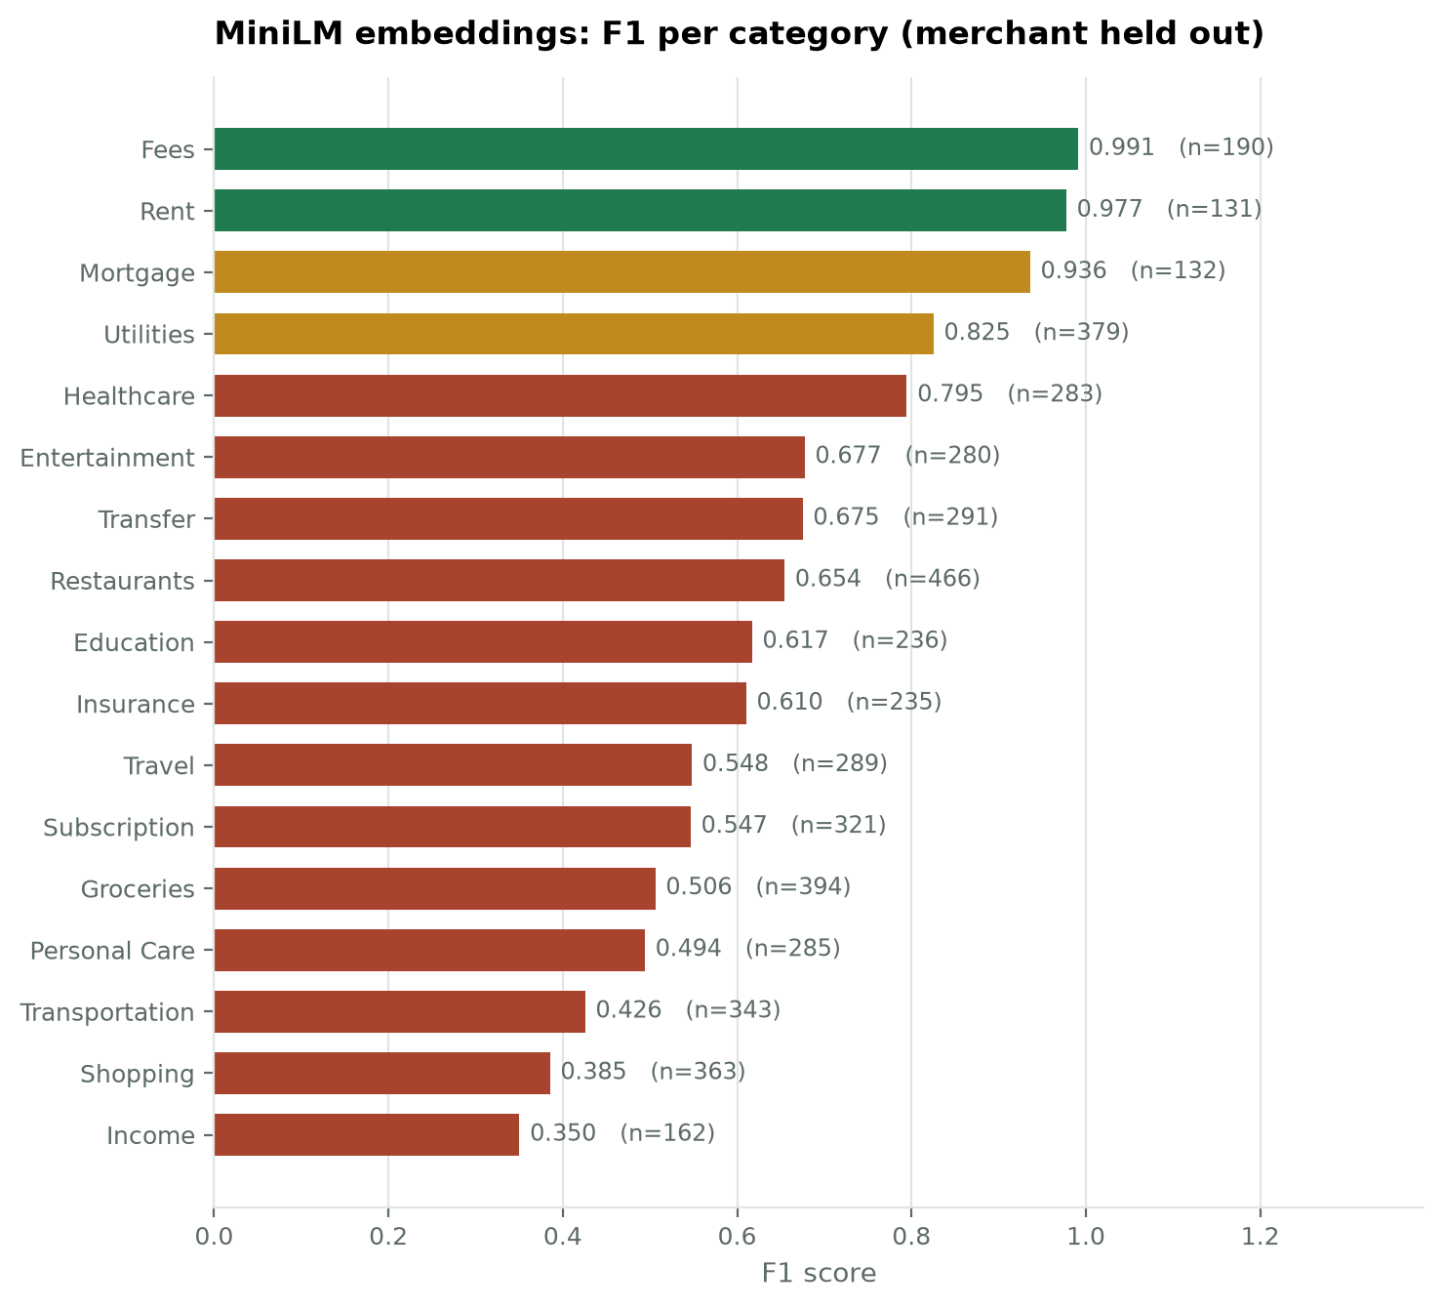
Figure 2. F1 per category, merchant held out.
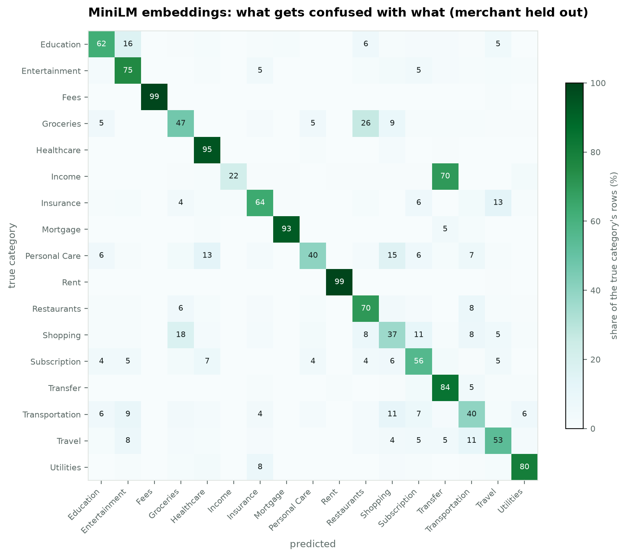
Figure 3. Confusion matrix, merchant held out.
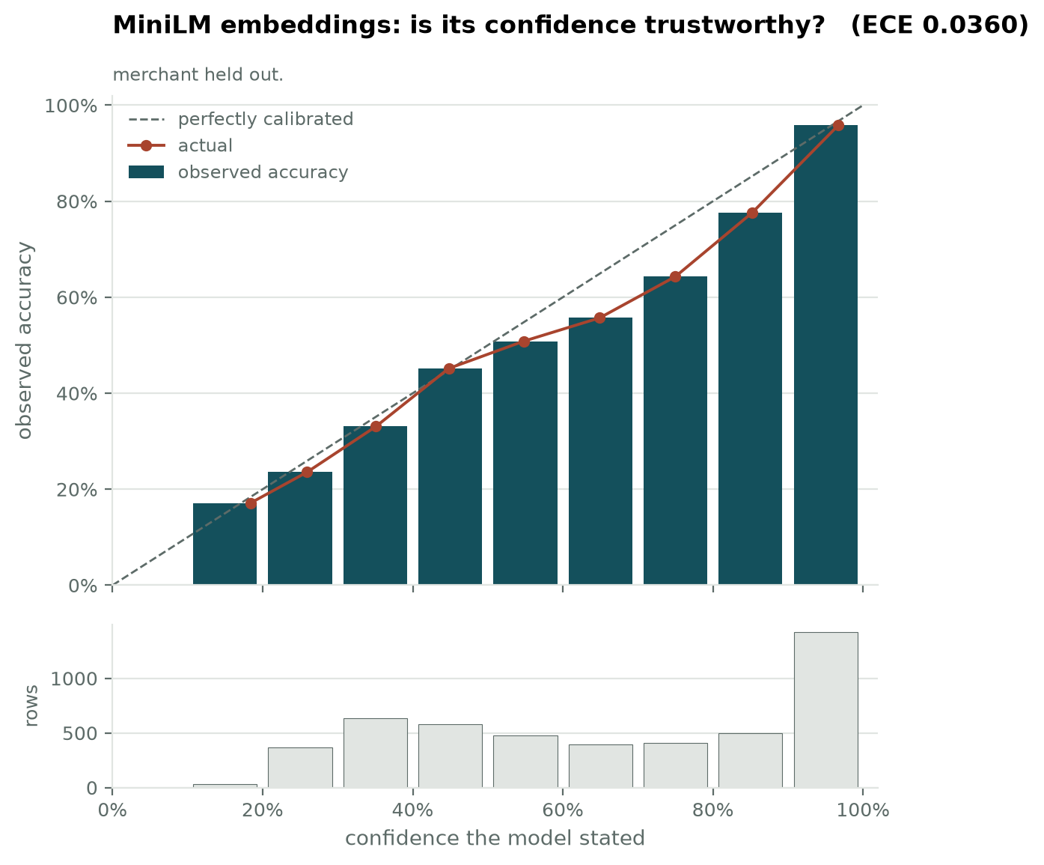
Figure 4. Reliability diagram, merchant held out.

3. Did semantics beat surface patterns?
Protocol | TF-IDF + Logistic regression | TF-IDF + Linear SVM | MiniLM + Logistic regression
Stratified (validation) | 0.9976 | 0.9984 | 0.9167
Merchant held out (validation) | 0.5980 | 0.6393 | 0.6479
of which strictly novel | 0.4636 | 0.5146 | 0.5936

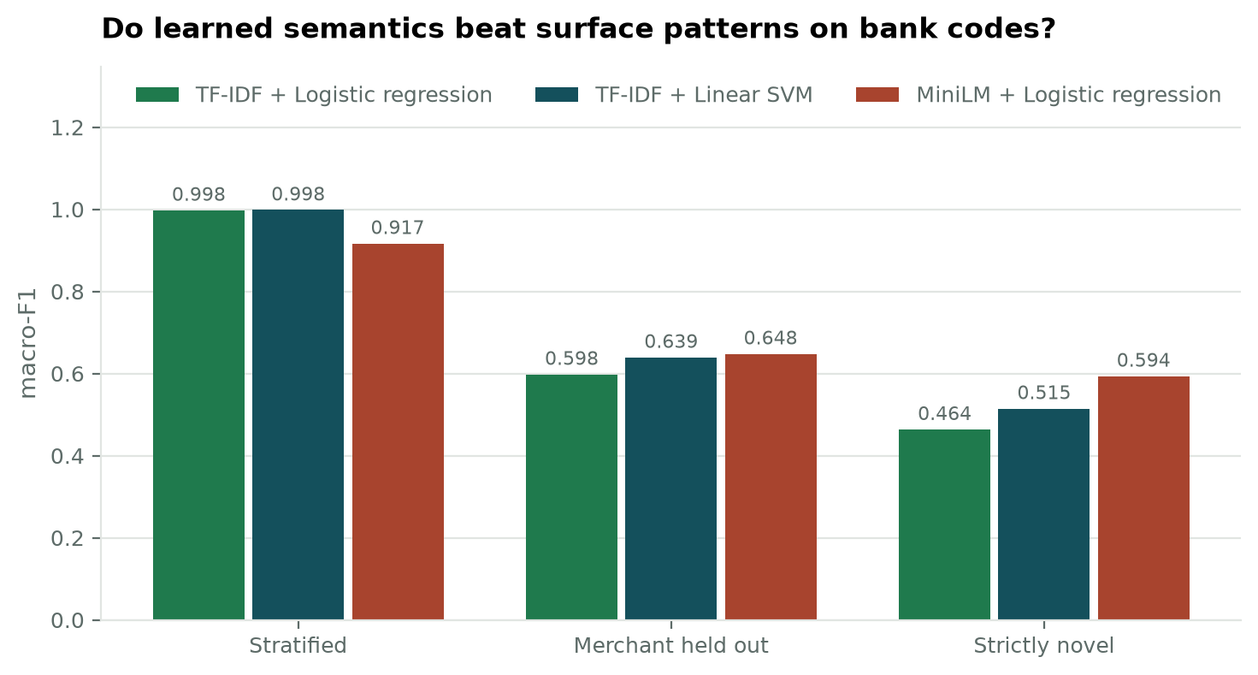
Figure 5. MiniLM against the two strongest TF-IDF models on all three protocols.
It depends entirely on whether the merchant is familiar, and that is the finding. MiniLM is the weakest model of the five where merchants recur (0.9167 against 0.9984 for the best TF-IDF model) and the strongest where they do not (0.5936 against 0.5146 on strictly novel merchants, a margin of +0.0790).
The explanation lies in what each representation can exploit. TF-IDF wins on familiar merchants because a brand name is a perfectly discriminative token: having seen SAFEWAY labelled Groceries, recognising it again is trivial, and no semantic understanding is required or useful. That advantage disappears entirely the moment the merchant is one the model has never seen, because the token simply is not in its vocabulary.
A sentence encoder has no such cliff. It places an unfamiliar merchant somewhere in a learned semantic space on the basis of whatever the description does contain - word fragments, format cues, the shape of the name - and that placement is still informative when the exact string is new. The two representations are therefore strongest in opposite conditions, which is a more useful result for this project than either one winning outright.
This bears directly on deployment. A finance application meets unfamiliar merchants constantly: every new user arrives with a set of shops the system has never encountered. The protocol that matters most for that situation is the one MiniLM leads.

4. Would MiniLM do better on more natural text?
Every model so far has received the shared normalised text, which is uppercase with long digit runs replaced by <NUM>. That suits TF-IDF but is unlike the text MiniLM was trained on, so the encoder was run a second time on lightly cleaned text that keeps natural case and punctuation. This checks that the comparison is not quietly handicapping the one model it could disadvantage.
Protocol | Shared normalised text | Lightly cleaned text | Difference
Stratified (validation) | 0.9167 | 0.9211 | +0.0044
Merchant held out (validation) | 0.6479 | 0.6314 | -0.0164
of which strictly novel | 0.5936 | 0.5776 | -0.0159

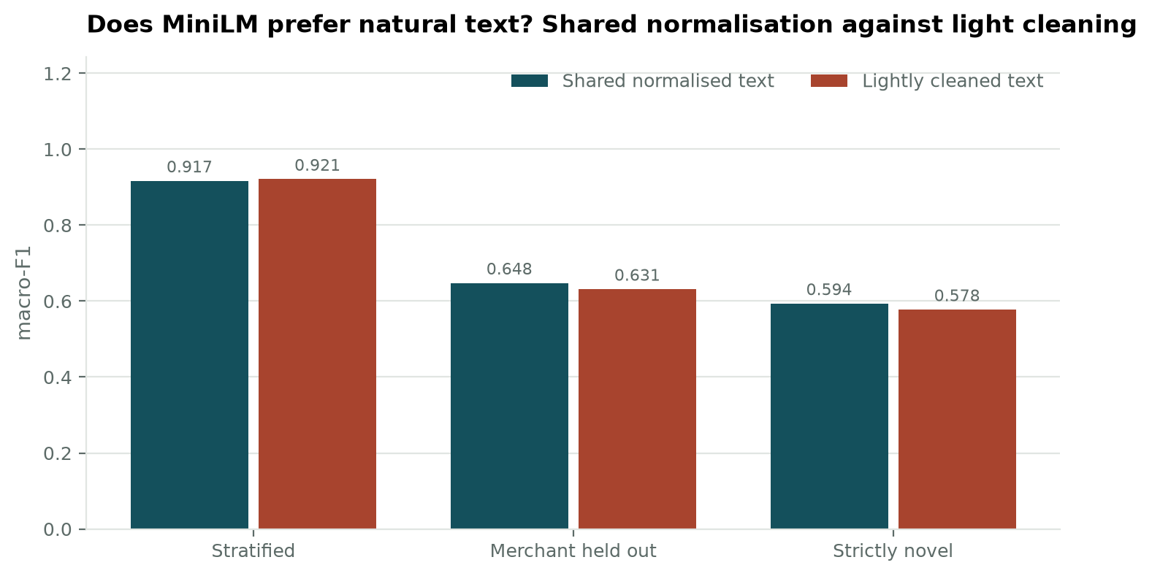
Figure 6. The same encoder on the shared normalised text against lightly cleaned text.
Lighter cleaning does not materially help. The shared normalisation is therefore not the reason for MiniLM's standing in this comparison, and the single shared representation used across all five models is defensible.

5. Limitations
- The encoder is frozen. Fine-tuning it on this data would likely improve matters, at a cost in training time, hardware and explainability that this project did not take on.
- An embedding is 384 anonymous numbers, so there is no token-level explanation to show a user. Models 3 and 4 can point at the words that drove a decision; this one cannot without a separate post-hoc method.
- Encoding is the dominant cost at prediction time, far above a TF-IDF transform, which matters for an interactive application.

6. For the report
MiniLM sentence embeddings with a logistic regression head reach a macro-F1 of 0.9167 on familiar merchants, 0.6479 with merchants held out and 0.5936 on strictly novel merchants. The comparison with TF-IDF reverses depending on the protocol: counted surface patterns win while merchants recur between training and evaluation, and learned semantics win once they do not. Reporting a single winner would therefore misrepresent the result. Which model is preferable depends on whether the deployed system expects to meet merchants it has already seen, and a consumer finance application plainly does not.

