Unit 2 - Model Comparison, Cascade Evaluation and Selection
Six models compared on validation; the chosen configuration evaluated once on the held-out test sets.

1. What Unit 2 set out to answer
Which categorisation model should the application deploy, and in what arrangement? Answering it required three things the individual model studies could not provide: the models seen together, the assembled system measured end to end, and a selection made against stated criteria rather than a single score.

2. The six models compared
Model | In-distribution | Unseen merchant | Strictly novel | Merchant ECE | Explanation
1. Rule baseline | 0.2924 | 0.2849 | 0.3068 | n/a | exact
1b. Merchant memory | 0.8500 | 0.0752 | 0.0156 | n/a | exact
2. Naive Bayes | 0.9809 | 0.5903 | 0.4657 | n/a | exact
3. Logistic regression | 0.9976 | 0.5980 | 0.4636 | 0.0406 | exact
4. Linear SVM | 0.9984 | 0.6393 | 0.5146 | 0.1452 | partial
5. MiniLM embeddings | 0.9167 | 0.6479 | 0.5936 | 0.0360 | approximate

Macro-F1 on validation. The rule baseline and merchant memory abstain, so every abstention counts against them and they are not comparable to the rest on this metric; they are included to show the floor and the shape of the problem.
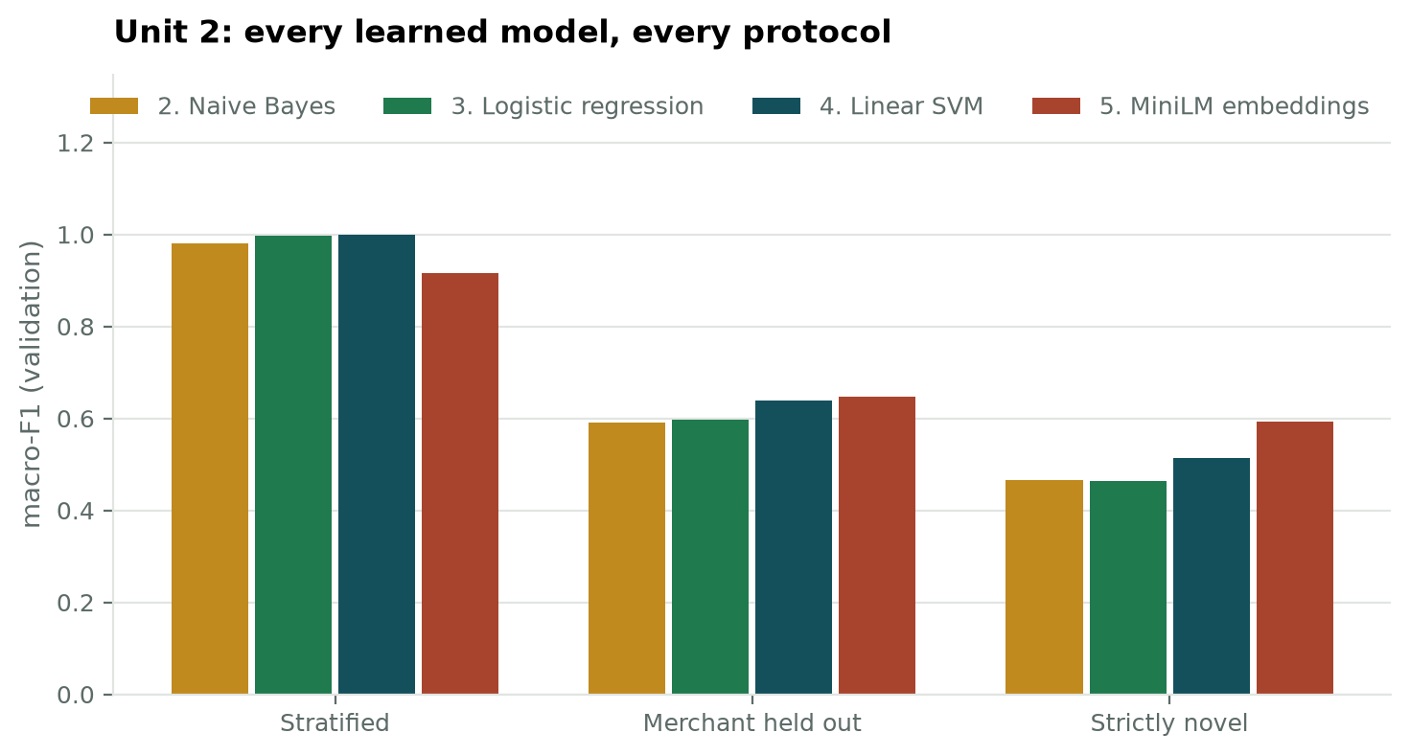
Figure 1. Every learned model across the three protocols.
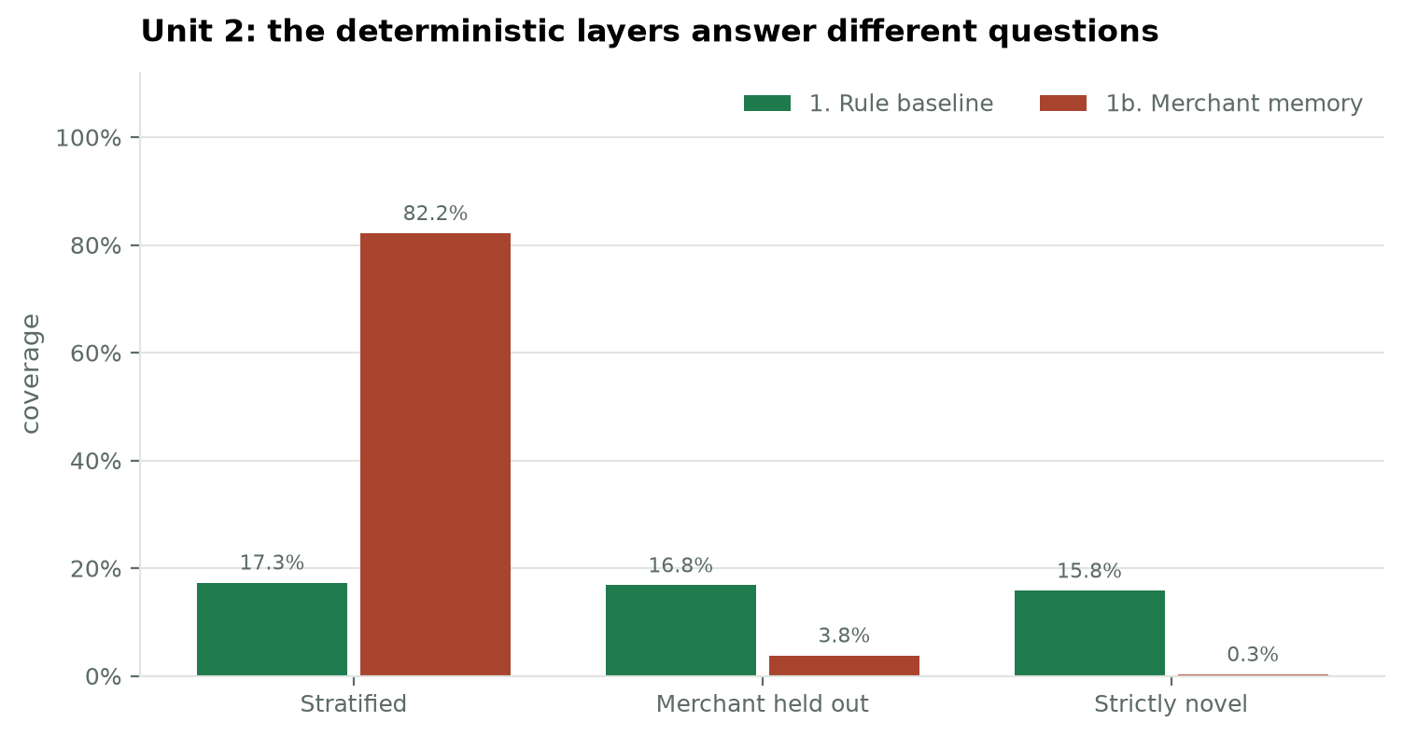
Figure 2. The two deterministic layers answer different questions: the rules hold steady as merchants become unfamiliar, the memory collapses.
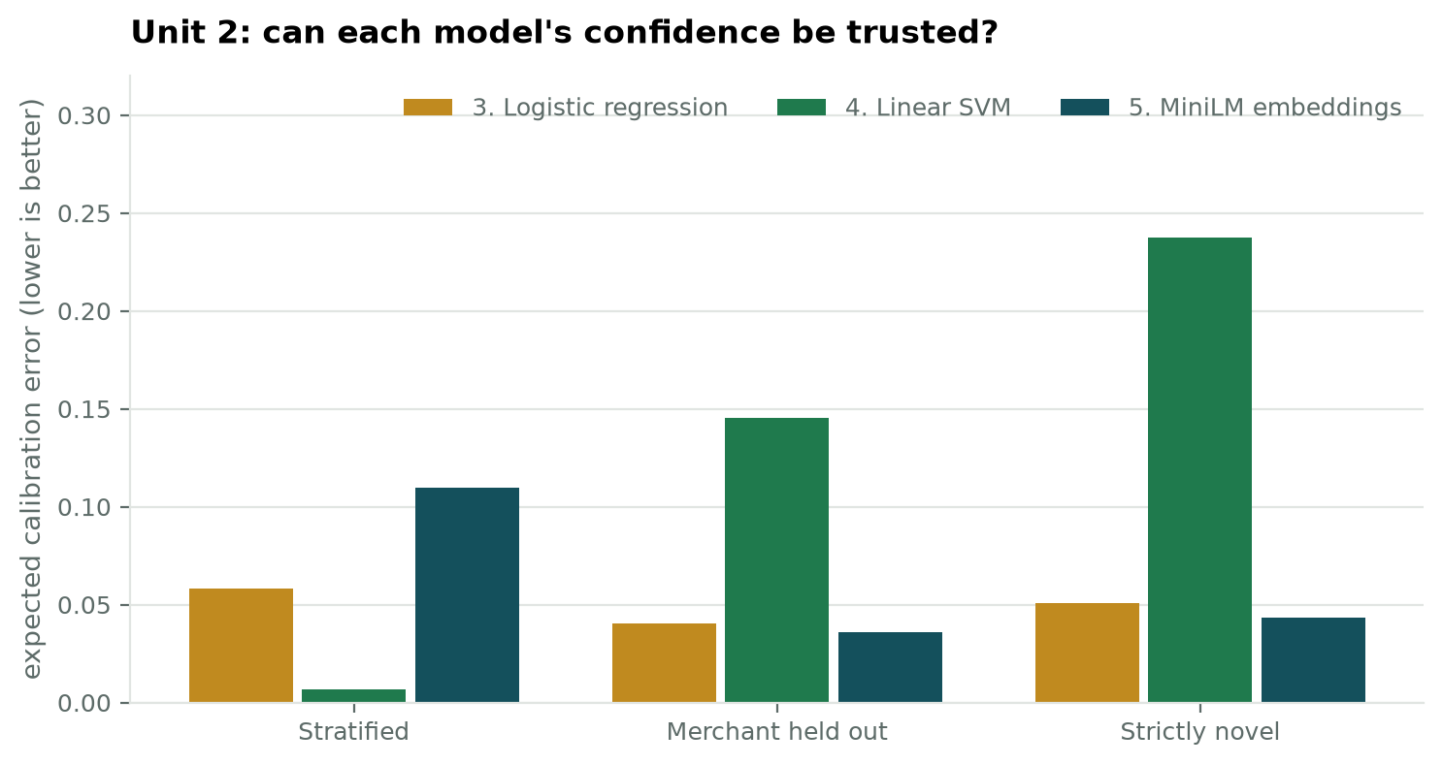
Figure 3. Expected calibration error. The calibrated SVM degrades sharply under distribution shift, because its sigmoid is fitted on folds of the training data that do not resemble unfamiliar merchants.

2.1 The central finding
Performance depends overwhelmingly on whether the merchant has been seen before, not on the choice of classifier. Three different linear models over identical features agree to within a few points on every protocol, and all of them fall by roughly half when merchants are held out. What did move the result was changing the representation: TF-IDF wins where merchants recur, because a brand name is a perfectly discriminative token, and sentence embeddings win where they do not, because an unfamiliar merchant still lands somewhere sensible in a learned semantic space.
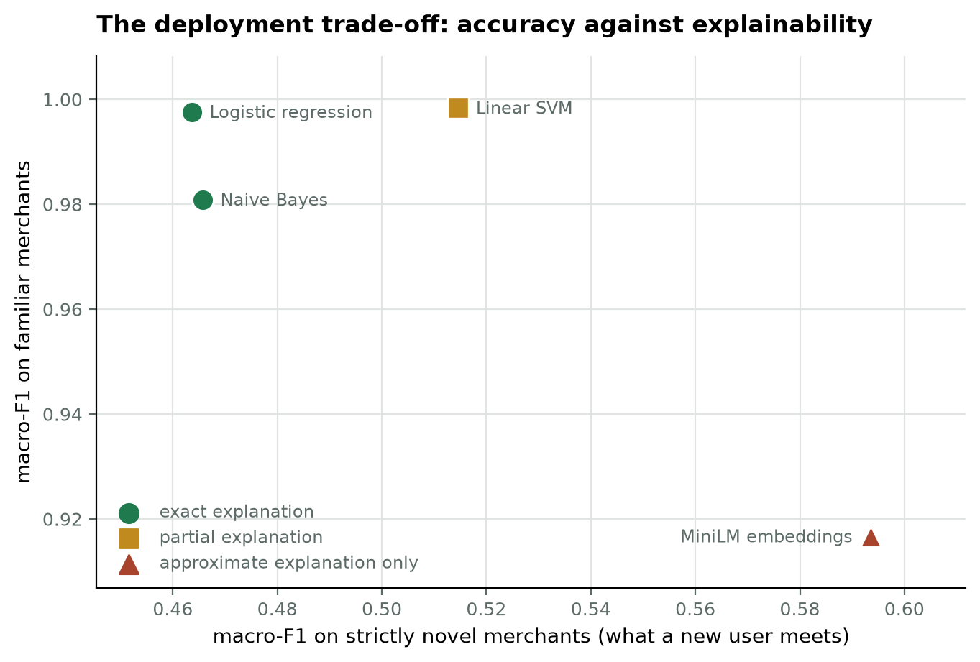
Figure 4. The deployment trade-off. The horizontal axis is what a new user meets; the marker shape is whether the model can explain itself.

3. The cascade
The deployed system is not a single model. Each transaction passes through deterministic rules, then merchant memory, then the learned model, with a confidence gate marking low-confidence model answers for human review.
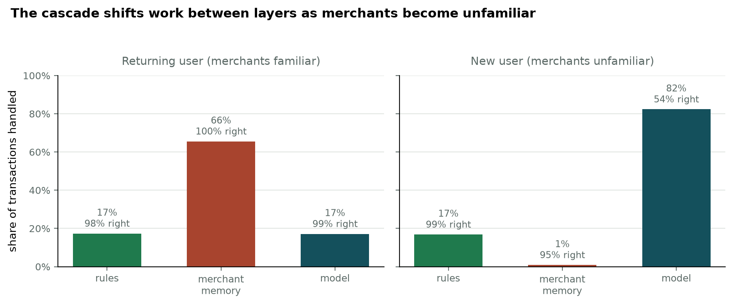
Figure 5. The cascade shifts work between layers on its own. For a returning user the memory answers two thirds of transactions at 100% accuracy; for a new user it answers 1% and the model carries 82%.
Model in the final slot | Change for a returning user | Change for a new user
Logistic regression | -0.0048 | +0.0302
Linear SVM | -0.0054 | +0.0220
MiniLM | +0.0516 | +0.0153
Naive Bayes | +0.0077 | +0.0287

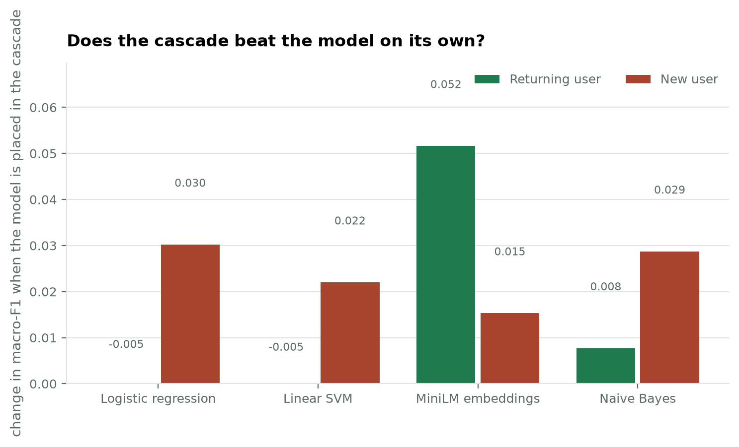
Figure 6. Assembling the cascade improves every model for a new user.
MiniLM gains most for a returning user because the deterministic layers cover precisely its weakness. The two strongest linear models lose a little there, because the merchant memory occasionally overrides a correct model prediction.

3.1 Choosing the confidence threshold
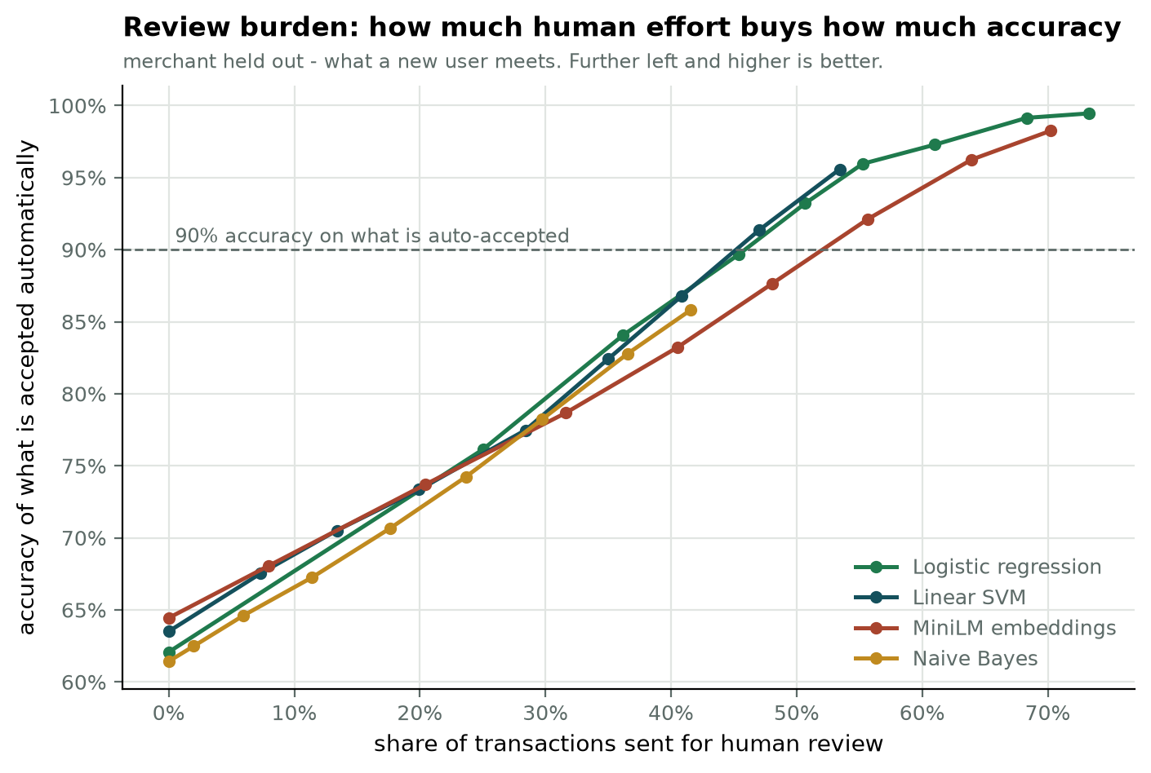
Figure 7. How much human review buys how much accuracy, on the protocol a new user meets.
Below roughly 30% review all candidate models behave alike. At about 45% review the better-calibrated models reach 90% accuracy on what they accept automatically. Only logistic regression continues to discriminate above 95%, reaching 99.5%, which is the calibration advantage made concrete. A threshold of 0.60 was chosen as the operating point.

4. Selection
MiniLM sentence embeddings with a logistic-regression head occupies the final slot.
It is the most accurate model on unseen and strictly novel merchants, which is the condition a new user meets, and the best calibrated of the six. It cannot produce token-level explanations directly, because its 384 dimensions carry no word-level meaning, so explanations are produced post hoc with LIME and SHAP.
The alternative was logistic regression, which supplies exact explanations at no cost and is the only model able to reach 99% accuracy on automatically accepted transactions, but is materially weaker on unfamiliar merchants. The choice is therefore a stated trade-off rather than a win, and the cost is quantified: roughly 0.10 macro-F1 on strictly novel merchants, exchanged for accuracy where it is scarcest.

4.1 Three caveats carried by this choice
- The explanation is approximate. For a linear model the explanation is the arithmetic the model performed; here it is a surrogate's estimate of it.
- LIME is stochastic, being fitted to randomly sampled perturbations, so the same transaction can yield slightly different explanations across runs.
- It costs roughly 96 encoder passes per explanation, against about a millisecond and no extra inference for a linear model.
Because no exact attribution exists for an embedding model, LIME and SHAP are validated on a linear model first, where exact contributions are computable, and only then applied to the deployed model.

5. Final result
The chosen configuration, refitted on train plus validation and evaluated once on the held-out test sets. These rows were never used for fitting, comparison or threshold selection.
Protocol | n | Accuracy | Macro-F1 | Sent to review | Accuracy of what is accepted
in distribution | 4,786 | 0.9636 | 0.9681 | 5.2% | 0.9896
unseen merchant | 4,780 | 0.6544 | 0.6808 | 33.8% | 0.8291
strictly novel | 2,245 | 0.5555 | 0.5636 | 42.8% | 0.7689

Read together these say: for a returning user the system is 96.4% accurate and asks for review on 5.2% of transactions; for a new user accuracy falls to 65.4% and the review burden rises to 33.8%; and for merchants the system has never encountered in any form it is 55.5% accurate. In every case the transactions it accepts automatically are substantially more reliable than its overall accuracy, which is what the confidence gate exists to achieve.

5.1 How these figures differ from the validation figures
The test figures are slightly lower than the validation figures reported earlier. That is expected and is the reason the test sets were reserved: a figure chosen from among many candidates is optimistic, and only a set used once is not.

6. What remains
- A neural-network head over the same embeddings, written and awaiting a run, to test whether depth adds anything.
- Validation of LIME and SHAP against exact contributions on a linear model, before they are relied upon in the interface.
- A user-correction memory, which requires real users and is therefore built in the application.
- Fuzzy merchant matching, which would raise the memory layer's coverage above the lower bound reported here.

