Unit 4.5 - Explaining the Cascade's Decisions
Layer-aware explanations: exact where possible, validated where not.

1. Why explanations differ by layer
Each layer of the cascade decides for a different reason, so each explains itself differently. Treating them uniformly would either waste effort or misrepresent what happened.
Layer | Why it decided | Explanation shown | Nature
Rule | a phrase matched | “The description contains SUSHI, which always indicates Restaurants.” | exact, free
Merchant memory | this shop was seen during training | “You have 2 previous transactions at RALPH SAN, 2 of which were Groceries.” | exact, free
Model | predicted from the text | token weights recovered by SHAP, with a note that the explanation is an approximation | approximate, costed

Only the model layer needs a post-hoc method. The deployed model is an embedding model whose 384 dimensions carry no word-level meaning, so a token-level explanation has to be reconstructed after the fact.

2. Most explanations are exact and free
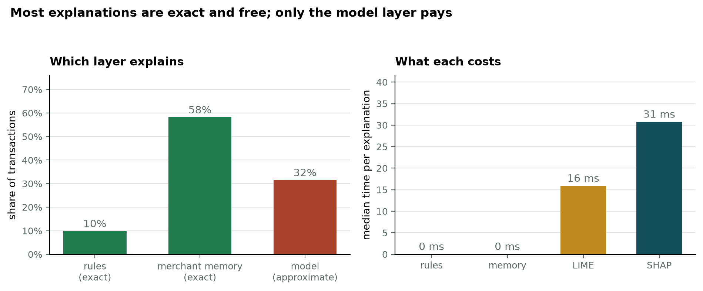
Figure 1. Which layer explains each transaction, and what each explanation costs.
Layer | Share of transactions | Cost per explanation
Rule | 10% | 0 ms, exact
Merchant memory | 58% | 0 ms, exact
Model | 32% | 31 ms median, approximate

68% of transactions receive an exact explanation at no cost. Only the remainder pays for a post-hoc approximation. The cascade therefore improves the quality and the cost of explainability at the same time as it improves accuracy, which is a benefit of the architecture that the accuracy figures alone do not reveal.

3. Validating the post-hoc methods
For the deployed embedding model there is no exact attribution to compare against, so LIME and SHAP cannot be checked there directly. They were therefore first run on a linear model, where the contribution of every token is exactly computable as weight times value, and their agreement with that ground truth was measured. Passing this test is what earns the right to use them where truth is unavailable.
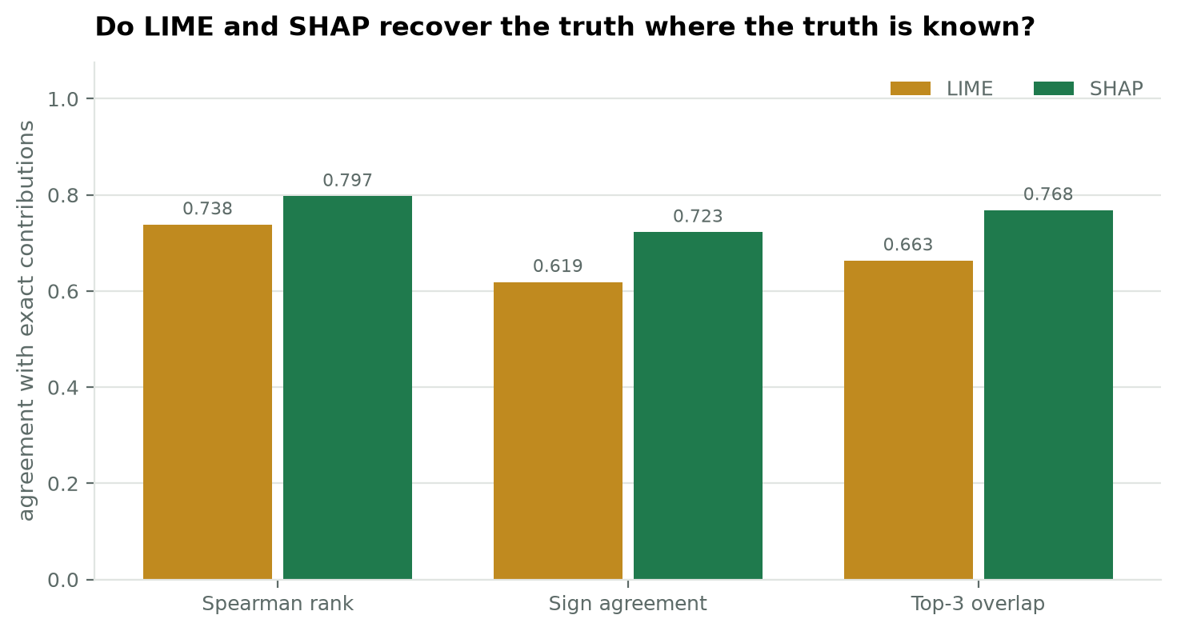
Figure 2. Agreement with exact contributions on a linear model, over 60 transactions.
Measure | LIME | SHAP | What it means
Spearman rank correlation | 0.7383 | 0.7971 | does it rank the tokens in the right order
Sign agreement | 0.6188 | 0.7225 | does it agree on which tokens help and which hinder
Top-3 overlap | 0.6633 | 0.7683 | does it identify the same leading evidence

SHAP agrees with the truth more closely than LIME on every measure. Its additivity residual is 2.24e-16, which confirms the Shapley values are enumerated exactly rather than sampled: descriptions in this corpus are short enough for every coalition to be evaluated. LIME's own surrogate explains only R² 0.7733 of the local variance it is fitted to, which is a weakness SHAP does not share.
SHAP is therefore the method served by the application, with LIME retained for comparison rather than as the recommended explainer.

4. Cost and stability
Method | Median | Maximum | Encoder passes | Top-3 stability across runs
LIME | 16 ms | 108 ms | 66 | 1.0000
SHAP | 31 ms | 125 ms | 66 | 1.0000

At a median of 31 milliseconds, an explanation can be produced when a user selects a transaction without any perceptible delay, so the interface needs no loading state. Explanations are nevertheless computed on demand rather than in advance: precomputing for every transaction would mean tens of thousands of encoder passes for a view most of which is never opened.
Stability is exact. Both methods return the same leading terms on every run, because the random seed is derived from a hash of the description rather than from the clock. Without that, a user refreshing the page could be shown different reasons for the same unchanged decision, which would rightly undermine trust in the feature. This corrects an earlier expectation that LIME would be unstable; seeded, it is not.

5. Honesty in the interface
The explanation shown for a model decision states in plain words that it is reconstructed after the fact and is an approximation of the model's reasoning. The explanations shown for the rule and memory layers make no such claim, because they are exact. A user can therefore tell how much weight to place on what they are being shown.

6. Limitations
- The agreement figures were measured on a linear model, not on the deployed embedding model. They establish that the methods behave correctly where truth is knowable; they do not prove the same fidelity holds on a different model.
- Only word-level tokens are attributed. The linear testbed also uses character n-grams, which contribute to its decisions and are excluded from the comparison because they read as fragments rather than evidence.
- Exact Shapley enumeration depends on descriptions being short. A description with more than twelve unique tokens falls back to a sampled estimate, and the additivity guarantee no longer holds exactly.

7. For the report
Explanations are produced per cascade layer. Rule and merchant-memory decisions explain themselves exactly and at no cost, covering 68% of transactions. Model decisions are explained with Shapley values, enumerated exactly for descriptions of twelve tokens or fewer, at a median of 31 milliseconds. Before being relied upon, both SHAP and LIME were validated against exact contributions on a linear model, where SHAP achieved a Spearman correlation of 0.7971 and 77% top-3 agreement with the truth, outperforming LIME on every measure.

