Unit 3 corrections, and changing the inference engine
Three faults found by reading the generator's output against the survey it claims to follow, and an engine replacement that had to be proved harmless before it was adopted.

1. Why these corrections exist
The demonstration amounts are generated, and generated data is only as good as the checking applied to it. Reading the dashboard against the survey the generator claims to follow exposed three faults that no unit test would have caught, because each produced output that was individually plausible.
The symptom was a household apparently saving half of everything it earned: income $130,229 against spending $65,496.

2. Income was gross, not take-home
The generator mapped income to the BLS line “average income before taxes” ($104,207 in 2024) and deposited it into a current account. No bank statement shows gross pay: what arrives is net of tax, social security and payroll deductions.
The obvious fix — use the matching after-tax line — is not available. BLS discontinued “income after taxes” with the 2024 release, stating it can no longer produce federal tax, state tax or after-tax income estimates for the CE tables, LABSTAT or the public use microdata.
The 2024 before-tax figure is therefore scaled by the last ratio BLS itself published, from 2023: $87,869 after tax against $101,805 before, a factor of 0.8631. Using the agency's own published relationship keeps the adjustment traceable to the source rather than to an assumed tax rate of this project's invention. Take-home becomes $89,942.

3. Recurring categories did not reconcile to their own target
Two quantities decided a recurring category's annual total and nothing made them agree. How many payments were emitted came from merchants × months; how large each was came from dividing the BLS annual figure by an assumed payments-per-year. Where those disagreed, the household was billed the wrong amount for the year.
Insurance names two merchants against a payments-per-year of twelve, so it emitted 24 payments sized for 12 and charged 2.27× the BLS figure — which is why insurance appeared as 9.4% of spending against a survey figure near 3.9%.
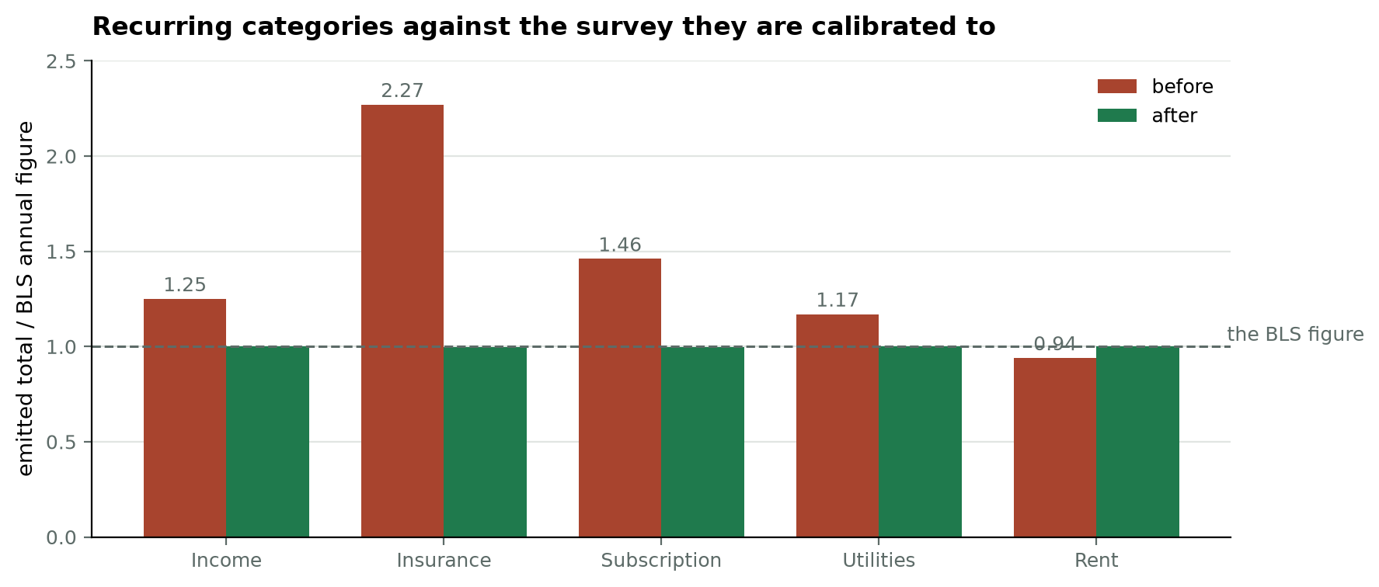
Figure 1. Each recurring category's emitted annual total as a multiple of the BLS figure it is calibrated to, before and after. The generator now prints this table and asserts that drift stays under 2% on every run.

4. A single draw decided a whole year
Each recurring merchant's payment amount was drawn once and repeated for twelve months. Income has one merchant — one employer — so a single random draw set the entire year's salary, and this seed landed on the clamp ceiling at +25%. A clamp bounds such an error without removing it; with one merchant there is no second draw to average against.
All three faults are fixed by one change: every merchant's base is drawn first, then the set is rescaled so the payments the category actually emits sum to its BLS annual figure by construction. Variety between merchants survives; only the overall level is pinned.

5. What was deliberately not corrected
One-off categories are left sampling freely. A household's restaurant and grocery spending genuinely varies from the national average, and forcing each to land on it exactly would be less realistic rather than more. With roughly a hundred independent draws those totals settle within a tenth of target on their own; categories drawn a handful of times are left visibly noisy, because that is what a small number of real purchases looks like.
 | before | after
income | $130,229 | $89,922
spending | $65,496 | $61,704
net | +$64,733 | +$28,217
insurance share | 9.4% | 4.7%

A surplus remains, and it is honest rather than residual error: the seventeen categories the classifier recognises do not cover everything a household spends on — no apparel, pensions, cash contributions or miscellaneous — so modelled spending sits below the BLS average annual expenditure of $78,535. That is a limit of the label set, not of the generator.

6. Changing the inference engine
Deploying the application to an instance that does not require a payment card means fitting inside 512 MB. With PyTorch loaded the application measured 401 MB resident, leaving too little headroom to be safe.
The encoder was moved to an ONNX graph under ONNX Runtime. The weights are the same 86 MB either way; PyTorch was the cost. Inference here is a fixed sequence of matrix multiplications with no training, no autograd and no dynamic graph, so the framework supporting those things was paying rent it did not earn.
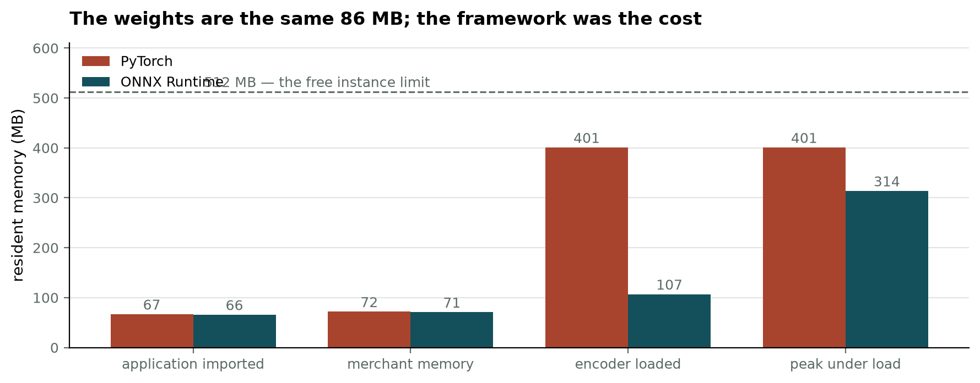
Figure 2. Resident memory at each stage, under both engines. Removing PyTorch also strips roughly a gigabyte of wheels from the deployment image.

7. Why the change had to be verified, not assumed
Swapping inference engines silently changes the system that every reported figure describes. Unless the predictions agree, the accuracy quoted in this report would no longer be the accuracy of the deployed application. `scripts/verify_onnx.py` is the evidence that they do.
comparison | result
embedding cosine similarity | min 0.99999988
embedding absolute difference | max 2.5e-07
class probability difference | max 2.7e-06
predicted category differs | 0 of 1,500
accept-or-review differs | 0 of 1,500
accuracy | identical to six decimal places

Re-importing the full demonstration set through the live cascade changed the category or review flag on 0 of 772 transactions. Floating-point arithmetic reorders differently across engines, so exact equality of embeddings is not expected; disagreement about any prediction would have been disqualifying.
One figure was re-measured rather than carried over. Shapley explanations take a median of 51 ms under ONNX against 31 ms under PyTorch. The application's own interface quotes the ONNX figure, because that is the engine that runs.

8. For the report
- Generated data needs reconciliation against its own source, not only unit tests. All three faults produced individually plausible output.
- A discontinued statistic is a citable methodological fact. Scaling by the agency's last published ratio is defensible; assuming a tax rate would not be.
- An engine substitution is a change to the system under measurement and must be verified at the level of predictions, not loss or embeddings alone.
- Where a measured figure changes, the interface should quote the new one.

