Unit 5: the application
A deployed multi-account dashboard in which every category can be questioned, corrected, and traced to the layer that decided it.

1. What the application has to prove
Units 2 and 4.5 established that a cascade beats the model alone and that most explanations can be exact. Neither claim means anything until a user can act on it. The application exists to make three things visible: that transactions from incompatible bank exports aggregate into one ledger, that every category carries a reason the user can read, and that a category the user disagrees with can be corrected and stays corrected.

2. Architecture
FastAPI with server-rendered Jinja templates and no build step. The absence of a frontend framework is deliberate: the whole application is one process, which is what allows it to run on a free instance, and every page renders without scripting.
layer | module | responsibility
adapters | backend/adapters.py | three bank export formats into one shape
ingestion | backend/ingest.py | feeds through the cascade into storage
classification | backend/classifier.py | the four-layer cascade and confidence gate
explanation | backend/explainability.py | per-layer, exact where possible
corrections | backend/review.py | the user-correction memory
analytics | backend/analytics.py | money, recurrence, anomalies, benchmarks
charts | backend/charts.py | inline SVG, server-side

Charts are drawn as SVG on the server rather than by a charting library. This keeps deployment to a single process with no asset pipeline, renders with scripting unavailable, and — the reason that matters in practice — lets every mark reference the same CSS custom properties as the page, so charts follow the light and dark themes and stay sharp at any zoom when captured for a document.

3. The cascade in production
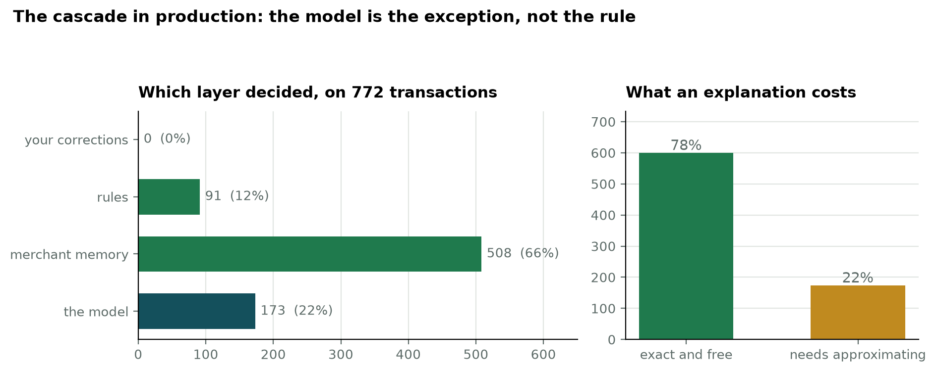
Figure 1. Which layer decided each of the demonstration account's 772 transactions, and what that implies for the cost of explaining them. 78% were decided by a layer that knows its own reason exactly.
The ordering is not an optimisation detail. Three of the four layers are exact, free, and able to state their own reason, so the cascade reduces what explanation costs as well as improving accuracy on unfamiliar merchants. Reaching the model at all is the exception.

4. The confidence gate and the review queue
The model declines below 60% confidence rather than filing a transaction somewhere plausible and leaving the user to discover it later. On the demonstration account 46 of 772 transactions (6.0%) are held for review, against the 5.2% measured offline under the matching protocol. The running application reproduces the measurement rather than quoting it.
The queue is sorted by ascending confidence, so the model's least certain decisions are seen first. A representative case: “[debit] P.F. CHANG'S #896 COLUMBUS” was filed as Groceries at 24% confidence, and the Shapley explanation shows why — the terms carrying the most weight were “896” (a store number), “DEBIT” and “COLUMBUS”, while the brand token “CHANG” carried a negative weight. The model had never seen the merchant and had nothing to go on but noise. That single view justifies the gate, the queue and the correction memory at once.

5. Corrections are about merchants, not transactions
Correcting one row and leaving forty identical rows untouched would make the feature feel broken. A correction is therefore keyed by merchant fingerprint, applied to every matching transaction the user has not personally ruled on, and consulted before any rule or model the next time that merchant appears. One correction updated 23 sibling rows in testing.
Confirming is deliberately not symmetric with correcting. Agreeing with one prediction is a statement about that prediction, not about the merchant, and does not license overriding the model elsewhere — so only that row is marked. A row the user has personally ruled on is never overwritten by a later merchant-level correction.

6. Honesty in the interface
Three places where the application tells the user something that is against its own interest, because the alternative would be misleading:
- The “How it works” page reports all three evaluation protocols — macro F1 0.968 when the merchant is familiar, 0.681 when it is held out, 0.564 at a cold start. Reporting only the first would be true and misleading at once.
- Explanations from the model layer are badged Approximate and say so in words; the other three layers are badged Exact. A single uniform presentation would imply the model's reconstruction is as sound as a matched rule phrase.
- The Insights page states that its comparison against the BLS household average is circular for the demonstration data, because those amounts were generated from the same survey lines. Close agreement there is arithmetic, not evidence.
The spending signals are descriptive and carry no score. Any financial-health rating would need a threshold, and every threshold available here would be invented; the application says so on the page and gives no financial advice.

7. Multi-account aggregation
Three export formats are reconciled: a single signed amount column with US dates, separate debit and credit columns with ISO dates, and twelve monthly files in which purchases are positive and payments negative. Every adapter discards the bank's own category column deliberately. Three institutions disagree about what a category is and none agrees with the others, so a category that holds across all of a person's accounts has to be derived from the description — which is the reason the classifier exists.

8. Deployment
The application is deployed and reachable at https://trace-fyp.onrender.com, as a Docker image on a free 512 MB instance with a managed Postgres database. Peak resident memory is 314 MB, which required replacing the inference engine; that change and its verification are documented in the Unit 3 corrections paper.
- Session cookies are signed, HTTP-only, and marked secure when deployed. The application refuses to start in a deployment environment without its own signing key, because the development fallback is published in the repository and a quiet fallback would make that failure invisible.
- Every user-visible row carries a user identifier and every query is scoped by it in one module, so a missing filter is a visible omission in one place rather than a silent leak across many.
- The encoder is baked into the image at build time and the application is offline at runtime, so a missing model fails the build rather than the first user request.

9. Limitations
Measured on the 772-transaction demonstration set, both concerning the merchant fingerprint:
- Six transactions (0.8%) produce an empty fingerprint, because every token is bank noise, a processor prefix or a reference code — for example “[debit] BP*86NSEW6Y3PW”. Merchant memory cannot learn these and a correction cannot be stored against them. The correction path guards the empty key, so this degrades rather than breaks.
- Seventy-four brands split across more than one fingerprint, because the key is the first two meaningful tokens and the second is often a city: SAFEWAY, SAFEWAY BOSTON and SAFEWAY COLUMBUS are three separate merchants to the system. Memory and corrections therefore fragment across branches of one chain. Exact matching was chosen so that the baseline answers if and only if it has seen the merchant before; a fuzzy or prefix match would raise coverage at the cost of that property.
- Statement upload is not implemented. The application reads exported files through its adapters, but the onboarding path offers only the demonstration set. Reading balances directly from a bank requires that bank's authorisation under an open-banking scheme, which is an institutional agreement rather than a technical obstacle.

10. For the report
- The cascade's value in production is twofold: better accuracy on unfamiliar merchants, and a lower cost of explanation, because 78% of decisions come from a layer that knows its own reason exactly.
- A deployed review queue turns a confidence threshold from a reported statistic into a visible workflow.
- The live application independently reproduces the offline review rate, which is a stronger claim than quoting it.
- Interface honesty is a design decision with consequences, not a disclaimer: badging approximate explanations and declaring the benchmark circular both cost the system apparent authority and are both correct.

