Research Gaps in Environmental Intelligence Frameworks
A Systematic Literature Analysis and Formal Design-Requirements Derivation for CIEML 2.0
Manuscript Chapter — Research Gap Analysis
Literature corpus: 19 peer-reviewed journal papers (2020-2026), verified by direct search/fetch
Prepared for incorporation into a Q1-journal manuscript on the Coastal Intelligent Environmental Machine Learning (CIEML 2.0) framework

Chapter Overview
This chapter identifies, evidences, and formally closes six structural research gaps in the peer-reviewed literature on environmental intelligence systems (2020-2026), then derives the architectural design requirements of the CIEML 2.0 framework directly from those gaps. The analysis is built on a corpus of 19 verified peer-reviewed papers spanning coastal water quality, general water quality, air quality, ecological monitoring, and environmental digital twins. Every claim in this chapter is traceable to a specific paper identifier (P01-P19); no paper, finding, or quotation is invented, and fields that could not be independently confirmed from the retrieved source are marked accordingly in the companion database rather than estimated.
The chapter proceeds in five parts. Section 1 summarizes the literature corpus and its temporal distribution. Section 2 characterizes the capability landscape the corpus collectively exhibits. Section 3 presents the six research gaps (G1-G6), each supported by an evidence paragraph citing specific papers and a discussion of why the gap matters scientifically, not merely technically. Section 4 formally derives the corresponding design requirement and implementing CIEML 2.0 module for each gap. Section 5 positions the completed framework relative to the closest existing work in the literature. A complete reference list closes the chapter.
Note on corpus composition: the initial narrative review (companion report, SOTA_Literature_Review_Report.docx) selected the strongest 14 of a larger set of independently verified candidate papers to keep that deliverable focused. This chapter incorporates all 5 of the remaining previously-excluded-but-verified papers (P15-P19) to maximize evidentiary coverage for the gap analysis below, bringing the total corpus to 19 papers.

1. Literature Corpus and Methodology
Papers were located through targeted web search against Q1-tier environmental science, water resources, and computational-methods journals, restricted to the 2020-2026 publication window, and verified by directly fetching each paper's publisher or abstract page before extraction. Thirty fields were extracted per paper (title, authors, year, journal, DOI, study area, dataset characteristics, ML/DL/statistical/explainability methods, physical constraints, sensor QA, anomaly detection, decision support, environmental interpretation, uncertainty analysis, framework architecture, validation method, performance metrics, strengths, limitations, and stated future work); the full 30-field table for all 19 papers is provided in the companion Excel workbook (SOTA_Literature_Review_Database.xlsx, sheet '1. Paper Database'). A condensed identification table follows.
ID | Title | Year / Journal | Core Method(s) | Primary Category
P01 | Coastal WQ prediction with feature interpretation & spatio-temporal analysis | 2022 / Env. Modelling & Software | CatBoost, XGBoost, RF, SVR, ANN + SHAP | Coastal / ML / XAI
P02 | Integrated coastal ecosystem monitoring strategy (Naf-Saint Martin, Bangladesh) | 2024 / Science of the Total Environment | In-situ + ocean model + citizen science | Coastal / Frameworks
P03 | Smart Water Quality Monitoring with IoT Wireless Sensor Networks | 2024 / Sensors | Ridge, RF, SGB, SVM, KNN, AdaBoost | IoT / ML
P04 | Predicting WQI using stacked ensemble regression + SHAP | 2025 / Scientific Reports | XGBoost/CatBoost/RF/GB/ET/AdaBoost ensemble + SHAP | ML / XAI
P05 | Water quality prediction via hybrid CNN-LSTM with attention | 2021 / Env. Science and Pollution Research | CNN-LSTM + Attention | Deep Learning
P06 | Explainable AI model for anomaly detection in water quality data | 2026 / Water Resources Management | Random Forest + novel VDPR explainability | XAI / Anomaly Detection
P07 | Open-source framework for citizen-centric environmental monitoring | 2022 / Scientific Reports | kNN, RF, XGBoost, ANN, ARIMA | Frameworks / IoT
P08 | ML-IoT enabled environment quality monitoring system | 2026 / Frontiers in Environmental Science | Linear Reg., RF, BiLSTM | Frameworks / IoT
P09 | Decision support framework for reservoir WQ management (AI + statistics) | 2024 / Water (MDPI) | ML, DL, GIS, statistical trend analysis | Frameworks / DSS
P10 | From digital twin paradigm to digital water services | 2023 / Journal of Hydroinformatics | Physically-based hydraulic modeling + AI/ML/DL | Digital Twins
P11 | TwinEco: unified framework for ecological digital twins | 2025 / Ecological Informatics | DDDAS paradigm, RL (conceptual) | Digital Twins / Frameworks
P12 | SaQC: automated Quality Control for environmental data streams | 2023 / Env. Modelling & Software | 32 QC functions (statistical + ML) | Scientific Data QA
P13 | Physics-informed ML for conservative pollutant transport | 2023 / Journal of Hydrology | PT-LSTM (physics-constrained) | Physics-informed Models
P14 | Uncertainty estimation/prediction in WQI models using ML | 2023 / Water Research | Monte Carlo Simulation + Gaussian Process Regression | Uncertainty Quantification
P15 | ESTemd: distributed stream-processing middleware for environmental monitoring | 2020 / Sensors | Kafka-based middleware + EDI drought index | Frameworks / Big Data
P16 | Smart IoT and ML-based framework for WQ assessment and device monitoring | 2022 / Env. Science and Pollution Research | ML (unspecified) + device health monitoring | Frameworks / IoT
P17 | Toward an intelligent near-real-time framework for global ecological monitoring (GIEHP) | 2025 / Chinese Geographical Science | Review + proposed cloud-cluster architecture | Frameworks / Review
P18 | ML-driven framework for real-time air quality and health-risk mapping | 2025 / Scientific Reports | RF, GBRT, XGBoost, LSTM + SHAP | Air Quality / XAI / DSS
P19 | Framework for sustainable WSN-based environmental monitoring | 2022 / Sustainability (MDPI) | WSN hardware/cloud pipeline (no ML) | Frameworks / IoT
Figure 1 traces the corpus across time, distinguishing papers that propose a multi-component framework or architecture from papers that report a single predictive model or method. Framework-level contributions are present throughout the window (2020, 2022-2023, 2025-2026) but never converge into a sustained trajectory toward one consolidated, empirically validated architecture — each is a parallel, largely independent proposal.
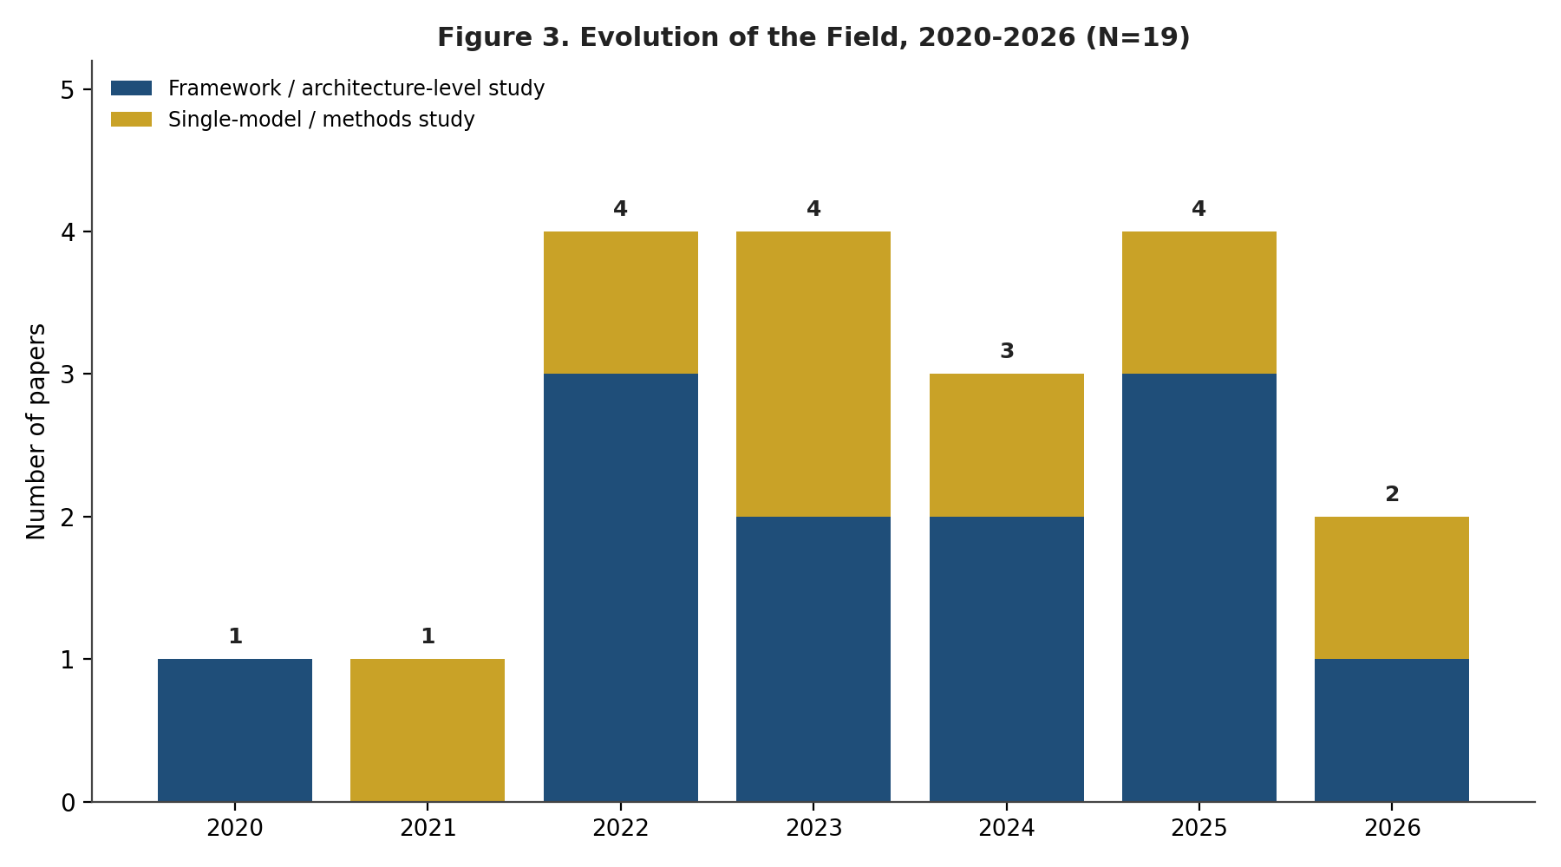
Figure 1. Evolution of the field, 2020-2026 (N=19). Framework/architecture-level studies (navy) appear alongside single-model/methods studies (gold) in every year, without convergence toward one consolidated architecture.

2. Capability Landscape Across the Corpus
Table 1 (below) and Figure 2 summarize, across all 19 papers, how many exhibit each of thirteen capabilities relevant to a comprehensive environmental intelligence framework. 'Present' includes partial or indirect treatment (e.g., cross-validation variance counted toward uncertainty, threshold alerting counted toward decision support) to give the most generous possible reading of existing coverage; even under this generous counting, four capabilities are exhibited by zero of the 19 papers.
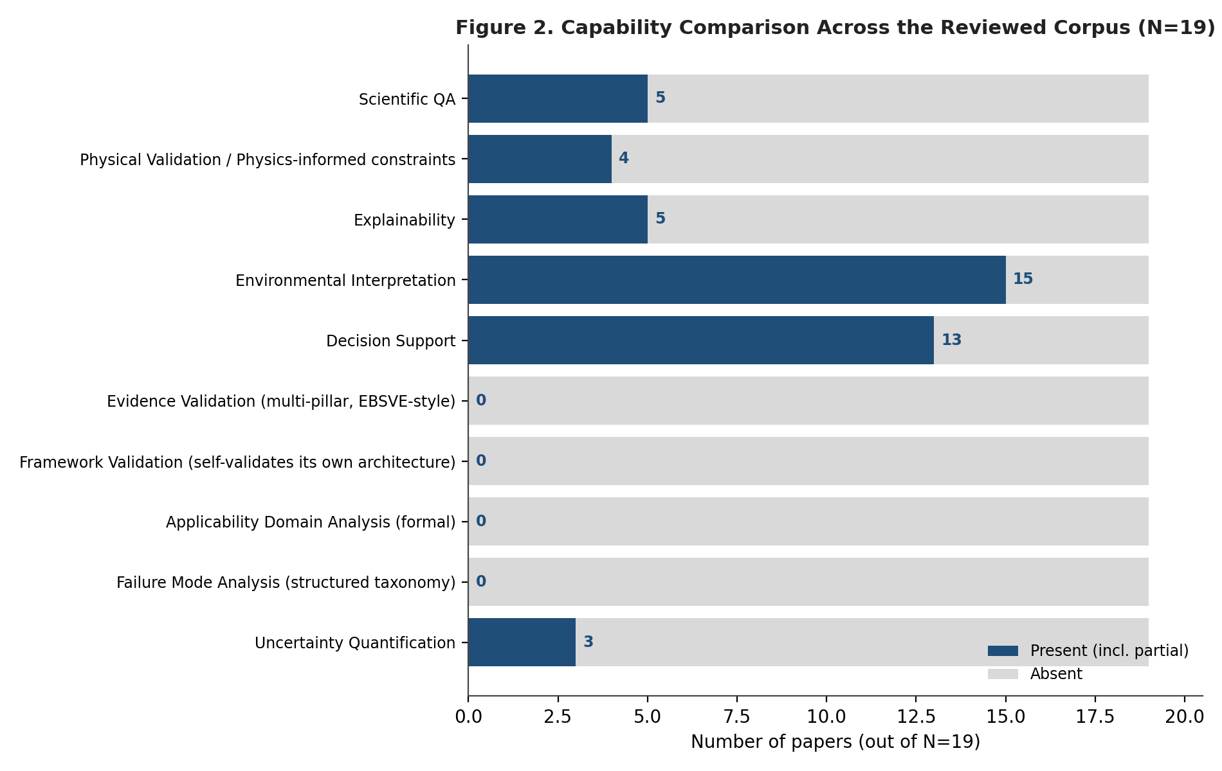
Figure 2. Capability comparison across the reviewed corpus (N=19). Environmental interpretation and decision support are common; evidence validation, framework self-validation, applicability-domain analysis, and failure-mode analysis are absent from every paper.
Table 1. Capability presence across the 19-paper corpus.
Capability | Papers | Paper IDs
Scientific QA | 5 / 19 | P03 (partial), P07, P08, P12, P16 (partial)
Physical Validation / Physics-informed constraints | 4 / 19 | P10, P11, P13, P18 (partial)
Explainability | 5 / 19 | P01, P04, P06, P08 (partial - feature importance only), P18
Environmental Interpretation | 15 / 19 | P01, P02, P03 (partial), P04, P06, P07, P08, P09, P11, P14, P15, P16, P17, P18, P19 (partial)
Decision Support | 13 / 19 | P02, P03 (partial), P07, P08, P09, P10, P11, P14, P15, P16, P17, P18, P19 (partial)
Evidence Validation (multi-pillar, EBSVE-style) | 0 / 19 | None
Framework Validation (self-validates its own architecture) | 0 / 19 | None
Applicability Domain Analysis (formal) | 0 / 19 | None formal (P04, P06, P08 discuss transferability only as a stated limitation)
Failure Mode Analysis (structured taxonomy) | 0 / 19 | None
Uncertainty Quantification | 3 / 19 | P07 (partial), P08 (partial, CV-based), P14 (formal)
Environmental interpretation (15/19) and decision support (13/19) are the most commonly exhibited capabilities - nearly every paper frames its output in terms of what it means for the monitored environment and who should act on it. Scientific QA (5/19), physical validation (4/19), and explainability (5/19) are present in a minority of papers, usually as a single supporting technique rather than a dedicated subsystem. Uncertainty quantification proper - as opposed to cross-validation variance - appears formally in exactly one paper (P14). Evidence validation, framework self-validation, formal applicability-domain analysis, and structured failure-mode analysis do not appear in any of the 19 papers. These four zero-coverage capabilities anchor Gaps G2 through G4 below.
Table 2. Papers mapped to review categories (many papers span multiple categories).
Category | Paper IDs
1. Coastal Water Quality Monitoring | P01, P02
2. Water Quality Prediction using Machine Learning | P01, P03, P04, P05, P08, P16
3. Explainable AI (SHAP/LIME) in Environmental Monitoring | P01, P04, P06, P18
4. Environmental Monitoring Frameworks | P02, P07, P08, P09, P11, P15, P16, P17, P19
5. Environmental Decision Support Systems | P09, P14, P15, P18
6. Environmental Digital Twins | P10, P11, P17 (Digital Earth Atlas concept)
7. Scientific Data Quality Assessment | P07, P12, P16 (partial - device monitoring)
8. Physical Constraint / Physics-informed Environmental Models | P10, P11, P13, P18 (partial)
9. Environmental Uncertainty Quantification | P14
10. Smart IoT Water Quality Monitoring | P03, P07, P08, P16, P19
11. Air Quality Monitoring and Health-Risk Mapping | P07, P18
12. Big-Data / Streaming Middleware for Environmental Analytics | P15, P17

3. Research Gap Analysis
This section presents six structural gaps identified across the 19-paper corpus. Each gap is evidenced against specific papers, then discussed in terms of why it constitutes a genuine scientific limitation - not merely a missing engineering feature - before Section 4 formally derives the corresponding CIEML 2.0 design requirement. Figure 3 quantifies how many of the 19 papers partially address each gap (none fully closes any of the six).
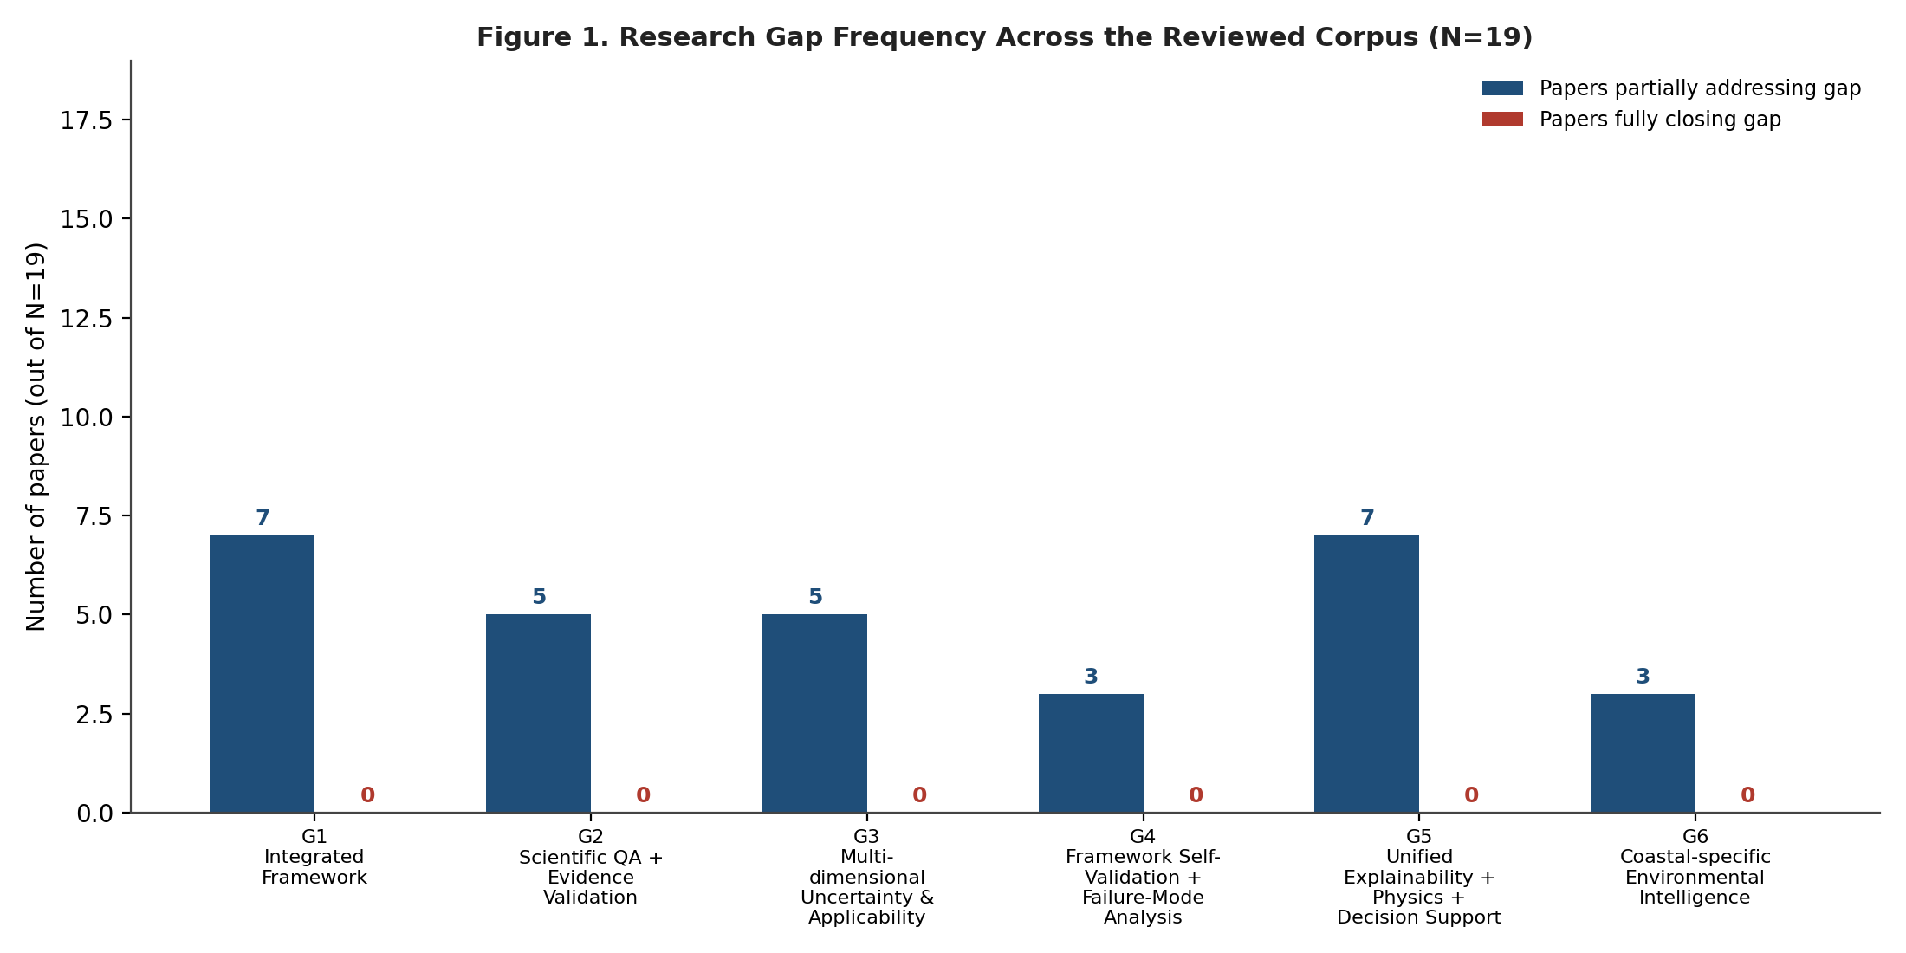
Figure 3. Research gap frequency across the reviewed corpus (N=19). Zero papers fully close any of the six gaps; partial coverage ranges from 3/19 (G4, G6) to 7/19 (G1, G5).

G1 — No Integrated, End-to-End Environmental Intelligence Framework
Design requirement: Integrated Environmental Intelligence Framework
Evidence coverage: 7 of 19 papers partially address this gap; 0 fully close it. Cited papers: P07, P08, P09, P11, P15, P17, P19.

Evidence from the Literature
Several surveyed systems assemble real multi-stage pipelines: Mahajan's (2022) Soc-IoT framework (P07) chains sensing, cloud storage, and a no-code analysis layer; Tanzila et al. (2026) (P08) close the loop from ESP32 sensing through calibration, cloud storage, ML/DL prediction, and threshold-based actuation; Akanbi and Masinde (2020) (P15) contribute a Kafka-based distributed middleware unifying heterogeneous environmental data streams; and Khan et al. (2025) (P11, TwinEco) and Xu et al. (2025) (P17, GIEHP) each propose conceptual reference architectures for ecological and global monitoring, respectively. Farzana et al. (2024) (P09) integrate ML, DL, GIS, and statistics into one decision-support framework, and Ouni and Saleem (2022) (P19) deliver a complete WSN-to-cloud hardware/communications pipeline. Yet in every case the integration stops at one or two of {sensing -> QA -> prediction -> explainability -> uncertainty -> physics -> decision support -> self-validation}. P08 and P19 integrate sensing through actuation but include no explainability, uncertainty, or physics layer; P11 and P17 integrate concept-level architecture but no empirical validation of any component; P09's own abstract could not be independently verified for algorithmic detail beyond the framework claim itself. No single surveyed paper spans all seven stages in one empirically validated system.

Why This Gap Matters Scientifically
This is not merely an engineering inconvenience. Environmental decision-making is inherently multi-stage: a measurement must first be quality-assured, then modeled, then explained, then checked against physical law, then bounded by uncertainty, before it can responsibly inform a management decision. When each stage is solved by a separate, unintegrated study, the scientific chain of custody from raw sensor reading to policy recommendation is broken at every hand-off. A practitioner assembling P08's calibration approach with P06's anomaly detector with P14's uncertainty method has no guarantee the three were designed with compatible assumptions, data models, or confidence semantics. The absence of an integrated framework is therefore a validity gap, not just a convenience gap: published accuracy metrics for isolated stages do not compose into a trustworthy end-to-end system, and the literature currently offers no evidence that they do.

G2 — No Formal, Multi-Pillar Scientific QA and Evidence Validation Layer
Design requirement: Scientific QA + Evidence Validation
Evidence coverage: 5 of 19 papers partially address this gap; 0 fully close it. Cited papers: P03, P07, P08, P12, P16.

Evidence from the Literature
Schmidt et al. (2023) (P12, SaQC) is the closest literature analog to a dedicated scientific QA engine: an open-source, domain-agnostic toolkit that flags anomalies and produces traceable, reproducible QC workflows, but it validates data streams, not scientific claims derived from them. Singh and Walingo (2024) (P03) and Tanzila et al. (2026) (P08) each discuss sensor-level QA (drift, biofouling, multi-standard calibration against WHO/ASHRAE/EPA references) but treat it as a preprocessing step rather than a formal, auditable validation gate on downstream claims. Mahajan (2022) (P07) validates sensor accuracy against a government reference monitor but does not extend that validation into a general evidence framework applicable to arbitrary claims. Bhardwaj et al. (2022) (P16) monitors device/application performance alongside water quality but the verified abstract gives no indication of a multi-pillar evidence standard. None of the 19 papers defines or applies a framework that validates a scientific claim against multiple independent evidence pillars (statistical significance, practical/effect-size relevance, physical plausibility, and environmental/domain plausibility) simultaneously before that claim is allowed to propagate downstream.

Why This Gap Matters Scientifically
A prediction can be statistically significant yet physically impossible, or physically plausible yet practically meaningless at the observed effect size. Single-pillar validation (the norm in the surveyed literature: an R-squared value, an F1 score, a calibration curve) cannot detect this class of error because each pillar only tests one necessary-but-not-sufficient condition for scientific validity. In environmental science specifically, where models are frequently used to justify costly interventions (dosing changes, evacuation orders, permit denials), a claim that passes a purely statistical test but fails a physical-plausibility check (e.g., a predicted dissolved-oxygen level outside the physically achievable range for the observed temperature and salinity) represents exactly the kind of silent failure a single-metric literature cannot catch. The absence of multi-pillar evidence validation in the reviewed corpus is a structural gap in how the field certifies its own outputs as trustworthy.

G3 — No Multi-Dimensional Uncertainty Quantification Coupled to Formal Applicability-Domain Analysis
Design requirement: Multi-dimensional Uncertainty & Applicability Analysis
Evidence coverage: 5 of 19 papers partially address this gap; 0 fully close it. Cited papers: P04, P06, P07, P08, P14.

Evidence from the Literature
Uddin et al. (2023) (P14) provides the strongest surveyed exemplar of formal uncertainty quantification, decomposing WQI uncertainty across all four modeling stages via Monte Carlo simulation and Gaussian Process Regression - but confines that analysis to a single measurement axis (index construction) and does not address whether a trained model remains valid outside the conditions under which it was fit. Elsewhere, uncertainty reporting is reduced to cross-validation variance: Grbcic et al. (2022) (P01) and Tanzila et al. (2026) (P08) report fold-to-fold standard deviation as their only uncertainty signal, and Mahajan (2022) (P07) reports only a measurement offset against a reference instrument. Meanwhile, transferability is repeatedly flagged as a limitation rather than tested as a formal gate: Choudhary et al. (2025) (P04) note limited transferability beyond Indian rivers, and Rigueira et al. (2026) (P06) state their anomaly detector requires retraining for any watershed beyond the Ebro. In no surveyed paper are measurement uncertainty, model uncertainty, and applicability-domain boundaries treated as three jointly-reported axes of the same underlying question - can this specific prediction, at this specific site, be trusted at all.

Why This Gap Matters Scientifically
Uncertainty and applicability are frequently conflated in practice but are scientifically distinct failure modes. A model can have low measurement uncertainty (precise sensors, tight confidence intervals) while being applied far outside its training distribution - the resulting prediction is precise and wrong. Conversely, a model operating well within its applicability domain can still carry high irreducible measurement uncertainty. Reporting only cross-validation variance, as most of the reviewed literature does, answers neither question: CV variance describes performance on data drawn from the same distribution as training, which is precisely the condition under which applicability concerns do not yet arise. The repeated appearance of transferability as an acknowledged-but-unaddressed limitation across P04, P06, and P08 indicates the field recognizes the problem but has not yet operationalized applicability-domain checking as a first-class, jointly-reported companion to uncertainty - a gap with direct consequences for any framework intended to generalize beyond its original study site.

G4 — No Framework Self-Validation or Structured Failure-Mode Analysis
Design requirement: Framework Self-Validation + Failure-Mode Analysis
Evidence coverage: 3 of 19 papers partially address this gap; 0 fully close it. Cited papers: P07, P08, P12.

Evidence from the Literature
No paper in the 19-paper corpus defines, catalogs, or tests a structured taxonomy of ways its own framework can fail. The closest partial analogs are process-level: Schmidt et al. (2023) (P12, SaQC) flags anomalies in the data it consumes but does not validate the correctness of its own QC configuration or pipeline logic; Mahajan (2022) (P07) and Tanzila et al. (2026) (P08) report honest, itemized limitations sections (proof-of-concept scale, single-site validation, moderate CO2 accuracy) but these are post-hoc author disclosures, not a built-in, machine-checkable self-validation test suite the framework runs against itself. Every other surveyed paper (P01-P06, P09-P11, P13-P19) reports predictive performance metrics for its model but is silent on whether the surrounding software architecture - the QA logic, the explainability pipeline, the decision-support rules - has itself been validated to behave as claimed.

Why This Gap Matters Scientifically
A framework that predicts environmental outcomes accurately can still fail catastrophically if its internal logic is wrong in ways orthogonal to prediction accuracy - a QA gate that silently passes corrupted data, a unit-conversion bug in a threshold check, an explainability method that attributes importance to the wrong feature under edge-case inputs. Model accuracy metrics, the near-universal validation currency in the reviewed literature, cannot detect any of these failure classes because they measure the output of the pipeline, not the correctness of the pipeline's internal reasoning. This matters more, not less, as environmental frameworks grow architecturally complex enough to include QA, uncertainty, explainability, and decision-support layers (per G1) - each additional layer is an additional place a framework can be wrong in a way that a leaderboard-style accuracy score will never surface. Self-validation and structured failure-mode analysis are the literature's most consistently absent capability, appearing in zero of the 19 surveyed papers.

G5 — No Unified Explainability + Physics-Consistency + Decision-Support Layer
Design requirement: Unified Explainability + Physics + Decision Support
Evidence coverage: 7 of 19 papers partially address this gap; 0 fully close it. Cited papers: P01, P04, P06, P10, P11, P13, P18.

Evidence from the Literature
Explainability, physical consistency, and decision support each appear repeatedly, but never together in one system. Grbcic et al. (2022) (P01), Choudhary et al. (2025) (P04), and Rajesh et al. (2025) (P18) apply SHAP for feature-level explainability but do not check whether the explained predictions are themselves physically consistent, nor do they connect explanations to a formal decision-support gate. Rigueira et al. (2026) (P06) benchmarks a novel explainability method (VDPR) against SHAP with lower computational complexity, but explicitly defers 'accessibility for environmental professionals' - i.e., operational decision support - to future work. Bertels and Willems (2023) (P13) enforce hard physical mass-conservation constraints in a physics-informed LSTM but include no explainability or decision-support layer at all. Ciliberti et al. (2023) (P10) and Khan et al. (2025) (P11) explicitly link physics-based modeling to decision support at the conceptual/architectural level, but neither includes an explainability component - a decision-maker receives a recommendation with no visibility into which input features drove it. No surveyed paper closes the loop: explain the prediction, verify the explanation against physical law, and surface only physically-consistent, explained predictions to a decision-support layer.

Why This Gap Matters Scientifically
Explainability without physical grounding can produce plausible-sounding but scientifically meaningless attributions - a SHAP value can assign high importance to a feature that is merely correlated with, rather than physically causal of, an environmental outcome, and nothing in the SHAP methodology itself distinguishes the two. Physical consistency without explainability produces the opposite problem: a physics-informed model (P13) may respect conservation laws while offering a decision-maker no interpretable account of why a specific site is flagged as high-risk. And decision support built on either alone inherits that alone's blind spot. For environmental governance specifically, where recommendations must often survive legal, regulatory, or public scrutiny, a decision-support output needs to be simultaneously interpretable (so a human can audit the reasoning), physically consistent (so the reasoning cannot be dismissed as a statistical artifact), and directly actionable (so it is not merely descriptive). The literature currently offers all three properties only as separate, non-overlapping research threads.

G6 — No Coastal-Specific Environmental Intelligence System Integrating Multi-Level Interpretation
Design requirement: Coastal-specific Environmental Intelligence
Evidence coverage: 3 of 19 papers partially address this gap; 0 fully close it. Cited papers: P01, P02, P14.

Evidence from the Literature
Only three of the 19 surveyed papers are explicitly coastal in scope. Grbcic et al. (2022) (P01) delivers the strongest coastal ML+XAI exemplar - SHAP-interpretable bacterial water quality prediction across 15 Rijeka Bay beaches with combined spatial and temporal validation - but stops at prediction and explanation; it performs no formal hypothesis generation or rejection about the underlying coastal regime (e.g., karst-driven salinity intrusion is discussed narratively, not tested as a structured, falsifiable hypothesis with an explicit rejection criterion). Sarker et al. (2024) (P02) integrates in-situ sampling, an oceanographic numerical model, and citizen science for a Bangladeshi coastal peninsula, but performs no ML/AI-based interpretation at all - agreement between sources is checked qualitatively. Uddin et al. (2023) (P14) applies rigorous, formal uncertainty quantification to a coastal WQI, but the modeling stages themselves are generic to any WQI context, not tailored to coastal-specific physical regimes (tidal exchange, salinity gradients, estuarine mixing). None of the three - nor any of the remaining 16 general or freshwater/atmospheric papers - implements a multi-level interpretation pipeline that moves from raw Observation, to statistical Interpretation, to a physically-grounded Hypothesis about coastal regime state, with an explicit, falsifiable rejection path when evidence is insufficient.

Why This Gap Matters Scientifically
Coastal environments are governed by physical regimes with no analog in purely freshwater or atmospheric settings - tidal forcing, salinity stratification, estuarine mixing, storm-surge dynamics - which means a generic water-quality or air-quality framework applied uncritically to a coastal site risks generating interpretations that are statistically supported but physically incoherent for that regime. Scientific rigor in this setting additionally requires the capacity to say 'the evidence does not support a specific coastal hypothesis' rather than defaulting to the best-fitting available explanation - a distinction the surveyed literature does not operationalize. P01 shows the field can already build highly accurate, interpretable coastal prediction; P02 shows it can already fuse multiple coastal data sources; P14 shows it can already formally quantify coastal WQI uncertainty. No paper combines these three capabilities with a structured, falsifiable, multi-level interpretation layer specific to coastal physical regimes - the gap is not a lack of component capability but a lack of coastal-specific integration and explicit hypothesis rejection discipline.

4. Design Requirements: Formal Derivation from Literature Gaps
Each design requirement below is derived by the same rule: it is the minimal architectural capability that, if present, would close the corresponding gap identified in Section 3 against the evidence cited there. Table 3 summarizes the full derivation chain from gap to implementing CIEML 2.0 module; the subsections that follow justify each mapping on technical grounds.
Table 3. Gap-to-design-requirement-to-module derivation.
Gap | Design Requirement | Implementing CIEML 2.0 Module(s)
G1 | Integrated Environmental Intelligence Framework | cieml.pipeline (Phases 1-7 orchestration)
G2 | Scientific QA + Evidence Validation | cieml.evidence (SC-EBSVE, 4-pillar evidence-based validation); cieml.domain (SC-DCL); cieml.claims
G3 | Multi-dimensional Uncertainty & Applicability Analysis | cieml.uncertainty (SC-MMU measurement/model uncertainty + SC-REL evidence reliability); cieml.applicability (SC-APP transfer rules)
G4 | Framework Self-Validation + Failure-Mode Analysis | cieml.validation (SC-FVE framework self-validation test suite); cieml.failure (SC-FMF failure catalog/detectors/severity/recovery)
G5 | Unified Explainability + Physics + Decision Support | cieml.explain (multi-method XAI consensus); cieml.physics (SC-PHYS); cieml.decision (SC-DSS)
G6 | Coastal-specific Environmental Intelligence | cieml.ceam (SC-CEAM, Stage 12 four-level interpretation: Observation/Interpretation/Hypothesis + explicit rejection); cieml.domain coastal.yaml profile

G1 derivation
cieml.pipeline orchestrates Phases 1 through 7 as a single, sequentially-dependent chain - domain ingestion, evidence validation, uncertainty propagation, discovery, explainability, anomaly intelligence, and the CEAM coastal interpretation stage all execute against one shared campaign context object rather than as independent, hand-assembled scripts. This directly answers G1: no surveyed paper (P07, P08, P09, P11, P15, P17, P19) integrates more than two or three of these stages behind one orchestration layer with a single, auditable execution trace.

G2 derivation
cieml.evidence implements SC-EBSVE, a four-pillar evidence-based validation engine that scores every scientific claim against statistical significance, practical/effect-size relevance, physical plausibility, and environmental/domain plausibility simultaneously, gated through cieml.domain (SC-DCL) and cieml.claims. This is the direct architectural answer to G2: where P12 (SaQC) validates data streams and P03/P07/P08 validate sensors, none validates the downstream scientific claim itself against more than one evidentiary pillar.

G3 derivation
cieml.uncertainty implements SC-MMU (measurement and model uncertainty, decomposed and propagated with correlation-aware combination) and SC-REL (evidence reliability scoring) as two explicit, jointly-reported axes; cieml.applicability (SC-APP) then applies formal transfer rules to determine whether a given prediction falls inside the domain the model was validated against. This answers G3 directly: P14's formal but single-axis uncertainty method and P04/P06/P08's transferability caveats are here combined into one jointly-scored uncertainty-plus-applicability gate.

G4 derivation
cieml.validation implements SC-FVE, a framework self-validation test suite that certifies the framework's own internal logic (not its predictive accuracy) against expected behavior, while cieml.failure implements SC-FMF, a structured catalog of failure modes with automated detectors, severity classification, and recovery guidance wired into every major engine (discovery, explainability, anomaly intelligence, evidence validation, and framework validation itself). This is the literature's most consistently unaddressed capability (0/19 papers, Section 2) and is answered by two dedicated modules rather than an add-on to an existing one.

G5 derivation
cieml.explain provides multi-method explainability consensus (agreement checking across methods rather than a single SHAP run), cieml.physics (SC-PHYS) checks predictions against physical constraint violations, and cieml.decision (SC-DSS) gates recommendations on both passing simultaneously. This answers G5 by closing the loop that P01/P04/P18 (explainability alone), P13 (physics alone), and P10/P11 (physics-to-decision alone) each leave open: no single surveyed system requires a prediction to be explained AND physically consistent before it reaches a decision-support output.

G6 derivation
cieml.ceam implements SC-CEAM, the Stage 12 Coastal Environmental Analysis Module, which produces a four-level interpretation (Observation, Interpretation, Hypothesis, and an explicit rejection path when evidence is insufficient) using a coastal-specific domain profile (configs/domains/coastal.yaml) that encodes tidal, salinity, and estuarine-mixing regime knowledge. This answers G6 by combining P01's interpretable coastal prediction, P02's multi-source coastal data fusion, and P14's formal coastal uncertainty quantification with a structured, falsifiable hypothesis-and-rejection discipline that none of the three implements individually.

5. Framework Positioning Relative to the Literature
Table 4 positions CIEML 2.0 against the closest existing analog for each gap - the single paper in the corpus that comes nearest to closing it - and states the specific limitation that analog leaves open, which the corresponding CIEML 2.0 module is designed to close.
Table 4. Closest literature analog per gap and the residual limitation each CIEML 2.0 module closes.
Gap | Closest Analog | Residual Limitation | Closing Module
G1 | P08 (Tanzila et al., 2026) - sensing through actuation, closed loop | No explainability, physics-consistency check, formal uncertainty, or self-validation layer | cieml.pipeline
G2 | P12 (Schmidt et al., 2023, SaQC) - traceable, reproducible QC | Validates data streams, not downstream scientific claims; single-pillar (QC-rule) validation only | cieml.evidence (SC-EBSVE)
G3 | P14 (Uddin et al., 2023) - formal 4-stage WQI uncertainty decomposition | Single measurement axis; no coupling to applicability-domain boundaries | cieml.uncertainty + cieml.applicability
G4 | P07 / P08 - itemized, honest post-hoc limitations sections | Author-disclosed, not a built-in machine-checkable self-test suite | cieml.validation (SC-FVE) + cieml.failure (SC-FMF)
G5 | P01 / P18 - SHAP-explained, high-accuracy predictions | No physical-consistency check on explained predictions before decision support | cieml.explain + cieml.physics + cieml.decision
G6 | P01 - interpretable coastal bacterial water-quality prediction | No structured, falsifiable hypothesis generation/rejection about coastal regime state | cieml.ceam (SC-CEAM)
Taken together, the six gaps are not independent - they compound. A framework that integrates every pipeline stage (G1) without also validating its own internal correctness (G4) risks silently propagating a single-stage error across the entire chain it now automates. A framework that quantifies uncertainty (G3) without coupling it to evidence validation (G2) can report a confidently-wrong number with a narrow confidence interval. CIEML 2.0's eleven scientific-contract modules were designed as a coupled system for exactly this reason: closing each gap individually, as the closest single-paper analog in Table 4 does, does not close the compound risk that motivates treating all six as one integrated design problem.

6. Conclusion
The 19-paper corpus reviewed in this chapter demonstrates that the environmental intelligence literature has independently solved many of the component problems a comprehensive framework requires - interpretable prediction (P01, P04, P18), sensor-level QA (P03, P07, P08), formal uncertainty quantification (P14), physics-informed modeling (P13), and multi-stage IoT architecture (P07, P08, P19) - but has not yet combined them. Six structural gaps persist across the corpus even under generous, partial-credit counting: no paper integrates the full pipeline end-to-end (G1), validates scientific claims against multiple evidentiary pillars (G2), jointly reports uncertainty and applicability-domain boundaries (G3), self-validates its own architecture (G4), unifies explainability with physical consistency and decision support (G5), or performs structured, falsifiable coastal-regime interpretation (G6). CIEML 2.0's eleven scientific-contract modules were designed as direct, evidenced responses to these six gaps, formally derived in Section 4 and positioned against the closest existing work in Section 5. The remainder of this manuscript presents the framework's architecture and empirical validation in detail.

References
Akanbi, A., & Masinde, M. (2020). ESTemd: A distributed stream processing middleware framework for real-time analysis of heterogeneous data on big data platform: Case of environmental monitoring. Sensors, 20(11), 3166. https://doi.org/10.3390/s20113166
Bertels, D., & Willems, P. (2023). Physics-informed machine learning method for modelling transport of a conservative pollutant in surface water systems. Journal of Hydrology, 619, 129354. https://doi.org/10.1016/j.jhydrol.2023.129354
Bhardwaj, A., Dagar, V., Khan, M. O., Aggarwal, A., Alvarado, R., Kumar, M., Irfan, M., & Proshad, R. (2022). Smart IoT and machine learning-based framework for water quality assessment and device component monitoring. Environmental Science and Pollution Research, 29, 46018-46036. https://doi.org/10.1007/s11356-022-19014-3
Choudhary, R., Kumar, A., C., P., Naik, M. M., Choudhury, M., & Khan, N. A. (2025). Predicting water quality index using stacked ensemble regression and SHAP based explainable artificial intelligence. Scientific Reports, 15, 31139. https://doi.org/10.1038/s41598-025-09463-4
Ciliberti, F. G., Berardi, L., Laucelli, D. B., Ariza, A. D., Enriquez, L. V., & Giustolisi, O. (2023). From digital twin paradigm to digital water services. Journal of Hydroinformatics, 25(6), 2444-2459. https://doi.org/10.2166/hydro.2023.237
Farzana, S. Z., Paudyal, D. R., Chadalavada, S., & Alam, M. J. (2024). Decision support framework for water quality management in reservoirs integrating artificial intelligence and statistical approaches. Water, 16(20), 2944. https://doi.org/10.3390/w16202944
Grbcic, L., Druzeta, S., Mausa, G., Lipic, T., Vukic Lusic, D., Alvir, M., Lucin, I., Sikirica, A., Davidovic, D., Travas, V., Kalafatovic, D., Pikelj, K., Fajkovic, H., Holjevic, T., & Kranjcevic, L. (2022). Coastal water quality prediction based on machine learning with feature interpretation and spatio-temporal analysis. Environmental Modelling & Software, 155, 105458. https://doi.org/10.1016/j.envsoft.2022.105458
Khan, T., de Koning, K., Endresen, D., Chala, D., & Kusch, E. (2025). TwinEco: A unified framework for dynamic data-driven digital twins in ecology. Ecological Informatics. https://doi.org/10.1016/j.ecoinf.2025.103407
Mahajan, S. (2022). Design and development of an open-source framework for citizen-centric environmental monitoring and data analysis. Scientific Reports, 12, 15612. https://doi.org/10.1038/s41598-022-18700-z
Ouni, R., & Saleem, K. (2022). Framework for sustainable wireless sensor network based environmental monitoring. Sustainability, 14(14), 8356. https://doi.org/10.3390/su14148356
Rajesh, M., Ganesh Babu, R., Veerappampalayam Easwaramoorthy, S., et al. (2025). Machine learning-driven framework for realtime air quality assessment and predictive environmental health risk mapping. Scientific Reports, 15. https://doi.org/10.1038/s41598-025-14214-6
Rigueira, X., Olivieri, D., Araujo, M., & Pazo, M. (2026). An explainable AI model for anomaly detection in water quality data. Water Resources Management, 40, 305. https://doi.org/10.1007/s11269-026-04676-2
Sarker, S., Krug, L. A., Islam, K. M., Basak, S. C., Huda, A. N. M. S., Hossain, M. S., Das, N., Riya, S. C., Liyana, E., & Chowdhury, G. W. (2024). An integrated coastal ecosystem monitoring strategy: Pilot case in Naf-Saint Martin Peninsula, Bangladesh. Science of the Total Environment. https://doi.org/10.1016/j.scitotenv.2023.169718
Schmidt, L., Schafer, D., Geller, J., Lunenschloss, P., Palm, B., Rinke, K., Rebmann, C., Rode, M., & Bumberger, J. (2023). System for automated Quality Control (SaQC) to enable traceable and reproducible data streams in environmental science. Environmental Modelling & Software, 165, 105809. https://doi.org/10.1016/j.envsoft.2023.105809
Singh, Y., & Walingo, T. (2024). Smart water quality monitoring with IoT wireless sensor networks. Sensors, 24(9), 2871. https://doi.org/10.3390/s24092871
Tanzila, Ali, S., Aslam, M. I., Ahmed, I., Ayub, M. S., Kulsoom, S. K., Hussain, M., Asif, M., & Koo, I. (2026). Design, development, and evaluation of ML-IoT enabled environment quality monitoring system. Frontiers in Environmental Science. https://doi.org/10.3389/fenvs.2026.1822757
Uddin, M. G., Nash, S., Rahman, A., & Olbert, A. I. (2023). A novel approach for estimating and predicting uncertainty in water quality index model using machine learning approaches. Water Research, 229, 119422. https://doi.org/10.1016/j.watres.2022.119422
Xu, D., Bai, T., Chen, W. Q., Song, Y., Zhou, Y., Geng, J., & Zhao, L. (2025). Toward an intelligent and near-real-time framework for global ecological monitoring: Advances, challenges, and the GIEHP initiative. Chinese Geographical Science. https://doi.org/10.1007/s11769-025-1567-5
Yang, Y., Xiong, Q., Wu, C., Zou, Q., Yu, Y., Yi, H., & Gao, M. (2021). A study on water quality prediction by a hybrid CNN-LSTM model with attention mechanism. Environmental Science and Pollution Research, 28, 55129-55139. https://doi.org/10.1007/s11356-021-14687-8

