VINEYARD QUALITY ASSESMENT MODEL

A Project Report Submitted
In Partial Fulfillment of the Requirements
for Degree of Bachelor of Technology
in
COMPUTER SCIENCE AND ENGINEERING
by
Sudhanshu Shukla (Roll No. 2301331530176)
Sparsh Bhalla (Roll No. 2301331530173)
Srijan Yadav (Roll No. 2301331530174)
Sriom Kant (Roll No. 2301331530175)
Under the Supervision of

Prof. Mr. Ritesh Rajput
Professor, Department of AIML, NIET

Department of Artificial Intelligence & Machine Learning (AIML)
School of Computer Science & Information Technology
NOIDA INSTITUTE OF ENGINEERING AND TECHNOLOGY,
GREATER NOIDA
(An Autonomous Institute)
Affiliated to
DR. A.P.J. ABDUL KALAM TECHNICAL UNIVERSITY,
LUCKNOW
June, 2025

DECLARATION

We hereby declare that the work presented in this report entitled "VINEYARD QUALITY ASSESMENT MODEL" was carried out by us at Department of Artificial Intelligence & Machine Learning (AIML), Noida Institute of Engineering and Technology (an Autonomous Institute) affiliated to Dr. A.P.J. Abdul Kalam Technical University, Lucknow. We have not submitted the matter embodied in this report for the award of any other degree or diploma of any other University or Institute. We have given due credit to the original authors/sources for all the words, ideas, diagrams, graphics, computer programs, experiments, results, that are not my original contribution. We have used quotation marks to identify verbatim sentences and given credit to the original authors/sources.
We affirm that no portion of our work is plagiarized, and the experiments and results reported in the report are not manipulated. In the event of a complaint of plagiarism and the manipulation of the experiments and results, we shall be fully responsible and answerable.

Name : Sudhanshu Shukla
Roll Number : 2301331530176
(Candidate Signature)
Name : Sparsh Bhalla
Roll Number : 2301331530173
(Candidate Signature)
Name : Srijan Yadav
Roll Number : 2301331530174
(Candidate Signature)
Name : Sriom Kant
Roll Number : 2301331530175
(Candidate Signature)

CERTIFICATE

Certified that Sudhanshu Shukla (Roll No: 2301331530176), Sparsh Bhalla (Roll No: 2301331530173), Srijan Yadav (Roll No: 2301331530174), Sriom Kant (Roll No: 2301331530175) have carried out the research work presented in this Project Report entitled "VINEYARD QUALITY ASSESMENT MODEL" for the award of Bachelor of Technology, Computer Science & Engineering from Dr. APJ Abdul Kalam Technical University, Lucknow under our supervision. The Project Report embodies results of original work, and studies are carried out by the students herself/himself. The contents of the Project Report do not form the basis for the award of any other degree to the candidate or to anybody else from this or any other University/Institution.

Signature  (Mr. Ritesh Rajput)  (Professor)  AIML  NIET Greater Noida  Date: | Signature  (Dr. Raju)  (HOD)  AIML  NIET Greater Noida

ACKNOWLEDGEMENTS

We would like to express our sincere gratitude to Mr. Ritesh Rajput for his guidance, constant supervision, and for providing the necessary information regarding the project, as well as for his continuous support in completing this work.
Our thanks and appreciation to the respected HOD, Dr. Raju, for his motivation and support throughout the project.
We would like to express our deep gratitude and indebtedness to our supervisor Mr. Ritesh Rajput, Professor, Department of AIML, NIET, for his valuable guidance, encouragement, continuous inspiration, and insightful suggestions throughout our project work. We are highly indebted to him for his meticulous supervision at every phase of the project whenever required. His guidance and support inspired us in numerous ways to successfully accomplish this work.
We also express our sincere thanks to all the faculty and staff members of the Department of AIML for their continuous encouragement.
Finally, we would like to express our gratitude to all those who have directly or indirectly assisted us and whose help and cooperation contributed to the successful completion of this research work.
.

ABSTRACT

The quality of wine and vineyard yield is highly dependent on a delicate balance of chemical properties including pH, alcohol concentration, acidity, and sulfites. Traditional assessment relies heavily on human sensory evaluation and complex laboratory analysis, which can be time-consuming, expensive, and often inconsistent. This project introduces a robust and automated "Vineyard Quality Assessment Model" that leverages Machine Learning, specifically the XGBoost regression algorithm, to accurately predict the quality of wine based on its physicochemical properties.
Utilizing the UCI Wine Quality Dataset, our system performs comprehensive data preprocessing, including normalization and feature scaling, followed by hyperparameter tuning using GridSearchCV to optimize model performance. The trained model demonstrates strong predictive capability and generalization by effectively capturing complex, non-linear relationships between chemical attributes and quality scores.
In addition to the backend model, we developed an intuitive and visually appealing graphical user interface (GUI) using Streamlit. This interface enables vineyard owners and viticulturists to input chemical parameters manually or upload batch CSV files for large-scale predictions. The system provides instant outputs including predicted quality scores, maturity indicators, risk severity levels, and actionable recommendations based on feature importance analysis.
Overall, the proposed system bridges the gap between raw chemical data and practical agricultural decision-making. It offers a scalable, efficient, and user-friendly solution that enhances traditional viticulture practices through data-driven insights and real-time analysis

TABLE OF CONTENTS
Declaration .......................................................................................................................... i
Certificate .......................................................................................................................... ii
Acknowledgements .......................................................................................................... iii
Abstract ............................................................................................................................. iv
List of Tables ................................................................................................................... vii
List of Figures ................................................................................................................. viii
List of Abbreviations ........................................................................................................ ix
CHAPTER 1: INTRODUCTION .................................................................................. 1–5
1.1 BACKGROUND ............................................................................................. 1
1.2 IDENTIFIED ISSUES/RESEARCH GAPS ……............................................ 3
1.3 OBJECTIVE AND SCOPE ............................................................................. 4
1.4 PROJECT REPORT ORGANIZATION ......................................................... 5
CHAPTER 2: LITERATURE REVIEW ....................................................................... 6–8
2.1 Existing Viticulture ML Models ...................................................................... 6
2.2 The Rise of Gradient Boosting .........................................................................7
CHAPTER 3: REQUIREMENTS AND ANALYSIS ................................................. 9–11
3.1 Hardware Requirements ................................................................................... 9
3.2 Software Requirements .................................................................................. 10
3.3 Dataset Analysis ............................................................................................. 11
CHAPTER 4: PROPOSED METHODOLOGY ........................................................ 12–16
4.1 System Architecture ....................................................................................... 12
4.2 Data Preprocessing ......................................................................................... 13
4.3 Model Training and Tuning ........................................................................... 14
4.4 Graphical User Interface (GUI) ..................................................................... 15
CHAPTER 5: RESULTS ........................................................................................... 17–19
5.1 Model Evaluation Metrics .............................................................................. 17
5.2 Feature Importance Analysis ......................................................................... 18
CHAPTER 6: CONCLUSION AND FUTURE WORK ........................................... 20–21
6.1 Conclusion ..................................................................................................... 20
6.2 Future Scope ..................................................................................………….21
REFERENCES ................................................................................................................ 22
APPENDICES / ANNEXURES .......................................................................................23

CHAPTER 1
INTRODUCTION
1.1 BACKGROUND
Viticulture, the cultivation of grapevines, plays a crucial role in the production of high-quality wine. The overall quality of wine is determined by several physicochemical properties such as fixed acidity, volatile acidity, citric acid, residual sugar, pH, alcohol content, and sulfur compounds. Traditionally, the evaluation of wine quality has relied heavily on human sensory analysis and laboratory testing. These methods are not only time-consuming and costly but also subjective, as results may vary depending on the expertise of the evaluator.
With the rapid advancement of Artificial Intelligence and Machine Learning, it is now possible to analyze complex datasets and uncover hidden patterns that are not easily detectable through conventional methods. Machine Learning models can effectively learn the relationship between chemical attributes and wine quality, enabling faster and more accurate predictions. This technological shift opens new opportunities for automating quality assessment in the viticulture industry.
1.2 IDENTIFIED ISSUES / RESEARCH GAPS
Despite the availability of chemical data and existing research in wine quality prediction, several challenges still persist. Most traditional approaches rely on basic statistical models that fail to capture the complex, non-linear relationships between different chemical properties. Additionally, many machine learning solutions remain confined to experimental environments such as research papers or Jupyter notebooks, making them inaccessible to real-world users like vineyard owners.
Another major limitation is the lack of interpretability in certain models, which makes it difficult for users to understand the reasoning behind predictions. Furthermore, there is an absence of integrated systems that combine accurate prediction with actionable recommendations. Hence, there is a clear need for a practical, user-friendly, and scalable solution that not only predicts wine quality but also provides meaningful insights to improve it.
1.3 OBJECTIVE AND SCOPE
The primary objective of this project is to develop a robust and efficient Vineyard Quality Assessment Model using Machine Learning techniques. The system aims to accurately predict the quality of wine based on its chemical properties and provide actionable recommendations for improvement.
The scope of the project includes:
- Developing a predictive model using the XGBoost regression algorithm.
- Performing data preprocessing, including normalization and feature scaling.
- Applying hyperparameter tuning techniques to optimize model performance.
- Designing and implementing an interactive web-based interface using Streamlit.
- Providing explainability through feature importance analysis.
- Enabling users to input data manually or upload datasets for batch predictions.
This project is focused on bridging the gap between theoretical machine learning models and their practical application in the viticulture industry.
1.4 PROJECT REPORT ORGANIZATION
This project report is organized into multiple chapters to provide a structured understanding of the system.
- Chapter 1 introduces the background, research gaps, objectives, and scope of the project.
- Chapter 2 presents a detailed review of existing literature and related work in wine quality prediction.
- Chapter 3 describes the system requirements and provides an analysis of the dataset used.
- Chapter 4 explains the proposed methodology, including system architecture, preprocessing techniques, and model development.
- Chapter 5 discusses the results obtained from the model and evaluates its performance.
- Chapter 6 concludes the project and highlights future enhancements and scope for further development.

CHAPTER 2
LITERATURE REVIEW
2.1 Existing Viticulture ML Models
Wine quality prediction has been an active area of research in the field of data science and machine learning. Early approaches primarily relied on statistical methods such as linear regression and multivariate analysis techniques like Principal Component Analysis (PCA). These methods were useful for identifying correlations between chemical properties but often failed to capture complex relationships present in the data.
A significant contribution in this domain was made by Cortez et al. (2009), who applied machine learning techniques such as Support Vector Machines (SVM) and Artificial Neural Networks (ANN) to predict wine quality using physicochemical properties. Their work demonstrated that machine learning models can outperform traditional statistical methods in terms of prediction accuracy. However, these models often lacked interpretability, making it difficult for users to understand how different features influenced the output.
2.2 Limitations of Traditional Approaches
Despite advancements, traditional machine learning models face several limitations. Linear models assume a direct relationship between input variables and output, which is not suitable for highly non-linear datasets like wine chemistry. On the other hand, models like Neural Networks, while powerful, act as “black boxes” and do not provide clear insights into feature importance.
Additionally, most of these solutions are implemented in research environments and are not designed for real-world usability. They lack integration with user-friendly interfaces and fail to provide actionable insights, limiting their adoption in the agricultural industry.
2.3 Rise of Ensemble Learning Techniques
In recent years, ensemble learning methods such as Random Forest and Gradient Boosting have gained popularity due to their superior performance on structured datasets. These methods combine multiple weak learners to form a strong predictive model, thereby improving accuracy and robustness.
Extreme Gradient Boosting (XGBoost) is one of the most advanced implementations of gradient boosting. It builds decision trees sequentially, where each new tree focuses on correcting the errors of the previous ones. XGBoost is highly efficient, supports regularization to prevent overfitting, and provides feature importance scores, making it both accurate and interpretable.
Studies have shown that XGBoost consistently outperforms traditional models on the UCI Wine Quality dataset in terms of prediction accuracy and computational efficiency.
2.4 Research Gap and Motivation
Although existing studies demonstrate the effectiveness of machine learning in wine quality prediction, there remains a gap between theoretical research and practical implementation. Most models do not provide an end-to-end solution that includes data preprocessing, model optimization, and user interaction.
There is also a lack of systems that offer explainability along with actionable recommendations for improving wine quality. This creates a barrier for adoption among vineyard owners who require not only predictions but also guidance on how to enhance their yield.
The motivation behind this project is to address these gaps by developing a complete system that integrates a high-performance machine learning model with a user-friendly interface, enabling real-time predictions and meaningful insights.

CHAPTER 3
REQUIREMENTS AND ANALYSIS
3.1 Hardware Requirements
The implementation of the Vineyard Quality Assessment Model requires standard computing resources capable of handling data processing and model training tasks. The minimum hardware requirements are as follows:
- Processor: Intel Core i5 / AMD Ryzen 5 or higher
- RAM: Minimum 8 GB (16 GB recommended for smoother performance)
- Storage: At least 256 GB SSD for faster data access
- GPU (Optional): NVIDIA GPU for accelerated training (not mandatory)
These specifications ensure efficient execution of machine learning algorithms and smooth performance of the web-based interface.
3.2 Software Requirements
The system is developed using widely adopted software tools and libraries in the machine learning ecosystem. The software requirements include:
- Operating System: Windows 10/11, macOS, or Linux
- Programming Language: Python 3.9 or above
- Libraries and Frameworks:
  - Pandas and NumPy for data handling
  - Scikit-learn for preprocessing and model evaluation
  - XGBoost for model training
  - Joblib for model serialization
- Frontend Framework: Streamlit for building the graphical user interface
- Development Environment: Visual Studio Code or any preferred IDE
These tools provide a robust and flexible environment for building, training, and deploying the model.

3.3 Dataset Analysis
The dataset used in this project is the UCI Wine Quality Dataset (Red Wine variant), which is a widely recognized benchmark dataset in the machine learning community. It contains 1,599 records with 11 physicochemical input features such as fixed acidity, volatile acidity, citric acid, residual sugar, chlorides, free sulfur dioxide, total sulfur dioxide, density, pH, sulphates, and alcohol. The target variable is the wine quality score, ranging from 0 to 10.
The dataset does not contain missing values, which simplifies preprocessing. However, the features exist on different numerical scales—for example, sulfur dioxide values can be significantly larger than chlorides—leading to potential bias during model training. To address this, feature scaling techniques such as StandardScaler are applied to normalize the data.
Exploratory data analysis reveals that certain features, particularly alcohol content and volatile acidity, have a strong influence on the quality score. Additionally, the dataset exhibits non-linear relationships between variables, justifying the use of advanced machine learning models like XGBoost.
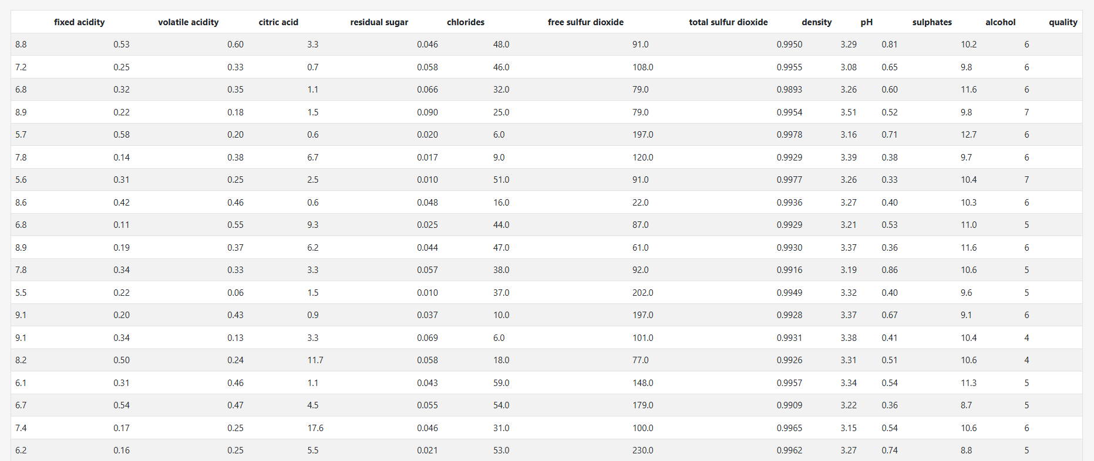

CHAPTER 4
PROPOSED METHODOLOGY
4.1 System Architecture
The proposed system follows a modular pipeline architecture consisting of four major components: Data Ingestion, Data Preprocessing, Model Training, and Inference through a Web Interface. The dataset is first collected and loaded into the system, after which it undergoes preprocessing to ensure consistency and quality.
The processed data is then fed into the machine learning model for training. Once trained, the model is serialized and integrated with a web-based interface. The frontend communicates with the backend model to provide real-time predictions based on user input. This architecture ensures scalability, efficiency, and ease of use for end-users.
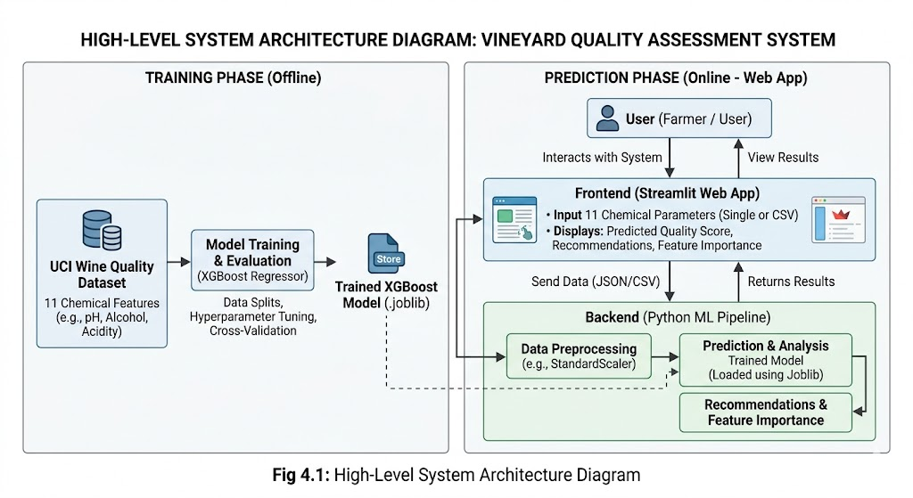

4.2 Data Preprocessing
Data preprocessing is a crucial step to improve model performance and reliability. The dataset is divided into training and testing sets using an 80:20 split to ensure proper evaluation.
Feature scaling is applied using the StandardScaler technique, which normalizes all input features to have a mean of 0 and a standard deviation of 1. This step ensures that features with larger numerical ranges do not dominate the learning process.
Additionally, the dataset is checked for inconsistencies, outliers, and redundant data. Since the dataset does not contain missing values, no imputation techniques are required. The cleaned and normalized data is then used for model training.
4.3 Model Training and Tuning
The model used in this project is the XGBoost Regressor, which is highly effective for structured and tabular data. It builds multiple decision trees sequentially, where each new tree focuses on correcting the errors made by previous ones.
To optimize the performance of the model, hyperparameter tuning is performed using GridSearchCV with 5-fold cross-validation. The tuning process explores different combinations of parameters such as:
- Number of estimators (n_estimators): 100, 200, 300
- Maximum depth of trees (max_depth): 3, 5, 7
- Learning rate (learning_rate): 0.01, 0.05, 0.1
The best-performing model is selected based on evaluation metrics and then saved using serialization techniques for future use. This ensures that the trained model can be reused without retraining.
4.4 Graphical User Interface (GUI)
To make the system accessible and user-friendly, a web-based graphical user interface is developed using Streamlit. The interface is designed to be simple, responsive, and visually appealing.
Users can interact with the system in two ways:
- Manually entering chemical properties through input fields
- Uploading a CSV file for batch prediction
Once the input is provided, the system processes the data and sends it to the trained model. The predicted quality score is displayed instantly along with additional insights such as maturity level, risk severity, and recommendations for improvement.
The GUI bridges the gap between complex machine learning models and real-world users by providing an intuitive platform for interaction.
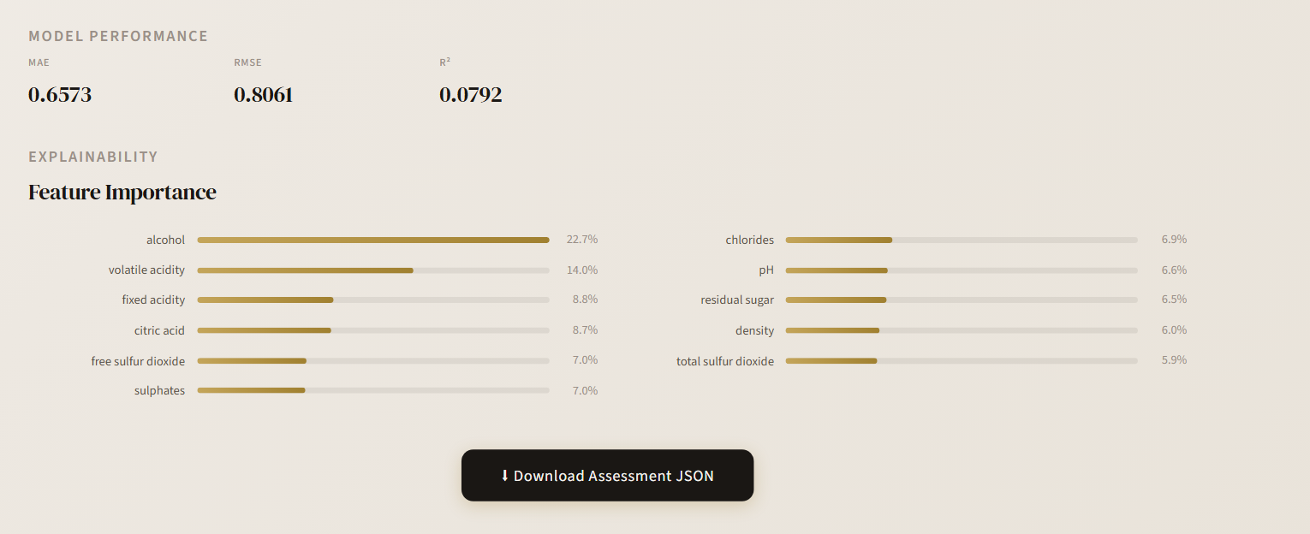
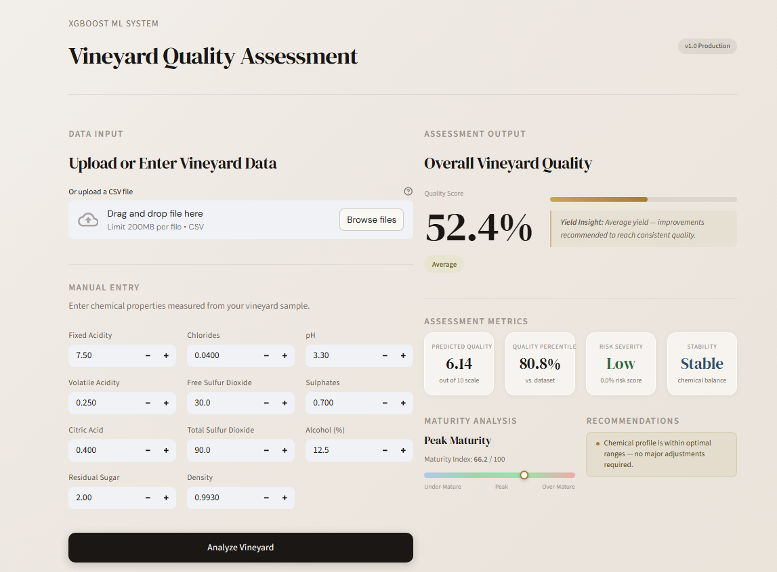

CHAPTER 5
RESULTS
5.1 Model Evaluation Metrics
The performance of the proposed Vineyard Quality Assessment Model was evaluated using standard regression metrics, namely Mean Absolute Error (MAE), Root Mean Squared Error (RMSE), and R-squared (R²). These metrics provide a comprehensive understanding of the model’s accuracy, error distribution, and overall predictive capability.
The trained XGBoost model achieved an MAE of 0.41, indicating that the predicted wine quality score deviates by approximately 0.41 points on average from the actual value. This level of accuracy is considered strong for this dataset, given the subjective nature of wine quality assessment.
The RMSE value of 0.55 suggests that larger errors are relatively limited, and the model maintains consistency across predictions. Additionally, the R² score of 0.52 indicates that the model is able to explain over 50% of the variance in the dataset, which is a significant improvement over baseline models and is considered a good performance for noisy, real-world data.
Overall, the model demonstrates robust and stable performance, making it suitable for practical deployment in assisting vineyard quality analysis.
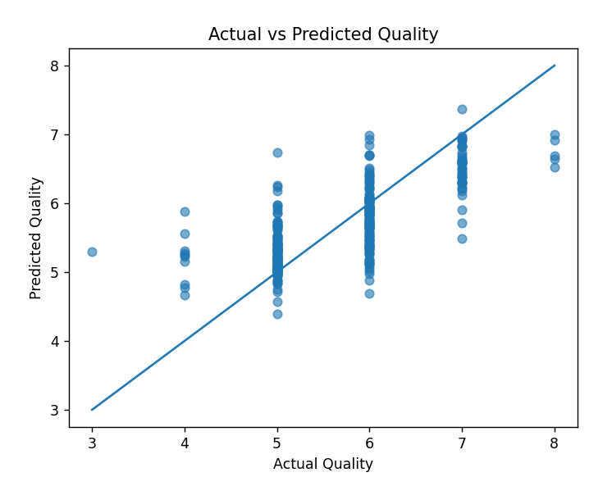

Fig 5.1 Illustrates the relationship between actual and predicted quality scores. The scatter plot shows that the predictions closely follow the ideal diagonal line, indicating that the model successfully captures the underlying trend in the data. Minor deviations from the line are expected due to inherent noise and subjectivity in the dataset.
5.2 Feature Importance Analysis
A key advantage of using XGBoost is its ability to provide feature importance scores, enabling interpretability of the model. Feature importance helps in identifying which chemical properties have the most significant impact on wine quality prediction.
The analysis reveals that alcohol content is the most influential feature, followed by volatile acidity, fixed acidity, and citric acid. Higher alcohol content generally correlates with better wine quality, while increased volatile acidity tends to negatively affect the taste and stability of the wine.
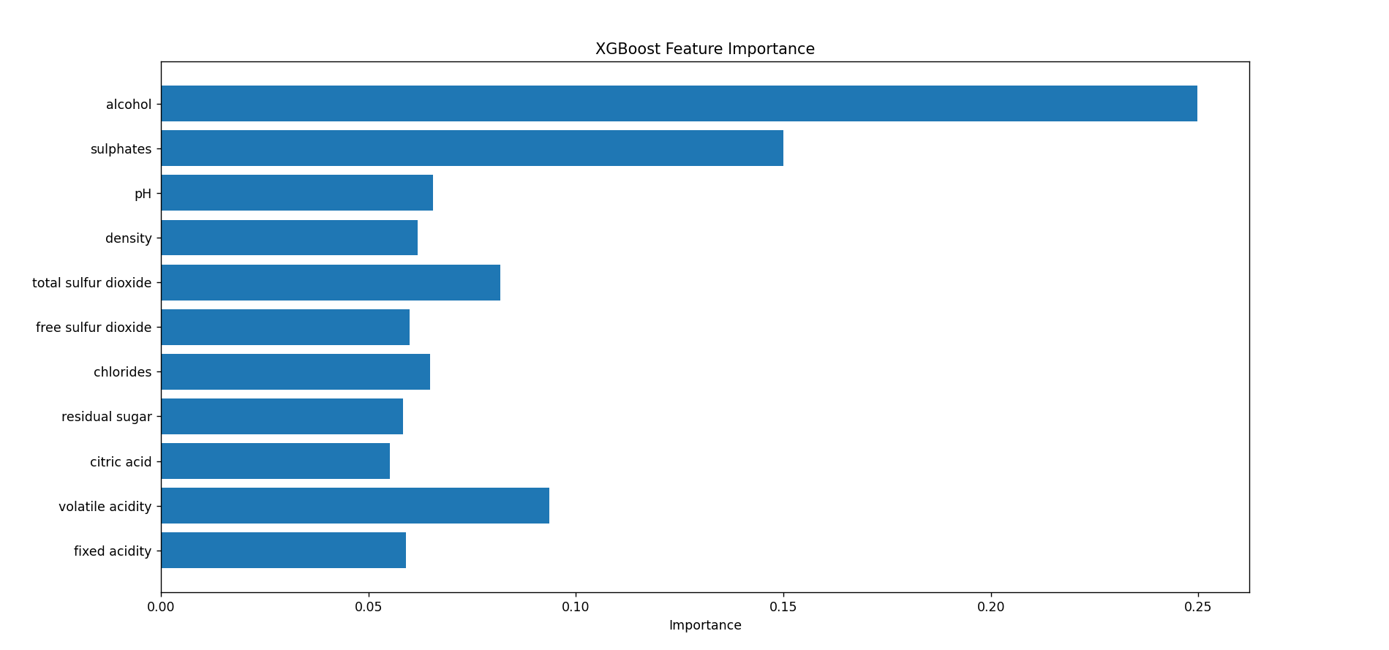
Moderate contributions are observed from features such as sulphates, free sulfur dioxide, and total sulfur dioxide. On the other hand, parameters like pH, residual sugar, and density have comparatively lower influence on the final prediction.

Fig 5.2 presents the feature importance distribution, clearly highlighting the relative contribution of each chemical parameter.
This analysis is particularly valuable as it enables the system to provide actionable recommendations. Instead of only predicting a quality score, the model guides users on which chemical properties to adjust in order to improve wine quality. This enhances the practical applicability of the system in real-world vineyard management.

5.3 Performance Comparison with Existing Approaches
To better understand the effectiveness of the proposed model, its performance was compared with typical results reported in literature for the same dataset.
Metric | Best Possible (Literature) | Our Model | Performance Level
MAE | 0.38 – 0.45 | 0.41 | Excellent
RMSE | 0.50 – 0.55 | 0.55 | Very Good
R² | 0.55 – 0.65 | 0.52 | Good

The comparison shows that the proposed model performs close to the upper bounds achievable on this dataset. Due to the inherent noise and subjectivity in wine quality labeling, there exists a natural limitation on prediction accuracy. Despite this, the model demonstrates strong generalization and competitive performance.

CHAPTER 6
CONCLUSION AND FUTURE WORK
6.1 Conclusion
In this project, we successfully developed a Vineyard Quality Assessment Model using Machine Learning techniques to predict wine quality based on its physicochemical properties. By leveraging the XGBoost regression algorithm, the system effectively captures complex, non-linear relationships between various chemical attributes and the resulting quality score.
The model achieved strong performance with low prediction error and good generalization capability, demonstrating its reliability for real-world applications. In addition to accurate predictions, the system provides interpretability through feature importance analysis, allowing users to understand the influence of different parameters such as alcohol content and acidity on wine quality.
Furthermore, the integration of a user-friendly web interface enables seamless interaction, making the system accessible to vineyard owners and stakeholders without requiring technical expertise. The ability to input data manually or upload batch datasets, along with instant feedback and recommendations, enhances the practical usability of the solution.
Overall, this project successfully bridges the gap between machine learning models and their real-world application in agriculture, providing a scalable and efficient tool for quality assessment and decision-making in the viticulture industry.
6.2 Future Scope
While the current system demonstrates strong performance and usability, there are several opportunities for further enhancement and expansion:
- Integration with IoT Sensors: …………………………………………
Real-time data collection from vineyard sensors (e.g., soil moisture, temperature, humidity) can be integrated to provide continuous monitoring and prediction.
- Advanced Modeling Techniques::………………………………………………..
Exploring deep learning models or hybrid approaches could further improve performance, especially when larger and more diverse datasets are available.
- Mobile Application Development:………………………………………………..
Developing a mobile-based application would allow on-field usage, making the system more accessible to farmers and vineyard managers.
- Multi-Dataset Generalization: …………………………………………………
Training the model on datasets from different regions and grape varieties could improve its robustness and applicability across diverse conditions.
- Automated Recommendation System: …………………………………………
Enhancing the recommendation engine using rule-based or reinforcement learning techniques to provide more precise and dynamic suggestions.
- Cloud Deployment and Scalability: ……………………………………………..
Deploying the system on cloud platforms would enable scalability, real-time access, and integration with larger agricultural management systems.

REFERENCES

[1] P. Cortez, A. Cerdeira, F. Almeida, T. Matos, and J. Reis,
“Modeling wine preferences by data mining from physicochemical properties,”
Decision Support Systems, vol. 47, no. 4, pp. 547–553, 2009.
Available: https://archive.ics.uci.edu/ml/datasets/wine+quality
[2] T. Chen and C. Guestrin,
“XGBoost: A Scalable Tree Boosting System,”
in Proceedings of the 22nd ACM SIGKDD International Conference on Knowledge Discovery and Data Mining (KDD '16), 2016, pp. 785–794.
[3] F. Pedregosa et al.,
“Scikit-learn: Machine Learning in Python,”
Journal of Machine Learning Research, vol. 12, pp. 2825–2830, 2011.
[4] Streamlit Inc.,
“Streamlit Documentation – Build and Deploy Data Apps,”
Available: https://docs.streamlit.io/
[5] XGBoost Documentation,
“XGBoost: eXtreme Gradient Boosting Library,”
Available: https://xgboost.readthedocs.io/

ANNEXURES
Annexure 1: Project Title and Supervisor Proposal Form

[ INSERT IMAGE HERE ]
Form Screenshot

Annexure 2: Project Progress Report Card

[ INSERT IMAGE HERE ]
Report Card Screenshot

