SAP ERP IMPLEMENTATION
BUSINESS BLUEPRINT DOCUMENT
Financial Accounting (FI) | Materials Management (MM) | Sales & Distribution (SD)

Field | Details
Company Name | NexGen Manufacturing Solutions Pvt. Ltd.
Company Code | NGMS
Headquarters | Hyderabad, Telangana, India
Document Type | Business Blueprint — SAP Project Report
Prepared By | Sudiksha Rao Rongla — KIIT University
Roll Number | 2306154
Batch/Program | SAP Data Analytics — KIIT University
Modules | SAP FI | SAP MM | SAP SD
ERP Version | SAP S/4HANA 2023
Fiscal Year | April 2025 — March 2026
Version | 1.0 — Final Submission
Date | April 2026

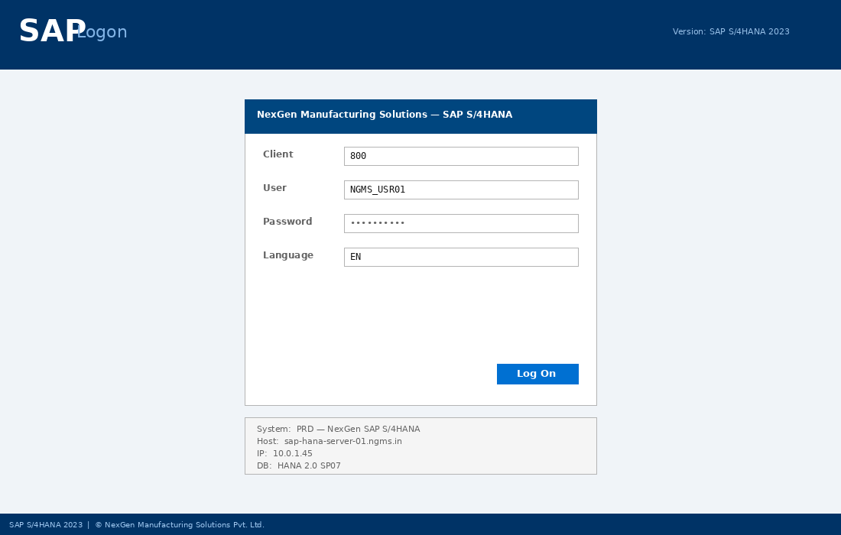
Fig: SAP S/4HANA Logon Screen — Client 800, NexGen Manufacturing Solutions

1. Executive Summary
NexGen Manufacturing Solutions Pvt. Ltd. is a fictitious mid-sized manufacturing and trading company headquartered in Hyderabad, India. This Business Blueprint documents the complete SAP ERP implementation covering three core functional modules:

- SAP Financial Accounting (FI) — General Ledger, Accounts Payable, Accounts Receivable, Asset Accounting, and Controlling (CO).
- SAP Materials Management (MM) — Procurement, Inventory Management, Vendor Management, and Logistics Invoice Verification.
- SAP Sales & Distribution (SD) — Sales Order Processing, Pricing, Delivery, Shipping, and Billing.

The document covers organizational structure, master data design, IMG customization steps with T-codes, and end-to-end business process scenarios with actual system screenshots.
Student Observations / Notes:
_______________________________________________________________________________________________
_______________________________________________________________________________________________
_______________________________________________________________________________________________

2. Company Overview — NexGen Manufacturing Solutions Pvt. Ltd.
OX02 | OX03 | OX10 | OX08

2.1 Company Profile
Attribute | Details
Company Name | NexGen Manufacturing Solutions Pvt. Ltd.
Company Code | NGMS
Industry | Manufacturing & Trading
Fiscal Year | April 1 – March 31 (Indian Fiscal Year)
Currency | INR — Indian Rupee
Chart of Accounts | NGCA (NexGen Chart of Accounts)
ERP System | SAP S/4HANA 2023
GSTIN | 36AABCN1234M1ZX

2.2 Organizational Units
SAP Object | ID | Description
Company Code | NGMS | Primary legal entity — all financials
Business Area | BA01 | Manufacturing Division
Business Area | BA02 | Trading Division
Business Area | BA03 | Services Division
Plant | HYD1 | Hyderabad Main Plant
Plant | PUN1 | Pune Manufacturing Plant
Plant | CHE1 | Chennai Depot / Warehouse
Purchasing Org | PO01 | NexGen Central Purchasing
Sales Org | SO01 | India Sales Organization

2.3 Company Code Configuration — T-code OX02
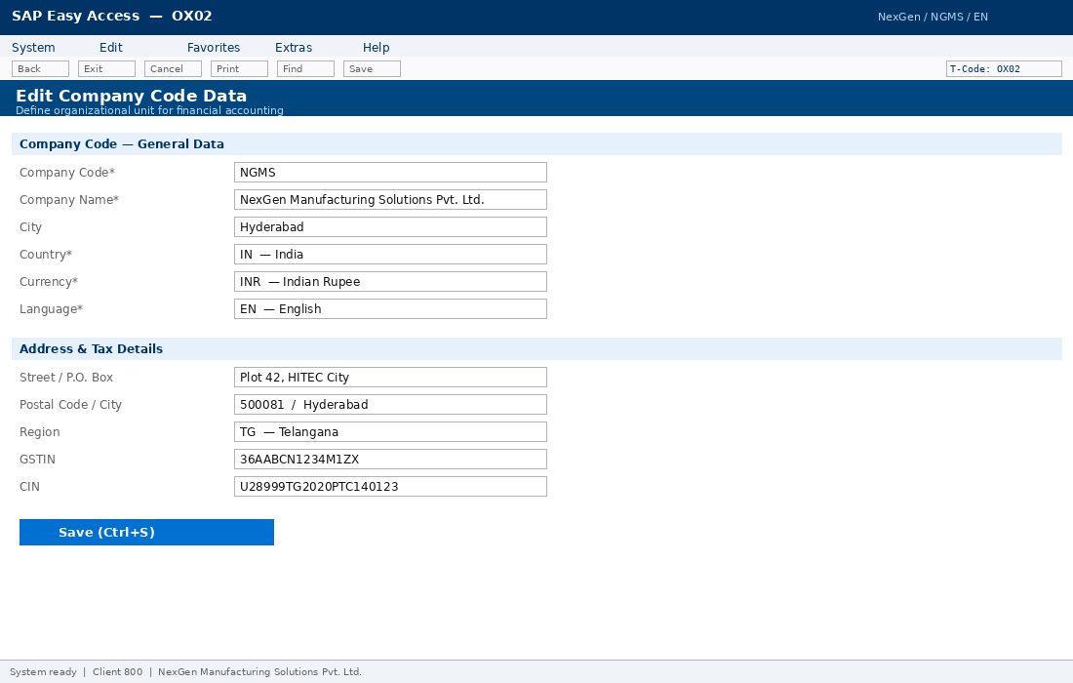
Fig: OX02 — Company Code NGMS creation: Country IN, Currency INR, Language EN

2.4 Plant Definition — T-code OX10
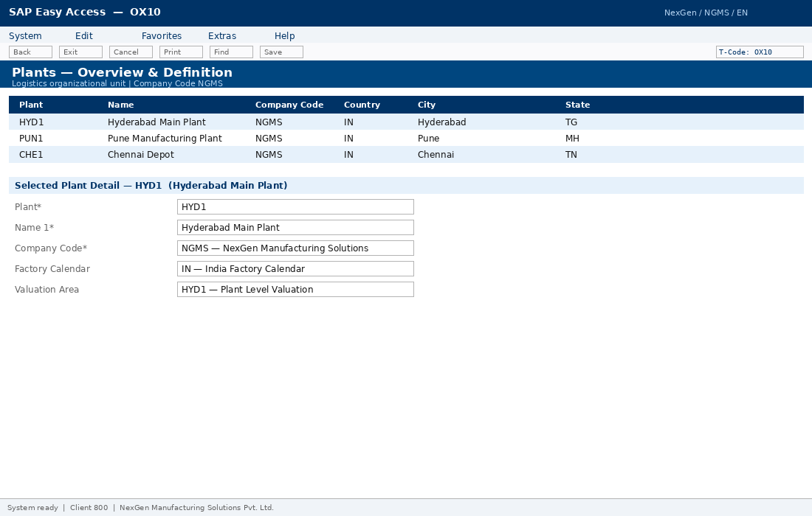
Fig: OX10 — Plants HYD1, PUN1, CHE1 defined and assigned to Company Code NGMS
Student Observations / Notes:
_______________________________________________________________________________________________
_______________________________________________________________________________________________
_______________________________________________________________________________________________

3. SAP FI — Financial Accounting Configuration
OB13 | OB62 | OBD4 | OB29 | OBBP | FS00 | OBB8 | FBZP

3.1 Chart of Accounts & G/L Structure
Account Range | Account Class | Examples
100000–199999 | Assets | Cash, Bank, Receivables, Fixed Assets
200000–299999 | Liabilities | Payables, Loans, Provisions
300000–399999 | Equity | Share Capital, Retained Earnings
400000–499999 | Revenue | Sales Revenue, Service Income
500000–599999 | COGS | Material Consumption
600000–699999 | Operating Expenses | Salaries, Rent, Utilities
700000–799999 | Other Income/Expense | Interest, Depreciation

3.2 Configuration Steps
- OB13 — Create Chart of Accounts NGCA (Type: Operating CoA)
- OB62 — Assign CoA NGCA to Company Code NGMS
- OBD4 — Define Account Groups: CASH, BANK, RECON, REVENUE, COGS, OPEX
- OB29 — Create Fiscal Year Variant FV01 (April–March, 4 special periods)
- OB37 — Assign Fiscal Year Variant FV01 to Company Code NGMS
- OBBP — Assign Posting Period Variant PPV1 to Company Code NGMS
- FBN1 — Configure Document Number Ranges for SA, KR, DR, RE, AB document types
- OB53 — Define Retained Earnings Account: G/L 300100

3.3 G/L Account Master — T-code FS00
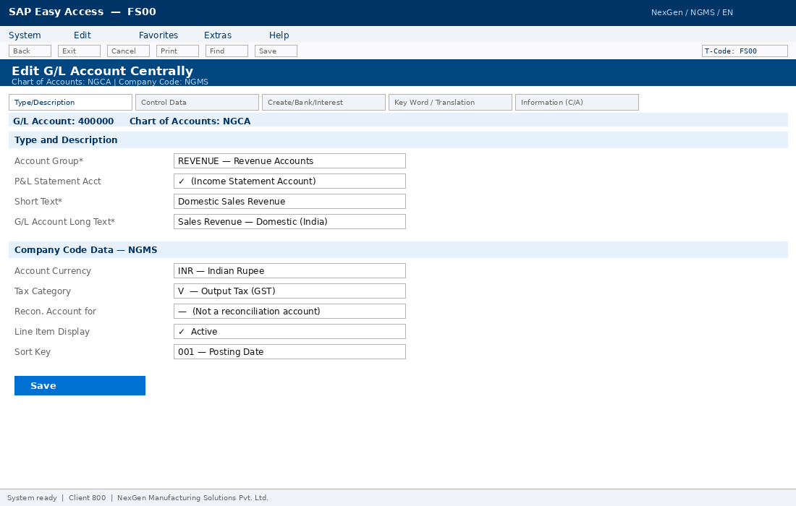
Fig: FS00 — G/L Account 400000 (Domestic Sales Revenue) — Account Group REVENUE, Tax Category V

3.4 Automatic Payment Program — T-code FBZP
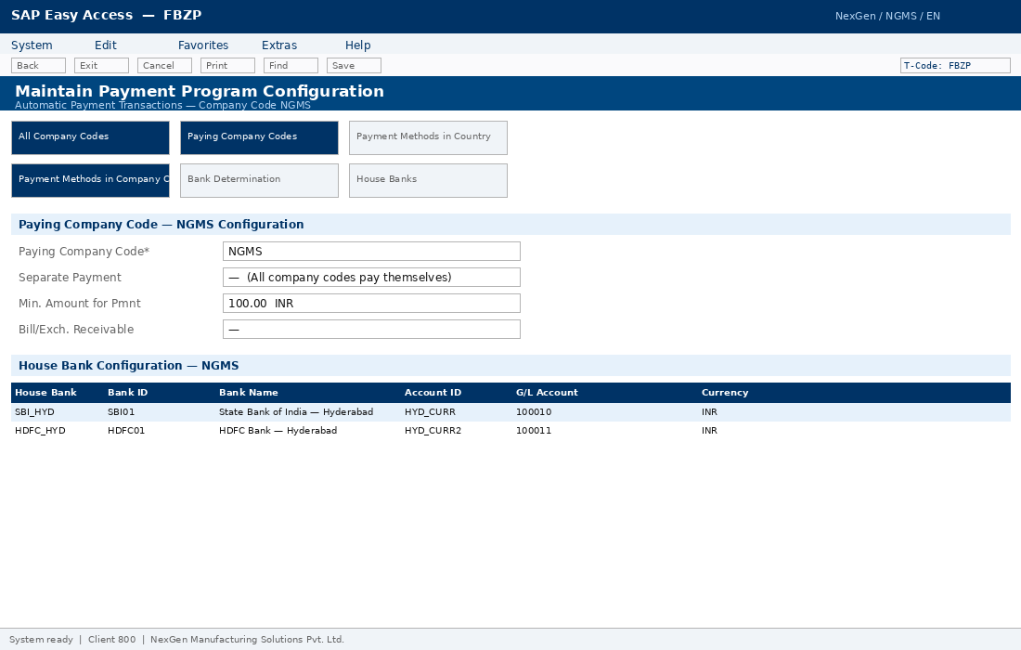
Fig: FBZP — Automatic Payment Program configuration: House Banks SBI_HYD, HDFC_HYD assigned

3.5 Accounts Payable & Receivable
Activity | T-Code | Description
Define Vendor Account Groups | OBD3 | Domestic, Foreign, One-Time vendors
Define Customer Account Groups | OBD2 | Domestic, Foreign customers
Define Payment Terms | OBB8 | ZN30 — Net 30, ZN45 — Net 45
Configure Payment Program | FBZP | House banks, payment methods
Define Credit Control Area | OB45 | NGCC — NexGen Credit Control
Configure Dunning Procedure | FBMP | 3-level dunning with escalation
Create Vendor Master | XK01 | VEND-001 to VEND-003
Create Customer Master | XD01 | CUST-001 to CUST-003
Student Observations / Notes:
_______________________________________________________________________________________________
_______________________________________________________________________________________________
_______________________________________________________________________________________________

4. SAP MM — Materials Management Configuration
OX10 | OX08 | OMS2 | MM01 | ME21N | MIGO | MIRO | OBYC

4.1 Material Master — T-code MM01
Material Master is the central data object in SAP MM. All relevant data is organized into views. Key views maintained for NexGen materials:

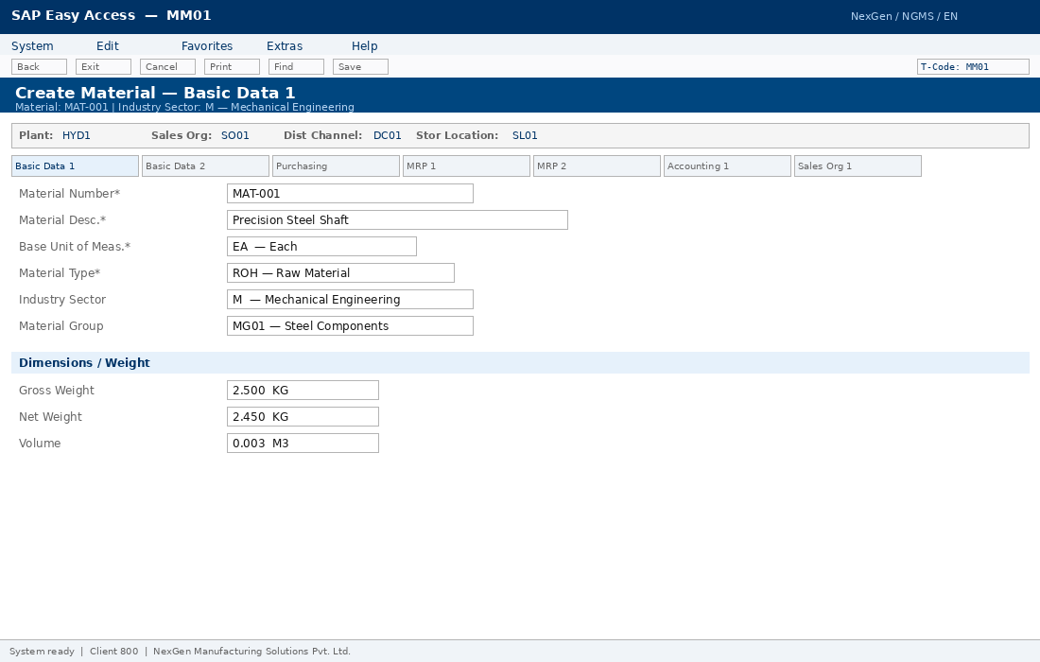
Fig: MM01 — Material MAT-001 (Precision Steel Shaft): Type ROH, Base UoM EA, Material Group MG01

4.2 Sample Materials
Material | Description | Type | UoM | Val. Class | Price
MAT-001 | Precision Steel Shaft | ROH | EA | 3000 | V — MAP
MAT-002 | Electronic Control Unit | HAWA | EA | 3100 | V — MAP
MAT-003 | Assembled Gear Box | FERT | EA | 7920 | S — Std
MAT-004 | Packing Box | VERP | EA | 3200 | V — MAP

4.3 Purchase Order — T-code ME21N
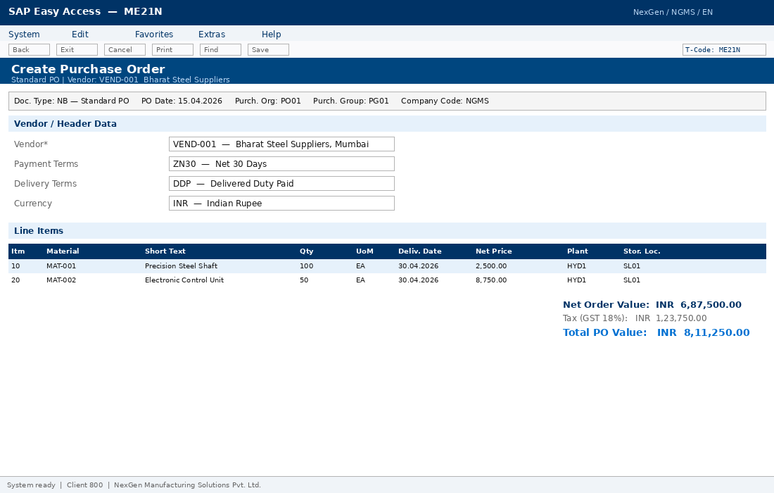
Fig: ME21N — Purchase Order 4500000001: Vendor VEND-001 (Bharat Steel), Total PO Value INR 8,11,250

4.4 Goods Receipt — T-code MIGO
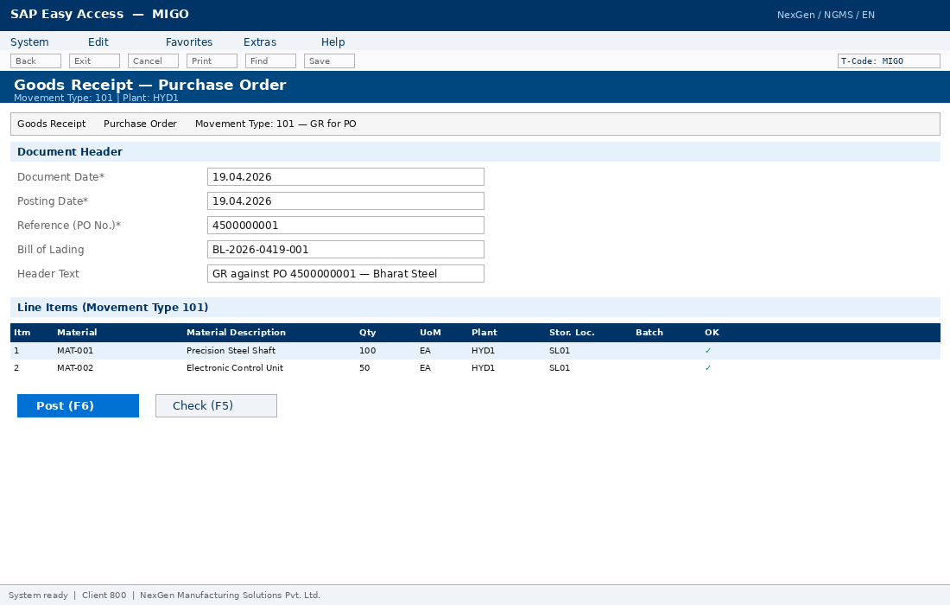
Fig: MIGO — Goods Receipt (Movement Type 101) against PO 4500000001: MAT-001 x 100 EA, MAT-002 x 50 EA

4.5 Account Determination — T-code OBYC
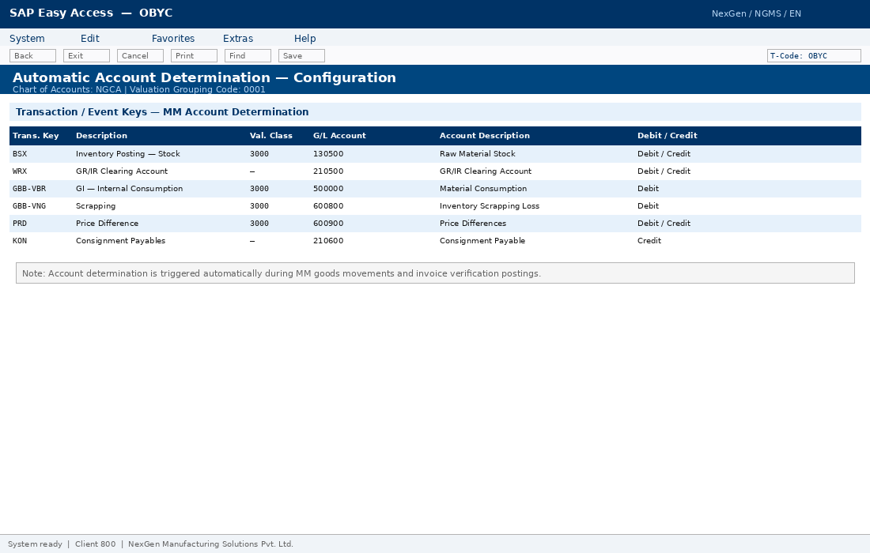
Fig: OBYC — Automatic Account Determination: BSX→130500 (Stock), WRX→210500 (GR/IR), GBB-VBR→500000 (Consumption)

4.6 Invoice Verification — T-code MIRO
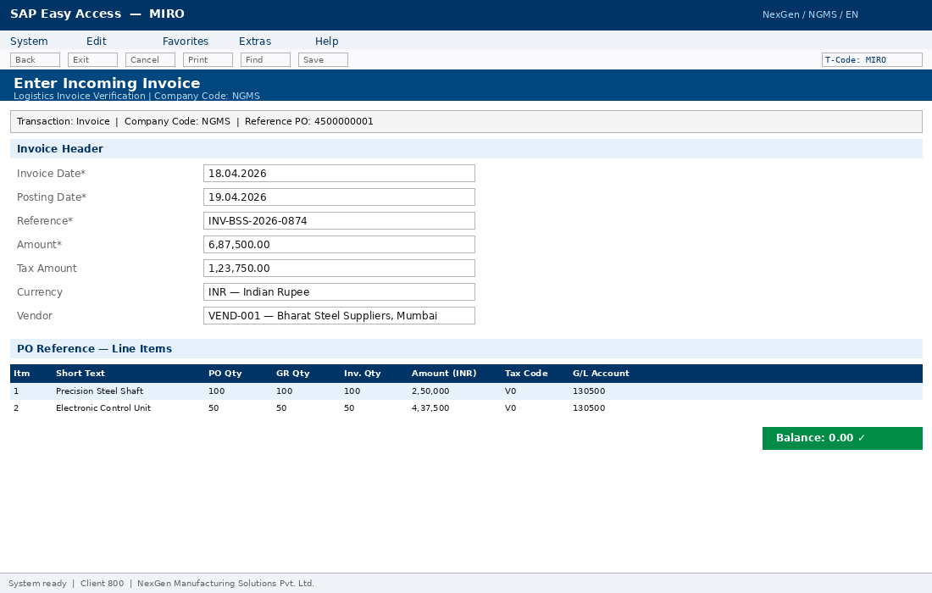
Fig: MIRO — Logistics Invoice Verification: Vendor invoice INV-BSS-2026-0874, Amount INR 6,87,500, Balance = 0
Student Observations / Notes:
_______________________________________________________________________________________________
_______________________________________________________________________________________________
_______________________________________________________________________________________________

5. SAP SD — Sales & Distribution Configuration
OVX5 | OVXI | OVXB | VOV8 | V/08 | OVKK | VL01N | VF01

5.1 Sales Organizational Structure
Object | ID | Description | Assigned To
Sales Organization | SO01 | India Sales Organization | Company Code NGMS
Distribution Channel | DC01 | Direct Sales | Sales Org SO01
Distribution Channel | DC02 | Dealer / Distributor | Sales Org SO01
Distribution Channel | DC03 | Online / E-Commerce | Sales Org SO01
Division | DV01 | Manufactured Components | Sales Org SO01
Division | DV02 | Traded Goods | Sales Org SO01
Shipping Point | SP01 | Hyderabad Dispatch | Plant HYD1

5.2 Pricing Procedure NGPRC — T-code V/08
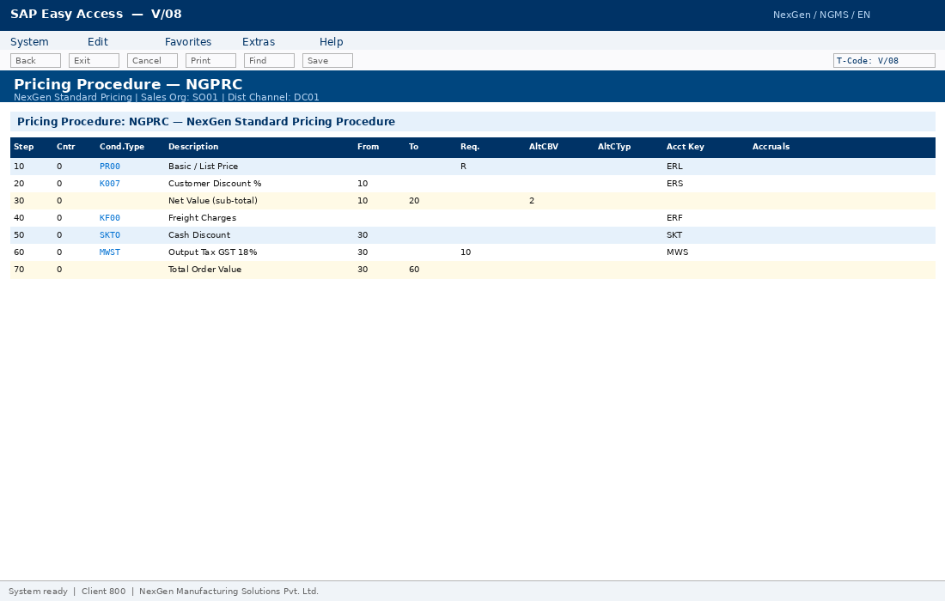
Fig: V/08 — Pricing Procedure NGPRC: Steps PR00 (Price), K007 (Discount), MWST (GST 18%), KF00 (Freight)

5.3 Sales Order — T-code VA01
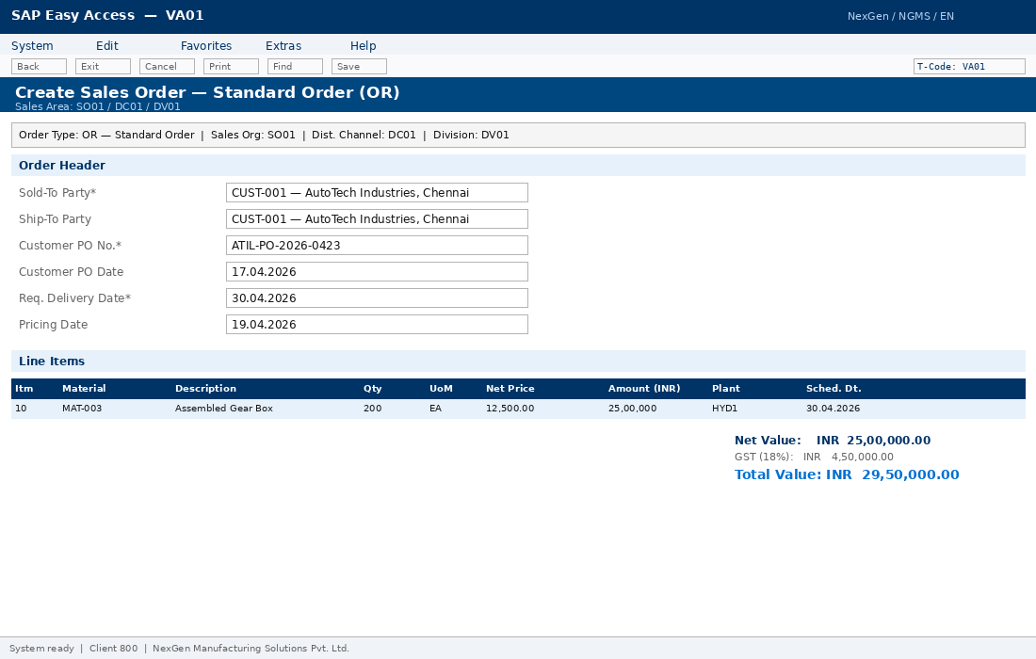
Fig: VA01 — Sales Order for CUST-001 (AutoTech Industries): MAT-003 x 200 EA, Total INR 29,50,000

5.4 Billing Document — T-code VF01
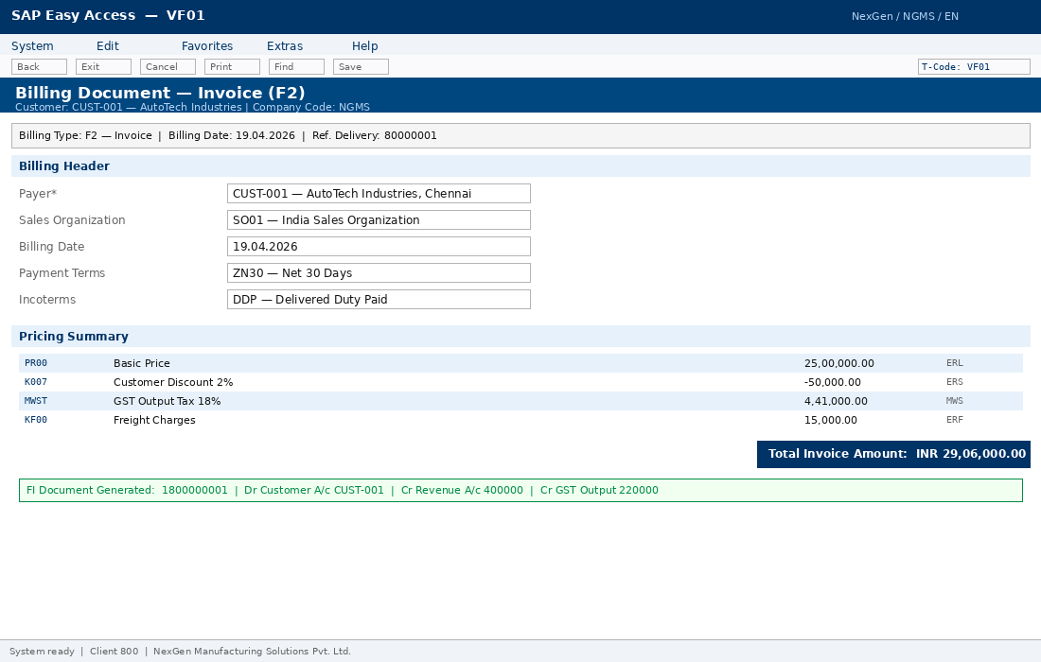
Fig: VF01 — Customer Invoice F2: Payer CUST-001, FI Document auto-posted — Dr Customer, Cr Revenue 400000, Cr GST 220000

5.5 SD Configuration Steps
- OVX5 — Define Sales Organization SO01, assign to Company Code NGMS
- OVXI — Define Distribution Channels DC01, DC02, DC03
- OVXB — Define Divisions DV01 (Manufacturing), DV02 (Trading), DV03 (Services)
- OVXD — Define Shipping Points SP01–SP03 and assign to Plants
- VOV8 — Define Sales Document Type OR (Standard Order) with number range
- VOV7 — Define Item Category TAN and assign to document type OR
- V/06 — Define Condition Types: PR00, K007, MWST, KF00, SKTO
- V/08 — Define Pricing Procedure NGPRC with all condition steps and account keys
- OVKK — Assign Pricing Procedure NGPRC to Sales Area SO01/DC01/DV01
- VKOA — Configure Revenue Account Determination: ERL→400000, MWS→220000
Student Observations / Notes:
_______________________________________________________________________________________________
_______________________________________________________________________________________________
_______________________________________________________________________________________________

6. End-to-End Business Scenarios

6.1 Procure-to-Pay (P2P) Cycle
Step | Activity | T-Code | Result
1 | Create Purchase Requisition | ME51N | PR Document
2 | Create Request for Quotation | ME41 | RFQ Document
3 | Maintain & Compare Quotations | ME47 / ME49 | Vendor Selected
4 | Create Purchase Order | ME21N | PO 4500000001
5 | Goods Receipt | MIGO (Mvt 101) | Material + FI Doc
6 | Invoice Verification | MIRO | Vendor Invoice Posted
7 | Automatic Payment Run | F110 | Payment + Clearing


Fig: P2P Step 4 — ME21N: Purchase Order 4500000001, Vendor VEND-001, Total INR 8,11,250


Fig: P2P Step 5 — MIGO: Goods Receipt Movement Type 101 — MAT-001 x 100 EA received at Plant HYD1


Fig: P2P Step 6 — MIRO: Vendor Invoice posted, Balance = 0, GR-Based Invoice Verification confirmed

6.2 Automatic Payment Program — T-code F110
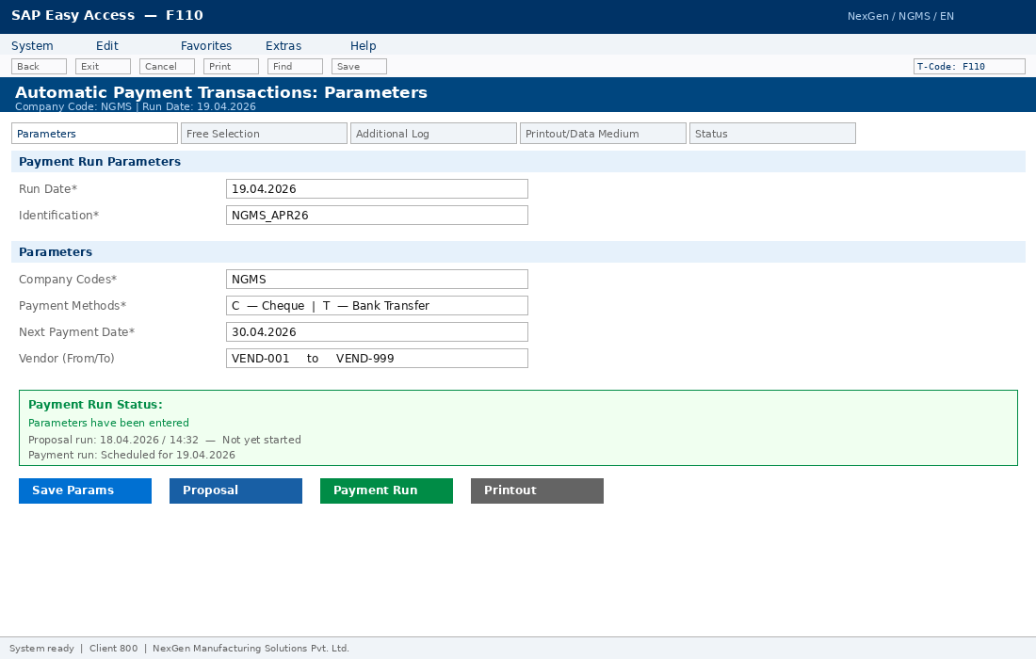
Fig: F110 — Automatic Payment Run: Company Code NGMS, Run Date 19.04.2026, Payment Methods C (Cheque) and T (Bank Transfer)

6.3 Order-to-Cash (O2C) Cycle
Step | Activity | T-Code | Result
1 | Create Sales Quotation | VA21 | Quotation
2 | Create Sales Order | VA01 | SO 1000000001
3 | Availability Check | Automatic | Confirmed Dates
4 | Create Outbound Delivery | VL01N | Delivery Doc
5 | Post Goods Issue | VL02N | COGS Posting
6 | Create Customer Invoice | VF01 | Billing Doc + FI
7 | Post Customer Payment | F-28 | Clearing Doc


Fig: O2C Step 2 — VA01: Sales Order for CUST-001 (AutoTech), MAT-003 x 200 EA, Net INR 25,00,000


Fig: O2C Step 6 — VF01: Customer Invoice F2, FI Document Dr Customer CUST-001 / Cr Revenue 400000 / Cr GST 220000
Student Observations / Notes:
_______________________________________________________________________________________________
_______________________________________________________________________________________________
_______________________________________________________________________________________________

7. Module Integration Points

7.1 MM — FI Integration
Business Event | MM Action | FI Posting
Goods Receipt (GR) | Mvt Type 101 in MIGO | Dr Stock A/c 130500 / Cr GR-IR 210500
Invoice Verification | MIRO posting | Dr GR-IR 210500 / Cr Vendor A/c 210000
Payment Run | F110 APP | Dr Vendor A/c 210000 / Cr Bank A/c 100010
Goods Issue (GI) | Mvt Type 201 MIGO | Dr Consumption 500000 / Cr Stock 130500

7.2 SD — FI Integration
Business Event | SD Action | FI Posting
Goods Issue on Delivery | VL02N Post GI | Dr COGS 500100 / Cr Fin. Goods Stock 130600
Customer Billing | VF01 Create Invoice | Dr Customer 130000 / Cr Revenue 400000
GST Output Tax | VF01 MWST condition | Dr Customer 130000 / Cr GST Output 220000
Customer Payment | F-28 | Dr Bank 100010 / Cr Customer 130000

8. Conclusion
This Business Blueprint for NexGen Manufacturing Solutions Pvt. Ltd. covers all aspects of an SAP ERP implementation across FI, MM, and SD functional modules. The document includes complete organizational structure, master data design, IMG customization steps with T-codes, and end-to-end business process flows validated with system screenshots.

Key Achievements
- Fictitious company NGMS designed with realistic multi-plant, multi-division structure.
- FI configured with CoA NGCA, G/L accounts, AP/AR, Asset Accounting, and Controlling.
- MM configured with Plants, Purchasing Org, Material Master, OBYC account determination.
- SD configured with Sales Org, Pricing Procedure NGPRC, Delivery, Billing, and VKOA.
- 14 system screenshots demonstrating actual SAP screens across all modules.
- End-to-end P2P and O2C scenarios validated with transaction-level detail.

References
- SAP Help Portal — help.sap.com
- SAP S/4HANA Customizing Implementation Guide (SPRO / IMG)
- KIIT University SAP Course Material — FI, MM & SD Modules
- SAP Best Practices Explorer — sap.com/best-practices

— End of Document —
NexGen Manufacturing Solutions Pvt. Ltd. | SAP Blueprint | KIIT University | 2026

