

**Online Vehicle Rental and Hiring Management System**

**Business Proposal**

ITP_B4_04

## **Details of group members:**

|  |  |  |  |  |
| --- | --- | --- | --- | --- |
|  | **Name with Initials**  **(Surname first)** | **Registration Number** | **Contact Phone Number** | **Email** |
|  | Jayasekara M.P.S.S | IT22580344 | 0772629286 | [it22580344@my.sliit.lk](mailto:it22580344@my.sliit.lk) |
|  | Chandrasekara C.M.P.V | IT22286246 | 0762404667 | [it22286246@my.sliit.lk](mailto:it22286246@my.sliit.lk) |
|  | Wijewantha H.D.C | IT22137128 | 0776183693 | [it22137128@my.sliit.lk](mailto:it22137128@my.sliit.lk) |
|  | Nathasha K.D.S | IT22230638 | 0703886818 | [it22230638@my.sliit.lk](mailto:it22230638@my.sliit.lk) |
|  | Jayasundara J.M.T.P | IT22281128 | 0786414979 | [it22281128@my.sliit.lk](mailto:it22281128@my.sliit.lk) |
|  | Tharuka M.S | IT22101242 | 0701215676 | [it22101242@my.sliit.lk](mailto:it22101242@my.sliit.lk) |
|  | Silva M.W.P.R.K | IT22124876 | 0777372445 | [it22124876@my.sliit.lk](mailto:it22124876@my.sliit.lk) |
|  | Abeysekara W.R.G.M | IT22271150 | 0776501141 | [it22271150@my.sliit.lk](mailto:it22271150@my.sliit.lk) |

## **Contents**

**Details of group members:** 2

**Contents** 3

**Client/Company Background** 5

**Problem Statement** 6

**Challenges for Vehicle Owners:** 6

**Challenges for Renters:** 6

**Motivations** 6

**Motivations for Vehicle Owners:** 6

**Motivations for Renters:** 7

**Aim** 7

**Objectives** 8

For Vehicle Owners: 8

For Renters: 8

Additional Considerations: 8

**System Overview** 9

**Booking and Payment Management System** 10

**Functional Requirements** 11

**Human Resources Management System** 11

**Functional Requirements** 12

**Customer management system** 12

**Functional Requirements** 13

**Vehicle management system** 14

**Functional requirements** 15

**Maintenance Management System** 16

**Functional requirements** 16

**Driver Management System** 17

**Functional requirements** 17

**Ratings and Review Management System** 18

**Functional requirements** 19

**Non-Functional Requirements** 19

**Technical Requirements** 20

**Literature Review** 22

Identify similar solutions and critically review each 22

Summarize high lightening why they cannot be used 22

**Methodology** 24

Analyzing and designing the basic structure 24

Project management 24

Programming languages 24

Databases 24

Web technologies 24

**Tools and Technology** 26

Project Management and Documentation: 26

Modeling and Drawing Tools: 27

Design and User Interface: 27

Database Modeling: 27

Programming Languages and Development Environments: 27

Application Development: 27

Full-Stack Development: 28

**Work Distribution** 29

**Gantt Chart** 30

**References** 31

## **Client/Company Background**

Our system caters to four main types of clients: Vehicle Owners, Renters, Drivers, and System Employees.

Vehicle Owners have the ability to list their vehicles on our platform, specifying their availability for rent or hire.

System Employees, particularly those in the Maintenance team, perform regular check-ups on these listed vehicles to ensure they are in optimal condition for use.

Renters have the flexibility to book a vehicle for either rent or hire, after checking its availability. For hires, the vehicle owner assigns a driver for the trip.

The system also facilitates seamless transactions. Renters can make payments directly through the system for their bookings. Similarly, Vehicle Owners can use the system to pay the Drivers for their services.

## **Problem Statement**

### **Challenges for Vehicle Owners:**

* Limited Exposure: Manual systems lack a dedicated platform to list vehicles, hindering their reach to potential renters and limiting their earning potential.
* Inefficient Booking Management: Managing bookings through phone calls or emails is time-consuming, prone to errors, and increases the risk of double bookings.
* Transparency Issues: Tracking earning history and payments from renters is difficult, leading to ambiguity and potential disputes.
* Manual Workload: Generating bills manually is tedious and error-prone, consuming unnecessary time and effort.

### **Challenges for Renters:**

* Limited Search Options: Filtering and selecting vehicles based on preferences and real-time availability is difficult without a proper platform, leading to inefficient searches.
* Inefficient Communication: Constant calls or meetings with vehicle owners to check availability are inconvenient and time-consuming.
* Lack of Visibility: Inability to view booking history and future bookings hinders planning and managing rental schedules.
* Limited Payment Options: Paying in cash or through manual methods can be inconvenient and lack security compared to online options.
* Absence of Reviews and Ratings: Difficulty in assessing the reliability of vehicles and owners due to lack of readily available feedback mechanisms.

## **Motivations**

### **Motivations for Vehicle Owners:**

* Increase earnings: By reaching a wider audience through an online platform, owners can attract more renters and potentially increase their income.
* Save time and effort: A streamlined booking system eliminates the need for manual communication and reduces the risk of errors, freeing up valuable time and resources. Gain transparency: Automatic tracking of earnings and payments provides clear financial records and reduces the potential for disputes.
* Reduce workload: Automated billing eliminates the need for manual work, saving time and minimizing the risk of errors.

### **Motivations for Renters:**

* Find vehicles easily: Advanced search filters allow for efficient searching based on specific criteria, saving time and effort.
* Convenient booking: Online booking eliminates the need for repeated calls or meetings, offering a more convenient and time-saving experience.
* Better planning: Access to booking history and future bookings allows for improved planning and organization of rental schedules.
* Secure payment options: Online payment methods offer convenience and security compared to traditional methods.
* Informed decision-making: Access to customer reviews and ratings helps renters make informed choices about vehicles and owners.

## **Aim**

* To empower individual vehicle owners with limited resources by providing a comprehensive and user-friendly software platform for managing their rental businesses.

## **Objectives**

### For Vehicle Owners:

* Increase reach and visibility: Enhance exposure to potential renters by 70% through the online platform within the first year.
* Simplify rental management: Streamline booking, communication, and financial processes, reducing management time by 50% within six months.
* Gain financial control: Ensure 100% transparency in earnings and payments through automated tracking and reporting.

### For Renters:

* Access diverse vehicle options: Expand search options to include vehicles from individual owners, increasing rental availability by 30% within the first year.
* Enjoy a seamless booking experience: Facilitate convenient online booking for all listed vehicles.
* Benefit from competitive pricing: Enable access to potentially lower rental rates offered by individual owners.
* Maintain secure transactions: Integrate secure online payment options for all rental transactions.

### Additional Considerations:

* Focus on user-friendliness: Design the platform with a simple and intuitive interface suitable for users with varying technical skills.
* Offer flexible customization: Allow owners to manage their listings, pricing, and policies according to their preferences.
* Build a supportive community: Foster communication and collaboration between owners and renters through the platform.

## **System Overview**

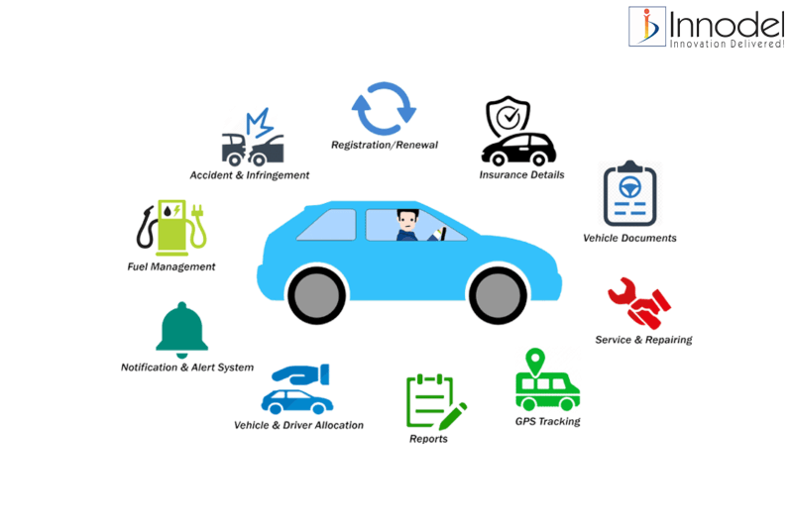

## **Booking and Payment Management System**

Our Booking Management System assists renters in booking a vehicle for either rent (without a driver) or hire (with a driver). Renters can filter and select a vehicle based on their preferences, and check its availability before placing a booking request. If the vehicle is available, the renter can place a booking request.

Upon receiving the request, the vehicle owner checks the booking details. If the booking is for hire, the owner also checks the driver’s availability. If everything is satisfactory, the owner accepts the booking request. The renter then pays a non-refundable booking fee to reserve the vehicle for future use. Renters have the option to physically inspect the vehicle before booking. Once a vehicle is booked, its availability status is updated to ‘reserved’, preventing other renters from placing booking requests for the same time period. Before booking, the system generates a full bill for the renter to review. Vehicle owners can decide on the packages they provide. If the owner provides packages, the renter can select one and the bill will be generated accordingly. For hires, renters usually pay the bill after the trip.

For rentals, renters are required to provide necessary information and proofs such as a copy of their National Identity Card (NIC), a utility bill, and if the renter is a foreigner, a copy of their passport. It’s up to the owner to decide what proof they require. Vehicle owners collect a refundable security deposit before renting out their vehicles. After the ride, a bill is generated by the system.

Our system has a special feature to generate a bill based on the vehicle’s meter reading. The owner must input the meter number before giving the vehicle to the renter and repeat the process when the vehicle is returned. The system then generates a bill based on these time duration and distance and other details. If the renter exceeds the agreed-upon limits, additional charges are added to the bill. Similarly, any damage incurred during the rental period will result in additional charges. The final bill amount is deducted from the initial security deposit, and the remaining balance is refunded to the renter.

For hires, Vehicle owners have to pay to drivers. The system provides facilities for paying drivers and managing payment history for both drivers and owners. Owners can check the earning history from each vehicle. Renters can keep a record of their booking history and payment history.

### **Functional Requirements**

* Booking Request and Booking Confirmation
* bill Generation and Payment Processing
* Earning History Management
* Payment and Booking History Management

## **Human Resources Management System**

The Vehicle Rental Platform's Human Resources (HR) Management System is designed to maximize worker productivity and improve operational excellence. The efficient management and employee onboarding procedures made possible by this all-inclusive HR system guarantee a positive experience for both management and employees. The system is simple for employees to use to register and establish profiles, and it has strong validation procedures in place to protect data confidentiality and integrity. After being on boarded, staff members have access to a number of tools that help them manage their accounts effectively. These tools include the ability to update personal information, control work schedules, and view business regulations and procedures. The technology offers a platform for job posting and application receipt, which helps to expedite the hiring process.

HR managers may readily create reports and monitor employee performance indicators in situations when they see possible staffing problems or disparities. This allows them to make proactive decisions and allocate resources. Furthermore, staff members have the ability to voice complaints or provide feedback via the system, guaranteeing that any HR-related difficulties they may run across are promptly addressed. All things considered, the Vehicle Rental Platform's HR management system is built to improve worker contentment, expedite administrative procedures, and propel organizational performance through efficient labor administration.

### **Functional Requirements**

* Employee details management (add, edit, delete)
  + This feature ensures an accurate and up-to-date employee database by making it simple for the operation manager to add, amend, or remove employee details such as contact information, job roles, and personal information from inside the system.
* Recording reasons for dismissal/resignation
  + The system provides a functionality to record and store reasons for employee dismissal or resignation in a separate database table, allowing the operation manager to track and review these instances for future reference or analysis.
* Salary allocation and updates based on overtime and bonuses
  + Employee compensation is guaranteed to be precise and timely thanks to this feature, which automates the process of assigning wages to workers and changing them depending on things like overtime hours worked and bonuses received.
* Leave request management (approve/reject)
  + This feature, which automates the process of allocating salaries to workers and altering them based on factors like overtime hours worked and bonuses earned, ensures that employee remuneration is accurate and timely.

## **Customer management system**

The Vehicle Renting Management System offers a comprehensive customer management system to enhance user experience. Users can easily register and create accounts within the system, ensuring a seamless onboarding process. Upon registration, validation mechanisms ensure the security and integrity of user accounts.

Once logged in, users gain access to a range of features designed to manage their profiles efficiently. They can update or delete their profiles as needed, Giving them with control over their information within the system.

The system Normally displays vehicle ads, providing wide selection of options. To streamline the search process, advanced filtering options are available, allowing users to personalize their searches according to specific criteria. Once they search something it will saved in our system and he can manage them by deleting or if he wants to search that again he can search it from a single click.

In cases where users encounter suspicious vehicles, they can report them, contributing to the safety and reliability of the platform. If the customer Founds a vehicle, he can add it to his favorites section and Anytime he can manage it by updating or deleting them from his favorite List. Additionally, users can put complaints at any time, ensuring proper attention to any issues they have to faced.

After renting a vehicle and receiving service, customers can leave reviews, enabling them to share their experiences and provide valuable feedback for future users. Overall, the customer management system is designed to improve the trust and efficiency throughout the vehicle renting process.

### **Functional Requirements**

* User Registration and Account Management
* Users can easily register and create a new account
* They have the option to delete their account if needed
* Vehicle Ads and Search Functionality
  + Renters can view vehicle ads within the system
  + If they can't find the desired vehicle, they can search for it, and the system saves their search results for easy access.
* Request and Management of Vehicle Bookings
* Renters can request vehicles from the system
* They have the flexibility to manage their requests by deleting or updating them as necessary.
* Flexible Booking Modifications and Refunds
* Renters can edit confirmed bookings within 24 hours
* Driver Finding Option
* Renters have the option to find a driver if needed when renting a vehicle
* Vehicle Reporting and Favorite List Management
  + Renters can report vehicles if necessary
  + They can also add vehicles to their favorite list and manage it at any time
* Feedback and Complain
  + After service, users can provide feedback
  + They can also submit complaints at any time

## **Vehicle management system**

The Vehicle Management System in an online vehicle rental management system offers fundamental services for efficient vehicle handling. After vehicle owners submit detailed information and upload forms, approved vehicles are added to the system by the vehicle manager, following approval from the maintenance manager. Renters can conveniently view all vehicles added by the vehicle manager. The vehicle manager, apart from the vehicle owners, has control over all vehicle details, including deletion and updates. Managing vehicle availability for rentals, the system segregates specific vehicles into maintained, reserved for future rentals, and ready for immediate rent for renter convenience. Additionally, the vehicle manager has access to rental reports and history provided by the rental manager, ensuring comprehensive oversight and optimization of the vehicle rental experience.

### **Functional requirements**

* Vehicle Manager Login:
* The system should provide a secure login mechanism for the vehicle manager to access their dedicated interface.
* Vehicle Details Management:
* The vehicle manager should be able to manage and update various details of vehicles, including specifications, registration information, and maintenance records.
* Vehicle Addition:
* The system should allow the vehicle manager to add new vehicles to the system, incorporating detailed information submitted by vehicle owners.
* Vehicle Availability Management:
* The vehicle manager should have the capability to manage the availability status of vehicles for rentals, ensuring accurate and up-to-date information.
* Rental Reports and History:
* The system must provide the vehicle manager with the ability to view comprehensive rental reports and historical data, allowing for informed decision-making.
* Renter Access to Vehicle Information:
* Renters should be able to easily access and view details of all vehicles added by the vehicle manager, facilitating a transparent and user-friendly experience.

## **Maintenance Management System**

Vehicle maintenance management in a vehicle rental service is a crucial process focused on ensuring the ongoing health and performance of the rental fleet. This involves regular inspections, scheduled maintenance, and prompt repairs to keep each vehicle in optimal condition. The system typically includes features such as automated maintenance scheduling, real-time monitoring of vehicle diagnostics, and a comprehensive record of past maintenance activities. By efficiently managing vehicle maintenance, rental services can minimize downtime, enhance overall fleet reliability, and provide customers with safe and well-maintained vehicles for a more satisfying rental experience. This proactive approach not only reduces unexpected breakdowns but also contributes to the longevity of the vehicles, optimizing the return on investment for the rental service.

### **Functional requirements**

* Vehicle Maintenance Manager login to the system.
* Vehicle Maintenance Manager can add vehicles to repair list for checking vehicle's conditions.
* Vehicle Maintenance Supporter can check vehicle's conditions.
* Vehicle Repairer can repair vehicles in repair list.

## **Driver Management System**

The Driver Management System within our vehicle rental platform seamlessly organizes and oversees all aspects of driver-related activities, ensuring a smooth and efficient experience for both users and administrators. From driver registration to identity verification, license validation, and performance monitoring, this system prioritizes safety and reliability. It offers a user-friendly interface for drivers to update personal information, view rental history, and access essential documentation.

In this system drivers can view the rental details and check dates. So they can response whether they are capable to attend the hire or not. If the driver is unable to attend, he can notify it to the system. So owners can assign another driver.

Customers can rate the drivers. Also they can leave a comment about the driver after they enjoyed the journey. Driver's behavior, how he obeyed to the traffic rules can be measured by those comments. If there are any complaints, the relevant driver would be notified and warned. The drivers who are getting the best ratings will be assigned for many hires.

### **Functional requirements**

* Allow drivers to register with the platform.
* Should be able to create and update their profiles.
* Provide a user-friendly interface for drivers to browse the available vehicles.
* Implement a feature to verify the authentication of their license.
* Send notifications for drivers for reservation confirmations, upcoming bookings etc.
* Keep records of driver activities like calculating working hours, distance travelled.

## **Ratings and Review Management System**

The Ratings and review management system can monitor, analyze and respond to customer feedbacks and reviews by the rental system platform. when the vehicle renter wants to add a rating or complaint, the renter can select rating or complaint. When the renter chooses to rate only, he/she can rate to driver and vehicle separately by using star box. after the rating, Renter can update or delete it anytime. When the renter wants to complain about the vehicle which he/she reentered, should choose to complain about the vehicle and fill out the complaints form, and submit with valid email. If renter submit a complaint about vehicle it can view vehicle manager. Vehicle manager can get a decision and send an email to the vehicle owner describing the complaint. and also vehicle manager sends reply email to the renter describing about the action we get. owner can only view complaints and reviews which own to owner's vehicle.

When renters choose to add complaint about the driver, he/she should choose complaint to the driver and fill the complaints form and submit it with a valid email. If the renter adds a complaint about the driver, driver manager can view it get decision, and sending a reply email to the renter and send another email to driver. vehicle manager and driver manager can delete driver and vehicle after the considering complaints.

### **Functional requirements**

* User authentication:
* Users should be required to create an account to rate vehicles and drivers or complain.
* To send a complaint about a driver or a vehicle user should have a valid email.
* Editing and Deleting Reviews:
* users can edit and delete their reviews and ratings anytime.
* When user delete reviews and ratings it should be permanently removed from the system.
* Notification system:
* When a user edits or deletes his review or rating, the system displays notification is it success or not.
* When the user enters an invalid email during complaints, the system displays ‘a notification about the validity of it.

## **Non-Functional Requirements**

* **Performance:**
* The system should be able to handle a high volume of users without significant performance degradation.
* Response times for user interactions such as searching for vehicles, making bookings, and updating profiles should be minimal
* **Scalability:**
* The system should be designed to scale horizontally to accommodate increased user demand over time.
* Scalability should be seamless to ensure uninterrupted service during peak periods.
* **Security:**
* User data, including personal information and payment details, should be encrypted and stored securely.
* Access to sensitive information should be restricted based on user roles and permissions.
* **Reliability:**
* The system should have a high level of reliability, ensuring minimal downtime and maximum uptime.
* **Usability:**
* The user interface should be intuitive and user-friendly, catering to users with varying levels of technical expertise.
* Navigation should be straightforward, with clear instructions and prompts guiding users through the rental process.
* **Availability:**
* The system should be available 24/7 to accommodate users across different time zones and schedules.
* Maintenance windows, if required, should be communicated to users in advance to minimize disruption

## **Technical Requirements**

**1.Programming Languages and Frameworks:**

* Node.js with Express.js for backend development.
* React.js for frontend development.

**2.Database:**

* MongoDB for storing user data, vehicle information, booking details, and reviews.

**3.Authentication and Authorization:**

* Implement user authentication using JWT (JSON Web Tokens) or sessions.
* Define roles and permissions for user access control.

**4.API Development:**

* Develop RESTful APIs for user authentication, vehicle management, booking functionalities, and reviews.

**5.User Interface:**

* Create a responsive and intuitive user interface with React components
* Utilize React Router for client-side routing.

**6.Payment Integration:**

* Integrate a payment gateway (e.g., Sandbox) for secure online transactions.

**7.Third-Party Services:**

* Integrate third-party services for features such as geolocation (e.g., Google Maps API) and email notifications.

**8.Deployment and Hosting:**

* Deploy the application on a cloud platform

**9.Security Measures**

* Implement input validation and rate limiting to prevent common security vulnerabilities.
* Secure sensitive data (e.g., API keys, access tokens) using environment variables or secret management solutions.

**10.Performance Optimization:**

* Optimize frontend and backend code for faster response times and improved user experience.

**11**. **Backup and Recovery:**

* Set up regular backups of the database to prevent data loss in the event of system failures.

**12.Scalability:**

* Design the system to scale horizontally to accommodate increased user demand over time.
* Utilize cloud services for elastic scalability and resource management.

## **Literature Review**

### Identify similar solutions and critically review each

In Sri Lanka, there exists large Number of vehicle rental management systems, many platforms, such as "Ikman.lk," offer vehicle rental services, yet their operations primarily target on vehicle listings rather than rental management.

Take, for instance, "Ikman.lk," a prominent vehicle rental facilitator. While they indeed provide a category for vehicle rentals, their role largely centers on connecting potential renters with available vehicles. Once the vehicle is rented out, the platform's involvement typically ends, with no ongoing management or oversight.

On a larger scale, certain vehicle rental companies may indeed rental management systems developed to their operations. However, these systems are typically proprietary and exclusive to the respective company. Third-party involvement in such systems is rare, as they are designed to meet the specific needs and protocols of the rental company itself.

In essence, while Sri Lanka hosts a variety of platforms offering vehicle rental services, the term "rental management system" often applies more to the operations of large-scale rental companies.

### Summarize high lightening why they cannot be used

In the Sri Lanka there where existing rental management systems often fall short of encompassing all the necessary tasks, we saw an opportunity to create something truly inclusive and accessible. Our vision is to design a website that is very useful to both large-scale rental companies and individual vehicle owners looking to rent out their vehicles.

What sets our platform apart is it is open to everyone who wishes to rent out their vehicles. Whether you're a major rental company or an individual with a single vehicle to spare, our system welcomes you with open arms.

One of the key features of our platform is its comprehensive payment management system. All payments, from rental fees to maintenance charges, are seamlessly processed through our website, providing a hassle-free experience for both owners and renters.

Additionally, we understand the importance of vehicle maintenance in ensuring a safe and reliable rental experience. That's why we've implemented scheduled maintenance checks for all vehicles registered on our platform. This regular upkeep ensures that every vehicle remains in top condition, giving renters peace of mind.

But we didn't stop there. Recognizing that some renters may require a driver along with their rental vehicle, we've extended our platform to accommodate drivers as well. Drivers can register on our system, and when renters request a driver, they can easily apply for the position if they choose to do so.

In essence, our platform is a game-changer in the rental industry. It's not just another rental management system; it's a community-driven platform that empowers both owners and renters alike. With simplicity at its core, our platform opens doors for everyone to participate in the rental economy, making vehicle rental more accessible and convenient than ever before.

## **Methodology**

Project planning and management play a pivotal role in ensuring that a project is well-organized, stays on track, and achieves its objectives efficiently. It's a dynamic process that involves continuous monitoring, adaptation, and collaboration among team members.

### Analyzing and designing the basic structure

* mind maps - Draw.io [1]
* UML uses case diagrams and user stories - Draw.io
* Simple hand written notes

### Project management

* GitHub Projects [2]
* To-do lists
* Everyday short meetings (10 Minutes approximately) [3]

### Programming languages

* JavaScript

### Databases

* MongoDB [4]

### Web technologies

* CSS / HTML
* The MERN architecture allows you to easily construct a three-tier architecture (front end, back end, database) entirely using JavaScript and JSON.

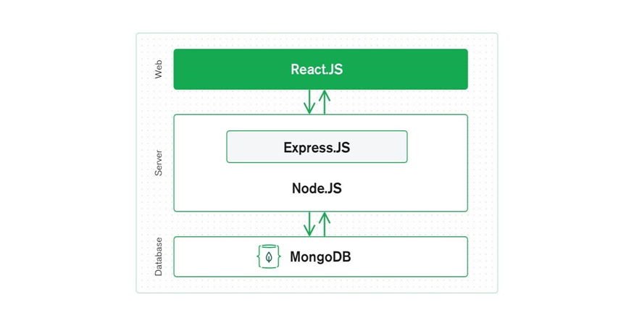

* MongoDB Express (web framework) [4]
* React (client-side JavaScript framework.) [5]
* Node.js (JavaScript web server) [6]





## **Tools and Technology**

In our online vehicle rental management system project, we adopted a comprehensive set of tools and technologies to ensure effective design, collaboration, and project management.

### Project Management and Documentation:

* **Microsoft Project** [7]**:** Used for project management tasks, scheduling, and resource allocation.
* **Microsoft PowerPoint** [8] **and Word** [9]**:** Utilized for crafting the project proposal presentation, creating the scrum presentation, and finalizing the work proposal document. Microsoft Office suite proved instrumental in facilitating collaborative efforts.

### Modeling and Drawing Tools:

* **Mock flow** [10]**, Draw.io** [1]**:** Employed for creating models and drawings. Mock flow for interface design, StarUML for UML diagrams, and Draw.io for collaborative drawing with shape libraries.

### Design and User Interface:

* **Figma** [11]**:** Employed Figma design software to ensure the design is clear and efficient. Figma is a powerful vector application tailored for productive and creative interface building for websites or apps.

### Database Modeling:

* **Hackolade:** Used as the database modeling tool for MongoDB, facilitating efficient database design and visualization.

### Programming Languages and Development Environments:

* **JavaScript and Node.js:** Leveraged as the primary programming language and runtime environment for executing JavaScript code outside of a web browser.
* **Microsoft Visual Studio Code** [12] **and Eclipse** [13]**:** Chosen as the main integrated development environments (IDEs) for coding, with Sublime Text as the backup editor.

### Application Development:

* **Express (Back-end Framework) and React (Front-end Framework):**
* **Express** [14]**:** Utilized as the back-end framework, simplifying the development of multiplatform and online applications while incorporating necessary functionalities.
* **React** [5]**:** Acted as the front-end framework, enabling the creation of intricate user interfaces for building single-page web apps.

### Full-Stack Development:

* **MERN Stack (MongoDB** [4]**, Express** [14]**, React** [5]**, Node.js** [6]**):** Adopted for full-stack development. MongoDB served as the data storage, Express as the back-end framework, React as the front-end framework, and Node.js as the runtime environment. This combination enables the development of high-performance web applications.

This arsenal of tools and technologies, ranging from project management to development frameworks, ensures the project's success and efficient collaboration among team members. The chosen stack aligns with modern web development practices, providing a robust foundation for building and managing an online vehicle rental management system.

|  |  |  |  |
| --- | --- | --- | --- |
|  | **Name** | **Student ID** | **Work allocated** |
|  | Jayasekara M.P.S.S | IT22580344 | Implement booking and payment management system |
|  | Chandrasekara C.M.P.V | IT22286246 | Implement human resources management system |
|  | Wijewantha H.D.C | IT22137128 | Implement the customer management system |
|  | Nathasha K.D.S | IT22230638 | Implement the vehicle management system |
|  | Jayasundara J.M.T.P | IT22281128 | Implement the maintenance management system |
|  | Tharuka M.S | IT22101242 | Implement the vehicle owner management system |
|  | Silva M.W.P.R.K | IT22124876 | Implement the driver management system |
|  | Abeysekara W.R.G.M | IT22271150 | Implement the ratings and review management system |

## **Work Distribution**

## **Gantt Chart**

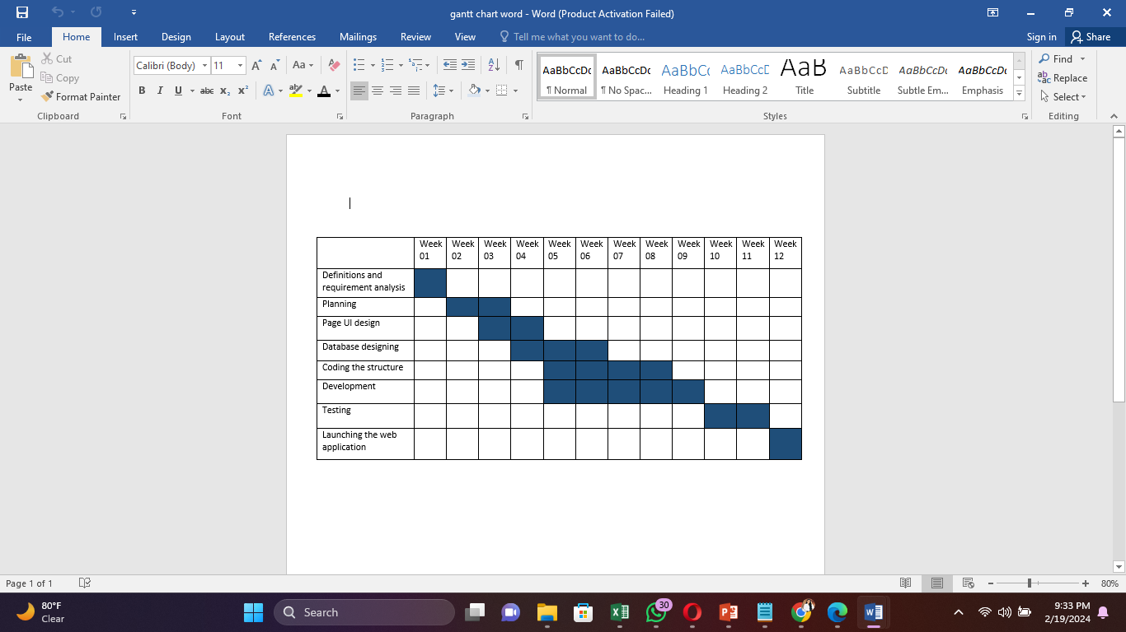

|  |  |
| --- | --- |
| 1] | "draw.io," [Online]. Available: [https://app.diagrams.net/.](https://app.diagrams.net/) |
| [2] | "github," [Online]. Available: [https://github.com/.](https://github.com/) |
| [3] | "google meet," [Online]. Available: [https://meet.google.com/.](https://meet.google.com/) |
| [4] | "Mongodb," [Online]. Available: [https://www.mongodb.com/.](https://www.mongodb.com/) |
| [5] | "react," [Online]. Available: [https://react.dev/.](https://react.dev/) |
| [6] | "node," [Online]. Available: <https://nodejs.org/en.> |
| [7] | "project-management," [Online]. Available: <https://www.microsoft.com/en-us/microsoft-365/project/project-management-software.> |
| [8] | "powerpoint," [Online]. Available: <https://www.microsoft.com/en-us/microsoft-365/powerpoint.> |
| [9] | "ms word," [Online]. Available: <https://www.microsoft.com/en/microsoft-365/word.> |
| [10] | "mockflow," [Online]. Available: [https://mockflow.com/.](https://mockflow.com/) |
| [11] | "figma," [Online]. Available: [https://www.figma.com/.](https://www.figma.com/) |
| [12] | "visualstudio," [Online]. Available: [https://code.visualstudio.com/.](https://code.visualstudio.com/) |
| [13] | "eclipse," [Online]. Available: www.eclipse.org. |
| [14] | "expressjs," [Online]. Available: [https://expressjs.com/.](https://expressjs.com/) |
| [15] | [Online]. Available: https: [//app.diagrams.net/.](//app.diagrams.net/) |
| [16] | "Github," [Online]. Available: [https://github.com/.](https://github.com/) |

# References