AUV COMPETITION:

1.NIOT Chennai Student Autonomous Underwater Vehicle (SAVe):

Competition : January

Competition on: January 2019

It’s national level competition .NIOT would support the winning team (maximum of 4 students) of the National Competition SAVe 2019, by sponsoring them to participate in the International competition being held annually in [AUVSI](http://www.auvsifoundation.org/) foundation San Diego, USA during July 2019. The competition is open to Indian national students only.

Evaluation Process:

S.No Description Max Point

1 Technical document & Uniform 10

2 System realisation based on review 10

3 System weight in air (< 38 kg), Length (≤ 1.83 m),

Width (≤ 0.91 m),Height (≤ 0.91 m) 10

4 System autonomy in water 10

5 System following the designated path 10

6 System Passing gate & identifying balls 10

7 System avoiding the obstacles in the path 10

8 Dropping the designated object at assigned place 10

9 System surfacing at designated place after completion of

assigned job 5

10 Time duration to complete the assigned job (<30 minutes) 5

11 Failure contingency plan 5

12 Team involvement 5

-------------------------------------------------------------------------------------------------------------------

Total point=100

### **AUV REQUIREMENTS**

**On Board Processor:**

* An integral part of the AUV is its powerful on-board computer, which is based upon a processor board. This computer should execute a control program based upon a flexible high-level behavioural language to be developed indigenously by students, and support vehicle control in a wide range of conditions and mission profiles. It should be a robust yet flexible platform so that new mission profiles can be quickly configured, tested and entered into the computer's library.

**Propulsion system**

* Easily manoeuvrable, energy efficient, simple propulsion control is required. Thrusters are to be designed. To monitor the attitude (orientation) of the AUV sensors have to be developed along with a control algorithm to control & orient its attitude to facilitate efficient data acquisition and precise navigation.

a.Software Analysis :

Software Frameworks :Several well tested frameworks for fast production time and increased reliability were looked at and the following is a selection of frameworks have been used by different AUV teams in competitors for years:

Like Qt,Opencv,ZeroMQ,LabView,GAZEBO etc;

b. Mission Planner:

The majority of the artificial intelligence takes the form of the mission planner. This planner is responsible for loading and parsing Mission Task, generating a directed graph of tasks, and developing a plan to maximize mission points in the least amount of time. A new plan is generated after the completion (or failure) of every task. An abstract class will be used to allow the development of several planning algorithms. The current plan is to implement an algorithm based on uniform weightage search or Dijkstra’s algorithm, but focusing instead on the path with maximum point value. A pseudo-code variation of Dijkstra’s algorithm exploring the largest point-value and taking time-cost into account is shown in Algorithm below.

ARENA: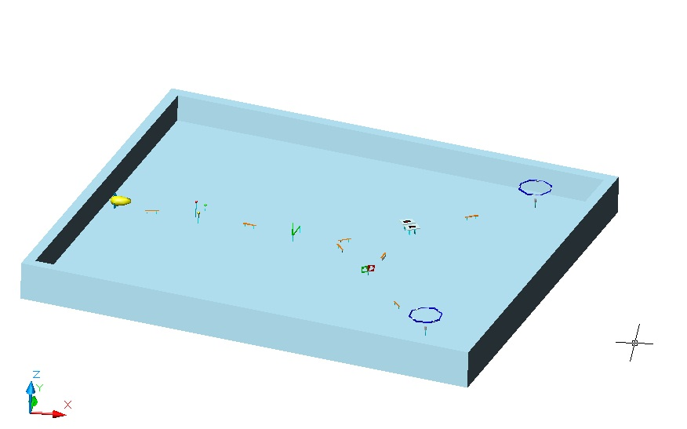

Tank Size ; 25x20x2.5 meter ( availability of swimming pool) Each Object distance is approx. 1 to 2.5 meter.

Yellow colour object is The AUV and we have to go to still the octagon.

The dimension of the arena is given in the link:<https://www.niot.res.in/SAVe/pdf/SAVe_Competition_Target_Details.pdf>

RULES:

They will specify Launching point. Starting from that, AUV have to dive down and follow an "orange path".AUV has to touch a buoy (meant for imitating "collect flowers". Then, AUV has to follow the orange path and pass through a "L" shaped PVC bar (AUV has to pass over this) and have a choice of two direction.

* In the left side route, AUV has to drop markers in bins(Markers may be plastic /metal sheet boards).
* In the right side route, AUV has to fire an arrow through a heart shaped cut out (fire a "torpedo" through a heart cut out).
* There exists a connecting path which joins these two routes. Depends on the time left, AUV can complete both route using the same time.
* Finally, by following available path, they can surface with in the octagon.
* AUV that at least one buoy places at least one marker in the bin and fires at least one torpedo through the heart cutout and surfaces fully within the octagons (no part outside the structure) that complete the mission 100%.

--------------------------------------------------------------------------------------------------------------------------------------------

PROBABLE APPROACH::

----------------------------------

* As they will specify launching point of the AUV so they can keep the AUV in any direction. As from there 5m apart there will be a red buoy(red colour flower) and 2 other buoy of different colour .
* So we can get three reference point from them taking the red one as middle we can get a path.
* We have touch at least one buoy so if we touch the red one as it is in the middle so it could be easier than rotate to the any other buoy and touch them.
* Then there would be an “L” shaped obstacle in between it and the buoys there would be an orange colour path so we have to follow that one and then have to move the boat above the obstacle.
* After it there will be two possible path we have to take any of the two path and have to approach to the next destination if there is two box we have to drop at least one marker in any of the two box .Then instead of going straight we can turn left and through available paths have to go to the heart shaped cut out cartons then through the hole we have to launch at least one torpedo through the heart shaped cut out.
* At the end we have to approach the octa gone. surfaces fully within the octagons (no part outside the structure).
* Then the task is over..

**Here is a link to get an overview from a video:<https://www.youtube.com/watch?v=oKIeFRFRG_A>

Here is the github link of the auv iit bombay (they won the competition in 2016)

:<https://github.com/auv-iitb/matsya_new>

N.B:we have to complete the task in and about half an hour.