**# Sudip Sen**

**#18-05-4534**

**Bangabandhu Sheikh Mujibur Rahman Agricultural University (BSMRAU)**

**Final Exam**

Date: 02-12-2024

**Marks: 50, Time: 2.5 Hour**

1. **Answer the followings: 10**
2. Explain the 68-95-99.7 Rule
3. Explain Type I and Type II Error
4. Differentiate correlation and regression
5. Which type of chart will you suggest to represent the following types of data:
6. Show trends or progress over time
7. Show the distribution of parts within a whole and emphasize the percentage contribution of each part.
8. Show the duration of activities within the project period.
9. Microbial sequencing data.
10. **Prepare a readable and analyzable data file for R from the supplied excel data file (Book1)**

1. **Prepare a bar plot using the prepared dataset containing the following properties- 10**

1. Consider ‘spirulina’ as a factor/treatment/independent variable and ‘Tomato fresh weight’ as dependent variable.
2. Insert error bar and appropriate chart title, xlab and ylab
3. Perform ANOVA test and Tukey HSD test and insert significant lettering in the bar plot.
4. Save/export the final graph as JPEG file
5. **Prepare a boxplot using the prepared dataset containing the following properties- 10**

1. Consider ‘Zinc’ and ‘spirulina’ as a factor/treatment/independent variable and ‘Tomato fresh weight’ as dependent variable.
2. Place the spirulina factor in x axis and group/fill by Zinc factor
3. Insert error bar and appropriate chart title, xlab and ylab
4. Perform ANOVA test and Tukey HSD test and insert significant lettering in the boxplot.
5. Save/export the final graph as JPEG file

**\*\*\*Bonus: Prepare a line graph using provided data set (Book2)**

1. **Explain the following Graphs of nitrogen concentrations and uptakes. 10**

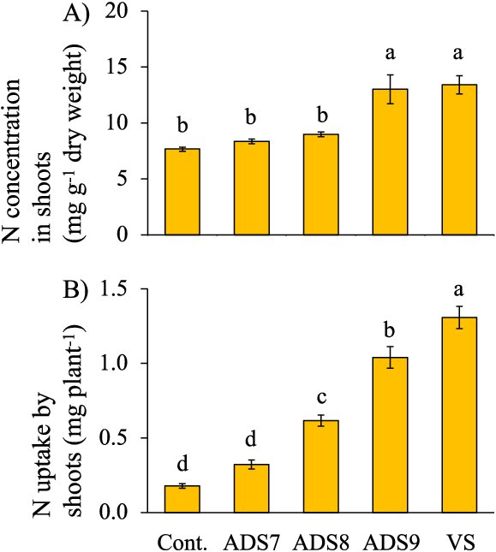

Email your command script (as R file/word file) along with final graphs to [humayun@bsmrau.edu.bd](mailto:humayun@bsmrau.edu.bd) immediate after finishing the exam (not more than 5 minutes).

\*\*\*\****Don’t forget to mention your name and registration number in your email***\*\*\*\*

**Answer to the question no 1:**

**i)** This 68-95-99.7 Rule describes the data distribution of the perfectly normal distribution where **68%** of the data falls within 1st standard deviation of the mean. **95%** of the data falls within two standard deviations of the mean. And overall **99.7%** of the data falls within 3rd standard deviations of the mean.

**ii)**

Type 1 error: When the hypothesis is true but we reject the hypothesis.

Type 2 error: When the hypothesis is false but we accept the hypothesis incorrectly.

**iii)**

Correlation measures the relationship between two variables. This relationship can be positive, negative, or zero. The correlation coefficient ranges from -1 to +1. Regression models the relationship between the dependent and independent variables. It can also suggest the causation of the relationship, where the correlation coefficient cannot imply causation.

**iv)** Use of charts:

1. Show trends or progress over time🡪 **Line chart**
2. Show the distribution of parts within a whole and emphasize the percentage contribution of each part🡪 **Pie chart**
3. Show the duration of activities within the project period🡪 **Grantt chart**
4. Microbial sequencing data🡪 **Phylogenic tree**

**Answer to the question no 3:**

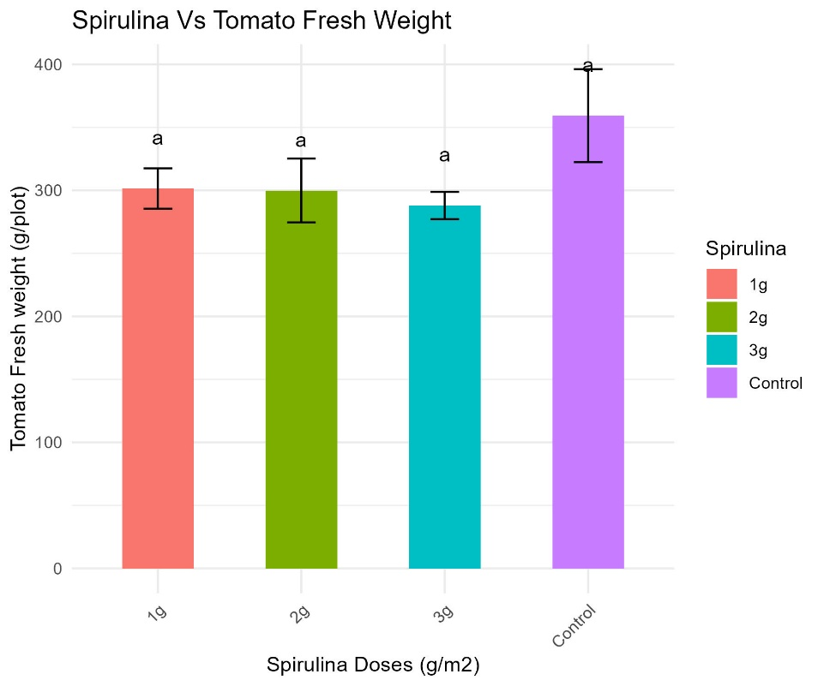

**Answer to the question no 4:**

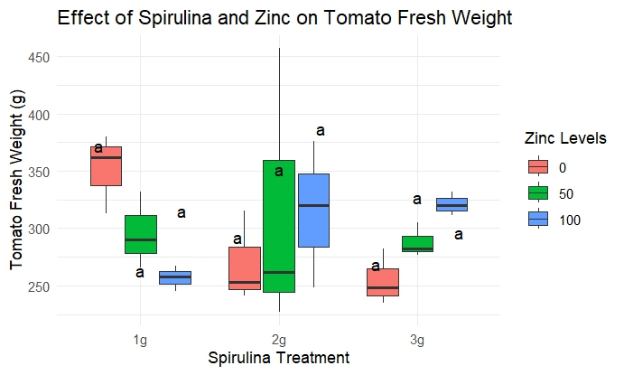

**Answer Bonus:**

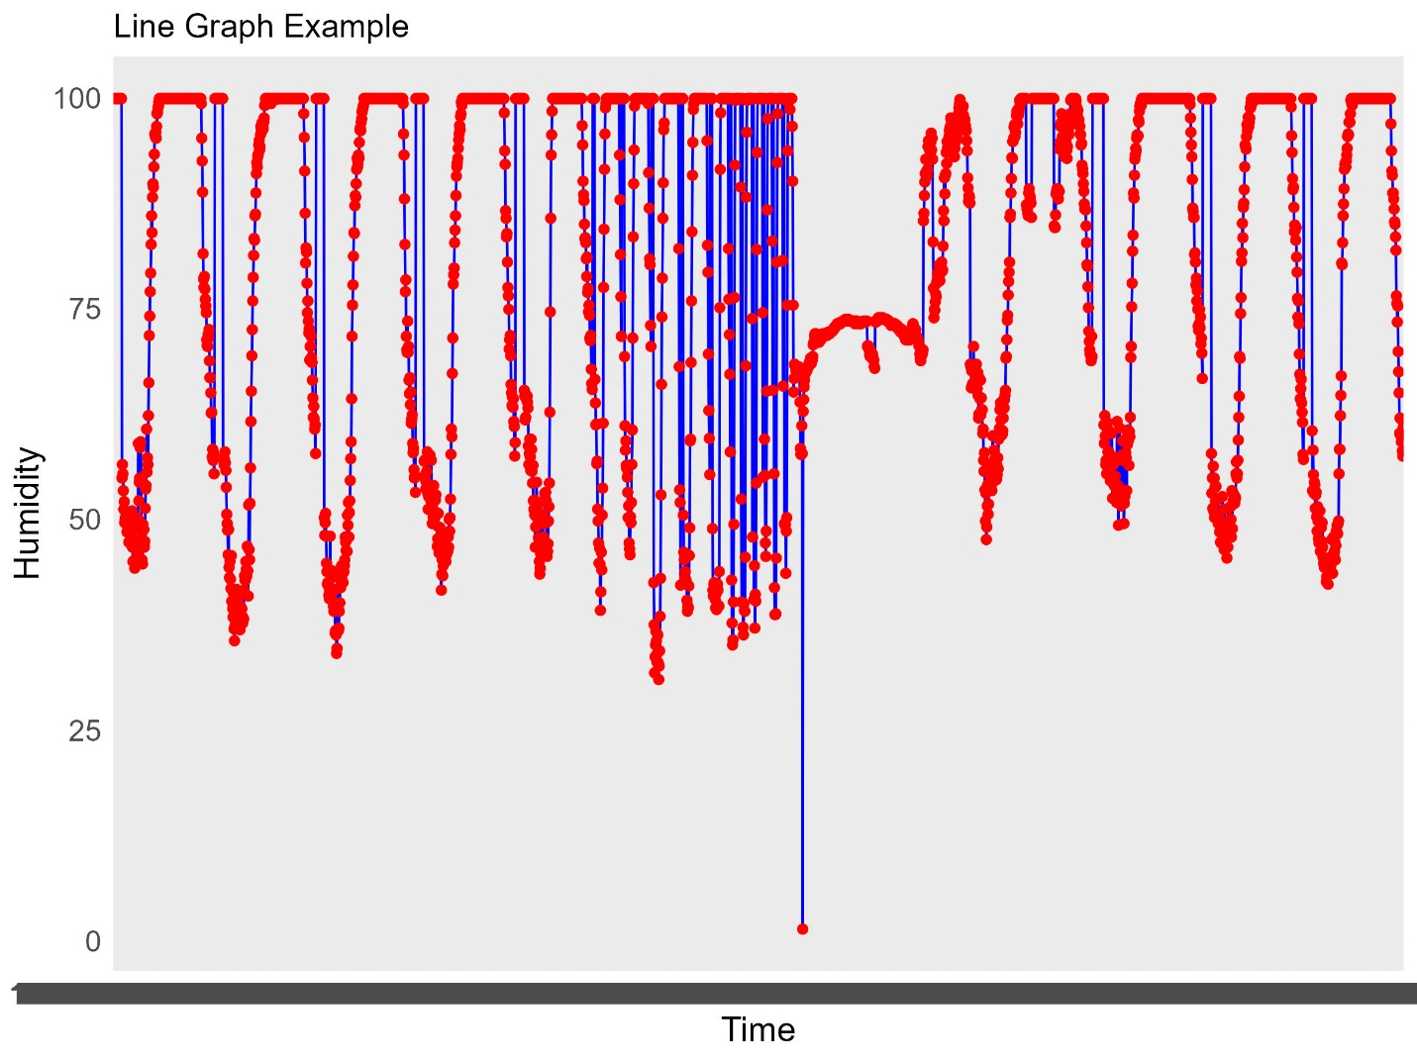

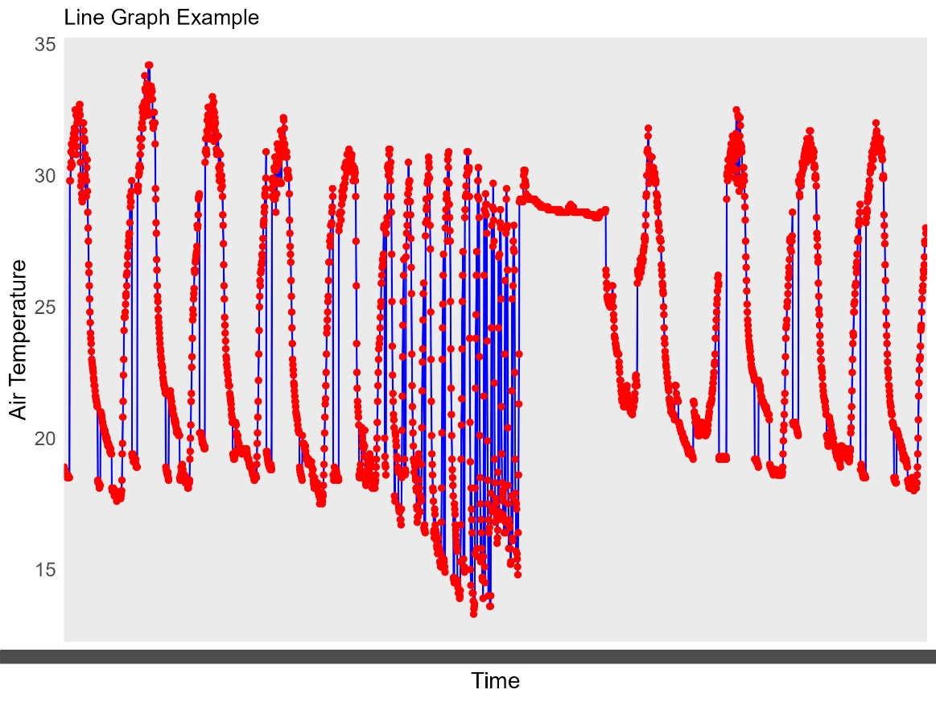

**Answer to the question no 5:**

Graph A shows nitrogen concentration in shoots across treatments. The control (Cont.) has the lowest concentration, while ADS7, ADS8, and ADS9 are similar (annotated 'b'). VS has the highest concentration, which is significantly different from others (annotated 'a').

Graph B depicts nitrogen uptake by shoots. The control has the lowest uptake (annotated 'd'), with ADS7 and ADS8 showing moderate uptake. ADS9 and VS have the highest uptake, with VS being the highest (annotated 'a').

VS and ADS9 treatments improve nitrogen concentration and uptake, while the control group performs the lowest.