

TRIBHUVAN UNIVERSITY
INSTITUTE OF ENGINEERING
NATIONAL COLLEGE OF ENGINEERING

A

MAJOR PROJECT PROPOSAL
ON

A UNIFIED AI TEXT DETECTION, PLAGIARISM ANALYSIS AND DOCUMENT FORENSICS SYSTEM

SUBMITTED BY:
AAVASH TIWARI (NCE080BCT001)
BIJAY NATH SHRESTHA (NCE080BCT009)
RAMESHWOR POUDEL (NCE080BCT028)
SUDIP DHUNGANA (NCE080BCT041)

SUBMITTED TO:
DEPARTMENT OF ELECTRONICS & COMPUTER ENGINEERING

LALITPUR, NEPAL
MARCH 2026

CONTENTS

LIST OF FIGURES iii
LIST OF TABLES iv
LIST OF ABBREVIATIONS v
1. INTRODUCTION 6
1.1 Background 6
1.2 Problem Statements 7
1.3 Objectives 8
1.4 Scope 8
2. LITERATURE REVIEW 9
2.1 Related Work 9
2.2 Related Theory 9
2.2.1 AI Text Detection: RoBERTa and Transformers 9
2.2.2 TF-IDF and Cosine Similarity 10
2.2.3 XMP Metadata and OOXML Forensics 12
2.2.4 Weighted Origin Scoring 13
2.2.5 Stylometric Analysis and Syntactic Fingerprinting 13
3. PROPOSED METHODOLOGY 15
3.1 Feasibility Study 15
3.1.1 Technical Feasibility 15
3.1.2 Economic Feasibility 15
3.1.3 Operational Feasibility 16
3.2 Requirement Analysis 16
3.2.1 Functional Requirements 16
3.2.2 Non-Functional Requirements 18
3.3 Data Collection 18
3.4 Proposed System Design 19
3.5 Model Testing and Evaluation 23
4. TIME SCHEDULE 25
5. EXPECTED OUTPUT 27
5.1 Trained Detection Modules 27
5.2 Web Application 27
6. REFERENCES 28

LIST OF FIGURES
Figure 3.1 : Block Diagram of Proposed System 20
Figure 3.2 : Flow Diagram of System 21
Figure 3.3 : Level 0 DFD Context Diagram 22
Figure 3.4 : Level 1 DFD Internal Process Flow 23

Figure 4.1 : Gantt Chart April to August 2026 25

LIST OF TABLES
Table 3.1 : Economic Estimation 16
Table 3.2 : Dataset Summary: Student Submission Formats 19
Table 3.3 : Dataset Summary: Metadata Fields Extracted per Format 19
Table 3.4 : Module Performance Metrics and Thresholds 24
Table 3.5 : Technology Stack Summary 24

LIST OF ABBREVIATIONS
AI Artificial Intelligence
API Application Programming Interface
CSV Comma Separated Value
DL Deep Learning
DOCX Document XML (Microsoft Word Format)
EXIF Exchangeable Image File Format
GPT Generative Pre-trained Transformer
HTR Handwritten Text Recognition
JSON JavaScript Object Notation
LLM Large Language Model
ML Machine Learning
NCE National College of Engineering
NLP Natural Language Processing
OOXML Office Open XML
OCR Optical Character Recognition
PDF Portable Document Format
PII Personally Identifiable Information
PPTX PowerPoint XML Format
REST Representational State Transfer
TF-IDF Term Frequency-Inverse Document Frequency
UI/UX User Interface / User Experience
XAI Explainable Artificial Intelligence
XML Extensible Markup Language
XMP Extensible Metadata Platform
ZIP Zone Information Protocol (archive format)

1. INTRODUCTION
Academic dishonesty in educational institutions has evolved significantly with the widespread availability of large language models (LLMs) such as ChatGPT, Gemini, and Claude. Students can now generate coherent, well-structured academic essays within seconds, creating a new category of integrity violation that existing tools are unprepared to address. At the same time, collusion among students, where one student shares a document and multiple others submit near-identical copies, remains a persistent challenge that standard checkers fail to trace to its source.
This project addresses these challenges by developing A Unified AI Text Detection, Plagiarism Analysis, and Document Forensics System, an intelligent document integrity system specifically designed for academic institutions. The system integrates three complementary detection layers: AI text detection using the openai-community/roberta-base-openai-detector model from the Hugging Face Transformers library, plagiarism analysis using TF-IDF vectorization and cosine similarity, and document forensics using XMP and OOXML metadata extraction. Together, these layers provide a multi-dimensional integrity assessment that goes far beyond what any single method can achieve.

1.1 Background
The concept of academic plagiarism detection has been practiced by educational institutions for decades. Early tools such as Turnitin and iThenticate operate by comparing submitted text against large databases of web content and previously submitted papers, flagging passages with high textual overlap. These systems work well for detecting verbatim copying from the internet but are fundamentally limited to text-level similarity matching.
Recent advances in natural language processing and transformer-based language models have introduced two new dimensions of academic dishonesty. The first is AI-generated text, where a student submits work produced by a language model without meaningful intellectual contribution. In paraphrased plagiarism, we use similarity-based detection. Standard plagiarism checkers cannot reliably detect either form because they look for matching text strings rather than statistical signatures of machine-generated language.
Anothe problem is collusion, where a group of students shares a single source document and submits variations as individual work. While similarity checkers can flag such submissions, they cannot determine who created the original. When students convert their Word documents to PDF before submission, they reset the visible timestamps, destroying the most obvious forensic evidence. However, as research in digital forensics has shown, XMP metadata embedded in PDF files and OOXML properties stored in Word documents preserve a richer record of authorship and edit history that survives most conversion attempts.
This project proposes a unified system that addresses all three challenges. By combining AI probability scoring, cross-document similarity analysis, and forensic metadata extraction into a single weighted decision engine, the system provides educators with concrete, explainable evidence rather than a single percentage score.

1.2 Problem Statements
The following core problems motivate this project:
- Standard tools cannot detect AI-generated text. Existing plagiarism checkers rely on database matching. Since LLMs generate novel word sequences not stored in any database, these tools return near-zero similarity scores for AI-written essays, providing no warning to the educator.
- Collusion networks are detected but not traced. When multiple students submit similar documents, current tools report the similarity percentage but cannot identify the original creator. A teacher is left knowing that cheating occurred but unable to determine who instigated it.
- File Format conversion erases surface metadata. The most common evasion strategy is to write the essay in Word, copy a peer's text, and convert the file to PDF before submission, effectively resetting the file creation date. Standard tools have no mechanism to recover the authorship information buried in the XMP and OOXML metadata layers.
- No unified open-source tool integrates all three detection layers. Commercial platforms such as Turnitin are expensive and proprietary. No freely available, teacher-facing tool currently combines AI detection, peer-to-peer similarity, and metadata forensics in a single workflow accessible without technical expertise.

1.3 Objectives
The specific objectives of this project are:
i. AI Text Detection. The system integrates the openai-community/roberta-base-openai-detector model from the Hugging Face library, splitting each document into overlapping 400-word chunks and producing a sentence-level heatmap of AI-generated passages.
ii. Plagiarism Analysis. TF-IDF vectorization and cosine similarity serve as the primary detection method, supported by spaCy stylometric analysis, syntactic structural template matching for variable substitution, and sentence-transformers semantic confirmation as a low-weight surety signal.
iii. Document Forensics. XMP metadata is extracted from PDF submissions using pypdf and OOXML core properties from DOCX files using python-docx, with a weighted scoring function ranking students within a collusion cluster to identify the most likely original author.
iv. Weighted Scoring Engine. Outputs from all three modules are combined into a single composite Integrity Score per submission, with configurable weights for each detection layer.
v. Web Dashboard. A React frontend and FastAPI backend allow a teacher to upload a ZIP archive of submissions and receive a full integrity report with visual heatmaps, similarity matrices, and a forensic metadata panel.

1.4 Scope
This project focuses on the academic document integrity domain. The scope includes:
i. Document formats. The system processes student submissions in PDF, DOCX, and PPTX formats, with text extracted using pypdf, python-docx, and python-pptx respectively.
ii. Detection modules. Three analysis modules cover AI-generated text probability, cross-document textual similarity using TF-IDF and supporting stylometric techniques, and forensic metadata analysis from embedded PDF and DOCX properties.
iii. Backend and frontend. A FastAPI backend accepts batch ZIP uploads and returns structured JSON integrity reports, while a React and Tailwind CSS dashboard displays AI heatmaps, similarity matrices, forensic metadata panels, and a composite Integrity Score for each submission.

2. LITERATURE REVIEW

2.1 Related Work
Solaiman et al. [1] showed that a fine-tuned binary classifier trained on GPT-2 outputs could exceed 95 percent detection accuracy, and their model is now available as the openai-community/roberta-base-openai-detector on the Hugging Face Hub [9], forming the core of the AI detection module in this project. The underlying RoBERTa architecture, described by Liu et al. [8], provides the transformer backbone. Mitchell et al. [2] proposed DetectGPT, a zero-shot approach based on log-probability curvature, though its high inference cost rules it out for batch processing of student submissions and motivates the choice of a fine-tuned classifier here. Guo et al. [3] demonstrated that paraphrase-based humanization attacks can reduce RoBERTa detector accuracy from 95 percent to below 50 percent, which directly justifies the multi-layer design of this system so that forensic and plagiarism evidence remains available when AI detection alone is insufficient.
For plagiarism detection, Salton et al. [4] introduced the vector space model that underpins TF-IDF and cosine similarity, and Alzahrani et al. [5] confirmed through systematic review that this approach remains competitive with more complex semantic methods for near-verbatim and lightly paraphrased copying when batch processing speed matters. On the forensics side, Kieseberg et al. [6] showed that the xmpMM:DocumentID field in PDF XMP metadata frequently survives format conversion from Word, which is the forensic foundation of the collusion detection feature in this project. Finally, Foltynek et al. [7] reviewed a decade of academic plagiarism research and specifically recommended combining stylometric, metadata, and semantic approaches into layered systems, directly validating the three-module architecture adopted here.

2.2 Related Theory

2.2.1 AI Text Detection: RoBERTa and Transformers
RoBERTa (Robustly Optimized BERT Pretraining Approach) is a transformer-based language model that uses bidirectional self-attention across all layers. When fine-tuned as a binary sequence classifier, RoBERTa takes a sequence of up to 512 tokens as input and outputs a probability distribution over two labels: Real (human-written) and Fake (AI-generated).
The self-attention score between token i and token j is computed using the scaled dot-product formula:
Attention(Q, K, V) = softmax( QKᵀ / √dk ) · V
Where,
- Q is query matrix derived from input token embeddings.
- K is key matrix derived from input token embeddings.
- V is value matrix derived from input token embeddings.
- Dk is dimension of the key vectors; division by √dk prevents gradient vanishing in deep stacks.
- QKᵀ / √dk is scaled dot-product attention score between every pair of tokens.
The binary classification is performed by a linear layer on top of the [CLS] token embedding, followed by softmax:
P(Fake | x) = softmax( W · h[CLS] + b )
Where,
- x is the input text chunk being classified.
- h[CLS] is final hidden state of the [CLS] token from the RoBERTa encoder.
- W, b is learned classification weight matrix and bias vector.
- P(Fake | x) is predicted probability that chunk x was generated by an AI language model.

2.2.2 TF-IDF and Cosine Similarity
Term Frequency-Inverse Document Frequency (TF-IDF) is a numerical statistic that quantifies the importance of a word in a document relative to a corpus. For a word w in document d within a corpus D containing N documents, the TF-IDF weight is defined as:
TF-IDF(w, d, D) = TF(w, d) × log( N / DF(w, D) )
Where,
- w is the term being weighted.
- d is the document chunk containing the term.
- D is the full corpus of all student submissions.
- TF(w, d) is raw frequency of word w in document d.
- N is total number of document chunks in the corpus.
- DF(w, D) is number of chunks across the corpus that contain word w.
Each document is represented as a TF-IDF weight vector in a high-dimensional space. The cosine similarity between two document vectors A and B is:
CosineSim(A, B) = (A · B) / ( ‖A‖ × ‖B‖ )
Where,
- A, B is TF-IDF vector representations of two document chunks being compared.
- A · B is dot product of the two vectors, measuring shared weighted term overlap.
- ‖A‖, ‖B‖ is Euclidean norms of each vector, used to normalise the score to the range 0 to 1.
- CosineSim is output similarity score; 1.0 means identical, 0.0 means no shared vocabulary.
The plagiarism analysis module strengthens this core TF-IDF and cosine similarity approach with three supplementary techniques that all operate within the same module. First, chunk-level stylometric analysis using spaCy extracts a feature vector of writing-style measurements per 400-word chunk, including average word length, sentence length distribution, punctuation rates, part-of-speech ratios, and connector word frequency. Two chunks with matching style vectors but low TF-IDF similarity indicate vocabulary-replaced copying. Second, syntactic structural template matching detects variable substitution plagiarism by replacing variable symbols with positional placeholders and comparing the resulting sentence templates, catching the case where a student replaces every x with θ throughout a mathematical proof. Third, semantic similarity using the sentence-transformers all-MiniLM-L6-v2 model encodes each chunk as a 384-dimensional meaning vector and computes cosine similarity in semantic space. This third technique is used only as a low-weight confirmation signal in rare cases where two chunks share the same meaning with entirely different vocabulary, since the primary evidence comes from TF-IDF overlap, stylometric matching, and structural templates. Together these four techniques form a single unified plagiarism analysis module that handles direct copying, synonym substitution, variable renaming, and meaning-based paraphrasing without requiring separate processing pipelines.

2.2.3 XMP Metadata and OOXML Forensics
Every document carries two types of metadata. The first is file system metadata stored by the operating system, which shows the created date, modified date, and file size visible in Windows Explorer. This is unreliable for forensic purposes because copying or moving a file resets the created date. The second is embedded metadata stored inside the file bytes themselves. This travels with the file regardless of how many times it is copied, emailed, or uploaded. The forensics module uses only embedded metadata and ignores file system metadata completely.
For PDF files, pypdf reads two embedded layers in a single pass. The first layer is the Document Information Dictionary, present in every PDF regardless of how it was created. It provides /Author which records who created the source document, /Creator which records the software used to author the original file, /Producer which records the software that converted it to PDF, /CreationDate which is the original creation timestamp, and /ModDate which updates each time the PDF is re-exported. The second layer is the XMP metadata packet, an XML block embedded inside the PDF. The xmpMM:DocumentID field is the forensic cornerstone: it is assigned once when a document is first created and never changes regardless of how many times the file is saved, exported, or copied. If two PDF submissions share the same DocumentID they were exported from the exact same source document, which is direct evidence of collusion. The xmpMM:InstanceID changes with every save or export and identifies which specific version was submitted. The xmp:CreatorTool records the exact software version used to create the file. When the XMP packet is absent, which occurs with PDFs from older or simpler tools, the system falls back to the Document Information Dictionary fields only and marks DocumentID-based collusion detection as unavailable for that file.
For DOCX files, python-docx reads the core properties from docProps/core.xml inside the document ZIP structure. This provides dc:creator which is the account name of whoever first created the document, cp:lastModifiedBy which is the account name of whoever last saved it, dcterms:created which is the original creation timestamp embedded when the file was first made, dcterms:modified which is the last save timestamp, and cp:revision which is the total number of times Save was pressed since the document was created. A genuine 20-page assignment typically has a revision count of 30 or above across multiple writing sessions. A revision count of 2 or 3 on a long submission is a strong indicator the file was not genuinely authored by the submitter. The total editing time is stored separately in docProps/app.xml under the ep:TotalTime field, which records the total minutes the document was actively open for editing. The system reads this by treating the DOCX as a ZIP archive and parsing app.xml directly, since python-docx does not expose this field through its standard interface. Unlike PDF files, DOCX files do not carry a DocumentID equivalent, so collusion detection for Word submissions relies entirely on revision count, editing time, and author name rather than a shared document identifier. The same OOXML metadata structure also exists in PPTX and XLSX files, though the system currently processes only DOCX files through this forensic path.

2.2.4 Weighted Origin Scoring
When multiple student submissions share the same DocumentID (forming a collusion cluster), the weighted origin scoring function ranks each submission by its probability of being the original source. The score S for submission i is computed as:
Sᵢ = 50 × norm(Rᵢ) + 30 × norm(Tᵢ) + 20 × Aᵢ
Where,
- norm(Rᵢ) is normalised revision count of submission i, equal to Rᵢ / max(R).
- norm(Tᵢ) is normalised total editing time of submission i, equal to Tᵢ / max(T).
- Aᵢ is author match indicator, 1 if dc:creator or cp:lastModifiedBy matches the registered student name, 0 otherwise.
- Sᵢ is composite origin score; the highest score identifies the most likely original author.

2.2.5 Stylometric Analysis and Syntactic Fingerprinting
Stylometric analysis quantifies the writing style of a document through measurable linguistic features rather than vocabulary content. For each 400-word chunk, the spaCy en_core_web_sm pipeline extracts six feature groups. Lexical features include average word length, type-token ratio (vocabulary richness), and the proportion of long words exceeding six characters. Structural features capture average sentence length, its standard deviation, and the range between the longest and shortest sentence in the chunk. Punctuation features measure the per-word rate of commas, semicolons, colons, and parentheses. Part-of-speech features record the ratio of nouns, verbs, adjectives, adverbs, and pronouns as well as the passive voice construction rate. Connector features count the per-word frequency of academic connectors such as furthermore, consequently, and nevertheless alongside informal connectors such as also, but, and so. Together these features form a stylometric vector per chunk.
The stylometric distance between two chunks is computed as the cosine similarity of their feature vectors, operating entirely separately from TF-IDF word vectors. A chunk in Student B’s document that shows stylometric similarity above 0.80 to a chunk in Student A’s document, while being stylometrically inconsistent with the surrounding chunks of B’s own document, is flagged as a style outlier and escalated for manual review.
Variable substitution detection addresses the specific case where a student copies a mathematical derivation and replaces every occurrence of one variable symbol with another, for example replacing x with θ and α with η throughout an optimisation proof. TF-IDF cosine similarity cannot detect this because the variable tokens differ between the two documents. The spaCy dependency parser assigns each token a syntactic role within its sentence. For single-character tokens and Greek letters tagged as NOUN or SYM, the system records their dependency label, their position in the sentence structure, and the sequence of surrounding POS tags, producing a structural template string such as [PRON][VERB][NOUN][VAR1][NUM][VERB][VAR1]=[VAR1]−[VAR2]∇[VAR3]([VAR1]). Two chunks whose structural templates match above a 0.90 threshold are flagged as mathematically equivalent regardless of the actual symbols used, catching variable substitution plagiarism that all other modules miss.

3. PROPOSED METHODOLOGY
This chapter describes the complete methodology for developing the system, from feasibility analysis and requirements capture through data collection, system design, module architecture, and testing strategy.

3.1 Feasibility Study

3.1.1 Technical Feasibility
All required technologies are openly available and have mature community support. Python 3.10 and above provides a stable environment for data processing and model inference. The Hugging Face Transformers library provides a stable Python API for loading and running the RoBERTa AI detection model without GPU requirements. The scikit-learn library provides robust TF-IDF vectorization and cosine similarity implementations. The pypdf and python-docx libraries provide direct access to XMP and OOXML metadata. FastAPI provides an asynchronous framework for the REST API, and React with Tailwind CSS provides the frontend dashboard. The system runs on any modern laptop with 8 GB of RAM without expensive cloud infrastructure.

3.1.2 Economic Feasibility
This project requires no financial expenditure beyond standard development hardware. All frameworks and development tools are open-source. The AI detection model is downloaded from the Hugging Face Hub at no cost and cached locally. The web application can be demonstrated locally or deployed to free-tier cloud platforms.

Table 3.1 : Economic Estimation
Item | Estimated Cost
Domain (.com.np) | Free / Rs. 1,500/year
Hosting (Render / Railway) | Free Tier
AI Model (Hugging Face) | Free (Open Source)
Python Libraries | Free (Open Source)
Development Tools (VS Code, GitHub) | Free
Miscellaneous (Printing, Stationery) | Rs. 1,000 – 1,500
Total Initial Cost | Rs. 1,500 – 3,000

3.1.3 Operational Feasibility
The proposed system is designed with the non-technical end user, the course instructor or academic integrity officer, in mind. The interface provides a single file upload control for the ZIP archive of student submissions. The teacher receives all results on a single dashboard page without requiring any understanding of the underlying ML models or forensic metadata standards. The modular architecture ensures that each detection module can be updated independently as new AI detection models become available, without rebuilding the entire pipeline.

3.2 Requirement Analysis

3.2.1 Functional Requirements
R.1: File Upload and Extraction
- R.1.1: The system shall accept a ZIP archive containing PDF, DOCX, and PPTX files as the primary input.
- R.1.2: On upload, the system shall identify each file by its extension and route it to the appropriate text extraction handler.
- R.1.3: The system shall extract plain text using pypdf for PDFs and python-docx for DOCX files.

R.2: AI Text Detection
- R.2.1: The system shall split each document into overlapping chunks of 400 words with a 50-word overlap.
- R.2.2: Each chunk shall be scored by the openai-community/roberta-base-openai-detector model from Hugging Face Transformers.
- R.2.3: The system shall display a sentence-level heatmap where red indicates high AI probability and green indicates low AI probability.
- R.2.4: An overall document AI probability percentage shall be the weighted average of all chunk scores.

R.3: Plagiarism Analysis
- R.3.1: The system shall convert extracted text into TF-IDF vectors using scikit-learn's TfidfVectorizer.
- R.3.2: Pairwise cosine similarity shall be computed for all n(n-1)/2 document combinations.
- R.3.3: Results shall be displayed as a color-coded similarity matrix. Cells above 0.80 are flagged yellow; cells above 0.95 are flagged red.
- R.3.4: The system shall use spaCy en_core_web_sm to extract per-chunk stylometric feature vectors comprising average word length, sentence length distribution, punctuation rates, POS ratios, and connector word frequency. Pairs where stylometric similarity exceeds 0.80 while TF-IDF similarity is below 0.60 shall be flagged as vocabulary-replaced copying within the plagiarism analysis module.
- R.3.5: The system shall detect variable substitution plagiarism by extracting syntactic structural templates from chunks containing single-character tokens or Greek letters, replacing each variable symbol with a positional placeholder such as VAR1 and VAR2, and flagging chunk pairs whose structural templates match above a 0.90 threshold as part of the plagiarism analysis output.
- R.3.6: For additional surety in rare cases where vocabulary and style evidence is inconclusive, the system shall encode each chunk using the sentence-transformers all-MiniLM-L6-v2 model and compute semantic cosine similarity between chunk pairs. This semantic score shall contribute a low weight of 0.10 to the final plagiarism score and shall not independently trigger a plagiarism flag. It serves only as a supporting confirmation signal when the primary techniques already indicate suspicious similarity.

R.4: Document Forensics
- R.4.1: The system shall extract XMP metadata including xmpMM:DocumentID, xmpMM:InstanceID, xmp:CreatorTool, and pdf:Producer from each PDF using pypdf.
- R.4.2: For DOCX files, the system shall extract OOXML core properties including dc:creator, cp:lastModifiedBy, cp:revision, and cp:modified using python-docx.
- R.4.3: The system shall group all submissions sharing the same DocumentID into a collusion cluster and apply the weighted origin scoring function to identify the most likely original creator.

3.2.2 Non-Functional Requirements
Performance
- All model inference calls shall complete processing of a 50-submission batch within 5 minutes on a server with 4 CPU cores and 8 GB RAM.
- The web dashboard shall display results within 3 seconds of analysis completion.

Scalability
- The system shall support batch processing for up to 200 student submissions using asynchronous task queues without architectural changes.

Reliability
- The system shall handle corrupted or password-protected PDF files gracefully, logging an error and continuing with remaining submissions.
- The AI detection module shall fall back to a locally cached model version if the Hugging Face Hub is unavailable at runtime.

Security and Privacy
- All uploads shall be validated by MIME type before processing. Raw student file content shall not be persisted beyond the duration of the analysis session.

3.3 Data Collection
The system does not require pre-labeled training datasets for the plagiarism or forensics modules, as these rely on mathematical computation and rule-based logic respectively. The AI detection module uses a pre-trained model from the Hugging Face Hub that requires no additional training data. The following tables describe the input data formats the system is designed to process.
Table 3.2 : Dataset Summary: Student Submission Formats
Attribute | Detail
Input Type | Files/ZIP archive of studentor users submission files
Supported Formats | PDF (.pdf), Word Document (.docx), PowerPoint (.pptx)
Typical Batch Size | 10 to 200 student submissions per ZIP
Expected File Size | 50 KB to 5 MB per submission
Text Extraction | pypdf (PDF), python-docx (DOCX), python-pptx (PPTX)
Pre-processing | Unicode normalization, stop-word removal, sentence tokenization via NLTK punkt

Table 3.3 : Dataset Summary: Metadata Fields Extracted per Format
File Format | Metadata Standard | Key Fields Extracted
PDF | XMP (ISO 16684-1) | xmpMM:DocumentID, xmpMM:InstanceID, xmp:CreatorTool, pdf:Producer
DOCX | OOXML core.xml | dc:creator, cp:lastModifiedBy, cp:revision, cp:modified
PPTX | OOXML core.xml | dc:creator, cp:lastModifiedBy, cp:revision, cp:modified
PDF (scanned) | EXIF (image layer) | GPS coordinates, capture timestamp, camera model

3.4 Proposed System Design
The system consists of three architectural layers: a data pipeline layer handling file ingestion, text extraction, and metadata extraction; a processing layer containing the three detection modules; and an application layer comprising the FastAPI backend and the React frontend dashboard.
The overall system operates in a single batch-analysis direction. A teacher uploads a ZIP archive through the frontend. The backend extracts all files, routes each to the appropriate text extractor and metadata extractor, and distributes the extracted content to the three detection modules running in parallel. The AI detection module returns a per-document AI probability score and sentence-level scores. The plagiarism module returns a pairwise similarity matrix. The forensics module returns a metadata table and collusion cluster report. All results are merged by the Weighted Scoring Engine into a composite Integrity Score per submission and returned to the frontend for display.
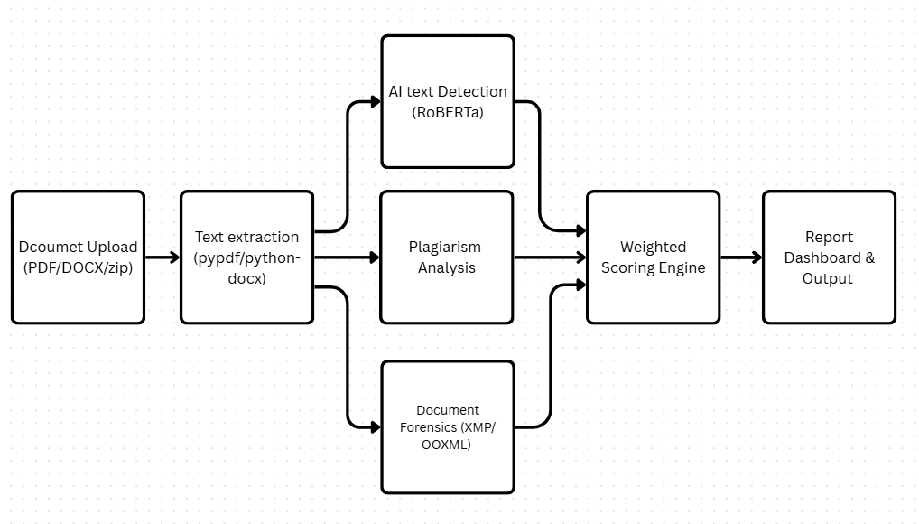
Figure 3.1 : Block Diagram of Proposed System
The block diagram illustrates the end-to-end data flow of the proposed system. A ZIP archive submitted by the teacher passes through a File Ingestion and Text Extraction stage before being distributed simultaneously to three parallel processing modules: AI Text Detection using RoBERTa, Plagiarism Analysis using TF-IDF and cosine similarity, and Document Forensics using XMP and OOXML metadata extraction. The outputs of all three modules converge at the Weighted Scoring Engine, which produces a composite Integrity Score for each submission and forwards the aggregated results to the Report Dashboard for visualization.
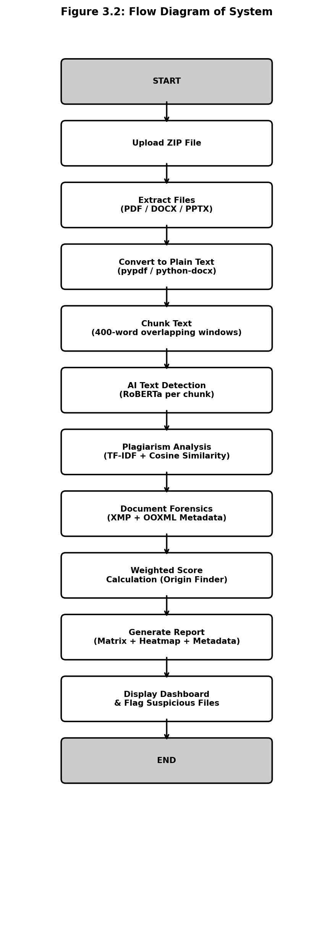
Figure 3.2 : Flow Diagram of System
The flow diagram traces the sequential execution of the system from ZIP upload through file extraction, format identification, text chunking, and analysis by the three detection modules. After each module produces its output, the results converge at the Weighted Scoring Engine, which calculates a composite Integrity Score for each student submission. The Report Generation stage formats all outputs into the visual dashboard and downloadable PDF report returned to the teacher.
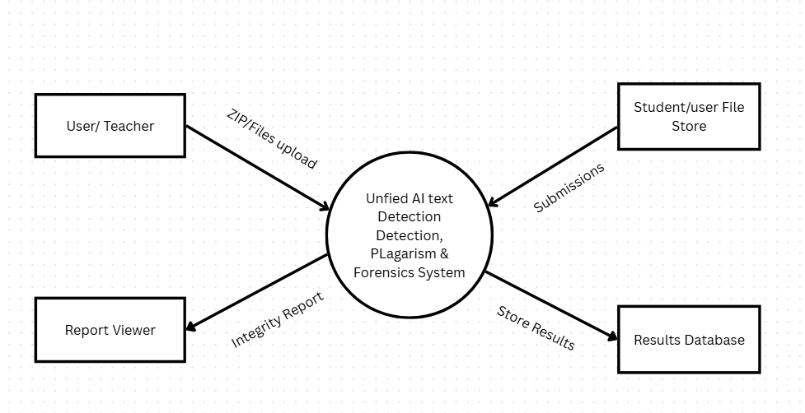
Figure 3.3 : Level 0 DFD — Context Diagram
The Level 0 Data Flow Diagram presents the system as a single system process at the center of its operational environment. The four external entities are the Teacher who provides the ZIP / Files Upload, the File DB holding raw submissions, the Report Viewer who consumes the output integrity report, and the Results Database where findings are stored for audit. All data flows between external entities and the system are labeled to indicate the nature of each exchange.
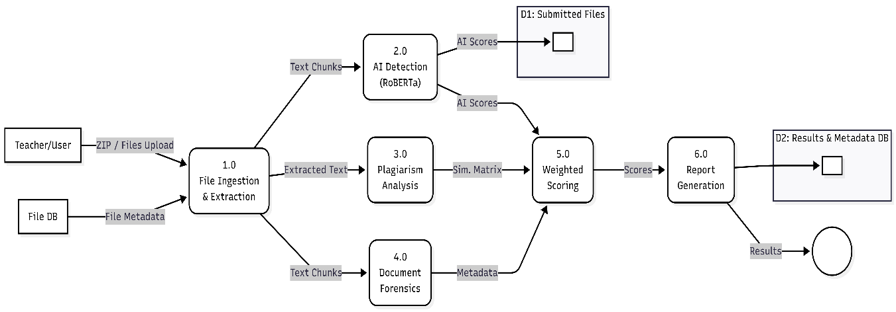
Figure 3.4 : Level 1 DFD — Internal Process Flow

The Level 1 DFD decomposes the central system process into six sub-processes. Process 1.0 handles file ingestion and text extraction from inputs provided by the Teacher and Teacher and File DB external entities. Processes 2.0, 3.0, and 4.0 perform AI text detection, plagiarism analysis, and document forensics respectively, writing intermediate results to Data Store D1. Process 5.0 aggregates outputs into weighted scores, and Process 6.0 generates the final integrity report, writing completed results to Data Store D2.

3.5 Model Testing and Evaluation
Each detection module will be evaluated independently before integration. The AI detection module will be tested on a balanced dataset of 200 human-written student essays and 200 GPT-4 generated essays at equivalent word counts. Performance will be measured using accuracy, precision, recall, and F1 score, with F1 as the primary metric. The plagiarism module will be tested using 20 document pairs with known similarity levels from 0 percent to 100 percent. The forensics module will be tested by generating 30 PDF files from the same source DOCX, verifying 100 percent DocumentID recall.

Table 3.4 : Module Performance Metrics and Thresholds
Module | Key Metric | Target Threshold
AI Text Detection | F1 Score | >= 0.85
Plagiarism Analysis | Precision at 0.80 threshold | >= 0.90
Document Forensics | DocumentID Recall | 100% within source cluster
Weighted Score | Overall Integrity Accuracy | >= 0.80 on labelled set

Table 3.5 : Technology Stack Summary
No. | Module | Algorithm | Task Type
1 | AI Text Detection | RoBERTa (Hugging Face) | Classification
2 | Plagiarism Analysis | TF-IDF + Cosine Similarity; with spaCy stylometric analysis, syntactic structural template matching, and sentence-transformers semantic confirmation (low weight, used for surety in rare cases) | Similarity
3 | Document Forensics | XMP + OOXML Extraction | Rule-based
4 | Weighted Scoring | Point-based aggregation | Pipeline

4. TIME SCHEDULE
The Gantt chart below presents the project time schedule covering the period from April 2026 to August 2026. Planning, literature review, and requirement analysis occupy the first two weeks of April. System design follows in weeks three and four. The three detection modules are developed in parallel during May and the first half of June, allowing independent testing before integration. Backend API development and frontend dashboard construction are scheduled for June and July. Testing, performance evaluation, and documentation run concurrently during July and August, with the final report and deployment demo in the last two weeks of August.
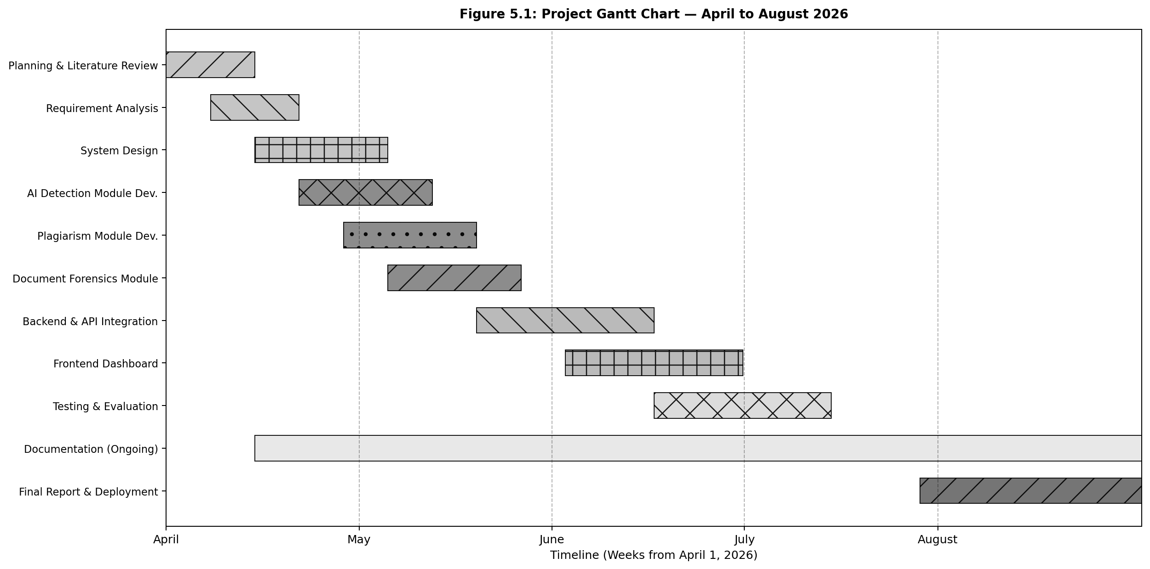

Figure 4.1 : Gantt Chart — April to August 2026

The Gantt chart displays the project timeline across twenty-two weeks from April to August 2026. Each bar represents a major project activity. Planning and design tasks occupy the first four weeks. The three detection modules are developed in weeks three through eleven. Integration, backend, and frontend work span weeks eight through fourteen. Testing, documentation, and deployment are scheduled for weeks twelve through twenty-two, with documentation running continuously as a background activity throughout the entire project duration.

5. EXPECTED OUTPUT
At the successful completion of this project, the following outputs are expected.

5.1 Trained Detection Modules
The system will deliver three functional detection modules. The AI text detection module, built on the openai-community/roberta-base-openai-detector, processes a 2,000-word essay in under 30 seconds on a standard CPU and targets an F1 score of 0.85 or above. The plagiarism analysis module, using TF-IDF and cosine similarity as its primary method with spaCy stylometric and structural template support, handles a batch of 50 submissions and returns a full pairwise similarity matrix with chunk-level match highlighting within 60 seconds, targeting precision of 0.90 or above at the 0.80 threshold. The document forensics module reads embedded PDF and DOCX metadata using pypdf and python-docx, groups submissions sharing the same xmpMM:DocumentID into collusion clusters with 100 percent recall, and ranks cluster members using the weighted origin scoring formula to identify the most likely original author.

5.2 Web Application
A FastAPI backend will serve endpoints for batch ZIP upload, returning structured JSON responses with AI scores, similarity matrices, metadata tables, and composite Integrity Scores. A React and Tailwind CSS frontend dashboard will present three views — an AI Detection heatmap, a Plagiarism Matrix with side-by-side passage comparison, and a Forensics panel showing metadata fields and collusion cluster rankings. A downloadable PDF report covering all three detection layers will be generated for each batch, formatted for use in academic integrity proceedings.

6. REFERENCES
[1] I. Solaiman, M. Brundage, J. Clark, A. Askell, et al., “Release Strategies and the Social Impacts of Language Models,” arXiv preprint arXiv:1908.09203, 2019.
[2] E. Mitchell, Y. Lee, A. Khazatsky, C. Manning, and C. Finn, “DetectGPT: Zero-Shot Machine-Generated Text Detection using Probability Curvature,” in Proceedings of ICML 2023, 2023.
[3] Y. Guo, R. Zhang, C. Xie, et al., “How Close is ChatGPT to Human Experts? Comparison Corpus, Evaluation, and Detection,” arXiv preprint arXiv:2301.07597, 2023.
[4] G. Salton, A. Wong, and C. S. Yang, “A Vector Space Model for Automatic Indexing,” Communications of the ACM, vol. 18, no. 11, pp. 613–620, 1975.
[5] S. M. Alzahrani, N. Salim, and A. Abraham, “Understanding Plagiarism Linguistic Patterns, Textual Features, and Detection Methods,” IEEE Transactions on Systems, Man, and Cybernetics, vol. 42, no. 2, pp. 133–149, 2012.
[6] P. Kieseberg, M. Leithner, M. Mulazzani, et al., “Forensic Analysis of PDF Metadata,” in Proceedings of the 8th International Conference on Advances in Mobile Computing and Multimedia, 2014.
[7] T. Foltynek, D. Meuschke, and B. Gipp, “Academic Plagiarism Detection: A Systematic Literature Review,” ACM Computing Surveys, vol. 52, no. 6, pp. 1–42, 2019.

