ANALOG COMMUNICATION TECHNIQUE LAB

EXPERIMENT 1

AIM

**To Generate Sine wave, square wave, triangle wave of frequency 1MHZ & analyse its frequency spectrum.**

CODE (WAVES WITH FREQUENCY 1MHZ)

a=4;

f=1000000;

FS=500000;

t=0:0.001:10;

subplot(221)

x=a*sin(2*pi*f/FS*t);

plot(t,x);

xlabel("Time");

ylabel("Amplitude");

title("Sine Wave");

subplot(222)

x=a*square(2*pi*f/FS*t,25);

plot(t,x);

xlabel("Time");

ylabel("Amplitude");

title("Square Wave");

subplot(223)

x=a*sawtooth(2*pi*f/FS*t,0.5);

plot(t,x);

xlabel("Time");

ylabel("Amplitude");

title("Triangular Wave");

OUTPUT

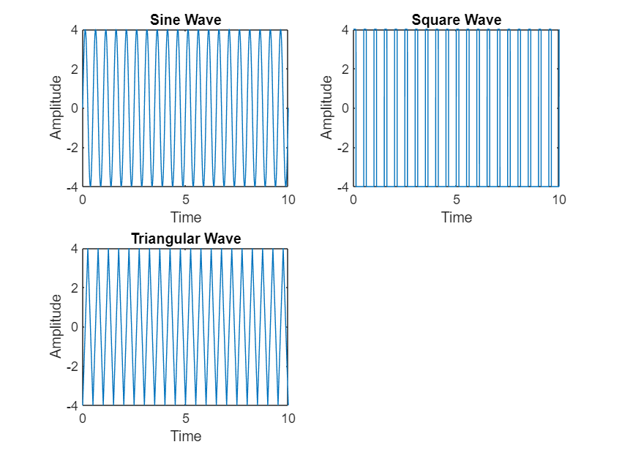

CODE (FREQUENCY SPECTRUM)

a = 4 ;

f = 1000000;

FS = 500000;

t = 0 : 0.001 : 10 ;

x = a * sin ( 2 * pi * f / FS * t );

title("B220061");

subplot(321);

plot(t,x);

xlabel("Time");

ylabel("Amplitude");

title("Sine wave");

subplot(322);

u = abs(fft(x));

plot(u);

title("Sine wave spectrum");

subplot(323);

x = a * square ( 2 * pi * f / FS * t ,0.5);

plot(t,x);

xlabel("Time");

ylabel("Amplitude");

title("Square wave");

subplot(324);

u = abs(fft(x));

plot(u);

title("Square wave spectrum");

subplot(325);

x = a * sawtooth ( 2 * pi * f / FS * t , 0.5);

plot(t,x);

xlabel("Time");

ylabel("Amplitude");

title("Triangle wave");

subplot(326);

u = abs(fft(x));

plot(u);

title("Triangle wave spectrum");

OUTPUT

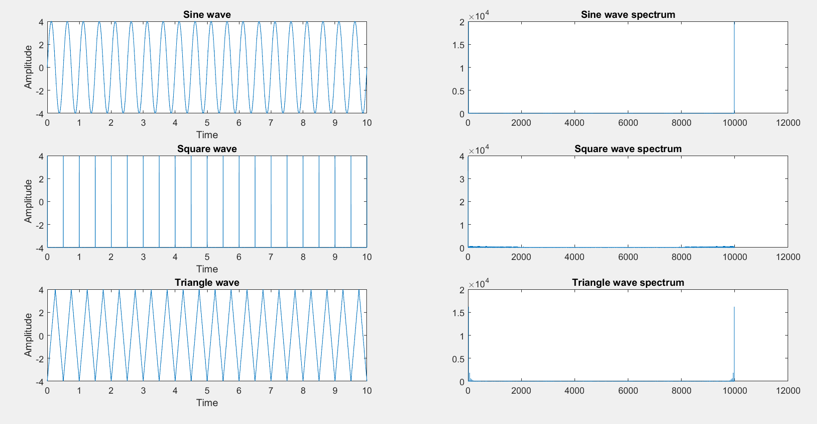

CONCLUSION

**Today, The generation of a signal (sine, square and triangular) with a particular frequency has been done and as well as the frequency contents of the signals were verified using FFT. FFT provides the spectrum of the signal. Spectrum means the frequency of the signal.**

SUBMITTED BY:-

NAME: SUDIP NAYAK

ROLL N0: B220061

BRANCH: ETC (4TH SEM)