ANALOG COMMUNICATION TECHNIQUE LAB

EXPERIMENT 2

AIM

**To generate a modulating signal, carrier signal and modulated signal using Amplitude Modulation Technique.**

SOFTWARE USED

**MATLAB and SimuLink**

THEORY

**Amplitude modulation is a technique used for transmitting messages with a radio carrier wave. In amplitude modulation the amplitude of the carrier wave is varied in proportion to that of the message signal, such as an audio signal. According to the standard definition “The amplitude of the carrier signal varies in accordance with the instantaneous amplitude of the modulating signal.” Which means, the amplitude of the carrier signal containing information varies as per the amplitude of the signal containing information, at each instant.**

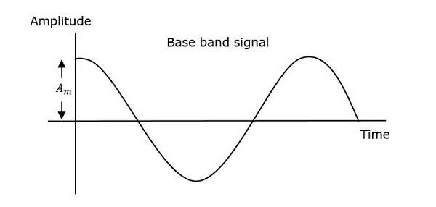





CODE (MATLAB)

Am = 1; %Modulating signal amplitude

fm = 2; %Modulating signal frequency

t = 0 : 0.001 : 1 ;

mt = Am * sin (2*pi*fm*t);

Ac = 2;

fc = 50 ;

ct = Ac * sin (2*pi*fc*t);

subplot(3,2,1);

plot(t,mt);

xlabel('Time');

ylabel('Amplitude');

title('Message signal');

subplot(322);

plot(t,ct);

xlabel('Time');

ylabel('Amplitude');

title('Carrier signal');

subplot(323);

st = (1 + (0.5).*mt).*ct;

plot(t,st);

xlabel('Time');

ylabel('Amplitude');

title('50% under modulated signal');

subplot(324);

st = (1 + (0.9).*mt).*ct;

plot(t,st);

xlabel('Time');

ylabel('Amplitude');

title('90% under modulated signal');

subplot(325);

st = (1 + (1).*mt).*ct;

plot(t,st);

xlabel('Time');

ylabel('Amplitude');

title('100% modulated signal');

subplot(326);

st = (1 + (1.5).*mt).*ct;

plot(t,st);

xlabel('Time');

ylabel('Amplitude');

title('150% over modulated signal');

OUTPUT

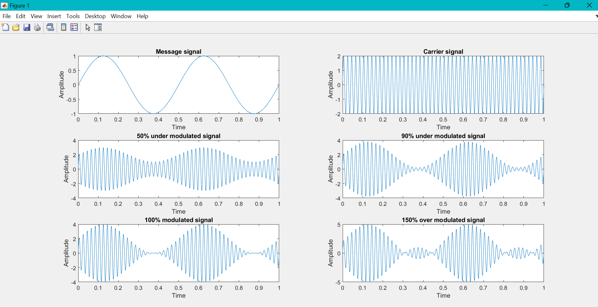

SIMULINK MODEL

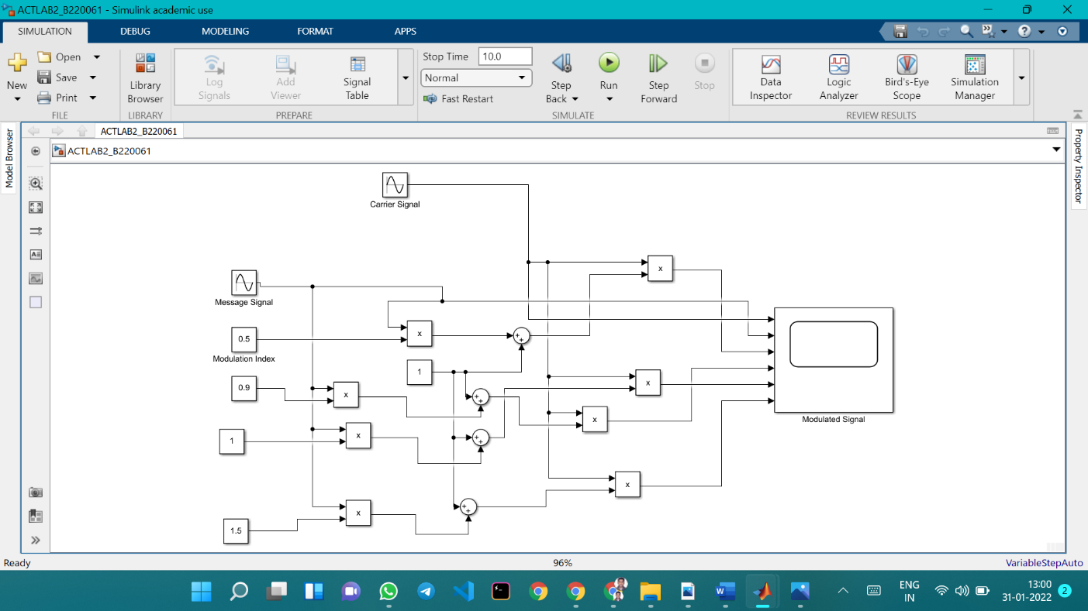

SCOPE OUTPUT OF THE SIMULINK MODEL

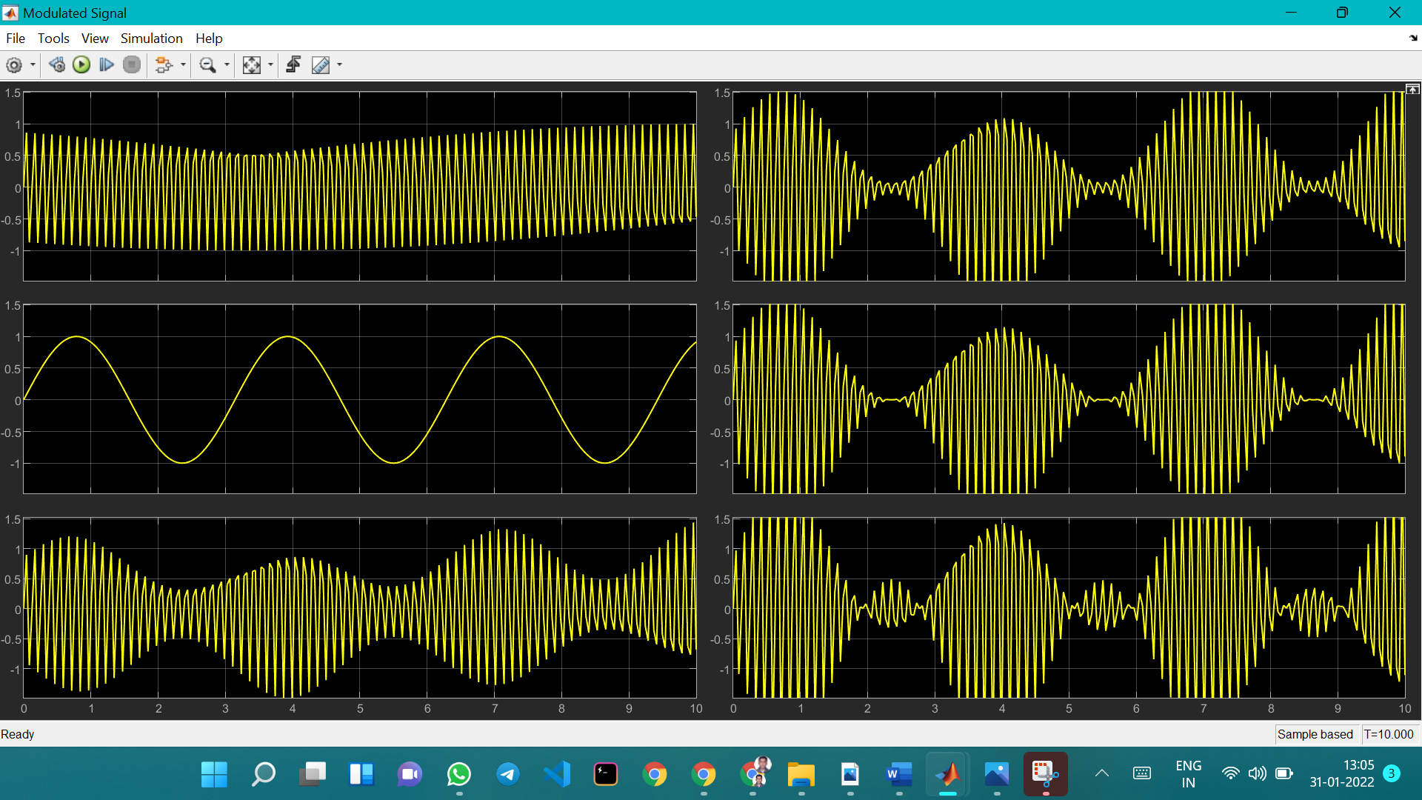

CONCLUSION

**Hence, the amplitude modulation operation is performed successfully.**

SUBMITTED BY:-

NAME: SUDIP NAYAK

ROLL N0: B220061

BRANCH: ETC (4TH SEM)