ANALOG COMMUNICATION TECHNIQUE LAB

EXPERIMENT 3

AIM

**To Generate DSB-SC, SSB-SC signals using MATLAB.**

SOFTWARE USED

**MATLAB**

MATLAB CODE (DSB-SC SIGNAL)

%DSB-SC signal

%Sudip Nayak B220061

n=[1:1000];

fc=1/10;

fm=1/500;

x= cos(2*pi*fc*n);

y= sin(2*pi*fm*n);

z=x.*y;

subplot(2,2,1);

plot(x);

title('Carrier Wave');

subplot(2,2,2);

plot(y);

title('message signal');

subplot(2,1,2);

plot(z);

title('DSB-SC Signal');

OUTPUT

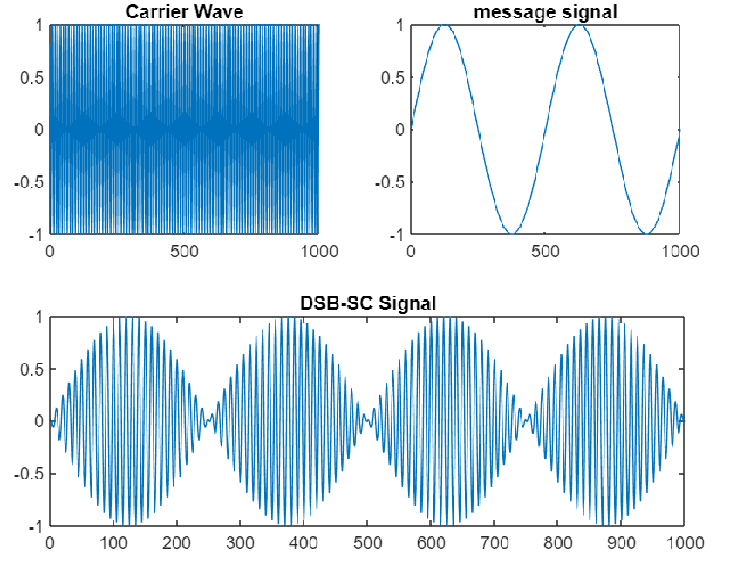

MATLAB CODE (SSB SIGNAL USING HILBERT FUNCTION)

%Sudip Nayak (B220061)

%SSB Signal

t = 0 : 0.001 : 1 ;

Am = 2 ;

Ac = 1 ;

fm = 2 ;

fc = 50 ;

m = Am * cos(2*pi*fm*t);

c = Ac * cos(2*pi*fc*t);

dsbsc = m .* c ;

mh = imag(hilbert(m));

sbu = m .* cos(2*pi*fc*t) - mh .* sin(2*pi*fc*t);

sbl = m .* cos(2*pi*fc*t) + mh .* sin(2*pi*fc*t);

subplot(321);

plot(t,m);

title('Modulating Signal');

xlabel('Time');

ylabel('Amplitude');

subplot(322);

title('Carrier Signal');

plot(t,c);

title('Carrier Signal');

xlabel('Time');

ylabel('Amplitude');

subplot(323);

plot(t,sbu);

xlabel("Time");

ylabel('Amplitude');

title('SSB-SC USB Signal');

subplot(324);

plot(t,sbl);

title("SSB-SC LSB Signal");

xlabel('Time');

ylabel('Amplitude');

OUTPUT

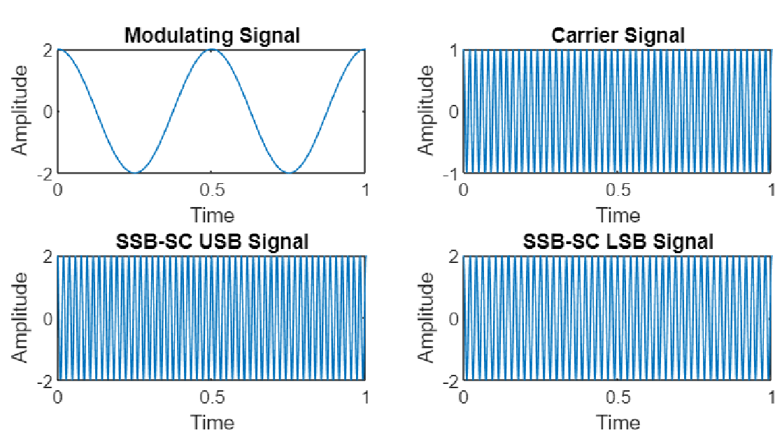

MATLAB CODE (DSB-SC SIGNASL AND SSB SIGNAL USING HILBERT FUNCTION)

%Code by Sudip Nayak B220061

%DSB-SC and SSB Signal

t = 0 : 0.001 : 1 ;

Am = 2 ;

Ac = 1 ;

fm = 2 ;

fc = 50 ;

m = Am * cos(2*pi*fm*t);

c = Ac * cos(2*pi*fc*t);

dsbsc = m .* c ;

mh = imag(hilbert(m));

sbu = m .* cos(2*pi*fc*t) - mh .* sin(2*pi*fc*t);

sbl = m .* cos(2*pi*fc*t) + mh .* sin(2*pi*fc*t);

subplot(321);

plot(t,m);

title('Modulating Signal');

xlabel('Time');

ylabel('Amplitude');

subplot(322);

title('Carrier Signal');

plot(t,c);

title('Carrier Signal');

xlabel('Time');

ylabel('Amplitude');

subplot(323);

plot(t,dsbsc);

title('DSB-SC Signal');

xlabel('Time');

ylabel('Amplitude');

subplot(324);

plot(t,sbu);

xlabel("Time");

ylabel('Amplitude');

title('SSB-SC Upper Side Band Signal');

subplot(325);

plot(t,sbl);

title("SSB-SC Lower Side Band Signal");

xlabel('Time');

ylabel('Amplitude');

OUTPUT

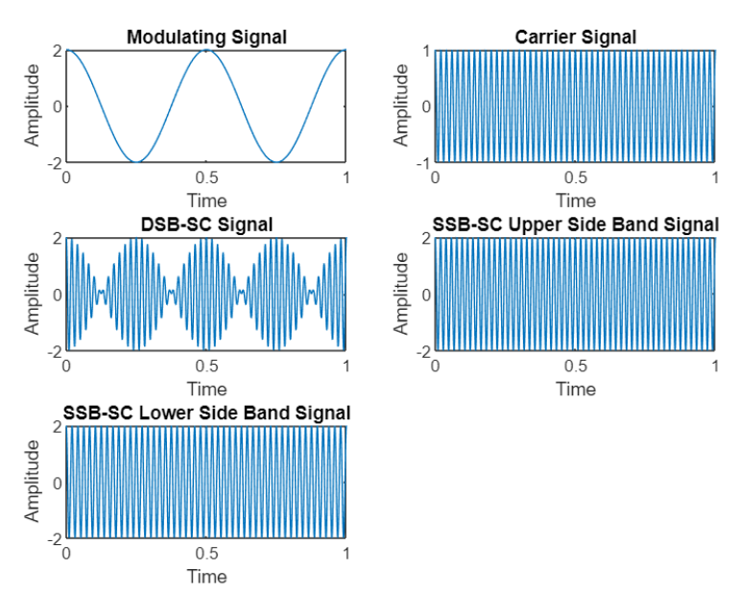

CONCLUSION

**Hence, the DSB-SC and SSB signal modulation is performed successfully using MATLAB.**

SUBMITTED BY:-

NAME: SUDIP NAYAK

ROLL N0: B220061

BRANCH: ETC (4TH SEM)