EXPERIMENT-4

AIM

To generate frequency modulated signal, demodulate it and analyse the spectrum of the modulated signal

SOFTWARE USED

MATLAB

THEORY

In FM modulation, the frequency of the carrier signal is varied depending upon the instantaneous amplitude of the modulating signal. When compared to AM signals, FM signals are less-noisy but require higher bandwidth.

Mathematical Expressions:

Let the modulating signal be m(t) = Am cos(2πfmt)

And the carrier signal be c(t) = Ac cos(2πfct)

Mathematically we can represent the FM signal as: 𝑠𝑓𝑚(𝑡)=𝐴𝑐cos(𝜔𝑐𝑡+2𝜋𝐾𝑓∫𝑚(𝑡)𝑑𝑡𝑡0)

Code and outputs:

MATLAB CODE:

%FM signal and frequency spectrum of the FM signal

kf = 15 ; %Frequency sensitivity factor

Am = 1 ; %Amplitude of modulating signal

fm = 2 ; %Frquency of modulating signal

f = 400 ;

b = (kf\*Am)/fm ; %beta

t = linspace(0,1,500); %Time axis

Ac = 1 ; %Amplitude of carrier signal

fc = 20 ; %Frequency of carrier signal

mt = Am \* cos(2\*pi\*fm.\*t); %Modulating signal

ct = Ac \* cos(2\*pi\*fc.\*t); %Carrier signal

sfm = Ac \* cos(2\*pi\*fc.\*t + b\*sin(2\*pi\*fm.\*t)); %FM signal

spectrumsfm = abs(fft(sfm)); %Spectrum of FM signal

subplot(411);

plot(mt);

title("Baseband Signal");

xlabel("Time");

ylabel("Amplitude");

subplot(412);

plot(ct);

title("Carrier Signal");

xlabel("Time");

ylabel("Amplitude");

subplot(425);

plot(sfm);

title("Frequency Modulated Signal");

xlabel("Time");

ylabel("Amplitude");

subplot(426);

plot(fmdemod(sfm,fc,f,50)); %Generating the De-modulated signal

title("De-Modulated Signal");

xlabel("Time");

ylabel("Amplitude");

subplot(414);

plot(spectrumsfm);

title("Frequency Spectrum of modulated Signal");

xlabel("Time");

ylabel("Amplitude");

OUTPUT

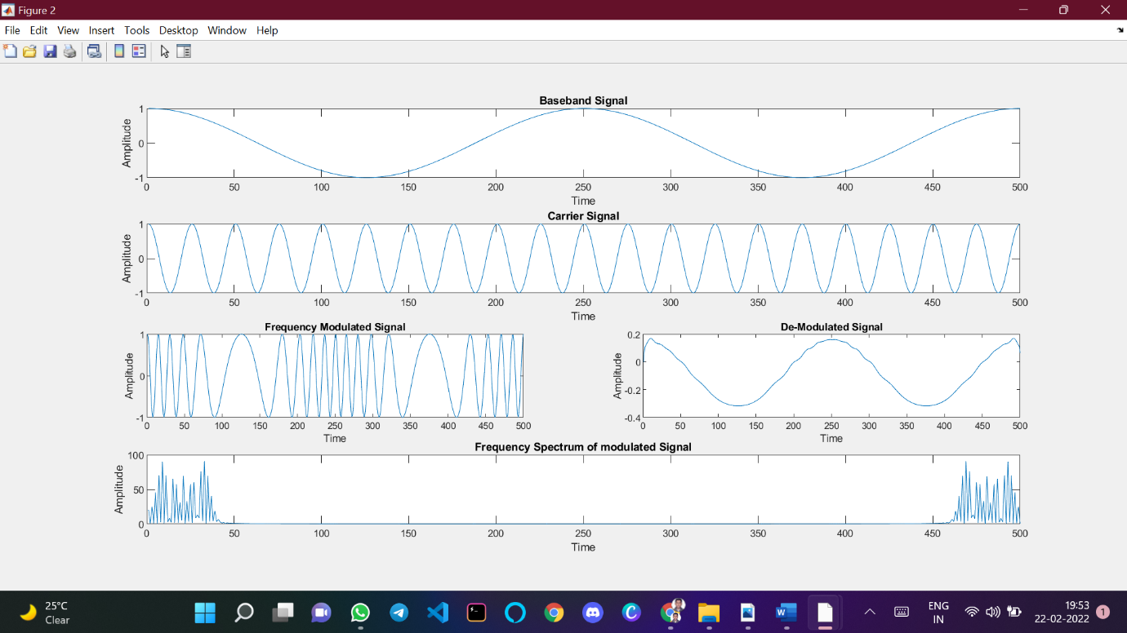

CONCLUSION

Hence, the frequency modulated signal was successfully generated, de-modulated and its spectrum was analysed.

Name: SUDIP NAYAK

ID: B220061

Branch: ETC (4th Semester)