

ANTENNA THEORY PROJECT

Design and Analysis of Antenna for a Nano-Satellite

**SUBMITTED BY**

**SUDIP NAYAK**

**B. Tech (3rd YEAR, 6TH SEMESTER, B220061)**

## ACKNOWLEDGMENT

I would like to express my sincere gratitude to Dr. Sanjeev Kumar Mishra for his invaluable guidance and support throughout the project on "**Design and Analysis of Antenna for a Nano-Satellite.**" His expertise, encouragement, and insightful feedback were instrumental in shaping the direction of this research work.

I would also like to extend my thanks to the faculty and staff of our concerned institute for their assistance and cooperation during the course of this project. Their knowledge and resources contributed significantly to the successful completion of this endeavour.

I am deeply thankful to my friends for their unwavering support and encouragement during this project. Their understanding and motivation were vital in keeping me focused and motivated.

Lastly, I would like to acknowledge the contributions of all the researchers and authors whose works I referenced in this project report. Their insightful research and studies provided a solid foundation for my work.

I am truly grateful to everyone who has directly or indirectly contributed to this project, and I sincerely appreciate their efforts and support.

Thank you.

Sudip Nayak

(3rd year, 6th Sem, B220061)

## ABSTRACT

This paper describes the simulations, practical tests and analysis carried out for monopole and dipole antennas for nano-satellites. The antennas are designed for a 2U nano- satellite. With the monopole and dipole antenna designed to operate in the amateur VHF & UHF bands respectively. The antennas are made of steel tapes, which are obtained from measuring tapes. The antennas have a width of 6mm and thickness 0.2mm. The length of the monopole is 570mm and that of the dipole is 203mm for each arm, with a feed gap of 11mm.

The paper further describes the simulations and modelling carried out for the antennas using a CAD software: Computer Simulation Technology (CST). A thermal simulation was done using the System Assembly and Modeling (SAM) module of the CST software to understand the effects of the varied temperature range in space on the antennas. After the intended design of the antennas is achieved using the CAD software, the antennas are practically tested, and the antenna length is altered to obtain the required results. For the intended frequency of operation, measured experimentally, the gain of the monopole and dipole antenna towards the earth facing side is -0.47dBi and -0.8dBi respectively. The return loss of the antennas was experimentally measured and found to be - 30.836dB for the monopole antenna and -28.672dB for the dipole antenna. The paper also analyzes the effect of thermal protection tape on the antennas.

**THEORITICAL STRUCTURAL CONSIDERATION**

The antennas are stowed within bases made of Delrin. Delrin, a Polyoxymethylene based thermoplastic, was chosen as the material for the antenna bases due to its high strength to weight ratio, low coefficient of friction and its property of being a good insulator [6]. The base for the dipole also helps in maintaining an angle of 950 between the two arms of the dipole, which is essential for matching the impedance of the antenna to the 50 ohm transmission line. The bases are screwed to the satellite body, which has dimensions of 100mm x 100mm x 227mm. The panels of the satellite have a thickness of 2mm each.

The antennas are wound around the bases and secured using a dyneema wire. To deploy the antennas, the Dyneema is heated using a resistor. When the Dyneema is melted and the mechanism is activated, firstly the monopole unwinds and takes the vertical position, simultaneously the right arm of the dipole unwinds, after which the left arm of the dipole unwinds and both the dipoles attain a deployed position of 95 degrees to each other, as shown in Figure 1.

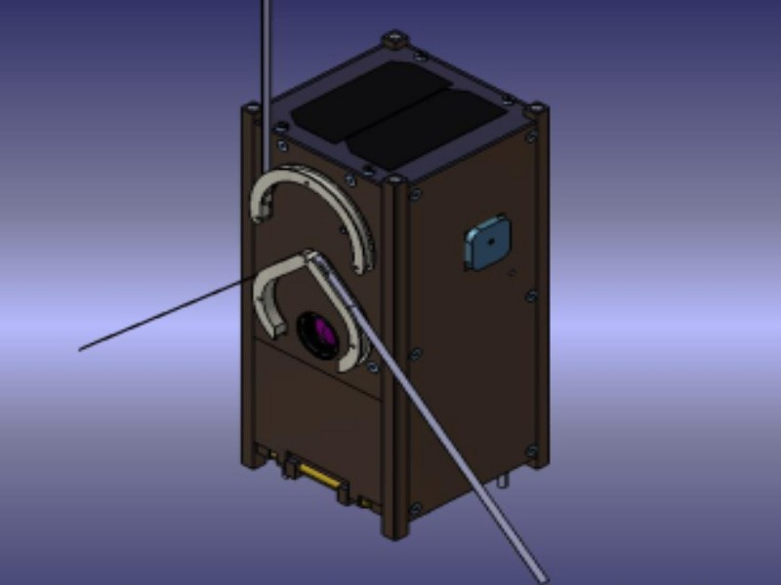

**Figure 1. Satellite Structure with Released Antennas**

**SIMULATION INSTRUCTIONS**

The model was simulated using CST Microwave Studio. A hollow aluminum cuboid of dimensions 100mm x 100mm x 227mm and a panel thickness of 2mm was constructed as an approximation of the nano-satellite model. Another layer of aluminum oxide of thickness 120µm was added over the satellite body to model the anodized layer over the panels. The simulation was done using Steel-1008 to model the antennas. A 5mm gap was left between the Aluminum model and the antennas as an approximation of the Delrin bases. At the intended frequency of operation, Delrin has a dielectric constant of 3.7, and dielectric strength of 19.6 MV/m. Simulations were carried out by incorporating Delrin bases and as the simulation results did not show any significant deviations, the bases were excluded to ease the

meshing and CAD solver complexity. A discrete port was used as an excitation source for the antennas. The presence of the wires connecting the antennas to the excitation sources would not have a significant effect on the antenna performance, but their inclusion would complicate the simulation, therefore, they were neglected from the simulation. The simulation was carried out in frequency domain. A parameter sweep was carried out for a range of lengths of the monopole and the dipole.

**Monopole Antenna**

The monopole antenna was chosen due to its ease of deployment and omnidirectional radiation pattern, which reduces the dependence on an overly accurate attitude determination and control subsystem. The monopole antenna is driven using a discrete source with the conducting satellite body acting as the ground plane for the antenna.

|  |  |  |  |
| --- | --- | --- | --- |
| **Length of Monopole (mm)** | **Impedance at 145.89 MHz** | | **S11 at 145.89 MHz (dB)** |
|  | **Real part** | **Imaginary** |  |
| 550 | 39.44 | -21.34 | -11.74 |
| 560 | 42.17 | -14.56 | -15.04 |
| 570 | 44.89 | -7.61 | -20.37 |
| **580** | **47.58** | **-0.32** | **-31.90** |
| 590 | 50.58 | 7.40 | -22.80 |
| 600 | 52.95 | 16.98 | -15.67 |
| 610 | 56.48 | 25.90 | -12.28 |
| 620 | 60.49 | 35.47 | -9.94 |
| 630 | 65.03 | 45.65 | -8.22 |
| 640 | 70.32 | 56.62 | -6.90 |

Table 1. Characteristics of the Monopole

The S11 characteristics of the monopole were plotted in Figure 2, in increments of 10mm starting from 550mm. As per the simulations, for the intended frequency of operation, at 145.89 MHz, the antenna length of 580mm provided the maximum efficiency. The efficiency of the monopole was - 0.06485dB, or 99.26%. Its -15dB bandwidth was 9.5MHz.

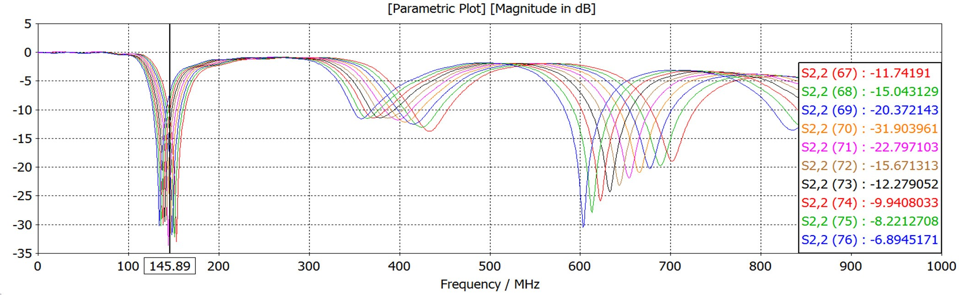

Figure 2. S11 of the Monopole

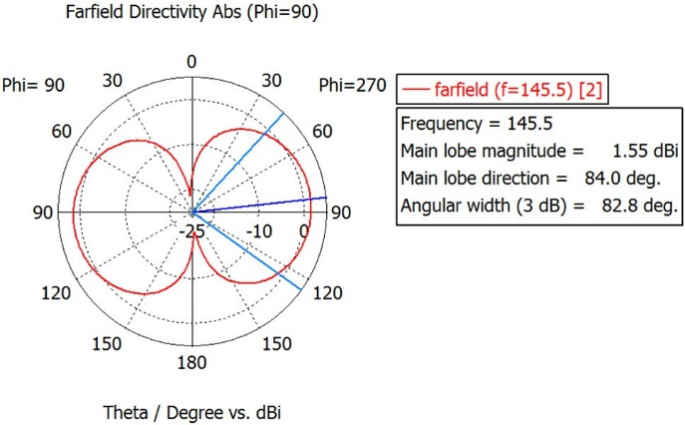

# **Figure 3. Monopole Far-field Polar Plot for Constant ф**

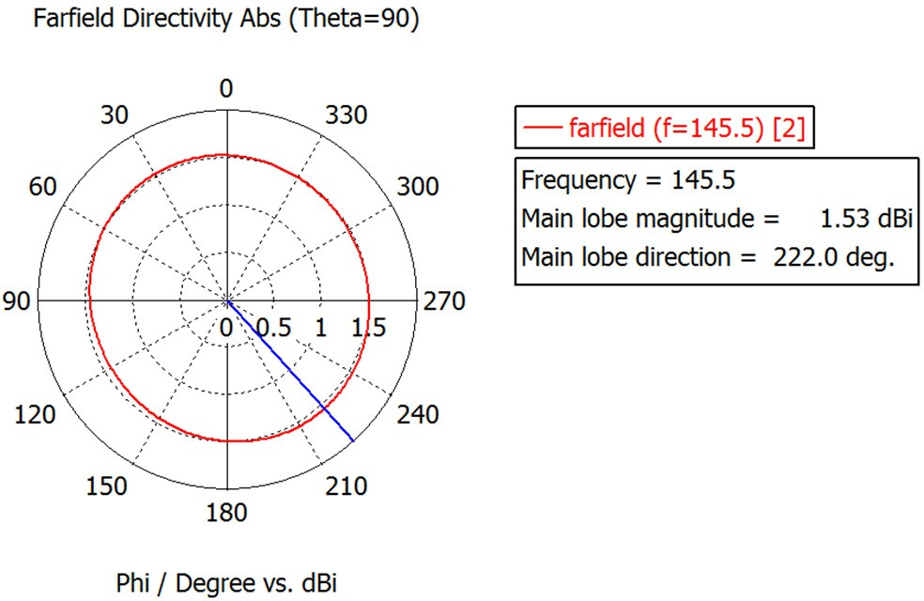

**Figure 4. Monopole Far-field Polar Plot for Constant θ**

Figure 3 shows the far-field radiation plot in the elevation plane, for a constant ф (ф = 90°). Figure 4 shows the far- field plot in the azimuthal plane, for a constant θ (θ = 90°), the azimuthal plane is the cross-polarization plane.

Figure 3-5 show the omnidirectional radiation pattern of the monopole antenna, which match the expected results.

The peak directivity in the elevation plane (ф = 90°) is 1.547dBi. For the antenna efficiency of -0.06485dB as obtained from the simulation, the antenna gain in the earth facing side is 1.536dBi.

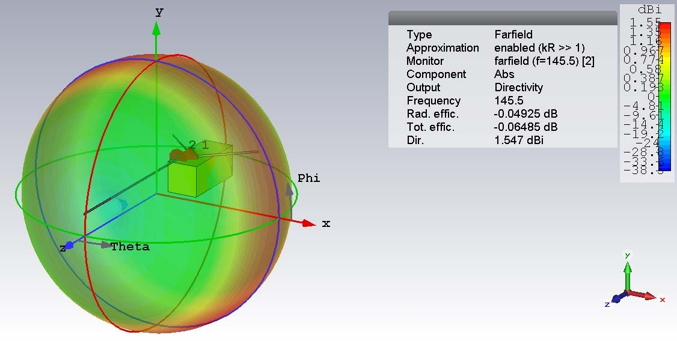

# **Figure 5. Monopole Far-field 3D plot**

**Dipole Antenna**

The dipole antenna was chosen due to its symmetric structure, radiation pattern, and ease of deployment.

The S11 characteristics of the dipole were plotted in Figure 6, in increments of 10mm starting from 160mm. According to the simulations, for the intended frequency of operation, at 437.8 MHz, the antenna length of 200mm for each dipole arm provided the maximum efficiency. The efficiency of the dipoles was -0.05098dB, or 99.41%. The -15dB bandwidth was 33.5 MHz

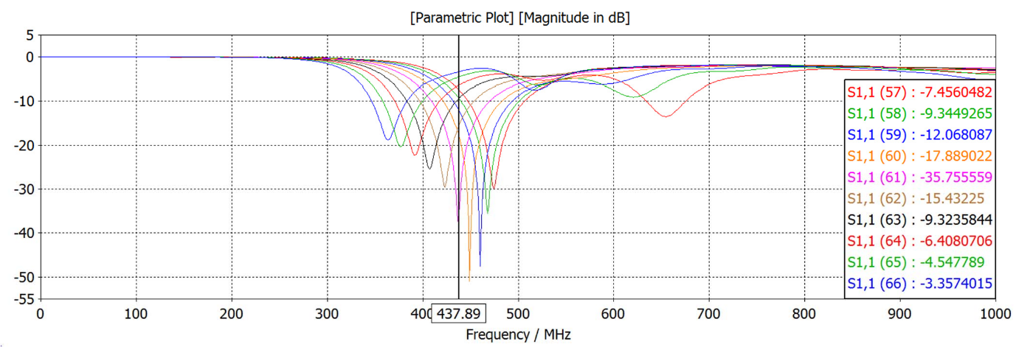

# Figure 6. S11 of the Dipole

# Table 2. S11 at 437.89 MHz (dB)

|  |  |  |  |
| --- | --- | --- | --- |
| **Length of one arm of the dipole (mm)** | **Impedance at 437.89 MHz** | | **S11 at 437.89 MHz (dB)** |
| **Real** | **Imaginary** |
| 160 | 27.78 | -27.0 | -7.46 |
| 170 | 31.26 | -21.96 | -9.34 |
| 180 | 35.26 | -16.19 | -12.07 |
| 190 | 41.58 | -8.61 | -17.89 |
| **200** | **51.55** | **-0.69** | **-35.76** |
| 210 | 67.86 | 8.49 | -15.43 |
| 220 | 98.62 | 15.16 | -9.32 |
| 230 | 141.57 | 2.09 | -6.41 |
| 240 | 179.67 | -51.10 | -4.55 |
| 250 | 164.13 | -122.59 | -3.36 |

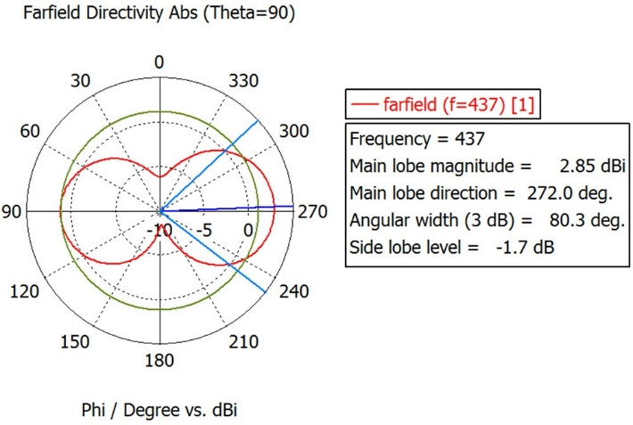

**Figure 7. Dipole Far-field Polar Plot for Constant θ**

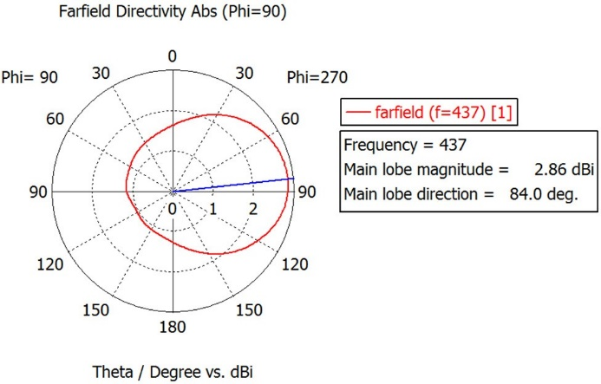

# **Figure 8. Dipole Far-field Polar Plot for Constant ф**

The 2D polar plot in Figure 7 and Figure 8 shows the radiation pattern of the dipole antenna. The peak directivity in the azimuthal plane (θ = 90°) is 2.86dBi. For the antenna efficiency of -0.05098dB as obtained from the CST simulation, the antenna gain in the earth facing side is 1.14dBi, while the peak gain of 2.84dBi is in the non-Earth facing side. The dipole antenna can be seen to have a distorted radiation pattern as seen from Figure 9, with a slightly higher directivity in the direction opposite to the earth facing side. The presence of conductive aluminum panels in the reactive near field of the dipole antenna could be a significant contributor towards the distorted radiation pattern.

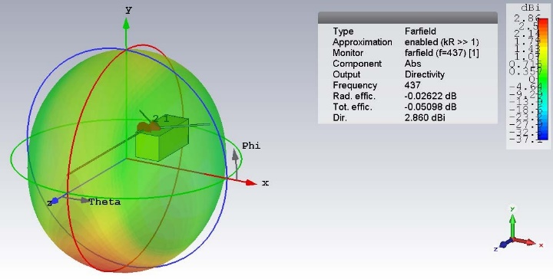

# **Figure 9. Dipole Far-field 3D Plot**

**SATELLITE COMMUNICATION**

In general, satellites are structures that are capable of transmitting and receiving or relaying signals from space. Due to their location, they are able to provide a wide coverage area with long communication range. Conventional satellites are larger, heavier, higher power, higher data rate, and multi-functional payloads that are capable of offering better RF performance in terms of EIRP, G/T, and spatial and polarization isolation. However, this makes the satellites very expensive and time-consuming to develop.

**MODERN SATELLITE COMMUNICATION**

The term "modem small satellite" denotes several types of satellites, including mini, micro, nano, Pico, and femto-satellites. Modem small satellites are typically one-tenth to one-one-hundredth of the mass and cost. The development of modern small satellites is mainly driven by two sets reasons: the first consists of the financial and political needs to reduce the cost; the other set is comprised of the technological advances in low-power micro-electronics and digital signal processing (DSP).Very- large-scale integration (VLSI) makes it possible to build sophisticated circuits into small volumes, with low mass and low power consumption. Modem technologies make it possible for a constellation of modem small satellites to realize many sophisticated functions. The development of modem small satellites thus leads to a significant reduction of cost for satellite industries. Another advantage of using modem small satellites is the short time scale: conventional satellites may take over five years from the proposal to final launch, while modem small satellites can be developed within one year. For example, UoSAT-2, developed by the University of Survey in 1984, took only six months. These modem small satellites are useful for various applications, including telecommunications, space science, Earth observation, mitigation and management of disasters (floods, fire, earthquake, etc.), in-orbit technology verification, military applications, education, and training.

### **NANO-SATELLITE COMMUNICATION**

The nano-satellite is a type of modem small satellite having a mass below 10 kg. The UNP is a collaborative program of student built nano-satellites, started in 1999. The US Air Force Office of Scientific Research (AFOSR) and the National Aeronautics and Space Administration (NASA) jointly funded 10 US universities in designing and assembling nano-satellites, and conducting creative low-cost space experiments, such as formation flying. Over the last decade, nano satellite missions have increased vividly for low earth orbit space missions. This concept has been very enthusiastic to the scientific, private, and government missions due to miniature electronics size with low- cost and low power consumption. Nano satellite space missions are being fruitful in coastal and inland critical observation of natural disaster, monitoring agree-environmental and agriculture conditions, and space atmosphere observation. Every nano satellite has some common functions for satellite operations like power system, uplink-downlink communications, and altitude control. The antenna is the key element of the uplink-downlink communications between satellite and Earth. The inherent relation between lower frequency and antenna size compels antenna researchers to compromise with antenna gain and efficiency for compliance with the Cube Sat standards. So, antenna design for nano satellites has been a critical issue to the CubeSats researchers, especially for lower frequency. CubeSats can come in various sizes, but they are all based on the standard Cube Sat unit, namely a cube-shaped structure measuring 10x10x10 centimeters with a mass of somewhere between 1 and

1.33 kg. This unit is known as 1U. After the first few years, this modular unit was multiplied and larger nano satellites are now common (1.5U, 2U, 3U or 6U). Today, new configurations are under development.

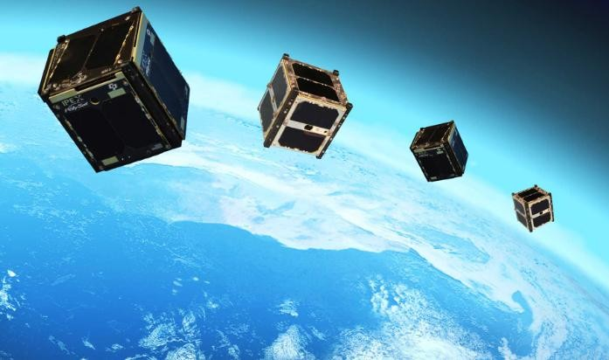

### **Examples of Recent Modern Small-Satellite Projects Disaster-Monitoring Constellation (DMC)**

The DMC, developed by Surrey, consists of a constellation of six remote-sensing micro-satellites. It is the first low-cost and integrated Earth-observation constellation dedicated to monitoring and mitigation of man-made and natural disasters. The DMC is operated for the Algerian, Nigerian, Turkish, Thailand, UK, and Chinese governments. Each satellite has a mass of about 90 kg. It provides 32 m multi-spectral Earth- observation imaging, and covers a vast 600 x 600 km, anywhere on the Earth.

The images cover 10 times more area, compared with images of less than 200 x 200 km currently available from other civilian Earth-observation satellites. The six micro-satellites in the DMC provide daily imaging worldwide, capable of monitoring any rapidly changing phenomena.

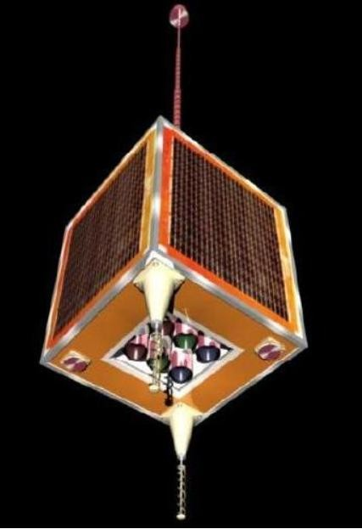

## OBJECTIVE

Our project is hoped to develop an Antenna to fulfill the following objectives:

1. By incorporating the design of the antenna, we are able to understand the comprehensive and qualitative details of monopole antennas in terms of their mass, size, gain, beam steer-ability, style of polarization, operative band, and come back loss.
2. The proposed antenna will have a high gain for 2.4 GHz nano satellite communications. This antenna has the very best gain among antennas that are appropriate to be used on a nano satellite.

## PROBLEM STATEMENT

Due to the special environment in space and the requirements of modern small satellites, antenna designs for modem small satellites have many challenges. The main challenges include:

1. Antennas must be highly reliable, as it is difficult to replace the antenna in space.

Antennas must be very small, have low mass, be highly efficient, and be low cost, due to the stringent requirements of small size, low mass, and low cost of modem small satellites.

1. Antennas must be mechanically robust, and able to survive both random vibration and shock during the launch.
2. The thermal design of the antennas must be carefully evaluated. The antennas are designed to perform over a wide temperature variation, typically from -150° C to +150°C. The normal thermal design for wide-coverage antennas is passive. Some designs must operate even down to below -200° C. No multi-layer insulation(MLI) or other thermal hardware is used.
3. Antennas must be able to survive the harsh radiation environment in space, such as ionizing radiation, cosmic radiation, and solar energetic particles. Effects of atomic oxygen need to be considered for LEO (low- Earth-orbit) missions. This can be handled by using a germanium-coated single-layer-insulation protective cover on the antenna, or by using a resistant surface treatment directly on the antenna.
4. Materials for the antennas need to be chosen carefully, considering the effects of vacuum and micro-gravity.
5. High data rates require a high antenna gain. However, the very limited space available on modem small satellites makes it difficult to accommodate a high-gain antenna, which usually consists of bulky and complicated reflector antennas or antenna arrays. Costly pointing will also be needed for high-gain antennas.
6. A major consideration for antenna design is the interaction between antennas and the modem small-satellite structures. The spacecraft's structure can cause electromagnetic scattering, as well as have blockage effects on the antenna's radiation patterns. The scattering can interfere with the antenna's radiation pattern, and cancause severe degradation in gain performance and sidelobes. This degradation will have a major influence on a communication-link system's performance, andneeds to be assessed.
7. Antennas have to be located (as far as possible) on the spacecraft in such a way that they can provide acceptable performance and, at the same time, do not disturb or interfere with other antennas, subsystems, or the allowed outer physical envelope of the satellite (i.e., they must fit under the fairing of the launcher used).

## SOME SAYINGS

1. Rajat Mathur, Randy Haupt Charles, Swenson in their paper described the nanosatellite program at Utah State University (USUsat). In addition, the communication link budget and antenna designs for this nano satellite are described in detail.
2. S Y Prahyang, M Z Dhiya’Ulhaq , O P Golim have worked on development of nanosatellite technology that has enabled satellites to be developed with multiple capabilities for a specific mission in a short time with a low cost. Thus Satellite communications are proved to be more effective in delivering information due to its large coverage area.
3. Abdul Halim Lokman, Ping Jack Soh, Saidatul Norlyana Azemi in their paper discussed about review of antennas suitable for nanosatellite applications. An overview of the applications of nanosatellites is first explained, prior to a discussion on their antenna requirements. Material and antenna topologies which have been used are subsequently discussed prior to the presentation of several deployable configurations.
4. R. Harrington; J. Mautz in their paper introduced to how diagonalise the scattering matrix of the body. Formulas for the use of these modes in antenna and scatterer problems are used. For electrically small and intermediate size bodies, only a few modes are needed to characterise the electromagnetic behaviour of the body.
5. Anthony Bellion, Kevin Elis, Stéphanie De Gaetano in their paper presented a new compact single-feed circularly polarised S-band antenna for nanosatellite applications. The antenna is composed of two crossed dipoles printed on both sides of a substrate, center-fed by a 50Ω coaxial cable that provides a unidirectional pattern to a reflector placed below the antenna. In order to reduce the size of the structure, this reflector is composed of an Artificial Magnetic Conductor (AMC).
6. T. K. Sreeja, A. Arun, J. Jaya Kumari in their paper mentioned about the antenna operating at S-band frequencies which is mainly focused to be applicable for the NIUSAT, i.e., nano-satellite. Obtaining optimum bandwidth efficiency by

choosing suitable size without affecting any other parameters of the antenna was the challenge taken in their project.

### **SOME MORE INFORMATION**

Nano-Satellite communications need the event of smaller size, low profile, low price and high gain antennas. To date, past works on antenna Styles for smaller satellites have considering totally different antennas. They include:

## Omnidirectional

They are needed by the telemetry system, to track and Command (TTC) sub-system to facilitate area to ground communications. They embrace monopole, patch-excited cups and helix antennas. whereas easy to deploy, these antennas tend to radiate altogether directions. They additionally occupy an oversized space. As a result, pico-satellites usually use light- weight and tiny sized micro-strip patch and slot antennas for TTC.

## High Gain

These antennas are primarily used for higher speed down-links to ground stations. High information rates need AN antenna with a gain of regarding 12 db. However, the terribly restricted area and power on pico-satellites build it tough to accommodate such a high gain antenna. The foremost common kind of high gain antennas employed by typical satellites could be a horn antenna with a point mechanism and S-band quadrifilar-helix antennas. Additionally, the authors of planned a high gain deploy-able hemisphere helical antenna for Nano-Satellite to ground communications.

## Medium Gain and Low backward radiation

This antenna is primarily utilized by receivers within the international Positioning System (GPS) to determine the position, velocity, and time of pico-satellites in LEO. many varieties are developed; specifically, patch-excited cup and shorted–annular patch antennas. they need a gain of regarding 12 dB, operate at one.575 and 1.227 GHz and have a little size. Also, they manufacture low back radiation to reduce interference with satellite parts. Recently, in the authors given a Geo helix ceramic

loaded quadrifilar-helix antenna.

## Directive self-steering

The main operate of those antennas is to produce circular polarization (CP) so as to determine communication links between satellites. Moreover, beam steering techniques will be utilized to extend radial asymmetry and succeed at higher gains. During this respect, Pico satellites use self-steering. In contrary, typical satellites use dynamic beam steering.

**Planar antennas**

They have a variety of characteristics, together with low profile, low cost, tiny size, are simply to fabricate and don't need a preparation mechanism. These characteristics build two- dimensional antennas appropriate for Cube Sat communications. The foremost limitations of the many low-profile two- dimensional antennas is their bandwidth of information measure and comparatively low gains. However, several techniques and approaches, like photonic band-gap (PBG) structures, cavity-backed model, folded-patch approach, and spatial structure, will be wont to enhance their gain and bandwidth.

## Frequency Bands Allocation for Nano-Satellite

Nano-Satellites use the array of frequency bands to produce communication links between Nano-Satellites and ground stations. These frequency bands embrace VHF (30-300 MHz), UHF (300 megacycle per second – three GHz), S-band (2-4 GHz), C-band (4-8 GHz), and X-band (8-12 GHz). The bulk of Nano-Satellites operate in the amateur band. They use a frequency of regarding 437 megacycle per second that could be a UHF-band for downlink communications and 144 megacycle per second in VHF-band for transmission communications. Antennas that use these frequency bands is wire antennas, i.e., dipole and monopole antennas. Alternative Nano-Satellites use patch and slot antennas that operates within the S-band or C- Band frequencies for downloading pictures to ground stations and providing a communication link between Nano-Satellites. Recently, some Nano-Satellites programs is operational within the X-Band frequencies to additional reducing the dimensions of the antenna.

## ANTENNA DESIGN

Monopole and patch antennas have found wide application in Nano-satellite communication. Each antenna was required to have a beam width of greater than 60 degrees, bandwidth greater than 10MHz, and gain greater than 7dB.We know, patch antennas can have high gain depending on the configuration, monopole antennas have lower gain, but omnidirectional. Specifically, the gain of patch and monopole antennas increases with ground plane size. Gain also depends on the ground plane shape, as seen in the parabolic corner reflector antenna. As monopole has gain of about 1.65dBi that can be increased by placing it on a large ground plane. But this gain can further be increased to 6dBi by placing a reflector behind the monopole.

Employing this concept, antenna configurations are designed, developed, and tested:

* 1U and 3U Reflector Antenna with Radiating Monopole.
* Extended Parabolic Reflector Antenna with deployable panels.

### **REFLECTING ANTENNA WITH RADUATING MONOPOLE**

A monopole antenna is the simplest antenna design, consisting of a quarter wavelength radiating element with a low gain of 1.65dB. This gain can be increased

proportionally to a ground plane size increase. Improvement in gain and directionality can also be achieved by placing a reflector behind the monopole. The distance between the reflector and the antenna defines the impedance and gain. The distance is maintained at about 0.2 the desired parabolic reflector antenna gain can be further improved with deployable solar panels such that the metallic solar panel support structures act as extensions of the parabolic reflector. The parabolic reflector antenna is placed in the middle of the longest side of 3U Cube Sat containing a deployable solar panel. The parabolic structure is embedded onto the body of Cube Sat, such that the body, as well as the deployable solar panel support structure, acts as an extension of the reflector, thus improving the antenna gain. Additionally, inclining the solar panel leads to further gain improvement. Thus, placing the parabolic antenna in the center of one of the sides with deployable panels provides an additional gain of more than 2dB (nearly 9dB) above the gain of parabolic reflector with monopole without deployable panels and an improvement in coverage through a wider beam width.

**PRACTICAL STRUCTURAL CONSIDERATION (USING CST SOFTWARE)**

## For monopole antenna

Given below are the three formulas used for designing the monopole

antenna:

L = 142.5 / f (MHz)

Pole Length = L/2 Radius = 0.008 * ( c/f )

Here

‘ f ’ is the frequency we have used for designing the antenna and it is in the range of Mega Hertz.

‘L’ is the length and width of the monopole antenna ground. Pole length is the length of the pole present in the antenna. ‘R’ is the radius of the pole.

‘c’ is the speed of light which is m/s For Simulation purpose we have taken the following considerations:

Here we are designing a monopole antenna operating in the frequency of 2.5 GHz .

Frequency Minimum:2 GHz Frequency Maximum: 3 GHz

## For reflector antenna

Reflector spacing = 0.25λmm

Lambda (for 2.4 GHz)=0.89*119.92mm Gap=2mm

The PEC type of material was taken into consideration for designing our monopole antenna due to its strength of weight ratio, having very low coefficient of friction and also because being a nice conductor. 50 Ohm impedance was taken to match the transmission line.

## DESIGNING OF ANTENNA

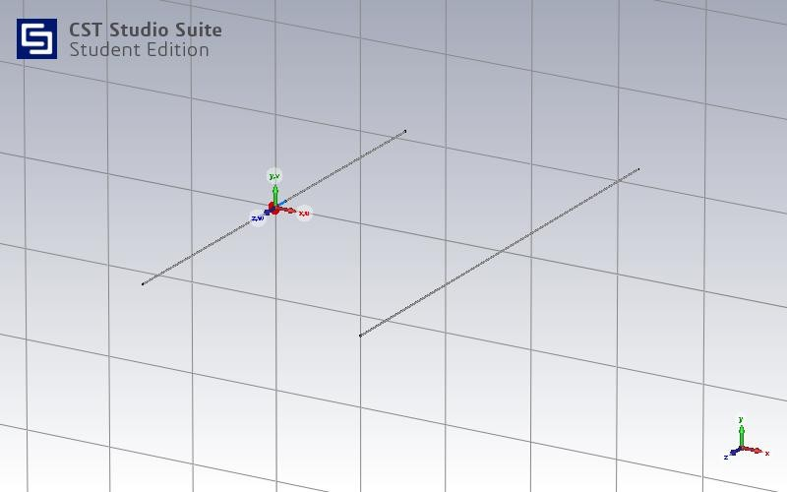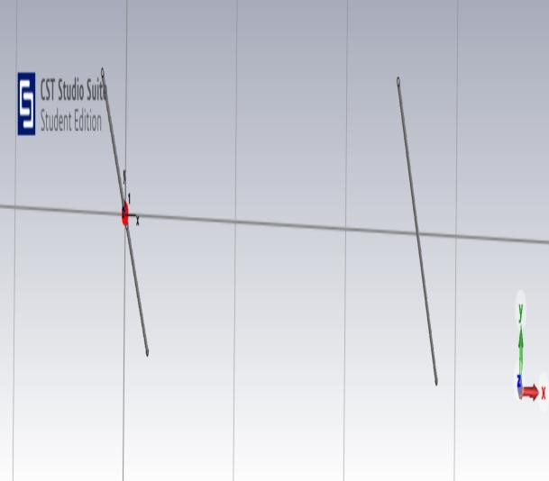

FIG (a) FIG (b)

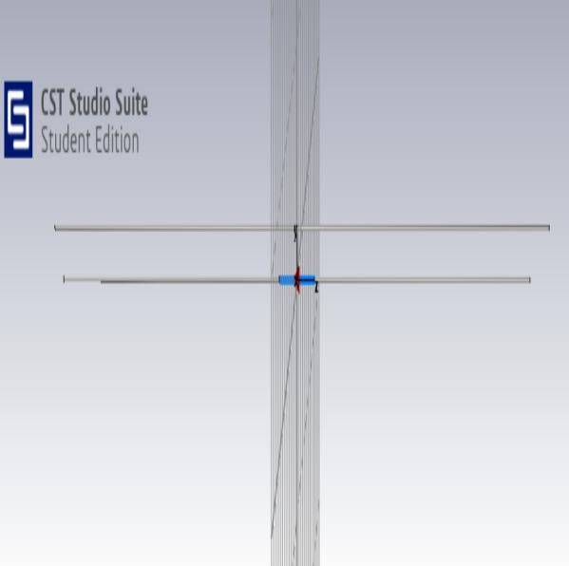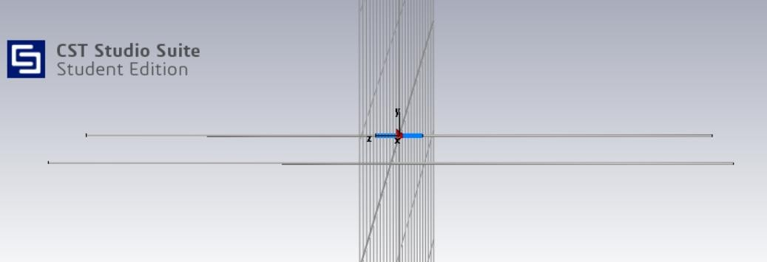

FIG (c) FIG (d)

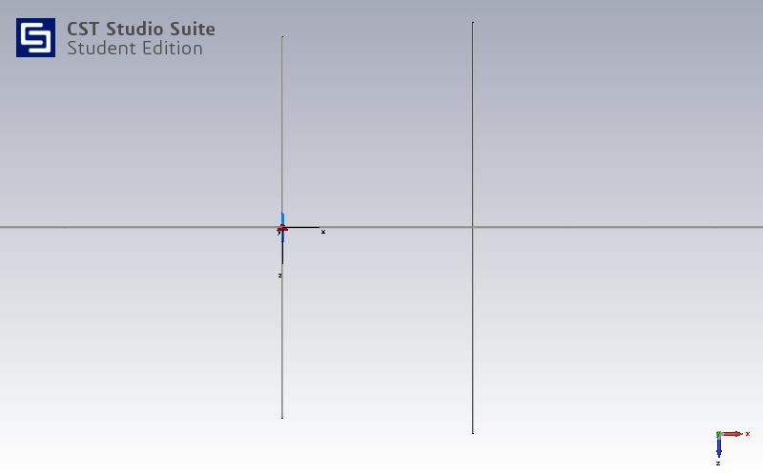 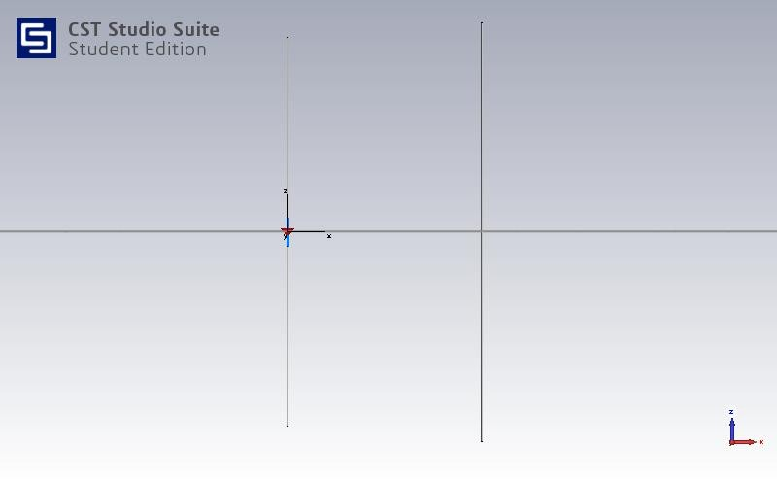

FIG (e) FIG (f)

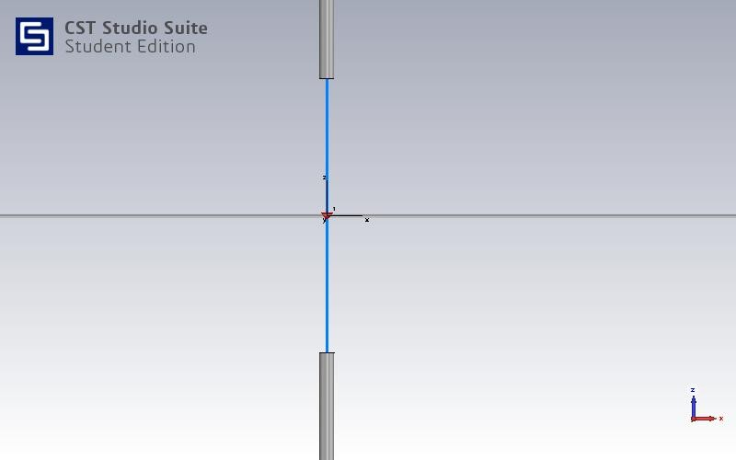

FIG (G)

Fig: (a) orthographic, (b) arbitrary view , (c) left , (d) right, (e) top , (f) bottom , (g) junction of two monopole antenna

# **Simulation Results and associated Discussions**

The model was designed and simulated using CST Microwave Studio software and was analyzed. The monopole antenna was chosen due to its ease of deployment and omnidirectional pattern, which helps in reducing the dependency on an overly accurate attitude determination and control sub-system.

## S-PARAMETER (return loss):

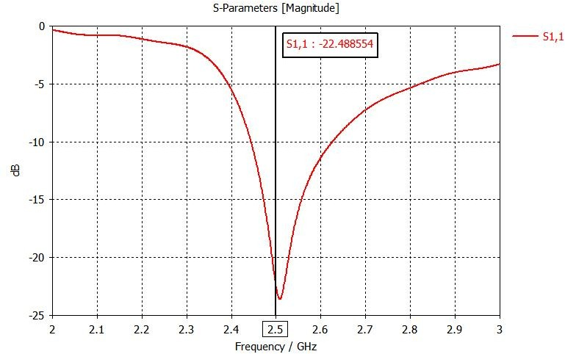

The return loss of the monopole antenna design proposed for nano satellite application is presented in here, the broad frequency ranges from [2.2 to 4 GHz] show a better accuracy on the adaptation of the monopole antenna is greater than -10 dB and it can work perfectly in the first peak (-22.48 dB) for 2.5 GHz.

# **VSWR**

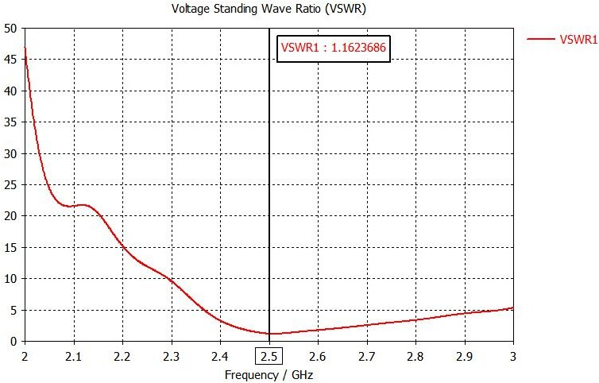

The Voltage Standing Wave Ratio of monopole antenna proposed is represented. The VSWR is well-established in frequency ranges from [2.2 to 4 GHz], also it is less than 2 and it which shows excellent matching for all the bandwidth covered for s band application.

## VSWR TABLE

|  |  |
| --- | --- |
| FREQUENCY | VSWR |
| 2.4GHz | 1.68 |
| 2.5GHz | 1.16 |
| 2.6GHz | 1.73 |

Voltage Standing Wave Ratio (VSWR) refers to how efficiently the power is transmitted through a transmission line to the load point. If the reflection coefficient and VSWR is less, it indicates that the antenna is matched. Here, the VSWR value is less than 2 that is 1.68 at 2.4 GHz as shown in figure indicating that the antenna is nicely matched and reflection losses are minimized. The antenna efficiency should be as high as possible.

# **EFFICIENCY**

The efficiency of the monopole antenna proposed is very high around (55% to 99.8 %) at frequency range from [2.3 to 4 GHz]. This application demonstrates the effectiveness of integration the monopole antenna in the space application.

## FARFIELDS

## 

The 3D and 2D radiation pattern in the E-plane and H Plane at the broad frequency range of the monopole antenna design proposed are presented in figure, we notice that the radiated power is concentrated along the x-z plane. A good gain value obtained at the operating frequency range from [2.2 to 4 GHz] is equal to 6.5dB. Where, these gains satisfy the requirement of s band for nano Satellite application.

**RADIATION PATTERN AT VARIOUS FREQUENCIES**

**Far field directivity at absolute phi=0**

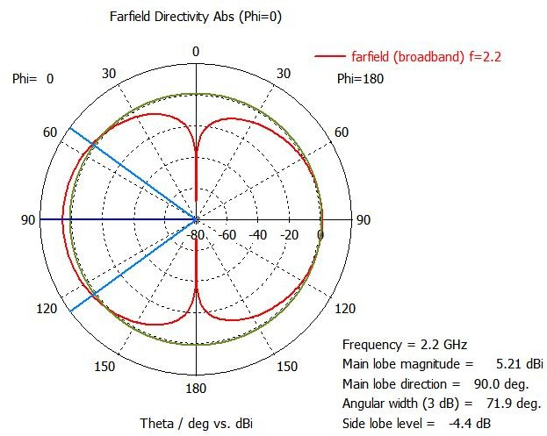

At frequency f=2.2GHz and phi=0, the directivity shows omnidirectional pattern as well as 71.9-degree angular width which is better result for this application.

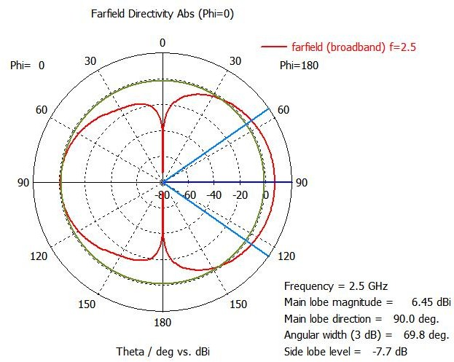

At frequency f=2.5GHz and phi=0, the directivity shows omnidirectional pattern as well as 69.8 deg. angular width which is better result for this application.

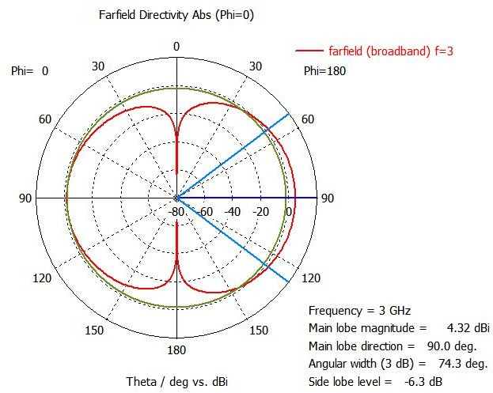

At frequency f=3GHz and phi=0, the directivity shows omnidirectional pattern as well as 74.3 deg. angular width which is better result for this application.

# **Far field directivity at absolute phi=90**

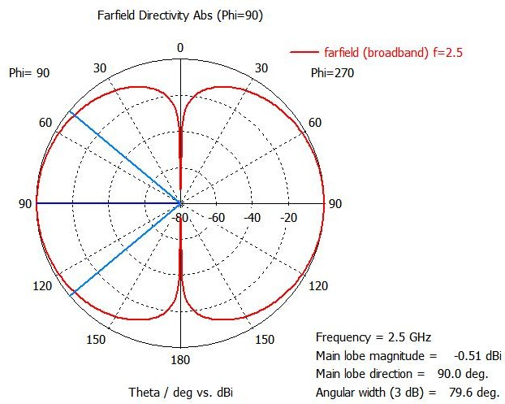

At frequency f=2.5GHz and phi=90, the directivity shows omnidirectional pattern as well as 79.6deg angular width which is better result for this application.

## Far field directivity at absolute theta=90

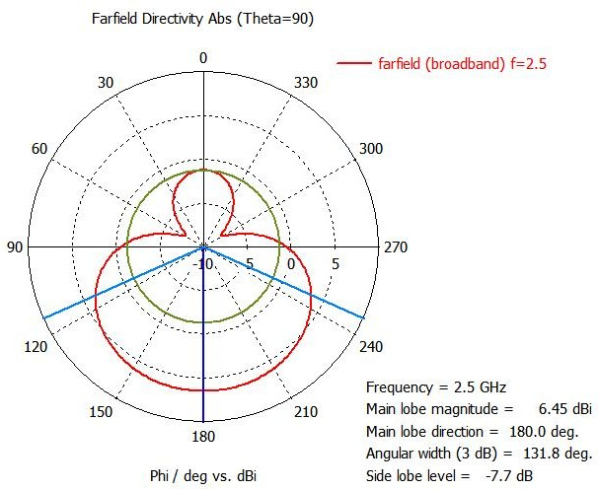

At frequency f=2.5GHz and theta=90, the directivity shows omnidirectional pattern as well as 131.8deg angular width which is better result for this application.

**GAIN**

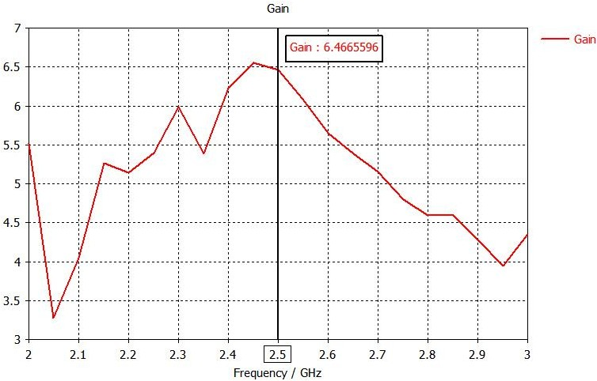

The variation of gain versus of S frequency ranges desired of a monopole antenna proposed. The maximum average gain value of 6.46 dB over the entire operating bandwidth. It can be noted that the gain is positive in all the bandwidth desired and fluctuate between 3.5 dB to 6.5 dB.

## SUMMARY

This project describes the simulations and analysis of monopole antenna for nano satellites. The antenna was designed for S- band frequency. The antenna was simulated using CST Software where for the intended frequency of operation the S11, VSWR, gain of the monopole antenna were calculated. The simulated results closely resemble the expected results. A monopole has an omnidirectional radiation pattern: it radiates with equal power in all azimuthal directions perpendicular to the antenna. However, the radiated power varies with elevation angle, with the radiation dropping off to zero at the zenith of the antenna axis. It radiates vertically polarized radio waves. Practically, monopole antennas are used on finite-sized ground planes. This affects the properties of the monopole antennas, significantly the radiations patterns. The antenna length was altered to obtain the required results.

## CONCLUSION

This paper describes the simulations and analysis of monopole for nano satellites. The antenna was designed for S-band frequency. The antenna was simulated using CST Software where the S11 and gain of the monopole antenna being -22.46 dB and 6.46 dB we observed. Each antenna was required to have a beam width of greater than 60 degrees, bandwidth greater than 10MHz.In this paper, a new monopole antenna design is proposed for small satellite applications with simple form and the small size can be easily integrated in the nano satellite or in the observation satellite earth station operating at S and C band. The monopole antenna proposed exhibits a good return loss (S11) value, the best efficiency of 99.84 %, a good VSWR less than 2, and positive gain 6.46 dB, a best simulation results are obtained and improved with CST software. In future experiments, measurements are expected to confirm the simulation results.

## Hoping to have a future with:

1. Nano Satellite technology is an attractive emerging alternative to conventional satellites in radio astronomy, earth observation, weather forecasting, space research, and communications.
2. Its relatively short development time and cost efficiency are the attractive features.
3. Nano satellites are ideal for testing new technologies in space (In-Orbit Demonstration).
4. Typical uses of Nano satellites call for high data processing and transmission capacities.
5. These small satellites provide affordable access to space for small companies, research institutes and universities.

## The Research or Base Papers used in making this project are:

1. New S / C band Monopole antenna design for satellite application. (https://ieeexplore.ieee.org/document/9497993)
2. Antennas for Modern Small Satellites(<http://ieeexplore.ieee.org/document/5338683/)>
3. International application published undewr the patent cooperation treaty (PCT)
4. Near-zero metamaterial inspired UHF antenna for nanosatellite communication system (https://[www.nature.com/articles/s41598-019-40207-](http://www.nature.com/articles/s41598-019-40207-) 3).
5. A Review of Antennas for Picosatellite Applications Abdul Halim Lokman,1 Ping Jack Soh,1 Saidatul Norlyana Azemi,1 Herwansyah Lago,1 Symon K. Podilchak,2 Suramate

Chalermwisutkul,3 Mohd Faizal Jamlos,1 Azremi Abdullah Al- Hadi,1 Prayoot Akkaraekthalin,3,4 and Steven Gao.

## References used in this project:

1. S. Gao et al., "Antennas for Modern Small Satellites", IEEE Antennas and Propagation Magazine, vol. 51, no. 4, pp. 40-56, 2009.
2. N. Annavarapu, B. S. Cheela and K. S. Sadasivan, "A robust low power communications architecture for nano- satellites," 2016 IEEE Aerospace Conference, Big Sky, MT, 2016, pp. 1-9
3. Design and analysis of antennas for a nano-satellite; Kshitij Sandeep Sadasivan; Srinivasan N. Shalini; Bhagath Singh Cheela; Nirav Annavarapu

<https://ieeexplore.ieee.org/document/7943809>

1. New S / C band Monopole antenna design for satellite application, Conference: 2021 IEEE International Conference on Design & Test of Integrated Micro & NanoSystems (DTS) https://[www.researchgate.net/publication/354126021_New_S_C](http://www.researchgate.net/publication/354126021_New_S_C)

_band_Monopole_ante nna_design_for_satellite_application

1. Compact Antenna for Small Satellite Applications [Antenna Applications Corner], M. T. Islam; Mengu Cho; M. Samsuzzaman;S.Kibria, <https://ieeexplore.ieee.org/abstract/document/7109243>
2. Technology Trends and Challenges of Antennas for Satellite Communication Systems, Yahya Rahmat-Samii; Arthur C. Densmore, <https://ieeexplore.ieee.org/abstract/document/6945379>
3. Issue Small Satellites, Steven Gao; Martin N. Sweeting; Shinichi Nakasuka; Simon Peter Worden, <https://ieeexplore.ieee.org/abstract/document/8303878>
4. UHF Deployable Helical Antennas for CubeSats, Joseph Costantine; Youssef Tawk; Ignacio Maqueda; Maria Sakovsky; Gina Olson; Sergio Pellegrino; <https://ieeexplore.ieee.org/abstract/document/7496961>
5. Antenna Designs for CubeSats: A Review; Suhila Abulgasem; Faisel Tubbal; Raad Raad; Panagiotis IoannisTheoharis;SininLu; Saeid Iranmanesh, <https://ieeexplore.ieee.org/abstract/document/9380228>
6. Characteristic Modes Analysis of Non-Uniform Metasurface Superstrate for Nanosatellite Antenna Design, Francesco Alessio Dicandia; Simone Genovesi, <https://ieeexplore.ieee.org/document/9207886>