**DCT LAB**

-submitted by

Sudip nayak

B220061,etc,5th sem

**PCM Codes**

close all;

clear all;

clc;

%%Generation of contionous time signal

fs=200;

t=0:1/fs:1;

f1=2;

f2=2.5;

fm=max(f1,f2);

x=1+sin(2*pi*f1*t)+2*sin(2*pi*f2*t)+cos(2*pi*f2*t);

subplot (221)

plot(t,x,'Linewidth',1.5);

grid on;

title('Input Singal');

xlabel('Time');

ylabel('Amplitude');

subplot(222)

stem(t,x);

grid on;

title('Sampled Singal');

xlabel('Time');

ylabel('Amplitude');

%%Quantization & Encoding

binary=[];

quantized_signal=[];

for n=1:length(t)

if x(n)>=3 && x(n)<4 q=3.5;

b='000';

elseif x(n)>=2 && x(n)<3 q=2.5;

b='001';

elseif x(n)>=1 && x(n)<2 q=1.5;

b='010';

elseif x(n)>=0 && x(n)<1 q=0.5;

b='011';

elseif x(n)>=-1 && x(n)<0 q=-0.5;

b='100';

elseif x(n)>=-2 && x(n)<-1 q=-1.5;

b='101';

end

quantized_signal=[quantized_signal,q];

binary=[binary,b];

end

subplot (223)

plot(t,quantized_signal,'Linewidth',1.5);

grid on;

title('Quantized Singal');

xlabel('Time');

ylabel('Amplitude');

%%decoder

decoder=[];

for n=1:3:length(binary)-2

if binary(n)=='0' && binary(n+1)=='0' && binary(n+2)=='0'

decoded=3.5;

elseif binary(n)=='0' && binary(n+1)=='0' && binary(n+2)=='1'

decoded=2.5;

elseif binary(n)=='0' && binary(n+1)=='1' && binary(n+2)=='0'

decoded=1.5;

elseif binary(n)=='0' && binary(n+1)=='1' && binary(n+2)=='1'

decoded=0.5;

elseif binary(n)=='1' && binary(n+1)=='0' && binary(n+2)=='0'

decoded=-0.5;

elseif binary(n)=='1' && binary(n+1)=='0' && binary(n+2)=='1'

decoded=-1.5;

end

decoder=[decoder,decoded];

end

%%reconstructive filter

fn=2*fm;

F=fir1(20, 2*fm/fs);

filtered_signal=filtfilt(F,1,decoder);

subplot (224)

plot(t,filtered_signal,'Linewidth',1.5);

hold on;

grid on;

title('Rege Singal');

xlabel('Time');

ylabel('Amplitude');

**PCM Matlab Output**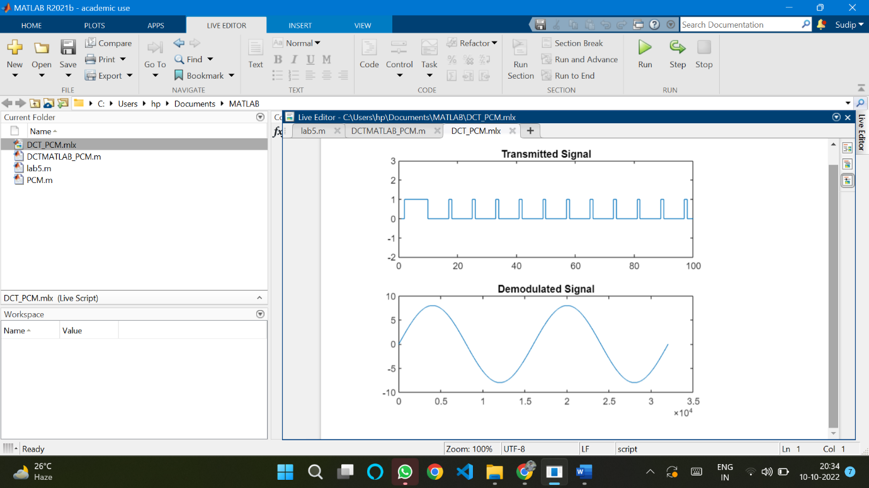

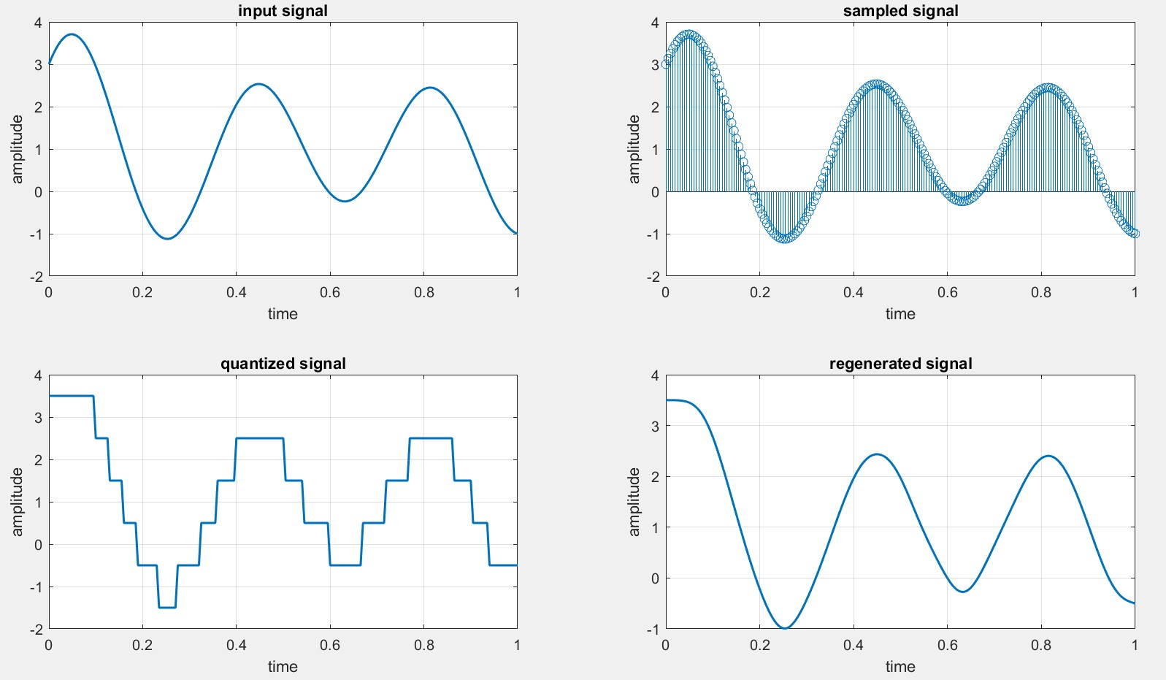

**PCM Simulink Output**

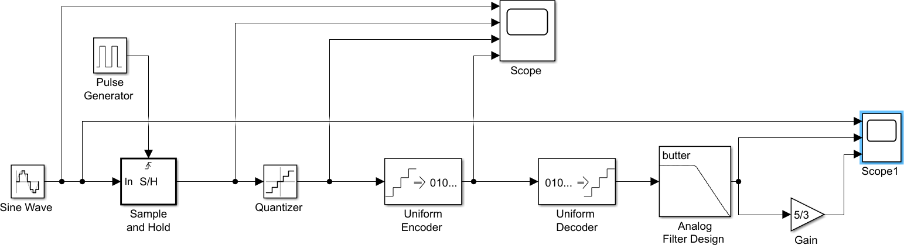

**DPCM Codes**

predictor = [0 1]; % y(k)=x(k-1)

partition = [-1:.1:.9];

codebook = [-1:.1:1];

t = [0:pi/50:7];

x =sin(3*t); % Original signal

subplot 221;

plot(t,x);

subplot 222;

stem(t,x);

% Quantize x using DPCM.

encodedx = dpcmenco(x,codebook,partition,predictor);

subplot 223;

plot(t,encodedx);

% Try to recover x from the modulated signal.

decodedx = dpcmdeco(encodedx,codebook,predictor);

subplot 224;

plot(t,decodedx);

**DPCM Matlab Output**

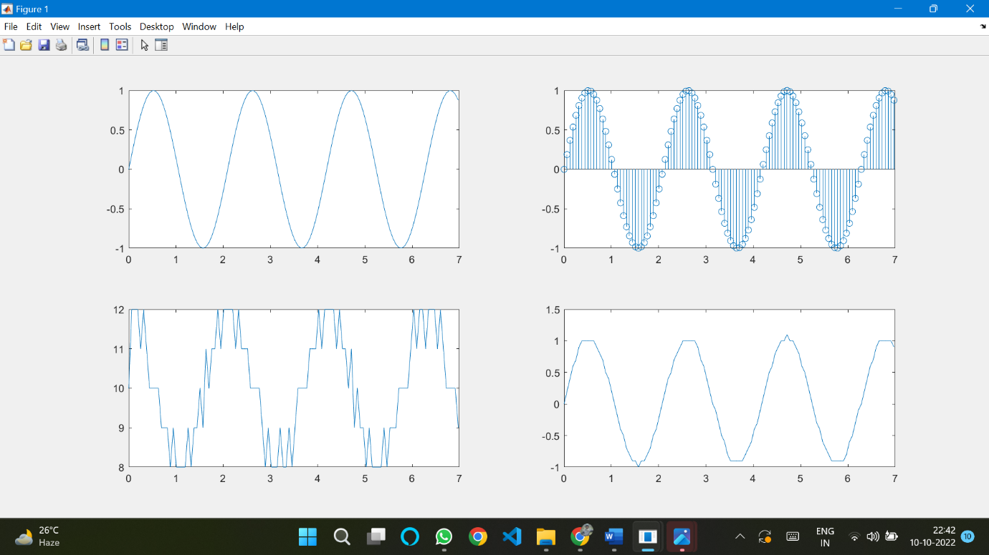

**DPCM Simulink Output**

