Simulation Lab Experiment-8

**Software Used:** LabVIEW

Simulation 1 (For Loop-Tunnelling):

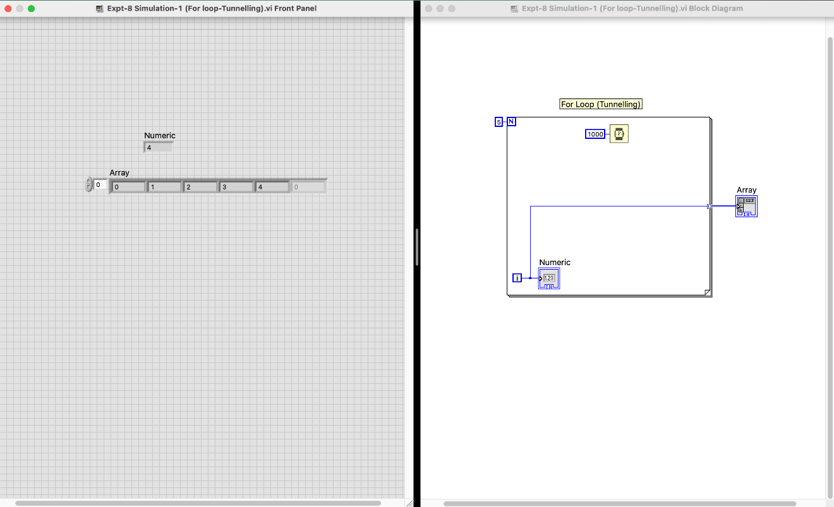

Simulation 2 (For loop-Square):

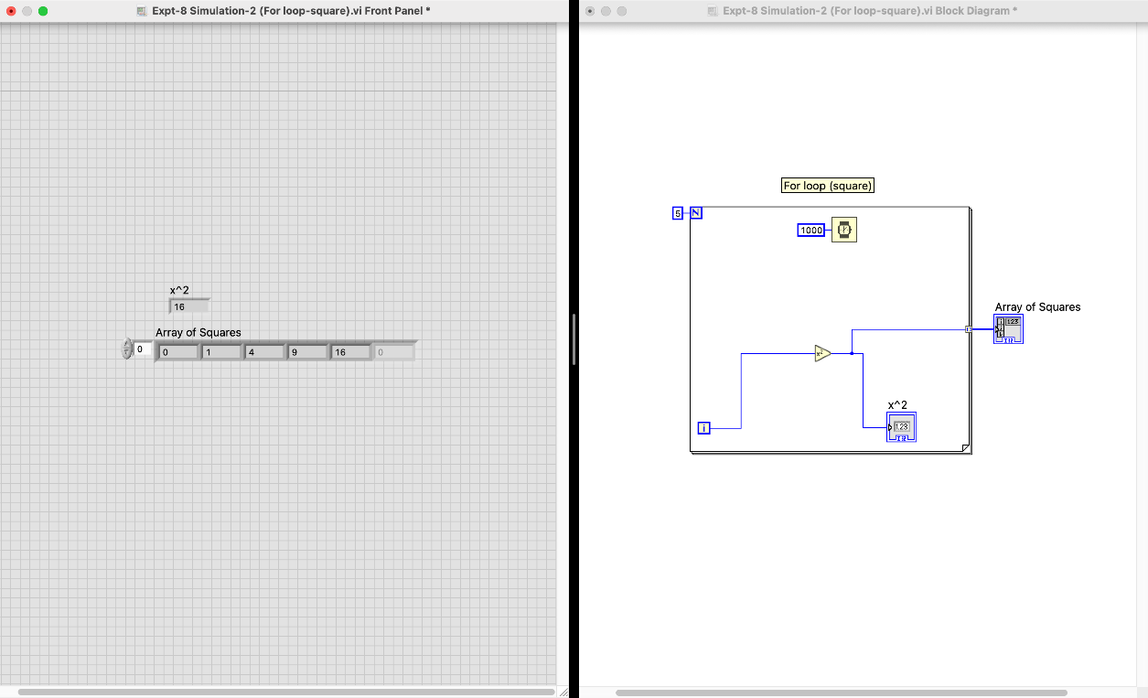

Simulation 3 (Shift Register):

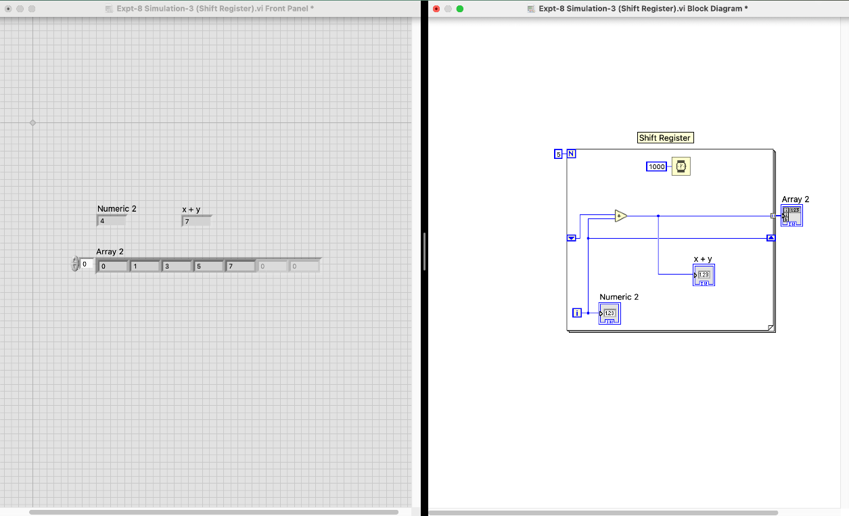

Simulation 4 (Case Control):

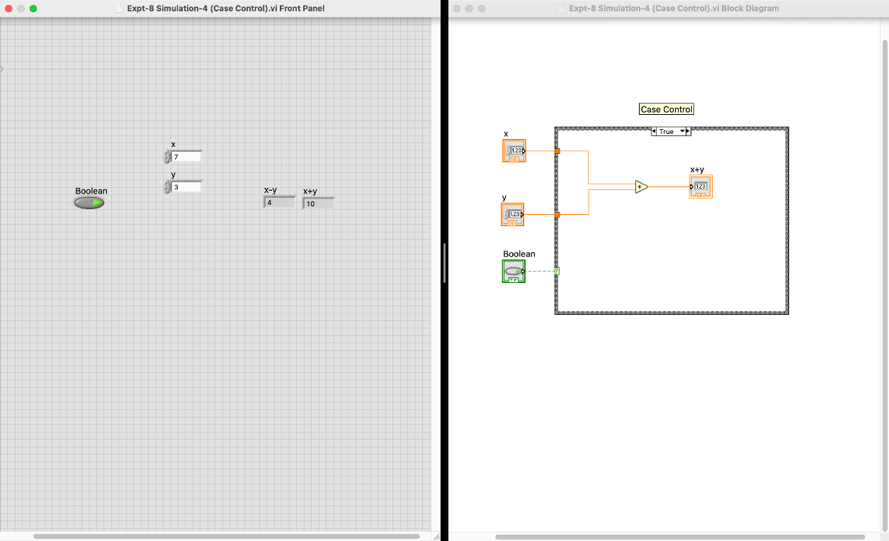

**Name:** Sudip Nayak

**Student ID:** B220061

**Branch:** ETC