**SIMULATION LAB EXPERIMENT – 9**

Program1: Plotting a pie chart

Code:

%Program1, pie chart

X = [ 1 2 3 4 5 6];

pie(X);

Output:

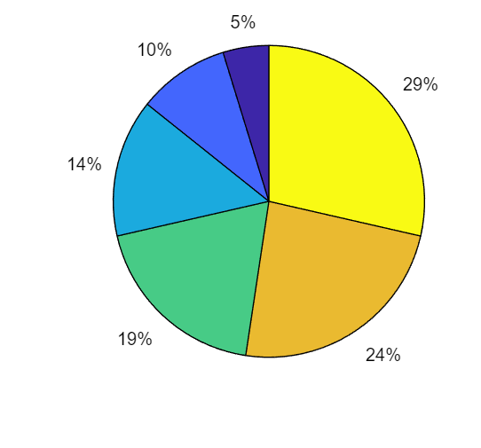

Program2: Plotting pie chart with the largest slice separated.

Code:

%Program2, pie chart

X = [1 2 3 4 5 6];

pie (X, X==max(X));

Output:

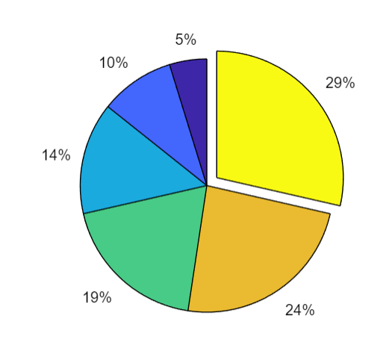

Program3: Bar chart

Code:

%Program3, bar chart

X=linspace(0,30,15);

Y=2.^(0.2*X);

bar (X, Y);

Output:

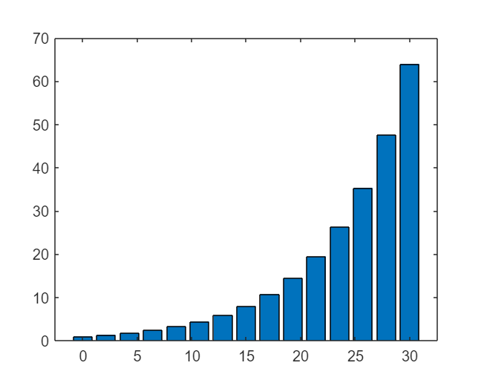

Program4: Horizontal Bar chart

Code:

%Program4, horizontal bar chart

X=linspace(0,30,15);

Y=2.^(0.2*X);

barh (X, Y);

Output:

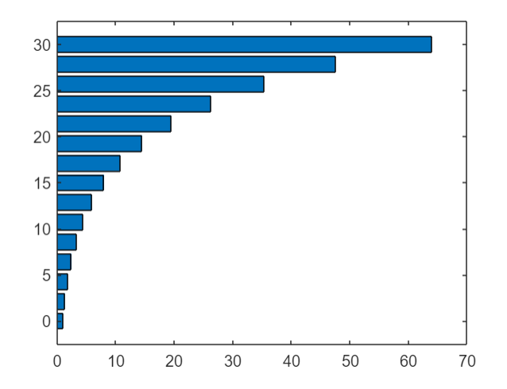

Program5: Stairs Plot

Code:

%Program5, stairs plot

X=linspace(0,30,15);

Y=2.^(0.2*X);

stairs (X, Y);

Output:

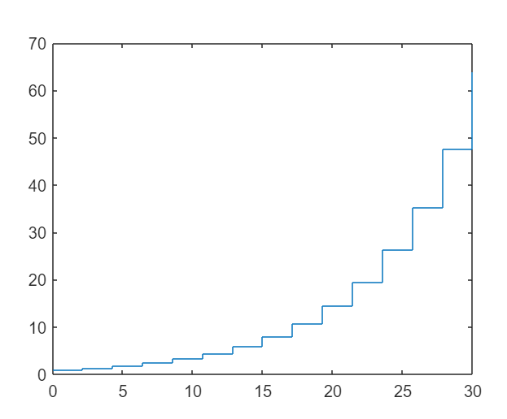

Program6: Polar Plot

Code:

%Program6, polar plot

X=linspace(0,2*pi,50);

Y=cos(X);

polarplot (X, Y);

Output:

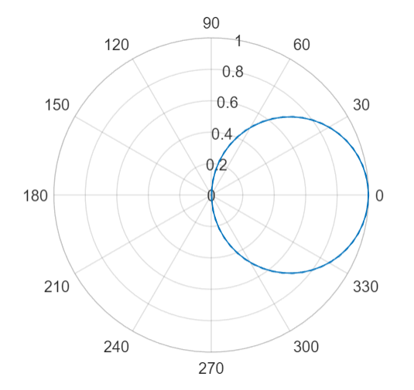

Program7: Mesh and Surface 3D plot

Code:

% Program 7, Mesh and surface 3D plot

clc;

close all;

clear;

x=0:0.05:5;

y=0:0.05:5;

[X, Y] = meshgrid (x,y);

Z=(X.^2+Y.^2);

subplot (2,1,2);

mesh (X, Y, Z);

title ('MESH PLOT');

subplot (2,1,1);

surf (X, Y, Z);

title ('SURFACE PLOT');

grid on;

Output:

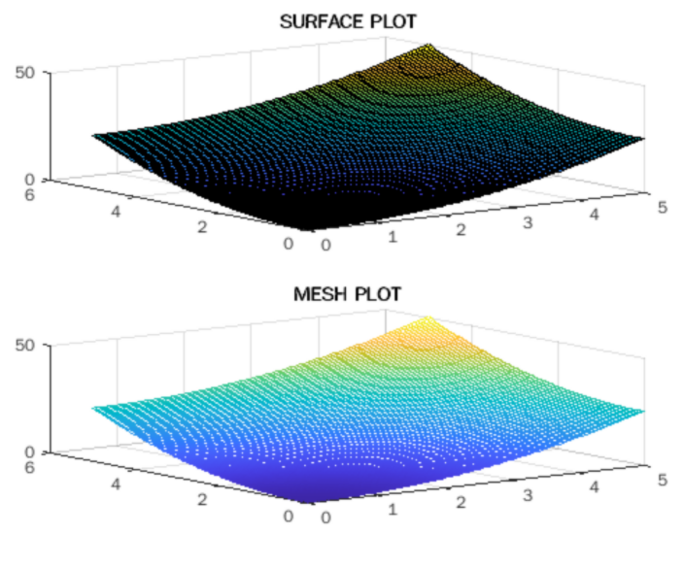

Program8: 3D Plot

Code:

% Program 8, 3D  plot

x=0:0.1:5;

y=0:0.1:5;

[X, Y] = meshgrid (x,y);

Z=(X.^2+Y.^2);

meshz(Z);

title ('MESHZ PLOT');

grid on;

Output:

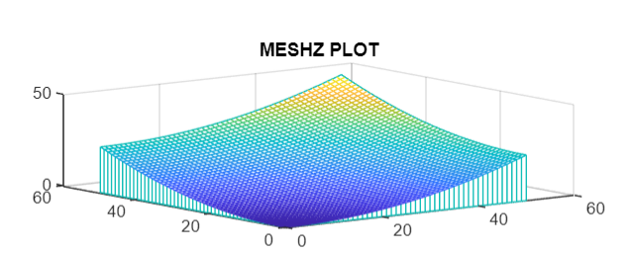

Program9: Contour Plot

Code:

% Program 9, 3D plot

x=-5:0.1:5;

y=-5:0.1:5;

[X, Y] = meshgrid (x, y);

Z=10+cos(X) – sin (0.5*Y);

contour3(Z,100);

title ('CONTOUR PLOT');

grid on;

Output:

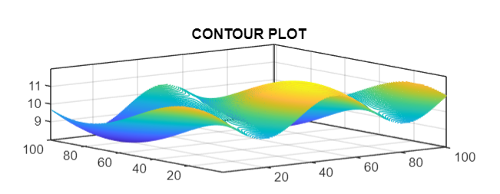

Program10: Ribbon Plot

Code:

% Program 10, ribbon plot

x=-5:0.1:5;

y=-5:0.1:5;

[X, Y] = meshgrid (x, y);

Z=10*cos (0.5*X) + 10*sin (0.5*Y);

ribbon(Z);

title ('RIBBON PLOT');

grid on;

Output:

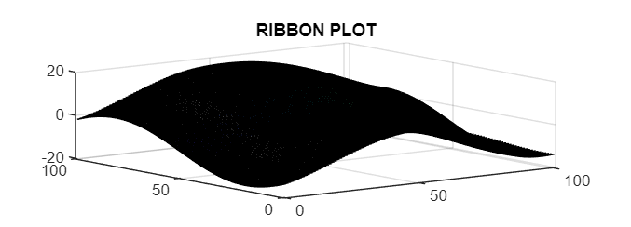

Program11: Sphere Plot

Code:

% Program 11,

Sphere plot [x, y, z]=sphere(36);

surf (x, y,z);

Output:

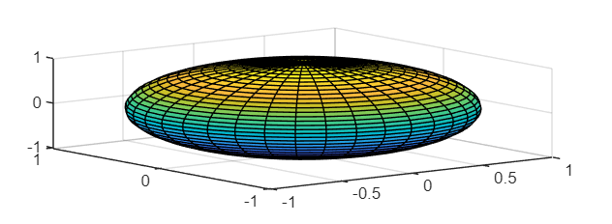

Program12: Pie Plot in 3D

Code:

% Program 12, Pie 3D plot

r=linspace(0,2*pi,20);

w=cos(r);

pie3(w);

Output:

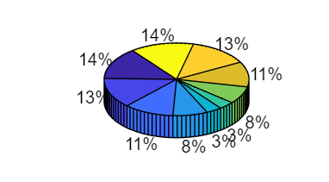

Program13: Cylinder Plot

Code:

% Program 13, Cylinder plot

r=linspace(0,2*pi,30);

w=cos(r);

cylinder(w);

Output:

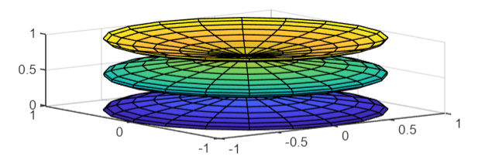

Program14: Using User-Defined Functions

Code:

|  |
| --- |
| function[z] = multi (z1, z2, z3)  %Returns the product of three complex numbers z1, z2 and z3  z = z1 * z2 * z3; |
| function[f] = factorial1(n)  %Returns the factorial of a natural number n  f = 1;  for i = 1 : 1 : n      f = f * i;  end |
| %Using the UDF multi (z1, z2, z3) and facorial1  a=1+2i;  b=1+2i;  c=1+2i;  p=multi(a,b,c);  disp("Product = ");  disp(p);  disp("Factorial of 5 =")  disp(factorial1(5)); |

Output:

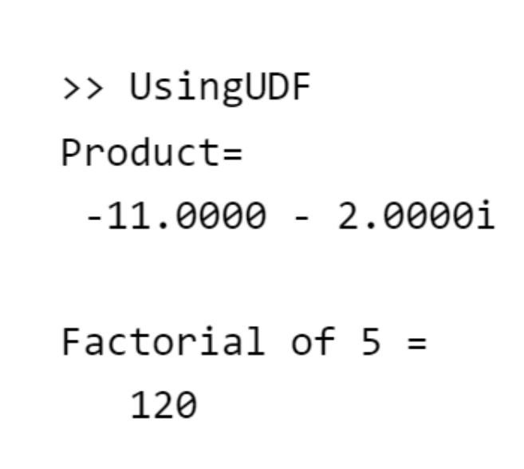

NAME: SUDIP NAYAK

STUDENT ID – B220061

BRANCH – ETC (3RD SEM)