SIMULATION LAB   
EXPERIMENT-10

AIM OF THE EXPERIMENT

MATLAB GUI, SIMULINK (Arithmetic operations: Addition, Substation, Division, Multiplication; User defined functions and plotting)

GUI IN MATLAB

**To perform arithmetic operations Addition, Subtraction and and  Multiplication using GUIDE.**

Addition



Subtraction



Multiplication



**SIMULINK**

Arithmetic Operations on Numbers

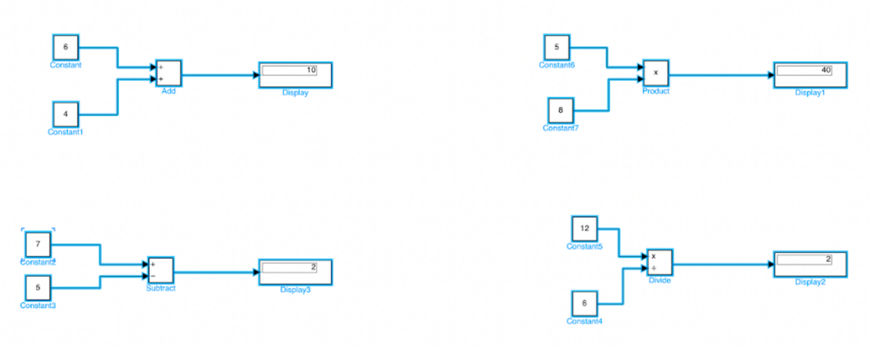

Arithmetic Operations on Matrix

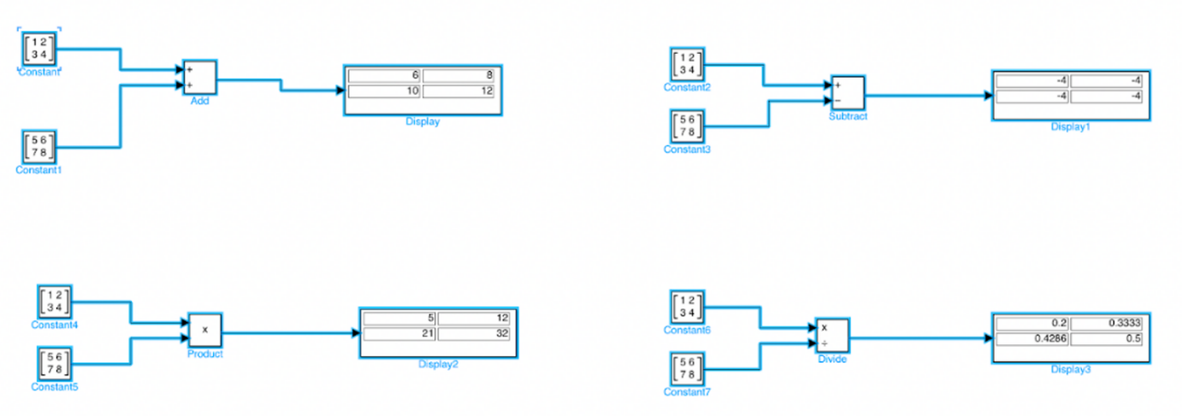

User-defined Function

**y = f(u) = u2**

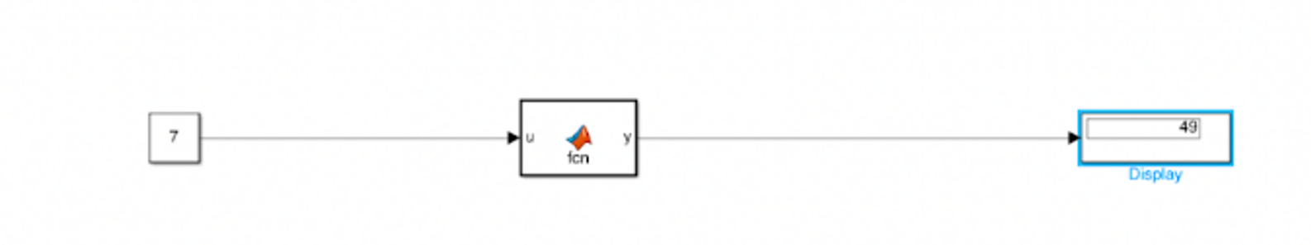

Plotting

**For Plotting of a parabola using the XY Graph Block**

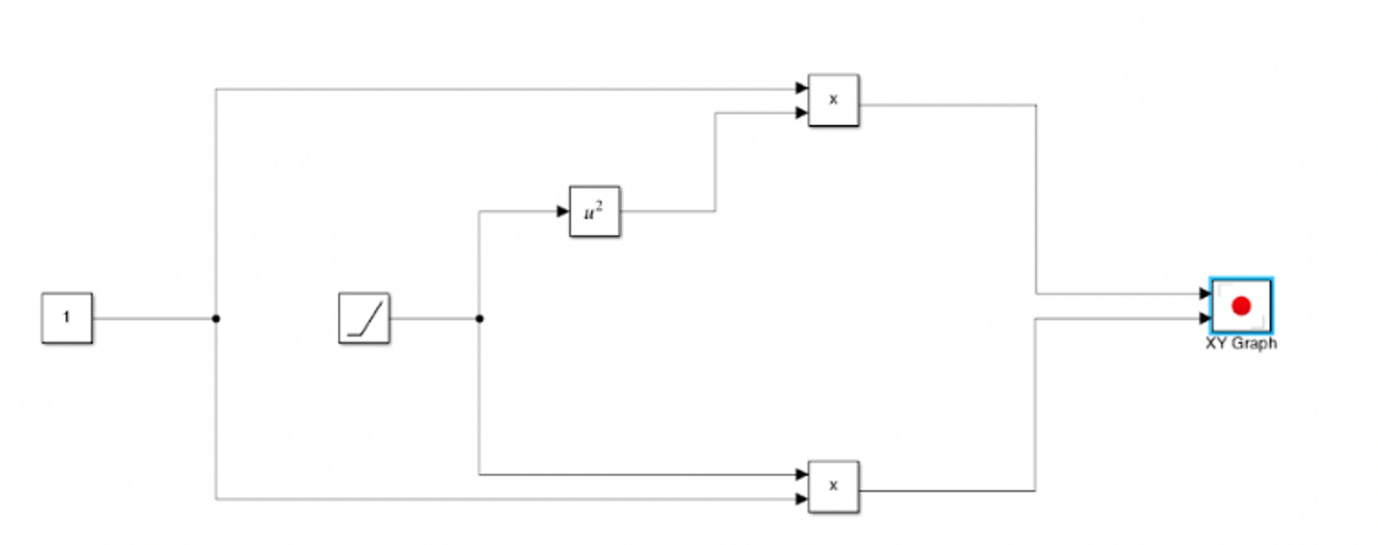

XY Graph

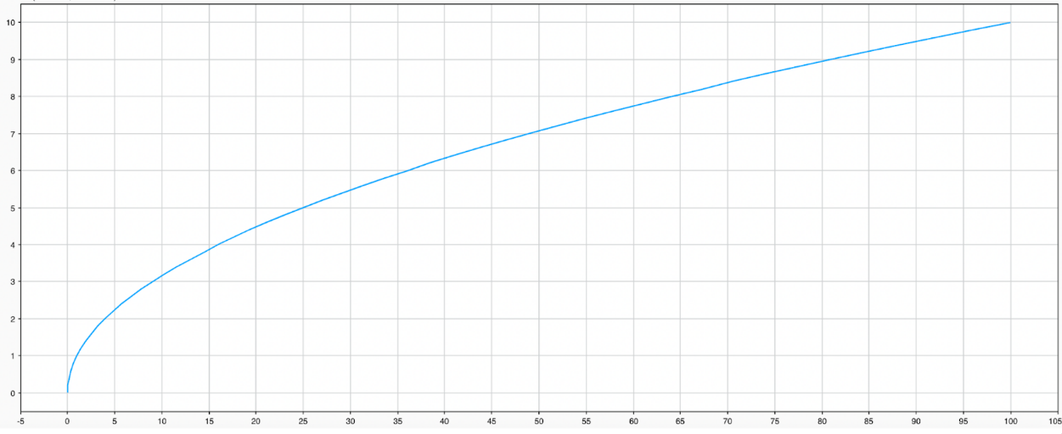

Name: Sudip Nayak

ID: b220061

Branch: ETC (3rd Sem)