SIMULATION LAB EXPERIMENT-5

Simulation1(Data types and controls in LabView)

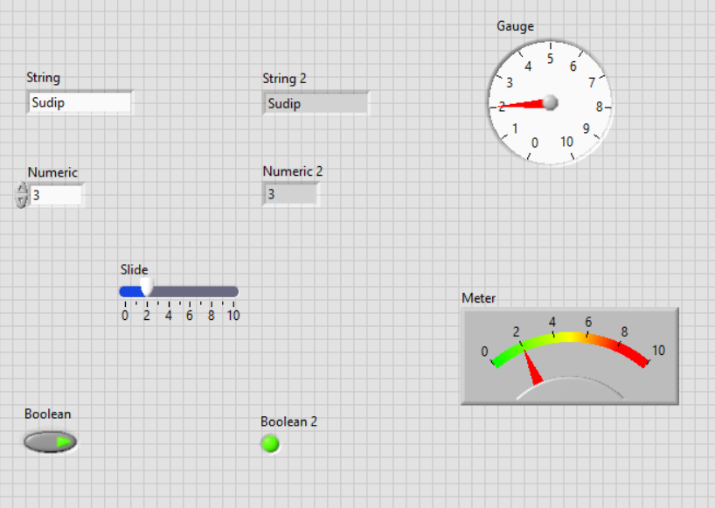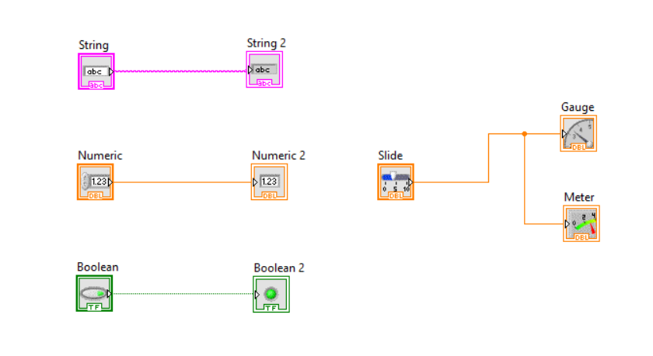

Simulation2(Arrays)

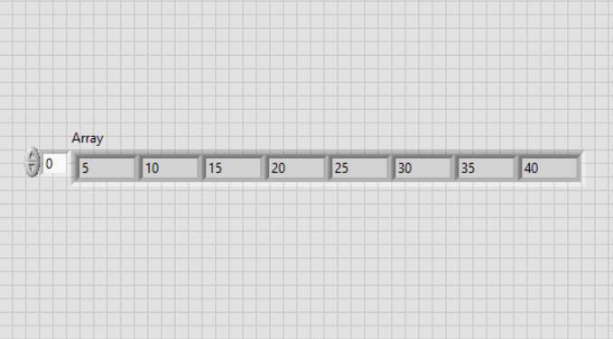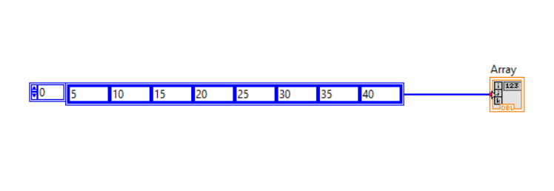

Simulation3(Bundled and Unbundled)

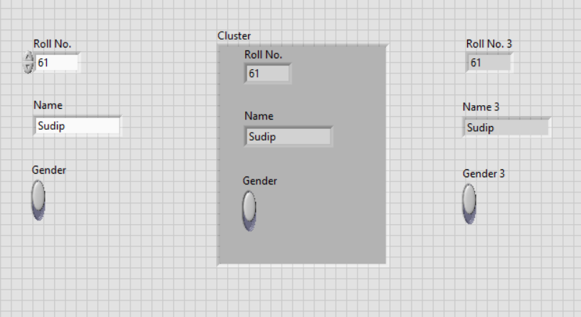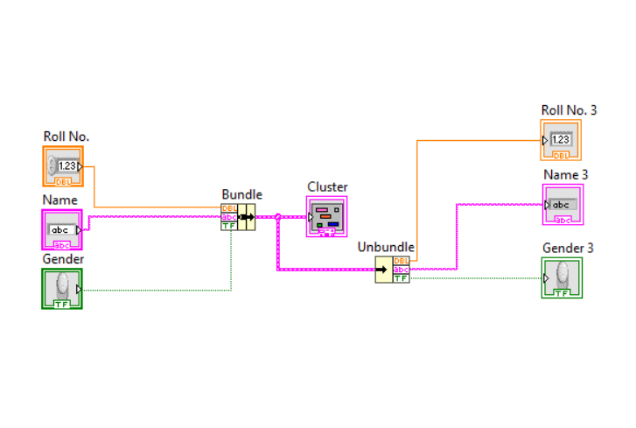

Name: Sudip Nayak

ID: B220061

ETC (3rd Semester)