SIMULATION LAB EXPERIMENT 6

SIMULATION 1(FORMULA NODE)

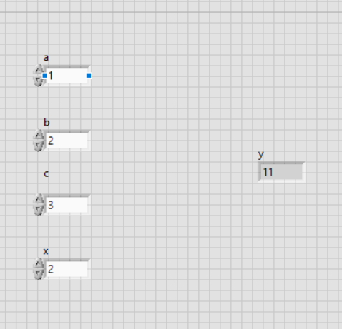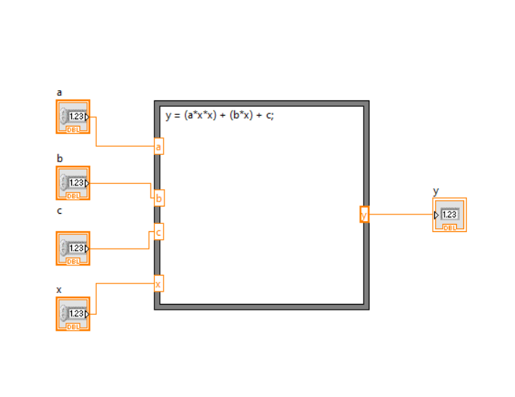

SIMULATION 2(SUB VI)

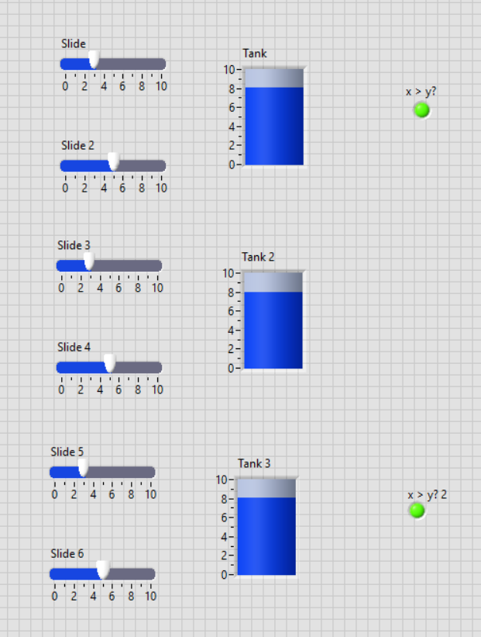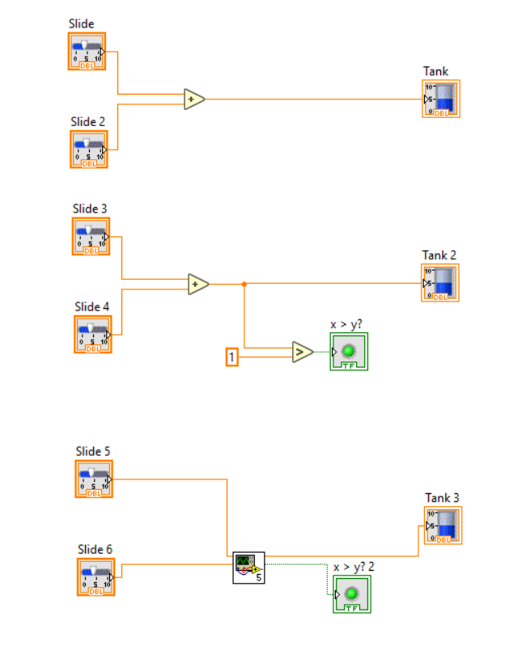

Submitted by:

Name- Sudip Nayak

Id- B220061

Branch- ETC (3rd year)