SIMULATION LAB EXPERIMENT-7

Simulation 1 (While loop)

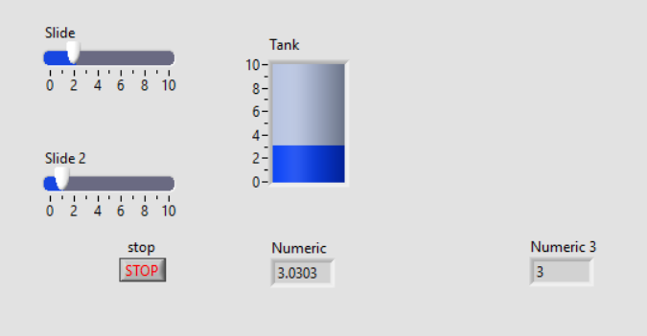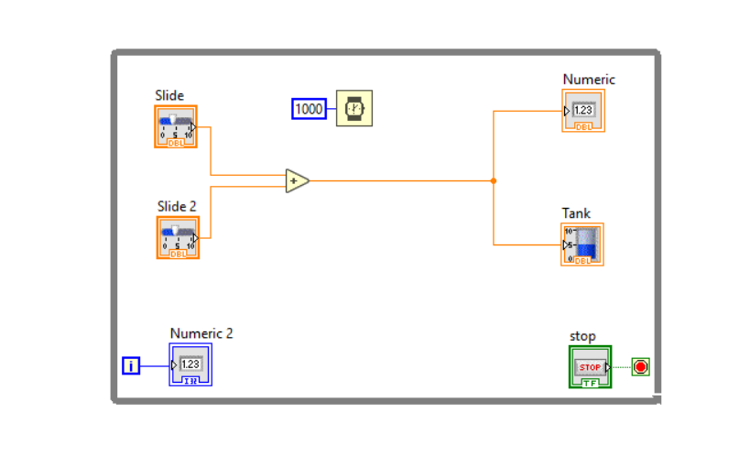

Simulation 2 (signal Generation)

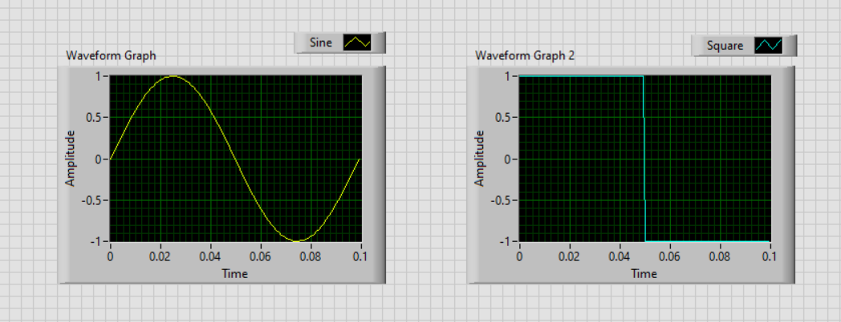

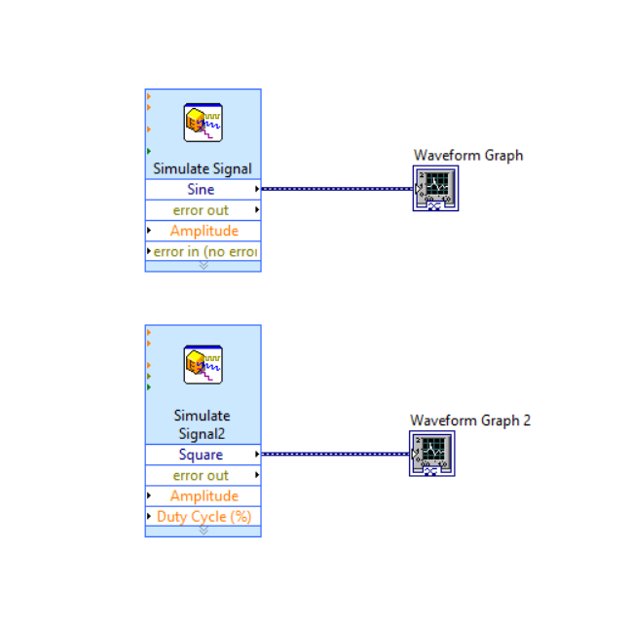

Name: Sudip Nayak

Id: B220061

Branch: ETC (3rd Sem)